TYSD FIELD PROJECT | ACADEMIC YEAR 2026-27
AI Interview Preparation Platform
Basic Modules, Data Design, Schema Design,
and Data Integrity & Constraints
Student Name | ________________________________
Roll Number | ________________________________
Class / Division | ________________________________
Project Guide | ________________________________
College | ________________________________
Submission Date | ________________________________
Submission: 4.1 Basic Modules | 4.2 Data Design | 4.2.1 Schema Design | 4.2.2 Data Integrity and Constraints

Executive Summary
The AI Interview Preparation Platform is a full-stack web application that helps users prepare for job interviews through authenticated accounts, resume analysis, role-based question generation, and guided mock interviews. React and Vite provide the user interface, while Node.js and Express implement the API. MongoDB Atlas is the permanent data store, and Mongoose defines collection schemas and validation rules.
Database purpose: MongoDB stores permanent user, resume, interview, and question records. Browser localStorage is used only as a temporary frontend cache and is not the authoritative data source.

Document Scope
- 4.1 Basic Modules - functional components currently implemented in the platform.
- 4.2 Data Design - database structure, collection ownership, and data flow.
- 4.2.1 Schema Design - field definitions for Users, Resumes, Interviews, and Questions.
- 4.2.2 Data Integrity and Constraints - validation, security, uniqueness, and ownership controls.

4.1 Basic Modules
No. | Module | Responsibility | Status
1 | Registration and Login | Creates accounts, hashes passwords, verifies credentials, and issues JWTs. | Implemented
2 | Resume Upload | Accepts authenticated PDF/DOCX uploads up to 5 MB using Multer. | Implemented
3 | Resume Analysis | Extracts text, skills, education, experience, and keywords and stores the result. | Implemented
4 | Resume Profile Editing | Allows users to correct target role, experience level, skills, education, experience, and keywords. | Implemented
5 | Question Generation | Uses Gemini first and a permanent role-aware local fallback if the API is unavailable. | Implemented
6 | Mock Interview | Displays saved questions one at a time with type, difficulty, source, and progress. | Implemented
7 | Answer Evaluation | Will evaluate correctness, confidence, communication, and technical accuracy. | Planned
8 | Analytics and History | Will show previous interviews, scores, progress charts, and suggestions. | Planned

Module Interaction
The modules execute in a controlled sequence: registration -> login -> resume upload -> resume analysis -> profile review/editing -> interview configuration -> question generation -> mock interview. Evaluation and analytics will extend this sequence in later modules.

4.2 Data Design
MongoDB Atlas was selected because the project stores nested resume-analysis data, evolving interview records, and user-specific documents. Mongoose provides application-level schemas, validation, indexes, references, defaults, and data-type enforcement.

Collection Relationship Model
Parent | Child | Cardinality | Reference
Users | Resumes | One-to-many | Resumes.userId -> Users._id
Users | Interviews | One-to-many | Interviews.userId -> Users._id
Resumes | Interviews | One-to-many | Interviews.resumeId -> Resumes._id
Interviews | Questions | One-to-many | Questions.interviewId -> Interviews._id

Ownership rule: Every protected read or update filters by the authenticated user ID. A user cannot retrieve or edit another user's resume or interview by changing a URL identifier.

4.2.1 Schema Design

Users Collection
Stores registered user identities. Password values contain bcrypt hashes and are excluded from normal model queries.
Field | Type | Required | Description / Constraint
_id | ObjectId | Yes | MongoDB document identifier
name | String | Yes | Trimmed; 2-80 characters
email | String | Yes | Unique, lowercase, and trimmed
password | String | Yes | bcrypt hash; select:false
createdAt | Date | Yes | Defaults to current date/time

Resumes Collection
Stores file metadata, the authenticated owner, interview preferences, extracted text, and editable structured analysis.
Field | Type | Required | Description / Constraint
_id | ObjectId | Yes | Resume identifier
userId | ObjectId ref User | Owner | Connects the resume to its user
fileName | String | Yes | Original uploaded filename
storedFileName | String | Yes | Unique safe server filename
filePath | String | Yes | Relative path under server/uploads
mimeType | String | Yes | PDF or DOCX MIME type
interviewPreferences.role | String | Defaulted | Editable target job role
interviewPreferences.experienceLevel | String | Defaulted | Fresher, 1-2, 3-5, or 5+ Years
interviewPreferences.difficulty | String | Defaulted | Beginner, Intermediate, or Advanced
analysis.skills | String[] | Default [] | Recognized and user-edited skills
analysis.education | String[] | Default [] | Education lines
analysis.experience | String[] | Default [] | Experience lines
analysis.keywords | String[] | Default [] | High-value resume terms
analysis.rawText | String | Yes | Complete extracted document text
uploadedAt | Date | Defaulted | Upload timestamp

Interviews Collection
Field | Type | Required | Description / Constraint
_id | ObjectId | Yes | Interview identifier
userId | ObjectId ref User | Yes | Indexed owner reference
resumeId | ObjectId ref Resume | Yes | Source resume reference
role | String | Yes | Trimmed; maximum 120 characters
type | String enum | Yes | HR, Technical, Behavioral, or Mixed
difficulty | String enum | Yes | Beginner, Intermediate, or Advanced
questionCount | Number | Yes | Minimum 5; maximum 15
generationSource | String enum | Default local | gemini or local
generationModel | String/null | No | Successful Gemini model identifier
status | String enum | Default | not_started, in_progress, or completed
score | Number/null | No | Future score constrained to 0-100
feedback | String | Default empty | Future evaluation feedback
createdAt | Date | Defaulted | Creation timestamp

Questions Collection
Field | Type | Required | Description / Constraint
_id | ObjectId | Yes | Question identifier
interviewId | ObjectId ref Interview | Yes | Indexed parent interview
order | Number | Yes | Minimum 1; unique within interview
question | String | Yes | Trimmed question text
type | String enum | Yes | HR, Technical, or Behavioral
difficulty | String enum | Yes | Beginner, Intermediate, or Advanced
skill | String/null | No | Related skill or competency
expectedPoints | String[] | Default [] | Reference points for future evaluation

4.2.2 Data Integrity and Constraints
Area | Constraint / Control | Integrity Benefit
Identity | Unique email index | Prevents duplicate registered accounts.
Credential security | bcrypt hashing | Plain-text passwords are never stored.
Authorization | JWT + ownership filter | Protects private routes and prevents cross-user access.
File integrity | Extension, MIME, and size validation | Only PDF/DOCX files up to 5 MB are accepted.
Resume editing | Array cleaning and item limits | Removes blanks/duplicates and limits field sizes.
Interview type | Mongoose enum | Rejects types outside HR, Technical, Behavioral, and Mixed.
Difficulty | Mongoose enum | Rejects levels outside Beginner, Intermediate, and Advanced.
Question count | min 5 / max 15 | Prevents invalid or excessive generation requests.
Question order | Compound unique index | One order number per question within an interview.
Score | min 0 / max 100 | Prevents invalid future evaluation scores.
AI response | Strict JSON schema + validation | Rejects malformed, duplicate, or wrong-type Gemini output.
Availability | Model failover + local fallback | External API failures do not crash question generation.

Validation Layers
- Frontend validation gives immediate feedback for required fields, file type, file size, and form ranges.
- Express controllers validate request values and authenticated ownership before database operations.
- Mongoose schemas enforce types, required values, defaults, enum lists, numeric ranges, and indexes.
- MongoDB Atlas provides persistent storage independent of browser refreshes or application restarts.

End-to-End Data Flow
Step | Application Action | Collection | Database Operation
1 | Register / Login | Users | Create user; return JWT after verification
2 | Upload Resume | Resumes | Store metadata and parsed analysis
3 | Edit Profile | Resumes | Save corrected role and structured resume fields
4 | Generate Interview | Interviews | Store configuration, source, model, and status
5 | Generate Questions | Questions | Store ordered role-specific questions
6 | Mock Interview | Interviews + Questions | Load only records owned by current user

Working Module Evidence
The following screenshots demonstrate the implemented frontend workflow. Screenshots are included as implementation evidence; personal login details, database credentials, and API keys are not displayed.
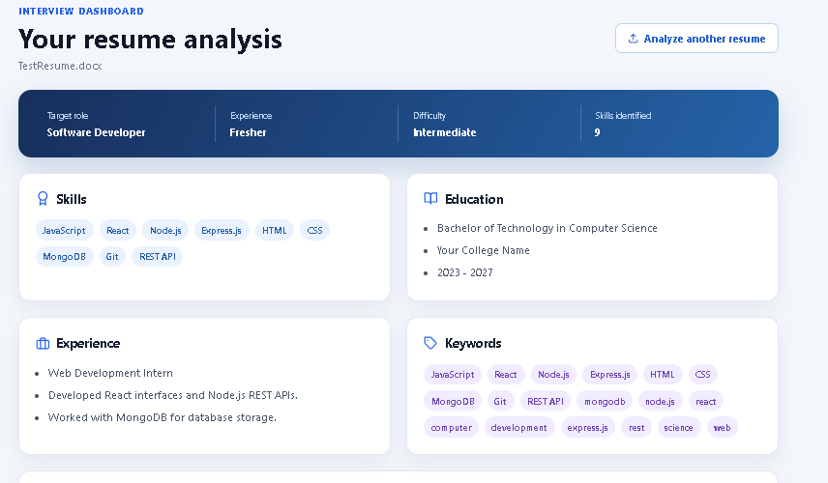
Figure 1. Resume Analysis Dashboard - extracted skills, education, experience, and keywords
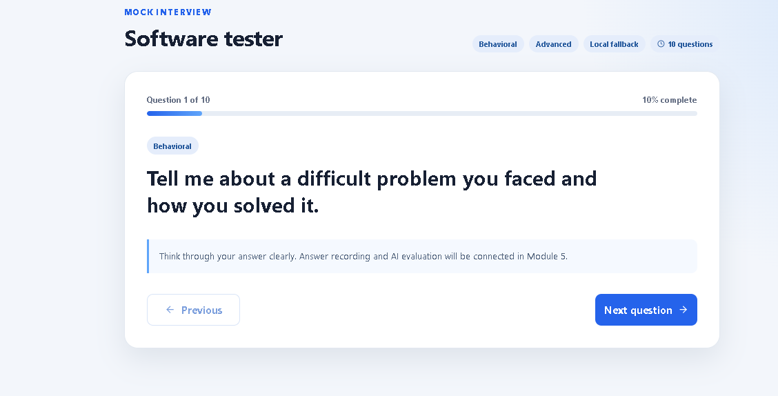
Figure 2. Mock Interview - question progress and visible generation source

Testing Summary
Test Area | Evidence | Result
Authentication | Unknown accounts rejected; registered user receives JWT | Pass
Resume upload | DOCX upload parsed and saved in MongoDB | Pass
Ownership | Latest resume/interview filtered by authenticated user | Pass
Question uniqueness | 15 unique questions across types and difficulties | Pass
Difficulty variation | Distinct Beginner, Intermediate, and Advanced banks | Pass
Gemini integration | Flash-Lite generated five structured questions | Pass
Fallback | Local role-aware questions returned when Gemini unavailable | Pass
Frontend quality | ESLint and Vite production build completed | Pass

Conclusion
The current platform implements a modular and secure foundation for AI-assisted interview preparation. MongoDB Atlas provides durable, user-specific storage; Mongoose schemas document and enforce the data model; JWT authentication protects ownership; and the hybrid Gemini/local generator keeps the mock interview usable during external API failures. The schema is prepared for answer evaluation, performance reports, and interview history in subsequent modules.
Submission note: Before submission, replace the cover-page blanks with your student details. If your instructor requires MongoDB Atlas screenshots, add a redacted screenshot of each collection without exposing connection strings, passwords, JWTs, or API keys.

