6. RESULTS AND DISCUSSION
6.1 Test Reports
Module 6 was tested after completing the analytics and interview-history features. The objective was to confirm that a logged-in user can view only their completed interviews, inspect saved performance reports, filter history records and see graph-ready analytics generated from MongoDB data. The tests were performed using the React frontend, Express API, JWT authentication middleware and MongoDB Atlas.
Test Condition | Input / Action | Expected Result | Actual Result
History API authorization | Call GET /api/interviews/history with JWT | Only logged-in user's completed interviews are returned | Pass - success:true response received
Analytics API | Call GET /api/interviews/analytics with JWT | Summary, category averages, trend and suggestions returned | Pass - safe empty response returned when no interview exists
Empty analytics | New user with zero completed interviews | Dashboard shows friendly empty state; no crash | Pass
Completed interview | Finish every question and save final report | Interview appears in history with score and date | Pass
History filter | Search role; choose type and difficulty | Only matching completed interviews displayed | Pass
Previous report | Select View from history row | Stored report opens at /interview/:id/report | Pass
Pagination | More than ten completed interviews | Previous/Next controls load correct page | Pass
Responsive interface | Open analytics on smaller screen | Cards, filters and history remain readable | Pass

6.1.1 Results Discussion
The protected API checks demonstrated that analytics are user-specific. The returned history object contains completed interviews only, while the analytics object contains total interviews, average score, highest score, latest score, improvement value, category averages, score-trend points and repeated suggestions. When the account has no completed interviews, null scores and empty arrays are intentionally returned; this prevents invalid calculations and gives a clean first-use experience.
After interviews are completed, the dashboard uses the stored performanceReport from Module 5 instead of recalculating every answer. This makes the history screen faster and supports direct navigation to previous reports. The score-trend component uses SVG and does not add an external chart dependency, keeping the frontend lightweight.
6.1.2 Module 6 Components
Component | Purpose | Result
GET /api/interviews/history | Returns paginated, filterable history | Protected and user-specific
GET /api/interviews/analytics | Calculates overall progress data | Graph-ready JSON response
AnalyticsDashboard.jsx | Loads analytics and history APIs | Protected analytics page
ProgressSummary.jsx | Displays totals and score cards | Shows empty values safely
PerformanceChart.jsx | Displays score trend using SVG | No additional chart library
InterviewHistory.jsx | Provides filters, paging and report links | Previous reports accessible

6.2 User Documentation
This section explains how a user operates the performance analytics module after completing at least one mock interview. The Analytics page is protected, therefore the user must first register and log in.
6.2.1 Opening Performance Analytics
• Start the backend server and frontend development server, then open the platform in the browser.
• Log in using a registered account.
• Open the Dashboard and click the Performance analytics button.
• The system opens the protected route: /analytics.
• If no interview is completed, the page shows an empty-state message and a Start new interview button.
6.2.2 Completing an Interview to Create Analytics
• Generate an interview from the resume profile. Five questions are recommended for quick testing.
• Type an answer or select Answer using microphone, allow microphone access, speak, stop voice input and edit the transcript if needed.
• Select Save and continue for every question. The answer is evaluated and saved.
• On the final question, select Save and finish. The final performance report opens automatically.
• Return to the dashboard and open Performance analytics again to see the score and interview-history entry.
6.2.3 Understanding the Analytics Page
Area | What the user sees | How to use it
Summary cards | Completed interviews, average score, highest score and improvement | Compare current progress with earlier interviews
Score trend | One point per completed interview | Hover or read labels to compare scores over time
Category analysis | Correctness, confidence, communication and technical accuracy | Focus practice on the weakest category
Improvement plan | Repeated evaluation suggestions | Use frequent suggestions as a revision checklist
Interview history | Role, type, difficulty, score, date and View action | Review any saved report
Filters | Role search, interview type and difficulty | Narrow history results without affecting stored data

6.2.4 Demonstration Procedure
For a classroom demonstration, create and complete two short interviews with the same account. Open Performance analytics, show both score points in the graph, select a type or difficulty filter, and click View on an older interview. Refresh the browser page to demonstrate that the report and history come from MongoDB Atlas rather than temporary frontend state.
6.2.5 Screenshots of Module 6
The following screenshots show the implemented performance analytics interface before completed interviews are available. The empty-state design clearly guides a new user to complete an interview, while preserving the same summary, graph, category and filtering layout used for completed data.
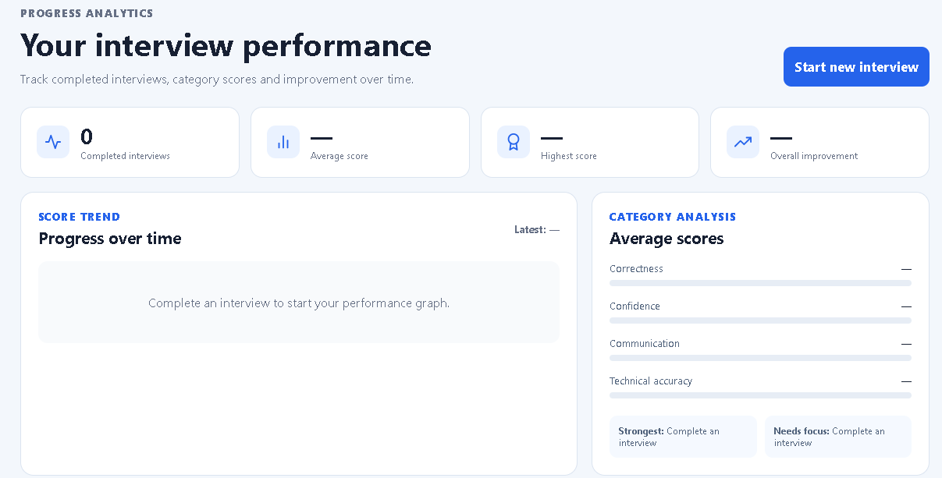
Figure 6.1: Performance Analytics overview - summary cards, score trend and category analysis.
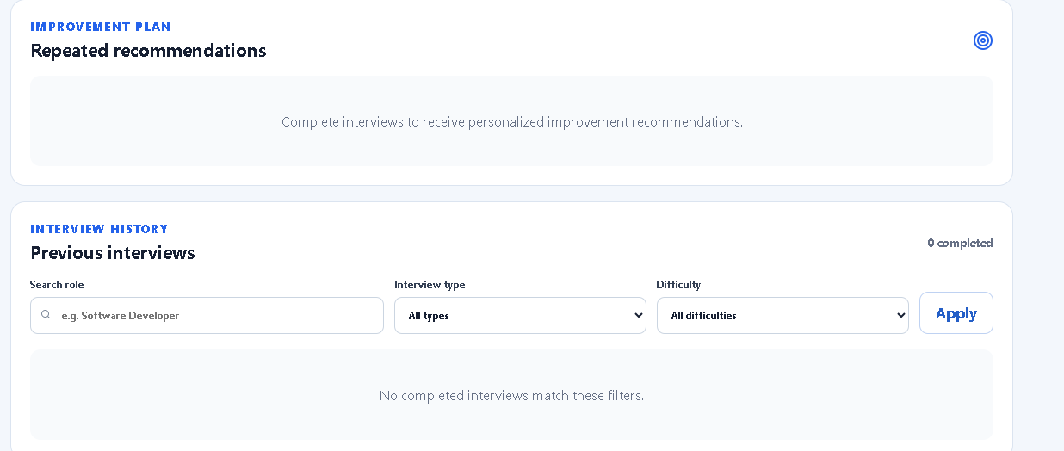
Figure 6.2: Improvement plan and Previous Interviews section with role, type and difficulty filters.
6.3 Conclusion
Module 6 completes the user-progress layer of the AI Interview Preparation Platform. The results confirm that completed interviews are stored permanently, shown only to their owner and transformed into meaningful scores, trends and recommendations. The module gives users a practical way to track improvement and prepares the application for final deployment and security improvements in Module 7.

