

**NATIONAL UNIVERSITY OF SCIENCES AND TECHNOLOGY**

School of Electrical Engineering and Computer Sciences

**Advanced Programming (CS-213)**

**ASSIGNMENT 1**

**SUBMITTED TO: Dr. Sidra Sultana**

**SUBMITTED BY: Muhammad Saad Tariq**

**CMS ID: 224921**

**Section: BSCS-7A**

**Date of Submission: 16th September 2019**

**Vanilla Forums**

Classification

Forum based

About

Vanilla forums is an open source web-based software that started in the year 2009 and provides an easy to use, free licensed, forum platform that can be utilized by any user to set up their own community. Forums are very popular types of web-based software that allow users of a specific community to discuss and display their opinions over a certain topic or product with other consumers who share a common interest. They are an effective way to increase social interaction and are a great method to boost interest in a particular product or topic. These forums can either be stand-alone where any user can post or reply to a topic, or they can be community based where a user must be a member of the community to contribute their opinions. Similarly, Vanilla provides a community-based forum for people to easily interact with each other.

Configuration

Vanilla provides a very easy configuration process. It can be summarized in the following steps:

1. Visit Vanilla Forums website and download the open source zip file.

<https://vanillaforums.com/en/software/>

1. Set up a localhost server, such as xampp, from the apachefriends website.

<https://www.apachefriends.org/download.html>

1. Ensure that both Apache and MySQL are actively running in the xampp server control panel.
2. Unzip all the contents of the downloaded Vanilla file into the htdocs folder in xampp in your pc.

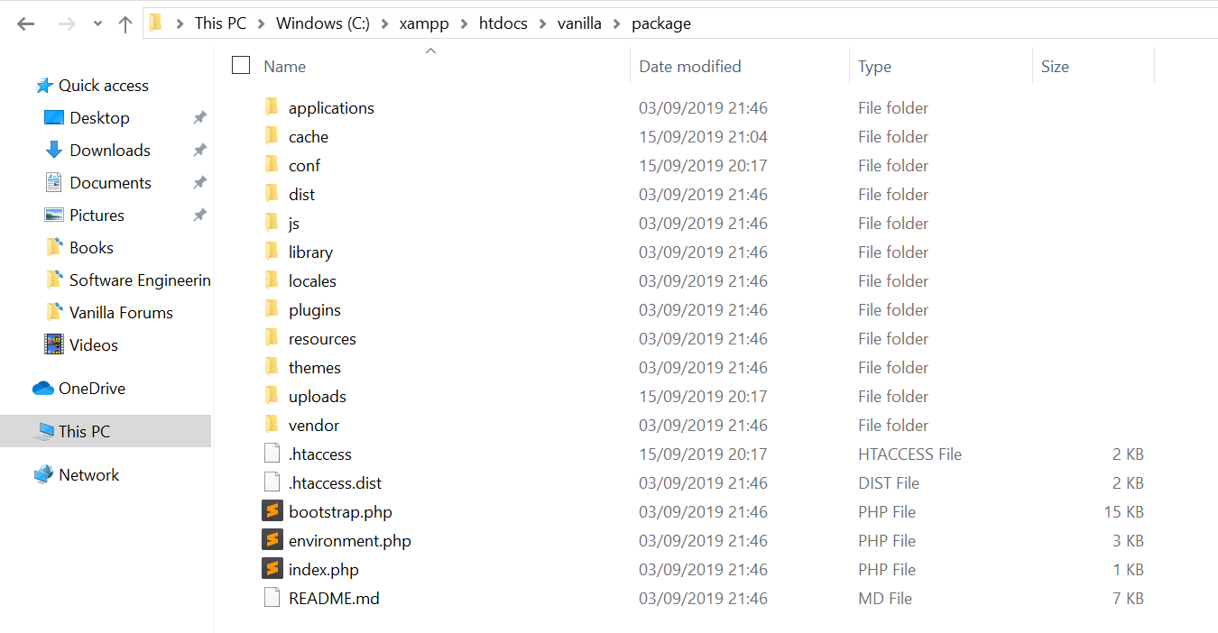

1. Open phpmyadmin from the xampp dashboard by accessing localhost from your browser URL, and create a database for the forum. (Database named vanilla can be seen in the picture below).

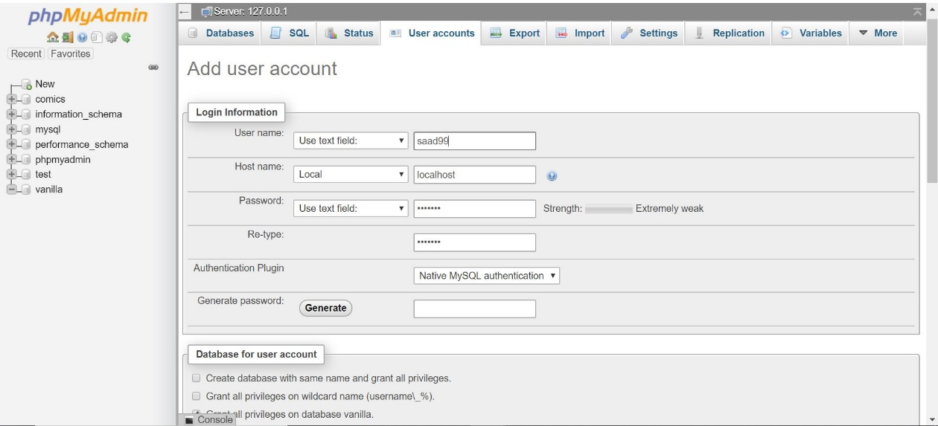

1. Set up a username and password to allow unrestricted access to the database, and use these credentials to set up the forum on your local server.
2. Type localhost/vanilla/packages in the browser URL and enter your credentials to activate the forum.

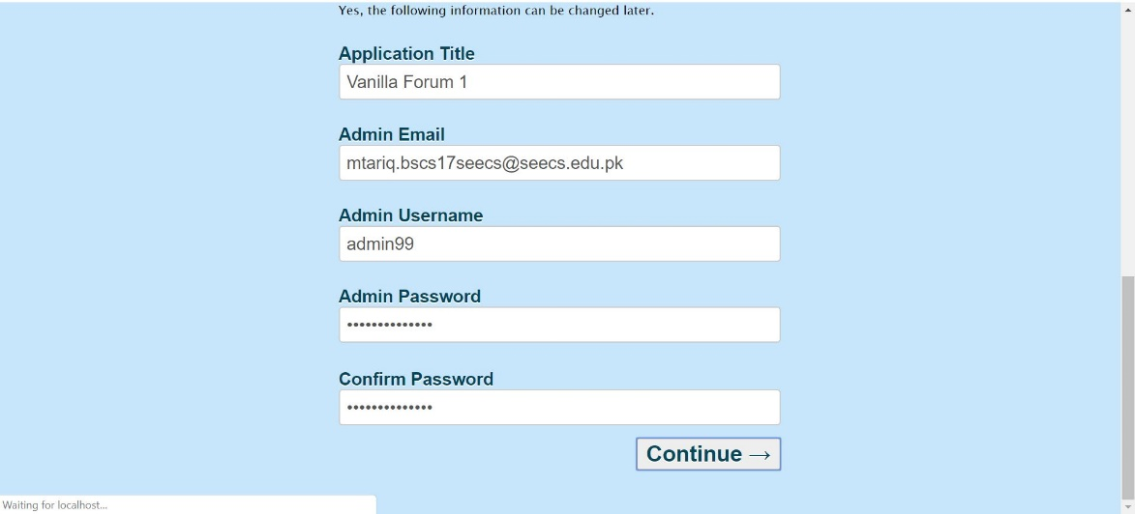

1. Vanilla Forums are now installed on your local server and the following display appears.

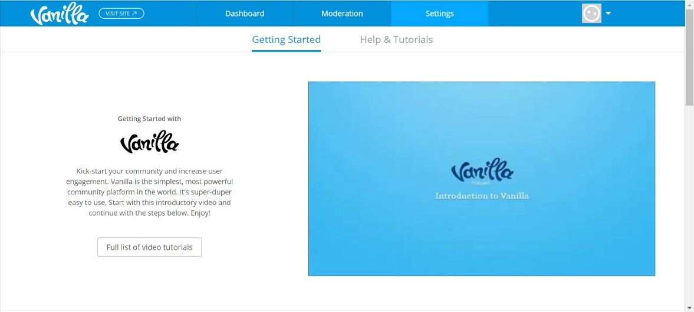

User’s perspective

Vanilla proves to be a very easy to manipulate software for the user, that allows the user to make all the changes of their likes on the action of a simple click. For ease of customer use, all processes in the front and back end are executed with a click of a mouse.

Back-end features:

* Dashboard – giving summary of active users, system updates and keeping up to date with latest news.

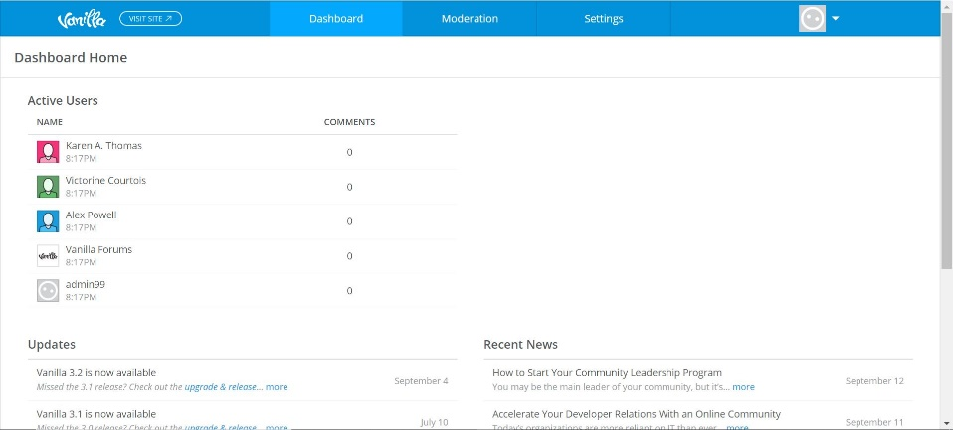

* Moderation tab – user controls content of forum, analyze spam and regulate content activity on the forum.

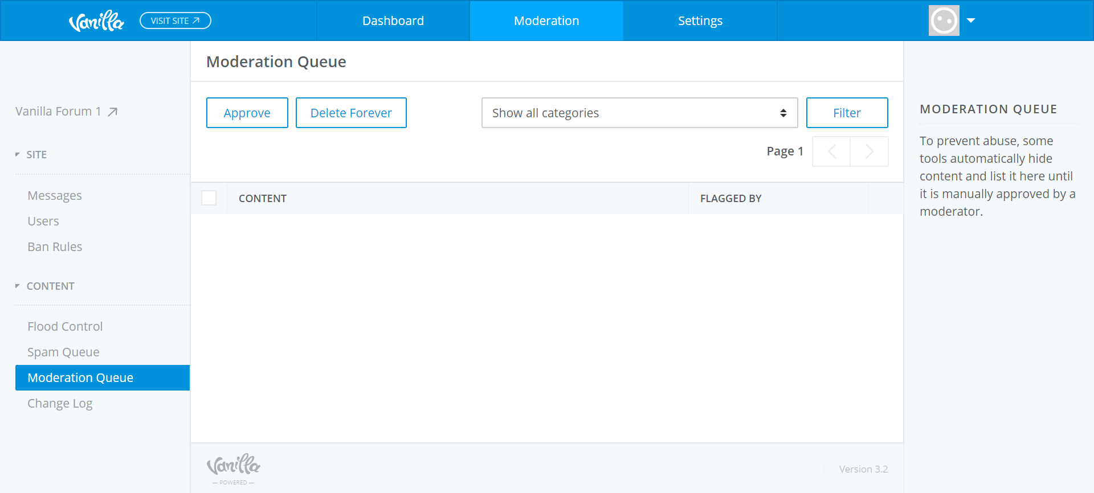

* Settings tab – where user can modify the look and feel of the forum and basically personalize their community experience. These include panels like Appearance, Membership, Discussions, Connections, Technical and Add-ons.

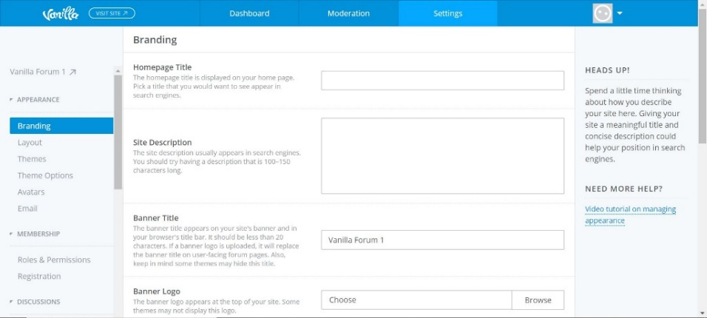

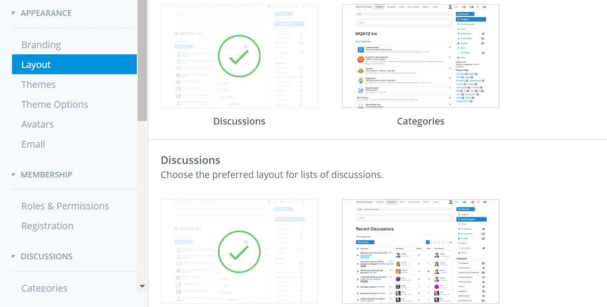

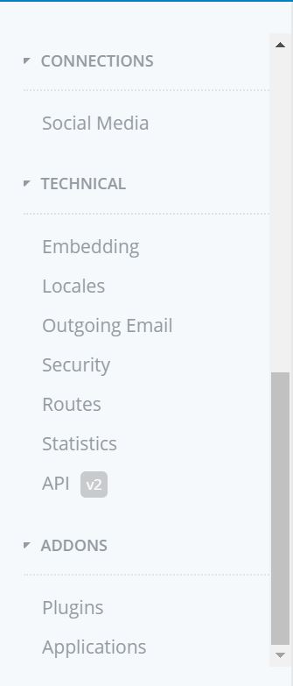 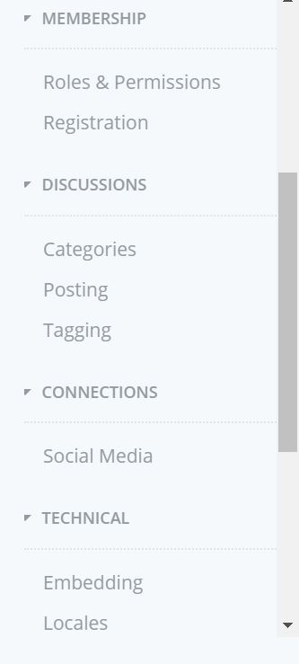

Front-end features:

* Categories & Discussions tab – user can see all on going chats either separately displayed or categorized, simply listing them.

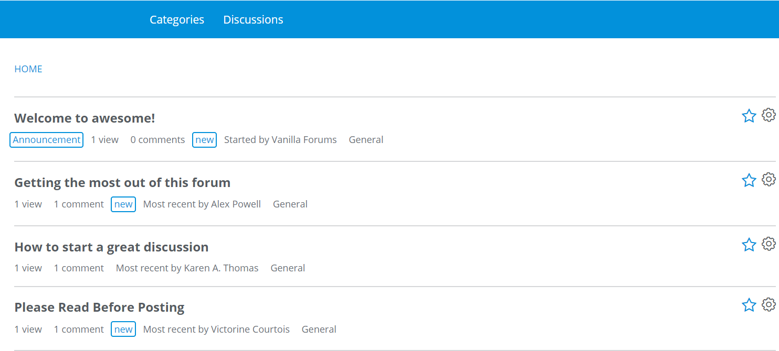

* 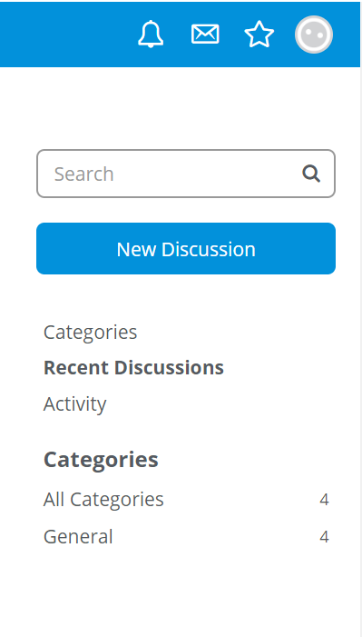Allows user to keep checks on new notifications (bell icon), read personal inbox, and revisit favorite discussions. Summary panel below records user’s activity.

Database Handling

Databases are an integral part of working with any server-based software, and being able to understand and work with the back-end databases is a defining aspect of how well a software is designed. Vanilla forums have a very simple way of setting up its initial database, and can be configured fairly easily. Steps include:

* Creating a new database in the phpMyAdmin dashboard.
* Set up an admin username to grant all access
* Enter these credentials into the set up page that pops up into the localhost/vanilla page as explained in step 7 in “Configuration”

Once Vanilla runs the database is set:

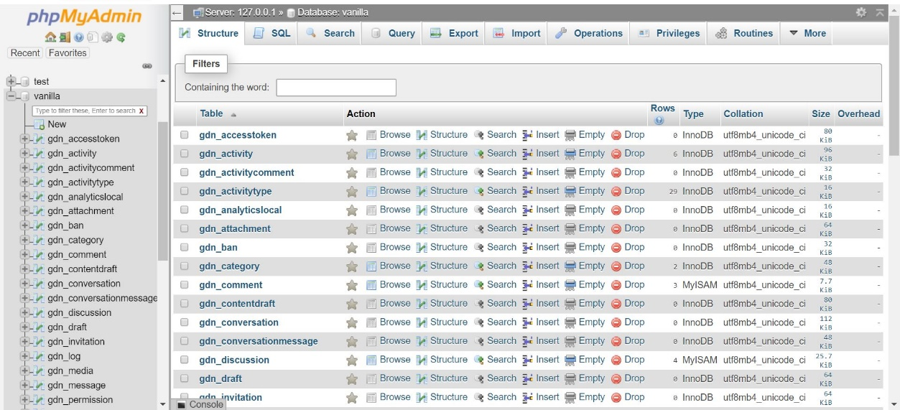

Exploration:

The database end is very easily understandable. As shown in the screenshot below the table by the name of ‘gdn_users’ can be easily displayed and holds my personal login info.

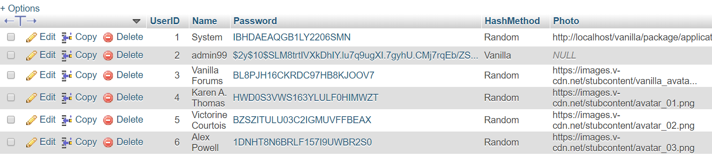

A new discussion was created as a test and its database directory was easily found in ‘gdn_discussion’.

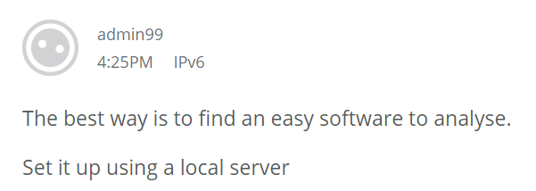

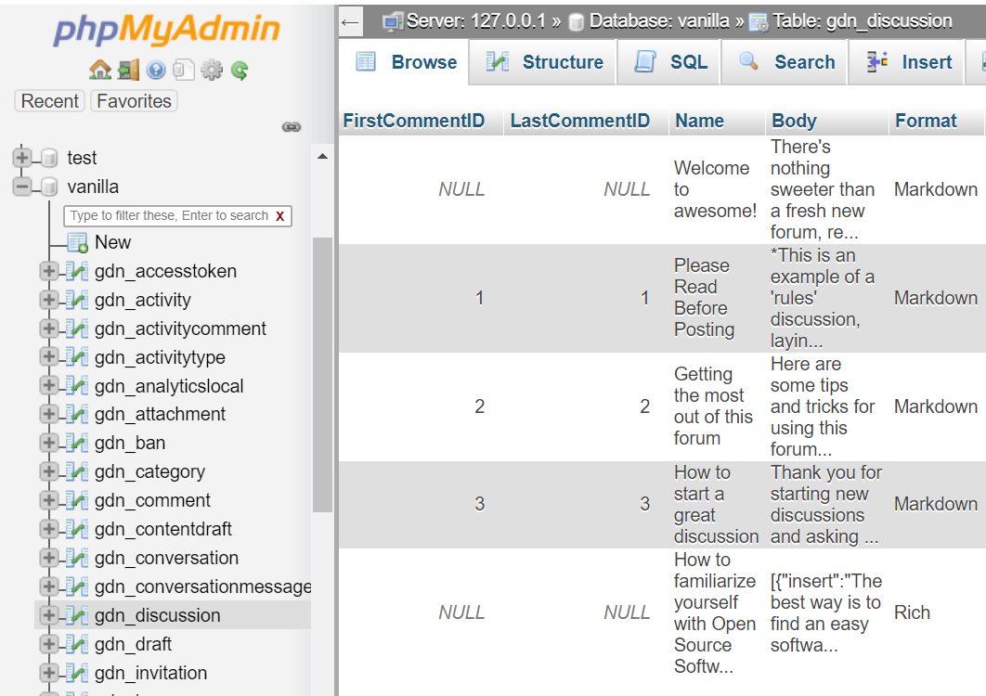

All database coding files are contained in the library/database folder

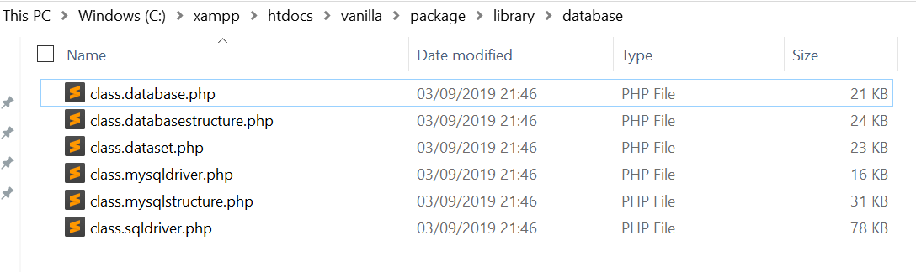

* The classdatabase file allows Vanilla to communicate with any independent database.
* The databasestructure file is used by database models to structure and create files according to the Vanilla requirements.
* Dataset class is a databse independent data manipulation class.
* The MySQLDriver class can be treated as an interface for all database engines.
* MySQL-specific structure tools for performing structural changes on MySQL database servers.

Coder’s perspective

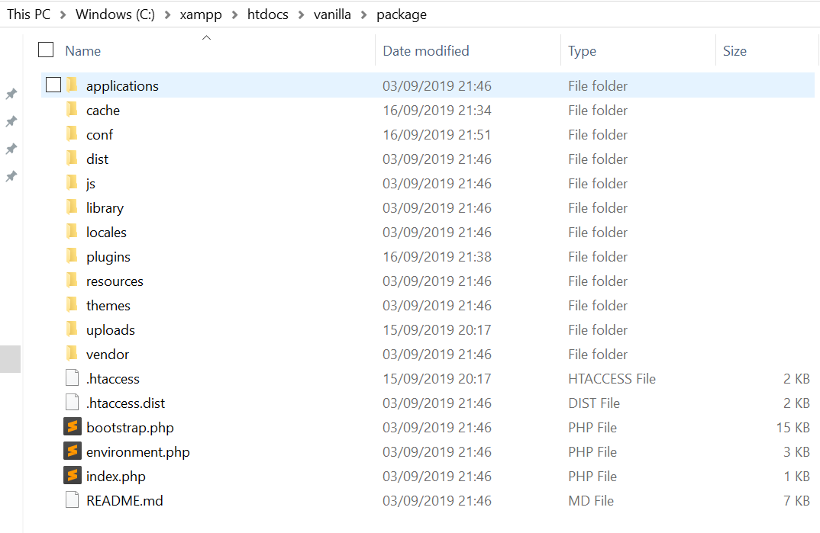

* Applications folder – consists of the three main applications of the forum namely: discussions, dashboard, and vanilla. The core functionalities of the software are contained in this folder.
* Cache folder – this contains the different themes of the forum that are available to the user to customize, also consists of a few addons and code for allowing API link.
* Configurations folder – contains the .htaccess file that allows overriding of default apache server and configures the software to the server.
* The js folder consists of some important JavaScript libraries for the forum.
* The library folder holds the core set up of the software including the database connection files, al including interacting with an independent database, structuring it, and MySQL transactions.

Modify via Plugins

The directory consists of a plugins folder that consists of a number of plugins for the software. To test and display the ease of plugins; an add-on by the name of ‘sitemaps’ was downloaded from the browser. The zip file was extracted into the plugins folder and refreshing the browser resulted in the add-on being readily available on site for use – hence, simple and easy to use.

**Before ‘sitemaps’:**

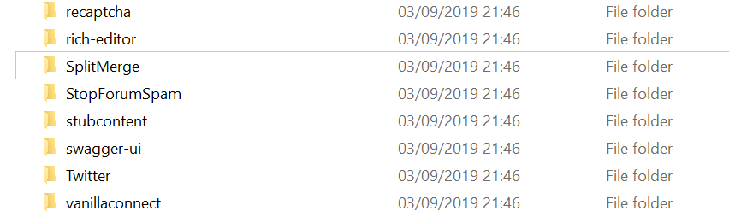

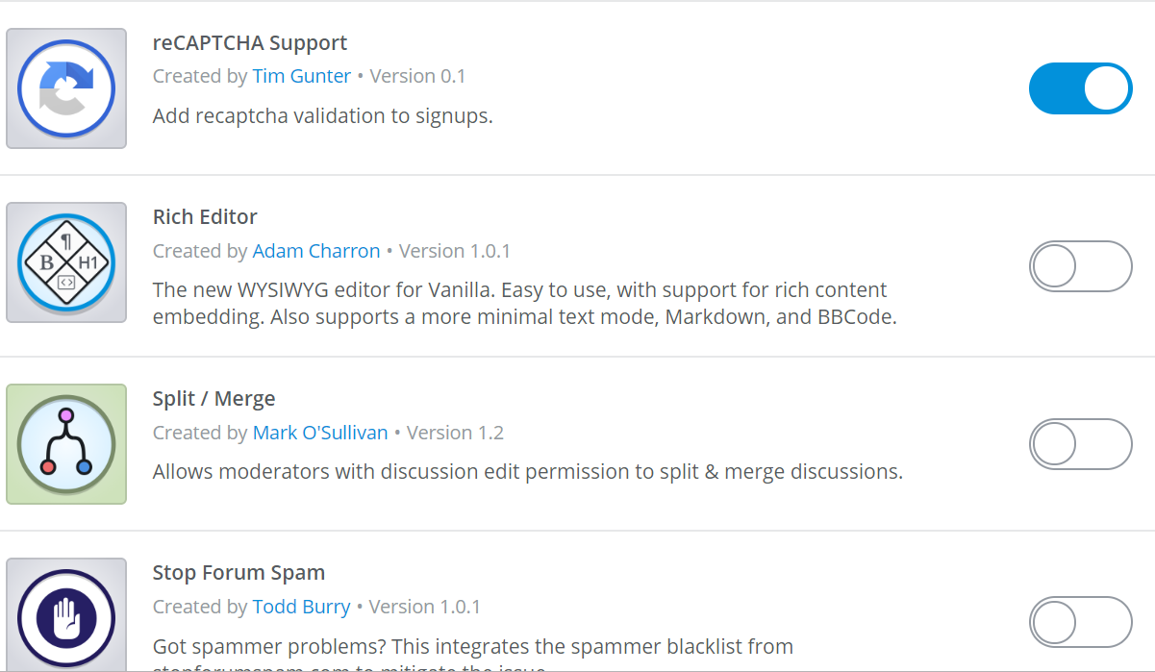

**After unzipping ‘sitemaps’ into plugins folder:**

