**Name: Muhammad Saad Tariq**

**CMS: 224921**

**Class: BSCS-7A**

**Course: Operating Systems (CS-330)**

**Lab 2**

**Step 1**

Install qemu using command “sudo apt-get install qemu” in terminal.

**Step 2**

Download pintos from the browser from source: <http://web.stanford.edu/class/cs140/projects/pintos/pintos.tar.gz>

**Step 3**

Create a directory called ‘os-pintos’ or any other for that matter in your home directory.

You can use the ‘mkdir’ command in the terminal.

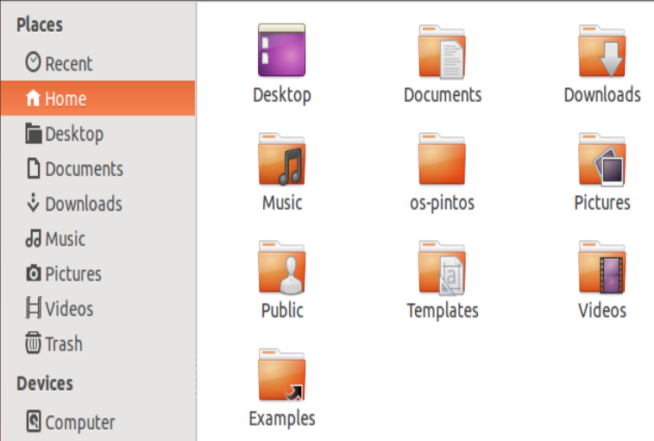

**Step 4**

Extract the “pintos.tar.gz” file into the above created directory. Use the ‘tar -xvzf pintos.tar.gz’ command in terminal.

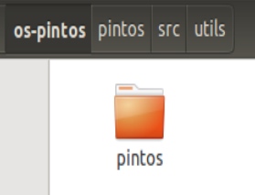



**Step 5**

Set GDBMACROS:

Open the “pintos-gdb” file located in ‘/home/saad/os-pintos/pintos/src/utils’ using any text editor and change line number 4 to the location ‘/home/saad/os-pintos/pintos/src/misc/gdb-macros’.

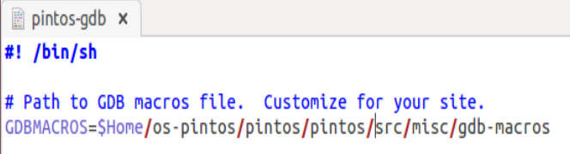

**Step 6**

Open the “Makefile” file int the same utils directory and edit line number 3 to

“LDLIBS = -lm” instead of “LDFLAGS = -lm”/

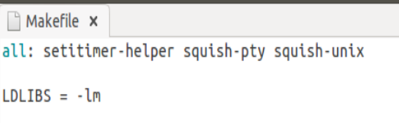

**Step 7**

Make sure you are in the utils folder by typing “cd /home/saad/os-pintos/pintos/src/utils” in the terminal.

Simply input “make” to compile the utilities.

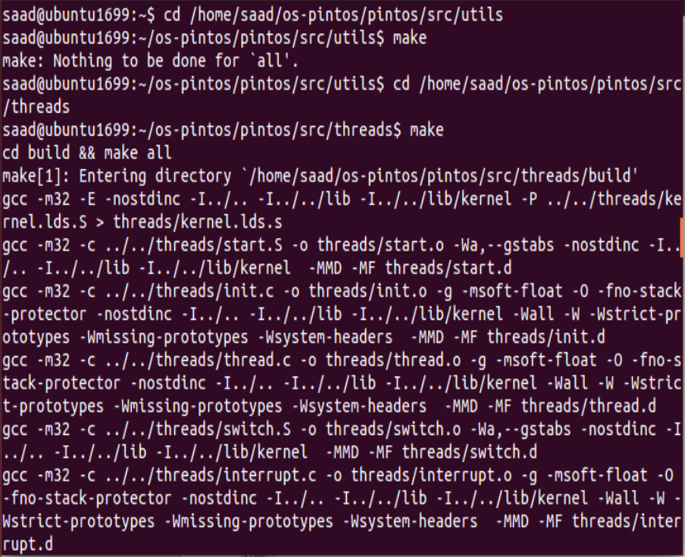

**Step 8**

Open the ‘Make.vars’ file located in ‘/home/saad/os-pintos/pintos/src/threads’ and change the last line (line number 7) to “SIMULATOR = -qemu” instead of “SIMULATOR = --bochs”.

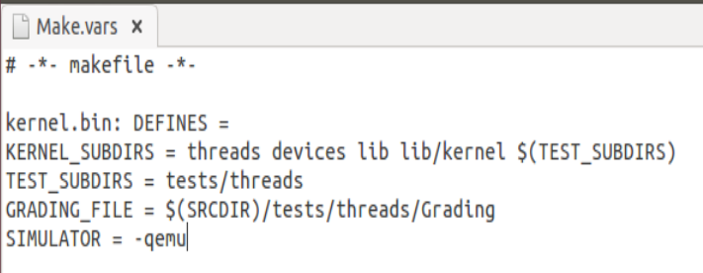

**Step 9**

Open the ‘Pintos’ file in the location ‘/home/saad/os-pintos/pintos/src/utils’ and make 3 changes:

1. Change line number 103 to “$sim = “qemu” if !defined $sim” to enforce qemu as simulator.

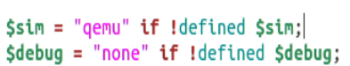

1. Change line number 257 to “my $name = find_file (‘/home/saad/os-pintos/pintos/src/threads/build/kernel.bin’)”

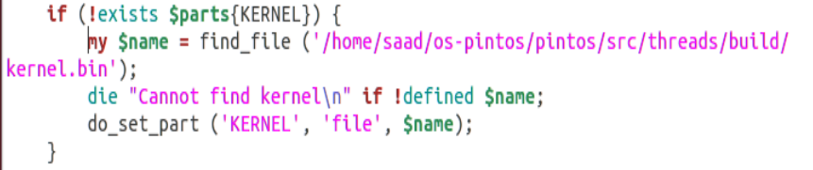

1. Change line number 621 to “my (@cmd) = (‘qemu-system-x86_64’)”.



**Step 10**

Open the ‘Pintos.pm’ file in the utils directory and edit line number 362 to say “$name = find_file (“(‘/home/saad/os-pintos/pintos/src/threads/build/loader.bin”)”.

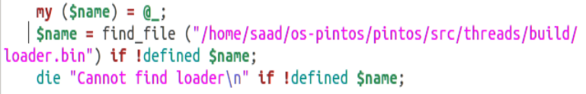

**Step 11**

Open terminal and type “export PATH=(‘/home/saad/os-pintos/pintos/src/utils:$PATH” to export utils directory path to variable PATH.



**Step 12**

Reoload terminal with the new environment variables by entering “source ~/.bashrc” in the terminal.



**Step 13**

Run pintos by making sure you are in the utils directory and execute “pintos run alarm-multiple” in the terminal.

Following output shows successful installation of pintos:

