RNG Extractors - Web Application Comprehensive Report

1. User Workflow and Extracted Output
The RNG Extractors web application is an advanced academic platform engineered to process raw bit streams from random number generators. It applies 20 specialized software extraction algorithms to enhance the randomness and strictly evaluates them against the NIST SP 800-22 cryptographic test suite. The platform serves as an end-to-end architecture pipeline for debiasing and entropy extraction.
General User Workflow:
Step 1: Data Upload: The user initiates the process by uploading raw bit streams in either a packed binary (.bin) or plain text (.txt) format onto the platform.
Step 2: Algorithm Selection: From a categorized list of 20 algorithms (Debiasing, Hash-Based, Matrix/Algebra, Mixing Methods, etc.), the user selects which extractors to run on the uploaded bits.
Step 3: Pipeline Execution: By triggering the execution, the platform asynchronously processes the algorithms and subsequently conducts the NIST SP 800-22 statistical test battery to evaluate the cryptographic viability of the extracted streams.
Step 4: Analytics Review: A comprehensive analytics dashboard is generated, offering interactive charts to compare computational efficiency, entropy, throughput, bias levels, and overall NIST pass rates across the chosen methods.
Step 5: Exporting Results: The user can export the processed, high-quality bit streams into a ZIP archive for downstream cryptographic applications and generate a professional PDF report summarizing the comparative analysis.

2. Overview Page
The Overview page serves as the entry point, featuring a modern, vibrant aesthetic. It provides a high-level summary of the tool's capabilities: processing through 20 extraction methods, evaluated against 15 NIST statistical tests, culminating in live comparative reports.
The page details the Complete Architecture Pipeline via an illustrative flowchart. Key buttons include 'Start Analysis', which navigates the user directly to the primary interaction pipeline (highlighted by a red arrow), and 'Read Documentation' for technical guidance.
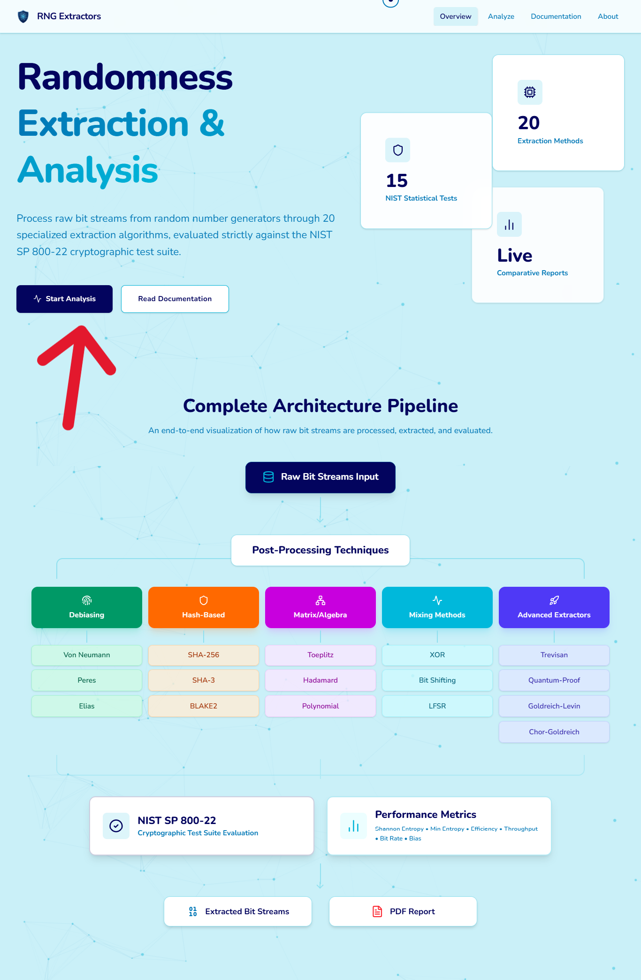

3. Documentation Page
Before beginning the analysis, users are advised to consult the Documentation page, which outlines system requirements, input specifications, and performance limits to ensure optimal usage.
Input Formats: The system accepts packed binary files (.bin), highly recommended as they are 8x smaller, facilitating faster uploads and processing. Plain text files (.txt) are also supported for legacy compatibility but consume more memory.
System Performance Tiers: The documentation explicitly categorizes file sizes into tiers to set user expectations regarding processing time, especially given the computational intensity of certain O(n²) algorithms:
• Tier 1 (Comprehensive Analysis - Optimal): For inputs ≤ 6.1 KB. Execution takes under 30 seconds.
• Tier 2 (Fast Path Only - Restricted): For inputs between 6.1 KB and 10.0 MB. Execution ranges around 1-2 minutes.
• Tier 3 (Extended Processing - Heavy Load): For large files > 10.0 MB. Extended wait times exceeding 5 minutes.
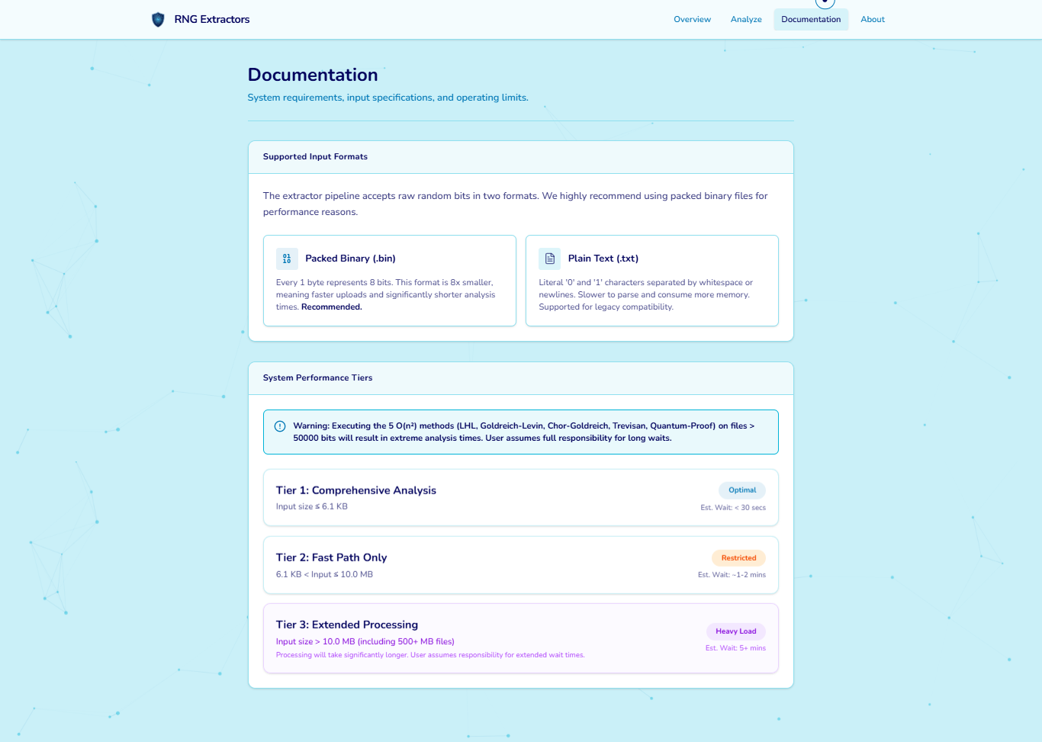

4. Analyze Page and Interaction Flow
The Analyze page is the core functional area of the application. It consists of a multi-step pipeline for uploading data, configuring parameters, and interacting with analytical results.

Step 4.1: Data Input and Configuration
The user encounters a clean interface with a drag-and-drop 'Input Source' zone on the left. The prominent red arrow highlights where users must upload their raw bits (.bin or .txt). Once uploaded, the file details (name and size) populate this block. On the right, the user can select individual or all 20 Extraction Algorithms to be applied.
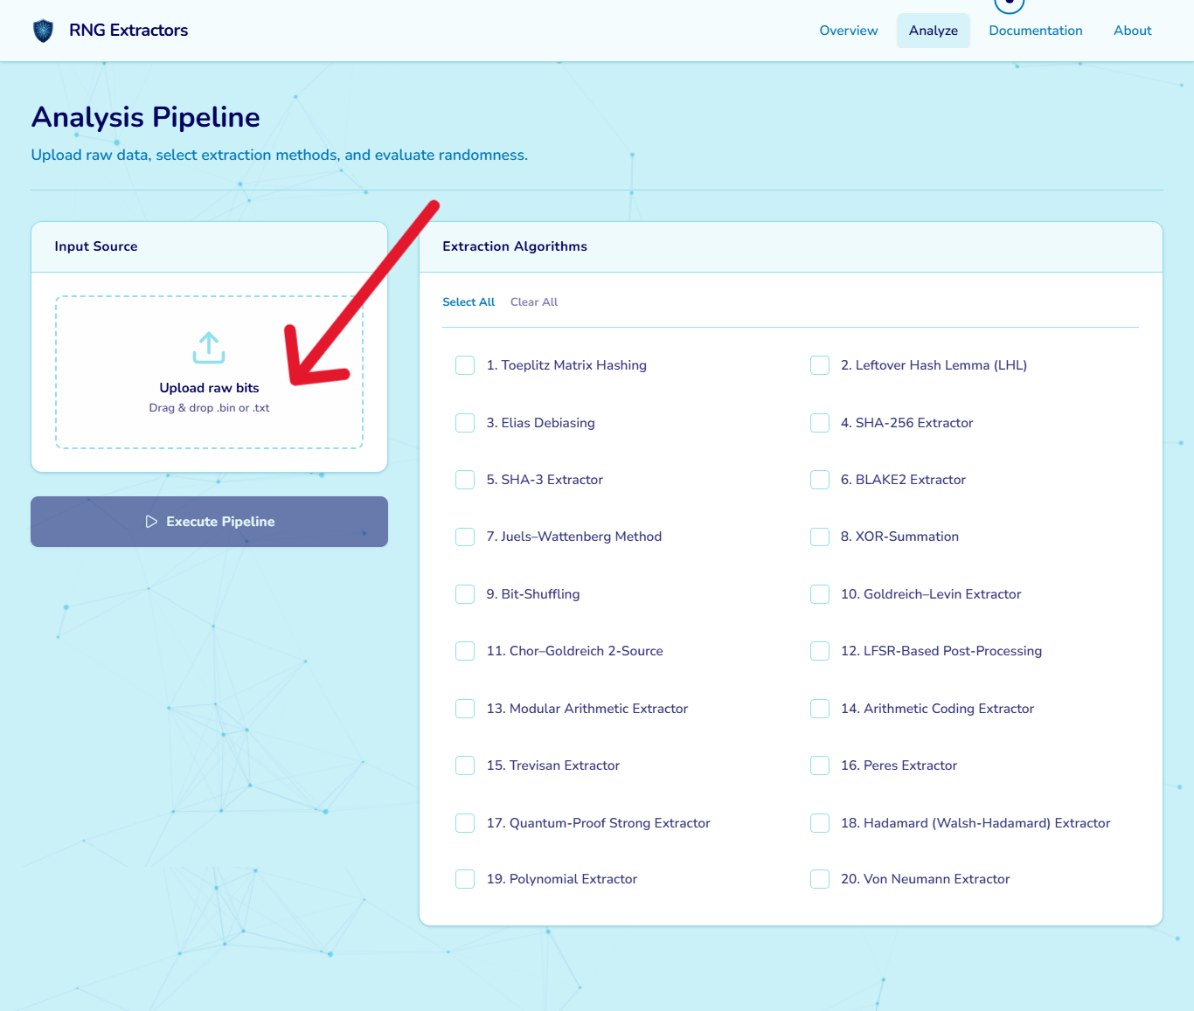
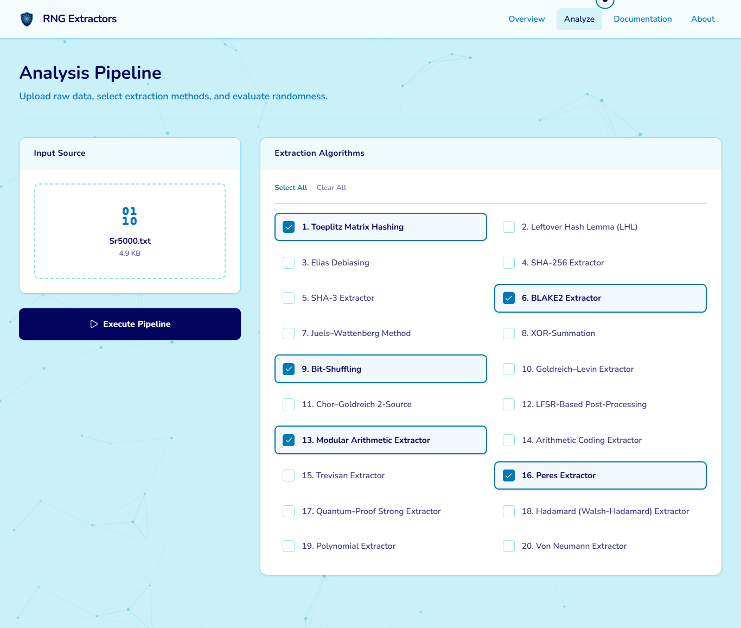

Step 4.2: Execution and Logging
With the file loaded and algorithms selected, the user clicks the 'Execute Pipeline' button (indicated by the red arrow). The application seamlessly transitions into a live 'Execution Log', displaying timestamped console outputs detailing batch processing, pipeline initialization, algorithm execution, NIST battery testing, and report compilation.
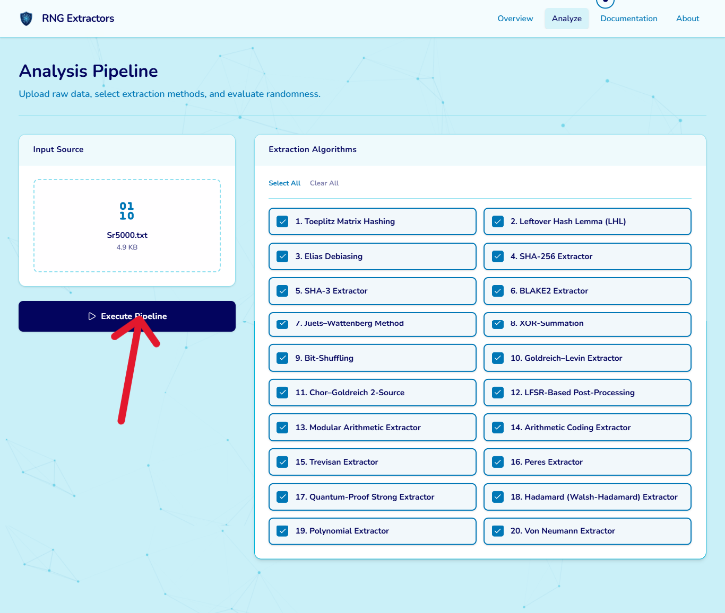
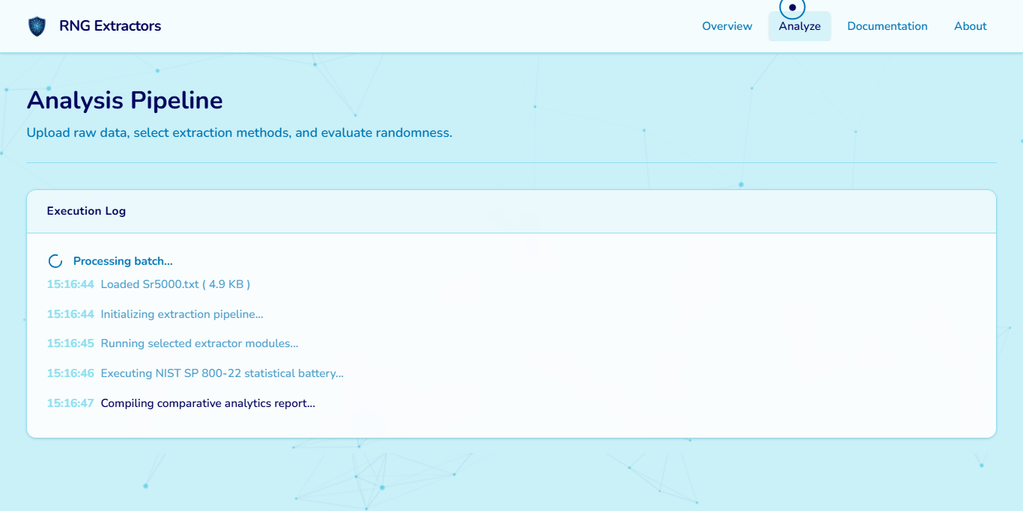

Step 4.3: Analysis Complete & Main Dashboard
Upon completion, the Analysis Complete banner provides a unique Session ID and action buttons for export. The dashboard below visualizes the data through interactive charts mapping Computational Efficiency (in milliseconds), Entropy Comparison, NIST SP 800-22 Pass Rate, Throughput (Bits Per Second), and Bias Level. A dynamic banner showcases the 'Optimal Method', and a tabular Performance Rankings list offers precise metric values for sorting and rigorous inspection.
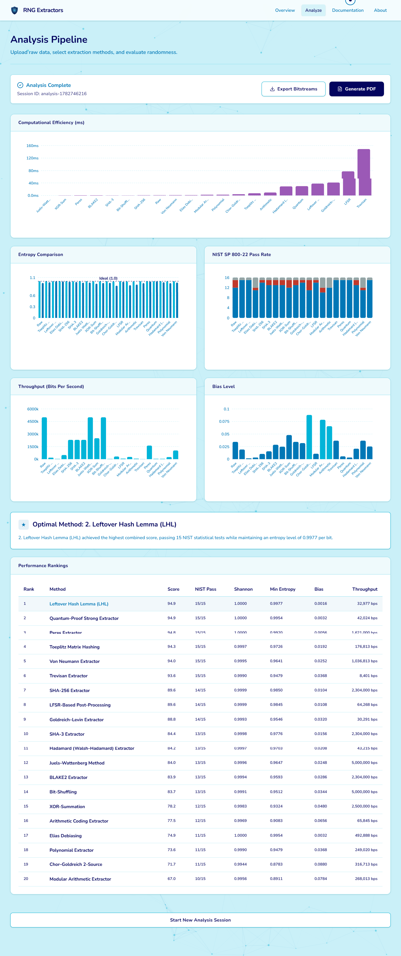

Step 4.4: Interactive Chart Exploration
The charts are highly interactive, allowing users to explore the data in depth. When a user clicks on the bars within a chart, the graph gets expanded for a more detailed, focused view. Furthermore, hovering over any specific bar in the expanded graph reveals a tooltip displaying the exact name of the extraction algorithm along with its corresponding performance metrics, which is crucial for deep cryptographic review.
Entropy & Bias: By utilizing this click-to-expand and hover interaction on the Entropy chart, users can clearly see the exact extractor name alongside its Shannon and Min-Entropy values, visualizing how close an extractor gets to the ideal 1.0 limit. Similarly, interacting with the Bias Level chart exposes the specific extractor's exact numerical bias, where lower values are preferred.
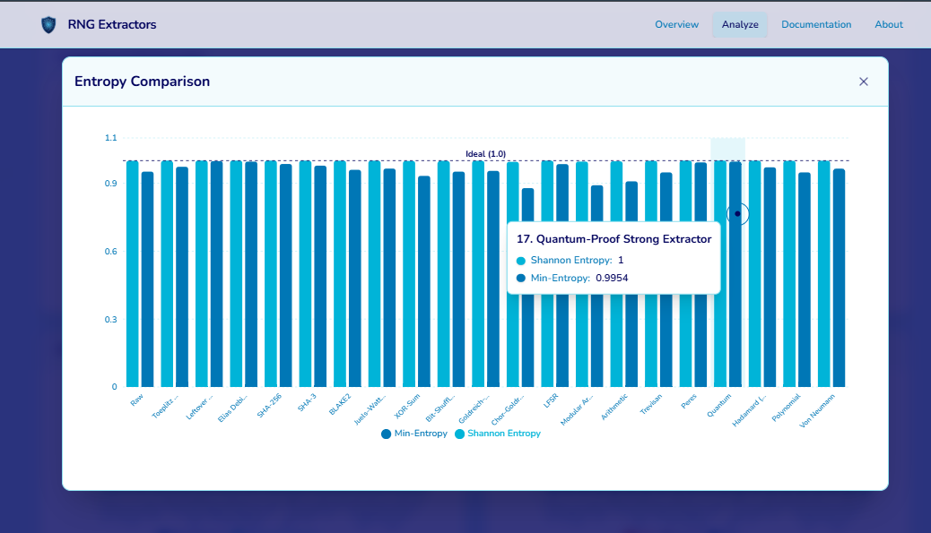
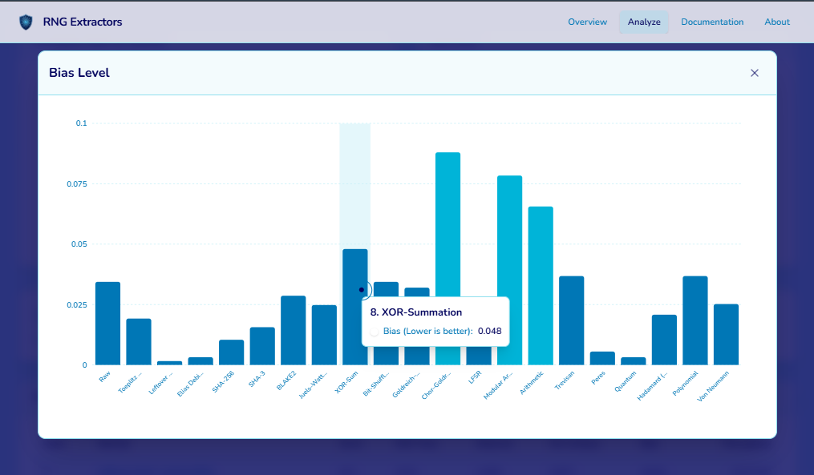

Throughput & NIST Details: Throughput tooltips highlight the Bit Rate (bps) to compare computational efficiency. For the NIST SP 800-22 Pass Rate chart, hovering displays a breakdown of Pass/Fail/Invalid instances. Additionally, interacting with the chart dynamically updates the 'Detailed NIST Results' side panel, providing a granular test-by-test breakdown (e.g., Frequency, Runs, Linear Complexity) for either the Raw baseline or a specifically selected algorithm like Elias Debiasing.
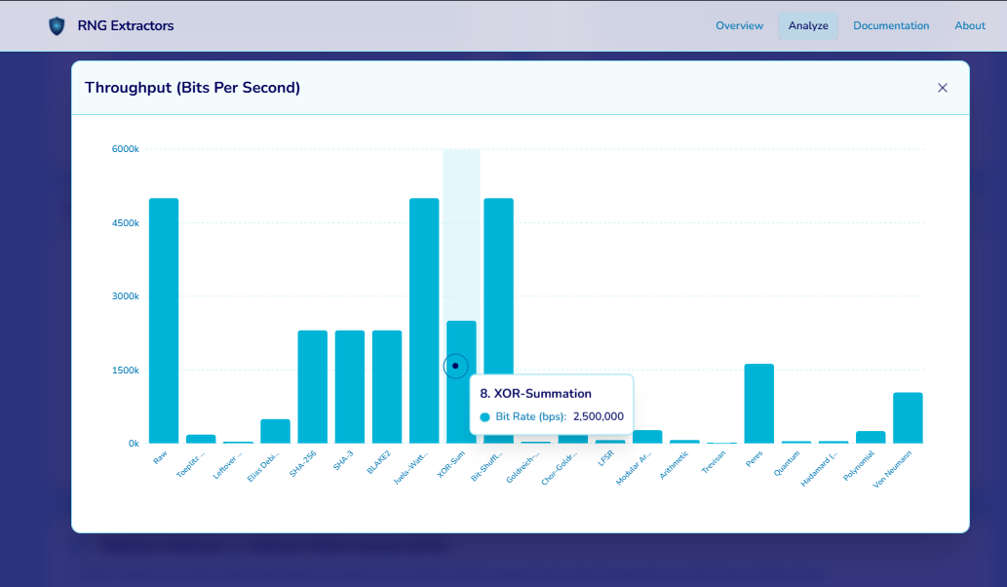
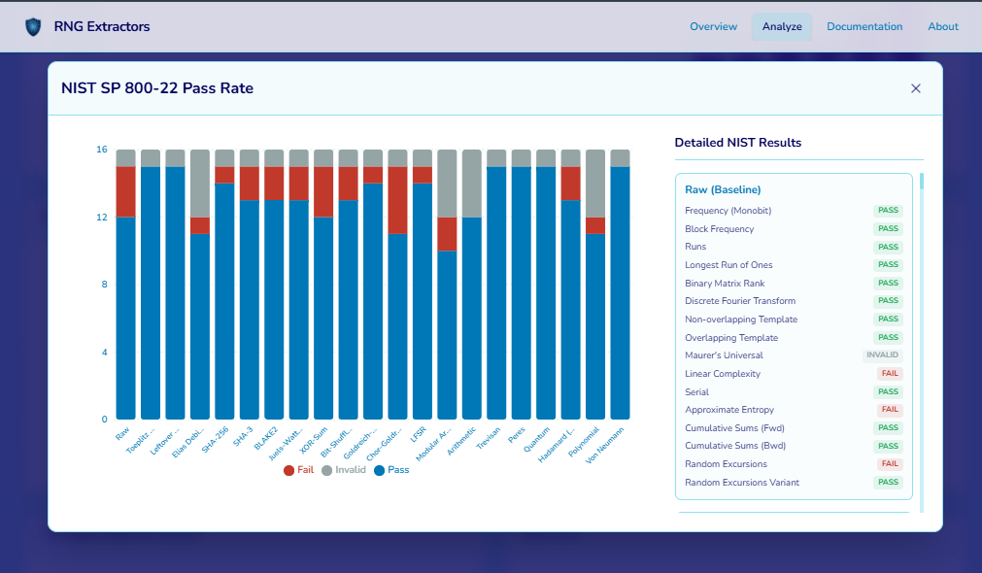
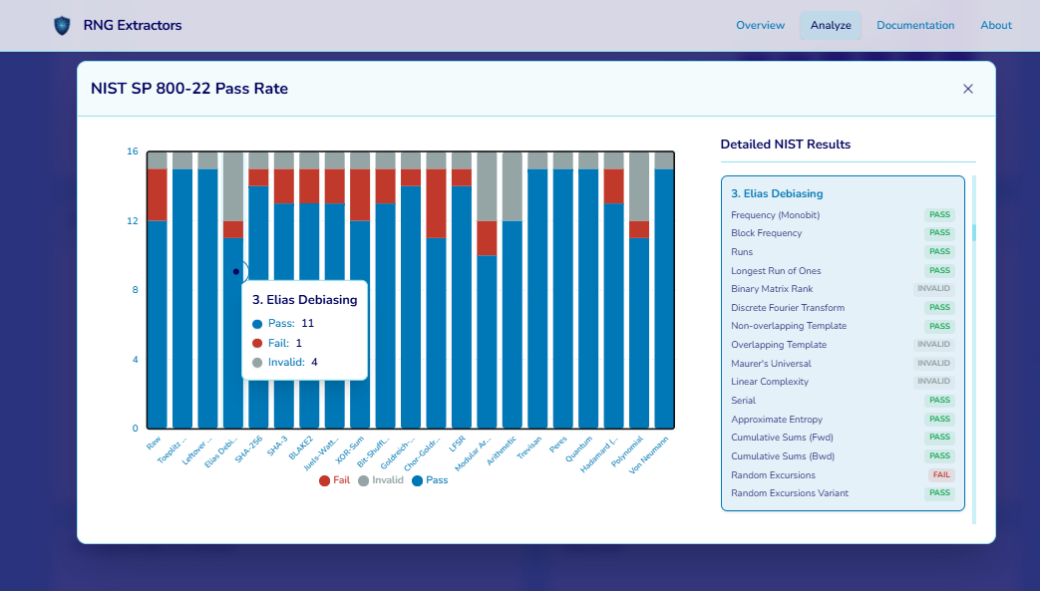

Step 4.5: Data Export and Archiving
The platform facilitates the extraction of the processed data for external use. Clicking the 'Export Bitstreams' button triggers an 'Archiving...' state. The user is prompted via a native file dialog to save a ZIP file containing the independent text files for every selected extraction algorithm alongside the raw baseline.
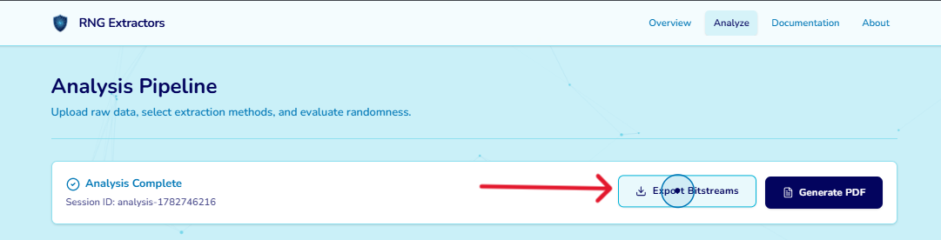
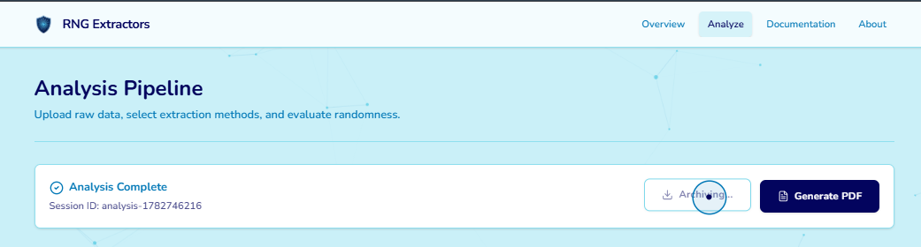
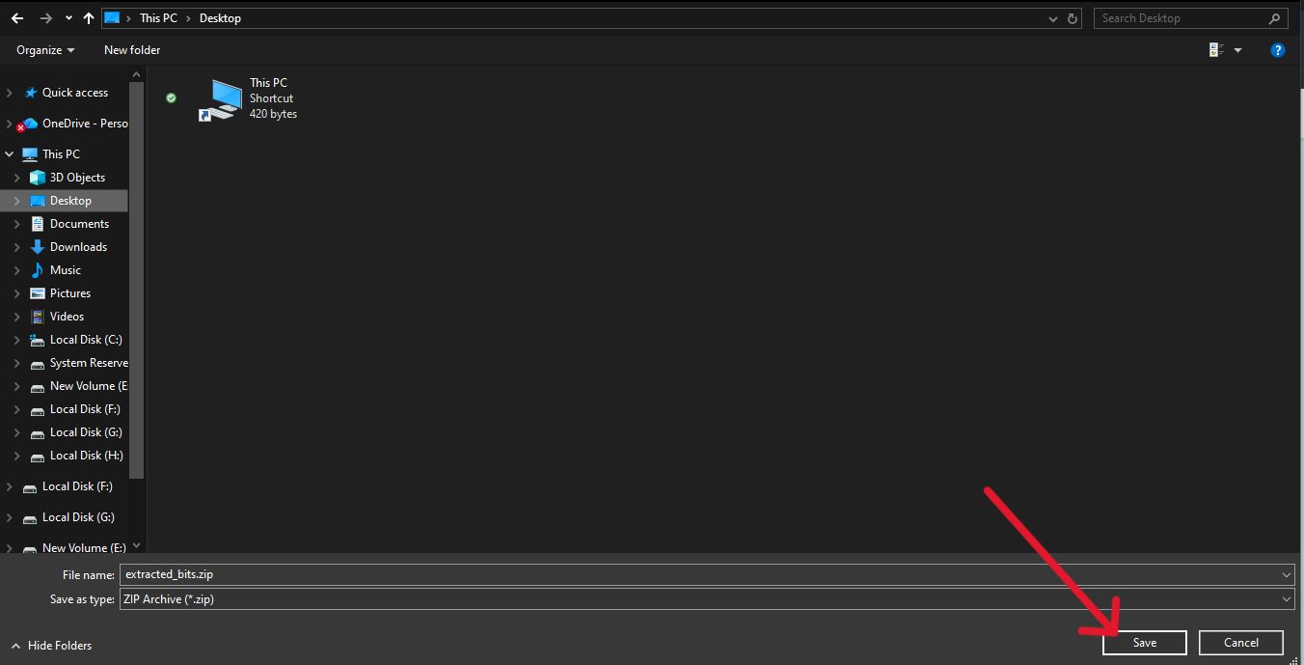
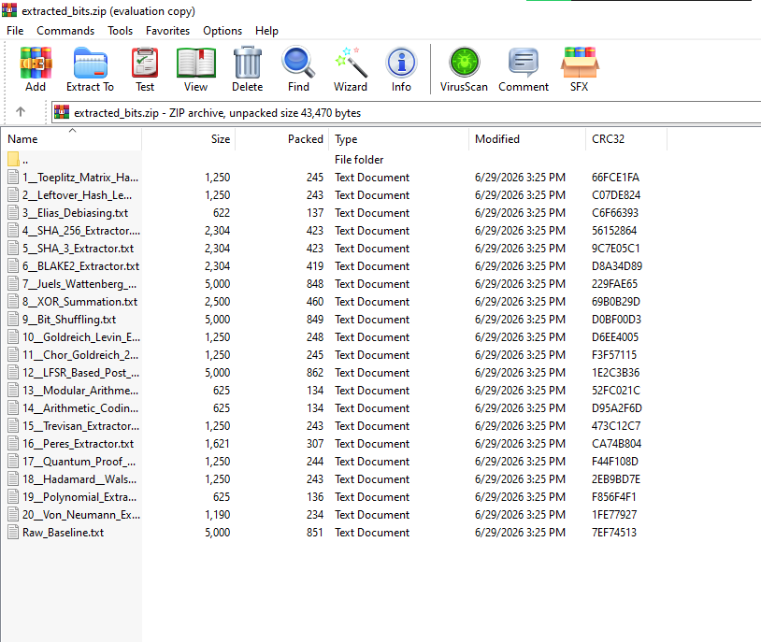

Step 4.6: PDF Report Generation
For comprehensive record-keeping, the user clicks the 'Generate PDF' button. After a brief 'Compiling...' phase, a multi-page PDF document is produced, formally summarizing the comparative analysis, visual charts, and ranked tabular metrics.
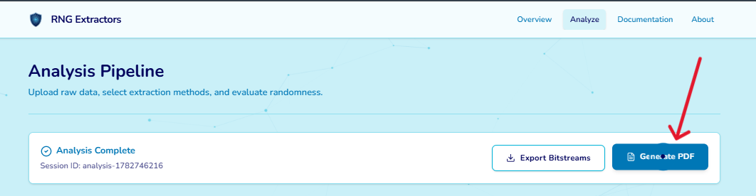
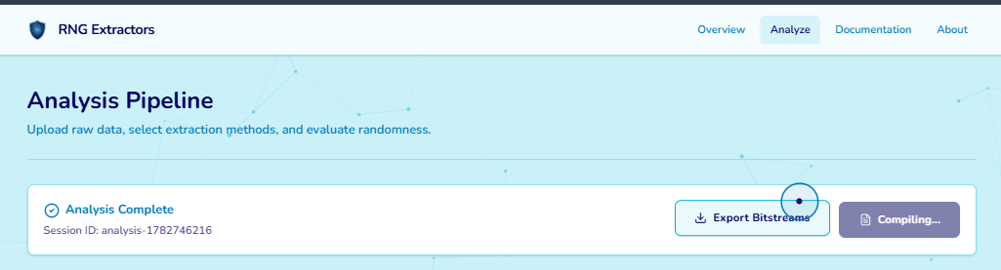
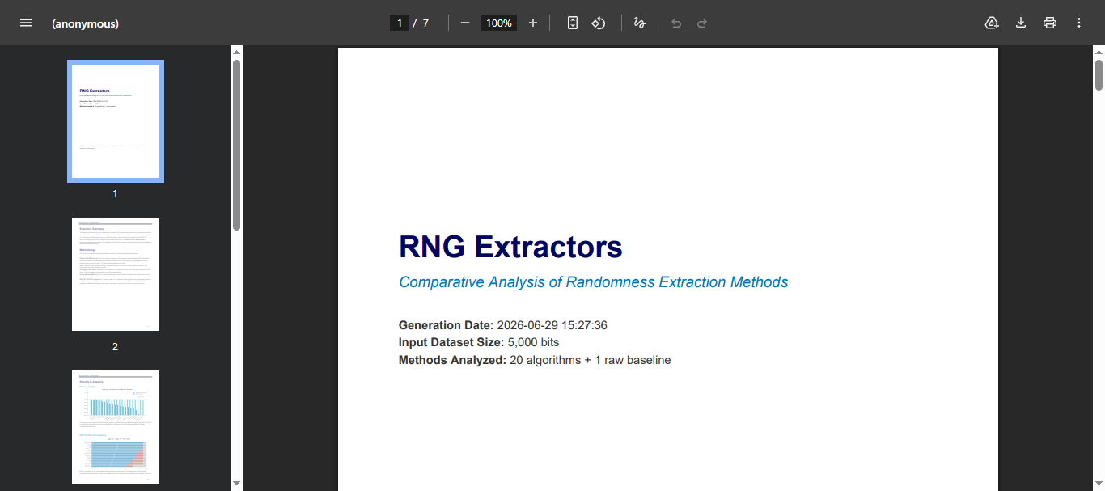

5. About Page
The About page provides essential academic research background, establishing the credibility and origins of the project. The Project Abstract outlines the core objective: evaluating and enhancing RNGs using software algorithms to secure modern cryptography against predictive attacks.
It proudly highlights the affiliation with the NED University of Engineering and Technology (Department of Physics & Center of Quantum Technologies). Finally, it acknowledges the dedicated Research Team driving the initiative, including supervisors Dr. Roohi Zafar and Dr. Tahir Malik, co-supervisor and director Dr. Kamran, and core developer Syed Muhammad Saad Hussain Zaidi.


