Operating Systems Assignment #1
Zainab Saad 23L-0646

Question 1:
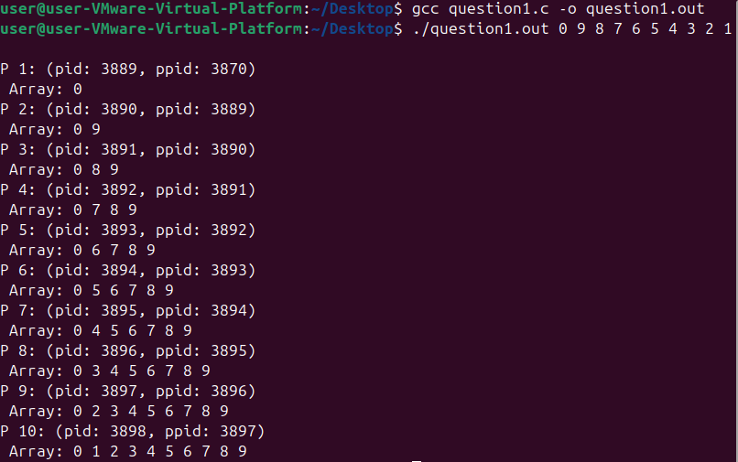
Question 2:
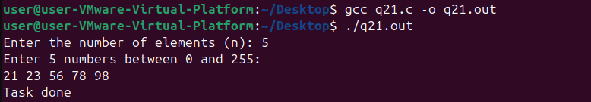

Question 3:
