OS Assignment 2
Zainab Saad 23L-0646

Question 1:
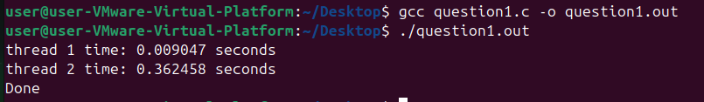

Question 3:
