Part A — Netflix Dataset
A1. Dataset Understanding
The uploaded Netflix dataset matches the expected size: 8,807 rows and 12 columns. It contains 6,131 Movies and 2,676 TV Shows.
One row represents a single Netflix catalogue title, either a movie or a TV show, with its metadata.
Variable-role table
Column | Variable type | Role
show_id | Identifier | Unique catalogue record
type | Categorical | Movie or TV Show
title | Text | Content title
director | Multi-valued categorical | Director names
cast | Multi-valued categorical | Actors appearing in the title
country | Multi-valued categorical | Associated production countries
date_added | Date (stored as text) | Date added to Netflix
release_year | Numerical (discrete) | Original release year
rating | Categorical | Maturity classification
duration | Mixed-format text | Movie minutes or TV seasons
listed_in | Multi-valued categorical | Genres and content categories
description | Text | Content synopsis
The important distinction is that duration cannot be treated as a single numerical variable: movie lengths and TV-show season counts measure different things.
A2. Data Quality Assessment
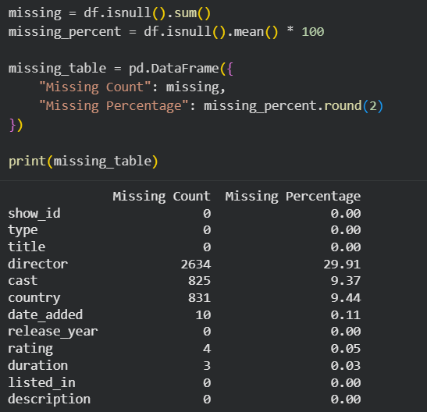
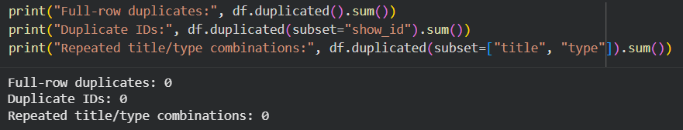
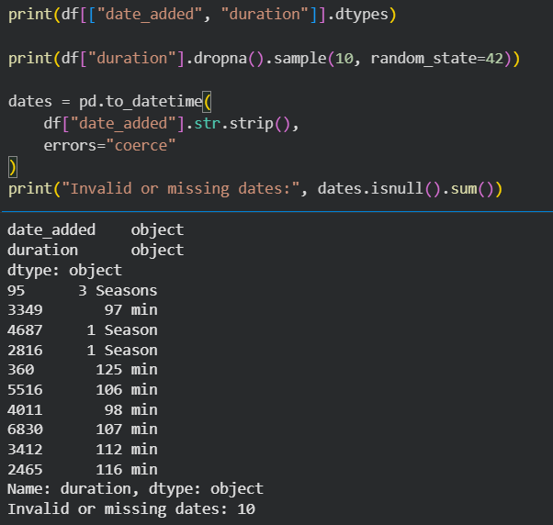
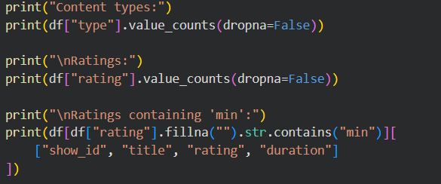
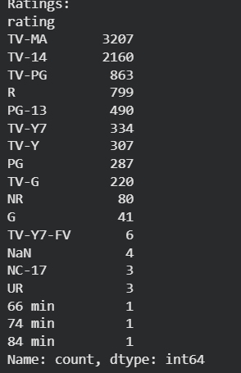
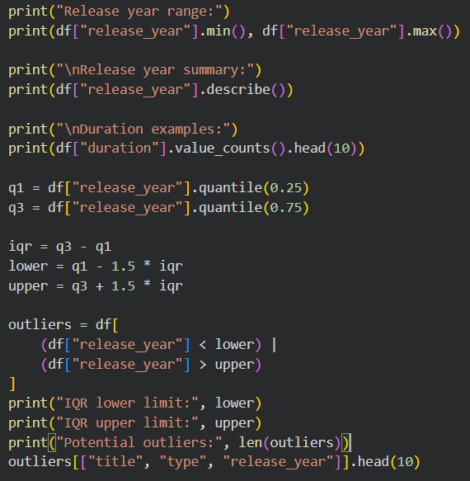
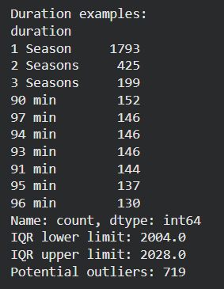
A3. Data Cleaning
The Netflix dataset was cleaned by correcting misplaced duration values, handling missing data, removing unnecessary whitespace, and converting dates into the appropriate format. Missing categorical values were replaced with "Unknown", while missing dates were retained to avoid introducing inaccurate information.
Six derived variables were created: year_added, release_gap, movie_minutes, seasons, num_countries, and num_genres. Unusual values were retained unless there was clear evidence of an error.
The final cleaned dataset contains 8,807 rows and 18 columns, with no duplicate identifiers. It was saved as a CSV file for use in Assignment 3.
Problem | Detection | Decision | Justification
Extra whitespace | Text column inspection | Trim leading/trailing spaces | Standardizes text values
Missing director | 2,634 missing | Fill with Unknown | Preserves titles without guessing
Missing cast | 825 missing | Fill with Unknown | Avoids unnecessary deletion
Missing country | 831 missing | Fill with Unknown | Avoids inventing country information
Missing rating | 4 missing; 3 misplaced durations | Fill with Unknown after correction | Actual ratings unavailable
Misplaced durations | 3 rating values: 74 min, 84 min, 66 min | Move to duration; mark rating missing | Corrects obvious field errors
Missing duration | 3 missing | Recover from rating | Restores movie lengths
Missing date_added | 10 missing | Keep as NaT | Avoids fabricated dates
Date data type | Stored as object | Convert to datetime | Supports date analysis
Mixed duration units | Minutes vs. seasons | Create movie_minutes and seasons | Avoids mixing incompatible units
Multi-valued country | Comma-separated entries | Create num_countries | Counts associated countries
Multi-valued genres | Comma-separated entries | Create num_genres | Counts genre labels
Release-to-addition delay | Compare release and addition years | Create release_gap | Measures catalogue age at addition
Unusual release years | IQR method | Retain | Historical titles may be legitimate
Unusual durations | Inspect extremes | Retain | Short films and long series may be legitimate
Negative release gaps | release_gap < 0 | Retain; flag for interpretation | Avoids unsupported correction
Duplicate IDs | duplicated() on show_id: 0 | No removal | No duplicate identifiers

A4. Univariate EDA
- Univariate analysis shows that Movies make up most Netflix titles (69.6%), while TV Shows account for 30.4%.
- The release-year distribution is concentrated toward recent years and is negatively skewed. TV-MA and TV-14 are among the most common maturity ratings.

- Movie durations have a median of about 98 minutes, while most TV shows have one season.
- The United States, India and the United Kingdom are among the most represented countries. International Movies, Dramas and Comedies are among the most common genre labels.
- Multi-valued country and genre fields were separated before counting to avoid misleading category frequencies.
A5. Bivariate EDA
- Numerical – Numerical (Release year vs Year Added): A scatter plot and Pearson correlation were used to examine the relationship. The weak positive correlation (r = 0.112) indicates little linear association, showing that Netflix adds titles from different release periods.
- Numerical – Categorical (Release year vs Content Type): A box plot was used to compare release years. TV Shows generally have more recent release years, while Movies have a wider distribution that includes older titles.
- Categorical – Categorical (Release year vs Maturity Rating): A grouped bar chart was used to compare rating percentages. TV-MA and TV-14 dominate both categories, but TV Shows have a higher proportion of TV-MA and children's ratings, while Movies include film-specific ratings such as R and PG-13.

A5. Multivariate EDA
- Release year vs Year added by Content Type: The scatter plot shows that the relationship is very weak for Movies (r = 0.039) but moderately positive for TV Shows (r = 0.388). Compared to the overall correlation of 0.112, the relationship weakens for Movies and strengthens for TV Shows. This suggests that TV Shows tend to be added closer to their release periods, while Movies include a wider range of older titles.
- Maturity Rating vs Year added by Content Type: The faceted bar charts show that TV-MA dominates both content types, particularly from 2018 onward. Movie additions peak around 2018–2019, while TV Show additions peak around 2019–2020 for TV-MA. Film-specific ratings such as R and PG-13 appear almost exclusively among Movies, highlighting differences in maturity-rating profiles across content types and years.

A7. Netflix-Specific Analytical Questions (2 Marks)
- How has the mix of Movies and TV Shows changed over time (by release year and by year added)?
Using a count plot, movies have increased more over time s compared to TV shows
- How does the gap between release year and the date added vary, and what does it suggest about
The release-to-addition gap is concentrated around smaller values, indicating that many titles were added relatively soon after their original release. However, the distribution has a long right tail, showing that some older titles were added decades later.
- Which countries and genres are most prominent, and do genre profiles differ between the top countries?
The United States, India and the United Kingdom are among the most represented countries. International Movies, Dramas and Comedies are among the most frequent genre labels.
- How are maturity ratings distributed, and do they differ by content type or over time?
TV-MA dominates both content types, particularly from 2018 onward. Movie additions peak around 2018–2019, while TV Show additions peak around 2019–2020 for TV-MA. Film-specific ratings such as R and PG-13 appear almost exclusively among Movies, highlighting differences in maturity-rating profiles across content types and years.

- How are movie durations and TV-show season counts distributed? Are there unusual cases, and how did you treat them?
  - Most movies are around 90 to 100 minutes, and TV shows are 1 season. And yes, using the IQR method, there are outliers in both.
A8. Netflix Insights and Handoff
Insight 1: Changing Content Mix
Observation: Movies account for 69.6% of all titles. However, the TV Show share among titles added increased from 25.0% in 2018 to 33.7% in 2021 (A7.1).
Interpretation: Although Movies dominate the catalogue, TV Shows gained a larger share of additions during this period.
Insight 2: Release-to-Addition Gap
Observation: The median release-to-addition gap is 1 year overall, compared with 2 years for Movies and 0 years for TV Shows (A7.2).
Interpretation: TV Shows tend to be added closer to their release year, while Movies include more older catalogue content.
Insight 3: Country and Genre Representation
Observation: The United States (3,690), India (1,046), and the United Kingdom (806) are the most frequent country labels. International Movies (2,752) and Dramas (2,427) are the leading genre categories (A7.3).
Interpretation: The catalogue has substantial international representation, although country and genre counts overlap because titles can have multiple labels.
Insight 4: Differences in Maturity Ratings
Observation: TV-MA accounts for approximately 42.8% of TV Shows compared with 33.6% of Movies (A5.3 and A7.4).
Interpretation: Mature-rated content has a higher proportional representation among TV Shows, indicating different maturity-rating profiles across content types.
Insight 5: Different Release-Year Patterns
Observation: The correlation between release year and year added is only 0.039 for Movies, compared with 0.388 for TV Shows (A6.1).
Interpretation: Release and addition years have almost no linear association for Movies, while TV Shows show a stronger positive relationship. This highlights how the overall pattern changes when content type is considered.
Handoff:
The most informative variables for future analysis are type, release_year, year_added, rating, release_gap, movie_minutes, seasons, num_countries, and num_genres. The original date_added and derived year_added overlap, while duration overlaps with the separated duration variables. Multi-valued fields such as country and listed_in require splitting before category-level analysis.
The show_id column is an identifier and should not be used as a predictive feature. title and description require text processing rather than direct numerical analysis.
Missing categorical values were labelled "Unknown", while missing dates were retained. Movie durations and TV Show seasons were separated to avoid mixing units. These cleaning decisions should be considered when interpreting future results.

