B1. Dataset Understanding
The Supermarket Sales dataset contains 1,000 rows and 17 columns, including transaction details, customer information, product categories, pricing, and payment methods.
One row represents a single supermarket sales transaction, including its purchased product category, quantity, price, customer details, and transaction date and time.
Variable-role table
Column | Variable type | Role
Invoice ID | Identifier | Unique transaction record
Branch | Categorical | Supermarket branch (A, B, C)
City | Categorical | City where the sale occurred
Customer type | Categorical | Member or normal customer
Gender | Categorical | Customer gender
Product line | Categorical | Category of products purchased
Unit price | Numerical (continuous) | Price per unit of product
Quantity | Numerical (discrete) | Number of units purchased
Tax 5% | Numerical (continuous) | Tax charged on the transaction
Total | Numerical (continuous) | Final transaction amount including tax
Date | Date (stored as text) | Date of transaction
Time | Time (stored as text) | Time of transaction
Payment | Categorical | Payment method used
Cost of goods sold | Numerical (continuous) | Transaction value before tax
Gross margin percentage | Numerical (continuous) | Gross margin rate
Gross income | Numerical (continuous) | Recorded gross income
Customer stratification rating | Numerical (continuous) | Customer satisfaction rating
The important distinction is that Total, Tax 5%, Cost of goods sold, and Gross income are mathematically related, so they should not be treated as independent features in later analysis. Additionally, Branch and City contain overlapping information, while Date and Time require conversion from text for temporal analysis.

B2. Data Quality Assessment
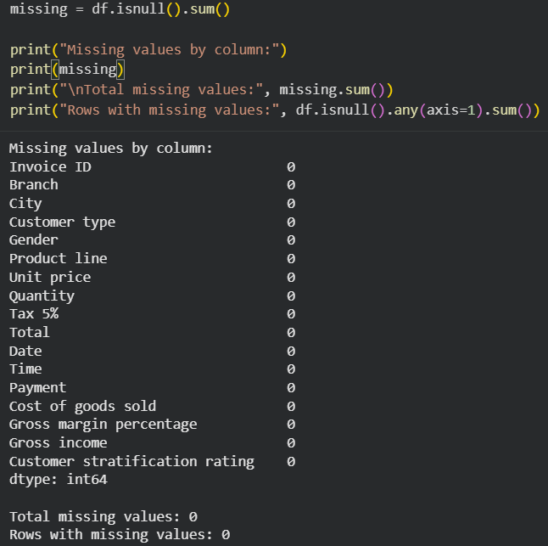
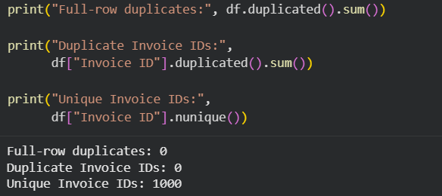
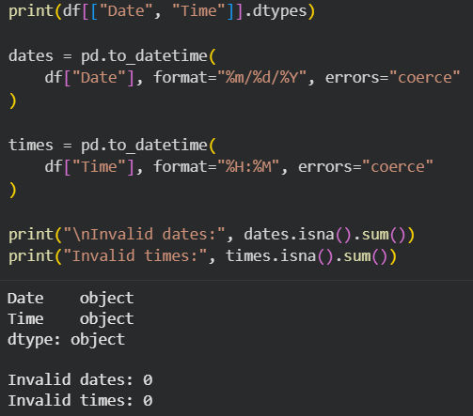
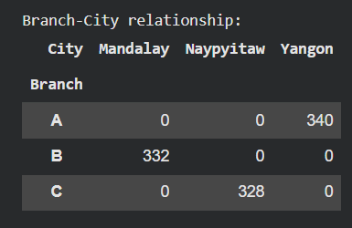
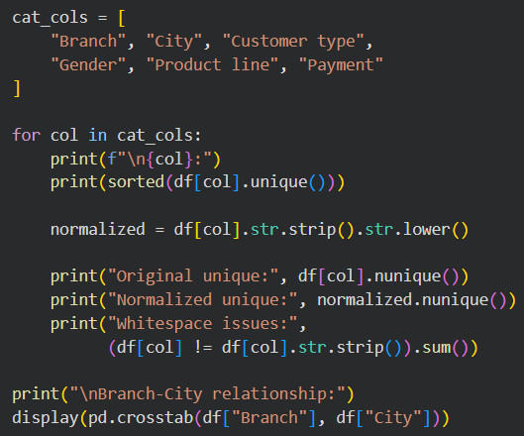
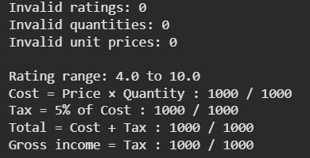
No invalid values were found. Customer ratings range from 4 to 10, while quantities and prices are positive. All financial relationships are mathematically consistent across 1,000 transactions. Gross income duplicates Tax 5%, and Gross margin percentage is constant, indicating redundant variables rather than data errors.
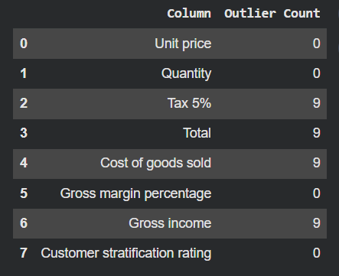
The IQR method identified nine potential outliers in transaction-related financial columns. These represent the same high-value transactions because the financial variables are mathematically related. Since the values satisfy the expected calculations, they are not necessarily errors and should be retained.
Cleaning decision: No rows need to be removed or imputed. Potential outliers should be retained, and redundant variables should be considered during feature selection in Assignment 3.
B3. Data Cleaning
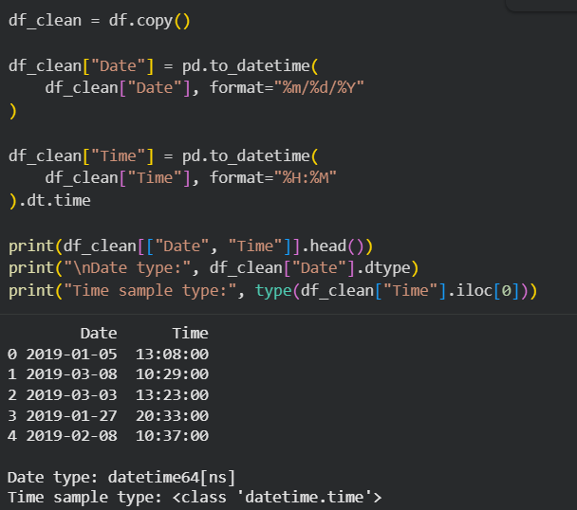

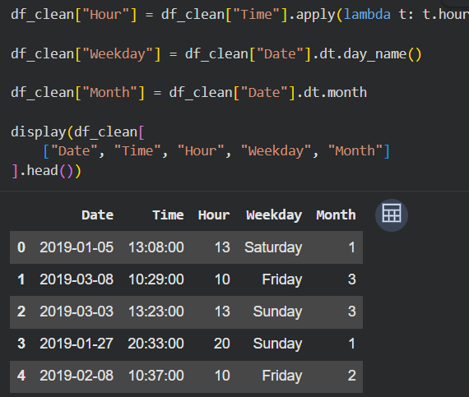
Hour helps identify peak shopping hours, Weekday supports daily sales comparisons, and Month enables monthly trend analysis. All three variables are retained for Assignment 3.
As calculated in B2, the nine high-value transactions were retained because their financial calculations are consistent and there is no evidence that they are erroneous. Redundant financial columns and overlapping Branch–City information were also preserved in the cleaned dataset for transparency, but should be considered during feature selection.
Cleaned csv:
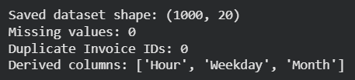
B4. Univariate Exploratory Data Analysis
Univariate analysis was performed on four numerical and four categorical variables. Histograms and boxplots were used to examine numerical distributions, spread, skewness, and outliers, while bar charts and frequency tables were used for categorical variables.
Numerical findings: Unit price (mean = 55.67), Quantity (mean = 5.51), and Customer stratification rating (mean = 6.97) have approximately symmetric distributions. Total transaction value has a mean of 322.97 and a median of 253.85, with moderate positive skewness (0.89). Nine potential high-value outliers were identified using the IQR method and retained.
Categorical findings: Branch A accounts for the largest proportion of transactions (34%), although all branches have similar frequencies. Fashion accessories is the most frequent product category (17.8%). Customer types are nearly balanced, with Members representing 50.1% of transactions. Ewallet is the most common payment method (34.5%), closely followed by Cash (34.4%).
Overall, most categorical distributions are relatively balanced, while transaction totals show greater variability and right-skewness. These findings provide a basis for examining relationships between sales, product categories, customer characteristics, and payment methods in subsequent analyses.
B5. Bivariate Exploratory Data Analysis
Bivariate analysis was performed to examine relationships between numerical and categorical variables using scatterplots, boxplots, bar charts, and contingency tables.
Numerical – Numerical Quantity vs Total: A strong positive correlation (r = 0.706) was observed, indicating that larger purchases generally have higher transaction values. However, this relationship is partly mathematical because Total is calculated using Quantity and Unit price.
Categorical – Numerical Product line vs Total: Home and lifestyle had the highest average transaction value (336.64), while Food and beverages generated the highest overall sales (56,144.84). This highlights the distinction between transaction value and total revenue.
Categorical – Numerical Branch vs Total: Branch C recorded the highest average transaction value (337.10) and total revenue (110,568.71), despite having fewer transactions than the other branches.
Categorical – Categorical Branch vs Payment: Payment preferences varied slightly across branches. Ewallet was most common in Branch A (37.1%), whereas Cash was most common in Branch C (37.8%).
Overall, the analysis reveals differences in transaction values across product categories and branches, while payment method distributions remain relatively balanced. The Quantity–Total relationship is partly a consequence of how the variables are defined, rather than independent evidence of purchasing behavior.
B6. Multivariate Exploratory Data Analysis
Two multivariate interactions were investigated using grouped bar charts and a heatmap.
Branch × Customer Type × Total: Members had higher average transaction values than Normal customers in Branch A (321.18 vs 303.83) and Branch B (325.48 vs 314.33). However, this difference disappeared in Branch C, where Normal customers spent slightly more (337.66 vs 336.58). This indicates that customer-type spending differences weaken when branch location is considered.
Product Line × Branch × Total: The highest-spending product category differed across branches. Home and lifestyle led in Branch A (344.88), Health and beauty in Branch B (376.99), and Food and beverages in Branch C (360.10). Therefore, overall product-line averages conceal important branch-specific variations.
These findings demonstrate that sales patterns are not uniform across customer segments and locations. However, the differences are descriptive and do not establish causal relationships or statistical significance.
B7. Supermarket Sales-Specific Analytical Questions
1. Product line revenue: Food and beverages generate the highest total revenue (56,144.84), whereas Home and lifestyle have the highest average transaction value (336.64). The rankings differ because total revenue also depends on transaction frequency.
2. Branch performance: Branch C records the highest total revenue (110,568.71) and average transaction value (337.10). However, differences between branches are small compared with within-branch sales variation, with standard deviations exceeding 230. Branch and City are equivalent groupings in this dataset.
3. Customer and payment behaviour: Members spend slightly more per transaction (327.79) than Normal customers (318.12). Cash has the highest average transaction value (326.18), but spending differences across payment methods are small relative to their variability.
4. Temporal sales patterns: Revenue peaks at 19:00 (39,699.51), while Saturday generates the highest weekday revenue (56,120.81). Higher transaction counts contribute to these peaks.
5. Customer ratings: Ratings have negligible correlations with Unit price (-0.009), Quantity (-0.016), and Total (-0.036). Average ratings also differ only slightly across product lines and branches, suggesting that these variables have limited explanatory power for customer satisfaction.
Overall, sales vary across product categories, branches, and time periods, but several group differences are modest. These findings are descriptive and do not establish causal relationships.
B8. Supermarket Sales Insights and Handoff
Five Key Insights
1. Revenue contribution differs from average transaction value.
Food and beverages generated the highest total revenue (56,144.84), while Home and lifestyle had the highest average transaction value (336.64). This indicates that revenue rankings depend on both transaction frequency and purchase value, so the category with the highest average spending is not necessarily the largest revenue contributor.
2. Branch performance differences are modest relative to transaction variability.
Branch C recorded the highest average transaction value (337.10), compared with Branch A (312.35). However, within-branch standard deviations were approximately 240–260, indicating substantial overlap in transaction values. Therefore, the difference may be relatively small in practical terms.
3. Customer membership shows limited association with spending.
Members spent an average of 327.79 per transaction compared with 318.12 for Normal customers, a difference of only 9.67. Given the large standard deviations (approximately 244–248), membership status alone does not strongly distinguish spending behaviour.
4. Sales activity varies across hours and weekdays.
Revenue peaked at 19:00 (39,699.51), while Saturday recorded the highest weekday revenue (56,120.81). Both periods also had relatively high transaction counts, suggesting that transaction frequency contributes to revenue peaks. Speculation: Higher evening and weekend activity may reflect customers' shopping schedules, although the dataset cannot confirm this explanation.
5. Customer ratings show little relationship with transaction characteristics.
Customer ratings had negligible correlations with Unit price (-0.009), Quantity (-0.016), and Total (-0.036). Average ratings also varied only slightly across branches and product lines. This suggests that the recorded transaction characteristics provide limited information for explaining customer satisfaction.
Assignment 3 Handoff Note
The most informative variables for future analysis are Total, Unit price, Quantity, Product line, Customer type, Payment, and the derived Hour, Weekday, and Month features. Customer stratification rating may be useful for satisfaction analysis, although its relationships with other variables appear weak.
Invoice ID should be excluded from analytical features because it is only an identifier. Branch and City overlap completely, while Total, Tax 5%, Cost of goods sold, and Gross income are mathematically related. Gross margin percentage is constant and offers little analytical value.
Cleaning preserved all 1,000 records, including nine valid high-value outliers. Date and Time were standardized, and three temporal features were added. Future analysis should avoid redundant predictors, consider potential data leakage from derived financial columns, and retain legitimate outliers unless a justified transformation is required.

