**HIMALAYA DARSHAN COLLEGE**

**Tribhuvan University**

**Institute of Science and Technology**



**A Proposal Report On**

**"Freelancing System"**

**Submitted to**

Department of Computer Science and Information Technology

Himalaya Darshan College

Biratnagar, Nepal

**Submitted by**

Bishow Chauhan (27316/077)

Manish Kumar Dev (27326/077)

Sagar Pokharel (27334/077)

Date:30thth Bhadra 2081

# Abstract

This project aims to create a dynamic web-based platform that connects freelancers with clients, offering job opportunities across various skill levels. This system aims to facilitate real-time communication, job application, and project management between freelancers and clients. The platform consists of three main modules: Freelancer, Client, and Admin. Freelancers can register, view, and apply for jobs posted by clients, while clients have the power to select suitable freelancers based on their profiles and skill sets. The system includes real-time communication features, a secure payment processing system managed by the admin, and a recommendation engine that suggests jobs to freelancers based on their skills. Additionally, the platform offers profile management, a rating system for clients, and comprehensive reports for overall management. This freelancing system aims to streamline the freelance job market by providing an efficient and user-friendly interface for both freelancers and clients.

Keywords:

# Table of Content

1.**Introduction** 1

2.**Problem statement** 1

3.**Objectives** 2

4**.Methodology** 2

4.1 Requirement identification 2

4.1.1 Literature Review 3

4.2. Requirement Analysis: 3

4.2.1 Functional Requirements 3

4.2.2 Non-Functional Requirements 5

4.3. Feasibility Study 5

4.3.1 Technical 5

4.3.2. Operational 6

4.3.3. Economic 6

4.3.4 Schedule 7

4.4. High Level Design of System: 8

4.4.1. Flowchart 8

4.4.1. Description for algorithm 11

5**.Expected Outcome** 12

6.**References** 13

# 

# 1. Introduction

Nepal, a nation known for its rich cultural heritage and breathtaking landscapes, is also experiencing a significant transformation in its labor market. As global trends shift towards more flexible and remote work arrangements, freelancing has emerged as a promising avenue for economic empowerment and professional growth.

Freelancing is becoming an important part of the job market in Nepal. This shift is largely due to advancements in technology and the growing popularity of remote work. Many Nepali professionals, including those in fields like software development, design, writing, and digital marketing, are now able to find work opportunities through online platforms.

In recent years, freelancing has gained traction in Nepal, driven by advances in digital technology and a growing pool of skilled individuals seeking opportunities beyond traditional employment. With the rise of online platforms and the increasing acceptance of remote work.

# 2. Problem statement

The current freelancing landscape for Nepali professionals faces several significant challenges, limiting its potential for growth and efficiency. One major issue is the lack of a centralized platform, which makes it difficult for freelancers and clients to connect efficiently. Freelancers struggle to stay updated on the latest job openings, as there is no streamlined system to provide real-time information on available projects. Additionally, many talented individuals face limited access to opportunities, especially those in rural or undeserved areas, making it hard for them to compete in the global market.

# Objectives

# The Specific Objectives are:

# To Develop a user-friendly web-based application for Freelancers and Client to perform their work

# To Enhance Economic Opportunities

# To Promote Skill Development

# To Expand Market Access

# To Foster Entrepreneurship

# To Improve Work-Life Balance

# To Support Technological Advancement

# 4. Methodology

## 4.1 Requirement identification

The existing freelancing system is highly fragmented and lacks centralization, making it difficult for freelancers and clients to connect efficiently. Currently, freelancers rely on multiple platforms or informal networks to find jobs, which leads to mismanagement of data, limited job visibility, and lack of real-time updates on new opportunities. Security is also a major concern. The manual processes involved in finding, bidding, and managing jobs are time-consuming and inefficient. Freelancers have to spend a significant amount of time manually searching for projects, negotiating terms, and managing payments, which could be better spent working on multiple jobs through an automated process. efficiency, accuracy, and security.

**4.1.1 Literature Review**

# 4.2. Requirement Analysis:

The requirement can be functional and non-functional.

4.2.1 Functional Requirements

1. User Registration and Authentication (Freelancer and Client)

2. User Profile Management

3. Job Posting and Management(Client)

4. Job Search and Filtering(Freelancer)

5. Job Acceptance

6. Messaging and Communication

7. Admin Panel

#### 4.2.2 Non-Functional Requirements

1. Performance

2. Reliability

3. Security

4. Usability

5. Scalability

6. Real Time Notification

7. Compatibility

## 4.3. Feasibility Study

The proposed project is feasible and has the potential of being successfully completed due to various aspects of the feasibility study done for the project.

#### 4.3.1 Technical Study

* Involves a through evaluation of existing technological infrastructure, including server capabilities, database management systems, and development frameworks.
* Assesses the compatibility of current hardware and software with the proposed freelancing platform’s requirements.
* Evaluates the availability of necessary development tools, programming languages, and third-party APIs for efficient project execution.
* Determines the scalability of the system to handle an increasing number of users and projects over time.
* Aims to confirm that the required technical resources are in place to guarantee the smooth development, deployment, and operation of the freelancing system.

**4.3.2.** **Operational**

#### Reviews the system's capability to handle and support freelancers and clients effectively during the operational phase.

#### The Freelancing System has been developed to simplify and streamline the job matching and project management process for users.

#### Ensures smooth performance, ease of use, operational efficiency, and provides a user-friendly interface for both freelancers and clients.

#### The platform is designed to be scalable, allowing for future growth in user base without compromising system efficiency.

**4.3.3. Economic**

* The Freelancing System Web App is highly feasible from an economic perspective due to its cost-effective development and maintenance process.
* The Freelancing System Web App is highly feasible from an economic perspective due to its cost-effective development and maintenance process.
* As the system is developed for a growing freelancing market, it offers high potential returns on investment due to increasing demand for freelance opportunities both locally and globally.

#### 4.3.4 Schedule

Below is a Gantt chart of the project which shows what tasks need to be done to complete the Project and how much duration is needed to complete each task.

|  |  |  |  |  |  |  |  |  |  |  |  |
| --- | --- | --- | --- | --- | --- | --- | --- | --- | --- | --- | --- |
| S. N | Task Name | Time period | 2081 | | | | | | | | |
| Bhadra | | | Ashoj | | kartik | | Mangsir-poush | |
| 1. | Study and Research | 15 days |  |  | | | | | | | |
| 2. | Design | 20 days |  |  | | |  | | | | |
| 3. | Implementation | 30 days |  | | | |  | |  | | |
| 4. | Testing and Analysis | 15 days |  | | | | | |  | |  |
| 5. | Documentation | 120 days |  | |  | | | | | | |

Fig. Gantt chart for time and its duration

**4.4 High level Of System**

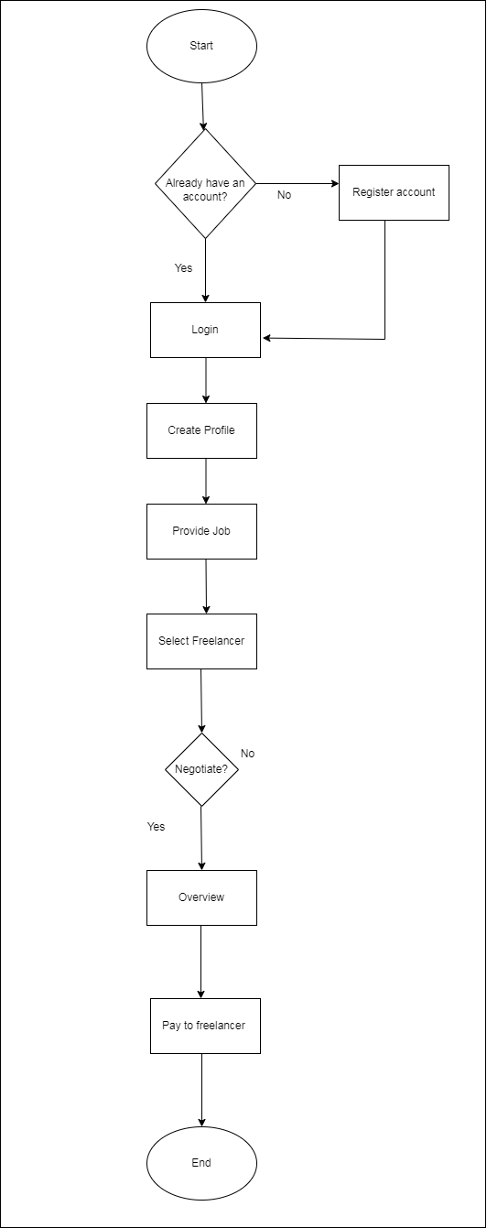

Fig. Flowchart of Client

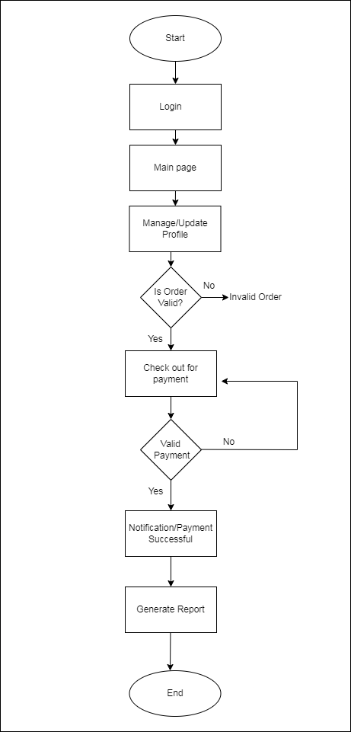

Fig. Flowchart of Admin

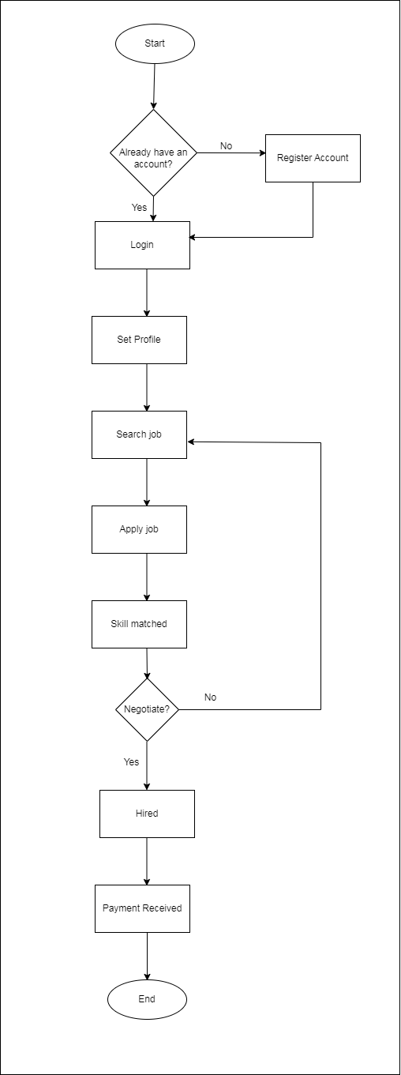

Fig. Flowchart of Freelancer

# Description for algorithm

# Expected Outcome

After the completion of this project, we are expecting the following outcomes:

* With the launch of our Freelancing System, users (freelancers) can easily browse and apply for jobs that match their skills. The system will streamline the entire process of finding work by displaying relevant job listings, secure payment methods, and clear communication channels with clients. No more hassles of endlessly searching across various platforms or dealing with unreliable clients.
* The platform is designed to make freelancing more efficient and accessible. Freelancers can showcase their portfolios, bid on projects, and manage their tasks all in one place. Clients can easily search for skilled freelancers based on expertise and experience, making the hiring process quicker and more straightforward.
* For clients, the system ensures efficient project management, allowing them to post projects, review freelancer profiles, communicate with potential hires, and track progress in one centralized platform. This will help clients find the right talent quickly, with less effort, and ensure project success.
* Overall, the Freelancing System aims to build a vibrant community of professionals and clients who can collaborate easily. It will empower freelancers by providing them with a user-friendly platform to grow their careers and give clients access to a skilled workforce, improving productivity and outcomes for both sides.
* Ultimately, the system seeks to boost the freelancing industry in Nepal, creating opportunities for freelancers to thrive in a secure, well-managed environment while giving clients access to a broader talent pool.

# References