Build Cool Things with Python
  - From Zero to Real-World Builder
A project-based introduction to programming

BUILD COOL THINGS WITH PYTHON
  - From Zero to Real-World Builder
Working textbook manuscript · Python 3.12+
[AUTHOR CREDIT TO BE CONFIRMED]

Edition and rights information
[EDITION, PUBLICATION DATE, PUBLISHER, ISBN, AND COPYRIGHT HOLDER TO BE CONFIRMED]
This working edition teaches with the ten applications in the companion repository. Project files, screenshots, and imported visual artwork retain their separate rights and permission records. The production report identifies evidence still needed before a public release. A reader may experiment with local copies of the exercises; this page does not grant distribution rights to any imported material.

Preface
The fastest way to make programming feel real is to make something you can use. A guessing game teaches a comparison because a player needs a hint. A file organizer teaches paths because a file must have a safe destination. A maze makes a queue visible because we can watch its search frontier spread. Each project in this book gives a reason to learn the next concept.
You do not need to know Python before opening Chapter 0. You will meet a small idea, trace it by hand, run a real program, and then change one behavior. Later projects use the same habits on larger problems: predict, execute, observe, and revise. The book favors understanding over transcription. The complete programs live in the companion files; the short listings here are teaching examples.
The creative applications are intentionally more elaborate than the first three games. You are expected to understand their data flow before every detail of their drawing mathematics. You can still change a color, trace a coordinate, or export an image while the advanced parts remain future learning goals.

Who this book is for
Absolute beginners can work in order, starting with the terminal and small values. Undergraduate students can use the diagrams, tests, and reasoning questions to discuss program behavior. Independent learners can use each chapter as a self-contained project tour. The examples assume basic computer use, but no previous experience with programming, Git, packages, or data analysis.

How to use this book
- Read a concept section before opening the project. Predict what a short example will do, then run or trace it.
- Use the exact project path printed in each chapter. The book chapter order and the Visual Art Lab folder prefixes differ for two creative projects.
- Keep a practice copy for edits and use made-up data. Exercises describe proposed changes; the original project does not include them by default.
- When an error appears, read its final line, identify the input or operation, and compare it with the chapter's troubleshooting table.
- Use the knowledge check without looking back. Explain answers in words before checking the selected hints in Appendix E.

Learning pathway
Stage | Projects | New kind of thinking
Workshop | Chapter 0 | Files, commands, Python, errors
Foundations | Chapters 1–3 | Values, choices, loops, functions, tests
Creative Python | Chapters 4–6 | Coordinates, images, animation, geometry
Useful tools | Chapters 7–8 | Safe files, validation, packages, exports
Applications | Chapters 9–10 | Data pipelines, interfaces, graph search
Portfolio | Chapter 11 | Explaining and maintaining a project

Contents
Page numbers reflect this working edition. Refresh them after any editorial changes.
Chapter 0 Your Python Workshop 5
Part I Foundations 8
Chapter 1 Number Guessing Adventure 9
Chapter 2 Rock, Paper, Scissors Tournament 14
Chapter 3 Password Generator & Strength Checker 19
Part II Creative Python 25
Chapter 4 Heartglow: Animated Heart Art 26
Chapter 5 Bloomcraft: Generative Flower Art 31
Chapter 6 Spiral Ink: Image-to-Text Art 36
Part III Useful Python Tools 41
Chapter 7 Smart File Organizer 42
Chapter 8 QR Code Studio 47
Part IV Real-World Applications 53
Chapter 9 Expense Tracker Dashboard 54
Chapter 10 Maze-Solving Visualizer 59
Chapter 11 From Project to Portfolio 64
Appendices 67

Chapter 0 Your Python Workshop
  - Set up a small, reliable place to experiment.

What a program does
A program is a sequence of instructions interpreted by a computer. The computer executes exactly the operations you describe, including mistakes. Your task as a programmer is to describe a goal precisely enough that the result can be checked. Start with inputs, transformations, and outputs. For a guessing game, the input is a player's text, the transformation is validation plus comparison, and the output is a hint.
Python is a programming language and an interpreter. A .py file contains text instructions. Running python file.py asks the interpreter to read and execute that file. The interpreter is separate from the editor, which is simply where you write text. A program can also open a graphical window or serve a page to a browser; those are different interfaces over the same Python rules.
Listing 1. A first standalone teaching example
name = "Ada"
print("Hello,", name)

Trace the first program
The variable name refers to a string value. The next line calls print, which writes to the terminal. Predict the output before you run the program. A comma in this call asks print to place a space between its arguments. The quotation marks mark text in the source; they are not printed. Change the name and notice which part of the result changes.

Install and verify Python
Install a current Python 3.12-or-later distribution appropriate for your operating system. Choose an editor that lets you save plain .py files and open a terminal. During a Windows installation, ensure the Python launcher or command is available from your terminal. On macOS and Linux, python3 is often the command name. These steps depend on your installation; if a command is missing, check the editor's selected interpreter and your system path.
Open a fresh terminal and ask Python for its version. This proves which interpreter the shell will use. Then ask it to execute a one-line print statement. If the version is older than 3.12, switch interpreters before installing project packages. A successful greeting is a small but useful diagnostic: the interpreter, shell, and output path all work.
Listing 2. Version and greeting commands; use python3 where required
python --version
python -c "print('Hello, Python!')"

Folders and working directories
A path tells the operating system where a file is. A working directory is the folder from which your command runs; a relative path is interpreted from there. If the terminal reports that it cannot open a file, first ask where you are and list the files there. On Windows PowerShell, Get-Location and Get-ChildItem show that information. In many shells, pwd and ls do the same. cd changes the working directory.
The companion repository has a root README and a projects directory. The numbered folders are the runnable applications. projects/visual-art-lab contains three creative projects. research records verification and rights questions. book and assets are organizational folders, not commands. Run commands in the chapter from the location stated immediately above each listing. Never paste a placeholder such as [COMPANION REPOSITORY INFORMATION TO BE ADDED] into a terminal.
Question | PowerShell | macOS/Linux shell
Where am I? | Get-Location | pwd
What files are here? | Get-ChildItem | ls
Move into a folder | cd projects/01-number-guessing | cd projects/01-number-guessing
Go up one folder | cd .. | cd ..

Obtain the companion files
[COMPANION REPOSITORY INFORMATION TO BE ADDED] Obtain a copy through the course or publication channel when its address is supplied. Place it in a folder where you have permission to read and write your own practice files. Confirm you see README.md and projects at its root. Keep a separate copy for experiments with file-moving tools and artwork exports. Paths in this book are written relative to that root unless a chapter explicitly tells you to enter a project folder.

Inputs, types, and errors
Python's input function returns text, even if the user types digits. Arithmetic requires a numeric value, so conversion is a deliberate step. A value's type controls which operations are meaningful. For example, adding two integers produces a sum; adding two strings joins text. A traceback is a report of where execution failed. Read its last line for the exception type and message, then look at the referenced line in your own file.
Do not try to memorize every error message. Build a habit: reproduce the problem with the smallest input, state what you expected, inspect the actual value and type, and change one assumption. If a conversion may fail, handle the specific failure. The guessing game in Chapter 1 does exactly that rather than crashing when the player enters a word.
Listing 3. A conversion boundary; standalone teaching example
answer = input("A whole number: ")
try:
number = int(answer)
except ValueError:
print("Please enter digits.")

Virtual environments and packages
A virtual environment is a private set of installed Python packages for a project. It helps one project use its dependencies without changing other projects. From the repository root, python -m venv .venv creates one. On Windows PowerShell, activate with .venv/Scripts/Activate.ps1; on macOS or Linux, use source .venv/bin/activate. An activated shell usually shows the environment name. If activation is blocked, run the environment's Python executable by path.
Install only what a project needs. The first three games, Heartglow, the file organizer, and maze search use the standard library for their main behavior. Bloomcraft needs Pillow and NumPy; Spiral Ink needs Pillow; QR Code Studio needs its requirements file; the dashboard needs Streamlit and Pandas. A desktop window also needs Tk and a graphical display. python -m pip connects package installation to the same interpreter used for execution. If an import fails after installation, compare the interpreter used by pip with the one running the program.
Listing 4. Environment and package commands from the repository root
python -m venv .venv
python -m pip install -r projects/08-qr-code-studio/requirements.txt

A first practice routine
Create a new file called hello.py in your own practice folder, type the first program from this chapter, save it, and run it. Change the variable to a number and observe how print behaves. Then introduce a spelling error in the variable name, run again, and read the last line of the traceback. Restore the file and run it successfully. This short loop—predict, execute, inspect, repair—will be the pattern for the rest of the book.

Workshop check
- What is the difference between a `.py` source file and the Python interpreter?
- Why can the same relative path work from one folder and fail from another?
- What type does `input` return, and what error might `int` raise?
- How can you tell which Python interpreter installed a package?
You are ready for Chapter 1 when you can run a short file, locate your working directory, and explain a simple traceback without guessing.

Part I Foundations
Three small programs teach values, decisions, and trustworthy inputs.

Chapter 1 Number Guessing Adventure
  - Make a small conversation with a program.

A. Project introduction
A secret number is chosen within a range. You submit guesses, receive a direction, and try to finish before the attempt limit. The project has a terminal game and a separate desktop window. This first application gives variables and conditions a concrete job: a guess must be stored, checked, compared, and explained.
You will trace one round by hand before inspecting the program. The aim is to understand why invalid text is rejected, why it does not use an attempt, and why the loop ends. A successful run is more than a lucky answer; it is a series of state changes you can account for.

B. Project preview
Look at the attempt meter and history in the captured window. The window adds Easy, Classic, and Challenge modes to the same basic rules. The terminal version prints the same kind of hint after each valid number. The image is a recorded application capture, not a diagram of imagined controls.
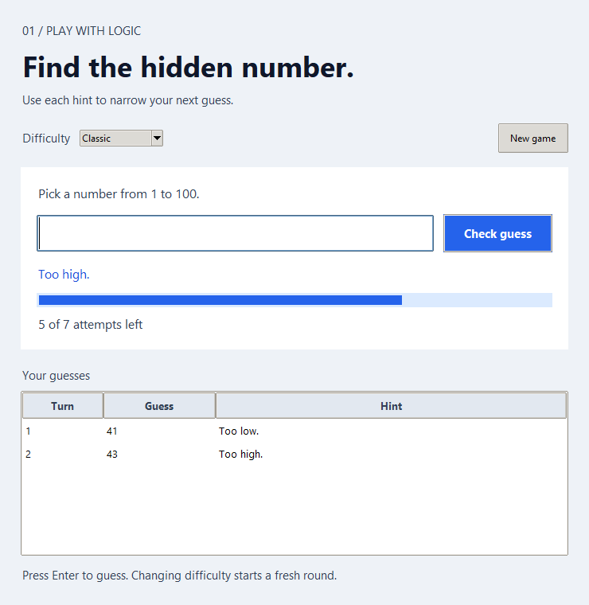
Figure 1. The number-guessing desktop window shows difficulty, attempts, and guess history.

C. Learning objectives
- Identify a variable, its value, and its type during a round.
- Trace an `if`/`elif` comparison and predict the next hint.
- Explain how a loop counts valid attempts but retries invalid input.
- Describe why input conversion may raise `ValueError`.
- Design a deterministic test by controlling the secret number.
Prerequisites: Chapter 0: run Python, change directory, and read a basic traceback.

D. Concepts before code

Values, names, and types
A variable name refers to a value. In this game, secret, guess, and used are separate ideas even when all three are integers. The program cannot compare a typed answer with the secret until it converts the answer from text to an integer. Treat conversion as a boundary: ask whether the value is well formed and whether it is inside the allowed range. A type is a rule about supported operations, not a label attached by the programmer for decoration.

Comparisons and branches
<, >, and == answer different questions. An if/elif/else chain selects one mutually exclusive result: too low, too high, or correct. The order matters. If you test guess < secret and it is false, the program still needs a second comparison to separate a high guess from an exact match. Write a small decision table before coding conditions; it makes missing cases visible.

Loops as controlled repetition
A while loop repeats while its condition remains true. Here the attempt count changes only after a valid, in-range number. continue can return to the top of the loop after invalid input. A loop that never changes the value in its condition may never stop. In a game, reaching the attempt limit or guessing correctly are both stopping conditions; quitting deliberately is a third.

Randomness and repeatability
Ordinary play selects a fresh secret through a random generator. The optional seed gives a repeatable practice sequence. That is valuable for teaching and testing because the same inputs can be compared with the same expected hints. It is not suitable for generating credentials; Chapter 3 uses a different source of randomness for passwords.
Listing 5. A comparison selects a hint; standalone teaching example
secret = 7
guess = 5
if guess < secret:
print("Too low")
else:
print("Try the other direction")

E. Understanding the project logic
The game starts with a validated range and attempt limit. It asks for text, detects quitting, attempts conversion, checks the range, then counts a valid guess and compares it with the secret. The desktop version keeps the same state in a round object and updates widgets after each submission. Both versions stop accepting guesses when the round is finished.
Stage | What happens | Why it matters
1 | Choose a secret | Keep it within the configured inclusive range
2 | Read an answer | Input is text, even when it contains digits
3 | Validate | Words and out-of-range values do not use an attempt
4 | Compare and count | Show low, high, or correct after a valid guess
5 | Finish | Win, use every attempt, or quit

A worked trace
Suppose the secret is 7, the range is 1–10, and the limit is three valid attempts. Enter hello: conversion fails and the remaining count stays three. Enter 12: conversion succeeds but the range check fails, so the count still stays three. Enter 5: the count becomes one and the hint is low. Enter 9: the count becomes two and the hint is high. Enter 7: the count becomes three and the round ends in a win. The important trace is not just the answers; it is where the count changes.

F. Obtain and run the project
[COMPANION REPOSITORY INFORMATION TO BE ADDED] Obtain the companion files from the publication or course channel and open a terminal at the repository root. The following path and filenames match the audited project files. A terminal command acts on the project; a desktop option requires Tk and a graphical display.
Project folder: projects/01-number-guessing
Entry point: main.py for terminal; gui.py for desktop
Runtime packages: Python standard library only for this entry point. Check Tk separately for a desktop window.
Listing 6. Launch from the repository root
python projects/01-number-guessing/main.py
python projects/01-number-guessing/gui.py
On Windows, pythonw projects/01-number-guessing/gui.py opens the desktop window without a console if Tk is installed. On macOS and Linux, use python3 if that is the available command. The terminal form works without a graphical display. From the project folder, python main.py --low 1 --high 20 --attempts 5 --seed 7 is a reproducible practice variation.

G. Understanding the output
A low or high hint says only how a guess compares with the secret; it does not disclose the answer. A correct guess reports how many valid attempts were used. After a loss the terminal reports the secret. In the window, a completed round disables guessing until New game. The history is useful evidence when checking your own prediction. Invalid input produces guidance and leaves the attempt meter unchanged.

H. Under the hood

A state invariant
An invariant is a statement intended to stay true throughout an operation. In this game, 0 ≤ used ≤ limit, and the number of recorded valid guesses equals used. If an invalid answer incremented the counter, the invariant about valid guesses would be broken. State invariants help you decide where updates belong.

Test a rule separately
The hint rule takes a guess and secret and returns one of three messages. It can be tested without a terminal or random number. A test can check 5 versus 7, 9 versus 7, and 7 versus 7. Then another test can check that invalid input leaves the attempt count unchanged. Separating rules from interface makes failures easier to locate.

I. Debugging and testing
The repository includes tests for comparisons, invalid inputs, round state, and terminal behavior. A useful manual test deliberately types a word, a number outside the range, and a valid guess. Check the attempt meter after each step, not only the final message. A seed is suitable for a practice trace because it controls the random sequence.
Symptom or boundary | Check | Reason
A word causes a crash | Look for integer conversion and its `ValueError` handling | Terminal input begins as text
Attempts vanish after an invalid entry | Locate the counter increment | It belongs after validation
A window does not open | Run `python -m tkinter` | The graphical Tk component may be unavailable
Unexpected secret | Check whether `--seed` was supplied | Unseeded games vary

Run the chapter suite from the repository root, when available:
Listing 7. Run this project's unit tests
cd projects/01-number-guessing
python -m unittest discover -s tests -v

J. Make it yours
Work on a separate practice copy. Each challenge below is an extension or investigation, not a claim about a feature already in the project. Predict the new behavior, write down a test case, then change the smallest possible part of the program.

Beginner
Change the default range to 1–50 in a practice copy. Predict how this affects the meaning of a 'too high' hint, then verify the displayed range.

Intermediate
Add a named difficulty preset without copying the entire game loop. Keep range and attempt settings together so tests can inspect them.

Advanced
Write a computer player that chooses the midpoint of the remaining interval. Compare its worst-case valid guesses with a strategy that chooses randomly.

K. Knowledge check
1. What type does `input` return before conversion?
2. Why should `used` increase after the range check?
3. In the worked trace, how many attempts remain after `12`? Explain.
4. If a secret is 7 and a guess is 9, which comparison is true?
5. Debug a version that never stops after a correct guess: what state or loop condition would you inspect?

L. Chapter summary
A program is easier to reason about when input, validation, state update, and output occur in a deliberate order. This game introduces that order with small values and visible hints. Chapter 2 keeps the same cycle but adds a second player's choice, a rule table, and a match score.

Chapter 2 Rock, Paper, Scissors Tournament
  - Turn a familiar game into explicit, testable rules.

A. Project introduction
The player and computer each choose rock, paper, or scissors. A draw is possible; otherwise one choice beats another. The program repeats for a fixed number of valid rounds and reports wins, losses, and draws. The desktop version makes the decision visible through large move buttons and a history of outcomes.
This chapter asks you to translate a social rule into a precise rule table. You will also distinguish a round from a match, and see why a score is derived from recorded events. The rules are small enough to check exhaustively: three player choices multiplied by three computer choices make nine cases.

B. Project preview
The capture shows the three move controls and the running score. The desktop offers three-, five-, and seven-round matches; keyboard shortcuts choose moves. The terminal accepts full names or their first letters. Both reject invalid choices without treating them as a round.
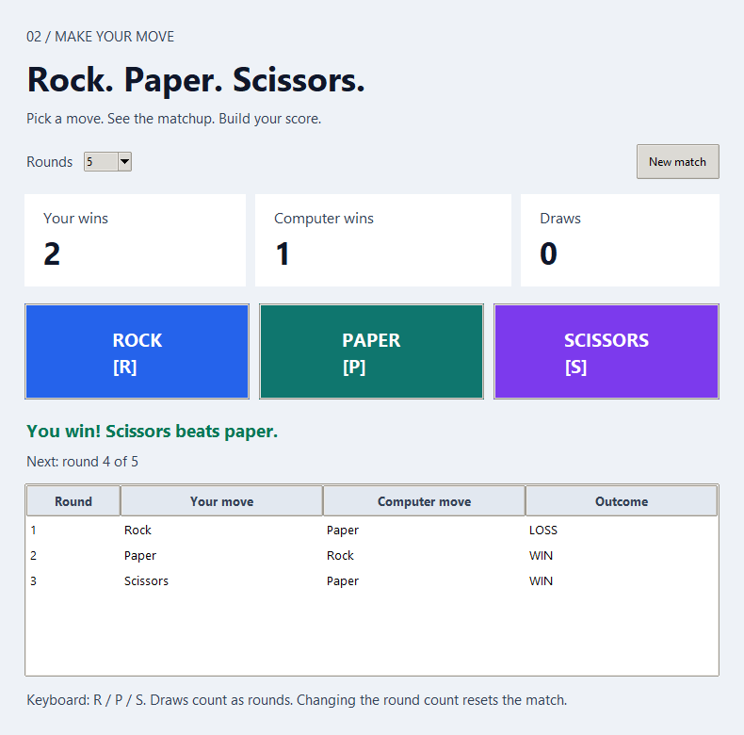
Figure 2. The tournament window shows move buttons, score cards, and round history.

C. Learning objectives
- Normalize user choices before evaluating rules.
- Enumerate the nine choice pairs and classify each outcome.
- Describe a function's inputs and return value.
- Track a match state without mixing it into the rule function.
- Explain how draws affect the fixed round count.
Prerequisites: Chapter 1: comparisons, loops, validation, and state changes.

D. Concepts before code

Normalize first
Human input varies: R, r, and rock mean the same move. Removing surrounding spaces and converting to lower case creates a normalized value. A short alias table can map the one-letter forms to full names. Validation follows normalization. This keeps later rule code simple because it sees only three canonical choices; it does not need a separate condition for every spelling.

Represent rules as data
The relation 'beats' can be stored as a dictionary: rock beats scissors, paper beats rock, and scissors beat paper. A dictionary maps a key to one associated value. If the choices match, the result is a draw. Otherwise, compare the computer move with the item beaten by the player's move. This representation is shorter and less error-prone than a long sequence of special cases.

Functions and contracts
A function packages a small operation under a name. The round_result function receives two moves and returns win, loss, or draw. Its contract includes invalid input behavior: unsupported choices raise a useful error. It does not update the match score. Keeping this contract narrow lets a test call it with all nine pairs without opening a window.

Match state and loops
A match records a sequence of completed rounds. The score can be counted from those records, so the history is an explanation of the displayed totals. A draw still consumes one of the fixed rounds. Invalid text consumes none. The terminal loop continues until the chosen round count is reached or the player quits; the desktop disables move buttons when the match finishes.
Listing 8. A rule table yields a round result; standalone teaching example
beats = {"rock": "scissors", "paper": "rock", "scissors": "paper"}
player = "paper"
computer = "rock"
result = "draw" if player == computer else ("win" if beats[player] == computer else "loss")
print(result)

E. Understanding the project logic
First normalize the player's choice. Then choose the computer's move, evaluate the pair, record the round, and display the updated score. The history is a list of triples: player choice, computer choice, and result. The interface layer reads the history and displays it. Keeping the rule separate from the random move and the widgets gives each part a single reason to change.
Stage | What happens | Why it matters
1 | Read player move | Accept full names or r/p/s
2 | Normalize and validate | Reject unsupported input before counting a round
3 | Choose computer move | Use randomness, or a seed for practice
4 | Evaluate | Draw if equal; otherwise consult the beats table
5 | Record and report | Append history and recompute score

A worked trace
Suppose the player chooses paper and the computer chooses rock. The choices differ, and beats["paper"] is rock, so the result is a win. In a second round, both choose scissors: that is a draw and still counts as a completed round. A third entry of lizard fails validation, so neither the history nor the round number changes. This trace shows why validation precedes scoring.

F. Obtain and run the project
[COMPANION REPOSITORY INFORMATION TO BE ADDED] Obtain the companion files from the publication or course channel and open a terminal at the repository root. The following path and filenames match the audited project files. A terminal command acts on the project; a desktop option requires Tk and a graphical display.
Project folder: projects/02-rock-paper-scissors
Entry point: main.py for terminal; gui.py for desktop
Runtime packages: Python standard library only for this entry point. Check Tk separately for a desktop window.
Listing 9. Launch from the repository root
python projects/02-rock-paper-scissors/main.py --rounds 3 --seed 7
python projects/02-rock-paper-scissors/gui.py
The terminal command runs on any supported platform with Python. On Windows, pythonw projects/02-rock-paper-scissors/gui.py can open the Tk window without a console. On macOS/Linux use python3 if required. The seed is an optional teaching aid; unseeded play varies.

G. Understanding the output
A terminal round prints both choices and its result, followed by a score at the end. In the window, the score cards and round history explain what happened; a completed match disables the move buttons. Changing the round count begins a new match. A score of one win and one draw after two rounds is consistent because draws count toward the match length but are stored in their own score category.

H. Under the hood

Exhaustive testing
Three moves on each side produce only nine pairs. A small table can specify the expected outcome of every pair. Test all three draws, all three wins, and all three losses. This is stronger than testing one lucky random match because it checks the whole finite decision space.

Derive, do not duplicate
The project calculates scores by counting results in history. If it also kept separate mutable win and loss counters, a missed update could make the score disagree with the history. A single source of truth is a design choice: record the rounds once, then derive displays from those records.

I. Debugging and testing
Tests cover choice normalization, all matchup classes, score accounting, invalid choices, and match completion. To debug a surprising result, write down the normalized player and computer choices, look up the beat relation, and compare it with the displayed result. Avoid blaming randomness for a rule error; supply controlled choices directly to the rule function.
Symptom or boundary | Check | Reason
Upper-case R is rejected | Check normalization before validation | Users may enter aliases and mixed case
A draw is missing from the count | Inspect when history is appended | Draws are valid rounds
Wrong winner | Trace the beats lookup | The relation is directional
Buttons remain active after the end | Inspect the finished state | The view must reflect match state

Run the chapter suite from the repository root, when available:
Listing 10. Run this project's unit tests
cd projects/02-rock-paper-scissors
python -m unittest discover -s tests -v

J. Make it yours
Work on a separate practice copy. Each challenge below is an extension or investigation, not a claim about a feature already in the project. Predict the new behavior, write down a test case, then change the smallest possible part of the program.

Beginner
Add a sentence explaining why the winning choice won. Verify it for rock versus scissors, paper versus rock, and scissors versus paper.

Intermediate
Design a best-of-five decisive-round mode in which draws do not consume one of the five. State clearly how it differs from the current fixed-round match.

Advanced
Compare a random opponent with an opponent that responds to a simulated player's past moves. Keep the rule function unchanged and discuss what a strategy can and cannot predict.

K. Knowledge check
1. How many valid outcome pairs exist, and why?
2. Why normalize before applying the beats dictionary?
3. Does a draw consume a round in the current implementation?
4. What result follows when scissors faces paper? Show the lookup.
5. If the history has two wins and a draw but the displayed score says one win, which layer would you inspect first?

L. Chapter summary
You turned a natural-language game into a table, a pure rule function, and a match history. This separation makes the program easier to test and explain. Chapter 3 uses similarly narrow functions and validation, but introduces a new constraint: random output must be suitable for passwords rather than merely entertaining.

Chapter 3 Password Generator & Strength Checker
  - Understand secure generation and the limits of strength labels.

A. Project introduction
The project generates passwords locally with Python's secrets module. You can choose a length and batch count and decide which character groups are allowed. The desktop interface masks results until you choose to reveal them. This chapter uses the generator to discuss what a strength checker would need to measure, but the audited project has no implemented strength-checker feature.
A password can look complicated yet still be unsafe if reused, leaked, or generated predictably. This chapter teaches precise program behavior—validation, sampling, and selected-character guarantees—and separates it from broader security advice. The examples use public demonstration strings; never reuse sample passwords as real credentials.

B. Project preview
The captured desktop window shows settings and a result list. The user can generate a batch, reveal masked values, copy one selected value, or clear the display. There is no strength score, breach lookup, account manager, or password history in the application. The terminal version prints generated values, so be aware that terminal scrollback remains visible.
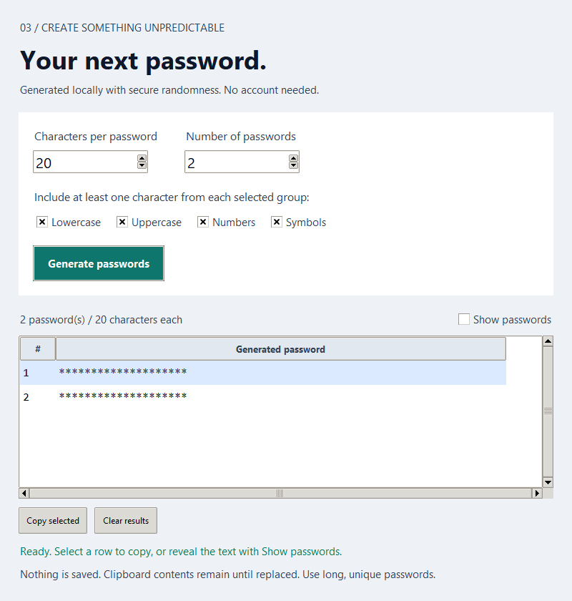
Figure 3. The password window offers length, count, character groups, masking, and copy controls.

C. Learning objectives
- Distinguish a character group from the full sampling alphabet.
- Explain why `secrets` is used for credentials while a seeded game generator is not.
- Trace rejection sampling and its validation conditions.
- Identify security claims that a simple length or category rule cannot support.
- Design tests for properties of random output rather than one fixed password.
Prerequisites: Chapters 1–2: values, conditions, functions, collections, and testing.

D. Concepts before code

Strings and character groups
A string is a sequence of characters. The generator's default groups are lower-case letters, upper-case letters, digits, and a defined symbol set. A selected group contributes allowed characters to one combined alphabet. The program checks that each selected group is nonempty and that the requested length can accommodate every group. A user may omit symbols, but the remaining groups must still be represented.

Randomness for secrets
The secrets module is intended for values that should resist prediction. A repeatable seed, useful for game tests, would let an observer reproduce a generated password if they knew the seed and process. secrets.choice draws from a source backed by the operating system. Good generation is only one part of account security: unique passwords, a trusted password manager, and multifactor authentication matter too.

Rejection sampling
The implementation draws each character from the combined alphabet. It accepts the candidate only if it contains at least one character from every selected group; otherwise it draws another. This method enforces a composition rule without simply placing fixed group characters at the front. It may retry more often when the length is short and many groups are required. The project limits length to 4–128 and count to 1–20; the four-character minimum is an input constraint, not real-world security guidance.

What a strength checker could and could not say
A checker might estimate search space for genuinely random passwords using length and alphabet size. That estimate assumes the password was sampled as claimed; it cannot verify uniqueness, secrecy, or whether the same password has appeared in a breach. A long password based on a famous phrase may be easier to guess than a shorter random one. The current project offers no score or meter, so any exercise that adds one must label its assumptions and limitations.
Listing 11. Sampling characters without asserting a particular result; standalone teaching example
import secrets
alphabet = "abc123"
sample = "".join(secrets.choice(alphabet) for _ in range(8))
print(len(sample))

E. Understanding the project logic
The terminal parser checks the length, count, and symbol option. The core generator validates groups and length, forms a unique-character alphabet, repeatedly samples a candidate, and returns a candidate containing every selected group. The desktop collects settings, clears stale results when settings change, and presents masked entries. Copy selected sends the chosen value to the system clipboard; clearing the window does not erase clipboard contents.
Stage | What happens | Why it matters
1 | Read settings | Length, count, and selected groups
2 | Validate | Reject impossible or out-of-range requests
3 | Build alphabet | Combine selected characters without duplicates
4 | Sample and check | Retry until every selected group appears
5 | Present | Print or mask a local batch; optionally copy one

A worked trace
Suppose the selected groups are letters ab and digits 12, with length four. A draw of aabb has no digit and must be rejected. A draw of a1ba contains at least one character from both groups and can be accepted. The final result is random, so a unit test should assert the length, allowed characters, and group coverage—not that the password equals a1ba.

F. Obtain and run the project
[COMPANION REPOSITORY INFORMATION TO BE ADDED] Obtain the companion files from the publication or course channel and open a terminal at the repository root. The following path and filenames match the audited project files. A terminal command acts on the project; a desktop option requires Tk and a graphical display.
Project folder: projects/03-password-generator
Entry point: main.py for terminal; gui.py for desktop
Runtime packages: Python standard library only for this entry point. Check Tk separately for a desktop window.
Listing 12. Launch from the repository root
python projects/03-password-generator/main.py --length 20 --count 3
python projects/03-password-generator/gui.py
The terminal version works on supported platforms without Tk; it prints passwords into the shell history view. On Windows, pythonw projects/03-password-generator/gui.py opens the desktop UI without a console. On macOS/Linux use python3 if needed. The desktop needs a graphical display and working Tk.

G. Understanding the output
A terminal invocation prints a batch of generated strings. The desktop shows masked rows until Show passwords is enabled; Copy selected uses the underlying value even while the row remains masked. Changing settings clears the previous batch, avoiding a misleading stale preview. No password is stored in a project file or sent to a network service by this program. The clipboard is outside the application's saved state and may retain copied text after Clear results.

H. Under the hood

Probability and constraints
If an alphabet contains A symbols and a password contains L independently sampled positions, the unconstrained candidate space is A^L. The project's group-coverage rule removes candidates that omit a selected group. A rough strength estimate based only on A^L would ignore that conditioning and other real-world attack factors. This is one reason the application does not promise a security score.

Property-based reasoning
Randomness makes exact expected output unsuitable for normal unit tests. Instead assert properties: requested length, membership in the allowed alphabet, group coverage, and valid count. Test validation separately with empty groups, too-short lengths, and invalid batch counts. This pattern appears whenever many different outputs are all correct.

I. Debugging and testing
The existing tests check generator properties and validation. Run them without attempting to predict a specific random string. For a manual check, choose no symbols and inspect whether the results contain only selected groups. Treat any sample printed in this book or repository as public. Never use a real password for experimentation.
Symptom or boundary | Check | Reason
A package seems missing | Check which Python runs the script | This core project needs only the standard library
The same result appears in a screenshot | Treat captures as public demonstrations | Random samples are not credentials
A generated row lacks a group | Inspect selected groups and acceptance check | Every enabled group must appear
Clearing results leaves clipboard text | Clear the system clipboard separately | The application clears its view, not the OS clipboard

Run the chapter suite from the repository root, when available:
Listing 13. Run this project's unit tests
cd projects/03-password-generator
python -m unittest discover -s tests -v

J. Make it yours
Work on a separate practice copy. Each challenge below is an extension or investigation, not a claim about a feature already in the project. Predict the new behavior, write down a test case, then change the smallest possible part of the program.

Beginner
Add a digits-only practice option while continuing to use secrets. Explain why it is a learning exercise rather than a recommendation for accounts.

Intermediate
Let users exclude visually ambiguous characters such as 0 and O. Reject any setting that leaves an empty alphabet, and test that boundary.

Advanced
Compare rejection sampling with choosing one character per group and shuffling. Discuss how each procedure changes the distribution of accepted strings; label any proposed strength estimate as limited.

K. Knowledge check
1. Why is a fixed seed useful in Chapter 1 but unsuitable here?
2. What property should a test assert when the output is random?
3. Does a long password always resist account compromise? Explain.
4. Why can a candidate be rejected even if every character is in the alphabet?
5. A strength meter is shown in a design mock-up: what evidence would you require before claiming the current program has one?

L. Chapter summary
You learned to validate a configuration, sample from a secure source, and test constraints without expecting a fixed result. You also learned to describe security limitations honestly. The next part moves from strings and terminal state to coordinates, animation, images, and visual output.

Part II Creative Python
Coordinates and state become pictures and animation.

Chapter 4 Heartglow: Animated Heart Art
  - Draw with coordinates, text, and time.

A. Project introduction
Heartglow makes a heart from phrases in multiple languages. The letters are not just decoration; each phrase is placed within a calculated shape and then animated into view. The source uses Turtle and Tkinter along with mathematics and randomness from the standard library. You can understand the high-level drawing pipeline without mastering every coordinate formula at once.
The book calls this Chapter 4, while its actual project folder has the prefix 05. The book follows the supplied teaching outline; the path below is the path that exists. This chapter begins with a simple coordinate grid and then explains how the application extends it into a heart boundary, font choice, and repeated animation steps.

B. Project preview
The saved frame shows a dark canvas with red phrases arranged in a heart. It is a representative still from an animation: the phrases move into place and later shimmer. A still can show the shape and typography but not the timing, so run the application on a computer with a display to observe the motion. Font coverage affects how some scripts appear.
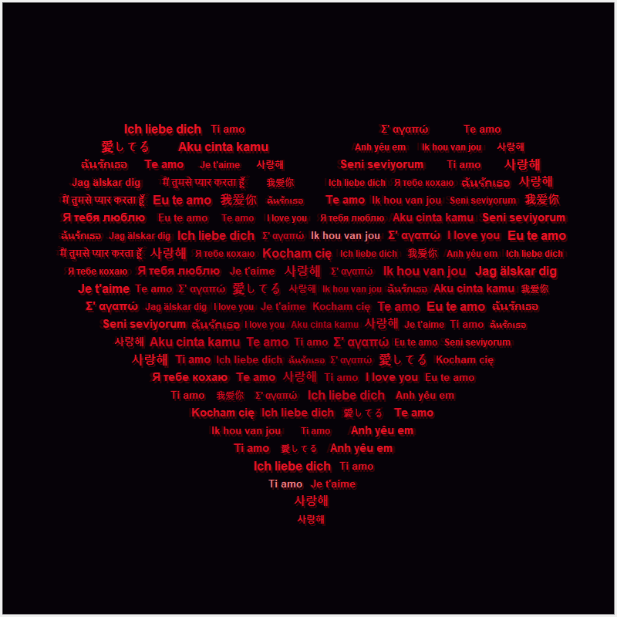
Figure 4. A recorded Heartglow frame: multilingual phrases form a heart silhouette.

C. Learning objectives
- Locate points using an x–y coordinate system.
- Explain how a parametric curve can define a boundary.
- Describe the difference between drawing a frame and scheduling another frame.
- Trace how repeated phrases fill a shape without claiming that the text is the shape formula.
- Recognize how font availability changes multilingual output.
Prerequisites: Chapter 3: strings, functions, loops; Chapter 0: Tk and a graphical display.

D. Concepts before code

A coordinate plane for pictures
A screen has a horizontal x direction and a vertical y direction. The origin and sign convention depend on the drawing library; do not assume that a larger y value always means 'up'. A point such as (20, 10) is a pair of numbers, not a character position in a line of text. To draw phrases in a shape, the program must decide where each row begins and ends.

A curve from a parameter
A parametric curve uses an input parameter, often an angle or normalized progress value, to calculate both x and y. Changing the parameter produces another point. The project uses a heart boundary and finds horizontal spans within it. A simplified circle, x = r cos(t) and y = r sin(t), is a useful warm-up: it shows how two outputs can come from one varying input. A heart curve is more elaborate but follows the same idea.

Text has geometry too
A phrase occupies width and height, and the visible width depends on the font and characters. Placing text inside a boundary therefore requires more than choosing its starting coordinate. The renderer cycles through phrases and adjusts size and position so the text stays within the silhouette. Different systems can choose different fallback fonts; a glyph missing from one font may show as an empty box.

Animation is repeated state
An animation is a sequence of related frames. The application changes positions over time, asks the GUI event loop to draw again, and later applies subtle shimmer. Easing changes how fast an object appears to move during a transition. A cubic ease-out starts with larger motion and slows toward the destination; this often looks less mechanical than a constant-speed step.
Listing 14. Coordinates can be represented as pairs; standalone teaching example
points = [(0, 0), (1, 2), (2, 1)]
for x, y in points:
print("draw at", x, y)

E. Understanding the project logic
The project builds a set of positions inside the heart boundary, chooses multilingual phrases, determines text size and color, and creates visible drawing elements. Timed callbacks advance their positions toward targets. Once the main arrival phase finishes, a shimmer phase keeps the composition subtly alive. The frame in Figure 4 is a saved observation of this process, not a separate static application.
Stage | What happens | Why it matters
1 | Calculate boundary | Determine which coordinates belong to the heart
2 | Choose phrases | Cycle through multilingual text
3 | Place and style | Fit each phrase to a horizontal span
4 | Animate | Update positions over timed callbacks
5 | Shimmer | Vary selected visual properties after arrival

A worked trace
Imagine one horizontal row at y = 0 whose heart interior stretches from x = −40 to x = 40. A phrase 30 units wide can begin at −40 and end at −10; another can begin near −5. A 90-unit phrase cannot fit unchanged on this row. The actual application measures text and uses many rows, but this simple example explains why geometry and typography meet at the placement step.

F. Obtain and run the project
[COMPANION REPOSITORY INFORMATION TO BE ADDED] Obtain the companion files from the publication or course channel and open a terminal at the repository root. The following path and filenames match the audited project files. A terminal command acts on the project; a desktop option requires Tk and a graphical display.
Project folder: projects/visual-art-lab/05-heartglow
Entry point: love.py
Runtime packages: Python standard library only for this entry point. Check Tk separately for a desktop window.
Listing 15. Launch from the repository root
python projects/visual-art-lab/05-heartglow/love.py
The command uses a graphical window and Tk support. Check python -m tkinter if no window appears. On macOS/Linux, use python3 where required. The source is an imported visual experiment; the project README documents behavior but does not provide a local unit suite. The repository's separate visual runtime checks exercised the animation on Windows.

G. Understanding the output
The canvas begins with phrases moving into a heart. Different words, scripts, and red tones create texture even when individual phrases are too small to read from a distance. The figure captures a completed-looking state; the program's visual effect depends on motion and font rendering as well. If a language appears as blank boxes, the program may still be running correctly while the chosen system font lacks those glyphs.

H. Under the hood

From curve to filled area
A boundary alone is an outline. To fill a heart, consider each horizontal y value, find where a line intersects the boundary, and place text inside the resulting intervals. Some y values may have more than one interval. This scanline idea is also used in raster graphics: determine which x values are inside a shape, then color or place something there.

The GUI event loop
A desktop animation must let the window respond to repainting and input. A callback that schedules the next short update gives the event loop a chance to work. A long blocking loop can freeze the window even if it eventually draws the right final image. The project uses timed steps, which is why frame state and scheduling are distinct concepts.

I. Debugging and testing
There is no Heartglow unit test directory in this repository. The saved runtime checks exercised its window and animation and recorded a still frame. For your own investigation, verify that a window opens, the phrases move, the silhouette remains visible, and the process closes normally. Compare behavior with and without a font that supports the included languages.
Symptom or boundary | Check | Reason
No window | Check Tk and a graphical display | This project is interactive desktop art
Empty boxes in text | Inspect installed font coverage | Unicode text still needs glyphs
Window freezes | Look for long work on the UI event loop | Rendering should yield between frames
Unexpected shape | Check coordinate scale and boundary spans | Text needs room inside the curve

Run the chapter suite from the repository root, when available:
This project has no unit suite. The repository records a GUI animation check in its visual-art verification report; rerun that checker only on a disposable copy when you need a fresh capture.

J. Make it yours
Work on a separate practice copy. Each challenge below is an extension or investigation, not a claim about a feature already in the project. Predict the new behavior, write down a test case, then change the smallest possible part of the program.

Beginner
Change one color in a practice copy and predict which part of the heart will change. Keep the text positions fixed.

Intermediate
Add a small legend explaining three coordinate positions used by the renderer. Draw a simplified grid before touching the animation.

Advanced
Compare constant-speed motion with ease-out motion for one phrase. Measure positions at equal time steps and explain the different visual rhythm.

K. Knowledge check
1. What does a pair `(x, y)` represent on a drawing canvas?
2. Why can a phrase that fits one row fail to fit another?
3. What information does the still frame omit?
4. How might a missing glyph differ from a broken string?
5. If animation freezes but the final drawing appears, which part of the program would you investigate?

L. Chapter summary
Heartglow combines text, curves, and timed state changes. You now have a vocabulary for discussing an advanced visual program without needing to memorize every formula. Chapter 5 applies similar coordinate thinking to a plant whose shape changes over a longer life cycle.

Chapter 5 Bloomcraft: Generative Flower Art
  - Build a changing scene from small drawing decisions.

A. Project introduction
Bloomcraft constructs a flower from many small marks rather than a single flat shape. Its animation moves through growth, flowering, and decline. Different point locations, curves, colors, and timing rules work together to make the result feel organic. The application also has PNG and GIF export options.
The book outline places Bloomcraft in Chapter 5, but its actual folder prefix is 04. Follow the path printed here. An older README inside the imported project refers to flower.py; the verified entry point in this repository is flow.py. This distinction matters because a correct-looking command with the wrong filename cannot run.

B. Project preview
The figure is a saved real render of a wilted-looking flower with a textured soil base. Other animation frames show different stages. The still is useful for studying the petal and stem geometry; running the desktop version reveals how state changes between frames. The imported project is more advanced than the beginner games, so begin with a tiny model of one plant before interpreting its full pointillist renderer.
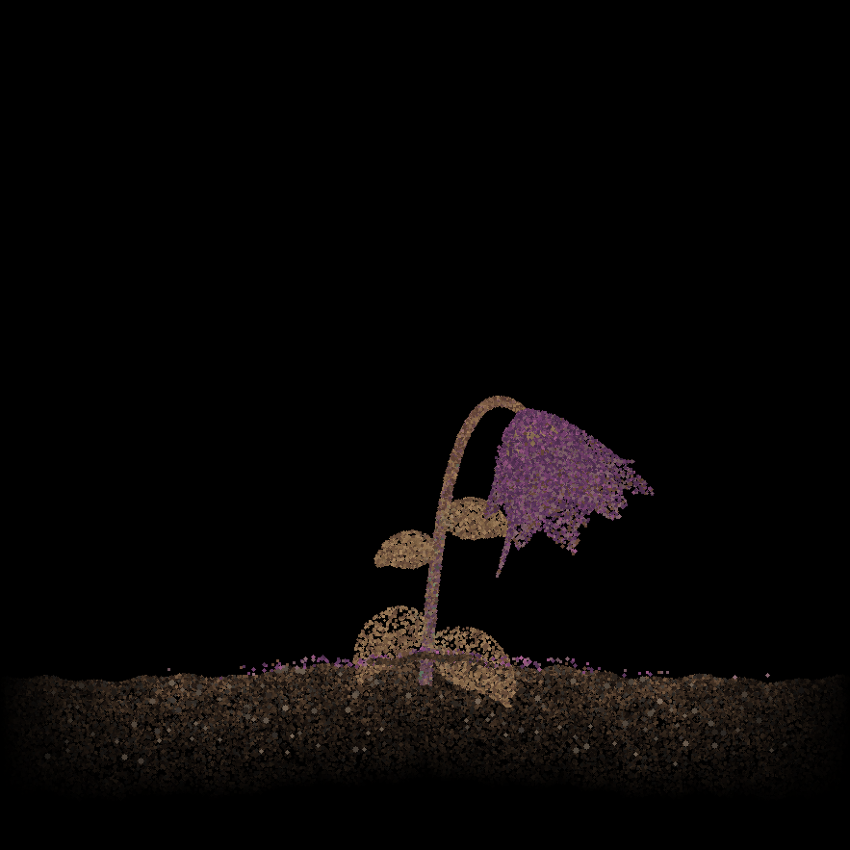
Figure 5. A saved Bloomcraft frame shows a flower made from many small marks.

C. Learning objectives
- Describe procedural generation as rules producing an image.
- Explain how a curve can interpolate between control points.
- Distinguish a time parameter from a frame number.
- Identify where randomness adds variation and where repeatability helps testing.
- Compare a still image with an animated sequence.
Prerequisites: Chapter 4: coordinates, curves, GUI animation; Chapter 0: package installation.

D. Concepts before code

Procedural generation
A procedural image is produced by a set of instructions rather than by saving every mark by hand. A simple rule might draw 100 points around a center, each with a slightly different distance. The generator's parameters control the family of possible images. Bloomcraft uses large numbers of colored marks for soil, stems, leaves, petals, aura, and decay. The image is rich because many small decisions combine coherently, not because each point is individually special.

Interpolation and life stages
Interpolation estimates a value between two known states. If a stem height changes from 0 to 100 over a growth phase, a time fraction of 0.4 suggests an intermediate height near 40 under linear interpolation. An easing function can alter the pacing without changing the endpoints. Bloomcraft divides its timeline into phases and smoothly transitions sizes, colors, positions, and visibility. A life-cycle model is thus a function of time, not a collection of unrelated pictures.

Curves and control points
A Bézier curve uses control points to guide a smooth path. The points need not all lie on the visible curve; some act like handles that bend it. The stem and petals in Bloomcraft use curved geometry. Before examining a cubic formula, draw a start and end point, then move a control point and predict how the curve bends. The mathematical formula is useful because it produces many intermediate positions from a few meaningful parameters.

Randomness with structure
Unrestricted random dots look noisy. Natural-looking variation uses constraints: points near a petal shape, colors near a palette, and movement limited by the plant's state. A pseudorandom generator can reproduce a composition when seeded, making comparisons and debugging easier. The program can then vary fine detail while the overall flower remains recognizable.
Listing 16. Linear interpolation as a simplified growth model; standalone teaching example
start_height = 0
end_height = 100
progress = 0.4
height = start_height + (end_height - start_height) * progress
print(height)

E. Understanding the project logic
A model computes the plant's current state from time. Geometry functions find stem, leaf, and petal positions. Drawing routines turn those positions into many marks and color effects. The GUI asks for a new frame as time advances. Batch exporters render selected stages as PNGs or many frames as a GIF. These outputs share the same model but differ in when and how frames are saved.
Stage | What happens | Why it matters
1 | Choose parameters | Canvas, palette, plant geometry, and timing
2 | Compute state | Decide growth, bloom, or decay from time
3 | Compute geometry | Interpolate curves and petal positions
4 | Render marks | Place constrained colored splats
5 | Display or export | Show animation or save stills/GIF

A worked trace
Consider three moments: t = 0 before the stem grows, t = 0.5 near full bloom, and t = 1 near decline. At each moment the program asks for a new state, then draws it. A still from t = 0.5 cannot by itself prove that the animation includes growth or decay. That requires observing additional frames or reviewing the state function and recorded export checks.

F. Obtain and run the project
[COMPANION REPOSITORY INFORMATION TO BE ADDED] Obtain the companion files from the publication or course channel and open a terminal at the repository root. The following path and filenames match the audited project files. A terminal command acts on the project; a desktop option requires Tk and a graphical display.
Project folder: projects/visual-art-lab/04-bloomcraft
Entry point: flow.py (not flower.py)
Listing 17. Install the project's required packages from the repository root
python -m pip install pillow numpy
Listing 18. Launch from the repository root
python projects/visual-art-lab/04-bloomcraft/flow.py
Run the desktop command on a machine with Tk and a display. The Visual Art Lab README also documents --png and --gif export flags; those write to the current working directory, so use a disposable copy or a chosen output location for experiments. On macOS/Linux, use python3 where required. Package versions are not pinned in this imported project.

G. Understanding the output
The window displays a developing flower on a dark field. Individual marks form broad structures when viewed together. A PNG export records one stage or set of stages; a GIF records motion as a sequence of frames. The observed production checks rendered six PNG stage images and an animated GIF, but those local checks are evidence of this repository snapshot, not a promise that every computer will render identical fonts, timings, or colors.

H. Under the hood

A model and a renderer
The plant model answers 'what is the state at time t?' The renderer answers 'how do we draw that state?' Keeping these questions separate allows the same model to support a desktop preview and batch exports. It also lets you test timing logic without needing to inspect every pixel.

Why many small marks work
Pointillist rendering relies on accumulation. One dot has little meaning, but thousands placed near geometric features establish a visual density. Change the spatial distribution and a petal can appear flat, mottled, or luminous. This is a useful lesson in simulation: local rules can create a global pattern.

I. Debugging and testing
Bloomcraft has no local unit suite in the current repository. Visual runtime checks exercised its PNG export, GIF export, and GUI. A useful manual test compares early, middle, and late frames to the stated life stages. If changing a timing value, inspect both the GUI and export so the two outputs still describe the same model.
Symptom or boundary | Check | Reason
Old command cannot find a file | Use `flow.py` | The imported README names an outdated filename
Import error | Install Pillow and NumPy in the active interpreter | Both are used by the visual program
No animation window | Check Tk and display availability | The GUI requires desktop graphics
Export appears in an unexpected folder | Check the working directory | Batch files use the current directory

Run the chapter suite from the repository root, when available:
This project has no unit suite. Its PNG, GIF, and GUI behavior is documented in the existing visual-art runtime checks; conduct new runs on an isolated practice copy.

J. Make it yours
Work on a separate practice copy. Each challenge below is an extension or investigation, not a claim about a feature already in the project. Predict the new behavior, write down a test case, then change the smallest possible part of the program.

Beginner
Identify one palette value and change it in a practice copy. Explain which stage or plant component you expect to change.

Intermediate
Plot three values of a chosen interpolation function at t = 0, 0.5, and 1; compare them with a straight-line interpolation.

Advanced
Design a deterministic image comparison that tolerates tiny raster differences while still detecting a missing stem or petal layer. Explain what your test would measure.

K. Knowledge check
1. What is the difference between a plant state and a rendered image?
2. Why does a random dot need geometric constraints to help form a flower?
3. What do the control points of a Bézier curve influence?
4. How is a GIF different from a single PNG?
5. A command says the script is missing: which filename should be checked first in this repository?

L. Chapter summary
Bloomcraft shows how time, geometry, and constrained randomness produce changing visual output. You can now separate model parameters from rendering details. Chapter 6 uses a different visual strategy: it reads an existing photograph and rebuilds its appearance with repeated text.

Chapter 6 Spiral Ink: Image-to-Text Art
  - Sample an image, then redraw it with letters.

A. Project introduction
Spiral Ink turns a source photograph into a field of letters arranged along a spiral. The current repository includes three supplied JPEGs: Pink lilies.jpg, Rockstar.jpg, and 900508888014745363.jpg for the water-lily preset. The shared renderer preserves the image's full composition and can animate its construction or export a PNG.
The trick is to separate a source image from a drawing surface. The program samples colors from the source, places glyphs along computed positions, and uses those glyphs to recreate recognizable light and shape. This chapter starts with pixel brightness and coordinate conversion, then adds the concept of a continuously winding path.

B. Project preview
The figure shows the pink lilies preset. At a distance the flowers appear photographic; close up, their form is made from repeated text. The still captures one point in the animation. The program also supports Rockstar and water-lily presets. These are the current names; older images mentioned in historical records are not current inputs.

Figure 6. A saved Spiral Ink frame renders the pink lilies as repeated letters.

C. Learning objectives
- Explain a pixel as a color sample at a coordinate.
- Use brightness and contrast to reason about readable text art.
- Describe how a spiral converts progress into x–y positions.
- Distinguish image input, animation state, and PNG output.
- Identify the asset path and source-protection checks for each preset.
Prerequisites: Chapters 4–5: coordinates, curves, animation, images; Chapter 0: Pillow installation.

D. Concepts before code

Pixels and brightness
A raster image is a grid of pixels. Each pixel carries color components; a bright pink petal and dark background differ in both color and luminance. If the program places the same bright glyph everywhere, the photograph's structure disappears. Spiral Ink samples from the image and adjusts rendering so text preserves much of its tonal pattern. Its water-lily and Rockstar presets lift dark details, while the pink lilies keep their gentler highlights.

From polar to screen coordinates
A spiral can be described with radius and angle. As the angle grows, the radius also grows, creating a winding path. A simplified conversion is x = center_x + r cos(angle) and y = center_y + r sin(angle). Screen coordinates need scaling and may invert the vertical direction. A text glyph is then rotated or positioned along a local direction so the sequence reads as part of the curve.

Image transformations
Opening a JPEG creates an image object in memory; it does not edit the original file. EXIF orientation may require rotating the pixels to match how a viewer displays them. Resizing should preserve the source aspect ratio rather than silently cropping people or flowers. Pillow provides image loading and drawing tools, while the program's own code controls how glyphs and samples are combined.

Exports and safe paths
An output path is a destination, not a source. The renderer refuses to save over the input photo. When no output name is supplied, exports are placed under the project's outputs directory with a name based on the photo. An explicit --output path is interpreted from the current working directory. This distinction is easy to miss when a command is run from a different folder.
Listing 19. A simple polar-to-Cartesian position; standalone teaching example
import math
angle = math.pi / 2
radius = 10
x = radius * math.cos(angle)
y = radius * math.sin(angle)
print(round(x), round(y))

E. Understanding the project logic
Choose a preset or custom photo, resolve its path, and load the image without changing it. Determine the target canvas and preserve the photo's aspect ratio. Build letter shapes, sample image colors, place many glyphs along a spiral, and display animated progress or save a composed PNG. Preset launchers pic1.py and pic2.py call the shared renderer with Rockstar and pink lilies respectively.
Stage | What happens | Why it matters
1 | Choose photo | Use current preset or a custom path
2 | Load and orient | Read pixels and honor EXIF orientation
3 | Plan spiral | Compute radius, angle, and glyph positions
4 | Sample and render | Use source colors and letters to rebuild the scene
5 | Display or export | Animate a window or write a new PNG

A worked trace
Imagine three source samples along one spiral turn: a dark background pixel, a pale petal pixel, and a midtone leaf pixel. If their glyphs are all drawn in the same color, the text remains visible but the photograph is harder to recognize. If each uses an appropriate sampled tone and the dark areas are handled carefully, the composition emerges. This is a conceptual trace; the real renderer draws many more samples and includes resampling and contrast adjustments.

F. Obtain and run the project
[COMPANION REPOSITORY INFORMATION TO BE ADDED] Obtain the companion files from the publication or course channel and open a terminal at the repository root. The following path and filenames match the audited project files. A terminal command acts on the project; a desktop option requires Tk and a graphical display.
Project folder: projects/visual-art-lab/06-spiral-ink
Entry point: spiral_art.py; pic1.py and pic2.py are preset launchers
Listing 20. Install the project's required packages from the repository root
python -m pip install pillow
Listing 21. Launch from the repository root
python projects/visual-art-lab/06-spiral-ink/pic2.py
python projects/visual-art-lab/06-spiral-ink/spiral_art.py --preset water-lily
The first command opens the pink lilies animation; pic1.py opens Rockstar. Add --png to an entry point for a file export without a window; run such exports in a disposable copy because the default output directory is inside the project. The desktop version needs Tk. On macOS/Linux use python3 if that is the installed command.

G. Understanding the output
The desktop frame reveals the source's overall shapes through tiny letters. In the pink lilies preset the phrase repeats LILIES; the water-lily and Rockstar presets use their own text. A PNG export is a new image file; the original JPEG remains unchanged. Press S in the window to save a full-size PNG, R to restart, and Esc to close. Export width is configurable, and custom text can replace a preset phrase.

H. Under the hood

Sampling and aliasing
A high-resolution image has more pixels than a page of text can show. The renderer must sample and combine information. Too few glyphs lose detail; too many can blend into visual noise at print size. Image resampling and a sensible output width help balance detail with readability. This is why visual quality depends on both computation and the final viewing scale.

Source integrity
Tests cover dimension preservation, dark-detail handling, EXIF orientation, paths with spaces, output naming, and refusal to overwrite the source. These are not merely aesthetic tests. A visually pleasing export is not acceptable if it destroys the photograph used to create it.

I. Debugging and testing
The repository has seven Spiral Ink unit tests and saved runtime checks for all three photo presets, animations, and invalid inputs. A manual check should compare source and output dimensions, confirm the original JPEG is still present, and inspect whether highlights and dark areas remain identifiable. Use a different output filename for every experiment.
Symptom or boundary | Check | Reason
Input image cannot be found | Check the exact current JPEG name | Presets resolve against the repository root
Output too dark | Inspect preset contrast and display size | Tonal mapping affects readability
Save would overwrite a photo | Choose a new output path | Source protection is intentional
Font differs from capture | Check available TrueType fonts | The renderer searches several fallbacks

Run the chapter suite from the repository root, when available:
Listing 22. Run this project's unit tests
cd projects/visual-art-lab/06-spiral-ink
python -m unittest discover -s tests -v

J. Make it yours
Work on a separate practice copy. Each challenge below is an extension or investigation, not a claim about a feature already in the project. Predict the new behavior, write down a test case, then change the smallest possible part of the program.

Beginner
Export one preset at two widths in a disposable copy and compare the detail at the same physical display size.

Intermediate
Choose a short custom phrase for a personal image you are permitted to use. Explain how phrase length affects visual texture.

Advanced
Design a quantitative comparison between the source brightness map and the exported art. State where a single numeric score might miss an obvious visual defect.

K. Knowledge check
1. Why must the original photo remain separate from the PNG export?
2. What do radius and angle contribute to a spiral position?
3. Which three source JPEGs are current in this repository?
4. What might change if a font fallback is used?
5. How would you test that an output path does not overwrite the input?

L. Chapter summary
Spiral Ink links image pixels with geometry and text drawing. It also shows that paths and preservation checks matter in a creative tool. Chapter 7 applies that safety mindset to real file operations, where a mistake could lose user data rather than merely spoil an image.

Part III Useful Python Tools
Preview, validate, and export with care.

Chapter 7 Smart File Organizer
  - Automate a folder without giving up control.

A. Project introduction
A cluttered folder can contain images, documents, music, archives, and code. This project classifies regular files by extension and plans destinations in category subfolders. Its default behavior is a preview; a separate action applies the plan. It records a manifest so unchanged moves can be undone.
This is the first application in the book that can change files on disk. Treat safety as part of the algorithm, not an optional extra. You will learn how paths are resolved, why duplicate names need a policy, how a journal supports recovery, and why an undo must inspect the current state before it acts.

B. Project preview
The captured window shows a chosen folder and a proposed organization. The button to apply moves is enabled after a preview. A separate undo preview is available after a run. The image shows the application's state before a move; it is evidence of a workflow, not evidence that the tool can safely organize every possible folder without care.
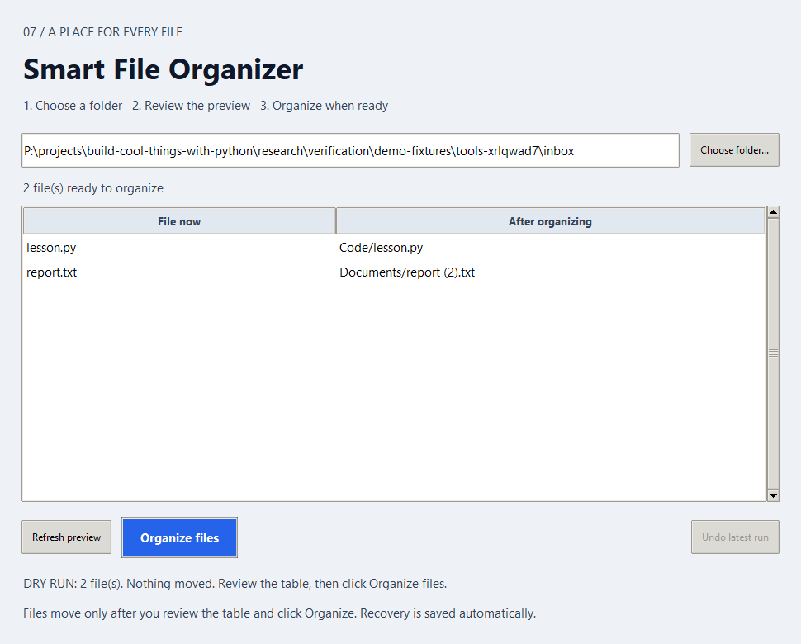
Figure 7. The organizer previews planned moves before the user applies them.

C. Learning objectives
- Use `pathlib.Path` to reason about a file's name, suffix, and parent.
- Explain dry-run preview and its relationship to the eventual applied plan.
- Describe collision handling and no-overwrite transfers.
- Trace manifest states through move and undo.
- Design checks that protect edited or newly created files.
Prerequisites: Chapters 1–3: validation, loops, functions, and testing; Chapter 0: paths.

D. Concepts before code

Paths as objects
A Path represents a location. path.suffix.lower() gives a normalized extension that can be compared with a category table. A path also has a parent and a filename. The organizer considers only regular, non-hidden files directly inside the chosen folder; it leaves subfolders and symlinks alone. This shallow rule makes the outcome easier to predict and avoids following a link outside the folder.

A dry run is a promise to review
A preview computes the proposed destination for each eligible file but does not move it. The user can inspect the result before applying. A safe tool must then recheck the folder because another program might have changed files after the preview. This is a general pattern in automation: plan, show, revalidate, apply, and record. Treat a preview as information about a moment, not as permanent authority to act later.

Name collisions and exclusive creation
If note.txt already exists in the Documents destination, the plan chooses a suffix such as note (2).txt. A check before copying is useful, but another process could create the destination immediately afterward. Opening the destination exclusively makes a late collision fail rather than overwrite an existing file. This is a concrete example of why validation and action must be close together.

Journal and undo
A manifest records the root folder, source and destination paths, file hashes, and progress states. The organizer writes a pending state before a move and updates it afterward. Undo previews which moves are still reversible, verifies the moved content, and refuses to overwrite a newly created original name. A journal cannot guarantee safety if unrelated programs edit the same folder concurrently; it does make recovery possible to reason about.
Listing 23. A small path categorization rule; standalone teaching example
from pathlib import Path
source = Path("notes.txt")
category = "Documents" if source.suffix.lower() == ".txt" else "Other"
target = Path(category) / source.name
print(target)

E. Understanding the project logic
The program scans one directory, skips ineligible entries, categorizes each file, assigns a collision-free destination, and hashes the source. In preview mode it reports the plan. On Apply it re-creates and compares the plan, writes a manifest, copies to a new destination, verifies both copies, and removes the original directory entry only after verification. Undo validates the manifest and current files before restoring anything.
Stage | What happens | Why it matters
1 | Scan | Consider only eligible top-level regular files
2 | Plan | Choose category and collision-free name
3 | Preview | Show proposed moves without changing inputs
4 | Apply | Journal, copy exclusively, verify hashes, complete move
5 | Undo | Preview restoration and refuse conflicting changes

A worked trace
Suppose the practice folder contains photo.JPG, note.txt, and a subfolder. The preview places the first file under Images and the second under Documents; the subfolder stays where it is. If Documents already contains note.txt, the planned destination receives a suffix. After applying, edit the moved note. An undo preview must refuse to restore it as if it were unchanged; otherwise it could silently lose your edit.

F. Obtain and run the project
[COMPANION REPOSITORY INFORMATION TO BE ADDED] Obtain the companion files from the publication or course channel and open a terminal at the repository root. The following path and filenames match the audited project files. A terminal command acts on the project; a desktop option requires Tk and a graphical display.
Project folder: projects/07-smart-file-organizer
Entry point: main.py for terminal; gui.py for desktop
Runtime packages: Python standard library only for this entry point. Check Tk separately for a desktop window.
Listing 24. Launch from the repository root
python projects/07-smart-file-organizer/main.py --gui
python projects/07-smart-file-organizer/main.py path/to/practice-folder
The second command is a dry-run preview from the repository root; use a real disposable folder path in place of the teaching placeholder. To apply from the terminal, add --apply only after reviewing a preview. The desktop can also be opened with python projects/07-smart-file-organizer/gui.py. Tk is required for the window; the CLI works without it. On Windows, desktop.pyw opens the simplified UI when file associations are configured.

G. Understanding the output
A preview lists each source and proposed destination. Applying writes the actual organized files and a manifest in .organizer/manifests/ inside the chosen folder. The desktop Undo latest run button finds the latest manifest and shows a restoration preview. The tool does not automatically clean up directories or delete a user's only copy. A failed copy may leave both the original and a partial destination for manual inspection.

H. Under the hood

Hashing and integrity
A SHA-256 digest summarizes file bytes. The tool records the source digest, copies bytes, then compares digests again before completing the move. A matching digest is strong evidence that the copied content matches, but the workflow still needs path and collision checks. A hash alone cannot tell whether a person edited a file intentionally after the move; the undo step uses it to decline a potentially destructive restoration.

A failure is a state, not just an exception
A transfer may fail midway because of permissions, disk space, or another writer. The manifest records progress states so an interrupted run can be inspected. The important safety question is whether at least one intact copy remains and whether the next step knows what happened. This is why the program avoids automatic deletion on error and asks the user to resolve conflicts before retrying.

I. Debugging and testing
The existing suite tests planning, collisions, symlink refusal, recovery behavior, and undo conflicts with temporary synthetic files. Manual practice belongs in a disposable folder, not a folder of irreplaceable documents. Verify a dry run leaves names and bytes unchanged; then apply to a small fixture and undo it. Compare bytes before and after, not merely filenames.
Symptom or boundary | Check | Reason
Preview differs from Apply | Refresh and inspect the folder | The tool rejects stale plans
Destination exists | Choose the next safe filename or retry preview | Existing files are never overwritten
Undo refuses a file | Check whether source or target changed | Refusal protects new or edited content
A lock remains | Confirm no organizer process is running | An interrupted run may leave its lock

Run the chapter suite from the repository root, when available:
Listing 25. Run this project's unit tests
cd projects/07-smart-file-organizer
python -m unittest discover -s tests -v

J. Make it yours
Work on a separate practice copy. Each challenge below is an extension or investigation, not a claim about a feature already in the project. Predict the new behavior, write down a test case, then change the smallest possible part of the program.

Beginner
Add a category for presentation slides in a practice copy and test upper-case extensions.

Intermediate
Show a count and total byte estimate for each category in the preview without changing its default dry-run behavior.

Advanced
Design crash-injection tests for journal transitions. State which copy must remain intact at each failure point.

K. Knowledge check
1. What happens to a subfolder in the selected directory?
2. Why must Apply recheck a preview?
3. What prevents a late-created destination from being overwritten?
4. Why does an edited moved file block undo?
5. A copy fails after creating a partial target: which artifacts should you inspect before trying again?

L. Chapter summary
The organizer teaches a transferable safety pattern: preview, validate, apply, record, and reverse only when current evidence permits. Chapter 8 keeps the validation and output-path discipline but generates a new file from text rather than moving an existing one.

Chapter 8 QR Code Studio
  - Encode text into a verifiable visual file.

A. Project introduction
QR Code Studio accepts text or an HTTP(S) address and encodes it into a QR matrix. A desktop window previews the result; exports can be raster PNG or vector SVG. This chapter treats the QR image as a data representation that must be checked after generation. It deliberately does not include a QR code in these pages.
The project adds third-party packages to the book's toolset. You will learn what a dependency contributes, how input validation prevents confusing output, why the empty border matters, and how two export formats can share one underlying matrix. A visually plausible square is not proof that a scanner will decode the intended message.

B. Project preview
The authentic window capture used for the figure is cropped to the input controls so that no scannable QR symbol appears in this book. In the running application, the other side of the window contains the preview and Save PNG and Save SVG controls. The application clears a stale preview when settings change.
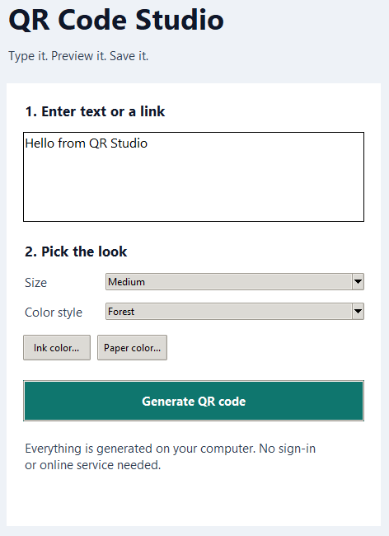
Figure 8. A cropped authentic QR Code Studio capture shows text, size, and color controls; the encoded preview is intentionally omitted.

C. Learning objectives
- Describe the QR matrix as data separate from its drawing format.
- Validate length, size, URL form, and visual contrast.
- Compare raster PNG with vector SVG exports.
- Explain the role of a quiet zone around the encoded pattern.
- Design an independent verification of decoded content.
Prerequisites: Chapters 1–3: strings and validation; Chapter 7: safe output paths; Chapter 0: packages.

D. Concepts before code

From message to matrix
The encoding library turns the message bytes into a grid of dark and light modules. The application limits the payload to 1,200 UTF-8 bytes for practical readability. This is a byte limit, not a character count: a non-ASCII character can use more than one byte. Encoding succeeds only when the chosen QR version can hold the data; the program reports an overflow instead of silently truncating the message.

Validation belongs before export
The app checks that text is nonempty, URLs use supported HTTP(S) forms, the module size is between 2 and 30 pixels, and colors form a sufficiently contrasting dark-on-light pair. The contrast threshold is a guardrail, not a promise that every camera will scan every print. A changed message or palette invalidates the existing preview so the user cannot save an image representing older settings.

Raster and vector
A PNG stores pixels at a chosen size. It is easy to preview but may blur when enlarged beyond its original resolution. An SVG stores drawing instructions, so its square modules can scale cleanly. Both outputs derive from the same QR matrix. The file format changes how the modules are represented, not what message they should decode to.

The quiet zone and verification
The blank border around a QR code helps a scanner identify where the matrix begins and ends. The project includes a four-module quiet zone. Cropping it can break scanning even when the dark squares remain intact. After exporting, use an independent camera or offline reader to decode the file, then compare the entire decoded text character for character with the input. Recheck after printing or resizing.
Listing 26. Character count and byte count are different concepts; standalone teaching example
message = "Hello Python"
encoded = message.encode("utf-8")
print(len(message), "characters")
print(len(encoded), "bytes")

E. Understanding the project logic
The user enters text and chooses size and colors. Validation returns usable RGB colors and checks the payload. The QR dependency constructs a matrix with a quiet zone. The program draws that matrix as pixels for PNG or as shapes for SVG. The save operation opens a new file exclusively, so a previous export is not overwritten. The desktop preview is tied to the current settings.
Stage | What happens | Why it matters
1 | Accept message | Keep exact text including intended spaces
2 | Validate settings | Check payload, size, URL form, and contrast
3 | Encode | Build QR matrix with error correction and quiet zone
4 | Preview | Show image matching the current settings
5 | Export and verify | Save PNG/SVG to a new name, then decode independently

A worked trace
Imagine the user generates a preview for Hello Python, then edits the message to Hello, Python!. If the old preview stayed active, saving could produce a file with the first message while the screen showed the second. The studio clears the preview after edits. The user must generate again and, after export, check decoded text against the new exact string, including punctuation.

F. Obtain and run the project
[COMPANION REPOSITORY INFORMATION TO BE ADDED] Obtain the companion files from the publication or course channel and open a terminal at the repository root. The following path and filenames match the audited project files. A terminal command acts on the project; a desktop option requires Tk and a graphical display.
Project folder: projects/08-qr-code-studio
Entry point: main.py for terminal; gui.py for desktop
Listing 27. Install the project's required packages from the repository root
python -m pip install -r projects/08-qr-code-studio/requirements.txt
Listing 28. Launch from the repository root
python projects/08-qr-code-studio/main.py --gui
python projects/08-qr-code-studio/main.py "Hello Python" --output output/hello-python.png
The desktop window also opens with python projects/08-qr-code-studio/gui.py when Tk is available. On Windows the project has desktop.pyw. On macOS/Linux, use python3 if needed. The CLI example writes to a new filename under the book's output folder; choose another name if it already exists. The application never visits an encoded address.

G. Understanding the output
The preview is a grid of dark modules on a light background. Save PNG produces a pixel image; Save SVG produces scalable vector markup. Existing destination files are protected. A successful save only confirms that a file was written. To confirm usefulness, decode it with an independent reader and compare the full result. For long messages, smaller module sizes, or weak contrast, scanning can still be unreliable.

H. Under the hood

One data model, two views
The matrix is the shared model. The PNG renderer paints filled modules into an image; the SVG renderer writes geometric shapes. This is a common software pattern: compute the meaning once, then provide multiple presentations. If the two formats decode differently, investigate the renderers or their saved files rather than assuming the encoder produced different content.

Why visual similarity is insufficient
A finder pattern can make an image resemble a QR code without preserving the full payload. Error correction can recover some damaged modules, but it is not a substitute for validating the message. Independent decoding exercises the artifact a reader will receive and therefore tests more than a preview window does.

I. Debugging and testing
Unit tests cover input validation, color rules, and both output formats. The repository's earlier application checks independently decoded PNG and browser-rendered SVG exports. For your own verification, use short non-secret text and a reader separate from the generating code. Test a new filename, a duplicate filename, an empty message, and a weak color pair.
Symptom or boundary | Check | Reason
Import error | Install the project's requirements with the running interpreter | qrcode and Pillow are external dependencies
Save refuses destination | Choose a fresh filename | Exports never overwrite existing files
Scanner cannot decode | Increase size, restore quiet zone, use strong contrast | A visual preview is not enough
Preview no longer saves | Generate again after editing | Stale settings are intentionally invalidated

Run the chapter suite from the repository root, when available:
Listing 29. Run this project's unit tests
cd projects/08-qr-code-studio
python -m unittest discover -s tests -v

J. Make it yours
Work on a separate practice copy. Each challenge below is an extension or investigation, not a claim about a feature already in the project. Predict the new behavior, write down a test case, then change the smallest possible part of the program.

Beginner
Add a button that fills in a non-secret plain-text sample message.

Intermediate
Offer three color presets with tested contrast and show their contrast ratio before generation.

Advanced
Build a regression set of short, long, and Unicode messages using an independent decoder. State which physical print sizes you tested.

K. Knowledge check
1. What data do PNG and SVG exports share?
2. Why can byte length differ from character length?
3. What purpose does the quiet zone serve?
4. Why is an independent decoder stronger evidence than a preview?
5. If a user edits text after generation, what must the UI do before allowing Save?

L. Chapter summary
QR Code Studio combines input validation, a third-party encoder, a shared data model, and two output formats. The next project shifts from visual encoding to tabular data, where validation protects the meaning of totals and charts rather than the readability of an image.

Part IV Real-World Applications
Make larger data flows and algorithms visible.

Chapter 9 Expense Tracker Dashboard
  - Turn careful CSV data into interactive evidence.

A. Project introduction
The dashboard reads a CSV of expenses, validates every row, and lets a reader filter by category, date, and description. It then shows totals, category summaries, monthly trends, and a downloadable filtered CSV. The included data is synthetic and contains no personal information.
This chapter combines the book's earlier habits: validate at the boundary, keep a clear internal representation, and ensure the output matches current settings. A polished chart can still be wrong if the input has malformed amounts or a filter means something different than the user expects. The application therefore treats data correctness as the first visual-design requirement.

B. Project preview
The real browser capture shows a sample total of 315.95 across 12 synthetic transactions and four categories. Its sidebar contains upload and filter controls; the main view contains metric cards, charts, and a selected-transactions table. A Deploy label supplied by Streamlit's browser UI is not a deployment feature of this project. The separate desktop launcher starts a local server and opens the browser automatically.
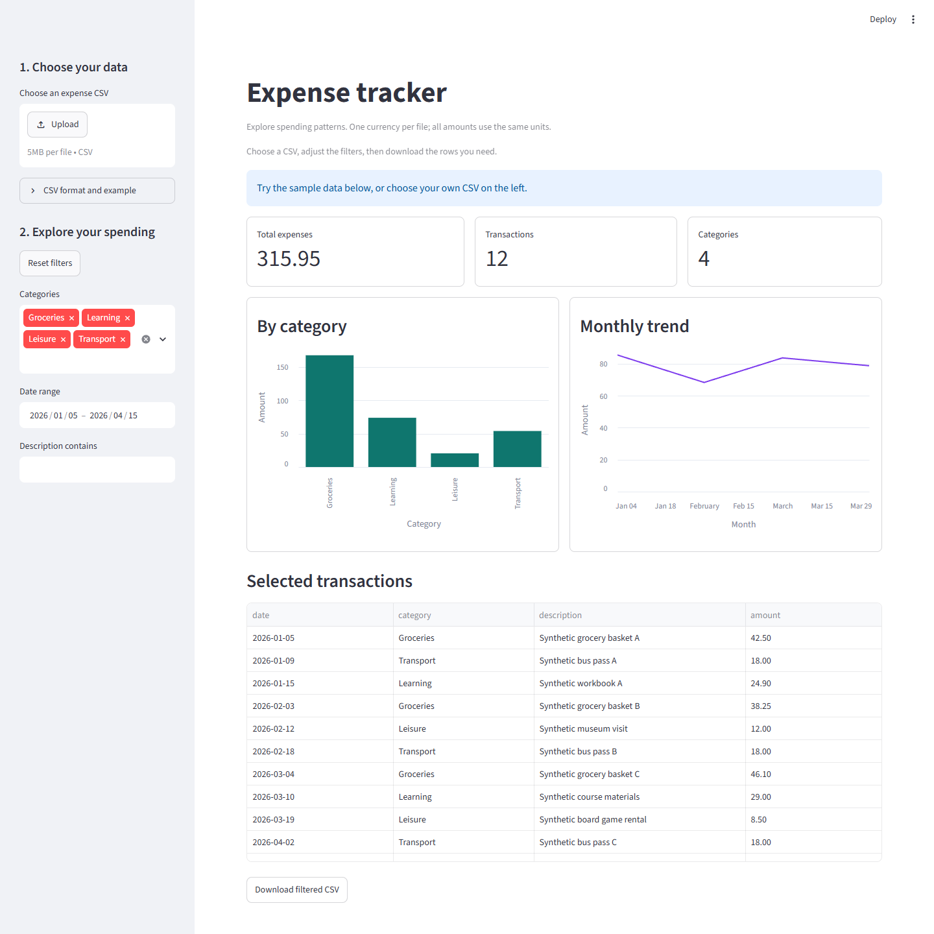
Figure 9. The dashboard shows synthetic totals, category spending, a monthly trend, and filtered rows.

C. Learning objectives
- Explain a CSV header, row, and data type.
- Trace validation from raw bytes to a DataFrame of integer cents.
- Apply category, date, and text filters consistently.
- Interpret category totals and zero-filled monthly trends.
- Describe the limits of descriptive statistics and one-currency input.
Prerequisites: Chapter 7: file safety; Chapter 8: packages and validation; Chapter 0: local server concepts.

D. Concepts before code

CSV is text, not a typed database
Each expense row has date, category, description, and amount. A CSV reader produces strings, so a date and monetary amount must be validated and converted. The parser requires exactly these columns, a valid date in the configured range, and a nonnegative decimal amount with at most two fractional digits. An invalid row rejects the upload with a row-specific message. Silent repair could produce misleading totals.

Use integer cents for exact sums
A binary floating-point value may not represent every decimal fraction exactly. The parser converts an accepted decimal amount into integer cents, such as 12.50 becoming 1250. Addition and grouping can then operate on integers. Formatting converts cents back to a decimal display. The sample total of 315.95 corresponds to 31,595 cents; it is a display of a precise stored total, not a floating-point approximation.

A DataFrame as a table
Pandas represents rows and columns in a DataFrame. The project sorts the validated rows by date, then uses filters to select a subset and groupby operations for category summaries. A filter is a question about data: which rows satisfy all selected conditions? Selecting no categories intentionally produces an empty state. The chart and downloadable CSV use the same filtered selection, making them consistent views of one result.

Monthly trends and statistics
A monthly sum answers how much was recorded in each month. The implementation inserts zero for missing months between selected transactions, so a gap in the chart is visible as a zero rather than disappearing. Descriptive statistics summarize observed rows; they do not predict future spending or account for currency conversion. The app assumes all amounts in one file use one currency, with no conversion performed.
Listing 30. Summing already validated integer cents; standalone teaching example
rows = [1250, 800, 450]
total_cents = sum(rows)
print(f"{total_cents / 100:.2f}")

E. Understanding the project logic
The interface loads the synthetic sample or an uploaded CSV. The parser validates bytes, header, dates, text lengths, and amounts before building a DataFrame. Sidebar controls choose categories, a date range, and optional description text. Helper functions produce a filtered table, category totals, and monthly totals. Streamlit renders metrics and charts and offers a CSV export of the current selection.
Stage | What happens | Why it matters
1 | Read CSV | Use sample bytes or an uploaded file
2 | Validate | Reject malformed rows and convert amounts to cents
3 | Filter | Select category, date range, and description
4 | Summarize | Compute total, counts, category and monthly groups
5 | Display/export | Show cards, charts, rows, and filtered CSV

A worked trace
Suppose three synthetic rows have 12.50, 8.00, and 4.50 in the same currency. Convert them to 1250, 800, and 450 cents. If a category filter excludes the last row, the displayed total and exported table should both represent 2050 cents, or 20.50. A chart that still includes 4.50 would indicate that the chart was built from unfiltered data.

F. Obtain and run the project
[COMPANION REPOSITORY INFORMATION TO BE ADDED] Obtain the companion files from the publication or course channel and open a terminal at the repository root. The following path and filenames match the audited project files. A terminal command acts on the project; a desktop option requires Tk and a graphical display.
Project folder: projects/09-expense-tracker-dashboard
Entry point: app.py through Streamlit; gui.py is the local launcher
Listing 31. Install the project's required packages from the repository root
python -m pip install -r projects/09-expense-tracker-dashboard/requirements.txt
Listing 32. Launch from the repository root
python -m streamlit run projects/09-expense-tracker-dashboard/app.py --server.address 127.0.0.1
The desktop launcher is python projects/09-expense-tracker-dashboard/gui.py; on Windows, desktop.pyw opens it when file associations work. Keep the launcher open while using the browser; its Stop button and window close shut down its own server. The terminal command serves locally on this computer. Use python3 -m streamlit on systems where the Python command is python3. Running python app.py directly is not the supported launch path.

G. Understanding the output
The sample data produces totals and charts from fictional rows. The category chart answers how spending is divided among categories; the monthly trend answers how the selected total changes by month. The table exposes individual contributing rows so a reader can check a chart against source data. Download filtered CSV writes the current selection and escapes text that could be treated as a spreadsheet formula. Uploaded data stays in a bounded in-process cache rather than a database.

H. Under the hood

Validation before visualization
The parser limits a CSV to 5 MB and 10,000 expense rows. It rejects missing fields, invalid dates, excess decimal places, negative values, and inconsistent quoting. These checks protect the interpretation of every later aggregate. If one malformed row were silently dropped, a chart could still look plausible while answering a different question than the user asked.

Consistent filtered views
A dashboard should compute one filtered data set and derive its metrics, charts, table, and export from that set. Otherwise the page can contradict itself. This separation also makes functions testable: a test can pass a synthetic table, apply a filter, and check cents and row counts without starting a browser.

I. Debugging and testing
The repository includes pure data tests, launcher lifecycle tests, and Streamlit AppTest interaction tests. Earlier verification loaded the actual dashboard in a browser. Test with synthetic rows: valid CSV, one bad row, no selected category, a missing month, and a description containing a spreadsheet formula prefix. Do not use real financial records in shared screenshots or tests.
Symptom or boundary | Check | Reason
Blank page or import error | Install Streamlit and Pandas in the active interpreter | Both are external dependencies
`python app.py` shows no dashboard | Use `python -m streamlit run app.py` | Streamlit must start its server
Upload rejected | Read the row-specific validation message | The app rejects the entire invalid file
Empty result | Inspect category and date filters | No selected categories means no rows

Run the chapter suite from the repository root, when available:
Listing 33. Run this project's unit tests
cd projects/09-expense-tracker-dashboard
python -m unittest discover -s tests -v

J. Make it yours
Work on a separate practice copy. Each challenge below is an extension or investigation, not a claim about a feature already in the project. Predict the new behavior, write down a test case, then change the smallest possible part of the program.

Beginner
Add a metric for the largest selected synthetic expense, including a clear empty-state message.

Intermediate
Add a category budget table stored in integer cents and test how a filter changes the displayed variance.

Advanced
Design a schema for refunds or multiple currencies. Specify conversion rules and test boundaries before altering the UI.

K. Knowledge check
1. Why is 12.50 stored as 1250 rather than a binary float?
2. What happens if one CSV row has a negative amount?
3. Which parts of the screen should change after a category filter?
4. Why is an empty month represented as zero?
5. If the chart total and download disagree, where would you inspect the data flow?

L. Chapter summary
The dashboard makes data validation visible through reliable summaries. It also demonstrates how a local interface can present several coordinated views of one filtered table. Chapter 10 replaces table aggregation with graph search, where the central question is which path an algorithm finds and how much work it performs.

Chapter 10 Maze-Solving Visualizer
  - Watch two search strategies answer the same question.

A. Project introduction
A maze is a set of open cells connected by legal moves. The project can generate a maze or load a predefined cyclic example, then compare breadth-first search (BFS) with depth-first search (DFS). The desktop animates exploration and highlights final paths. The terminal --solve mode prints a result without opening a window.
This chapter is about guarantees. BFS finds a shortest path measured in edges in an unweighted graph; DFS can find a valid but longer path. The difference is not visible from one successful result alone. The predefined maze deliberately gives alternative routes, making a comparison meaningful.

B. Project preview
The captured screen shows two algorithm panels, colored explored cells, and highlighted paths. Teal and violet indicate exploration, gold indicates the final route, green marks the start, and red the exit. The picture is a recorded state of a real run. The generated maze capture is another example, but a perfect generated maze has only one route, so final path lengths may match there.
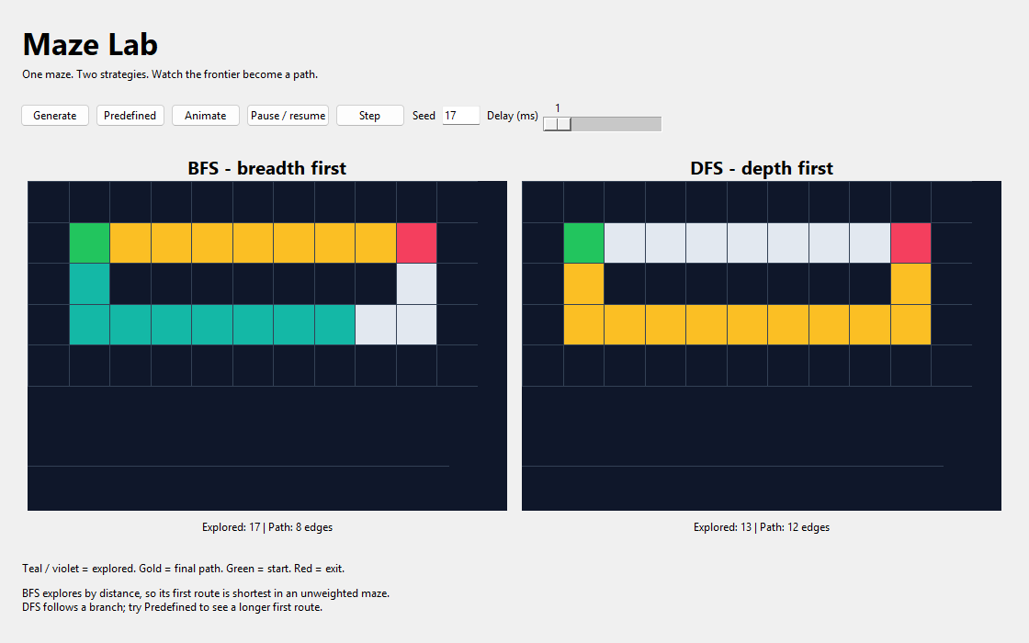
Figure 10. The maze visualizer compares BFS and DFS exploration and final routes.

C. Learning objectives
- Translate an open-cell maze into a graph of neighboring cells.
- Trace queue behavior in BFS and stack behavior in DFS.
- Reconstruct a path from parent links.
- Explain the shortest-path guarantee under equal edge costs.
- Interpret path length separately from explored-node count.
Prerequisites: Chapters 1–2: loops, lists, dictionaries, and testing; Chapter 4: visual state over time.

D. Concepts before code

A maze as a graph
Each open cell is a vertex. An edge connects two legal neighboring cells, usually one step up, down, left, or right. Walls are excluded. The project stores rows of characters and exposes a neighbor function with a fixed order: down, right, up, left. A path is a sequence of vertices from start to exit; its length is the number of edges, which is one less than the number of cells in that sequence.

Breadth-first search
BFS uses a first-in, first-out queue. It begins at the start and explores all reachable cells one move away before those two moves away. The project marks a neighbor when it is enqueued so it is not enqueued repeatedly. The first time it reaches the goal, the parent chain describes a minimum-edge path, provided every edge has equal cost. This is a layer-by-layer argument, not a visual guess.

Depth-first search
DFS uses a last-in, first-out stack. It follows one branch deeply before returning to alternatives. It can find a goal quickly if the branch happens to lead there, but the first route may contain more edges than another route. Neighbor order affects which branch is explored first. The algorithm is still useful for reachability and structure exploration; it simply does not promise a shortest route here.

Parent links and animation
A parent map remembers how each discovered cell was reached. Starting at the goal and following parents back to the start reconstructs a route, which can then be reversed for display. The GUI separately animates the order of explored cells and then highlights the route. Pausing affects presentation, not the already computed search result. A final route should not be confused with every cell the algorithm visited.
Listing 34. A FIFO frontier in a simplified search; standalone teaching example
from collections import deque
frontier = deque(["start"])
frontier.append("neighbor")
current = frontier.popleft()
print(current)

E. Understanding the project logic
The parser validates rectangular text mazes with one start and one exit. The generator creates an odd-sized perfect maze from a seed. BFS and DFS each maintain their own frontier, visited/parent information, and exploration order. The GUI receives those results and animates them side by side. The CLI --solve option prints a text solution and counts without a display.
Stage | What happens | Why it matters
1 | Build maze | Parse predefined text or generate odd-sized grid
2 | Find neighbors | Skip walls and out-of-bounds cells
3 | Search | Use queue for BFS or stack for DFS
4 | Reconstruct | Follow parents from goal to start
5 | Compare | Show explored counts and route lengths

A worked trace
In the predefined cyclic maze, the verified route lengths are eight edges for BFS and twelve for DFS. Both reach the exit, but DFS follows a longer branch first. BFS may explore more nodes while still finding the shorter route. An explored-node count measures work; path length measures the final answer. They are different quantities and neither should be silently substituted for the other.

F. Obtain and run the project
[COMPANION REPOSITORY INFORMATION TO BE ADDED] Obtain the companion files from the publication or course channel and open a terminal at the repository root. The following path and filenames match the audited project files. A terminal command acts on the project; a desktop option requires Tk and a graphical display.
Project folder: projects/10-maze-solving-visualizer
Entry point: main.py
Runtime packages: Python standard library only for this entry point. Check Tk separately for a desktop window.
Listing 35. Launch from the repository root
python projects/10-maze-solving-visualizer/main.py --predefined
python projects/10-maze-solving-visualizer/main.py --predefined --solve
The first command opens the Tk visualizer. The second uses terminal output and works without a graphical display. On macOS/Linux use python3 where needed. For generated mazes, --seed 17 --rows 21 --cols 31 --solve creates a reproducible run; height and width must be odd values from 5 to 61.

G. Understanding the output
The visualizer shows both exploration histories and final paths. A route can contain fewer cells than the set explored to discover it. In the terminal, walls are #, the path is marked with *, and the program reports path and exploration counts. An unreachable exit produces no path. The predefined maze is better for comparing shortest-path behavior because its cycle creates distinct alternatives.

H. Under the hood

Why BFS is shortest here
Let distance mean the smallest number of edges from the start. The queue initially contains only distance-zero start. Whenever BFS removes a distance-k cell, its newly discovered neighbors have distance at most k+1 and are appended after all earlier-layer cells. Therefore BFS cannot first discover a distance-(k+2) goal before every reachable distance-(k+1) option has been considered. With equal edge costs, the first goal path has minimum edge count.

When the guarantee changes
If moves had different costs, minimum edges would not necessarily mean minimum total cost. A route with three expensive edges could cost more than a route with five cheap edges. Ordinary BFS would still minimize edge count, not price. A weighted extension needs an algorithm such as Dijkstra's. This boundary is as important as the guarantee itself.

I. Debugging and testing
The unit suite tests parsing, generation, BFS and DFS independence, route reconstruction, and the cyclic comparison. The predefined example is a useful regression case because it distinguishes the algorithms. A perfect generated maze has only one path, so equal final lengths there do not prove the algorithms are implemented identically. Check path validity as well as reported length.
Symptom or boundary | Check | Reason
Even maze dimension rejected | Use odd row and column counts | The generator's grid construction requires them
No window | Use `--solve` or check Tk | Terminal mode avoids the display
DFS route seems long | Compare with BFS on a cyclic maze | DFS has no shortest-path guarantee
Explored count differs from path length | Inspect visited order versus parent chain | Work and result are distinct

Run the chapter suite from the repository root, when available:
Listing 36. Run this project's unit tests
cd projects/10-maze-solving-visualizer
python -m unittest discover -s tests -v

J. Make it yours
Work on a separate practice copy. Each challenge below is an extension or investigation, not a claim about a feature already in the project. Predict the new behavior, write down a test case, then change the smallest possible part of the program.

Beginner
Change the final route color in a practice copy and update the legend so the meaning remains clear.

Intermediate
Add a validated text-maze input. Reject uneven rows, missing start, multiple exits, and unsupported characters with useful messages.

Advanced
Give cells different costs and implement Dijkstra search. Construct a case where a minimum-edge path has a greater total cost than a longer route.

K. Knowledge check
1. What does an edge represent in this maze graph?
2. Why does BFS use a queue and DFS use a stack?
3. How many edges are in a path of nine cells?
4. Why does a perfect generated maze make route-length comparison less informative?
5. If moves have different costs, does ordinary BFS minimize total cost? Explain.

L. Chapter summary
The visualizer closes the ten-project sequence with a clear comparison between algorithms, output, and guarantees. You can now inspect a working program, identify its state, and ask what evidence supports a claim. The concluding chapter turns those skills toward maintaining and presenting your own projects.

Chapter 11 From Project to Portfolio
  - Make your work understandable to another person.

Read a codebase before changing it
A project is more than its main file. Start with the README to learn what the program promises, then identify the entry point, dependencies, tests, and sample outputs. Trace one user action from interface to logic and back. In the guessing game, that means following a submitted string through conversion, comparison, and the displayed hint. In the expense dashboard, it means following an uploaded CSV through validation, filtering, aggregation, and download.
Write down what you know and what you still need to verify. A file name or old screenshot can be stale; the actual directory and current source are stronger evidence. The Visual Art Lab examples show why this matters: the book's Chapter 4 and 5 teaching order differs from the existing folder prefixes, and one imported README names a script that is no longer present.

Organize a small project
A beginner-friendly project usually has a clear entry point, testable logic in a separate module when useful, a README, exercises, samples, and tests. The structure should help a new reader answer three questions quickly: How do I run it? Where are the rules? How do I know it works? You do not need many files for a small game; add modules when they clarify a responsibility. Keep generated outputs, private environments, and caches out of version control.
A README should identify prerequisites, exact commands, expected behavior, and common failures. Prefer a concise example that can be copied safely. If a command changes files, state its effect and offer a preview where possible. A screenshot should show the current application; if an old capture still has an earlier chapter badge, identify it as historical rather than altering evidence.

Testing and debugging as explanation
A test encodes an expectation about behavior. For a pure function, provide inputs and check a returned value. For a file operation, create temporary synthetic files and check both names and bytes. For a GUI, verify a meaningful interaction path and inspect a real capture. A passing test suite supports a bounded claim about tested cases; it does not prove every possible environment or user input works.
When a test fails, reduce the case. Ask what was expected, what happened, and which boundary changed first. For example, a wrong dashboard total might come from CSV parsing, filtering, or grouping. Inspect intermediate rows before changing a chart. A maze route mismatch might come from neighbor order, parent recording, or whether path length counts edges or cells. These are debugging hypotheses that can be checked separately.
Project | Useful evidence | Claim you may make
Guessing game | Three comparison tests and input-boundary tests | The tested hints and validation behave as expected
File organizer | Dry-run diff, hash check, undo conflict test | The tested operations preserve and protect fixture files
Dashboard | Synthetic CSV, data tests, browser capture | The tested sample summaries and interactions work locally
Maze | Cyclic example with two route lengths | The tested BFS route is shorter than that DFS route

Dependencies and reproducibility
A dependency is code your project uses but does not define itself. A requirements file makes package installation repeatable. Record supported version ranges, then record the exact versions used for a verification run separately. Two learners using different interpreter environments can see different import behavior even when they typed the same command. Confirm python --version and install packages through python -m pip for the interpreter used to run the application.
Reproducibility also needs controlled input. A seeded guessing game or generated maze can be repeated, while a password generator intentionally avoids a seed. Synthetic CSV fixtures let you share dashboard tests without exposing private data. A screenshot should include enough context for another person to understand what was exercised.

Git and version control
Version control records changes over time. A repository stores files and commits; a commit is a named snapshot of a coherent change. The working tree contains current edits. Stage a small, reviewed set of files, write a message that says what changed, and inspect the diff before sharing. Do not commit virtual environments, caches, generated diagnostics, secrets, or private financial data. A .gitignore file helps avoid new unwanted files, but it does not automatically untrack files that were already committed.
Branches let you work on an idea without changing the main line immediately. A useful learning habit is to make one small feature change, run relevant tests, and review its diff. The goal is not a long commit history; it is a history that makes decisions and reversals understandable. If an imported asset has unresolved rights, version control does not grant permission to publish it.
Listing 37. A review-first version-control sequence
git status
git diff
git add path/to/your-change.py
git commit -m "Explain the changed behavior"

Explain a project in a portfolio
A portfolio entry should state the problem, the user's path through the tool, one technical decision, and the evidence that supports it. For the organizer, explain why preview and manifest-based undo matter. For the dashboard, show how invalid CSV rows are rejected before charting. For the maze, explain when BFS's shortest-path guarantee applies. A screenshot is helpful when it demonstrates a working interface; it is not a substitute for describing behavior.
Be precise about your contribution. Distinguish your own code, modifications, and study notes from imported programs or assets. Confirm publication rights for screenshots and artwork before placing them in public material. The repository's existing audit records describe unresolved permissions for the imported creative projects and supplied photos. Make accurate credits part of project quality, just as you make tests part of quality.

Portfolio practice
- Choose one project. Write a five-sentence explanation of what it does, who uses it, and what a successful run looks like.
- Identify one difficult boundary and show a test or safe manual check that covers it.
- Create a synthetic example and a screenshot or terminal transcript that reveals the relevant behavior.
- Write a short 'known limitations' paragraph. Make every claim match current evidence.
- Ask another learner to follow your README from a fresh copy. Record where they hesitate, then improve the wording.

Where to go next
Continue by choosing a problem that matters to you, then make its input and output small enough to test. Extend an existing application one behavior at a time or build a new one with the same core habits. Learn more about data structures, accessibility, error recovery, packaging, and deployment when a project needs them. The most durable skill from this book is not a particular library call; it is the ability to make a claim about a program and gather evidence that the claim is true.

Appendices
Quick references for the workbench, the code, and the ideas behind it.

Appendix A Python syntax quick reference
Idea | Short form | Meaning
Assign | count = 3 | Bind a name to a value
Compare | count < limit | Evaluate a Boolean condition
Branch | if ready: ... | Run a block conditionally
Repeat | for item in values: ... | Visit each item in a collection
Function | def hint(value): ... | Name a reusable operation
Handle error | try: ... except ValueError: ... | Respond to a specific failure
List | [1, 2, 3] | Ordered, changeable sequence
Dictionary | {"rock": "scissors"} | Map keys to values
Path | Path("notes.txt") | Represent a filesystem location

Indentation is part of Python syntax. A block under if, for, while, def, or try is indented consistently, usually by four spaces. A colon introduces the block. Strings use quotes. == tests equality; = assigns a value. An exception is a specific failure report, and except should catch only the kinds of failure you can usefully handle.
Listing 38. Function, type hint, loop, and indentation recap
def double(value: int) -> int:
return value * 2
for item in [1, 2, 3]:
print(double(item))

Appendix B Terminal and environment commands
Task | PowerShell | macOS/Linux shell
Show location | Get-Location | pwd
List files | Get-ChildItem | ls
Enter project | cd projects/01-number-guessing | cd projects/01-number-guessing
Python version | python --version | python3 --version
Create environment | python -m venv .venv | python3 -m venv .venv
Activate environment | .venv/Scripts/Activate.ps1 | source .venv/bin/activate
Run repository suites | python scripts/run_project_tests.py | python3 scripts/run_project_tests.py

Paths printed in this book are relative to the companion repository root unless a chapter explicitly tells you to enter a project folder. A command containing path/to/practice-folder is a teaching placeholder and must be replaced with an actual disposable folder path. Use a fresh output filename for tools that protect existing exports.

Appendix C Troubleshooting reference
Symptom | First check | Likely next step
'python' is not recognized | Installed command and shell | Try the platform's Python 3 command
Cannot open file | Current working directory | Use the verified relative path
ModuleNotFoundError | Active interpreter and requirements | Install into that interpreter
Tk window will not open | Display and Tk availability | Use CLI mode where offered
A CSV upload fails | Reported row and required header | Correct the source file, then reload
Export refuses a filename | Whether the destination exists | Choose a new filename
Undo refuses a file | Current bytes and name conflict | Resolve safely before retrying
Maze has no path | Walls, start, and goal | Inspect connectivity, not just algorithm

When troubleshooting, preserve evidence. Record the command, working directory, Python version, input, and exact final error message. Try the smallest reproducible example. Do not turn off a safety check merely to make an error disappear; understand which condition it protects.

Appendix D Glossary
Term | Meaning
algorithm | A finite procedure for solving a class of problems.
argument | A value supplied to a function or program command.
Boolean | A true or false value used by conditions.
branch | One path through conditional logic.
byte | A unit of encoded data; one character may occupy more than one UTF-8 byte.
callback | A function called later in response to an event or timer.
CSV | Comma-separated text representing rows and columns.
DataFrame | A labeled in-memory table provided by Pandas.
dependency | External software a project needs to run.
dictionary | A Python mapping from keys to values.
dry run | A preview that reports planned actions without applying them.
edge | A connection between two vertices in a graph.
entry point | The file or command that starts an application.
exception | A report that normal execution could not continue as expected.
function | A named block of code that performs a defined operation.
graph | Vertices and connections between them.
invariant | A condition intended to remain true while an operation proceeds.
iteration | One repetition of a loop.
manifest | A record of files and states used for audit or recovery.
module | A Python file that defines reusable names.
parameter | A name in a function definition receiving an argument.
path | A location of a file or folder.
pixel | One colored sample in a raster image.
queue | A first-in, first-out collection.
stack | A last-in, first-out collection.
state | The current values a program uses to decide its next behavior.
test | An executable check of a specific expected behavior.
type | A category of value and the operations it supports.
validation | Checking whether input meets a program's requirements.
vertex | A node in a graph, such as an open maze cell.
working directory | The folder relative commands and paths are interpreted from.

Appendix E Selected answers and reasoning hints

Chapter 0
input returns text. Conversion with int may raise ValueError for a word or malformed number. A relative path depends on the current directory.

Chapter 1
An invalid or out-of-range answer uses no valid attempt. In the worked trace, 12 leaves three attempts. A counter that increments before validation violates the intended round rule.

Chapter 2
There are nine possible pairs. Scissors beats paper. In the current fixed-round match, a draw consumes a round and appears in history.

Chapter 3
Test length, allowed alphabet, and group coverage; do not assert a particular random string. The project has no actual strength checker.

Chapter 4
Coordinates locate elements; measured phrase width determines whether text fits a span. A still omits motion, easing, and shimmer timing.

Chapter 5
The actual executable file is flow.py. A plant state describes what should be drawn at a time; the renderer turns that state into pixels.

Chapter 6
A radius and angle identify a point on the spiral after coordinate conversion. A new PNG must not replace the input JPEG.

Chapter 7
Apply rechecks a preview because the folder may have changed. Exclusive destination creation prevents overwriting a late-created file.

Chapter 8
PNG and SVG share the encoded matrix. An independent decoder checks the saved artifact rather than only the application's own preview.

Chapter 9
12.50 becomes 1250 cents. An invalid upload is rejected instead of changing totals silently; a filtered chart and export must use the same selected rows.

Chapter 10
Nine cells contain eight connecting edges. BFS minimizes edge count only when edges have equal cost; DFS has no such guarantee.

Appendix F References and acknowledgments
The companion repository's project READMEs, Python entry points, unit tests, saved runtime checks, and license audit provided the technical record for this manuscript. The three Visual Art Lab projects include imported source material and requester-supplied photographs. Their exact source commits and pending publication permissions are documented in the repository's research records. Author, rights-holder, publisher, and edition details require confirmation before publication.
This working manuscript contains no external addresses. Formal bibliographic references, acknowledgments, credits, and approved companion access details should be added only after the relevant rights and editorial facts are confirmed. The production report lists the source files for each inserted figure and the remaining checks.

