**Liquorr**

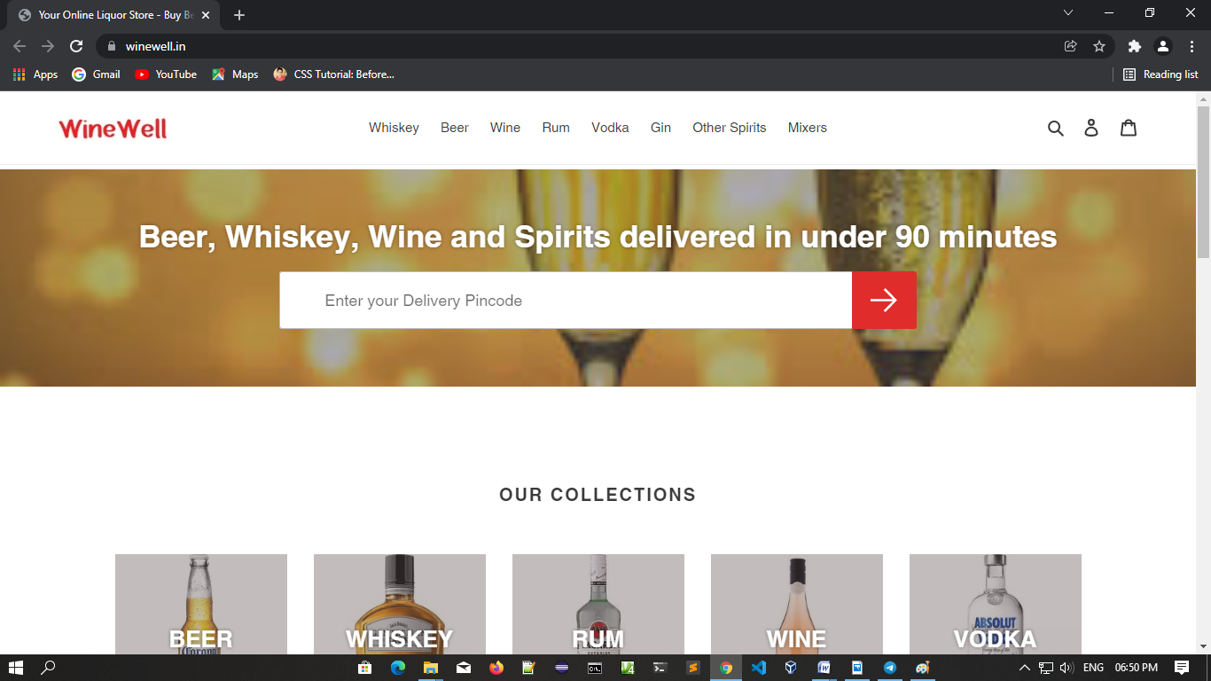

**Overview:**

The website where users can buy Liquor like beer , wine , vodka , whisky , rum any types of liquor by their choice at one place.

**Home page:**

* Navigation bar on top
  + - Logo and Name
    - Search Bar
    - Category of Liquor
    - Account(creates new account and login)
    - My Carts
* Menu bar

A horizontal division below navigation bar where different categories of items are available to see.

* + - All category (beer , wine, vodka etc.)
* Special Edition bar

A horizontal division below Menu bar where different categories of special items are available to see.

* Most Selling bar

A horizontal division below special edition bar where different categories of most items are available to see.

* Footer
  + - Social media links
    - Address
    - Quick links
    - Search bar

**Listing Page (Item list):**

When user click on any box in category then the respected category listing page will open.

**Detail Page:**

On Detail page information about items details and wine shop detail.

* Items price
* Wine shop detail
* Rating
* Add to cart button

**Login page:**

User can login through login details or new user can register through email.

* Login
  + - Username or email
    - Password
  + Register
    - Email
    - Full name
    - Password
    - Confirm password

**Payment Page :**

Payment Methods

* UPI(Phone pe, google pay)
* Cash on delivery
* Cards

**Reference site :**

https://www.winewell.in/