API Documentation for Mini Project

Table of Contents
1. Introduction
2. Prerequisites
3. Setup and Running the Application
4. Database Configuration
5. API Endpoints
6. Testing with Postman
7.Git Repoitory

Introduction
This document provides detailed information on the APIs implemented in the Mini Project, including steps to set up the application, database scripts, and sample data for testing using Postman.

Prerequisites
Required Tools
- Java 17+
- Spring Boot 3.x
- MySQL 8.x
- Postman
- IDE (e.g., IntelliJ IDEA, Eclipse)
- Maven 3.x
Required Dependencies
Ensure the following dependencies are added to your `pom.xml` file:
```xml
<dependencies>
<dependency>
<groupId>org.springframework.boot</groupId>
<artifactId>spring-boot-starter-web</artifactId>
</dependency>
<dependency>
<groupId>org.springframework.boot</groupId>
<artifactId>spring-boot-starter-data-jpa</artifactId>
</dependency>
<dependency>
<groupId>mysql</groupId>
<artifactId>mysql-connector-java</artifactId>
</dependency>
</dependencies>
```

Setup and Running the Application
1. Clone or download the project.
2. Import the project into your IDE.
3. Configure the `application.properties` file for database connection.
4. Build the project using Maven.
5. Run the application.
6.Befor Running the Application Check ID Password for database.

Database Configuration

Entity Relation Ship Diagram Based On ORM (Object Relation Mapping)
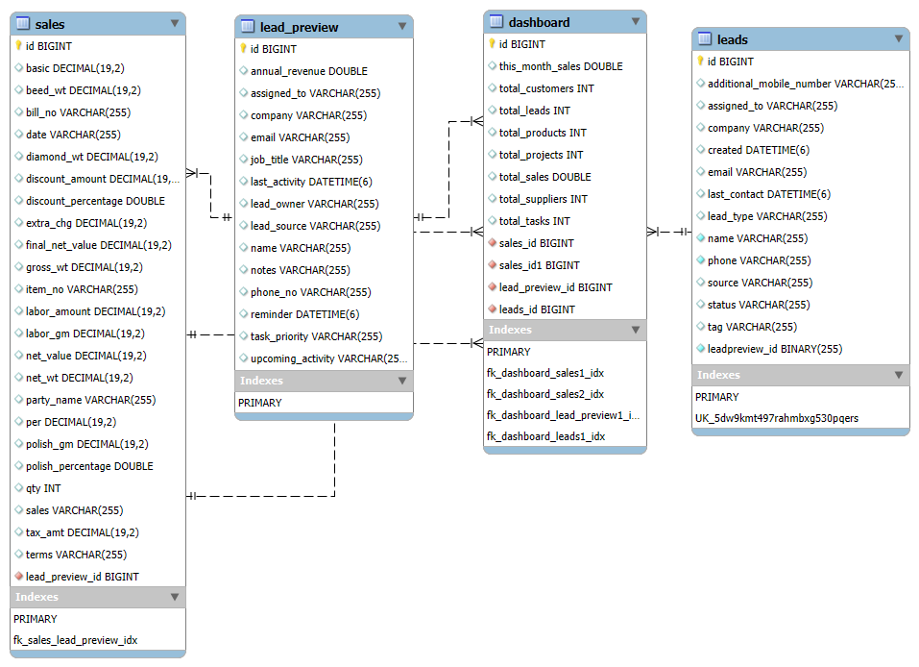

Data Base Schema For MiniProject
- Databse Creation
CREATE DATABASE MiniProjectDB;
2)
USE MiniProjectDB;
- DashBoard Table

CREATE TABLE dashboard (
id BIGINT AUTO_INCREMENT PRIMARY KEY,
totalSales DOUBLE,
thisMonthSales DOUBLE,
totalCustomers INT,
totalSuppliers INT,
totalProducts INT,
totalProjects INT,
totalLeads INT,
totalTasks INT
) ENGINE=InnoDB DEFAULT CHARSET=utf8mb4;

- Lead Table
CREATE TABLE leads (
id BIGINT AUTO_INCREMENT PRIMARY KEY,
name VARCHAR(255) NOT NULL,
company VARCHAR(255),
email VARCHAR(255) UNIQUE NOT NULL,
phone VARCHAR(50) NOT NULL,
assignedTo VARCHAR(255),
tag VARCHAR(255),
status VARCHAR(255),
lastContact DATETIME,
created DATETIME,
additionalMobileNumber VARCHAR(50),
leadType VARCHAR(255),
source VARCHAR(255)
) ENGINE=InnoDB DEFAULT CHARSET=utf8mb4;

5)Sale Table

CREATE TABLE sales (
id BIGINT AUTO_INCREMENT PRIMARY KEY,
date DATE,
terms VARCHAR(255),
partyName VARCHAR(255),
sales VARCHAR(255),
billNo VARCHAR(255),
itemNo VARCHAR(255),
grossWt DECIMAL(15, 2),
netWt DECIMAL(15, 2),
diamondWt DECIMAL(15, 2),
beedWt DECIMAL(15, 2),
qty INT,
netValue DECIMAL(15, 2),
polishPercentage DOUBLE,
polishGm DECIMAL(15, 2),
laborGm DECIMAL(15, 2),
laborAmount DECIMAL(15, 2),
per DECIMAL(15, 2),
extraChg DECIMAL(15, 2),
basic DECIMAL(15, 2),
discountAmount DECIMAL(15, 2),
discountPercentage DOUBLE,
taxAmt DECIMAL(15, 2),
finalNetValue DECIMAL(15, 2)
) ENGINE=InnoDB DEFAULT CHARSET=utf8mb4;

6) Foregin Key Relations

ALTER TABLE lead_preview
ADD COLUMN lead_id BIGINT,
ADD CONSTRAINT FK_LeadPreview_Lead
FOREIGN KEY (lead_id) REFERENCES leads(id);

ALTER TABLE sales
ADD COLUMN lead_preview_id BIGINT,
ADD CONSTRAINT FK_Sale_LeadPreview
FOREIGN KEY (lead_preview_id) REFERENCES lead_preview(id);

ALTER TABLE sales
ADD COLUMN lead_preview_id BIGINT,
ADD CONSTRAINT FK_Sale_LeadPreview
FOREIGN KEY (lead_preview_id) REFERENCES lead_preview(id);

Indexing For Better Performancs

CREATE INDEX idx_lead_email ON leads (email);
CREATE INDEX idx_lead_name ON leads (name);
CREATE INDEX idx_sale_partyName ON sales (partyName);

Testing with Postman
Steps:
1. Open Postman and create a new request.
2. Use the endpoints listed above with the appropriate HTTP method.
3. Set the request body to `raw` and choose `JSON` format for POST and PUT requests.
4. Click `Send` to execute the request.

API Endpoints

Dashboard Controller
HTTP Method | Endpoint | Description
POST | /api/dashboards/add | Create a new dashboard
GET | /api/dashboards | Retrieve all dashboards
GET | /api/dashboards/{id} | Retrieve a specific dashboard
PUT | /api/dashboards/{id} | Update a specific dashboard
DELETE | /api/dashboards/{id} | Delete a specific dashboard
Create a new Dashboard
(POST /api/dashboards/add)
{
"title": "Sales Dashboard",
"description": "Dashboard for tracking sales performance across regions.",
"data": {
"totalSales": 100000,
"regions": [
{"region": "North", "sales": 25000},
{"region": "South", "sales": 30000},
{"region": "East", "sales": 20000},
{"region": "West", "sales": 25000}
]
}
}
Expected output must be 200 ok
With The Same example hit remaining apis

Lead Controller
HTTP Method | Endpoint | Description
POST | /api/leads/add | Add a new lead
GET | /api/leads | Retrieve all leads
GET | /api/leads/search | Search leads by filters
GET | /api/leads/{id} | Retrieve a specific lead

1. Add a New Lead
Endpoint: POST /api/leads/add
{
"name": "Rahul Sharma",
"email": "rahul.sharma@example.com",
"phone": "+919876543210",
"company": "Tech Innovators Pvt Ltd",
"assignedTo": "Amit Verma",
"tag": "Hot Lead",
"status": "In Progress"
}
Expected Output Must Be
Response 200 ok
{
"id": 1,
"name": "Rahul Sharma",
"email": "rahul.sharma@example.com",
"phone": "+919876543210",
"company": "Tech Innovators Pvt Ltd",
"assignedTo": "Amit Verma",
"tag": "Hot Lead",
"status": "In Progress"
}
All the remaingn APIs with these Example

Lead Preview Controller
HTTP Method | Endpoint | Description
POST | /api/lead-previews/add | Add a new lead preview
GET | /api/lead-previews | Retrieve all lead previews
GET | /api/lead-previews/{id} | Retrieve a specific lead preview
PUT | /api/lead-previews/{id} | Update a specific lead preview
DELETE | /api/lead-previews/{id} | Delete a specific lead preview

1. Add a New LeadPreview
Endpoint: POST /api/lead-previews/add
{
"name": "Aarav Mehta",
"email": "aarav.mehta@gmail.com",
"phoneNo": "9876543210",
"leadOwner": "Priya Sharma",
"company": "Tech Solutions Pvt Ltd",
"jobTitle": "Project Manager",
"annualRevenue": "1,200,000",
"leadSource": "LinkedIn",
"lastActivity": "2025-01-10",
"upcomingActivity": "2025-01-15",
"reminder": "Follow up with client",
"taskPriority": "High",
"assignedTo": "Rajesh Singh",
"notes": "Discuss project requirements with the client."
}

Expected Output –
HTTP Status: 201 Created
{
"id": 1,
"name": "Aarav Mehta",
"email": "aarav.mehta@example.com",
"phoneNo": "9876543210",
"leadOwner": "Priya Sharma",
"company": "Tech Solutions Pvt Ltd",
"jobTitle": "Project Manager",
"annualRevenue": "1,200,000",
"leadSource": "LinkedIn",
"lastActivity": "2025-01-10",
"upcomingActivity": "2025-01-15",
"reminder": "Follow up with client",
"taskPriority": "High",
"assignedTo": "Rajesh Singh",
"notes": "Discuss project requirements with the client."
}

Same As All The Represeted API’s Just Hit The Endpoints.

Sale Controller
HTTP Method | Endpoint | Description
POST | /api/sales/add | Add a new sale
GET | /api/sales | Retrieve all sales
GET | /api/sales/{id} | Retrieve a specific sale
PUT | /api/sales/{id} | Update a specific sale
DELETE | /api/sales/{id} | Delete a specific sale

1. Add a New Sale
Endpoint: POST /api/sales/add
{
"productName": "Samsung Galaxy S23",
"customerName": "Amit Sharma",
"saleDate": "2025-01-12",
"quantity": 2,
"price": 79999,
"totalAmount": 159998
}
Expected Response Must Be
Response 200 ok
{
"id": 1,
"productName": "Samsung Galaxy S23",
"customerName": "Amit Sharma",
"saleDate": "2025-01-12",
"quantity": 2,
"price": 79999,
"totalAmount": 159998
}

Now Hit Remaining APIs s.

Git Repository To Commit The Mini Project.
https://github.com/saahilch/BackEnd_MiniProject

