**Building a Computer – Report**

**(TEJ3M)**

**By: Saahiti Annamneedi**

**For**

**Mr. Laxton**

**June 3, 2013**

# Table of Contents

|  |  |
| --- | --- |
| Table of Contents…………………………………………………………………… | 2 |
| Abstract…………………………………………………………………………………. | 3 |
| Motherboard Preparation …………………………………………………….. | 4 |
| CPU Installation ……………………………………………………………………. | 5 |
| Heat Sink ………………………………………………………………………………. | 6-7 |
| RAM ……………………………………………………………………………………... | 7 |
| Other Integrated Components ……………………………………………… | 8 |
| DVD Burner.…………………………………………………………………………. | 9 |
| Booting the Computer…………………………………………………………… | 10 |
| Conclusion ……………………………………………………………………………. | 11 |

## Abstract

Computers are complex systems that involve a wide range of integral and peripheral components. This report provides a detailed step-by-step guide to building a computer. The procedure is divided into major sections that include preparing the motherboard, installing the CPU, heat sink and RAM modules, in addition to expansion cards such as video cards. In order to safely and successfully complete the procedure, grounding is essential to get ward of electric discharge; an anti-static wrist band is highly recommended. The computer parts are to be handled with care as physical tension can damage these parts. It is also wise to keep all computer parts, including packaging material, as theses will be required by the manufacturer in the case of an exchange or return.

## Motherboard Preparation

1. The first step before installation is to retrieve the power supply unit out of the packaging. Ensure you keep all of the packaging as this will be required by the manufacture if the computer is to be replaced or returned. If the equipment is cold, wait for a while until it has reached room temperature.
2. Place the power supply unit inside the computer case. Insert the proper screws through the case to mount the PSU onto the case.
3. Ground the power supply by connecting it to a 3-prong grounded outlet. Ensure that it is grounded by checking the voltmeter. The reading will return a value that is greater than zero volts – this is necessary to prevent voltage spikes.
4. Next, ground yourself using an anti-static wrist band. It is essential from this point onward to stay grounded whenever handling internal electric components, in order to prevent a potentially dangerous static discharge that can damage hardware. If you don’t have a band, ground yourself by resting a hand on the metal frame of the case. While purchasing a computer, take note that a metal case is better than a plastic case because the static build-up is lower. Prepare the case for the motherboard by running a 585 V current through it. Take out the generic part on the bottom of the computer, and install the motherboard faceplate into the case.

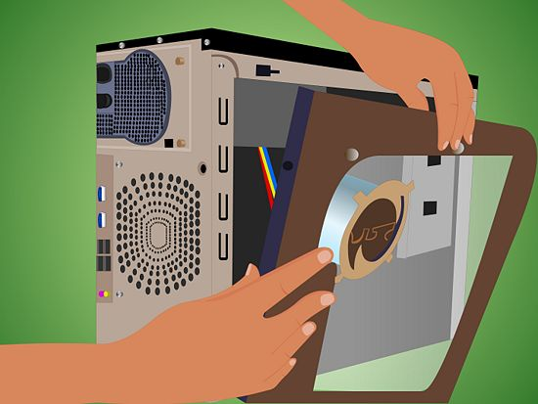

Figure 1: Remove the side panels of the case (Retrieved from [www.wikihow.com](http://www.wikihow.com))

1. Remove the side panels if necessary. Bend back the big prongs on the port panel and pop it in from the inside of the computer. Push the panel into the computer.

## CPU Installation

1. Make sure that the chip’s label on the chip box is not broken.
2. Don’t break the seal of the CPU box until you are ready to install it; this avoids unnecessary exposure.
3. Retrieve the CPU box carefully; do not flick it open as the CPU chip may fall out. Make sure you do not damage the CPU in the process, as it is one of the most important components of your computer.
4. Keep all of the packaging.
5. A special plastic wrap is included with the packaging; this material is conductive and allows for the easy discharge of static electricity. Place the wrap on a table and put the chip on top of it.
6. On the motherboard, locate the socket for the CPU. Push down on the lever by the CPU’s socket, and unlatch it; it pops up. Never put fingers on the CPU socket.
7. Keep the plastic cover on the CPU socket aside, do not throw it.
8. Release the latch down gently with an index finger. Open the hinge and remove the plastic protector. Don’t push down or bend any pin.
9. Now retrieve the processor chip. Look at the corners, pin 1 is indicated by an arrow pointing diagonally outward toward the corner. Place the CPU in its slot.

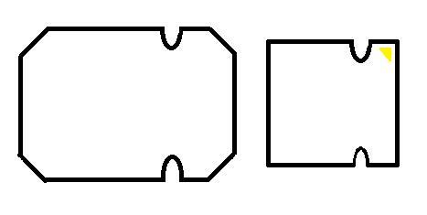

Figure 2: The shape and markings on the CPU chip (right) and socket (left) indicate the right orientation. (Made in Paint)

1. Check that the chip is intact and flat on the slot. Gently tap your finger on the chip to make sure it is firm, but do not push down. If the chip doesn’t slip right in, it is probably placed not in the correct configuration. You can check the alignment with the markers on the board. Keep everything in the box.
2. Locate the screw holes that you will be using to connect the motherboard to the case. Do not fasten the screws in too tight; this may cause a crack in your motherboard. Screw in until the screws meets its resistance point.

## Heat Sink

1. Pull the plastic plugs off the fan’s legs by rotating the adjustment knobs counter-clockwise. Make sure that you don’t break the trace wires.
2. Retrieve the thermal paste – which helps attach the fan onto the CPU cache; it is included with CPU box. The thermal paste is gooey – avoid contact with skin. Keep it in the pack until ready to use.
3. If the heat sink comes with pre-applied thermal paste, remove it and use your own thermal paste as this is more effective in attaching the fan onto the CPU. Note that the grooves on the CPU paste do not allow for 100% efficiency, but it is necessary for the heat sink to stay sturdy.
4. Apply a pea-sized amount of paste evenly on the centre of the CPU cache.

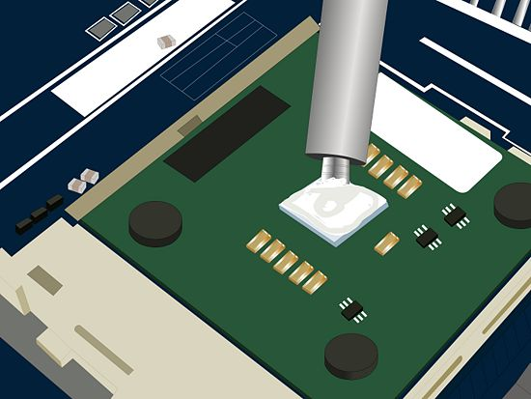

Figure 3: Apply a minimal amount of thermal paste evenly on to the centre of the CPU cache. (Retrieved from [www.ehow.com](http://www.ehow.com))

1. Install your heat sink onto the mounting bracket. Use something clean with a straight edge to smooth the paste, making sure that there aren't any gaps, or the fan will be unbalanced
2. Place the fan gently on top of the CPU.
3. While installing the fan into its slot, push down on diagonally opposite ends to ensure the fan is not unbalanced or unsteady. Wait for the click.
4. You can put a dull piece of wood to keep the board balance. This should not be necessary in most cases, unless the manufactured piece is faulty.
5. Loosen the wires in the fan so that the fan can spin freely.
6. Locate the heat sink’s plug (it has a dent on it); plug into the CPU fan slot.

## RAM

1. Prior to and while handling the RAM, ensure you are grounded and be extremely cautious of static discharge. Do not touch any pins directly on the board.
2. Check that the seal on the RAM cards is unbroken.
3. Locate the socket on the motherboard. Since the processor chip is an Intel i5, its compatible socket model is the LGA 1155. When buying parts, make sure they are compatible with one another.
4. Drop the RAM cards into the slot. Push them in so they click, with your thumbs both sides. Refer to your motherboard’s manual to check where each of the chips is to be inserted. If you inserted the chips correctly the little latches on the either side will snap back into place.
5. Make sure that you leave a row between the D-RAM slots (place the DRAM cards alternately) to utilize its dual data channel.

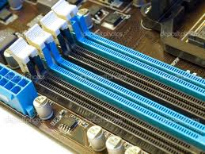

Figure 4: The DDR2 and DDR3 RAM slots (Retrieved from [www.webzdarma.cz](http://www.webzdarma.cz))

## Hard Drive

1. Place the hard drive in the hard drive bay. Ground yourself – this is very important.
2. Don’t touch the back of the board, especially the circuit. Use the screwdrivers with shanks on them to install the hard drive. Be careful, as the hard drive case is usually made of a soft metal.
3. Mount the drive top side up. If it doesn’t fit, take out the grommets.
4. Make sure the holes line up.
5. If you have a video card, make sure you put the hard drive on top or else you will run out of space.
6. Make sure the grommets are in and tighten the screws.
7. Connect the system hard drive to the first drive on the primary SATA controller. Ensure that the cable is inserted into the controller and is stable.
8. Identify the power cable for the hard drive – the wire has 3 heads. Connect it to the power supply.

## **Other Integrated Components** – Audio and Video Cards

1. Remove the case expansion slot bracket to install the additional video or audio cards. Two slots might have to be removed depending on the size of the video card.
2. Unscrew the PCI slot cover and keep the screw.
3. One you have installed the video card onto the 16x PCI-Express slot, use the screw that you previously removed to screw the slot back in.
4. Connect the regular screws (without washers) onto the motherboard. Fit it in sideways.
5. The screw holes will line up – tighten them putting the screws on a screwdriver. Don’t tighten anything until all the screws are balanced. If you drop the screws in, use needlework pliers to retrieve them out.
6. Locate the front panel and plug their respective wires in.
7. Plug in the audio cord into the audio port.
8. Insert the card readers into the computer. Take out the rubber grommets – allow the hardware to absorb electric shocks.
9. Pop out the black casing near the card reader slots.
10. Put the card readers where there are no grommets, but holes. Screw in the card reader through the holes.
11. Don’t tighten the screws until you know that the holes are aligned. You can tape the screws onto the screwdriver to help get them in.
12. Plug in the USB cord – the socket has 9 pins.

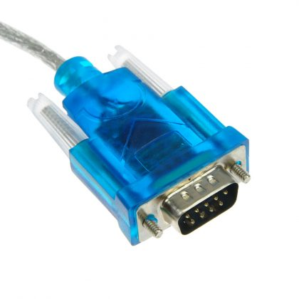

Figure 5: A 9-Pin USB Cord (Retrieved from [www.ebay.com](http://www.ebay.com) )

## DVD Burner

1. Remove the side panel of the computer case by placing your hand inwards through the opening at the back of the case.
2. Turn the metal pipe, where the DVD goes, break it and take it out. The metal pipe makes the case more rigid.
3. Slide the DVD drive into its designated location in the case - typically at the front top section of the case.
4. Use the screws that look like they have washers on them. Screw the drive in using an appropriate screwdriver. Install the side panel of the case and screw it in.
5. Connect the L-SATA cord that is connected to the DVD to the power supply. Retrieve the power supply cable and plug it into a power outlet.
6. When plugging the DVD, use SATA cables. The wire has two heads – the normal power connector and the SATA power connector.
7. Plug in the L-shaped SATA cable at a 90-degree angle.
8. Tie-wrap the SATA (data) cables together, not to the case, but out of the way.
9. Plug the power cables to the video card.
10. Use the double-headed wire - both ends are the same.
11. Plug in the cables that come with the cord to cord connection, and connect the ends to these extensions.
12. Tie-wrap the remaining extra wires away from the fan and preferably toward a corner on the motherboard.
13. Makes sure the DATA and power cables are connected to all the required components on the board, and ensure that everything is in the right place before closing the case.

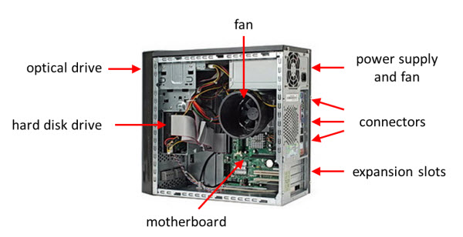

Figure 7: Internal Components of a Computer Case (Retrieved from [www.education-portal.com](http://www.education-portal.com) )

1. Take the side panel that was previously removed, and connect it onto the case using appropriate screws. Once it has been attached firmly, the computer is ready for a hardware boot.

## Booting the Computer

1. Take a paperclip and bend it open. Put it into the hole on the DVD drive, eject, and insert your operating system drive into the DVD drive before powering the computer. Make sure that the grounding cord is connected to an outlet.
2. The computer will start booting. Do not touch the mouse or keyboard. Try to avoid reboots.
3. Use USB 2.0 and 3.0 LAN motherboard drivers on the DVD.
4. Load the video card driver.
5. Load the SSD driver.
6. Shut the power. In case of a faulty boot, do not soft boot; only hard boot by plugging in the paperclip to eject the DVD drive. Do not use the keyboard or mouse, but have them plugged in.

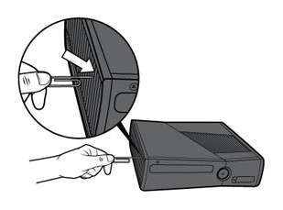

Figure #: Insert a paperclip to eject the drive and to reboot. (Retrieved from [www.suport.xbox.com](http://www.suport.xbox.com) )

# Conclusion

Building a computer is a comprehensive procedure that is requires attention to detail. One of the foremost factors is safety: to stay grounded throughout the process. Warding off electrostatic discharge is vital, and can avoid electric shocks. The configuration of internal parts should be done carefully, and appropriate screws and devices must be used in order to build a system that is sturdy an intact. Some electronic parts are delicate, and so should be handled with care. Excessive pressure on any off the computer parts can permanently damage them and hamper the functioning of the computer. All packaging parts should be kept, in case of an exchange or return. While connecting the power cables, the power connectors should be attached using the correct polarity. The speaker on the motherboard is a helpful feature as it signals if there is anything wrong with the placement of components on the board. Good computer practices are essential in order to maintain an efficient and long-lasting computer.