PROJECT REPORT ON
VIRTUAL BOOKSHELF WEBSITE BY
SABIHA NAAZ SALAMULLAH KHAN


YASHWANTRAO CHAVAN MAHARASHTRA OPEN UNIVERSITY
BACHELOR OF COMPUTER APPLICATION YEAR: TYBCA (SEM-VI)

2022-2025

CERTIFICATE OF ORIGINALITY

Date: -

This is to certify that the project entitled VIRTUAL BOOKSHELF WEBSITE Submitted to the School Of Computer Science in partial fulfilment of the requirement for the award of the degree of BACHELOR OF COMPUTER APPLICATIONS (Yashwantrao Chavan Maharashtra Open University), is an original work carried out by Ms Sabiha Naaz Salamullah Khan Exam Seat No. KP131050751 Under my guidance. The matter embodied in this project is a genuine work done by the student and has not been submitted to this Organization or any other University/Organization for the fulfilment of the requirement of any course of study.

Signature of the Internal Guide Signature of the Student
Prof. Archana Patil Ms. Sabiha Naaz Salamullah Khan

CERTIFICATE

This is to certify that the project report entitled VIRTUAL BOOKSHELF WEBSITE Submitted to the School Of Computer Science in partial fulfillment of the requirement for the award of the Degree of BACHELOR OF COMPUTER APPLICATIONS (Yashwantrao Chavan Maharashtra Open University) Is an original work carried out by Ms Sabiha Naaz Salamullah Khan Exam Seat No KP131050751.

The matter embodied in this project is a genuine work done by the student and has been
Certified by the following external examiners deputed by Yashwantrao Chavan Maharashtra Open University.

External Examiner



Bunts Sangha Mumbai Anna Leela College of Commerce and Economics & Shobha Jayaram Shetty College for BMS Shashi Manmohan Shetty Higher Education Complex,
Buntara Bhavanmarg, Kurla (E), Mumbai 400070

Date:

Certificate of Completion

This is to certify that Ms. Sabiha Naaz Salamullah Khan of B.C.A have completed the Project Work titled "VIRTUAL BOOKSHELF WEBSITE" under my guidance and supervision. The project report has been written according to the guidelines given by the Yashwantrao Chavan Maharashtra Open University.

Signature of the Study Centre Coordinator Signature of the Guide

Name of the Study Centre Coordinator Name of the Guide

Stamp of the Study Centre

Date:



Bunts Sangha Mumbai Anna Leela College of Commerce and Economics & Shobha Jayaram Shetty College for BMS Shashi Manmohan Shetty Higher Education Complex,
Buntara Bhavanmarg, Kurla (E), Mumbai 400070

Certificate of Evaluation

This is to certify that the undersigned has assessed and evaluated the Project work titled “VIRTUAL BOOKSHELF WEBSITE” submitted by the student
Ms. Sabiha Naaz Salamullah Khan.

The Project Report has been (accepted) for the partial fulfilment of B.C.A Programme.

Signature of Examiner

Name of Examiner

Stamp of Study Centre

ACKNOWLEDGEMENT
I express my deep sense of gratitude to Prof./Archana patil and Prof./ Ranjita Rathore for the deepest interest, valuable guidance, constant supervision, support and encouragement throughout the course of the project.

I am also grateful to respected Principal Dr. Rajendra Patil, IT faculty and the whole Department of Information Technology for giving me an opportunity to embark on this project.

I would like to thank all other teaching staff for their valuable teaching and constant advice which made me to finish this program successfully.

Finally, my deepest gratitude goes to my parents and my friends who have given me much needed support, encouragement and inspiration for completing this project.

INDEX PAGE

CHAPTER | TITLE | PAGE NO:
1. | Introduction
1.1 | Institute Profile | 12
1.2 | Abstract | 13
1.3 | Existing System | 14
1.4 | Need for System | 14
1.5 | Scope of System | 16
1.6 | Operating Environment- Hardware and  Software
1.6.1 | Hardware Requirements | 18
1.6.2 | Software Requirements | 19
1.7 | Brief Description of Technology Used
1.7.1 | Frontend and Backend Technologies | 22
1.7.2 | Database and Tools And Platforms | 22
2. | Proposed System | 24
2.1 | Study of Similar Systems | 26
2.2 | Feasibility Study | 29
2.3 | Objectives of Proposed System | 31
2.4 | Users of System | 33
3. | Analysis and Design
3.1 | System Requirements | 35
3.1.3 | Functional Requirements | 35
3.1.2 | Non-Functional Requirements | 36
3.2 | Entity Relationship Diagram(ERD) | 38
3.3 | Table Structure | 40
3.4 | Use Case Diagram | 46

3.5 | Class Diagram | 48
3.6 | Activity Diagram | 49
3.7 | Deployment Diagram | 50
3.8 | Module Hierarchy Daigram | 51
3.9 | Sample Input and Output Screens | 52
4. | Coding
4.1 | Algorithms | 56
4.2 | Code Snippets | 57
5 | Testing
5.1 | Test Strategy | 59
5.2 | Unit test Plans | 59
5.3 | Acceptance Test Plans | 59
5.4 | Test Case/Test Script | 60
5.6 | Defect report/Test log | 61
6. | Limitations of Proposed System | 62
7. | Proposed Enhancements | 64
8. | Conclusion | 66
9. | Bibliography | 67
10. | Publication/Competition certificates | 68
11. | Appendix–Cost sheet, Datasheet | 69
12. | User Manual | 70

PROJECT SYNOPSIS

Title of the Project:
Virtual Bookshelf-A Book Review and Discovery Platform
Student Name: Sabiha Naaz Salamullah Khan
PRN: 2022017001173704

Introduction
A virtual library or bookshelf for book readers who love to read and keep track of their progress. In this web application, users can also rate books and read reviews. This platform aims to provide user-generated content, and social interaction features.

Objectives / Existing System and Need for System Objectives:
The Current book platforms lack the ability for a smooth user experience. Users cannot rate books with stars. Users struggle to find relevant books matching their reading preferences and interests. This web application wi l overcome these problems to make it an easier and a satisfactory experience for them.

Need for the System:

Existing book platforms often fail to provide personalized recommendations and lack robust social features that foster meaningful interactions and book discussions among readers, making it harder for users to discover books that truly match their interests and connect with like-minded readers

Scope of the Project

User profile management Book search and discovery A section for user’s library Rating and reviewing system Social interaction features

Technologies Used
Frontend: React.js, HTML, JavaScript Backend: Node.js with Express Database: MongoDB

System Architecture
Basic architecture layout:
Frontend: Dynamic web interface with login, search, and user dashboard
Backend: API layer handling authentication, book data, reviews, and recommendations Database: Stores user profiles, book information, ratings/reviews, and discussion threads

Modules and Functionalities
Homepage: Overview, featured books, navigation links
User Login/Signup: Secure registration, login, and session management
Book Search & Discovery: Search by title, author, genre, with advanced filters User Library: Track reading status (to-read, reading, completed)
Book Details: View book info, ratings, reviews, and add to library
Rating & Review System: Submit and view star ratings and written reviews Social Features: Comment on books, join discussions, follow users Recommendations: Personalized suggestions based on reading history and ratings FAQ & Contact Page: Common questions and feedback form

Methodology
Agile Model: Development wi l proceed in iterative sprints, a lowing for feedback-driven updates and incremental feature integration such as social features and personalized recommendations.

Expected Outcome
Fu ly responsive and interactive virtual BOOKSHELF website Personalized user experience with tailored book recommendations Active community engagement through reviews and discussions Efficient book discovery with advanced search and filtering
Easy tracking of reading progress and personal library management

Conclusion
The Virtual Bookshelf project transforms traditional book catalogues into a dynamic, user-driven platform. By integrating social interaction, personalized recommendations, and a robust review system, it offers a modern and engaging experience for book enthusiasts.
Let me know if you'd like to further customize any section or add more technical details!

CHAPTER 1
- INTRODUCTION

Institute Profile
This project is submitted under the academic curriculum of [Bunts Sanghas’s , Anna Leela College of Commerce and Economics ], a recognized institution that emphasizes excellence in education, innovation, and skill development in the domain of information technology and computer science. The institute fosters a holistic learning environment that integrates theoretical knowledge with hands-on, real-world projects.
The academic program encourages students to undertake practical projects that not only reflect their technical skills but also solve real-world problems. This project, "Virtual Bookshelf Website" is a testament to the institute’s focus on leveraging technology to solve everyday problems and enhance user experiences in the digital age. The institute's focus on emerging technologies like artificial intelligence, web development, and database systems provides the ideal foundation for building such a comprehensive and dynamic platform.
Through faculty mentorship and institutional support, the development of this system aligns with the institute's broader vision of nurturing industry-ready professionals capable of leveraging digita l innovations to improve quality of life.

Abstract

The “Virtual Bookshelf – A Book Review and Discovery Platform” is an innovative, interactive web application designed to transform the experience of book readers by providing a comprehensive digital environment for book discovery, review, and social engagement. This platform bridges the gap between isolated reading experiences and vibrant literary communit ies by integrating modern web technologies with user-centric features that promote both individ ual exploration and collective interaction.
The primary objective of this project is to empower readers with tools that a low them to manage their personal libraries, track their reading progress, and contribute to the community through star- based ratings and detailed reviews. The system addresses the limitations of existing book platforms, which often lack seamless user experiences, robust recommendation engines, and meaningful social features. By enabling users to search for books using advanced filters, add books to their own digital shelves, and participate in discussions, the Virtual Bookshelf fosters a dynamic and supportive community of book enthusiasts.
A standout feature of the platform is its personalized recommendation system, which leverages user preferences, reading histories, and community trends to suggest books that align with individual interests. This intelligent content filtering ensures that every user’s discovery journey is unique and relevant, enhancing satisfaction and engagement. The social interaction layer- comprising discussion threads, comments, and the ability to follow fe low readers-further enriches the platform by facilitating knowledge sharing and literary conversation.
The technical foundation of the Virtual Bookshelf is built using React.js for a responsive and engaging frontend, Node.js with Express for efficient backend processing, and MongoDB for flexible, scalable data management. This technology stack ensures high performance, scalabilit y, and ease of maintenance, while supporting the integration of future enhancements such as machine learning-based recommendations and mobile accessibility.

Existing System and Need for the System

Existing System

Current online book platforms and virtual libraries often fall short in delivering a truly engaging and personalized reading experience. Most existing systems either function as basic catalogues or e-commerce sites, offering limited features such as simple book listings and generic search options. These platforms rarely provide users with the ability to rate books using intuitive star systems or to write and share detailed reviews. Social interaction features are minimal or absent, restricting users to passive consumption of content rather than active participation.
Furthermore, many platforms lack advanced recommendation engines, making it difficult for readers to discover books that align with their unique interests and reading histories. The absence of user-centric features such as personal bookshelves, progress tracking, and communit y discussions means that readers cannot effectively manage their literary journeys or connect with like-minded individuals. As a result, the current landscape is fragmented and fails to foster a vibrant, interactive community for book enthusiasts.

Need for the System

With the increasing popularity of online reading and digital communities, there is a clear demand for a platform that not only provides access to a wide selection of books but also enhances the overall reading experience through personalization and social engagement. Users are looking for tools that allow them to organize their personal libraries, track their reading progress, and receive book recommendations tailored to their preferences.
The proposed "Virtual Bookshelf – A Book Review and Discovery Platform" addresses these gaps by:
      - Enabling users to rate and review books, contributing valuable insights to the community.

      - Offering personalized book recommendations based on individual reading habits and interests.
      - Providing advanced search and filtering options for efficient book discovery.

      - Creating a space for social interaction, including discussions, comments, and the ability to follow other readers.
      - Delivering a seamless, intuitive, and visually appealing user interface accessible to all.

By integrating these features, the Virtual Bookshelf transforms the traditional book catalogue into an interactive, user-driven platform. It empowers readers to take control of their literary journeys, connect with a community of fellow enthusiasts, and discover new books in a way that is both engaging and personalized. This project fills the void left by existing systems and sets a new standard for online book discovery and community building.

Scope of the System
The scope of the "Virtual Bookshelf – A Book Review and Discovery Platform" has been meticulously crafted to provide a flexible, scalable, and highly engaging environment for book lovers and reading communities. The system’s modular architecture ensures that new features- such as mobile app support, advanced analytics, or AI-driven recommendation upgrades-can be seamlessly integrated in the future. The initial release is focused on delivering a robust set of features that offer immediate value, laying a strong foundation for a modern and interactive literary ecosystem.
The platform is designed to serve a wide audience, from casual readers to avid bibliophi les, reviewers, and community organizers. It aims to transform the solitary act of reading into a social, dynamic, and personalized experience. The core features included in the first version are as follows:

- User Registration and Authentication: Users can securely create accounts using their email and password, with all sensitive information encrypted for privacy. Once registered, users gain access to personalized features, including their own digital bookshelves, reading history, and social interactio ns. Session management ensures a safe and seamless user experience.

- Personal Library Management: Each user has a virtual bookshelf where they can add, categorize, and organize books according to their reading status-such as “to-read,” “currently reading,” or “completed. ” This digital library mimics the flexibility of a physical bookshelf, allowing users to curate their collection and track their progress from any device, anytime and anywhere.
- Book Search and Discovery: The platform offers advanced search and filtering options, enabling users to browse books by title, author, genre, rating, or even keywords in descriptions. Intelligent sorting and recommendation features help users discover new titles aligned with their interests, expanding their literary horizons beyond traditional catalogues.
- Rating and Review System: Users can rate books using an intuitive star system and write detailed reviews to share their opinions with the community. This user-generated content enriches the platform, providing valuable insights for other readers and fostering a sense of shared discovery.

- Social Interaction Features: Beyond solitary reading, the system encourages social engagement through discussion forums, comment sections, and the ability to follow other users. Readers can participate in group activities, join book clubs, and exchange recommendations, making reading a collaborative and interactive pursuit.

- Personalized Recommendation Engine: The platform leverages user preferences, reading history, and community trends to suggest books tailored to each individual. This dynamic recommendation system ensures that users

are continually exposed to new and relevant content, enhancing engagement and satisfaction.
- Content Organization and Privacy: Books can be organized by various criteria-such as genre, author, or user-created categories-giving users control over their digital shelves. The platform also priorit izes privacy, offering features to restrict access, make shelves private, or even encrypt sensitive content as needed.

- Anytime, Anywhere Access: As a cloud-hosted solution, the Virtual Bookshelf enables users to access their collectio n and participate in the community from any device, whether online or offline, ensuring uninterrupted engagement with their reading journey.

- Support for Group Activities: The system supports collaborative reading experiences, such as group discussions and shared bookshelves, making it ideal for book clubs, study groups, or classroom use.
- FAQ and Support: An integrated FAQ and support module answers common user queries and provides a channel for feedback or assistance, ensuring a smooth onboarding and ongoing experience.
This comprehensive scope ensures the Virtual Bookshelf is not just a digital repository, but a vibrant, evolving platform that empowers readers to manage, discover, and discuss books in a way that is both deeply personal and richly communal. The architecture is intentionally future-ready, allowing for the integration of new technologies and features as user needs and literary trends evolve.

Operating Environment – Hardware and Software
To ensure the successful development, deployment, and smooth operation of the "Virt ual Bookshelf – A Book Review and Discovery Platform," it is crucial to define a robust hardware and software environment. The system is engineered to function efficiently on widely available hardware and leverages a modern, fu l-stack software architecture that supports scalabilit y, security, and user engagement. The following are the detailed specifications for both development and deployment environments.

Hardware Requirements

The hardware requirements are specified to accommodate both development and end-user needs, ensuring flexibility and optimal performance under various workloads.

Component | Minimum Requirements | Recommended Requirements
Processor | Intel Core i3 / AMD Ryzen 3 | Intel Core i5/i7 / AMD Ryzen 5 or above
RAM | 4 GB RAM | 8 GB RAM or more
Storage | 250 GB HDD | 512 GB SSD
Display | 720p HD Display | 1080p Fu l HD Display

      - Processor: A minimum of Intel i3 or equivalent is sufficient for basic development and testing. For a smoother experience, especia ly when running multiple services such as the frontend, backend, and database simultaneously, a more powerful processor like Intel i5/i7 or AMD Ryzen 5 is recommended.
      - RAM: The system can run on 4 GB RAM, but 8 GB or more is ideal for multitasking and handling concurrent user sessions during development or deployment.
      - Storage: While a 250 GB HDD meets the minimum requirement, a 512 GB SSD is preferred for faster data access, reduced latency, and improved overa l development efficiency.

      - Display: A higher-resolution display (1080p Fu l HD) is beneficial for managing mult ip le windows, debugging, and UI/UX design, while a 720p HD display suffices for basic use.
These hardware specifications ensure that both developers and users experience reliable performance, whether accessing the platform loca ly or via cloud-hosted environments.

Software Requirements

The software environment for the Virtual Bookshelf project is selected for its reliability, scalabilit y, and widespread community support, ensuring a seamless development process and a robust end- user experience.

Operating System (Development and Deployment):

        - The system is fu ly compatible with Windows 10/11 and major Linux distribut io ns such as Ubuntu 22.04. Linux offers efficient resource management and termina l- based development tools, while Windows provides a familiar user interface for many developers.

Web Browsers:

        - Google Chrome and Mozilla Firefox are used for testing cross-browser compatibility, responsiveness, and accessing the platform from different user perspectives.

Editor/IDE:

        - Visual Studio Code (VS Code) is the preferred integrated development environment, offering features like real-time linting, Git integration, extensions for JavaScript and Node.js, and built-in terminal support.

Frontend Technologies:

        - React.js is utilized for building dynamic, responsive, and component-based user interfaces. HTML, Tailwind CSS, and JavaScript are used to ensure a modern and visually appealing design.

Backend Technologies:

        - Node.js with Express framework powers the backend, handling server-side logic, routing, API endpoints, user authentication, and business logic efficiently.

Database Systems:

        - MongoDB serves as the primary database, providing flexible, schema-less storage for user profiles, book information, reviews, and discussion threads. Its scalabilit y and support for unstructured data make it ideal for a content-rich platform.

API Testing Tools:

        - Tools such as Postman and Thunder Client (VS Code extension) are used to validate API endpoints, test backend logic, and debug services during development.

Design and Prototyping Tools:

        - Figma or Adobe XD can be used for UI/UX design, creating wirefra mes, prototypes, and user flows to ensure consistency and usability before implementation.

Version Control System:

        - Git is used for local version control, while GitHub serves as the remote repository, enabling collaborative development, code review, and backup.

Deployment Platforms:

        - The frontend can be deployed using platforms like Vercel or Netlify, which offer seamless integration with GitHub, continuous deployment pipelines, and custom domain support.
        - The backend services are deployable on Heroku, AWS EC2, or similar cloud platforms, providing scalability, secure hosting, and easy integration with MongoDB Atlas or other managed database services.
By adhering to these hardware and software requirements, the Virtual Bookshelf platform remains accessible, efficient, and future-proof, supporting ongoing enhancements and ensuring a positive experience for both developers and end users. This environment lays the groundwork for a scalable

and maintainable system, capable of adapting to evolving user needs and technologica l advancements.

Brief Description of Technology Used

Frontend
- HTML5 & CSS3: Provides the structural foundation and styling for the Virtual Bookshelf’s user interface, enabling semantic layouts and modern, responsive designs.
- JavaScript (ES6+): Adds interactivity and dynamic behavior to the platform, supporting features such as real-time updates, form validation, and seamless navigation.
- React.js: Powers the frontend with a component-based architecture, ensuring scalabilit y, efficient state management, and a smooth user experience. React facilitates the creation of reusable UI elements, making the interface consistent and easy to maintain.

Backend

- Node.js: Serves as the server-side JavaScript runtime, enabling asynchronous operations and scalable backend development.
- Express.js: A lightweight Node.js framework that simplifies server routing, middleware integration, and RESTful API creation. It manages user authentication, book manageme nt, review submissions, and social interactions efficiently.
- REST API: Enables dynamic communication between the frontend and backend, a lowing real-time data exchange for book information, user actions, and community features.

Database

- MongoDB: Acts as the primary database, offering a flexible, document-oriented structure ideal for storing user profiles, book metadata, reviews, and discussion threads. MongoDB’s schema-less design supports rapid changes and efficient querying, which is essential for personalized recommendations and social features.

Recommendation Engine

- Personalized Book Recommendation System: The platform features a dynamic recommendation engine that analyzes user preferences, reading history, and community trends to suggest books tailored to individual interests.
  - User Inputs: Includes genre preferences, reading status, ratings, and past activity.

  - Logic Implementation: Utilizes rule-based filtering and can be expanded with machine learning algorithms for more refined suggestions in future versions.
  - Output: Delivers curated book recommendations to users, enhancing discovery and engagement.
  - Integration: Recommendations are displayed on user dashboards and discovery
sections, fetched dynamically via API ca ls from backend logic and database queries.

Integration and Workflow

- The frontend communicates with the backend through RESTful APIs, ensuring that actions such as adding books, submitting reviews, and participating in discussions are instant ly reflected across the platform.
- MongoDB’s flexible schema supports evolving application needs, while React’s component-driven approach a lows for straightforward integration of new features and modules.
This technology stack ensures the Virtual Bookshelf is modern, scalable, and ready for future enhancements, providing users with a seamless, interactive, and community-driven book discovery experience.

CHAPTER 2
- PROPOSED SYSTEM
The proposed system, titled "Virtual Bookshelf – A Book Reviewand Discovery Platform," is envisioned as a comprehensive, interactive web application designed to transform the way readers discover, manage, and engage with books. Unlike traditional online book catalogues or static library websites, this platform places the user at the center of the experience by integrating dynamic content, personalized recommendations, and community-driven features.
At the heart of the system is a robust recommendation engine that analyzes user preferences, reading history, and community trends to suggest books tailored to each individual’s interests. Users can search for books using advanced filters such as genre, author, and rating, and receive curated recommendations that adapt as their reading journey evolves. This intelli gent recommendation logic operates through rule-based filtering and can be expanded with machine learning algorithms in future iterations, ensuring that book suggestions remain relevant and engaging.
The platform is built with modular design principles, making it easy to expand and maintain. The homepage offers a welcoming introduction and intuitive navigation, while registered users are provided with a personalized dashboard that displays their reading progress, recently viewed books, and recommended titles. Key modules include a personal library for tracking reading status, a rating and review system for sharing insights, and social features such as discussion forums and the ability to follow other users. Informational sections offer book summaries, author profiles, and curated lists, enhancing users’ literary knowledge and discovery.
The proposed system is designed to achieve several core objectives:
- Empower users to manage their personal digital libraries and track reading progress.
- Enable user-generated content through star ratings and in-depth reviews.
- Provide personalized book recommendations based on user activity and preferences.
- Foster a vibrant reading community with discussion forums and social networking feature s.
- Deliver an accessible, visually appealing, and responsive user experience across devices.

Technologically, the platform is built using a modern stack: React.js for the frontend, Node.js with Express for backend logic and API development, and MongoDB for flexible, scalable data

storage. The frontend ensures a responsive, component-based interface, while the backend manages secure user authentication, data processing, and real-time content delivery. RESTful APIs facilitate seamless communication between client and server, ensuring that user actions-such as adding a review or updating reading status-are instantly reflected throughout the platform.
Ultimately, the proposed Virtual Bookshelf system is designed to be scalable, adaptable, and user-
focused. By blending personalized discovery, community engagement, and robust digital library management, it offers a modern solution that addresses the limitations of existing book platforms and meets the evolving needs of today’s readers.

STUDY OF SIMILAR SYSTEMS

To better understand the competitive landscape and refine the objectives of the "Virtual Bookshelf – A Book Review and Discovery Platform," it is essential to analyze existing systems that offer similar services in the domain of online book discovery, review, and community engagement. Several well-known platforms and web-based applications serve readers worldwide, each providing a unique set of features. However, most have notable limitations in terms of personalization, interactivity, or accessibility.

Goodreads:
Goodreads is the most widely used online platform for book lovers, offering features such as book cataloging, star ratings, written reviews, reading challenges, and the ability to join groups. While it boasts a large user base and an extensive book database, the platform’s interface is often considered outdated and cluttered. Its recommendation system is relatively basic, relying largely on broad reading history rather than nuanced user preferences. Social features exist but are not deeply integrated, and meaningful discussions can be difficult to find or follow.

LibraryThing:
LibraryThing provides detailed cataloging tools and supports the management of personal book collections. However, its focus is more on collection management than on facilitating social interaction or personalized discovery. The interface can be complex for new users, and book recommendations are limited in sophistication.

StoryGraph:
StoryGraph is a newer platform that emphasizes mood-based recommendations and detailed reading analytics. It offers more advanced filtering and some personalization, but its social features are still developing, and the overall user base is smaller compared to established platforms.

BookBub:
BookBub is known for its daily book deals and curated recommendations, but its primary focus is on promoting discounted books rather than fostering a community or enabling in-depth reviews. The platform provides limited opportunities for users to interact, review, or track their reading progress.

Amazon Books:
Amazon’s book section a lows users to rate and review books, but the experience is tightly

integrated with e-commerce, prioritizing sales over community building or personalized discovery. Recommendations are driven by sales algorithms rather than reader interests.

Gaps in Existing Systems
Upon evaluating these platforms, several gaps become clear:
- Limited Personalization: Few systems offer real-time, highly personalized book recommendations that adapt to user preferences, reading history, and nuanced interests.
- Outdated or Cluttered Interfaces: Many platforms lack a modern, intuitive, and visually appealing user interface, which can hinder overall engagement and ease of use.
- Fragmented Social Features: Social interaction is often secondary, with limited opportunities for meaningful discussions, book clubs, or following like-minded readers.
- Restricted Discovery Tools: Advanced filtering, dynamic search, and real-time content updates are often missing or underdeveloped.
- Lack of Integrated Progress Tracking: Few platforms allow users to comprehensive ly
track their reading journey, organize books by status, or visualize their progress in an engaging way.

How the Proposed System Stands Out
The "Virtual Bookshelf – A Book Review and Discovery Platform" is designed to address these shortcomings by:
- Offering a modern, user-friendly interface that prioritizes ease of navigation and visual appeal.
- Providing advanced, personalized book recommendations based on detailed user profiles, reading history, and community trends, ensuring each user’s discovery journey is unique and relevant.
- Enabling robust social interaction through features such as discussion forums, comments, and the ability to follow other readers, fostering a vibrant and engaged community.
- Supporting comprehensive personal library management, allowing users to organize books by reading status, track progress, and curate custom shelves.
- Delivering real-time, dynamic content updates and advanced search/filtering tools to streamline book discovery.

- Ensuring accessibility and scalability by using open-source, modern web technologies, making the platform freely available and easy to maintain.
By integrating these features, the Virtual Bookshelf aims to redefine the online reading experience, making it more interactive, personalized, and community-driven than existing platforms. This approach not only fills the gaps left by current systems but also sets a new benchmark for digita l book discovery and engagement.

FEASIBILITY STUDY
Conducting a feasibility study is crucial to evaluate the practical implementation, sustainabilit y, and real-world impact of the "Virtual Bookshelf – A Book Review and Discovery Platform." This assessment examines the project from multiple perspectives to ensure its effectiveness and long- term viability.

Technical Feasibility:
The proposed system leverages a modern, robust, and widely adopted technology stack, includ ing React.js for the frontend, Node.js with Express for backend development, and MongoDB for data management. All these technologies are open-source and supported by large developer communities, ensuring extensive documentation, libraries, and community-driven support. The system’s architecture is modular, enabling straightforward integration of new features such as advanced recommendation engines or mobile app support in the future. The personalized recommendation logic and real-time content updates are achievable using standard web development practices, making the system technically feasible on conventional web servers without requiring specialized hardware.

Economic Feasibility:
The project is highly cost-effective, as it relies on free or open-source development tools such as Visual Studio Code for coding, Git and GitHub for version control and collaboration, and Postman for API testing. Deployment can be managed through cloud-based platforms like Vercel or Netlify for the frontend and Heroku, AWS Free Tier, or similar services for the backend, all of which offer free or low-cost hosting options. The absence of licensing fees and the use of open-source frameworks significantly reduce the financial burden, making the system ideal for academic purposes and public deployment.

Operational Feasibility:
The Virtual Bookshelf is designed for operational stability and ease of use. Its modular structure allows for independent updates and scaling of individual components, such as book manageme nt, review systems, and user profiles. Administrators can efficiently manage content, moderate discussions, and ensure platform security with minimal technical overhead. For end users, the platform provides an intuitive interface, personalized dashboards, and seamless navigat io n, ensuring a positive and engaging experience for readers of all backgrounds.

Legal Feasibility:
The project does not pose significant legal risks, as it uses publicly available book data and clearly states that user-generated content is for informational and community purposes only. User authentication and data privacy are enforced through secure login systems and encryption of sensitive information. The platform adheres to standard data protection practices and privacy regulations, ensuring user data is handled responsibly and transparently.
The results of this feasibility study strongly support the continued development and deployment of the Virtual Bookshelf. The system is technically sound, economically viable, operationally stable, and legally compliant, making it a promising solution for enhancing the online reading and book discovery experience.

OBJECTIVES OF THE PROPOSED SYSTEM
The "Virtual Bookshelf – A Book Review and Discovery Platform" has been conceptualized with a clear set of objectives to deliver significant value to readers, foster a vibrant literary communit y, and address the limitations of existing online book platforms. The system’s goals encompass both technical innovation and social impact, aiming to enhance the reading experience and promote lifelong engagement with literature.
- To Empower Readers with Knowledge : The platform serves as an accessible hub where users can explore a vast collection of books, read detailed summaries, and access author profiles. By providing user-generated reviews and ratings, it helps readers make informed decisions about what to read next.

To Centralize Book Discovery and Management:
By integrating features such as advanced book search, personalized recommendations, user libraries, and review systems, the Virtual Bookshelf becomes a one-stop destination for all book-related needs. This centralization simplifies the process of discovering, organizing, and tracking books.
- To Enable Personalized Recommendations: A core objective is to offer intelligent, personalized book suggestions. The recommendation engine analyzes user preferences, reading history, and community trends to present tailored reading options, ensuring each user’s journey is unique and relevant.
- To Foster Social Interaction and Community Engagement: The platform encourages users to connect through discussion forums, comments, and the ability to follow other readers. These social features create a sense of belonging and stimulate meaningful conversations around books, authors, and genres.
- To Improve Accessibility and Usability: The Virtual Bookshelf is designed as a web-based, responsive application, ensuring that users can access their libraries and participate in the community from any device, anywhere. The intuitive interface makes it easy for users of all ages and technical backgrounds to navigate and engage with the platform.

To Promote Digital Literary Engagement:
By offering features such as reading progress tracking, status updates (to-read, reading,

completed), and personalized dashboards, the system motivates users to set and achieve reading goals, thereby cultivating consistent reading habits.

To Provide a Scalable and Adaptable Framework:
Built on a modular and scalable architecture, the platform is prepared for future enhancements, such as the integration of machine learning for smarter recommendatio ns, mobile app support, or additional community features.
- To Encourage Lifelong Learning and Literary Exploration: Regular updates, curated book lists, and featured reviews keep users engaged and informed about new releases, trending books, and literary events, fostering a culture of continuo us discovery.
- To Support Group Activities and Shared Reading Experiences: The system is designed to accommodate book clubs, study groups, and classroom use, allowing for shared bookshelves, group discussions, and collaborative reading experiences.
- To Ensure Data Privacy and Security: User data is handled with care, employing secure authentication and encryption practices to protect personal information and maintain user trust.
By achieving these objectives, the Virtual Bookshelf not only fills a significant gap in the digita l reading ecosystem but also serves as a model for user-centered, community-driven software design. It aspires to redefine how readers interact with books and each other in the digital age, making reading more social, personalized, and enjoyable for everyone.

2.4. USERS OF THE SYSTEM
The "Virtual Bookshelf – A Book Review and Discovery Platform" is designed to serve a diverse and growing community of readers, reviewers, and literary enthusiasts. The system’s intuit ive design, accessibility, and feature-rich environment make it inclusive and valuable for users with varying backgrounds, reading habits, and technical skills. Below are the primary categories of users who will benefit from this platform:

General Readers:
Individuals who enjoy reading for leisure or personal development wi l find the platform’s easy-to-use book search, personalized recommendations, and review features ideal for discovering new titles and tracking their reading progress. The Virtual Bookshelf helps casual readers organize their to-read lists, log completed books, and share their opinions with others.
- Avid Book Lovers and Reviewers: Enthusiastic readers and book critics can contribute detailed reviews, rate books using the star system, and participate in vibrant discussions. These users benefit from advanced filtering, community engagement features, and the ability to follow other reviewers, making the platform a hub for sharing literary insights and recommendations.
- Book Club Members and Group Readers: The platform supports group activities such as shared bookshelves, group discussions, and collaborative reading challenges. Book clubs, study groups, and classrooms can use these features to coordinate reading schedules, exchange thoughts, and foster a sense of community around shared literary interests.
- Students and Academic Users: Students and researchers can leverage the platform to find relevant literature, manage reading assignments, and access peer reviews. The ability to organize books by genre, author, or custom categories aids in academic projects and research work.
- Authors and Content Creators: Authors can use the platform to engage with their audience, receive feedback on their works, and participate in discussions related to their books. This interaction provides valuable insights and helps authors build a loyal reader base.

- Administrators and Moderators: Platform administrators are responsible for managing content, moderating discussions, and ensuring a safe, respectful environment for all users. They have access to tools for user management, content curation, and platform analytics.

Accessibility and User Experience
The system is built with responsive design principles and user-friendly navigation, ensuring that users of all ages and technical abilities can access and benefit from it equally. Whether someone is a new reader, a seasoned book reviewer, or an educator managing a reading group, the Virtual Bookshelf offers tools and features tailored to their needs.

The core objectives of this system are:
- To educate and inform users about books, authors, and literary trends through user- generated reviews and curated content.
- To offer a centralized platform for discovering, organizing, and reviewing books.
- To provide personalized book recommendations based on user preferences and reading history.
- To enhance user engagement through discussion forums, social networking features, and
personalized dashboards.
- To make book discovery and community interaction accessible to all, using open-source technologies and free web deployment.
By addressing the needs of these varied user groups, the Virtual Bookshelf stands out as a comprehensive, inclusive, and engaging platform for everyone passionate about reading and literature.

CHAPTER 3

Analysis and Design

System Requirements
    - Functional Requirements
The functional requirements define the core operations and user interactions that the Virtual Bookshelf platform must support to fulfill its mission of enhancing book discovery, review, and community engagement. These requirements ensure that both regular users and administrators can efficiently utilize and manage the system.

User Registration and Login:
The system must allow new users to register securely using an email address and a strong password. During registration, user input is validated on both client and server sides to ensure data integrity and prevent malicious entries. Passwords are securely stored using encryption (such as bcrypt hashing). Upon successful registration, users can log in and access personalized features. The login process uses secure authentication protocols (such as JWT tokens or session cookies) to manage sessions. Password recovery or reset functionality should be available for enhanced user experience.

Book Browsing and Filtering:
Users can access a comprehensive catalog of books, each with detailed metadata including title, author, genre, publication year, and cover image. Books are organized into categories and can be filtered based on user preferences such as genre, author, rating, or reading status. This enables users to quickly find books that match their interests and current reading goals.

Personal Library Management:
Each user has a personal digital bookshelf where they can add books, categorize them (e.g., “to- read,” “currently reading,” “completed”), and track their reading progress. Users can update the status of books, remove books from their library, and view summaries of their reading journey.

Book Rating and Review System:
Users can rate books using a star-based system and submit written reviews. These reviews are visible to the community and can be sorted by most recent, most helpful, or highest rated. Users

can edit or delete their own reviews, and administrators can moderate content to ensure communit y guidelines are followed.

Personalized Book Recommendations:
The system analyzes user preferences, reading history, and community trends to provide personalized book suggestions. The recommendation engine uses rule-based filtering and, in future versions, can incorporate machine learning for even more accurate recommendations.

Search Functionality:
A dynamic search bar is available on all major pages, allowing users to search for books, authors, genres, or keywords. The search functio n provides real-time suggestions and displays relevant results with minimal latency, improving accessibility and user satisfaction.

Discussion Forums and Social Features:
Users can participate in book discussions, comment on reviews, and follow other readers. These social features foster community engagement and allow users to share insights, recommendatio ns, and literary opinions.

Admin Panel:
Administrators have access to a protected admin panel where they can manage book entries, user accounts, reviews, and forum discussions. The panel includes CRUD (Create, Read, Update, Delete) functionality and employs role-based access control to prevent unauthorized changes. Admin actions are logged for accountability.

FAQ and Contact:
A dedicated FAQ section answers common user questions, reducing the need for direct support. A contact form allows users to submit feedback or report issues, which are routed to the admin panel for review and response.

Non-Functional Requirements
Non-functional requirements specify the quality attributes, constraints, and standards that the Virtual Bookshelf platform must fulfill to ensure reliability, performance, and user satisfaction.

Performance:
The application must deliver a responsive experience, with at least 95% of user actions-such as navigation, searching, and loading recommendations-completing within 3 seconds. This is

achieved through optimized database queries, efficient React frontend rendering, and minim ized API payloads. Techniques like lazy loading and caching are used to further enhance performance. Scalability:
The system should support at least 100 concurrent users without performance degradation. The architecture is designed for horizontal scaling, allowing backend services to be distributed across multiple servers or cloud instances as user demand grows.

Security:
User data is protected through strong encryption of passwords (e.g., bcrypt), secure session management (JWT tokens or HTTP-only cookies), and encrypted data transmission (HTTPS). Input validation and sanitization are enforced to prevent XSS and injection attacks. The platform adheres to privacy best practices, ensuring user information is handled responsibly.

Usability:
The user interface is intuitive, clean, and accessible, supporting users of all ages and technical backgrounds. Responsive design ensures compatibility across desktops, tablets, and smartphones. Clear navigation, helpful tooltips, and contextual error messages guide users through all features. Maintainability:
The codebase follows modern development practices, with clear separation between frontend and backend layers. React’s component-based structure and Node.js/Express RESTful APIs facilitate easy updates, debugging, and extension. Git is used for version control, and CI/CD pipelines automate testing and deployment.

Availability:
The system targets a monthly uptime of 99% or higher. It is hosted on reliable cloud infrastruc ture with redundancy, automated backups, and health monitoring. Application and server logs are monitored, and alerts are configured to notify administrators of critical issues. Automated recovery mechanisms ensure rapid restoration in case of outages.
By fulfilling these functional and non-functional requirements, the Virtual Bookshelf platform is positioned to deliver a seamless, secure, and engaging experience for all users, while remaining robust, scalable, and easy to maintain for future growth.

ERD Diagram

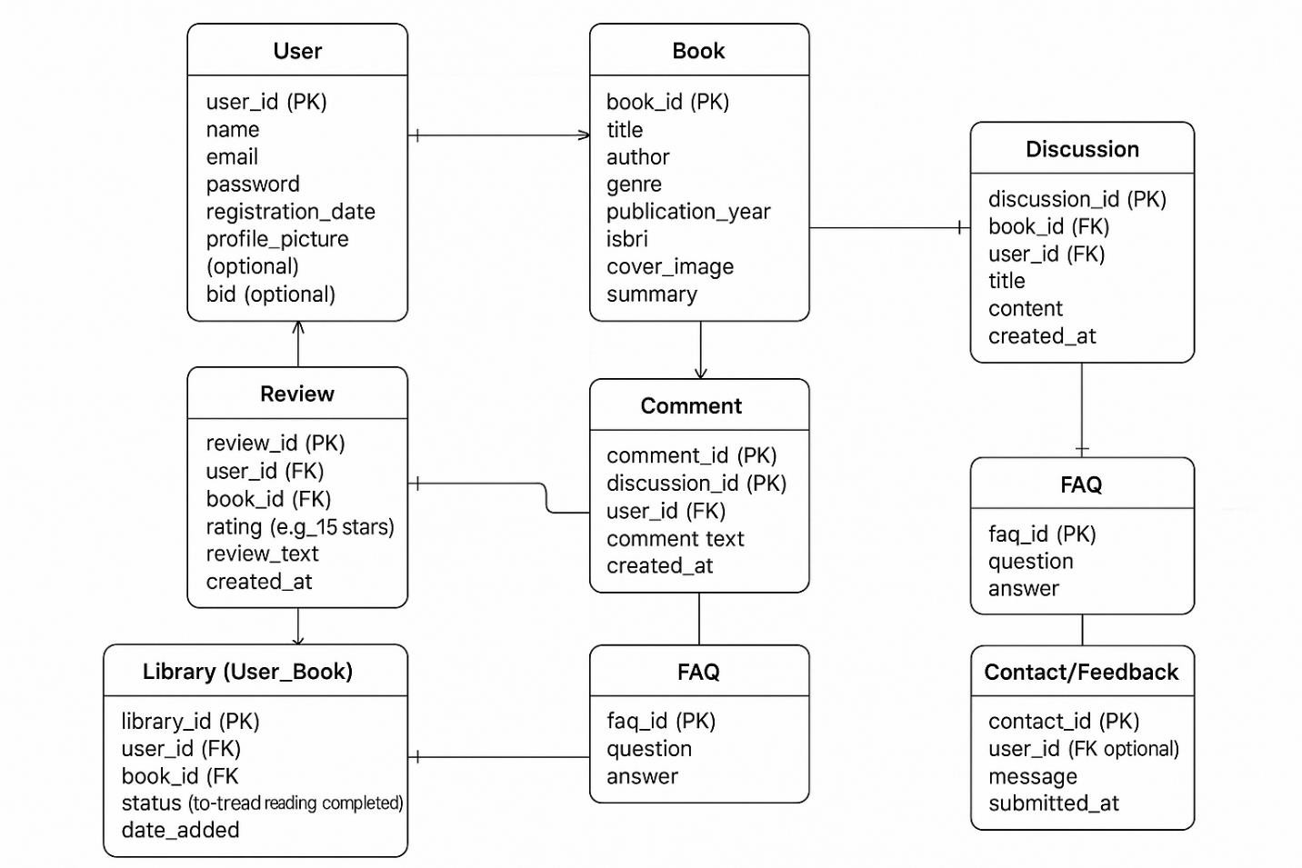

Entity Relationship Diagram (ERD) – Virtual BOOKSHELF
The Entity Relationship Diagram (ERD) for the Virtual BOOKSHELF outlines the key entities and their relationships that form the backbone of the platform’s database. At the center is the User entity, which connects to several other entities to enable personalized and interactive experiences. Each user can add multiple books to their Library, categorizing them by reading status such as “to-read,” “reading,” or “completed.” Users can also write multiple Reviews for different books, providing both star ratings and written feedback, which are then visible to the community.
The Book entity holds essential information like title, author, genre, and publication details, and
is related to many users through the Library and Review entities. Books also serve as the basis for Discussions, where users can initiate or join topic threads related to a specific book. Each

discussion can have multiple Comments, allowing for deeper engagement and literary conversation.
To enhance book discovery, the Recommendation entity records which books are suggested to which users, based on their preferences or reading history. The FAQ entity provides commonly asked questions and answers, accessible to all users for guidance and support. Additiona l ly, the Feedback entity allows users to submit suggestions or report issues, helping administra tors improve the platform.
Relationships are managed through primary and foreign keys, ensuring data integrity and effic ie nt data flow. Many-to-many relationships, such as users having multiple books and books belonging to multiple users, are handled through associative entities like Library. This ERD structure supports robust user interaction, efficient book management, and a vibrant community, all while keeping the backend organized and scalable.

Table Structure

User

Stores registered users’ information, including their unique ID, name, email, password, and profile details. This table manages user authentication and personalizes each user’s experience on the platform.

Column Name | Data Type | Data | Constraints | Description
user_id | INT | PK | Primary Key | User's unique ID
name | VARCHAR(100) |  |  | User's full name
email | VARCHAR(255) | Unique |  | User's email address
password | VARCHAR(255) |  |  | Hashed password
profile_pic | VARCHAR(255) |  |  | URL to user's profile picture (optional)
created_at | DATETIME |  |  | Account creation timestamp

Book
Contains details about each book in the library, such as title, author, genre, publication year, ISBN, cover image, and summary. It serves as the main catalog for all book-related features.
Column Name | Data Type | Data | Constraints | Description
book_id | INT | PK | Primary Key | Book's unique ID
title | VARCHAR(255) |  |  | Title of the book

author | VARCHAR(100) |  |  | Author of the book
genre | VARCHAR(50) |  |  | Genre/category of the book
publication_year | INT |  |  | Year of publication
isbn | VARCHAR(20) | Unique |  | ISBN number
cover_image | VARCHAR(255) |  |  | URL to cover image
summary | TEXT |  |  | Short summary of the book

Review
Records user-submitted reviews for books, including star ratings and written feedback. Each review links a user to a specific book, enabling community-driven opinions and ratings.
Column Name | Data Type | Data | Constraints | Description
review_id | INT | PK | Primary Key | Review's unique ID
user_id | INT | FK | Foreign Key | Linked to User (user_id)
book_id | INT | FK | Foreign Key | Linked to Book (book_id)
rating | INT |  |  | Star rating (1-5)
review_text | TEXT |  |  | User's written review
created_at | DATETIME |  |  | Review creation timestamp

Library(User_Book)
Tracks which books each user has added to their personal library, along with their reading status (to-read, reading, completed) and the date added. This enables users to organize and manage their reading journey.
Column Name | Data Type | Data | Constraints | Description
library_id | INT | PK | Primary Key | Record's unique ID
user_id | INT | FK | Foreign Key | Linked to User (user_id)
book_id | INT | FK | Foreign Key | Linked to Book (book_id)
status | VARCHAR(20) |  |  | Reading status (to-read, reading, completed)
date_added | DATETIME |  |  | Date book was added to library

Discussion
Stores discussion threads initiated by users about specific books, including the discussion’s title, content, and creation date. It facilitates community conversations and literary engagement.
Column Name | Data Type | Data | Constraints | Description
comment_id | INT | PK | Primary Key | Comment's unique ID
discussion_id | INT | FK | Foreign Key | Linked to Discussion (discussion_id)
user_id | INT | FK | Foreign Key | Linked to User (user_id)

comment_text | TEXT |  |  | Comment content
created_at | DATETIME |  |  | Comment creation timestamp

Comment
Holds comments posted by users within discussions, allowing for threaded conversations and deeper interaction on book-related topics.
Column Name | Data Type | Data | Constraints | Description
comment_id | INT | PK | Primary Key | Comment's unique ID
discussion_id | INT | FK | Foreign Key | Linked to Discussion (discussion_id)
user_id | INT | FK | Foreign Key | Linked to User (user_id)
comment_text | TEXT |  |  | Comment content
created_at | DATETIME |  |  | Comment creation timestamp

Reccomendation
Keeps records of books recommended to users, either by the system or other users, along with the date of recommendation. This table supports personalized book discovery.
Column Name | Data Type | Data | Constraints | Description
recommendation_id | INT | PK | Primary Key | Recommendation's unique ID

user_id | INT | FK | Foreign Key | Linked to User (user_id)
book_id | INT | FK | Foreign Key | Linked to Book (book_id)
recommended_on | DATETIME |  |  | Date of recommendation

FAQ
Contains frequently asked questions and their answers, providing users with quick help and guidance about using the platform.
Column Name | Data Type | Data | Constraints | Description
faq_id | INT | PK | Primary Key | FAQ's  unique ID
question | VARCHAR(255) |  |  | FAQ  question
answer | TEXT |  |  | FAQ answer

Relational Design Considerations
- Foreign key constraints maintain data integrity between Users and their Reviews, Library entries, Discussions, Comments, and Recommendations. This ensures that all user- generated content and interactions are correctly associated with the right user and book records.
- The Library (User_Book) table efficiently tracks which books each user is reading, has read, or plans to read, supporting personalized experiences and reading progress management.

- Discussion and Comment tables enable robust community interaction, allowing users to engage in conversations about specific books. Foreign keys ensure that comments are always linked to valid discussions and users.
- The modular design supports easy extension, so additional tables (such as Book Clubs, Author Profiles, or Achievement Badges) can be integrated in the future without disrupting the existing schema.
- The system is horizontally scalable, allowing new users, books, reviews, and discussio ns to be added seamlessly as the platform grows, without the need to alter the core database structure.
- Recommendation and Feedback tables provide a foundation for personalized book suggestions and continuous platform improvement, ensuring the system can adapt to user needs and preferences over time.
These considerations ensure your Virtual BOOKSHELF remains robust, maintainable, and ready for future enhancements while supporting a rich, interactive user experience.

Use Case Diagrams

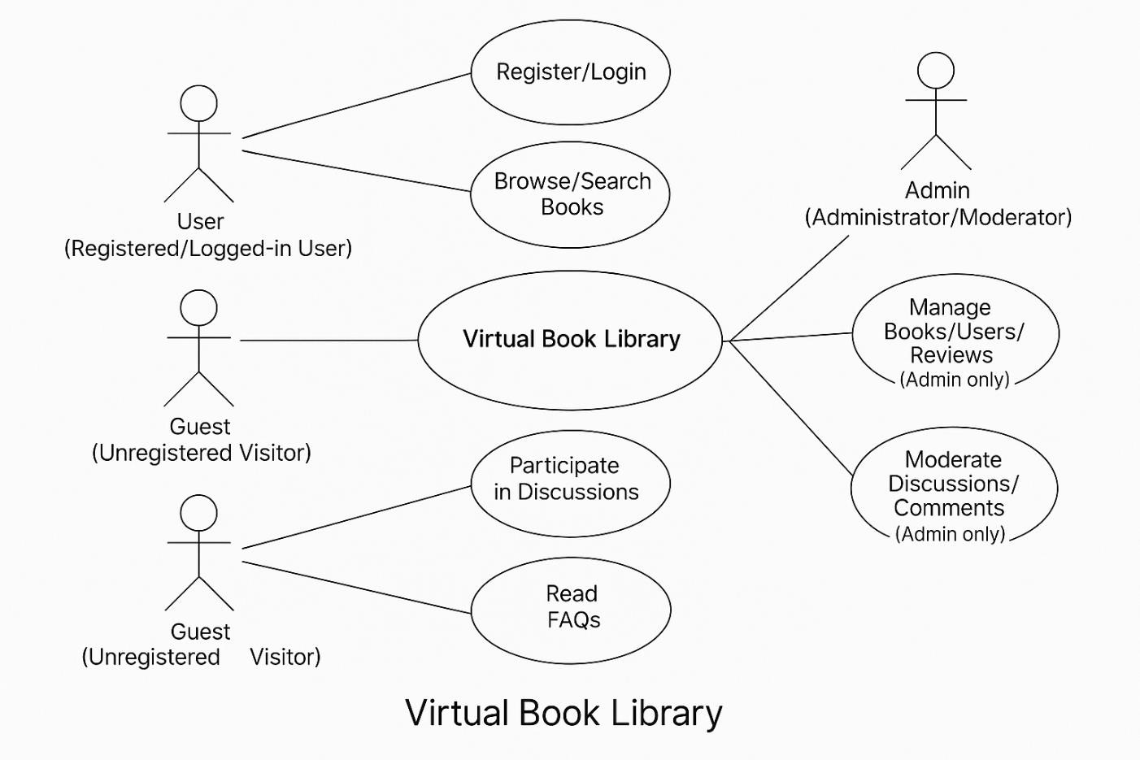

The Use Case Diagram for the Virtual BOOKSHELF system i lustrates a l possible interactio ns between users and the platform, clarifying user roles and the range of available features. The primary actor is the Registered User, who, after logging in, gains access to the fu l suite of functionalities. Guests (unregistered visitors) may browse public content such as book listings, reviews, and FAQs, but cannot personalize their library, submit reviews, or join discussions.
The main use cases for a Registered User include Register/Login (the gateway to personalized features), Browse/Search Books to discover titles, Add Books to Personal Library with status tracking (to-read, reading, completed), Rate and Review Books to share opinions, and Get Personalized Recommendations based on reading history and preferences. Users can also Participate in Book Discussions and Comment on Threads, promoting communit y engagement. Additional use cases include Read FAQs for guidance.

An optional Admin actor is included for content moderation and management. Admins can manage the book catalog, oversee user reviews, and moderate discussions and comments to maintain a healthy community environment.
Each use case is visually connected to the relevant actor, with shared actions such as authentica t ion (Register/Login) optionally marked as ‘included’ in other scenarios. This diagram helps stakeholders quickly understand the scope of user engagement and the distinct roles within the Virtual BOOKSHELF system, ensuring a clear, user-centered design.

Class Diagram
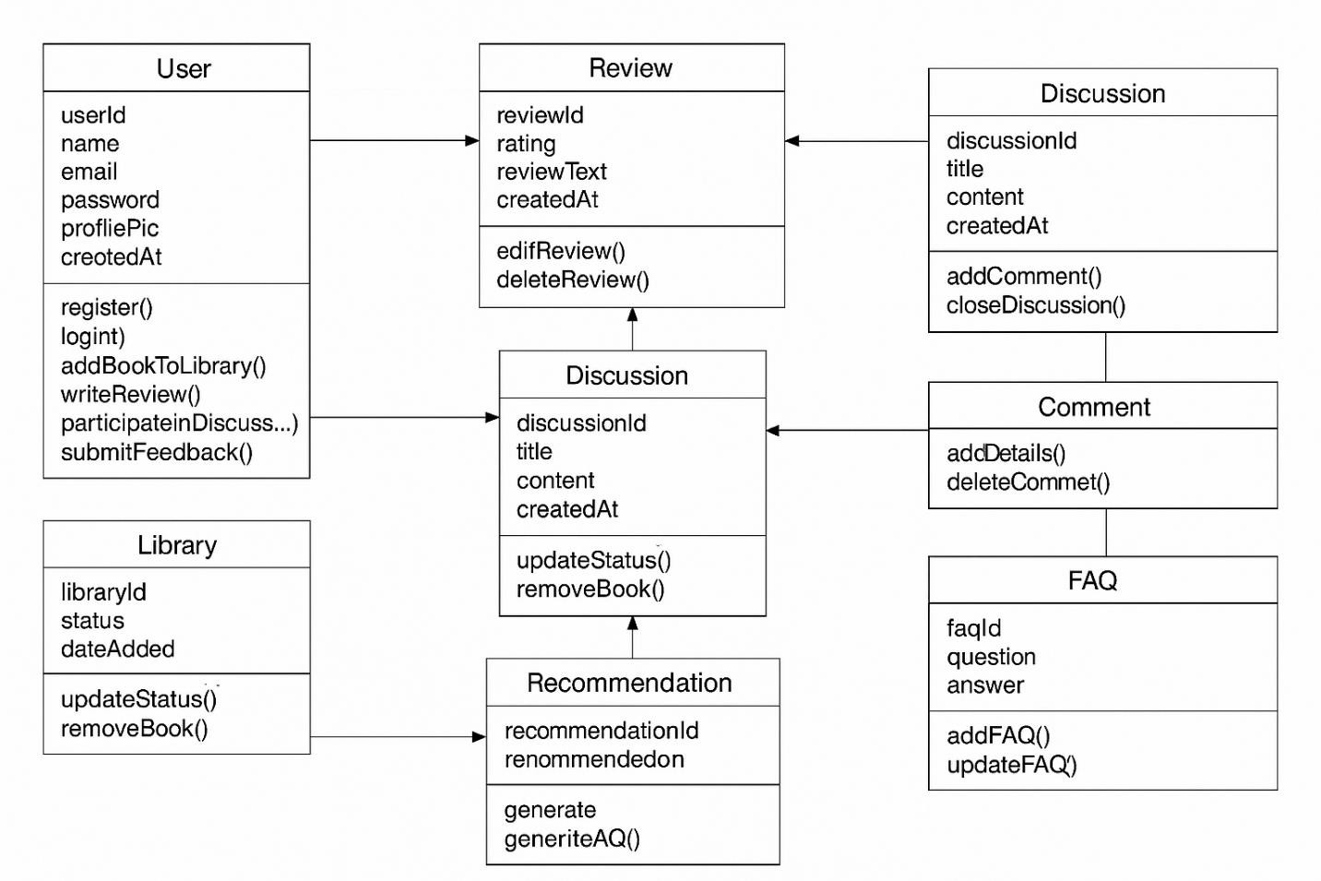

The class diagram for the Virtual BOOKSHELF models the core components and their interactions within the system. At the center is the User class, which encapsulates a l user-related data and behaviors, including registration, authentication, and content creation. Users can add books to their personal Library, write Reviews for books, participate in Discussions, and leave Comments. The Book class represents a l cataloged books and connects to reviews, library entries, and discussions, supporting rich user engagement. Recommendation objects link users to suggested books, while the FAQ classe provide support and communication channels. Each class is designed with clear attributes and methods, and relationships are established via associations and aggregations, ensuring data integrity and supporting a scalable, maintainable system architecture for the virtual library platform.

Activity Diagram
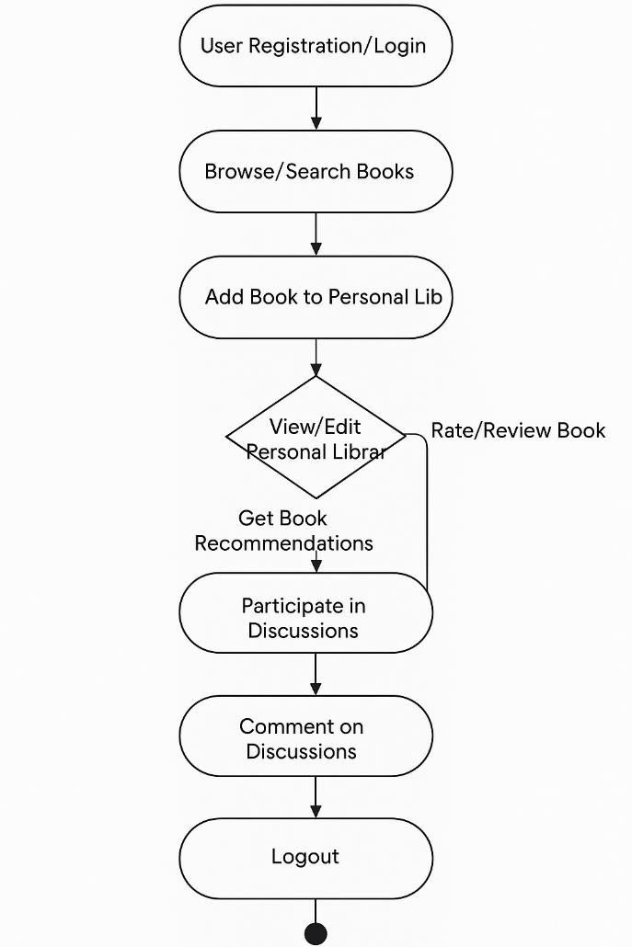
The activity diagram for the Virtual BOOKSHELF i lustrates the sequential flow of user actions from login to logout. The process begins with user registration or login, granting access to the platform’s features. Once authenticated, users can browse or search for books, view detailed information about each title, and add books to their personal library for tracking their reading status. Users may also rate and review books, enhancing the community-driven content, or join discussions and comment on threads to engage with other readers. The system offers personalized book recommendations based on user preferences and reading history. At any point, users can view or edit their personal library to manage their reading journey. The flow concludes with the logout action, ensuring secure session management. This activity diagram captures the interactive, user- centric nature of the Virtual BOOKSHELF , supporting a seamless and engaging reading experience.

Deployment Diagram
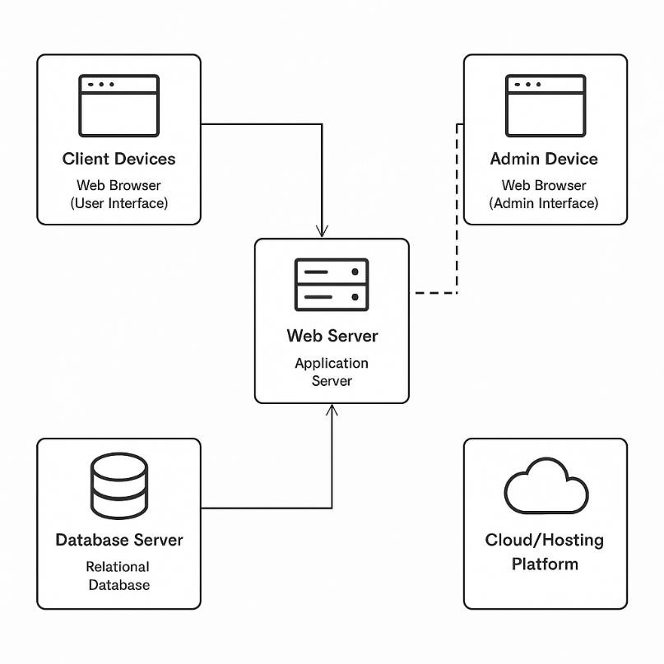
The deployment diagram for the Virtual BOOKSHELF illustrates how the system’s components are distributed across different physical and virtual nodes to deliver a robust, scalable service. End users and administrators access the system through web browsers on their devices, communicating securely with a central web server over HTTPS. The web server hosts the application logic, handling user authentication, book browsing, reviews, library management, discussions, and recommendations. It also provides a dedicated admin interface for managing content and moderating user interactions. All persistent data-including user accounts, book details, reviews, library entries, discussions, comments, and FAQs-is stored in a relational database server, which the application server accesses via secure database connections. The entire system can be deployed on a cloud platform such as AWS or Heroku, ensuring high availability, scalability, and ease of maintenance. This architecture supports seamless user experiences, centralized management, and efficient data handling for the Virtual BOOKSHELF.

Module Hierarchy Diagram
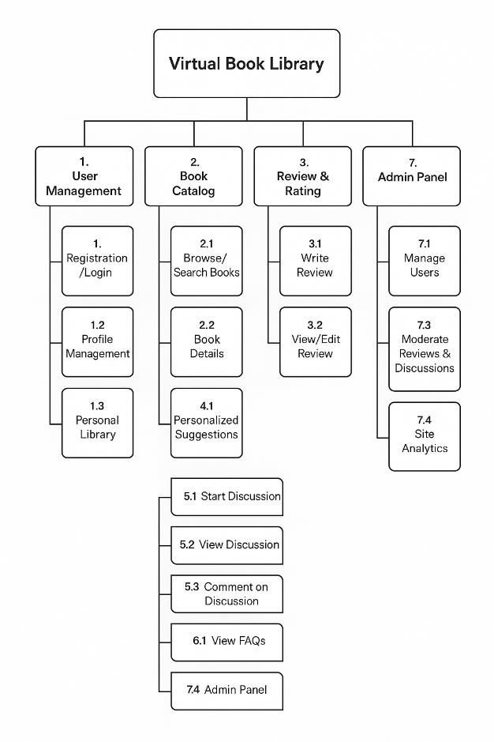
The module hierarchy diagram for the Virtual BOOKSHELF i lustrates the structured organizat ion of the platform’s main functional components. At the top level is the Virtual BOOKSHELF system, which branches into several core modules. User Management handles registration, login, profile editing, and personal library features, ensuring each user can securely manage their account and reading activities. The Book Catalog module enables users to browse, search, and view detailed information about books, as we l as add new titles. The Review & Rating module a lows users to share and manage their opinions on books, fostering communit y engagement. The Recommendation System provides personalized book suggestions based on user preferences and reading history. The Discussion Forum supports interactive conversatio ns, enabling users to start and participate in discussions and comments about books. FAQ & Help offers users quick access to frequently asked questions and guidance. Fina ly, the Admin Panel empowers administrators to manage users, books, reviews, discussions, and view site analytics, ensuring smooth and secure operation of the platform. This hierarchical structureens ures scalability, maintainability, and a clear separation of concerns, making the Virtual BOOKSHELF robust and user-friendly.

3.9 Sample Input and Output Screens


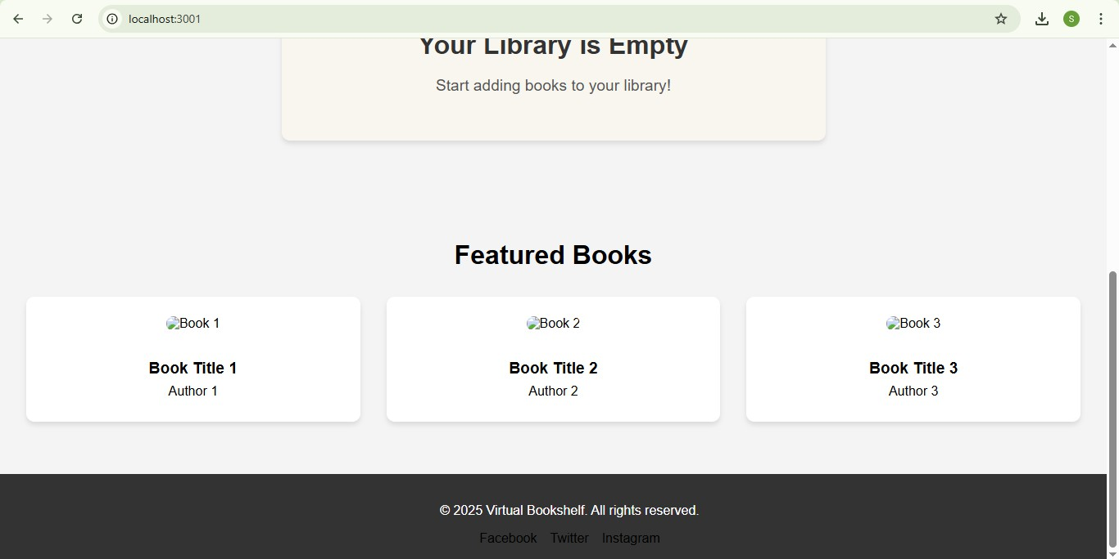

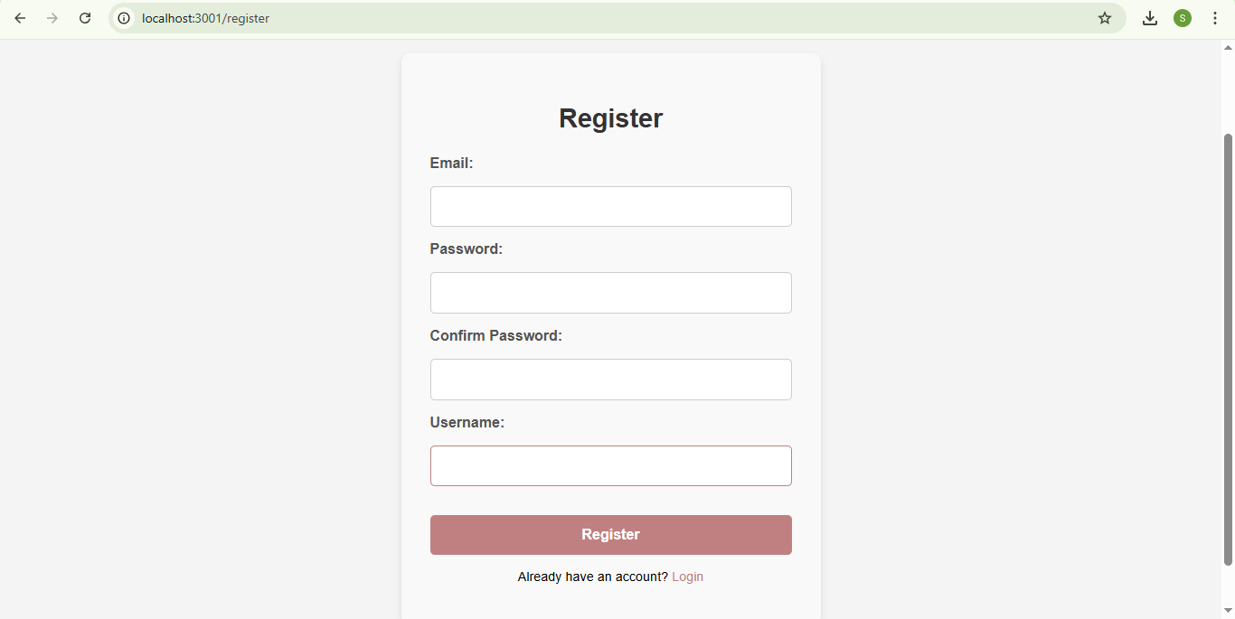

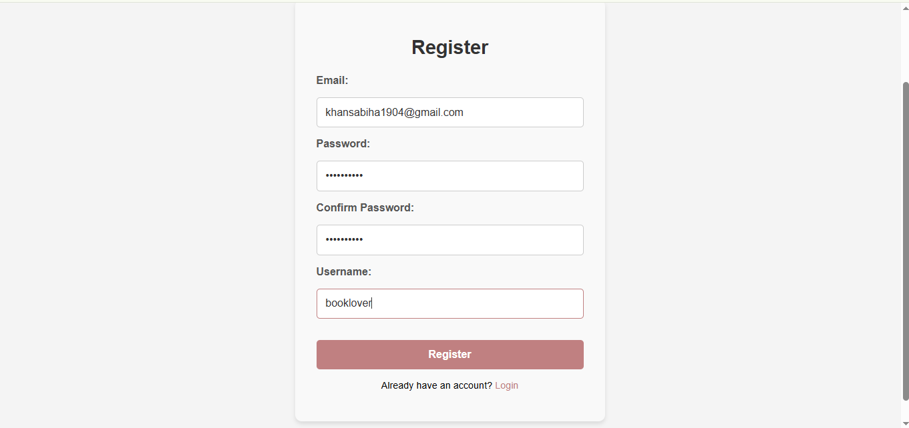

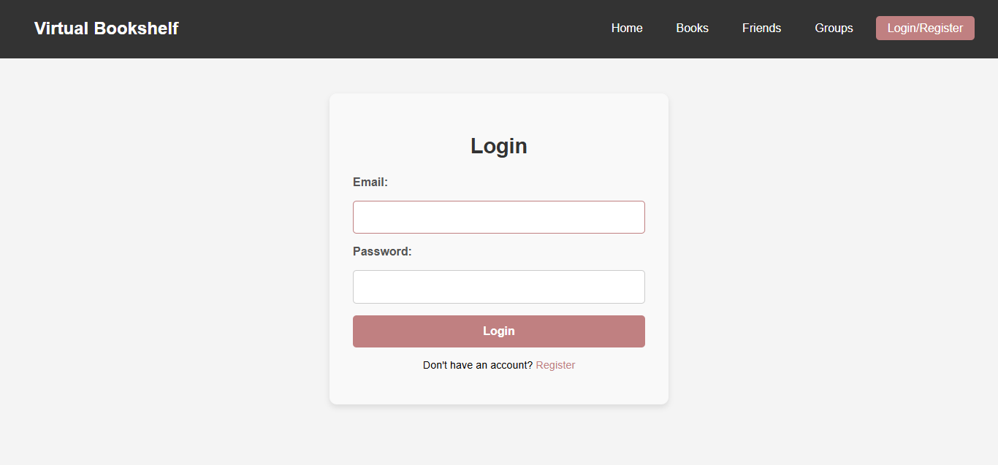

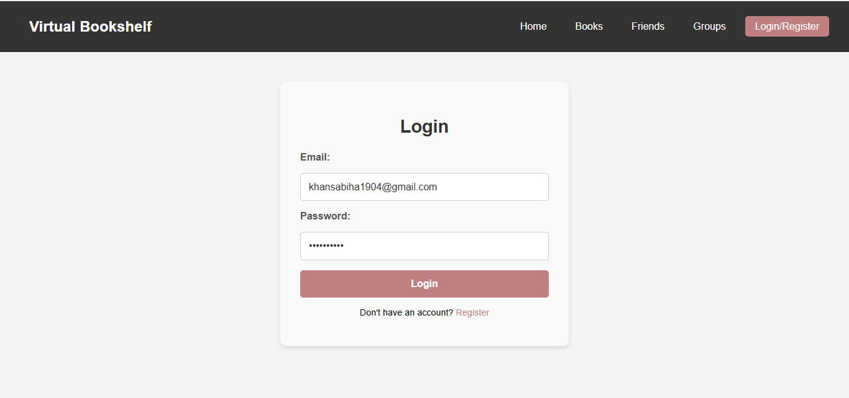

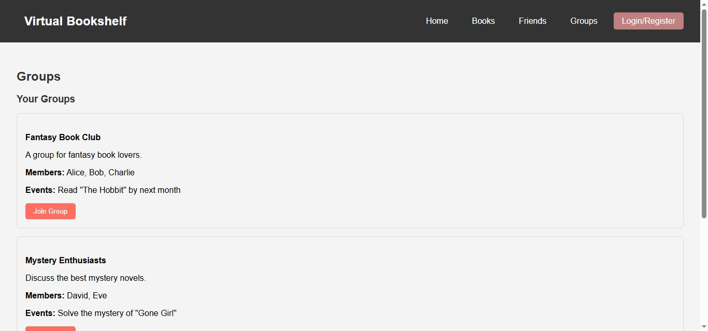

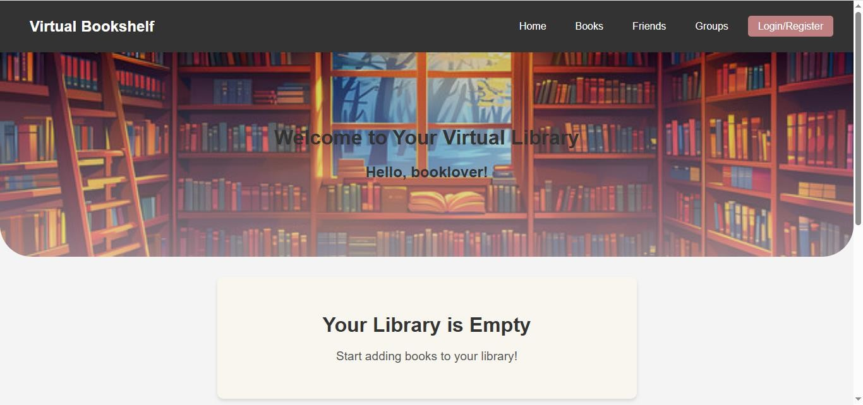

CHAPTER 4

Coding

Algorithms
- Book Search Algorithm
Inputs: search query, filter parameters (genre, author, etc.)

Steps:
  - Receive the user’s search query and selected filters.
  - Query the books database for titles, authors, or genres matching the input.
  - Apply additional filters as needed (e.g., genre, publication year).
  - Return the list of matching books.

Add Book to Library Algorithm
Inputs: user_id, book_id, status (to-read, reading, completed)

Steps:
  - Check if the book already exists in the user’s library.
  - If not, insert a new record linking user_id and book_id with the selected status.
  - If it exists, update the status as needed.
  - Return confirmation of the action.

Book Recommendation Algorithm
Inputs: user_id, user’s reading history, book preferences

Steps:
  - Retrieve the user’s reading history and preferred genres/authors.
  - Analyze books read/rated highly by the user.
  - Find similar books not yet read by the user, prioritizing popular or highly rated titles in those genres.
  - Return a personalized list of recommended books.

Review Submission Algorithm
Inputs: user_id, book_id, rating, review_text

Steps:
  - Check if the user has already reviewed the book.
  - If not, insert the new review into the reviews table.

  - If yes, update the existing review.
  - Recalculate the book’s average rating if necessary.
  - Return confirmation.

Discussion Participation Algorithm
Inputs: user_id, book_id, discussion_title, comment_text

Steps:
  - User creates or joins a discussion thread for a book.
  - Insert the new discussion or comment into the respective table, linked to user_id and book_id/discussion_id.
  - Return confirmation and update the discussion thread view.

Code Snippets
- Book Search (JavaScript/Node.js Example)

javascript
const books = await Book.find({
$or: [
{ title: { $regex: query, $options: 'i' } },
{ author: { $regex: query, $options: 'i' } },
{ genre: { $regex: query, $options: 'i' } }
],
...filters // e.g., { genre: 'Fiction' }
});

Add Book to Library
javascript
const existing = await Library.findO ne({ user_id, book_id });
if (!existing) {
await Library.create({ user_id, book_id, status });
} else {
existing.status = status;
await existing.save();
}

Book Recommendation (Simple Example)
javascript
const user = await User.findById(user_id);
const preferredGenres = user.getPreferredGenres(); const recommendations = await Book.find({ genre: { $in: preferredGenres },
_id: { $nin: user.getReadBookIds() }
}).sort({ rating: -1 }).limit(10);

Submit Review
javascript
const existing = await Review.findO ne({ user_id, book_id });
if (!existing) {
await Review.create({ user_id, book_id, rating, review_text });
} else {
existing.rating = rating; existing.review_text = review_text; await existing.save();
}

Add Comment to Discussion
javascript
await Comment.create({ discussion_id,
user_id, comment_text,
created_at: new Date()
});

CHAPTER 5

Testing
This section outlines the testing strategy and approach adopted to ensure the functionalit y, performance, and reliability of the Virtual BOOKSHELF web application. The testing process includes unit testing of individual modules, integration testing across components, and acceptance testing to verify that user requirements are met.

Test Strategy
The testing strategy adopted for the Virtual BOOKSHELF includes the following:
- Types of Testing: Unit testing, integration testing, and user acceptance testing (UAT).

Tools Used:
  - Jest and React Testing Library for unit testing
  - Cypress for end-to-end testing
  - Manual test cases for UAT
- Testing Environment: Testing is conducted in local and staging environments prior to deployment to production.

Unit Test Plan
Each functional component of the Virtual BOOKSHELF is unit tested individually:

Component | Description | Testing Method
User  Authentication | Validates login, registration, and session  management | Jest, React Testing  Library
Book Search | Checks search input, filtering, and result accuracy | Jest
Add to Library | Ensures books are added/removed correctly | Jest
Book Review | Validates review submission, editing, and display | Jest
Recommendation | Tests personalized book suggestion logic | Jest
Navigation | Ensures correct routing via React Router | React Testing Library

Acceptance Test Plan
End-user scenarios are tested to confirm that the application behaves as expected in a real-world environment.

Scenario | Expected Outcome | Status
User logs in with valid  credentials | Redirected to dashboard/home | Pass
User searches for a book | Displays accurate search results | Pass
User adds a book to library | Book appears in user’s library | Pass
User submits a review | Review is displayed for the book | Pass
User receives  recommendations | Personalized book suggestions shown | Pass
User logs out | Returns to login/home page | Pass

Test Cases / Test Scripts

Test Case  ID | Description | Steps | Expected Result | Status
TC001 | Login with valid  credentials | Enter credentials → Click  login | User is logged in and  redirected | Pass
TC002 | Book search  functionality | Enter search term → Click  search | Relevant books are  displayed | Pass
TC003 | Add book to library | Click “Add to Library” on  book page | Book appears in user’s  library | Pass
TC004 | Submit a book  review | Write review → Submit | Review is visible on  book page | Pass
TC005 | Navigation between  modules | Click navigation links  (Library, Search, Profile) | Correct page/component  is shown | Pass

  - Defect Report / Test Log

Bug ID | Description | Severity | Status | Steps to Reproduce | Resolution
BUG001 | Book not added to library | High | Fixed | Click "Add to Library" → No update | Fixed state  update logic
BUG002 | Review not updating after edit | Medium | Closed | Edit review → Save → Old review shown | Fixed review  update API
BUG003 | Search returns empty for valid term | Low | Closed | Search for existing book | Fixed  search query logic
BUG004 | Navigation bar link  broken | Low | Closed | Click "My Library" → No  redirect | Fixed  route path

This comprehensive testing approach ensures that the Virtual BOOKSHELF is robust, user- friendly, and meets all functional requirements, providing a seamless experience for every user.

CHAPTER 6

Limitations of Proposed System (Expanded)
Despite its aim to provide a comprehensive platform for book discovery, reading manageme nt, and community engagement, the current implementation of the "Virtual BOOKSHELF " system faces several limitations in both technical scope and user experience:
- Manual Data Entry Dependency: Users must manually add books to their library and update reading status or reviews. This reliance on user action can lead to incomplete or outdated records, affecting the accuracy of personal reading logs and recommendations.
- No Real-Time Integration with External Book Sources: The system does not currently integrate with external APIs (such as Google Books or Open Library) for real-time book data, ISBN scanning, or automatic book imports, making book addition and cataloging more tedious for users.

Limited Personalization and AI:
Book recommendations are generated using fixed logic based on genre or basic reading history. There is no advanced machine learning or adaptive recommendation engine that evolves with user preferences or behavior over time.
- Lack of Social Reading Features: The platform does not support real-time book clubs, live reading sessions, or peer-to-peer messaging, which could enhance community engagement and collaborative reading experiences.
- No Offline or Mobile App Support: The Virtual BOOKSHELF is currently accessible only via the web and requires an active internet connection. There is no offline mode or dedicated mobile application, limit ing usability for users in low-connectivity areas.

Limited Accessibility and Language Support:
The system is only available in English and may not be fully accessible to users with disabilities (e.g., lacking screen reader optimization or adjustable font sizes). It also does not cater to users seeking books or discussions in other languages.

- No Integration with E-Readers or Annotation Tools: Users cannot sync their reading progress or notes with popular e-readers (Kindle, Kobo, etc.) or annotate books within the platform, restricting the system’s usefulness for serious readers and researchers.

Minimal Gamification or Motivational Features:
There are no achievements, badges, reading challenges, or progress tracking visualizat ions to motivate users to read more or engage with the community.
- Basic Moderation and Content Control: The current admin features for moderating reviews, discussions, and user activity are limited, potentially leading to spam, inappropriate content, or lack of quality control in community areas.
- No Advanced Analytics or Insights: Users do not have access to detailed analytics about their reading habits, genre preferences, or community engagement, which could help them better understand and improve their reading journey.
These limitations highlight opportunities for future development-such as integrating real-time book data, adding AI-powered recommendations, supporting mobile/offline access, and expanding social and motivational features-to make the Virtual BOOKSHELF more robust, accessible, and engaging for a wider range of users.

CHAPTER 7

Proposed Enhancements (Expanded)
To To overcome the current limitations and further enrich the user experience, the following key enhancements are proposed for future versions of the Virtual BOOKSHELF system:
- Integration with External Book APIs and ISBN Scanning The system will support integration with APIs from sources like Google Books, Open Library, and Goodreads to automatically fetch book details, cover images, and metadata. An ISBN/barcode scanning feature will allow users to quickly add books to their library using their device camera.
- AI-Driven Personalized Recommendations Implementation of machine learning models that analyze user reading history, ratings, and preferences to deliver adaptive and predictive book recommendations. The system will learn from user behavior to suggest books that match evolving interests.

Mobile App with Offline Reading and Library Management
Development of Android and iOS mobile applications with offline capabilities, allowing users to browse their library, read downloaded e-books, and write reviews even without an internet connection.
- Social and Community Features Introduction of book clubs, reading groups, live chat, and peer-to-peer messaging to foster community engagement. Users will be able to join discussions, participate in group reading challenges, and share book recommendations with friends.
- Multilingual and Regional Support The platform will be translated into multiple languages and offer region-specific book suggestions, making it accessible and relatable to a diverse, global audience.
- Integration with E-Readers and Annotation Tools Support for syncing reading progress, highlights, and annotations with popular e-readers (such as Kindle or Kobo) and enabling in-app note-taking and bookmarking.
- Gamification and Reading Challenges Features like badges, reading streaks, achievement levels, and public reading challenges will be introduced to motivate users and make reading more engaging and rewarding.

- Advanced Analytics and Insights Users will have access to detailed analytics on their reading habits, genre preferences, and review activity, helping them track progress and set reading goals.

Accessibility Improvements
Enhanced support for users with disabilities, including screen reader compatibilit y, adjustable font sizes, high-contrast modes, and voice navigation, to ensure inclusivity.
- Enhanced Moderation and Content Control More robust admin tools for moderating reviews, discussions, and user activity, includ ing AI-powered spam detection and content quality checks.
- Integration with Digital Libraries and Open Educational Resources Partnership with digital libraries and open educational resource platforms to provide access to free e-books, academic papers, and educational content.
These enhancements are designed to make the Virtual BOOKSHELF more intelligent, accessible, social, and user-friendly, ensuring it remains a leading platform for book lovers and reading communities worldwide.

CHAPTER 8

Conclusion
The Virtual BOOKSHELF is a user-centric platform designed to simplify book discovery, reading management, and community engagement for readers of all backgrounds. With features such as book search, personal library organization, review and rating submission, and discussion forums, the system empowers users to curate and share their reading experiences. The current implementation provides a solid foundation for a digital reading community by supporting both individual exploration and social interaction around books. While the platform already enhances the reading journey, its true potential will be realized through future enhancements like AI-driven recommendations, mobile support, and richer community features. By continuously evolving based on user feedback and technological advancements, the Virtual BOOKSHELF aspires to become a comprehensive and inclusive hub for book lovers everywhere.

CHAPTER 9

Bibliography
- Google Books API Documentation – https://developers.google.com/books/

- Open Library API Documentation – https://openlibrary.org/developers/api

- Goodreads API Documentation – https://www.goodreads.com/api

- React Documentation – https://reactjs.org/

- Node.js Official Documentation – https://nodejs.org/en/docs/

- MySQL Official Documentation – https://dev.mysql.com/doc/

- Tailwind CSS Documentation – https://tailwindcss.com/

- W3Schools HTML, CSS, and JavaScript Tutorials – https://www.w3schools.com/

- Mozilla Developer Network (MDN) Web Docs – https://developer.mozilla.org/

- Lucidchart ERD and UML Diagram Resources – https://www.lucidchart.com/pages/er- diagram-symbols-and-meaning
- draw.io Diagram Tool – https://www.diagrams.net/

- “Best Online Book Communities” – Book Riot, https://bookriot.com/best-online-book- communities/
- “How to Build a Book Review Website” – freeCodeCamp, https://www.freecodecamp.org/news/how-to-build-a-book-review- website/
- GitHub – Open Source BOOKSHELF Projects, https://github.com/topics/book-library

CHAPTER 10

Publications and Presentations
- The development and implementation of the Virtual BOOKSHELF web application have been documented and presented as part of the academic curriculum.
- Project findings, design strategies, and system architecture were shared in internal seminars
and project review meetings within the institution.
- The project report serves as a comprehensive documentation of the system’s design, development, testing, and deployment processes.

CHAPTER 11
- Appendix – Datasheet (Updated)

Module | Technologies Used | Purpose
User Authentication | React, Node.js, JWT | Handles user registration, login, and secure session management.
Book Search &  Catalog | React, Node.js,  MySQL/MongoDB | Enables users to search, filter, and browse the book  database.
Personal Library | React, Node.js, MySQL/MongoDB | Allows users to add, organize, and track their own collection of books.
Review & Rating | React, Node.js, MySQL/MongoDB | Lets users submit, edit, and view reviews and ratings for books.
Recommendation  Engine | Node.js, Python (optional),  ML libs | Suggests books to users based on their reading history  and preferences.
Discussion Forum | React, Node.js, MySQL/MongoDB | Provides a platform for users to participate in book discussions and post comments.
UI Components | shadcn/ui, Tailwind CSS | Ensures a consistent and responsive user interface across devices.
Navigation &  Routing | React Router | Manages navigation between modules like  library, search, reviews, and discussions.
Input Validation | Form Libraries (Formik, Yup, etc.) | Ensures all user inputs (reviews, registration, etc.) are valid and correctly formatted.
Admin Panel | React, Node.js,  MySQL/MongoDB | Allows administrators to manage users, books,  reviews, and moderate discussions.

CHAPTER 12

User Manual
This user manual guides end-users through the key modules and functionalities of the Virtual BOOKSHELF system. The application is developed using React.js and Tailwind CSS for the frontend, Node.js for the backend, and MySQL/MongoDB for data management. The platform is designed to make book discovery, reading management, and community engagement simple and interactive for all users.

Home Page Purpose:
Provides an overview of the platform and easy navigation to all main sections.

Features:
- Welcome message and introduction to the library
- Navigation bar with links to Search, Library, Reviews, Discussions, and Profile
- Responsive design for both mobile and desktop

Validation:
- No input fields on this page

User Login / Signup Purpose:
Allows users to securely register and log in for a personalized experience.

Features:
- Login form (email and password)
- Registration form (name, email, password, confirm password)
- Password reset option

Validation:
- Email must be in valid format (e.g., user@example.com)
- Password: Minimum 6 characters, must include letters and numbers
- Confirm Password must match Password
- All fields required

Book Search & Catalog

Purpose:
Enables users to search for books by title, author, or genre.

Features:
- Search bar for keywords
- Filter by genre, author, or publication year
- Book details view with cover, description, and ratings

Validation:
- Search input must not be empty
- Maximum 50 characters
- Only letters, digits, and spaces allowed

Personal Library Purpose:
Allows users to manage their own collection of books.

Features:
- Add/remove books from library
- Update reading status (To-Read, Reading, Completed)
- View and organize personal reading list

Validation:
- User must be logged in to modify library
- Book addition/removal confirmed with notifications

Review & Rating Purpose:
Lets users submit and view reviews and ratings for books.

Features:
- Submit star rating and written review
- Edit or delete own reviews
- View all reviews for a book

Validation:
- Review text: 10–500 characters
- Rating: 1–5 stars
- Only logged-in users can submit or edit reviews

Recommendation Engine Purpose:
Suggests books to users based on their reading history and preferences.

Features:
- Personalized book recommendations on dashboard
- Option to refresh or dismiss suggestions

Validation:
- Recommendations update only after user activity (reading, rating, etc.)

Discussion Forum Purpose:
Enables users to participate in book-related discussions and comment threads.

Features:
- Start new discussion threads on books
- Post and reply to comments
- View all active discussions

Validation:
- Discussion/comment text: 5–500 characters
- Only logged-in users can post

Blogs & Articles Purpose:
Provides dynamic content such as book reviews, author interviews, and reading tips.

Features:
- Scrollable blog/article list
- Search by keyword

Validation:
- Keyword input limited to 40 characters
- Alphanumeric search input only

Search Functionality Purpose:
Allows users to quickly find books, authors, or articles.

Input:

- Search bar in header

Validation:
- Input must not be empty
- Max 50 characters
- Only letters, digits, and spaces allowed

FAQ & Contact Page Purpose:
FAQs address common queries; contact form allows feedback or support requests.

Input Fields (Contact Form):
- Name
- Email
- Message

Validation:
- All fields required
- Email must be valid
- Message: 10–500 characters
This manual ensures that users can easily navigate and utilize all features of the Virtual BOOKSHELF, from discovering books to engaging with the reading community.

