HEALTHHUB UI REDESIGN   
By Saaipranav Subramanian,   
Frederick Rico Hartanto, Sihan Chen  
  
  
  
  
  
  
  
  
Project overview  
Welcome to the HealthHub Redesign Project! This initiative aimed to enhance the user experience of the HealthHub app, a popular health platform in Singapore. The end goal of this project will be to create high-fidelity prototypes, addressing usability concerns, and optimizing key features to improve overall user satisfaction. Project Goals Objective: To redesign HealthHub for improved user engagement and satisfaction. Key Focus Areas: Usability, UI/UX enhancements, feature optimization. Hypothesis: Improved UI/UX designs, and additional features will attract more users and improve overall user satisfaction.  
  
**Project Phase 1;** Interviews... and some more interviews.  
In the initial phase of our project, we conducted interviews to gather insights and assess the user experience of the HealthHub app specifically what aspects of HealthHub did they dislike or found confusing and if that is the reason you stay away from it.   
In this stage we also attempted to secure an interview with HealthHub’s software engineer team on some *questionable* design choices but sadly we were unsuccessful [fig 1,2], leading us to back to our original approach – interviewing people at our university !

Figure 2

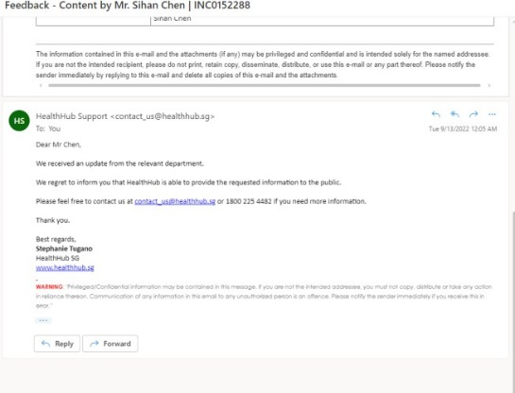

Figure 2

|  |  |  |  |  |
| --- | --- | --- | --- | --- |
| **Product under test:**  Original HealthHub App  Nonprototype MVP | **Test objectives:**  Find out if any parts of HealthHub are confusing users, and if that is the reason why they are not  willing to use it. | **Participants:**  1 interviewee,  1 interviewer, 1/2 observer(s) | **Test tasks:**  Showcase HealthHub App, ask for any confusion. | **Responsibilities:**  Interviewers need to use unbiased interview questions to retrieve users’ opinions |
|  |  |  |
| **Business case:**  What parts of HealthHub UI/UX are confusing to users |  | **Equipment:**  Original HealthHub App Nonprototype MVP |  | **Location and dates:**  Discord Sep 9th |
| **Procedure:**  Display HealthHub App to interviewee  => ask what parts of HealthHub make them frustrated  => ask what their reasons are to not use HealthHub  => ask interviewee what improvements they would love to see | | | | |

*Interview Table*  
  
  
*Feedback Grid*

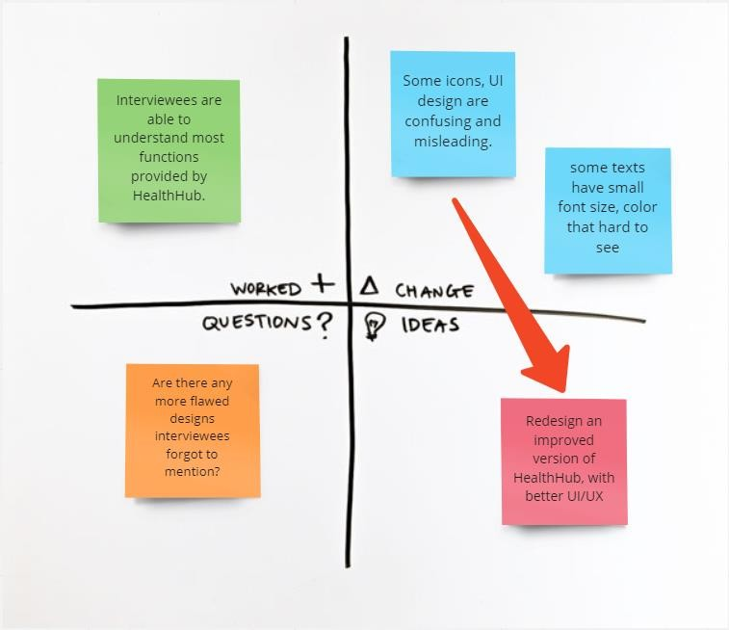

*Figure 3 - Nonprototype Feedback Grid  
  
  
  
Summary*

We believe to recreate and make improvements on HealthHub UI/UX, would make it appeal to more users, and solve the problem we are facing.  
  
  
  
  
 **Project Phase 2;** Low-fidelity MVP  
  
*Things that can be improved*  
1. No map function when selecting appointment, for people who are not familiar with surroundings (people who just moved to a new flat, foreigner) have no idea which hospital/clinic to choose from  
2. Missing text description on the bottom navigation tab  
3. Account balance page change be changed to e-receipt page  
4.Contact us page  
5. Different profiles  
6.Much more clear page title  
7.Miscellaneous bugs and bad designs: ‘Appointment’, ‘Payment’ are not fully integrated into HealthHub, more like opening new web page inside the HealthHub App.  
  
  
*MVP*

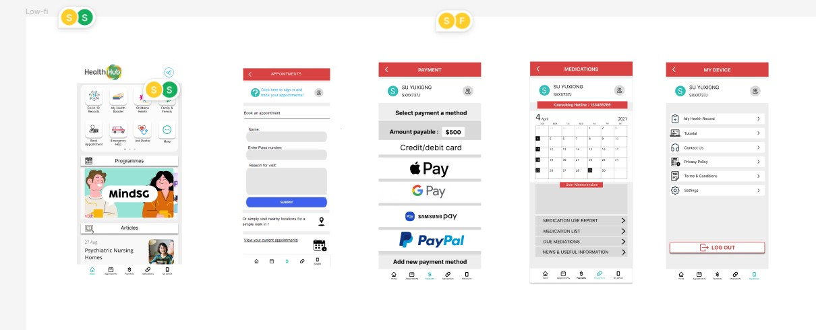

*Figure 4 – Low-Fi MVP*

*Interview Table*

|  |  |  |  |  |
| --- | --- | --- | --- | --- |
| **Product under test:** Low-fi MVP | **Test objectives:**  Find out if interviewee recognize our improvements are useful.  Ask for critics and feedbacks. | **Participants:**  1 interviewee,  1 interviewer, 1/2 observer(s) | **Test tasks:**  Showcase MVP, ask if user approve of our modifications.  What design elements are confusing to them.  What did we miss, any more potential improvements we did not think of? | **Responsibilities:**  Tester needs to clearly explain what changes we made, and the reasonings behind them. |
| **Business case:** Get interviewee feedback on low-fi MVP | **Equipment:**  Low-fi MVP | **Location and dates:**  Discord Sep 11th |
| **Procedure:**  Showcase Low-fi MVP  => ask interviewee if they like the changes we made  => ask for critics, and is there any more things we missed that use some improvement | | | | |

*Feedback Grid*

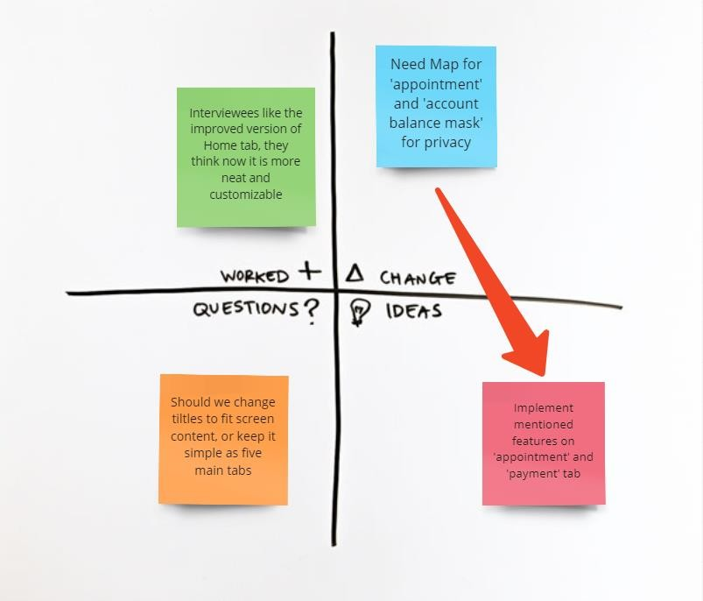

*Figure 5 - Low-Fi Feedback Grid*

*Summary*

We used design studio technique, each group member re-created several tabs from HealthHub, and we gave

critics and feedbacks to each other. Finally, we merge our works together into low-fi MVP.

After we finished interviews, we learned that despite the unembellished design, interviewees are appreciating adjustments we made, they believe those changes make App more straightforward and relatable to their real-life scenarios. However, there are still more improvements and new features we can implement:

* Map for nearby search on ‘Appointment’ tab
* Privacy blur for account balance on ‘Payment’ tab
* Overall display, as well as a detailed version of health-related transactions on ‘Payment’ tab
* Add text descriptions on Navbar icons
* Use high contrast color for better visibility