CIPHER BLOCK CHAINING

Cipher block chaining (CBC) is a mode of operation for a block cipher (one in which a sequence of bits are encrypted as a single unit or block with a cipher key applied to the entire block). Cipher block chaining uses what is known as an initialization vector (IV) of a certain length. One of its key characteristics is that it uses a chaining mechanism that causes the decryption of a block of cipher text to depend on all the preceding ciphertext blocks. As a result, the entire validity of all preceding blocks is contained in the immediately previous ciphertext block. A single bit error in a ciphertext block affects the decryption of all subsequent blocks. Rearrangement of the order of the ciphertext blocks causes decryption to become corrupted.

ERROR PROPAGATION

Before the widespread use of message authentication codes and authenticated encryption, it was common to discuss the "error propagation" properties as a selection criterion for a mode of operation. It might be observed, for example, that a one-block error in the transmitted ciphertext would result in a one-block error in the reconstructed plaintext for ECB mode encryption, while in CBC mode such an error would affect two blocks.
Some felt that such resilience was desirable in the face of random errors (e.g., line noise), while others argued that error correcting increased the scope for attackers to maliciously tamper with a message.
However, when proper integrity protection is used, such an error will result (with high probability) in the entire message being rejected. If resistance to random error is desirable, error-correcting codes should be applied to the ciphertext before transmission.

ENCRYPTION

In cipher block chaining, the plaintext is divided into blocks of 128 bits and each plaintext block is XORed initially with an Initialisation Vector (IV) and the resultant text block is again XORed with a key, the key is common to all blocks of text, thus resulting in cipher text for the first block. Then, the next block of plain text is taken and XORed with the immediately previous ciphertext block, and then the resultant block is XORed with the common key and thus the chain goes on.

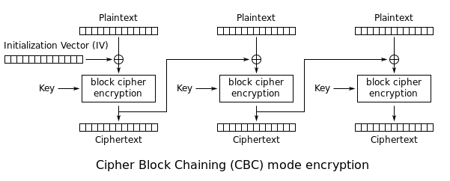

DECRYPTION

In cipher block chaining, the cipher text is divided into blocks of 128 bits and the first such block is taken and is XORed with the common key , then the resulting text block is taken and XORed with the Initialisation Vector(IV) and thus the plaintext for the first cipher text block is obtained, now a similar procedure is followed for decrypting the next cipher text block, but here, the immediately previous block becomes the Initialisation Vector now and thus the chain goes on.

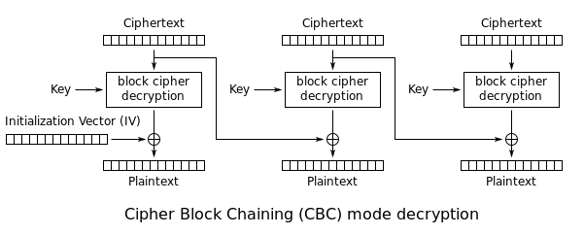

WORKING

FIRST WINDOW

On running the file, first, a window opens which has 4 options, there , we can chose to:

Instant Encryption / Decryption: Encrypts or Decrypts a few lines.

File Encryption / Decryption: Encrypts or Decrypts a file in the same directory as the CBC file.

Folder Encryption / Decryption: Encrypts or Decrypts all files in a folder in any chosen directory.

Exit: Closes the current window.

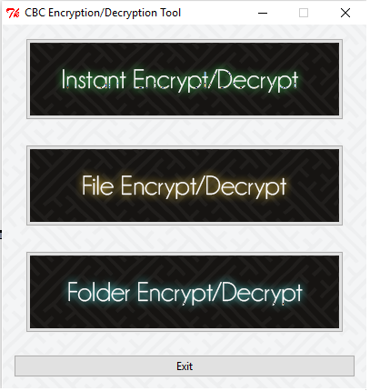

INSTANT ENCRYPTION / DECRYPTION WINDOW

This window has a text box where you can input the text you want to encrypt or decrypt, this window also has a box which has the key for encryption / decryption and then there is another box which stores the outputted decrypted / encrypted text. This window has 3 buttons, The “Encrypt” button encrypts data, the “Decrypt” button decrypts data and “Exit” button closes the window.
And at the bottom of the window there is a status bar, which tells us about the status of the current operation being performed.

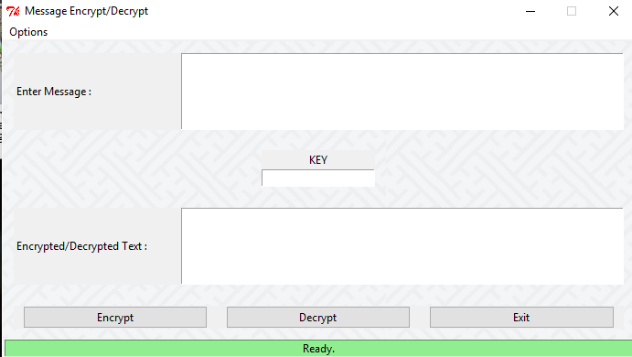

FILE ENCRYPT / DECRYPT WINDOW

This window has a text box where you can input the name of the file you want to encrypt or decrypt, you can also browse to the location of the file using the browse button, this window also has a box which has the key for encryption / decryption. This window has 3 buttons, The “Encrypt” button encrypts data, the “Decrypt” button decrypts data and “Exit” button closes the window.
And at the bottom of the window there is a status bar, which tells us about the status of the current operation being performed.

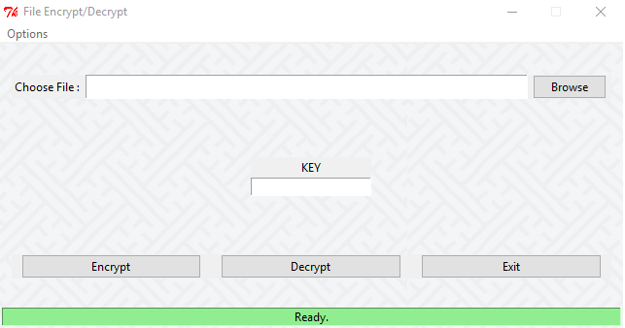

FOLDER ENCRYPT / DECRYPT WINDOW

This window has a text box where you can input the name of the folder you want to encrypt or decrypt, you can also browse to the location of the folder using the browse button, this window also has a box which has the key for encryption / decryption. This window has 3 buttons, The “Encrypt” button encrypts data, the “Decrypt” button decrypts data and “Exit” button closes the window. And at the bottom of the window there is a status bar, which tells us about the status of the current operation being performed.

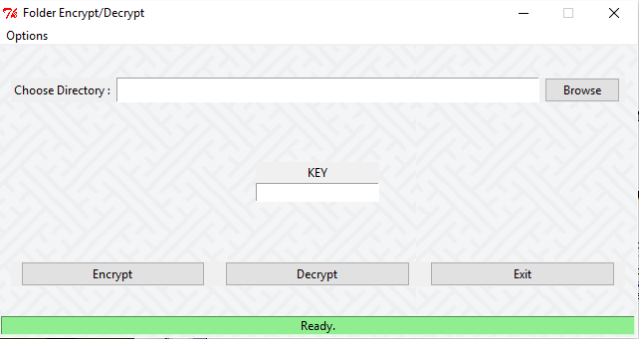

MODULES

Functions

displayMessagea() – This function displays a warning message if you try to close the window by clicking a button which isn’t the “Exit” button.

displayError() –This function is called if any unexpected error arises while execution of the program.

askToQuit() – This function is called when the user decides to quit the profram and it displays a message asking the user to confirm his choice.

ExitScreen()- This function is called when you press the exit button and it closes the window temporarily

InitializeMenu()- This function creates the menu bar for a window

Classes

MainWindow- This class is responsible for the Main window

__init__() – This is the constructor for the class and initialises all
elements to legal false values

option1() – This function is called when the user clicks the first button
(I.E Instant encryption / decryption)

option2() – This function is called when the user clicks the second
button (I.E File encryption / decryption)

option3() – This function is called when the user clicks the third
button (I.E Folder encryption / decryption)

InstantEnc – This class has all the functions and statements needed to open and run the Instant encryption / Decryption window

FileEnc – This class has all the functions and statements needed to open and run the File encryption / Decryption window

FolderEnc – This class has all the functions and statements needed to open and run the Folder encryption / Decryption window

