J S S Mahavidyapeetha

Sri Jayachamarajendra College of Engineering (SJCE), Mysuru – 570 006

An Autonomous Institute Affiliated to

Visvesvaraya Technological University, Belagavi

|  |  |  |
| --- | --- | --- |
| final2 |  |  |

**Web Technologies Lab Record**

Lab record submitted in partial fulfillment of curriculum prescribed for the award of the degree of

#### BACHELOR OF ENGINEERING

**IN**

**COMPUTER SCIENCE AND ENGINEERING**

*by*

# **Saif Ali**

**(4JC14CS086)**

**DEPARTMENT OF COMPUTER SCIENCE & ENGINEERING**

**October 2017**

1. Design a web page using CSS with suitable design for the following:
2. Demonstrate different font styles
3. Control the repetition of image with background-repeat property
4. Define style for links as a:link, a:active, a:hover, a:visited
5. Demonstrate Element visibility property.

**Program:**

<html>

<head>

<title>Program 1</title>

<meta description="Author" content="Saif Ali" />

<styl

.container {

margin: 10 auto;

max-width: 1000px;

background: #d3d3d3;

display: block;

overflow: hidden;

padding: 20px;

}

.cont2 {

margin: 0px 10px 10px 10px;

padding: 5px;

display: block;

overflow: hidden;

}

.italic {

font-style: italic;

}

.oblique {

font-style: oblique;

}

.one-third {

width: calc(30% - 5px);

float: left;

padding: 5px;

min-height: 250px;

border: 1px solid black;

background-image: url("img.jpg");

}

.mylink {

color: red;

text-decoration: none;

}

.mylink:hover {

color: blue;

text-decoration: underline;

font-style: oblique;

}

.mylink:visited {

color: purple;

text-decoration: none;

font-style: italic;

}

.mylink:active {

color: green;

}

</style>

<script type="text/javascript">

function hideIt(){

var dom = document.getElementById("flo").style;

if(dom.visibility=="hidden")

dom.visibility="visible"

else

dom.visibility="hidden"

}

</script>

</head>

<body>

<div class="container">

<h1>1. Different font styles </h1>

<div class="cont2">

<p>This is normal font</p>

<p class="italic">This is italicized font</p>

<p class="oblique">This is oblique font</p>

</div>

<hr>

<h1>2. Repeated image </h1>

<div class="cont2">

<div class="one-third" style="background-repeat:repeat-y;"><img src="flower.jpg"></div>

<div class="one-third" style="background-repeat:repeat-x;"><img src="flower.jpg"></div>

<div class="one-third" style="background-repeat:repeat;"><img src="flower.jpg"></div>

</div>

<hr>

<h1>3. Link styles </h1>

<div class="cont2">

<a class="mylink" href="#">Click here for more fllowers</a>

</div>

<hr>

<h1>4. Element visibility </h1>

<div class="cont2">

<div class="one-third" style="visibility:visible;">

<img id="flo" style="visibility: visible;" src="flower.jpg">

<button onclick="hideIt()">Click</button>

</div>

<div class="one-third" style="visibility:collapse">Visibility:collapsed</div>

</div>

</div>

</body>

</html>

**Output:**

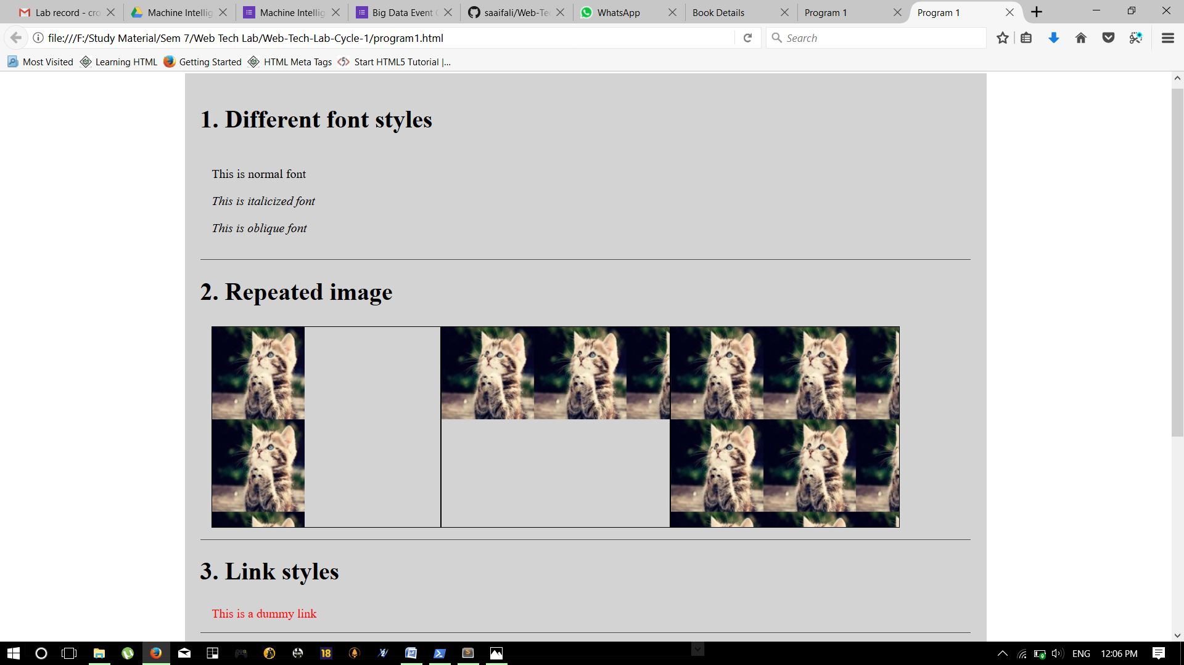

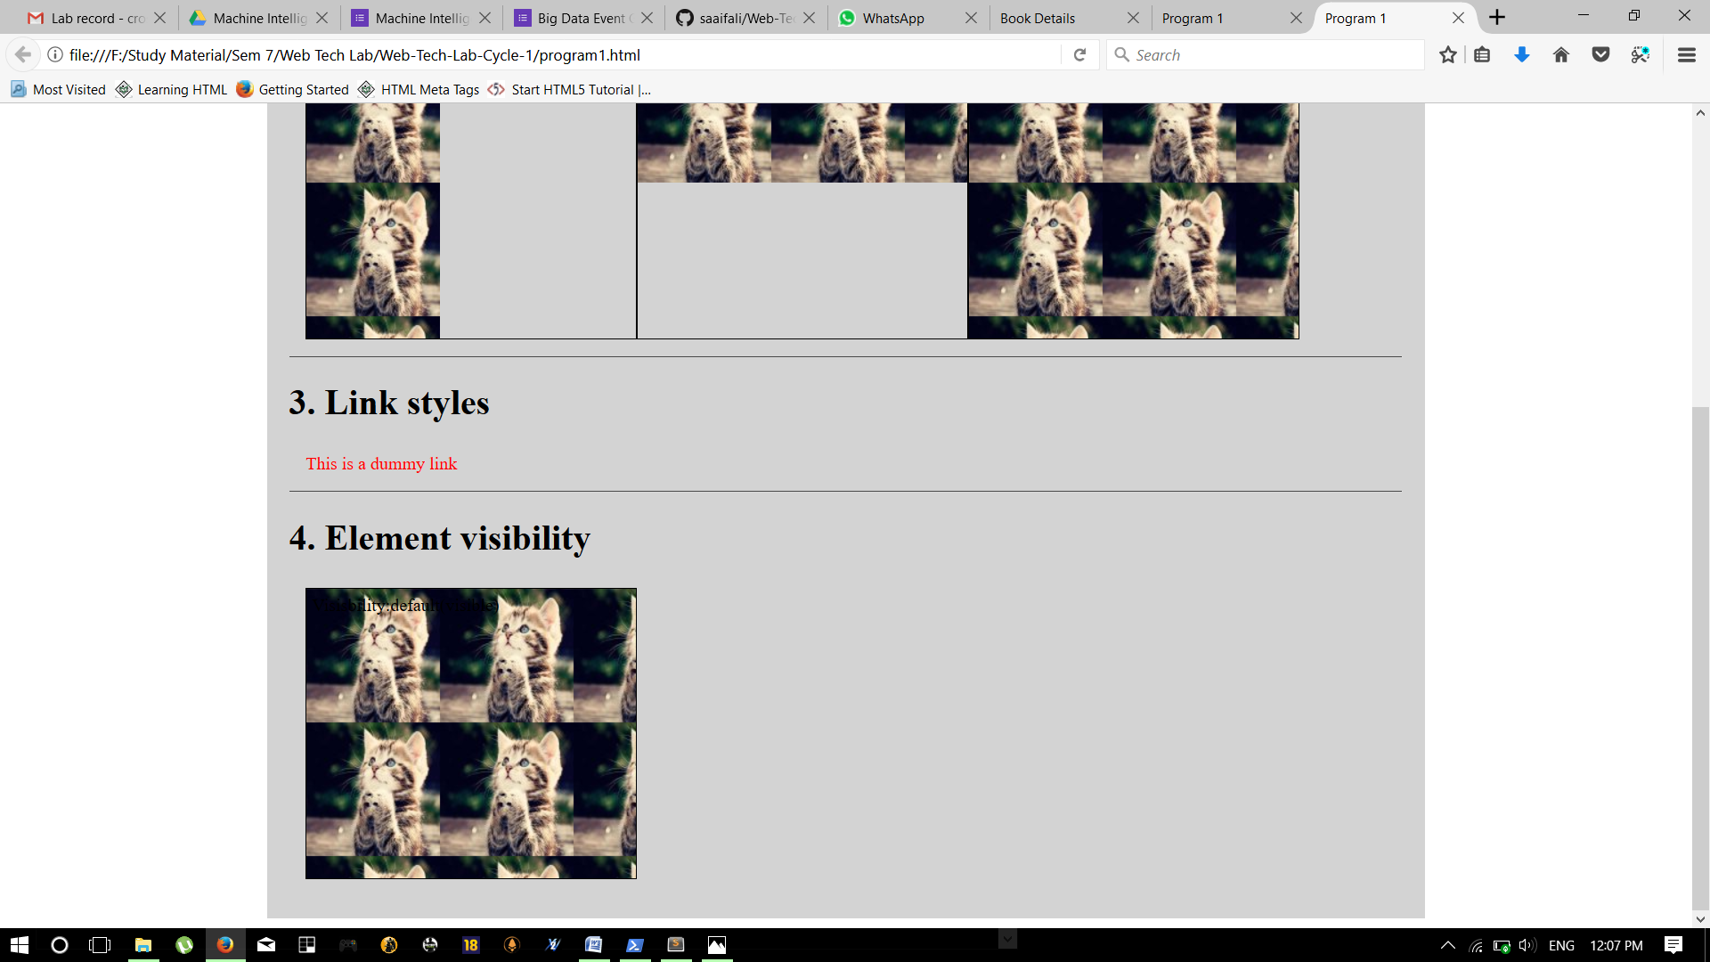

1. Write an XHTML and java script to validate the following fields in a registration page
   1. User ID (must be of length 5 to 12)
   2. Name (only alphabets and the length should not be less than 15 characters)
   3. Password (must be eight characters including one uppercase letter, one special character and alphanumeric characters)
   4. E-mail(should not contain invalid addresses)

**Program:**

<html>

<head>

<h1 align=center>Welcome to Validation Checking</h1>

<hr width=50%>

<script language="javascript">

function validation() {

var x = f.un.value;

var len = x.length;

var val = x.charCodeAt(0);

var p = f.pw.value;

var c = f.cpw.value;

var a = f.email.value;

var atpos = a.indexOf("@");

var dotpos = a.lastIndexOf(".");

if (len < 6 || x == '' || x == null) {

alert("check your username! must be minimum 6 characters");

if (val < 65 || val > 90 && val < 97 || val > 122)

alert("username must begin with an alphabet");

return false;

} else if (val < 65 || val > 90 && val < 97 || val > 122) {

alert("username must begin with an alphabet");

return false;

} else if (p == '' || c == '' || p.length < 6 || c.length < 6 || p != c) {

alert("Password and Confirm Password should be same and greater than 6 characters!");

return false;

} else if (atpos < 6 || dotpos < atpos + 6 || dotpos + 2 >= a.length) {

alert("Not a valid email id");

return false;

} else

alert("Congragulations! you have submited successfully");

}

</script>

</head>

<title> Validation Check! </title>

<body>

<table align=center border=1>

<form name="f" action="success.html" onsubmit="return validation();" method="post">

<tr>

<td>User Name:</td>

<td><input type="text" name="un" /></td>

</tr>

<tr>

<td>Password:</td>

<td><input type="password" name="pw" /></td>

</tr>

<tr>

<td>Confirm Password:</td>

<td><input type="password" name="cpw" /></td>

</tr>

<tr>

<td>E-mail ID:</td>

<td><input type="text" name="email" /></td>

</tr>

<tr>

<td></td>

<td><input type="submit" value="Submit" /></td>

</tr>

</form>

</table>

</body> </html>

**Output:**

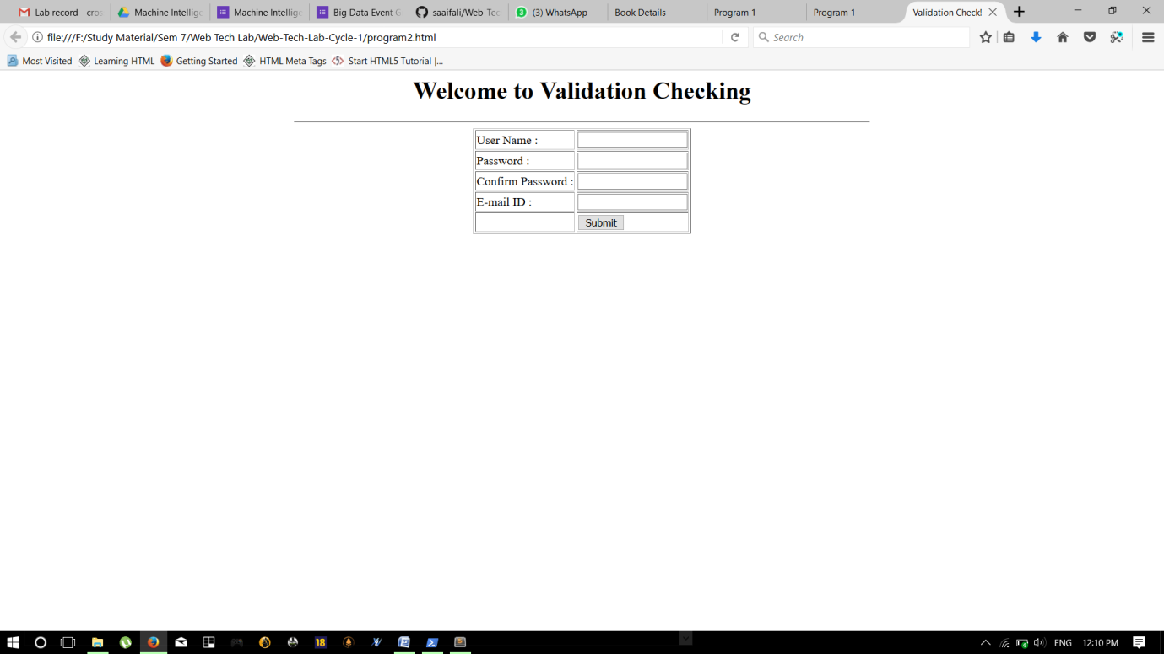

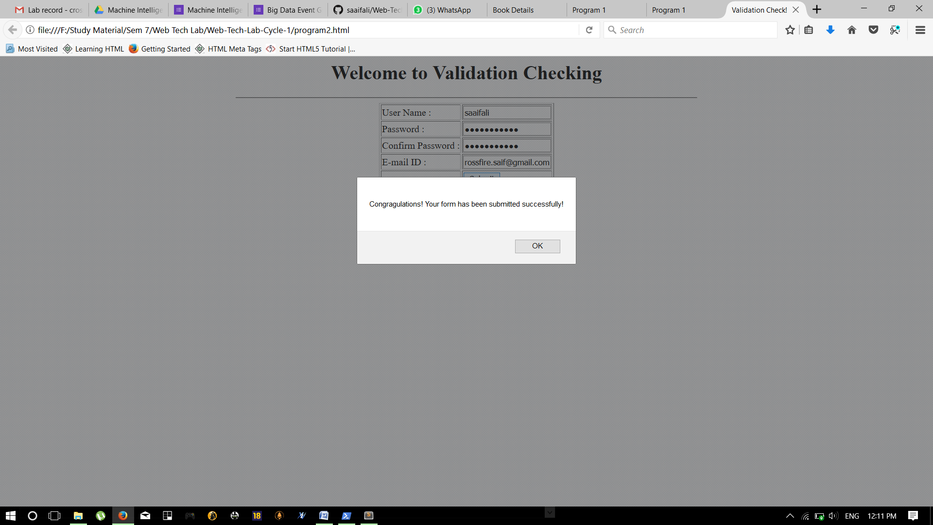

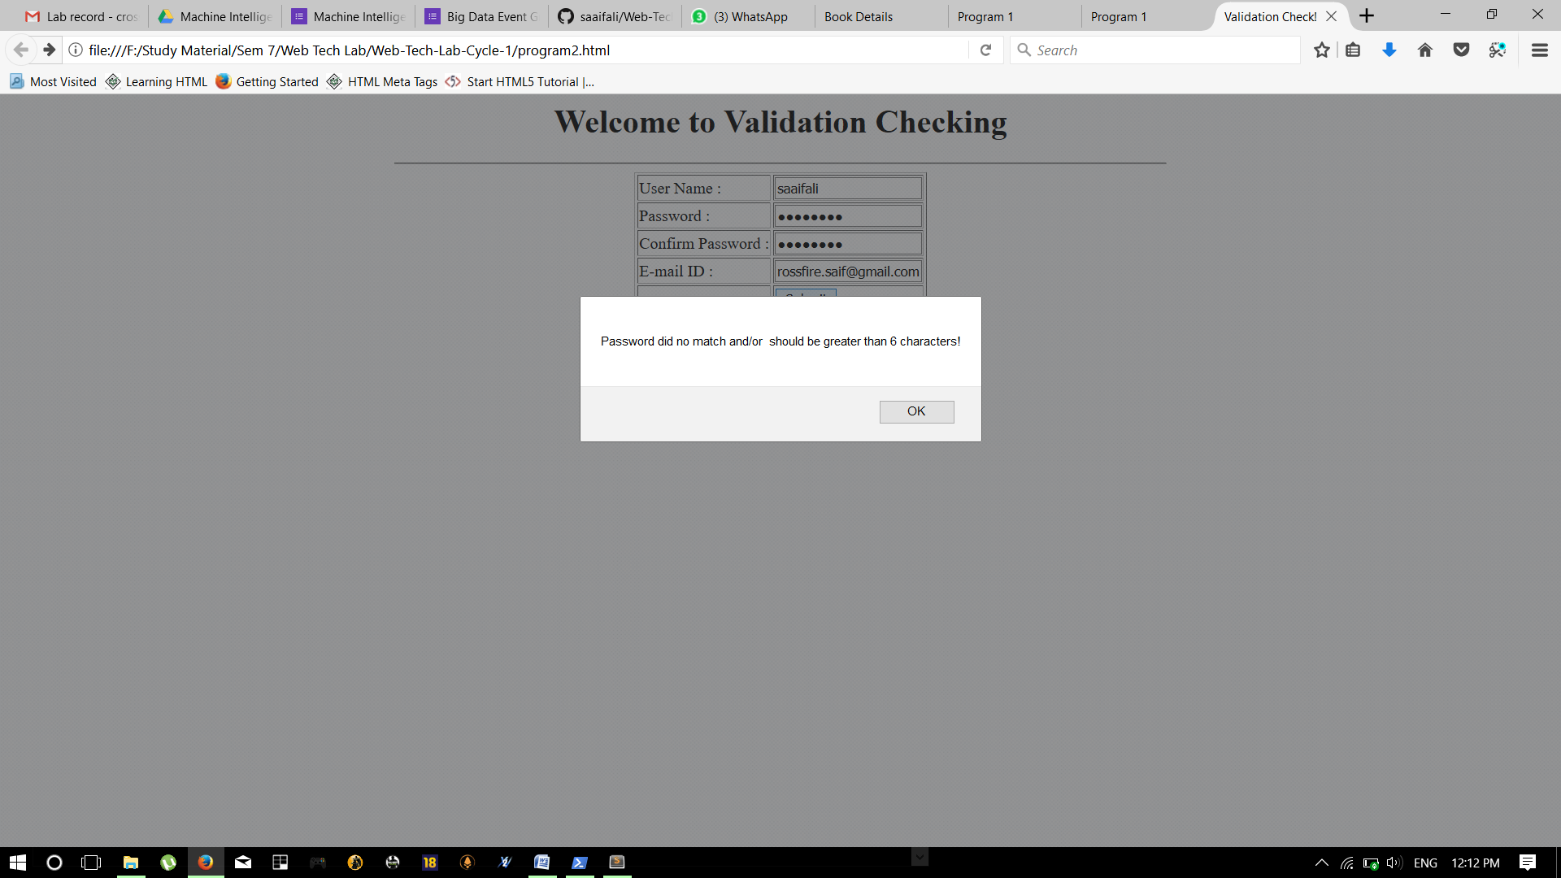

1. Write an XHTML document which displays a form containing text elements to input register number, sub-code, marks in three tests and a button element. Also write java script code to compute average of two better tests on click of button and print average marks using alert.

**Program:**

<html>

<head>

<h1 align=center>Welcome to Validation Checking</h1>

<hr width=50%>

</head>

<title> Validation Check! </title>

<body>

<table align=center border=1>

<tr>

<td>Register No:</td>

<td><input type="text" id="reg" /></td>

</tr>

<tr>

<td>Subject:</td>

<td><input type="text" id="subj" /></td>

</tr>

<tr>

<td>Marks 1:</td>

<td><input type="number" id="mrk1" /></td>

</tr>

<tr>

<td>Marks 2:</td>

<td><input type="number" id="mrk2" /></td>

</tr>

<tr>

<td>Marks 3:</td>

<td><input type="number" id="mrk3" /></td>

</tr>

<tr>

<td>

<input type="submit" onclick="validate();" />

</td>

<td>

<input type="reset" onclick="reset();" />

</td>

</tr>

</table>

<span id="Result"></span>

<script language="javascript">

var rg = document.getElementById("reg");

var sb = document.getElementById("subj");

var m1 = document.getElementById("mrk1");

var m2 = document.getElementById("mrk2");

var m3 = document.getElementById("mrk3");

function reset() {

rg.value = "";

sb.value = "";

m1.value = m2.value = m3.value = "";

}

function validate() {

var m1v = m1.value;

var m2v = m2.value;

var m3v = m3.value;

if (m1v > 100 || m2v > 100 || m3v > 100 || m1v < 0 || m2v < 0 || m3v < 0) {

alert("Wrong inputs");

f.reset();

}

var arr = [parseInt(m1v), parseInt(m2v), parseInt(m3v)];

arr = arr.sort(function(a, b) {

return b - a

});

var avg = (arr[0] + arr[1]) / 2.00;

document.getElementById("Result").innerHTML = ("Average of 2 max marks is " + avg);

}

</script>

</body>

</html>

**Output:**

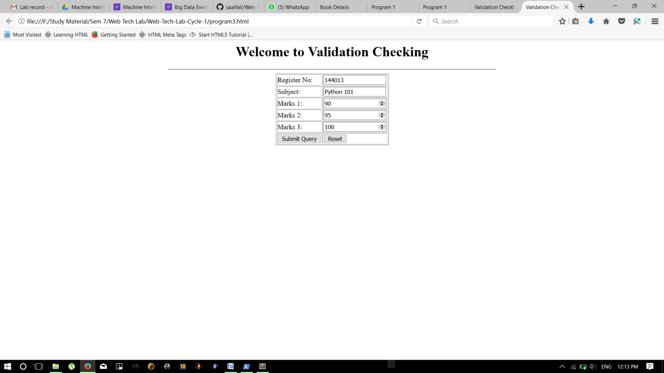

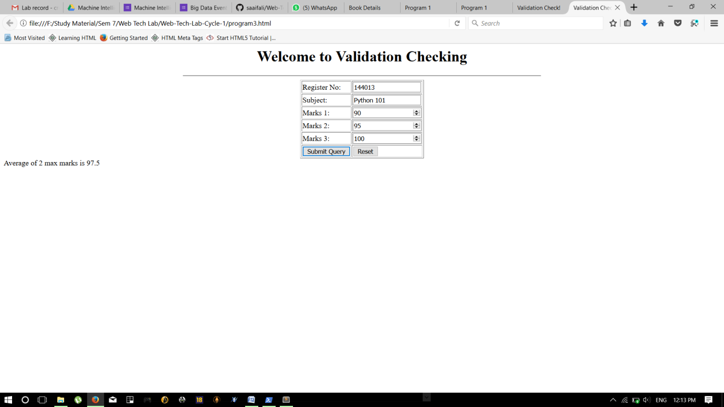

1. Write an XML file which will display the Book information which includes the following: Title of the book, Author Name, ISBN number, Publisher name, Edition and Price. Define the building blocks of XML document using XML Schema. Create an XSLT and CSS style sheet to display the document in browser.

**Program:**

**DTD file**

<!ELEMENT bookdetails (books+)>

<!ELEMENT books (title,author,edition,price)>

<!ELEMENT title (#PCDATA)>

<!ELEMENT author (#PCDATA)>

<!ELEMENT edition (#PCDATA)>

<!ELEMENT price (#PCDATA)>

**XML file**

<?xml version="1.0"?>

<!DOCTYPE bookdetails SYSTEM "program4_1.dtd">

<?xml-stylesheet type="text/xsl" href="program4_3.xsl"?>

<bookdetails>

<books>

<title> C </title>

<author> Balaguruswamy </author>

<edition> Edition-II </edition>

<price>Rs. 300.00</price>

</books>

<books>

<title> C++ </title>

<author> Yaswanth Kanethkar </author>

<edition> Edition-I </edition>

<price>Rs. 350.00</price>

</books>

<books>

<title> JAVA </title>

<author> Herbert Schildt </author>

<edition> Edition-IV </edition>

<price>Rs. 500.00</price>

</books>

</bookdetails>

**XSL file**

<?xml version="1.0"?>

<xsl:stylesheet version="2.0" xmlns:xsl="http://www.w3.org/1999/XSL/Transform">

<xsl:template match="/">

<html>

<head> <title>Book Details</title> </head>

<body>

<hr width="50%"/>

<table border="1" align="center">

<tr>

<th> TITLE </th>

<th> AUTHOR </th>

<th> EDITON </th>

<th> PRICE </th>

</tr>

<xsl:for-each select="bookdetails/books">

<tr>

<td> <xsl:value-of select="title"/></td>

<td> <xsl:value-of select="author"/></td>

<td> <xsl:value-of select="edition"/></td>

<td> <xsl:value-of select="price"/></td>

</tr>

</xsl:for-each>

</table>

</body>

</html>

</xsl:template>

</xsl:stylesheet>

**Output:**

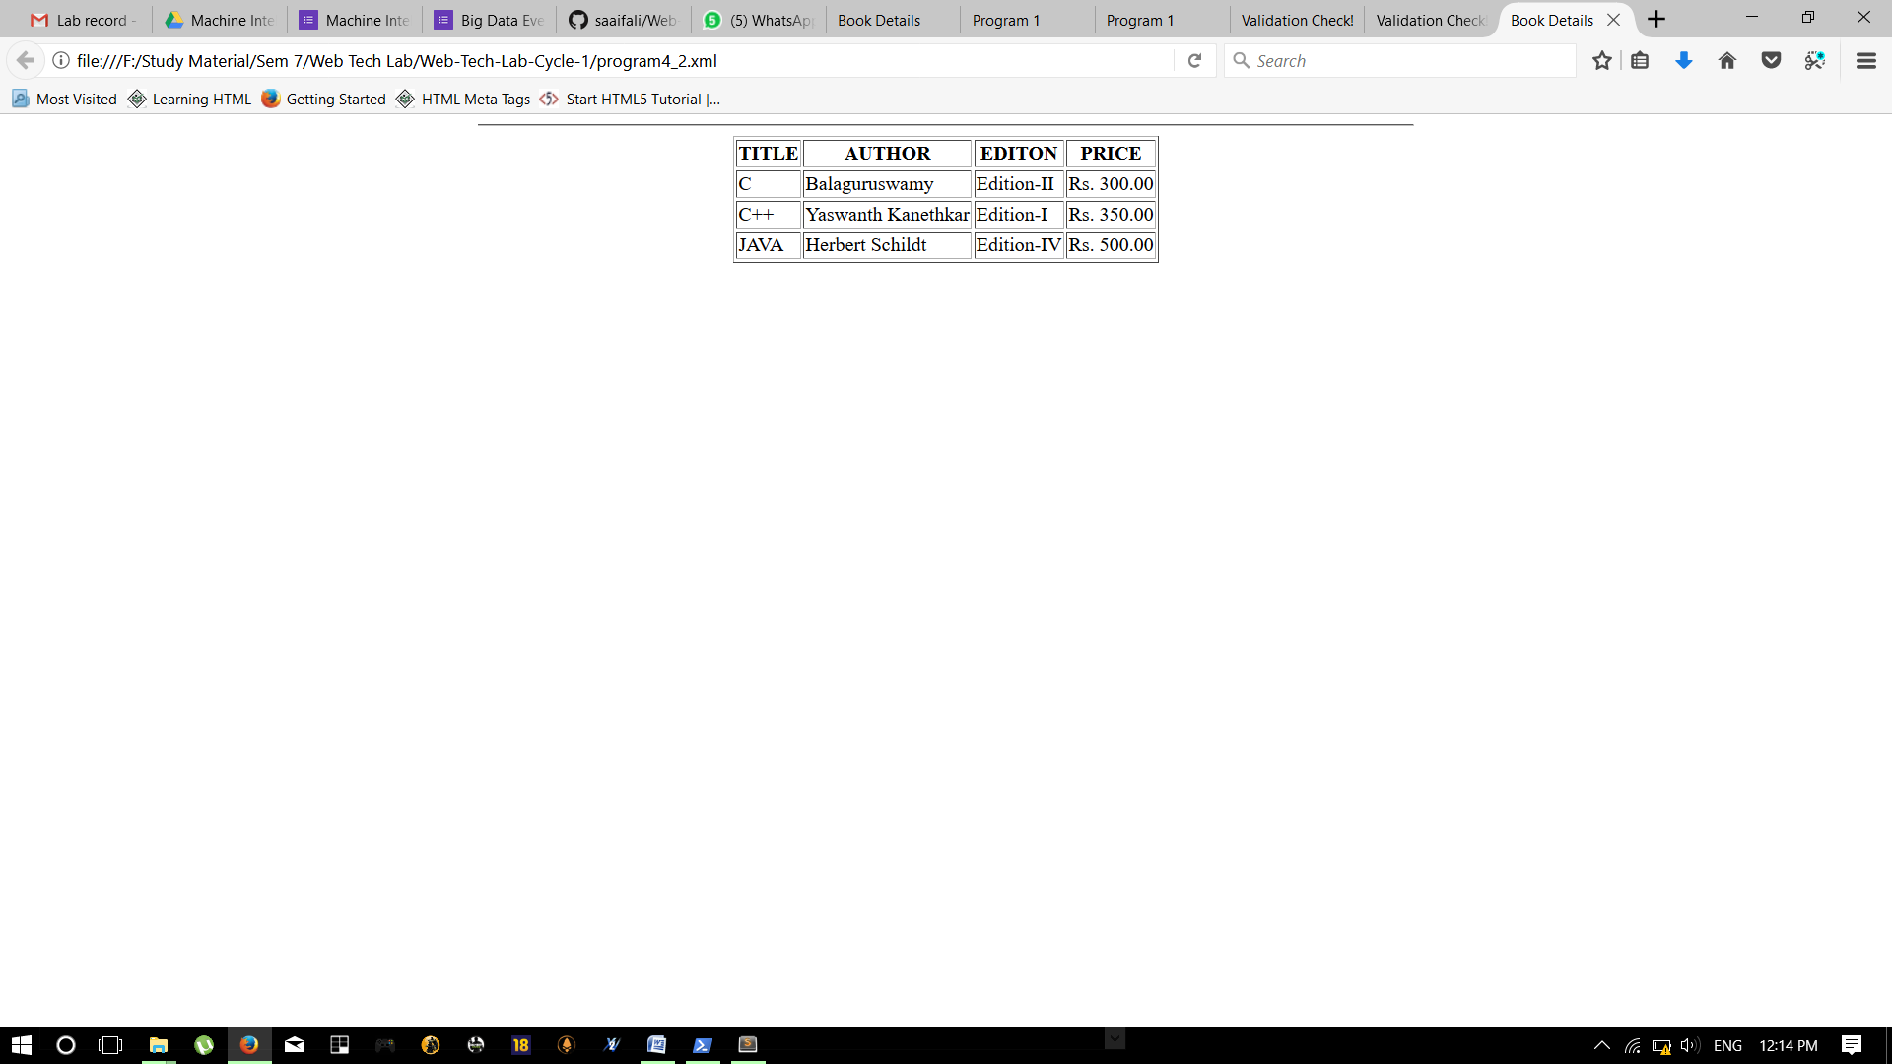

1. Design an XML page as per the following specification
2. Create a DTD for describing student details of an engineering college affiliated to VTU, where each student has child elements, USN, Name, Name of the College, Brach, Year of Joining, and e-mail id.
3. Create XML document with at least three instances of students defined in the above DTD.
4. Create an XSLT and CSS style sheet to display the above XML document.

**Program:**

**DTD File**

<!ELEMENT studentdetails (students+)>

<!ELEMENT students (USN,Name,College,Branch,Joining,Email)>

<!ELEMENT USN (#PCDATA)>

<!ELEMENT Name (#PCDATA)>

<!ELEMENT College (#PCDATA)>

<!ELEMENT Branch (#PCDATA)>

<!ELEMENT Joining (#PCDATA)>

<!ELEMENT Email (#PCDATA)>

**XML File**

<?xml version="1.0"?>

<!DOCTYPE studentdetails SYSTEM "program5_1.dtd">

<?xml-stylesheet type="text/xsl" href="program5_3.xsl"?>

<studentdetails>

<students>

<USN>4JC14CS086</USN>

<Name>Saif Ali</Name>

<College>SJCE, Mysuru</College>

<Branch>Computer Science</Branch>

<Joining>2014</Joining>

<Email>crossfire.saif@gmail.com</Email>

</students>

<students>

<USN>4JC14CS080</USN>

<Name>Sheetal Raina</Name>

<College>SJCE, Mysuru</College>

<Branch>Computer Science</Branch>

<Joining>2014</Joining>

<Email>sheetal.raina@gmail.com</Email>

</students>

<students>

<USN>4JC14IS102</USN>

<Name>Ankit Singh Bhamra</Name>

<College>SJCE, Mysuru</College>

<Branch>Information Science</Branch>

<Joining>2014</Joining>

<Email>ankitsbhamra@gmail.com</Email>

</students>

</studentdetails>

**XSL File**

<?xml version="1.0"?>

<xsl:stylesheet version="2.0" xmlns:xsl="http://www.w3.org/1999/XSL/Transform">

<xsl:template match="/">

<html>

<head> <title>Students Details</title> </head>

<body>

<hr width="50%"/>

<table border="1" align="center">

<tr>

<th> USN </th>

<th> NAME </th>

<th> COLLEGE </th>

<th> BRANCH </th>

<th> JOINED </th>

<th> EMAIL </th>

</tr>

<xsl:for-each select="studentdetails/students">

<tr>

<td> <xsl:value-of select="USN"/></td>

<td> <xsl:value-of select="Name"/></td>

<td> <xsl:value-of select="College"/></td>

<td> <xsl:value-of select="Branch"/></td>

<td> <xsl:value-of select="Joining"/></td>

<td> <xsl:value-of select="Email"/></td>

</tr>

</xsl:for-each>

</table>

</body>

</html>

</xsl:template>

</xsl:stylesheet>

**Output:**

