Iqra University

Usability Phase

Submitted By: Muhammad Saaim (50441)

**Group Members:**

|  |  |  |
| --- | --- | --- |
| **Name** | **Student ID** |  |
| **Syed Rafay Hussain** | **51381** |  |
| **Osama Abdullah** | **50442** |  |
| **Muhammad Saaim** | **50441** |  |

**Paper Prototype:**

**Login Page:**

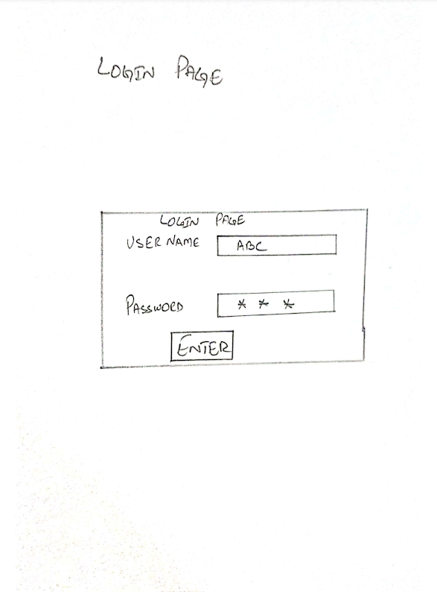

Welcome Page:

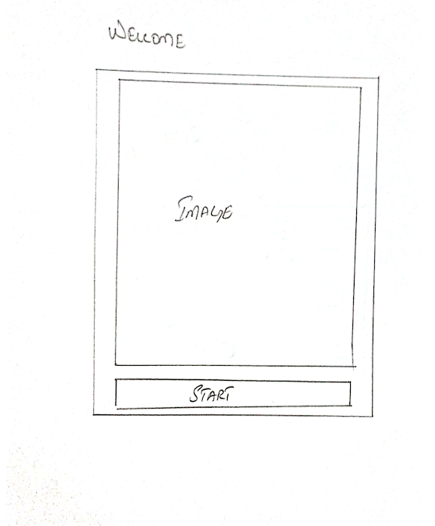

Main Menu:

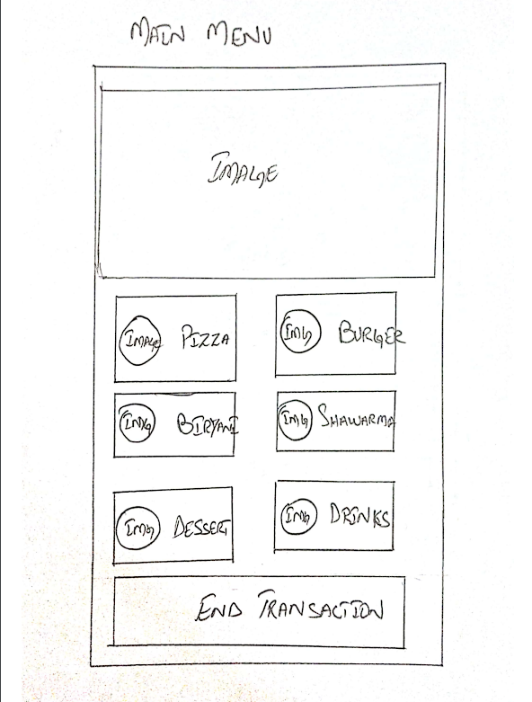

Sub-Menu

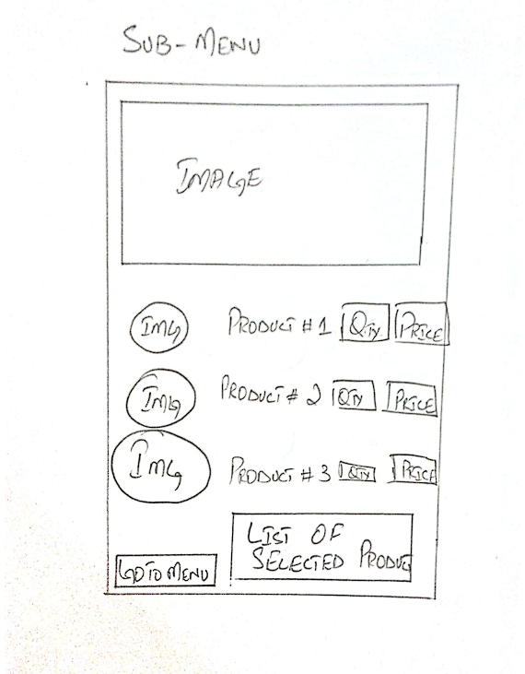

Invoice Tab:

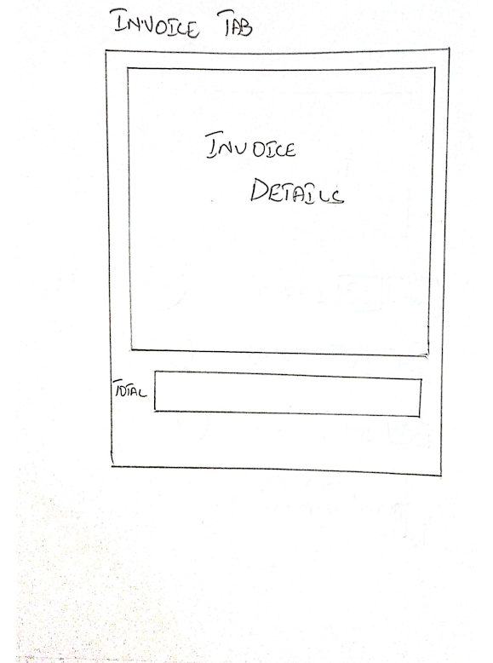

Admin Control Page:

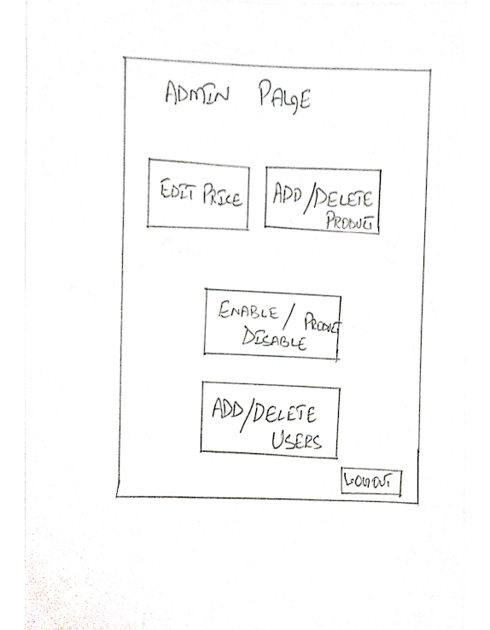

Edit Price Page:

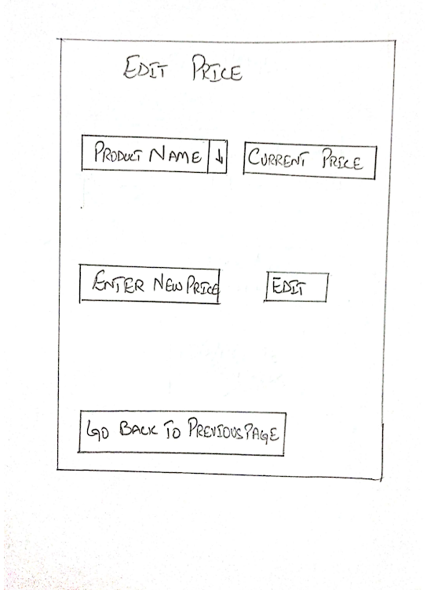

Enable\Disable Product:

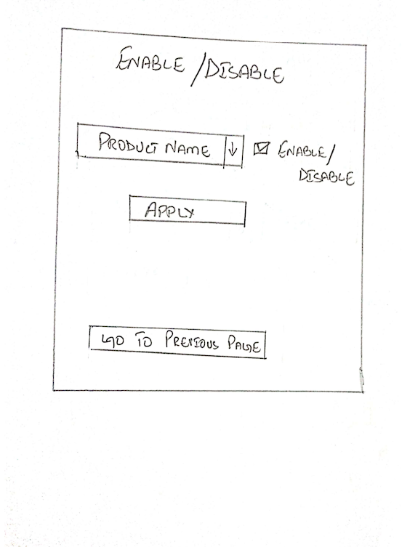

Add\Delete User:

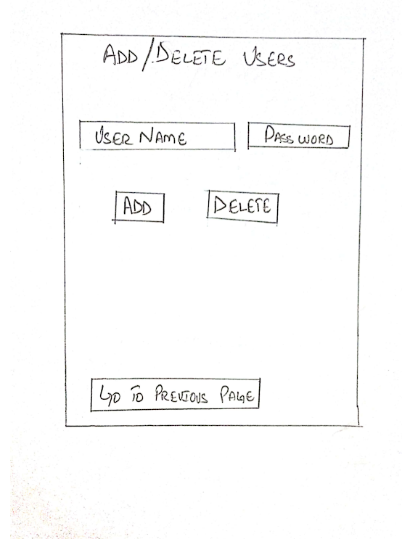

Digital Prototype:

**Login Page:**

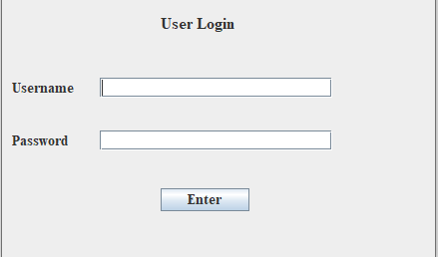

Welcome Page:

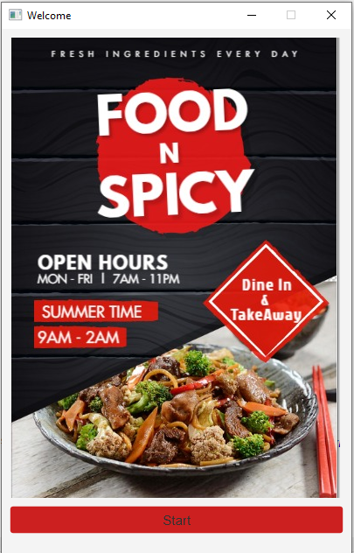

Main Menu:

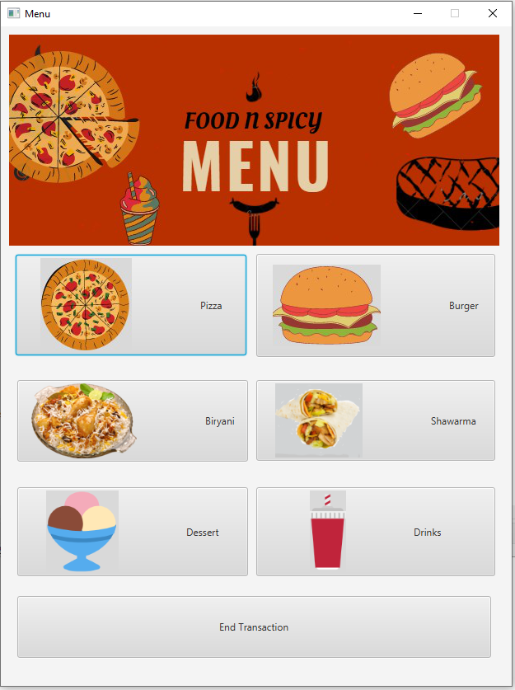

Sub-Menu

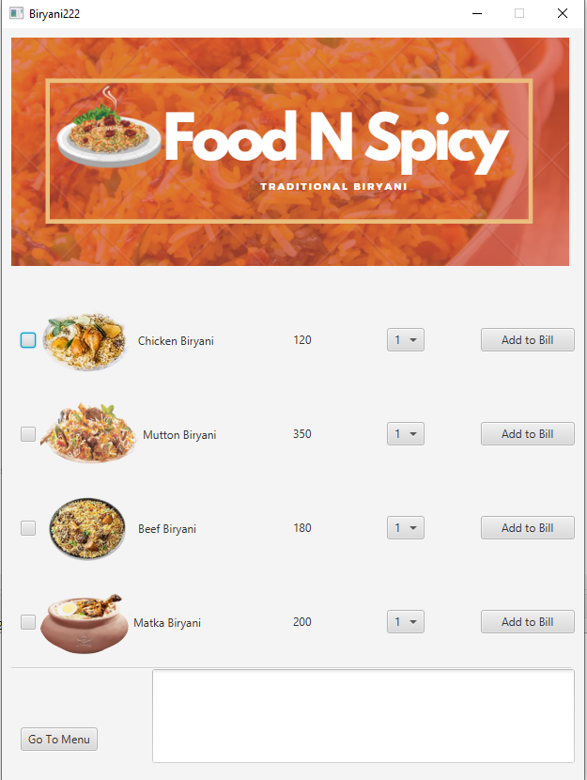

Invoice tab:

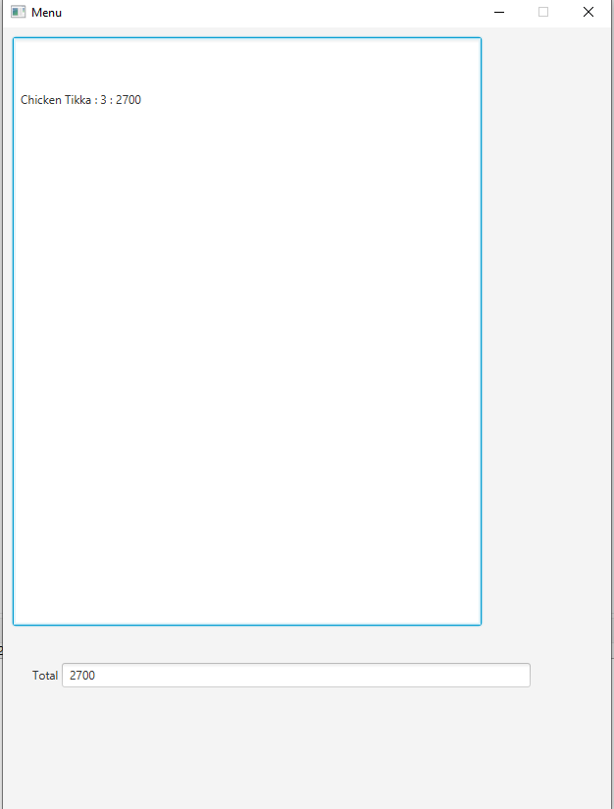

Admin Control Page:

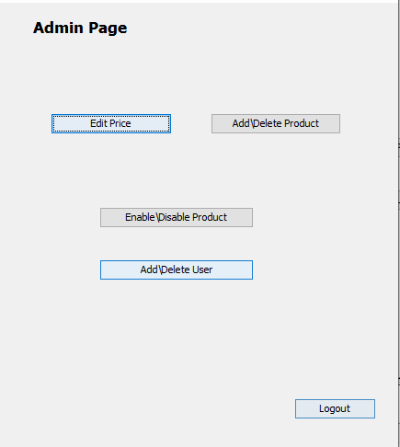

Add\Delete User:

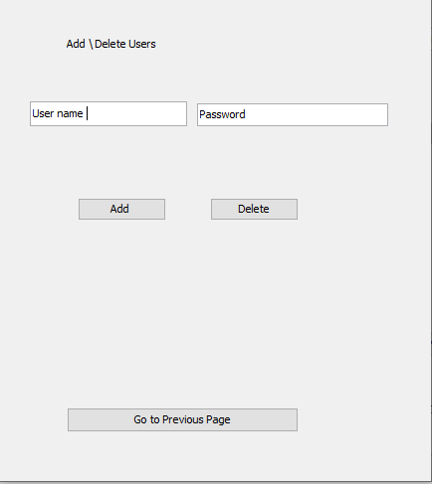

Edit Price:

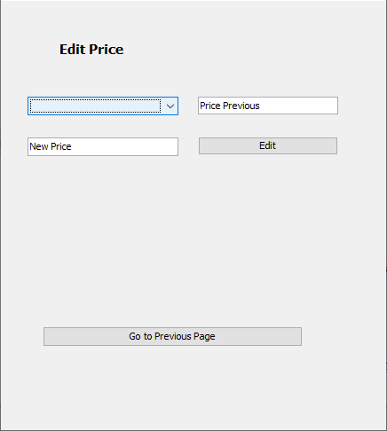

Enable\Disable Product:

