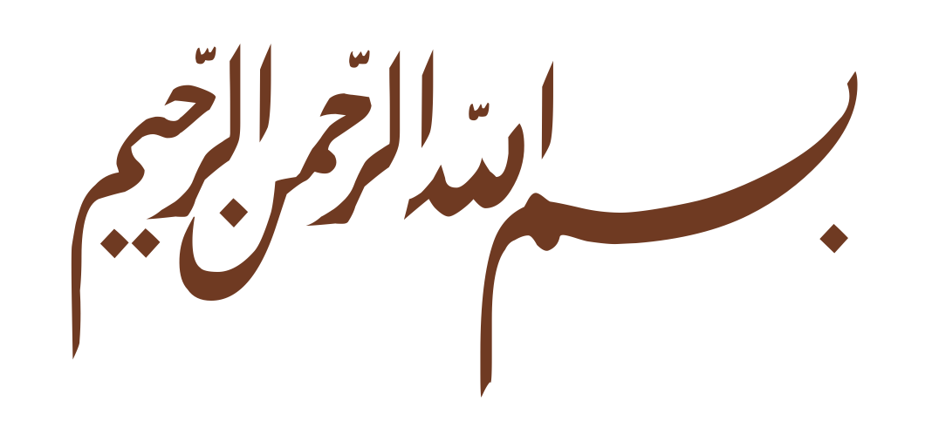
Ikram
Registered Non-Governmental Organisation · Addu City, Maldives

Organisation Profile
Ikram is a registered non-governmental organisation based at Masjidul Ikram in Addu City, Maldives. Established in 2025 under the Associations Act 2022, Ikram works to strengthen the religious life of the community through Qur’an education, the teaching and revival of prayer, and mosque-based programmes for children and families. Though a young organisation, it is led by experienced Imams and qualified teachers, and has already delivered religious programmes across multiple mosques.
Mission  To nurture faith and good character in the community — especially among its children — by teaching the Qur’an, establishing prayer, and creating consistent, welcoming opportunities for worship and learning at the mosque.  Vision  A community whose children grow up able to pray with understanding and devotion, and whose mosques are vibrant centres of learning, worship, and belonging.  What We Do  Qur’an & Arabic education. Sustained instruction for children in reading and understanding the Qur’an.  Prayer teaching & revival. Programmes such as Namaadh Noor that teach children to pray and build the habit through congregational attendance.  Mosque-based programmes. I’tikaf, Ramadan initiatives, and acts of worship centred on Masjidul Ikram.  Family & community engagement. Involving families to sustain religious practice beyond each programme.  Track Record  In its most recent Ramadan programme, Ikram organised I’tikaf across two mosques simultaneously — Masjidul Ikram and Masjid Baqiyathus Salihath — managing around 40 participants and approximately MVR 40,000. Its next initiative, Namaadh Noor — a two-part children’s prayer programme — is due to launch soon. | At a Glance  Type Registered NGO  Reg. No. 493-NGO/CERT/2025/133  Established 19 November 2025  Legal basis Associations Act 2022  Based at Masjidul Ikram, Addu City  Leadership  Hammad Hilalul Ameen — President  Governed by a registered executive committee (2026–2028). Programmes are delivered by experienced Imams and qualified Qur’an and Arabic teachers.  Contact  Email jamiyyathulikram@gmail.com  Phone 9997715  Masjidul Ikram, Addu City, Maldives

