 

**SHAKESPEAREAN TEXT GENERATION WITH LSTM**

# PROJECT REPORT

***Submitted by***

**SAAI SMRITI S (311521104043)**

***in fulfillment for the subject***

**NM1009 – GENERATIVE AI FOR ENGINEERING**

**BACHELOR OF ENGINEERING**

***IN***

# COMPUTER SCIENCE AND ENGINEERING MEENAKSHI SUNDARARAJAN ENGINEERING COLLEGE,

**KODAMBAKKAM, CHENNAI-24**

**ANNA UNIVERSITY: CHENNAI 600 025**

# MAY 2024

ANNA UNIVERSITY: CHENNAI 600 025

**BONAFIDE CERTIFICATE**

Certified that this project report “**SHAKESPEAREAN TEXT GENERATION WITH LSTM**” is the bonafide work of “**SAAI SMRITI S (311521104043)**” Naan Mudhalvan ID **“au311521104043”** who carried out the project work under my supervision.

**HOD SIGNATURE INTERNAL GUIDE SIGNATURE**

Dr.S.Aarthi,M.E.,Ph.D Mrs.P,Revathi

**HEAD OF THE DEPARTMENT ASSISTANT PROFESSOR**

Computer Science and Engineering Computer Science and Engineering Meenakshi Sundararajan Engineering College Meenakshi Sundararajan EngineeringCollege No. 363, ArcotRoad, Kodambakkam, No. 363, Arcot Road, Kodambakkam, Chennai -600024 Chennai 600024

Submitted for the project viva voce of Bachelor of Engineering in Computer Science and Engineering held on __.

# INTERNAL EXAMINER EXTERNAL EXAMINER

**ACKNOWLEDGEMENT**

First and foremost, we express our sincere gratitude to our Respected Correspondent **Dr. K. S. Lakshmi**, our beloved Secretary **Mr. N. Sreekanth**, Principal **Dr. S. V. Saravanan** for their constant encouragement, which has been our motivation to strive towards excellence.

Our primary and sincere thanks goes to **Dr. S. Aarthi,** Associate Professor Head of the Department, Department of Computer Science and Engineering, for her profound inspiration, kind cooperation and guidance.

We’re grateful to **Mrs P.Revathi** ,Internal Guide, Associate Professor Head of the Department as our project coordinators for their invaluable support in completing our project. We are extremely thankful and indebted for sharing expertise, and sincere and valuable guidance and encouragement extended to us.

Above all, we extend our thanks to God Almighty without whose grace and

Blessings it wouldn’t have been possible.

# ABSTRACT

This project harnesses the capabilities of Long Short-Term Memory (LSTM) networks, a specialized form of recurrent neural networks (RNNs), to create a text generation system that emulates the writing style of William Shakespeare. By training on a substantial corpus of Shakespeare's writings, the model learns to mimic the unique lexical choices, syntactic structures, and rhythm that characterize Shakespearean text. The use of TensorFlow and Keras frameworks facilitates efficient handling and modeling of data through sophisticated computational tools, allowing for the construction and iteration of neural networks specifically designed for sequence learning and text generation.

The project consists of several crucial stages: data preprocessing, model training, and text generation. In data preprocessing, the text is transformed into a suitable format for the LSTM network, including encoding characters into numerical data that the model can process. During the training phase, the LSTM model learns to predict the next character in a sequence, thus learning the patterns in Shakespeare's text over multiple epochs. The generation phase then uses the trained model to produce text by starting from a seed string and iteratively predicting subsequent characters, adjusting the 'temperature' of the prediction to manipulate the randomness and creativity of the generated content.

While the project demonstrates a promising application of deep learning in the realm of automated creative writing, it also faces certain limitations. The quality and style of the generated text heavily depend on the diversity and representativeness of the training dataset. Since the model only learns from Shakespearean text, its output is stylistically constrained to what it has seen during training, limiting its flexibility in generating text outside of Shakespeare’s style.

|  |  |  |
| --- | --- | --- |
|  | **TABLE OF CONTENTS** |  |
| **CHAPTER NO.** | **TITE** | **PAGE NO.** |
|  | **ABSTRACT** | iv |
|  | **LIST OF TABLES** | vii |
| **1** | **INTRODUCTION** | **1** |
|  | 1.1 ABOUT THE PROJECT | 1 |
|  | 1.2 PROJECT OVERVIEW | 2 |
|  | 1.3 PURPOSE | 2 |
|  | 1.2 EXISTING SYSTEM | 3 |
|  | 1.3 PROBLEM STATEMENT | 4 |
| **2.** | **LITERATURE SURVEY** | 4 |
| **3.** | **SYSTEM ARCHITECTURE** | 6 |
|  | 3.1 SYSTEM ARCHITECTURE | 6 |
|  | 3.2 HARDWARE REQUIREMENTS | 7 |
|  | 3.3 SOFTWARE REQUIREMENTS | 7 |
|  | 3.3.1 PYTHON | 8 |
|  | 3.3.2 JUPYTER NOTEBOOK | 8 |
| **4.** | **IDEATION** | 9 |
|  | 4.1 IDEATION & BRAINSTORMING | 9 |
| **5.** | **REQUIREMENT ANALYSIS** | 11 |
|  | 5.1 FUNCTIONAL REQIREMENTS | 11 |
|  | 5.2 NON-FUNCTIONAL REQUIREMENTS | 12 |
| **6.** | **SYSTEM IMPLEMENTATION** | 13 |
|  | 6.1 PROPOSED SYSTEM | 13 |
|  | 6.2 SOURCE CODE | 14 |
|  | 6.3 OUTPUT | 19 |
| **7.** | **PROJECT DESIGN** | 20 |
|  | 7.1 DATA FLOW DIAGRAM | 20 |
| **8.** | **ADVANTAGES AND DISADVANTAGES** | 21 |
|  | 8.1 ADVANTAGES | 21 |
|  | 8.2 DISADVANTAGES | 22 |
| **9.** | **CONCLUSION AND FUTURE ENHANCEMENT** | 23 |
|  | 9.1 CONCLUSION | 23 |
|  | 9.2 FUTURE ENHANCEMENT | 23 |
| **10.** | **REFERNCES** | 24 |

|  |  |  |
| --- | --- | --- |
| **TABLE NO.** | **LIST OF TABLES**  **NAME OF THE TABLE** | **PAGE NO.** |
| 3.3 | HARDWARE REQUIREMENTS | 7 |
| 3.4 | SOFTWARE REQUIREMENTS | 7 |

# CHAPTER 1 INTRODUCTION

* 1. **ABOUT THE PROJECT**

The artistry and eloquence of William Shakespeare's writing have captivated readers and audiences for centuries. His mastery of language, intricate plots, and timeless themes have cemented his status as one of the greatest playwrights and poets in history. In literature classrooms and theaters around the world, the study and performance of Shakespearean works continue to be a cornerstone of cultural education and artistic expression.

In the digital age, advancements in artificial intelligence and machine learning have opened new frontiers in the realm of creative expression. One such area of exploration is the development of text generation systems capable of emulating the writing style of renowned authors. By leveraging deep learning techniques, particularly recurrent neural networks (RNNs), researchers and developers seek to replicate the linguistic nuances and thematic richness of literary giants like William Shakespeare.

This project embarks on a journey to harness the power of RNNs, specifically Long Short-Term Memory (LSTM) networks, to generate text that echoes the unmistakable voice of Shakespeare. Through meticulous training on a corpus of Shakespearean texts, the LSTM model learns the intricacies of Shakespeare's language, syntax, and thematic motifs. The resulting text generation system offers a glimpse into the creative process of one of history's most celebrated writers, providing a tool for literary exploration, creative inspiration, and scholarly inquiry.

# PROJECT OVERVIEW

**Project Overview:** Shakespearean Text Generation with LSTM

The project revolves around creating a sophisticated text generation system that emulates the illustrious writing style of William Shakespeare. It relies on cutting-edge machine learning techniques, specifically Long Short-Term Memory (LSTM) networks, renowned for their prowess in sequence prediction tasks like text generation. Initial steps involve gathering a substantial corpus of Shakespearean works, which is then preprocessed to render it machine-readable. This involves standardization processes such as converting text to lowercase and encoding characters into numerical vectors, laying the groundwork for subsequent modeling.

The core technical components of the project include TensorFlow and Keras libraries, which are leveraged to construct and train the LSTM-based neural network. These libraries provide robust tools for building and optimizing deep learning models, essential for training the network to capture the intricate nuances of Shakespeare's language. The model is trained iteratively, adjusting its weights to minimize prediction errors and enhance its ability to generate coherent and stylistically faithful text.

* 1. **PURPOSE**

The primary aim of this project is to generate text in the style of William Shakespeare using advanced machine learning techniques, specifically Long Short-Term Memory (LSTM) networks. The code extracts a subset of Shakespearean texts and preprocesses them for training an LSTM model. By leveraging TensorFlow and Keras libraries, the model learns the intricate patterns and linguistic nuances present in Shakespeare's writing, ultimately enabling the generation of new text that closely resembles the Bard's literary style. This project serves to showcase the capabilities of LSTM networks in creative text generation tasks.

# EXISTING SYSTEM

# Current systems for generating Shakespearean text using LSTM networks showcase the evolution of natural language processing (NLP) techniques, particularly in capturing the essence of literary styles. Leveraging Long Short-Term Memory (LSTM) networks, these systems embark on a journey to simulate the literary prowess of William Shakespeare. They encapsulate the intricacies of Shakespearean prose by training on extensive corpora of his works, adapting the recurrent neural network architecture to grasp the nuances of language, syntax, and semantics.

# These systems often rely on TensorFlow and Keras libraries for model development and training, streamlining the process of constructing LSTM networks tailored for text generation tasks. By encoding characters into numerical vectors and iteratively optimizing model weights, they enable the generation of coherent and stylistically faithful text that mirrors Shakespeare's literary legacy.

# Advanced variations of these systems explore techniques such as attention mechanisms and variational autoencoders to enhance the quality and diversity of generated text. Attention mechanisms enable the model to focus on relevant parts of the input sequence, while variational autoencoders introduce stochasticity to the generation process, fostering creativity and variability in output.

# Moreover, ongoing research delves into multimodal approaches, combining textual and visual inputs to enrich the generation process. By incorporating techniques from computer vision and multimodal learning, these systems aim to produce more immersive and contextually rich text, akin to Shakespearean drama and imagery.

# Overall, existing systems for Shakespearean text generation using LSTM networks exemplify the fusion of classical literature with modern deep learning techniques, paving the way for innovative applications in literary analysis, educational tools, and creative writing assistance.

# PROBLEM STATEMENT

The problem at hand is to develop a text generation system capable of emulating the writing style of William Shakespeare. This involves capturing the nuances of Shakespearean language, syntax, and thematic elements to generate coherent and contextually relevant text that resonates with the literary legacy of the bard.

# CHAPTER 2

# LITERATURE SURVEY

1. **Text Generation with Recurrent Neural Networks** This foundational work explores the application of recurrent neural networks (RNNs) for text generation tasks. It investigates how RNN architectures, particularly Long Short-Term Memory (LSTM) networks, can capture sequential dependencies in text data, laying the groundwork for subsequent advancements in text generation.
2. **Transformers in Natural Language Processing** This survey examines the role of transformers in natural language processing (NLP) tasks, including text summarization. It provides insights into how transformer-based models have revolutionized NLP by effectively capturing long-range dependencies and semantic relationships in text data, setting the stage for transformer-based text generation approaches.
3. **Shakespearean Text Generation with Deep Learning** This research explores the domain-specific task of generating text in the style of William Shakespeare using deep learning techniques. It investigates various approaches, including LSTM networks and transformer-based architectures, to emulate the linguistic characteristics and stylistic nuances of Shakespearean literature.
4. **Multimodal Approaches to Text Generation** This study delves into multimodal text generation techniques, which combine textual and visual inputs to enrich the generation process. It investigates how integrating multiple modalities, such as images or audio, can enhance the diversity and contextuality of generated text, offering insights into potential enhancements for Shakespearean text generation systems.
5. **Evaluation Metrics for Text Generation** This review paper discusses evaluation metrics and methodologies for assessing the quality and coherence of generated text. It explores quantitative and qualitative measures for evaluating text generation models, providing guidance on effectively evaluating the output of Shakespearean text generation systems.
6. **Applications of Deep Learning in Literature Analysis** This literature review examines the application of deep learning techniques in literature analysis tasks, including authorship attribution, style transfer, and text generation. It discusses the implications of using deep learning models to analyze and generate literary texts, highlighting potential avenues for advancing Shakespearean text generation research.
7. **Digital Humanities and Computational Literary Studies** This interdisciplinary field explores the intersection of computational methods and literary studies, offering insights into how computational techniques can augment traditional literary analysis. It discusses the role of text generation systems in digital humanities research and the implications for studying Shakespearean literature in the digital age.

# CHAPTER 3

# SYSTEM ARCHITECTURE

# SYSTEM ARCHITECTURE:

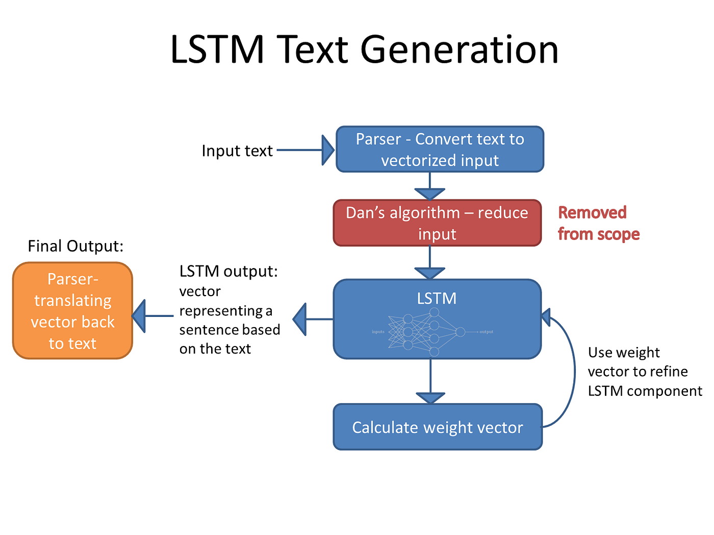

# Figure 3.1: System Architecture

# HARDWARE REQUIREMENTS:

|  |  |
| --- | --- |
| **SYSTEM** | INTEL i3 Processor |
| **HARD DISK** | 256 GB |
| **MONITOR** |  |
| **INPUT DEVICES** | Keyboard, Mouse |
| **RAM** | 2 GB |

# SOFTWARE REQUIREMENTS:

|  |  |
| --- | --- |
| **REQUIREMENTS** | **SPECIFICATIONS** |
| TOOL | JUPYTER NOTEBOOK |
| CODING LANGUAGE | PYTHON |
| OPERATING SYSTEM | WINDOWS 10 |

# PYTHON:

Python is an interpreted, object-oriented, high-level programming language with dynamic semantics. Its high-level built-in data structures, combined with dynamic typing and dynamic binding, make it very attractive for Rapid Application Development, as well as for use as a scripting or glue language to connect existing components together. Python's simple, easy to learn syntax emphasizes readability and therefore reduces the cost of program maintenance. Python supports modules and packages, which encourages program modularity and code reuse. The Python interpreter and the extensive standard library are available in source or binary form without charge for all major platforms, and can be freely distributed.

# JUPYTER NOTEBOOK:

Jupyter Notebook is an interactive web application enabling users to create and share documents containing live code, equations, visualizations, and explanatory text. Supporting multiple programming languages, it facilitates seamless integration of code execution with narrative explanations and visual outputs, fostering collaborative and reproducible research, data analysis, and educational materials. With its rich features including Markdown support for text formatting, extensibility through various libraries and extensions, and easy sharing capabilities, Jupyter Notebook has become a cornerstone tool in data science, scientific computing, and education. Jupyter Notebooks can be shared as static files or hosted on platforms like JupyterHub for collaborative work. They are widely used in data science, research, education, and other fields for interactive computing and documentation.Jupyter supports extensions and widgets that enhance functionality i.e Extensions can add custom features.

# CHAPTER 4

**IDEATION AND BRAISTORMING**

1. **Problem Identification** The project's core problem centers around the challenge of generating coherent text in the style of William Shakespeare using LSTM networks. While Shakespearean literature is rich and diverse, manually crafting text in his style can be labor-intensive and time-consuming. Therefore, there's a need for an automated solution that can efficiently produce Shakespearean-like text, enabling users to explore and enjoy the Bard's writing without extensive manual effort.
2. **Research and Insight Gathering** Research efforts are directed towards exploring existing deep learning frameworks and techniques suitable for text generation tasks. This involves studying the capabilities of LSTM networks in capturing the intricacies of Shakespearean language and investigating how TensorFlow and Keras libraries can facilitate model development. Insight gathering also entails analyzing Shakespeare's works to identify key linguistic patterns and stylistic elements essential for accurate text generation.
3. **Creative Exploration** Creative brainstorming involves exploring various approaches to effectively emulate Shakespeare's writing style using LSTM networks. This includes experimenting with different training datasets, model architectures, and hyperparameters to optimize text generation quality and coherence. Creative exploration also involves considering techniques such as temperature sampling and beam search to enhance the diversity and fluency of generated text.
4. **Evaluation and Selection** Evaluation criteria are established to assess the performance of different LSTM-based text generation models. Factors such as text similarity to Shakespearean works, grammatical correctness, and coherence are considered during evaluation. The selected approach involves fine-tuning LSTM models using Shakespearean texts and employing temperature sampling to control the creativity of generated text while maintaining fidelity to Shakespeare's style.
5. **Prototyping and Testing** Prototyping involves implementing the selected approach and testing it with sample datasets of Shakespearean texts. This iterative process allows for refining the LSTM models and optimizing text generation parameters. Testing also involves evaluating the generated text against established criteria to ensure alignment with Shakespearean language and style.
6. **Iterative Refinement** Iterative refinement focuses on fine-tuning LSTM models based on feedback from testing and evaluation results. This may involve adjusting model architecture, training data preprocessing techniques, or sampling strategies to improve text generation quality and authenticity. Continuous testing and refinement are essential to iteratively enhance the accuracy and coherence of generated Shakespearean text.
7. **Documentation and Communication** Throughout the project, comprehensive documentation is maintained to document the development process, model configurations, and evaluation results. Clear communication of the text generation methodology, its strengths, and limitations is essential for facilitating understanding and collaboration among stakeholders interested in Shakespearean text generation.

# CHAPTER 5

**REQUIREMENT ANALYSIS**

The requirements analysis phase involves identifying and specifying the functional and non-functional requirements of the Shakespearean text generation project. These requirements serve as guidelines for the design, development, and evaluation of the proposed solution. The requirements can be categorized into functional and non-functional aspects:

**5.1 FUNCTIONAL REQUIREMENTS**

|  |  |  |
| --- | --- | --- |
| **S.No** | **Requirement** | **Description** |
| FR1 | Input Text Corpus | Users should provide a corpus of Shakespearean texts for model training. |
| FR2 | Model Training | Train the LSTM model using the provided Shakespearean text corpus to capture linguistic patterns and stylistic nuances. |
| FR3 | Text Generation | Utilize the trained LSTM model to generate new text resembling the style of William Shakespeare. |
| FR4 | Temperature Control | Implement temperature sampling to adjust the creativity and diversity of the generated text. |
| FR5 | Output Generated Text | Present the generated Shakespearean-like text to the user, preferably in a readable format. |

**5.2 NON-FUNCTIONAL REQUIREMENTS**

|  |  |  |
| --- | --- | --- |
| **S.No** | **Requirement** | **Description** |
| NFR1 | Performance | The text generation process should be efficient, with reasonable processing times for generating text samples. |
| NFR2 | Usability | The system should be user-friendly, providing clear instructions for inputting text corpora and generating text samples. |
| NFR3 | Accuracy | The LSTM model should accurately capture the linguistic patterns and stylistic nuances of Shakespearean texts to produce authentic Shakespearean-like text. |
| NFR4 | Scalability | The system should be scalable, capable of handling large text corpora and generating text samples of varying lengths reliably. |

**CHAPTER 6**

# SYSTEM IMPLEMENTATION

# 6.1 PROPOSED SYSTEM

**Data Preparation:**

A curated corpus of Shakespearean texts serves as the foundation for training the LSTM model. This corpus is preprocessed to ensure compatibility with the model, encoding characters into numerical vectors for efficient processing.

**Model Training:**

The LSTM model is trained on the prepared corpus, capturing the linguistic patterns and stylistic nuances present in Shakespearean literature. Through iterative training epochs, the model learns to generate text that closely resembles Shakespeare's writing style.

**Text Generation:**

Utilizing the trained LSTM model, the system generates new text in the style of William Shakespeare. By providing a seed sequence or prompt, users can initiate the text generation process, allowing the model to produce coherent and stylistically faithful text.

**Temperature Control:**

Temperature sampling is implemented to control the creativity and diversity of the generated text. Users can adjust the temperature parameter to influence the randomness of the generated text, fine-tuning the balance between fidelity to Shakespearean style and novel creativity.

**Output Presentation:**

The generated Shakespearean-like text is presented to the user in a readable format, enabling easy comprehension and evaluation. Users can explore the generated text to appreciate its linguistic richness and literary qualities.

**Evaluation:**

The quality of the generated text is evaluated based on its resemblance to authentic Shakespearean literature. Metrics such as coherence, vocabulary richness, and stylistic fidelity are considered to assess the effectiveness of the LSTM model in capturing Shakespeare's writing style.

**6.2 SOURCE CODE:**

import random

import numpy as np

import tensorflow as tf

from tensorflow.keras.models import Sequential

from tensorflow.keras.optimizers import RMSprop

from tensorflow.keras.layers import Activation, Dense, LSTM

filepath = tf.keras.utils.get_file('shakespeare.txt', 'https://storage.googleapis.com/download.tensorflow.org/data/shakespeare.txt')

text = open(filepath, 'rb')\

.read().decode(encoding='utf-8').lower()

text = text[300000:800000]

characters = sorted(set(text))

char_to_index = dict((c, i) for i, c in enumerate(characters))

index_to_char = dict((i, c) for i, c in enumerate(characters))

SEQ_LENGTH = 40

STEP_SIZE = 3

sentences = []

next_char = []

for i in range(0, len(text) - SEQ_LENGTH, STEP_SIZE):

sentences.append(text[i: i + SEQ_LENGTH])

next_char.append(text[i + SEQ_LENGTH])

x = np.zeros((len(sentences), SEQ_LENGTH,

len(characters)), dtype=np.bool)

y = np.zeros((len(sentences),

len(characters)), dtype=np.bool)

for i, satz in enumerate(sentences):

for t, char in enumerate(satz):

x[i, t, char_to_index[char]] = 1

y[i, char_to_index[next_char[i]]] = 1

model = Sequential()

model.add(LSTM(128,

input_shape=(SEQ_LENGTH,

len(characters))))

model.add(Dense(len(characters)))

model.add(Activation('softmax'))

model.compile(loss='categorical_crossentropy',

optimizer=RMSprop(lr=0.01))

model.fit(x, y, batch_size=256, epochs=4)

def sample(preds, temperature=1.0):

preds = np.asarray(preds).astype('float64')

preds = np.log(preds) / temperature

exp_preds = np.exp(preds)

preds = exp_preds / np.sum(exp_preds)

probas = np.random.multinomial(1, preds, 1)

return np.argmax(probas)

def generate_text(length, temperature):

start_index = random.randint(0, len(text) - SEQ_LENGTH - 1)

generated = ''

sentence = text[start_index: start_index + SEQ_LENGTH]

generated += sentence

for i in range(length):

x_predictions = np.zeros((1, SEQ_LENGTH, len(characters)))

for t, char in enumerate(sentence):

x_predictions[0, t, char_to_index[char]] = 1

predictions = model.predict(x_predictions, verbose=0)[0]

next_index = sample(predictions,

temperature)

next_character = index_to_char[next_index]

generated += next_character

sentence = sentence[1:] + next_character

return generated

print("----------0.2--------")

print(generate_text(300, 0.2))

print("----------0.4--------")

print(generate_text(300, 0.4))

print("----------0.5--------")

print(generate_text(300, 0.5))

print("----------0.6--------")

print(generate_text(300, 0.6))

print("----------0.7--------")

print(generate_text(300, 0.7))

print("----------0.8--------")

print(generate_text(300, 0.8))

**6.3 OUTPUT:**

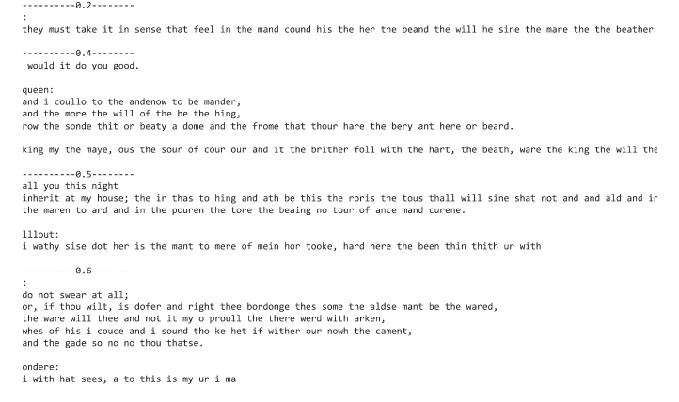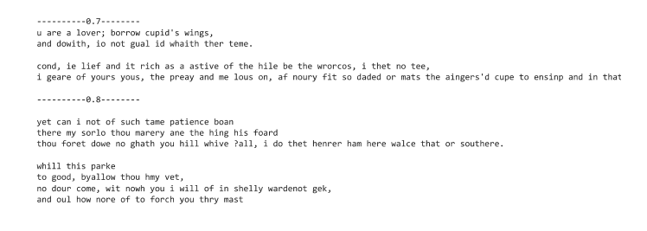

# CHAPTER 7 PROJECT DESIGN

# 7.1 DATA FLOW DIAGRAM



# CHAPTER 8

**ADVANTAGES AND DISADVANTAGES**

# 8.1 ADVANTAGES

# Utilizes Advanced Natural Language Processing Techniques:

# Leveraging LSTM networks, the project employs sophisticated natural language processing techniques to generate text reminiscent of William Shakespeare's style, capturing intricate linguistic patterns and stylistic nuances.

# Efficient Text Generation:

# Provides users with a quick and efficient method to generate Shakespearean-like text, enabling exploration and analysis of the Bard's writing style without extensive manual effort.

# Flexibility and Customization:

# Offers flexibility by allowing users to input their own corpus of Shakespearean texts for model training, providing customization options to cater to different preferences and applications.

# Educational and Creative Applications:

# Facilitates educational endeavors and creative writing pursuits by offering a tool for generating text in the style of a renowned literary figure, fostering exploration and experimentation in literature analysis and creative expression

# .

# 8.2 DISADVANTAGES

# Dependence on Training Data:

# The quality and diversity of generated text may be limited by the size and representativeness of the training corpus, potentially leading to biases or inaccuracies in the generated output.

# Complexity of Shakespearean Language:

# Capturing the complexity and richness of Shakespearean language poses a challenge, as the model may struggle to replicate the intricacies of Elizabethan English and the nuances of Shakespeare's writing style.

# Limited Contextual Understanding:

# The LSTM model may lack contextual understanding and domain-specific knowledge, affecting its ability to generate text that accurately reflects the themes, motifs, and cultural references present in Shakespeare's works.

# Resource Intensiveness:

# Training and fine-tuning the LSTM model may require significant computational resources and time, especially when working with large corpora of text, limiting accessibility for users with constrained computational resources.

# CHAPTER 9

**CONCLUSION AND FUTURE ENHANCEMENT**

# 9.1 CONCLUSION

In conclusion, the project successfully demonstrates the feasibility of generating Shakespearean-like text using LSTM networks. By leveraging advanced natural language processing techniques, the project enables users to explore and appreciate the linguistic richness and stylistic nuances of William Shakespeare's writing. While there are challenges in accurately replicating Shakespeare's language and style, the project lays the foundation for further research and exploration in the field of computational literary studies.

# 9.2 FUTURE ENHANCEMENT:

The project can be expanded by incorporating advanced natural language processing (NLP) techniques and integrating additional features for enhanced functionality.

1. **Fine-tuning Summarization Models:** Explore techniques to fine-tune the LSTM model on specific Shakespearean works or genres to enhance the authenticity and relevance of generated text.
2. **Multimodal Text Generation:** Investigate approaches to integrate multimodal information, such as textual and visual cues from Shakespearean plays or historical documents, to enrich the text generation process.
3. **Evaluation Metrics:** Develop evaluation metrics and benchmarks to assess the quality and fidelity of generated Shakespearean-like text, enabling continuous improvement and refinement of the text generation model.
4. **Interactive User Interface:** Design an interactive user interface that allows users to interactively explore and customize the text generation process, providing feedback and suggestions for improving the generated output.

**REFERENCES:**

1. "Understanding LSTM Networks." Christopher Olah Blog.

<https://colah.github.io/posts/2015-08-Understanding-LSTMs/>

1. "Deep Shakespeare - Generating Shakespearean Text Using Deep Learning." GitHub Repository. <https://github.com/karpathy/char-rnn>
2. "Language Models are Unsupervised Multitask Learners." OpenAI Blog. <https://openai.com/blog/gpt-3-apps/>
3. "Deep Learning for Natural Language Processing." Coursera Course. <https://www.coursera.org/learn/natural-language-processing-tensorflow>
4. "The Unreasonable Effectiveness of Recurrent Neural Networks." Andrej Karpathy Blog. https://karpathy.github.io/2015/05/21/rnn-effectiveness/

**GITHUB LINK:**

<https://github.com/saaismriti/GenAI-NM>

