**Graph**

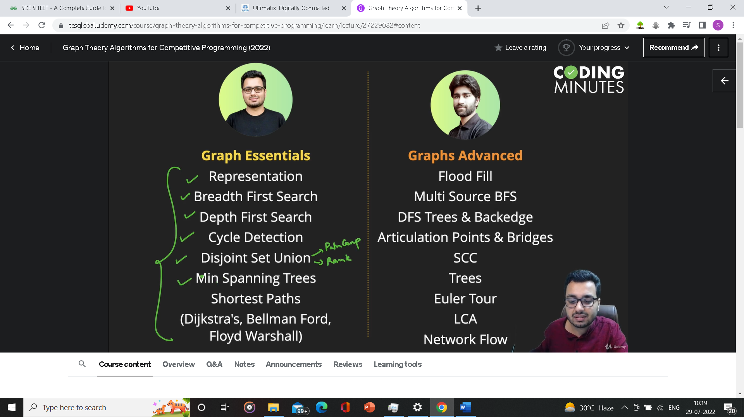

A Graph is a network of nodes/vertex and edges between them. Node represents some information and edge represent relation between them.

A graph can be directed or undirected, weighted or unweighted.

**How to store a graph**

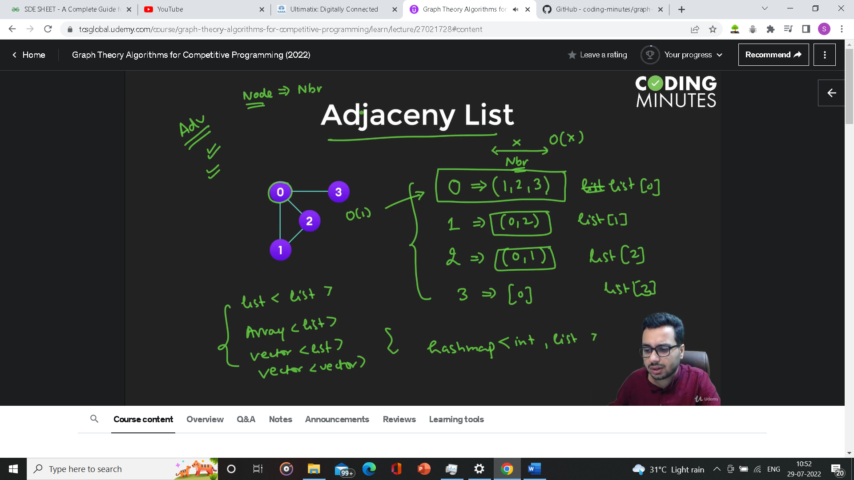

List at index 0 will contain all the neighbours of 0 and same applies for other nodes.

Adv: less memory, less iteration for returning neighbours

Dis: can’t be used for weighted graph imo

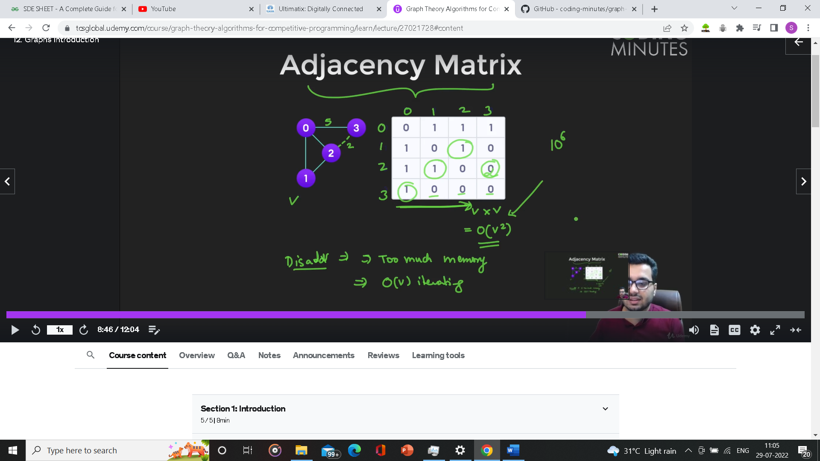

Adv: can be used for weighted graph.

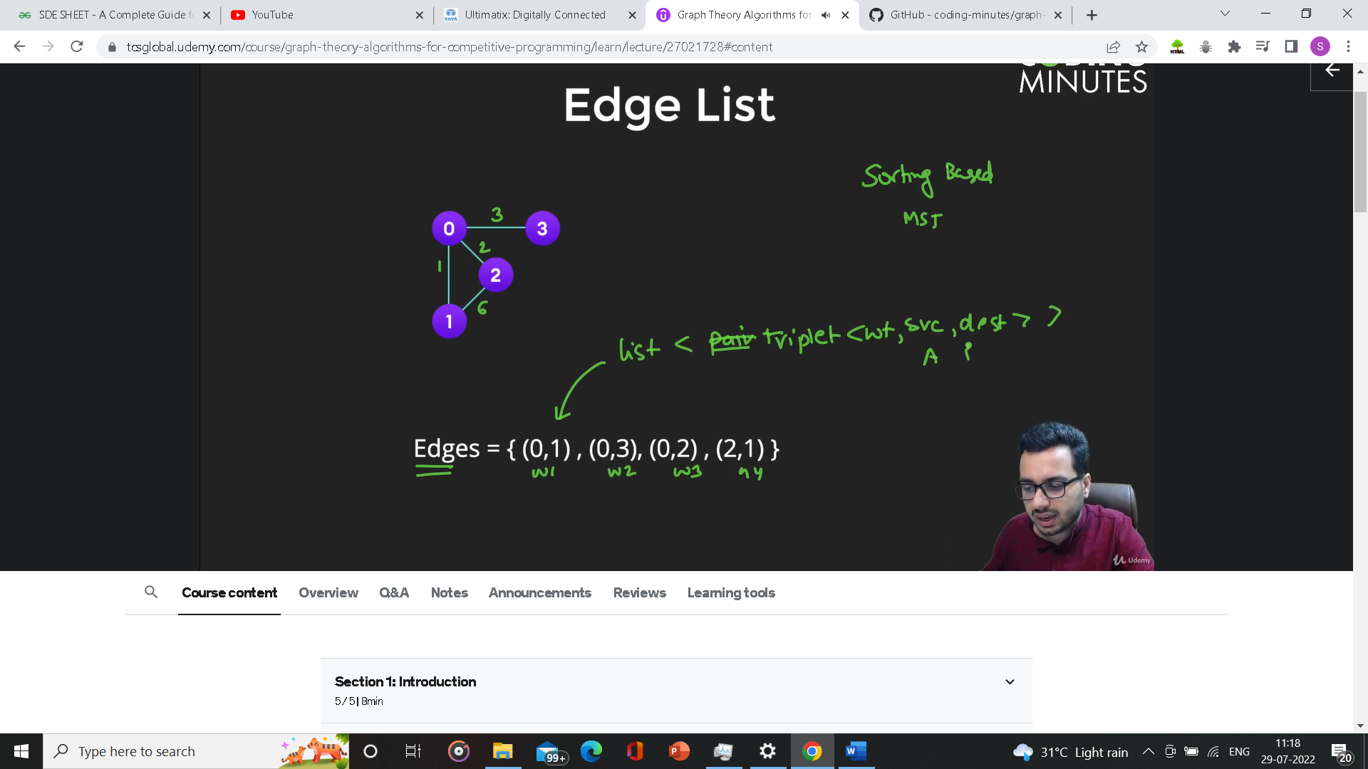

It’s a list of just edges

**Implicit Graph**

