**Assignment**

**Difference between Activity diagram and flowchart**

**Activity diagram: -** A graphical representation of workflows of stepwise activities and actions with support for choice, iteration, and concurrency.

It helps to understand the business process or workflow of the system.

It is associated with UML.

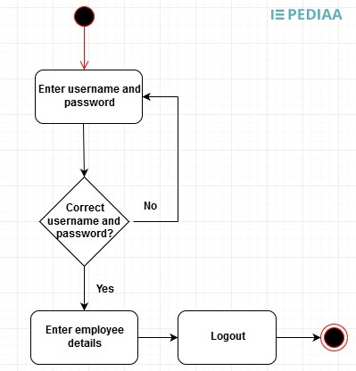

It is simple employee details entering system activity diagram.

The black circle represents the start node of the activity diagram.

Each step is an action. Moreover, the diamond symbol represents a decision node.

After successful entering of employee details the end node represents the termination of the diagram.

**Flowchart: -** Flowchart is a diagrammatic representation that illustrates a solution model to a given problem.

Flowchart helps to analyse and design a program.

It is associated with programming.

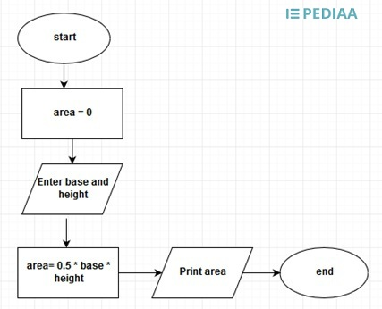

This flowchart calculates the area of a triangle.

The oval symbol represents the start of the flowchart.

While the rectangle represents a process.

The rhombus represents the input or output operation.

Next step is a process and the rhombus represents the printing the variable area.

Finally, the oval symbol terminates the flowchart.