1. I am using “pandas” library from Python for **Data Exploration & Cleaning  
     
   Check "**[**Task_1.ipynb**](https://drive.google.com/open?id=1sWTqs73nDmxB4mQvMYaVuzgdG8TaU6f8)**"**

At first I checked any missing or duplicate on any type of type inconsistency using isnull() function from pandas, so I didn't get any duplicate or in consistency, or no (necessary) missing values.

Even if I got any duplicate values, we can use drop_duplicates() to drop those extra rows, and for missing values we can use interpolate() that uses a Linear method based on surrounding data points to fill up missing values.

**Dataset Summary:**

<class 'pandas.core.frame.DataFrame'>

RangeIndex: 20000 entries, 0 to 19999

Data columns (total 14 columns):

# Column Non-Null Count Dtype

--- ------ -------------- -----

0 user_id 20000 non-null int64

1 install_date 20000 non-null object

2 last_active_date 20000 non-null object

3 subscription_type 20000 non-null object

4 country 20000 non-null object

5 total_sessions 20000 non-null int64

6 page_views 20000 non-null int64

7 download_clicks 20000 non-null int64

8 activation_status 20000 non-null int64

9 days_active 20000 non-null int64

10 pro_upgrade_date 20000 non-null object

11 plan_type 20000 non-null object

12 monthly_revenue 20000 non-null int64

13 churned 20000 non-null int64

dtypes: int64(8), object(6)

memory usage: 2.1+ MB

**Distribution of Free vs. Pro users:**

subscription_type

Free 79.855

Pro 20.145

Name: proportion, dtype: float64

2. **Check "**[**Task_2.ipynb**](https://drive.google.com/open?id=1B6GPofWrI_rSlOIKiyUNjguZRIXAWJjJ)**"**

1. Average number of sessions for Free vs. Pro users:

subscription_type

Free 76.081210

Pro 154.677836

Name: total_sessions, dtype: float64

1. Top 5 most active users based on total sessions:

user_id total_sessions subscription_type

188 189 300 Pro

821 822 300 Pro

1571 1572 300 Pro

2456 2457 300 Pro

3348 3349 300 Pro

1. Top 5 countries with the highest engagement:

country

India 272202

Germany 266319

Canada 264217

USA 261635

France 259495

Name: total_sessions, dtype: int64

3. **Check "**[**Task_3.ipynb**](https://drive.google.com/open?id=1bJk45nKI9puv2CS-IPuWeMtWVpJ1v74h)**"**

1. Overall churn rate for Free vs. Pro users:

subscription_type

Free 28.595579%

Pro 28.245222%

Name: churned, dtype: float64

1. Correlation of features with churn:

churned 1.000000

user_id 0.012038

download_clicks 0.000974

total_sessions -0.000273

page_views -0.005605

activation_status -0.005823

monthly_revenue -0.008328

days_active -0.617213

Name: churned, dtype: float64

**Top 3 factors contributing to churn:**

Index(['user_id', 'download_clicks', 'total_sessions'], dtype='object')

1. Churn Trends: Free vs Pro users

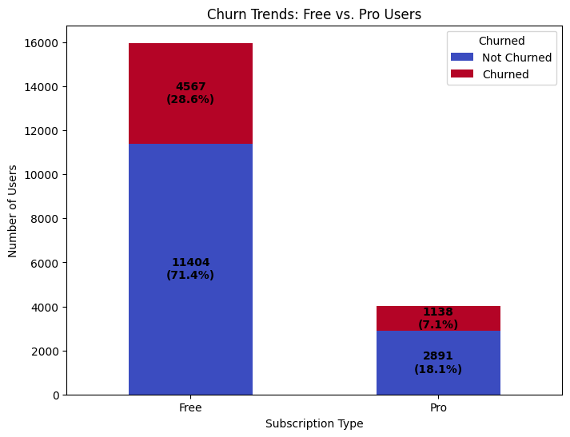

4. **Check "**[**Task_4.ipynb**](https://drive.google.com/open?id=1Uckor6b4OXoKV-W1epfQxXkVZfwCZ1Cz)**"**

1. Percentage of users who upgraded from Free to Pro: 20.14%
2. Total monthly revenue from Pro users: $235,481.00
3. Average time to upgrade (in days) by country:

country

UK 87.899654

USA 90.242215

France 91.164311

Germany 91.525510

India 92.578151

Canada 93.571184

Australia 93.683919

Name: upgrade_time, dtype: float64

5. **Check "**[**Task_5.ipynb**](https://drive.google.com/open?id=13tK2hLlY63Pq6XUujgpDZqbRWe_aC2Zu)**"**

**1. 3 Strategies to Reduce Churn**  
  
  
We can divide churned users into three categories:

Low Engagement, Medium Engagement, & High Engagement based on total_sessions, page_views, days_active  
  
  
1. Low Engagement Users may need re-engagement campaigns. (e.g., personalized emails, notifications etc.)

2. Medium Engagement Users may benefit from targeted upsells, because they have already spent more time than the Low Engagement Users, so they may need some little push.

3. High Engagement Users may have churned due to specific issues (e.g., pricing, feature gaps). We should have an option for the users to give feedback, so that we can analyze what's the main issue, such as pricing or any feature gaps, so that we can work on to get things right, because these are the high value users, we should keep them active.  
  
Besides these specialised actions, We should take other text book actions to reduce the churned rate.  
Provide social proof (e.g., testimonials, case studies) to demonstrate how Pro features have helped other users.

**2. Ways to Increase Free-to-Pro Conversions**

1. We can target those free users who have pro-like behaviour based on total_sessions, page_views, days_active, but still they didn't subscribe to any pro plan, we can highlight the Value of Pro Features for them. Because, Users may not fully understand the benefits of upgrading to Pro. And if needed we can offer time-limited discounts or free trials to encourage upgrades.
2. We can simplify the Upgrade Process, because users who click "Download Pro" (download_clicks = 1) but do not upgrade may face barriers in the conversion process. We can use exit-intent pop-ups to capture users who are about to leave without upgrading. We can showcase other user's testimonies to demonstrate how Pro features have helped them.

**3. Potential Market Expansion Opportunities**

**Top 5 high-engagement countries based on total_sessions:**

**country**

**India 272202**

**Germany 266319**

**Canada 264217**

**USA 261635**

**France 259495**

**Name: total_sessions, dtype: int64**

**Top 5 underpenetrated markets based on total_sessions:**

**country**

**Australia 255270**

**UK 259152**

**France 259495**

**USA 261635**

**Canada 264217**

**Name: total_sessions, dtype: int64**

a. Focus on High-Engagement Countries

Why: Countries like the USA, Germany, and the UK have high engagement and faster upgrade times.

Action:

Invest in localized marketing campaigns to attract more users from these regions.

Partner with local influencers or businesses to promote the plugin.

Offer region-specific features or pricing plans to cater to local needs.

b. Target Underpenetrated Markets

Why: Countries with slower upgrade times (e.g., Canada, France) may have untapped potential.

Action:

Conduct market research to understand barriers to adoption in these regions.

Offer localized support (e.g., language-specific customer service, regional pricing).

Run pilot campaigns to test demand and refine strategies for these markets.

6. **Check "**[**Task_6.ipynb**](https://drive.google.com/open?id=1y2azRpXB9ENRWLCmcaMoFHK0x6FmGEwE)**"**a)If WPPOOL increases the landing page conversion rate by 10%, the estimated impact on Pro upgrades:  
  
Current conversion rate: 40.29%

New conversion rate (10% increase): 44.32%

Estimated additional Pro upgrades: 403  
  
b) Contingency Table:

[[4744 256]

[4716 284]]

Chi-square statistic: 1.43

P-value: 0.2322  
  
The result is not statistically significant. The new landing page does not improve conversions. Because P-value is > 0.05

### c) Three A/B Test Ideas to Improve Conversion Rate & How to Measure Success

### Call-to-Action Button Design & Placement

* A (Control): Current button design & placement
* B (Test): New design (e.g., color, size, text) and placement (above-the-fold vs. below-the-fold)

Metrics to Measure Success:  
 Conversion rate (percentage of users who complete the desired action after clicking)  
 Time to convert (how long users take to complete the action)

### Simplified vs. Detailed Pricing Page

* A (Control): Current pricing page layout
* B (Test): Simplified version (fewer distractions, clearer benefits, FAQs for objections)

Metrics to Measure Success:  
 Bounce rate on the pricing page  
Time spent on the pricing page  
 Upgrade rate (percentage of users who purchase a paid plan after viewing pricing)

### 3️. Social Proof & Testimonials Placement

Hypothesis: Adding customer reviews, testimonials, and success stories near key conversion points may increase user trust and drive more conversions.

* A (Control): No or minimal social proof
* B (Test): Testimonials added near the CTA buttons, pricing page, or checkout

Metrics to Measure Success:  
 Conversion rate uplift after adding testimonials  
 User engagement (scroll depth, time spent on page)  
 Drop-off rate before purchase

Key Performance Indicators (KPIs):

Churn Rate: 28.52%

Conversion Rate (Free to Pro): 25.23%

Customer Lifetime Value (CLV): $701.36

**7.** **Check "**[**Task_7.ipynb**](https://drive.google.com/open?id=1RwjrJ59O2fdRbnFsVyYO5HC-Tb4fzT_P)**"  
  
1. Key Performance Indicators (KPIs) WPPOOL should track:**

Churn Rate: 28.52%

Conversion Rate (Free to Pro): 25.23%

Customer Lifetime Value (CLV): $701.36

**2. Actionable Growth Strategies**

a. Improvement on Onboarding and Activation: Users who do not activate the plugin (activation_status = 0) are more likely to churn and less likely to upgrade.

1. We can simplify the activation process with clear instructions and tooltips.
2. We can use behavioral triggers (e.g., pop-ups, emails) to guide users through activation.
3. We can offer incentives (e.g., free trials, discounts) for users who activate the plugin.

b. Targeted Upselling Campaigns: Users who click "Upgrade to Pro" but do not upgrade represent a significant opportunity for conversion.

1. We can use email campaigns to highlight the benefits of Pro features for users who clicked "Upgrade to Pro".
2. We can offer time-limited discounts or free trials to incentivize upgrades.
3. We can use exit-intent pop-ups to capture users who are about to leave without upgrading.

**c) Measure the success of these strategies?**

1 Comparing activation rates and churn rates before and after implementing the strategy.

2 Using A/B testing to evaluate the impact of different onboarding approaches.  
  
3 Using A/B tests to compare conversion rates between users who receive the campaign and a control group.

4 Tracking revenue and CTR over time to assess the campaign’s effectiveness.