1. CREATE DATABASE
MongoDB Query:
use Students
Explanation: Creates or switches to the Student database.

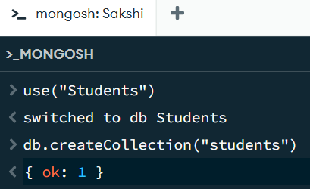

2. CREATE COLLECTION
MongoDB Query:
db. create Collection("students")
Explanation: Creates a collection named students.
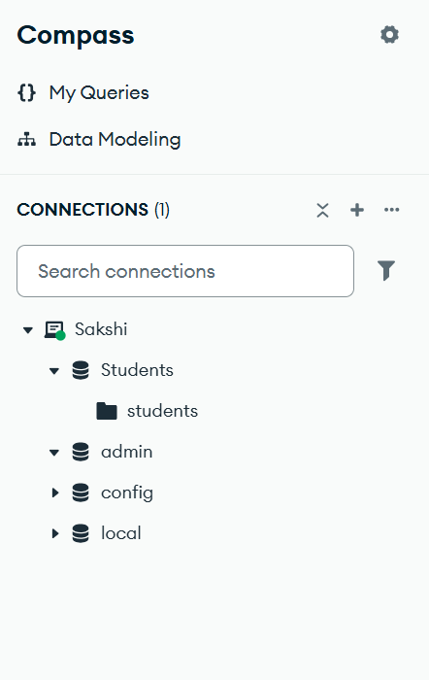
3. INSERT 50 STUDENTS
MongoDB Query:
db. students. Insert Many([ ])
[
{roll:1,name:"Ananya",age:18,marks:86,city:"Lucknow"},
{roll:2,name:"Rohan",age:19,marks:74,city:"Kanpur"},
{roll:3,name:"Meera",age:20,marks:93,city:"Agra"},
{roll:4,name:"Aditya",age:18,marks:68,city:"Varanasi"},
{roll:5,name:"Kavya",age:19,marks:82,city:"Lucknow"},
{roll:6,name:"Arjun",age:20,marks:89,city:"Prayagraj"},
{roll:7,name:"Ishita",age:19,marks:71,city:"Jaunpur"},
{roll:8,name:"Vihaan",age:18,marks:95,city:"Lucknow"},
{roll:9,name:"Sanya",age:20,marks:77,city:"Gorakhpur"},
{roll:10,name:"Karan",age:18,marks:64,city:"Kanpur"},
{roll:11,name:"Nikhil",age:20,marks:73,city:"Jaunpur"},
{roll:12,name:"Diya",age:19,marks:96,city:"Lucknow"},
{roll:13,name:"Aarav",age:18,marks:84,city:"Agra"},
{roll:14,name:"Sneha",age:19,marks:87,city:"Prayagraj"},
{roll:15,name:"Rahul",age:20,marks:76,city:"Varanasi"},
{roll:16,name:"Pihu",age:18,marks:91,city:"Lucknow"},
{roll:17,name:"Manav",age:19,marks:83,city:"Kanpur"},
{roll:18,name:"Dev",age:18,marks:57,city:"Gonda"},
{roll:19,name:"Aditi",age:20,marks:92,city:"Lucknow"},
{roll:20,name:"Yash",age:19,marks:63,city:"Bareilly"},
{roll:21,name:"Tanvi",age:18,marks:79,city:"Lucknow"},
{roll:22,name:"Kabir",age:19,marks:88,city:"Jaunpur"},
{roll:23,name:"Mahi",age:20,marks:72,city:"Kanpur"},
{roll:24,name:"Aryan",age:19,marks:81,city:"Agra"},
{roll:25,name:"Nandini",age:18,marks:67,city:"Prayagraj"},
{roll:26,name:"Avni",age:20,marks:94,city:"Lucknow"},
{roll:27,name:"Krish",age:19,marks:88,city:"Varanasi"},
{roll:28,name:"Simran",age:18,marks:61,city:"Gorakhpur"},
{roll:29,name:"Mohit",age:19,marks:75,city:"Kanpur"},
{roll:30,name:"Riya",age:20,marks:79,city:"Lucknow"},
{roll:31,name:"Vivek",age:18,marks:69,city:"Jaunpur"},
{roll:32,name:"Anika",age:19,marks:90,city:"Lucknow"},
{roll:33,name:"Jiya",age:20,marks:55,city:"Agra"},
{roll:34,name:"Lakshya",age:18,marks:83,city:"Kanpur"},
{roll:35,name:"Shreya",age:19,marks:97,city:"Prayagraj"},
{roll:36,name:"Muskan",age:20,marks:70,city:"Lucknow"},
{roll:37,name:"Priyanshu",age:18,marks:81,city:"Varanasi"},
{roll:38,name:"Ansh",age:19,marks:66,city:"Gorakhpur"},
{roll:39,name:"Dhruv",age:20,marks:93,city:"Lucknow"},
{roll:40,name:"Nivedita",age:19,marks:85,city:"Kanpur"},
{roll:41,name:"Pallavi",age:18,marks:74,city:"Jaunpur"},
{roll:42,name:"Akanksha",age:20,marks:89,city:"Lucknow"},
{roll:43,name:"Neha",age:19,marks:62,city:"Agra"},
{roll:44,name:"Anushka",age:18,marks:78,city:"Prayagraj"},
{roll:45,name:"Sara",age:20,marks:84,city:"Lucknow"},
{roll:46,name:"Nisha",age:19,marks:73,city:"Kanpur"},
{roll:47,name:"Aman",age:18,marks:59,city:"Gonda"},
{roll:48,name:"Priya",age:20,marks:87,city:"Lucknow"},
{roll:49,name:"Varun",age:19,marks:64,city:"Bareilly"},
{roll:50,name:"Isha",age:18,marks:91,city:"Varanasi"}
] 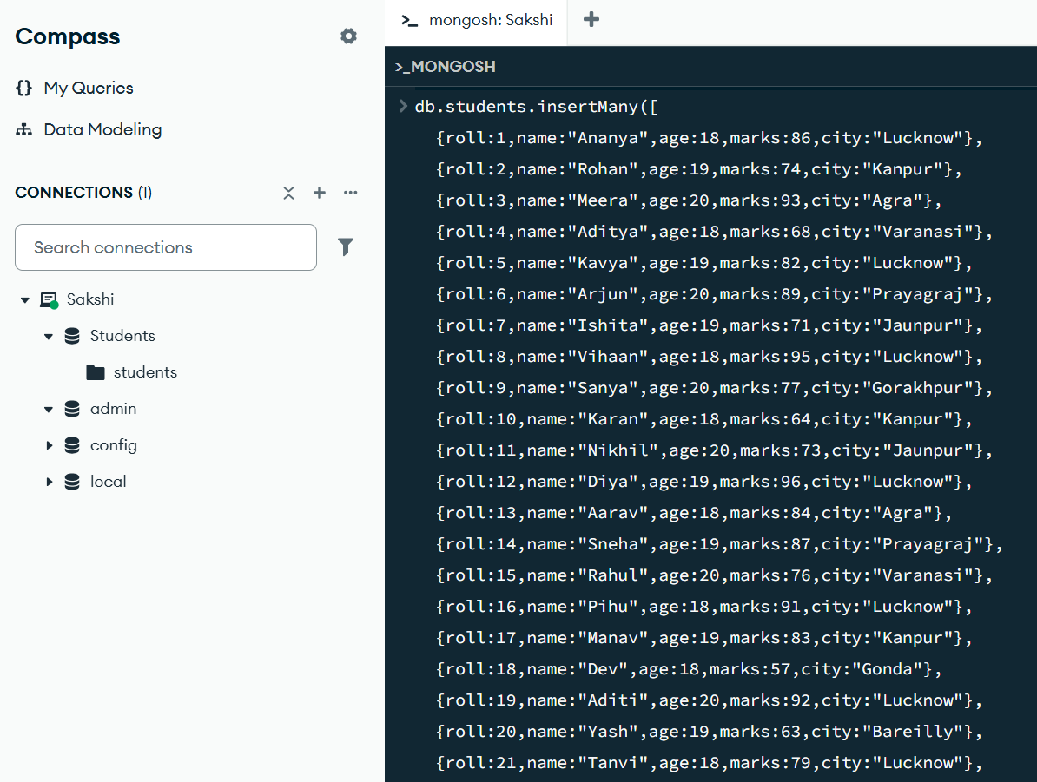
Explanation: Inserts multiple student documents into the collection.

4. DISPLAY ALL STUDENTS
MongoDB Query:
db. students. Find ()
Explanation: Retrieves documents from the students collection.
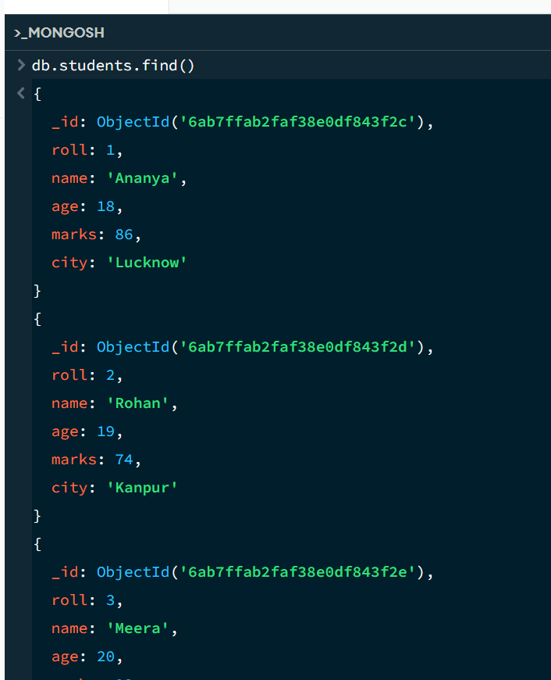

5. EQUAL TO — $eq
MongoDB Query:
db. students. find ({marks: {$eq: 88}})
Explanation: Finds students whose marks are exactly 88.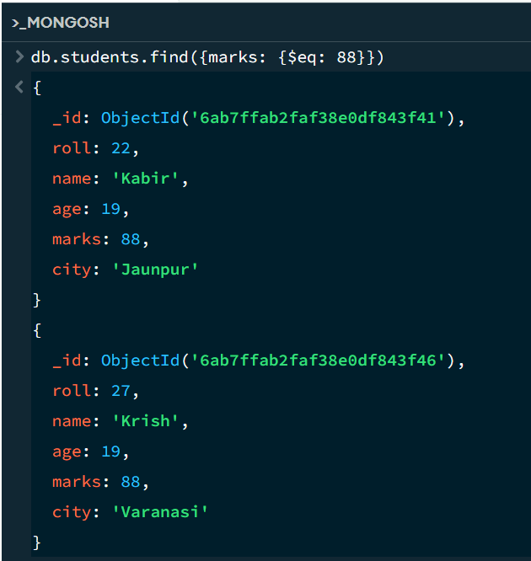

6. GREATER THAN — $gt
MongoDB Query:
db.students.find({marks: {$gt: 85}})
Explanation: Finds students whose marks are greater than 85.
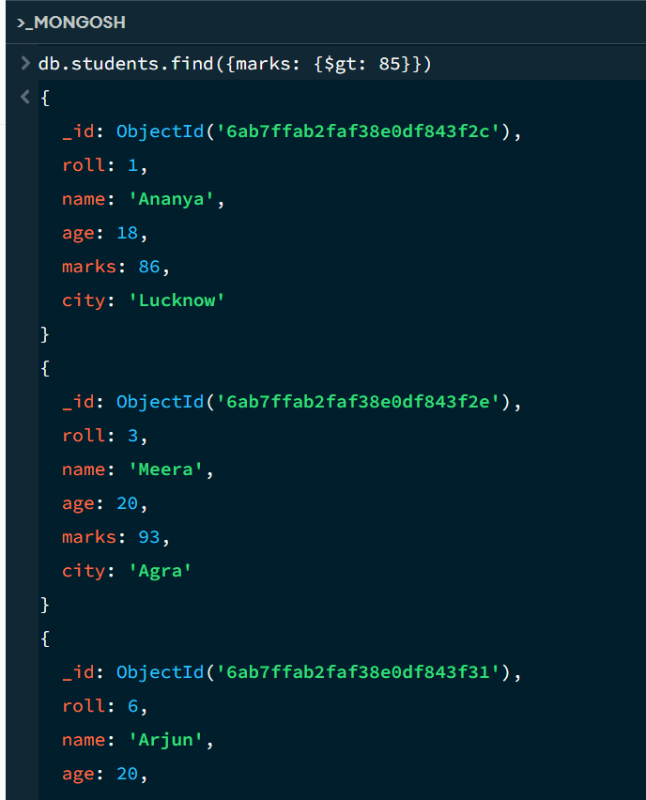

7. LESS THAN — $lt
MongoDB Query:
db. students. find ({marks: {$lt: 60}})
Explanation: Finds students whose marks are less than 60.
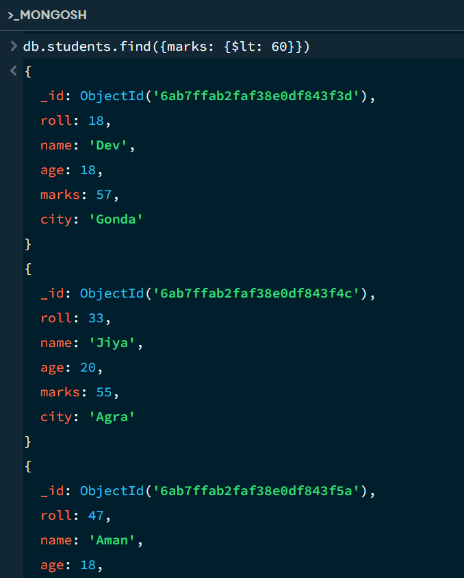

8. GREATER THAN OR EQUAL TO — $gte
MongoDB Query:
db. students. find({marks: {$gte: 90}})
Explanation: Finds students whose marks are 90 or above.
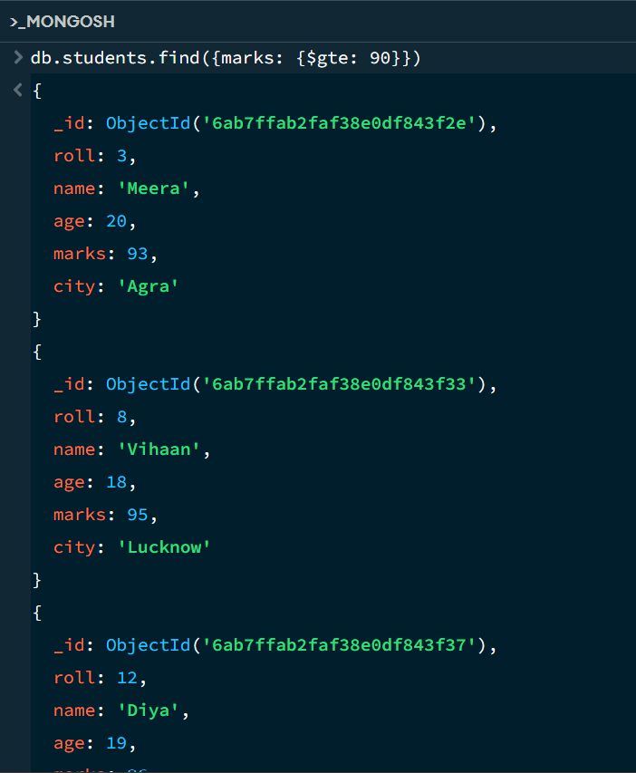

9. LESS THAN OR EQUAL TO — $lte
MongoDB Query:
db. students. find({marks: {$lte: 70}})
Explanation: Finds students whose marks are 70 or below.

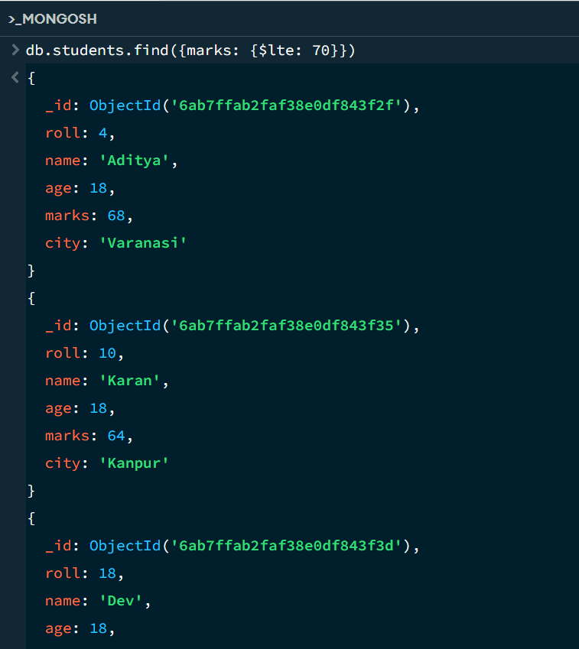

10. UPDATE OPERATION
MongoDB Query:
db.students.updateOne(
{roll:5},
{$set:{marks:95}}
)
Explanation: Updates the marks to 95 of the student with roll number 5.

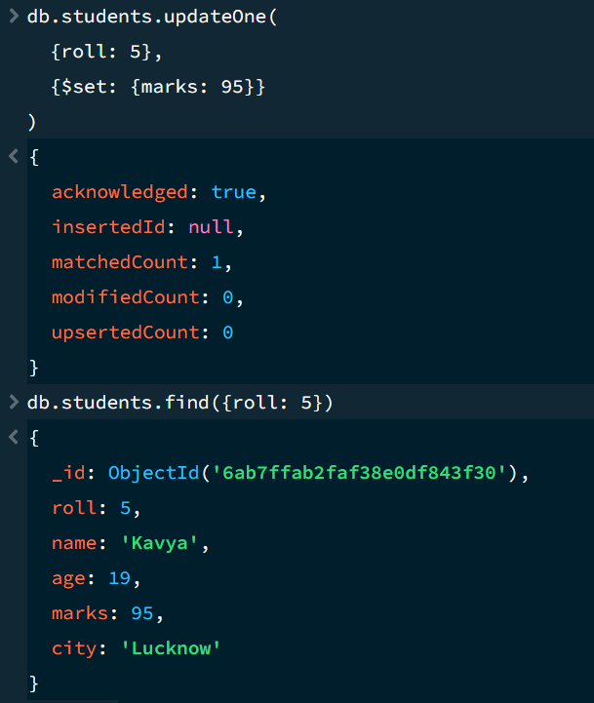

11. DELETE ONE OPERATION
MongoDB Query:
db.students.deleteOne({roll:10})
Explanation: Deletes one document matching roll number 10.

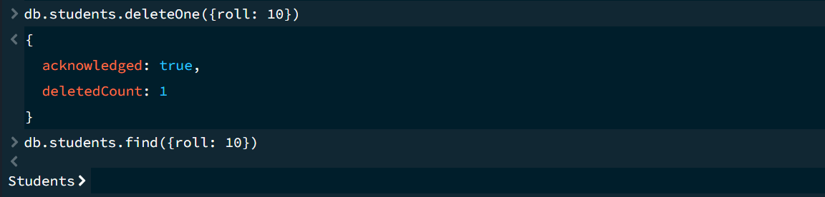

12. DELETE MANY OPERATION
MongoDB Query:
Explanation: Deletes all students having marks below 60.

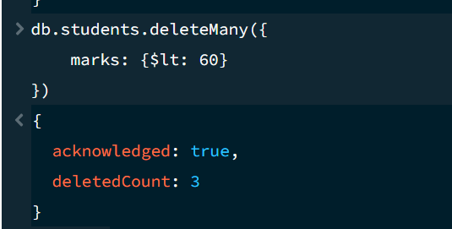
13. AND OPERATION — $and
MongoDB Query:
db. students. find({
$and:[
{marks:{$gt:80}},
{age:19}
]
})
Explanation: Finds students satisfying both conditions.
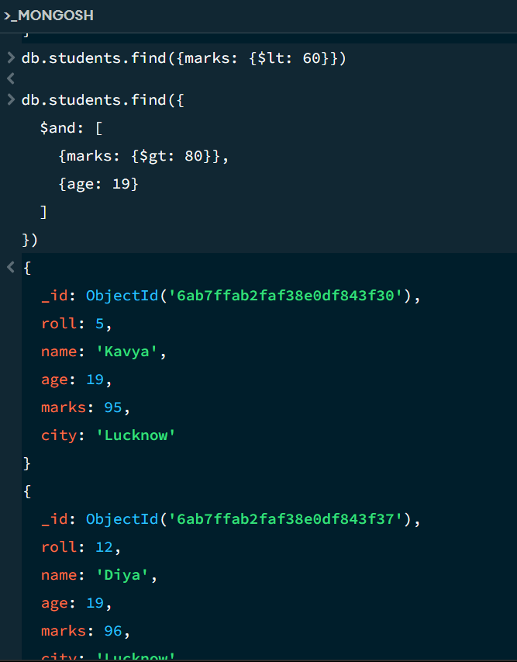

14. OR OPERATION — $or
MongoDB Query:
db.students.find({
$or:[
{city:"Lucknow"},
{city:"Kanpur"}
]
})
Explanation: Finds students from Lucknow or Kanpur.
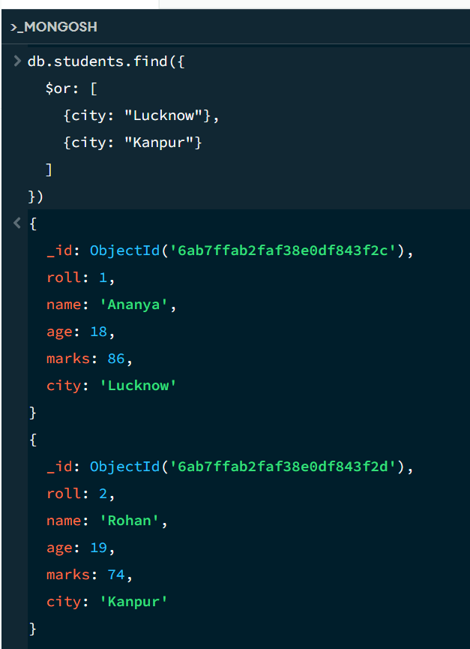

15. SORT OPERATION
A.MongoDB Query:
db. students. find (). sort({marks : 1})
Explanation: Sorts students by marks from lowest to highest. Use 1 for ascending order.
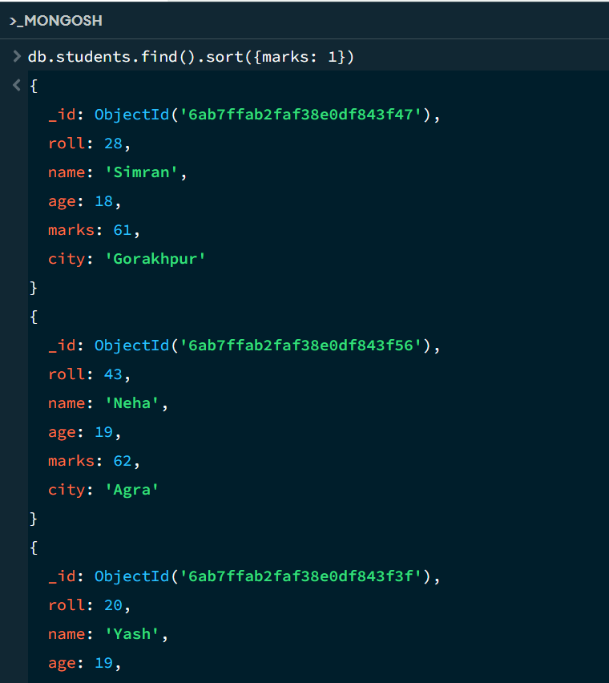

B. MongoDB Query:
db. students. find (). Sort ({marks: -1})
Explanation: Sorts students by marks from highest to lowest. Use -1 for descending order.
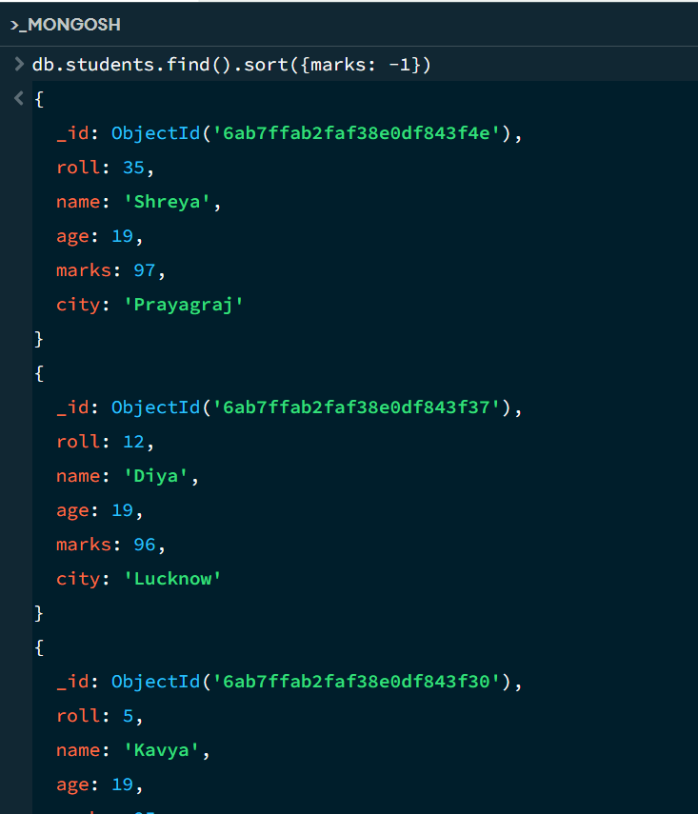
16. LIMIT OPERATION
MongoDB Query:
db. students. find (). limit (5)
Explanation: Displays only the first five documents.

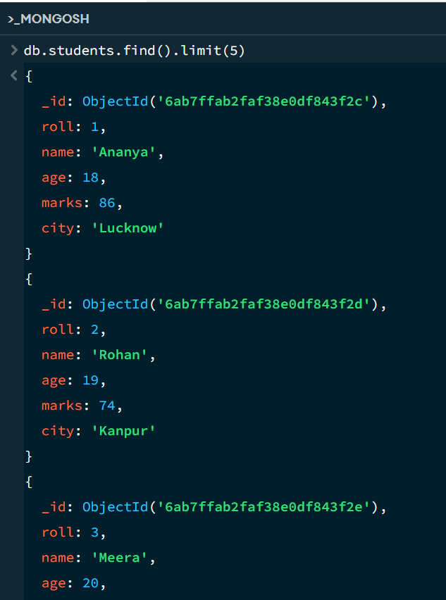

17. SEARCH BY CITY
MongoDB Query:
db.students.find({city:"Lucknow"})
Explanation: Finds all students whose city is Lucknow.
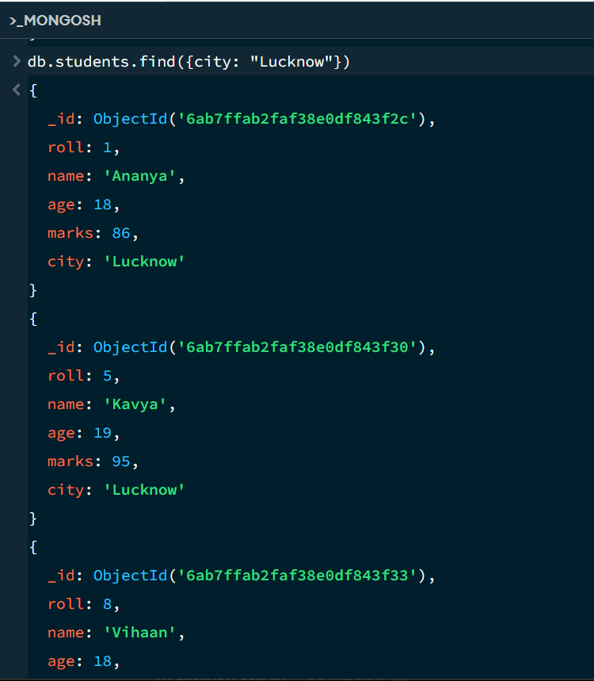

18. COUNT DOCUMENTS
MongoDB Query:
db. students. count Documents ()
Explanation: Counts documents currently present in the collection (performing after the delete function).
