Hi Recruitment / Technical Team,

Hope you are good!

Please refer below GIT URL and changes made by me as instructed in assessment.

**Documentation for GIT Repository to get my changes at your end to review or validate:**

Please let me know @ [saakolkar@gmail.com](mailto:saakolkar@gmail.com) if you face any issue in cloning this project at your end # **PLEASE CHECK UNDER MASTER BRANCH**

GIT HUB URL : <https://github.com/saakolkar/CucumberProtractorRepo.git>

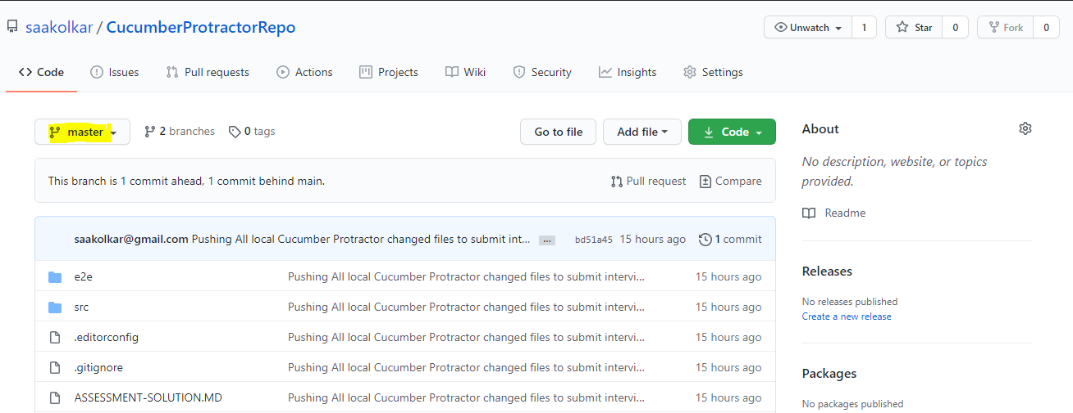

**Documentations for Changes made by me in the assessment shared:**

I made few corrections when I opened the shared folder in Visual studio code:

* Protractor.confiig.js has # feature file path as './e2e/features/*/*.feature' I made correction to './e2e/features/*.feature
* Frame wok path in protractor.config.js was missing but I added it as below

frameworkPath: 'node_modules/protractor-cucumber-framework',

* Protractor-cucumber-framework' was not installed I installed it using npm install command
* Under shared folder # test-reports folder was missing and I made correction and added it and also ran the tests successfully by deploying the shared Anguler project and launched the , also configured protractor.conf.js to configure report format as json

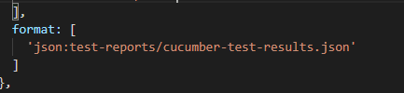

* browser and Application also cucumber report.json is generated under Reports folder
* Also installed chai with cucumber framework
  1. npm install --save-dev chai cucumber protractor-cucumber-framework
  2. npm install --save-dev @types/chai
  3. npm install --save-dev @types/cucumber
* and in tsconfig.json added chai and cucumber

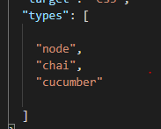

* Removed requrie statements with import statements because import is latest syntax introduced by es6( latest scripting version standard

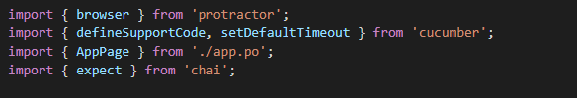

* Removed Timeout for each async framework and set default time

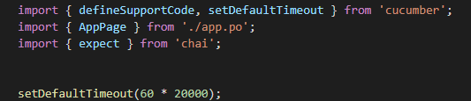

* Added page Object Class and inside it added page operation methods to implement ‘page Design pattern / Page object model design pattern’

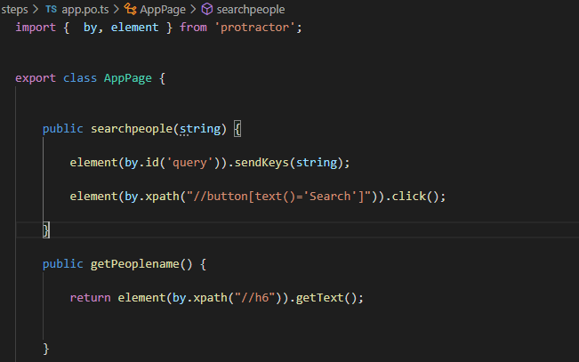

* Added two scenarios one for people search and another for planet search

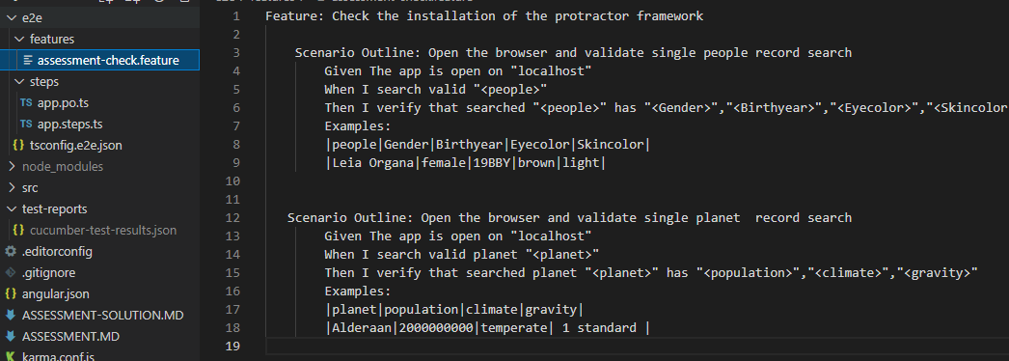

* Added Step definitions

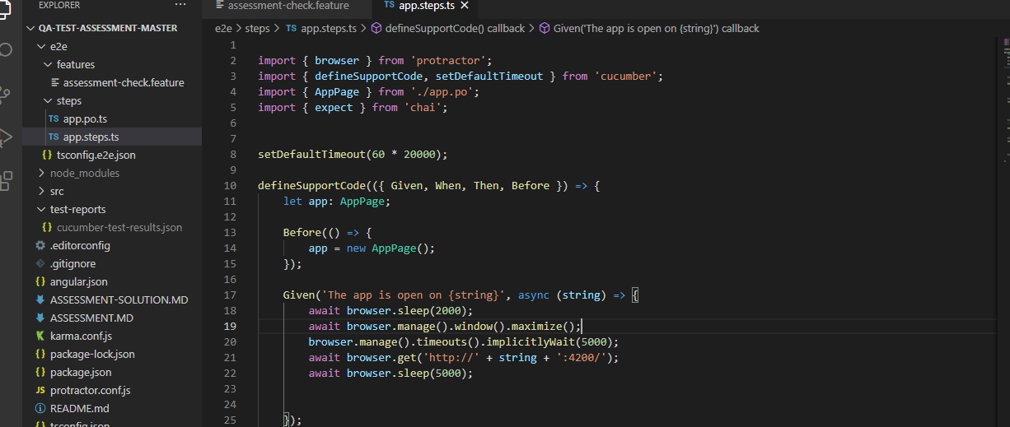

* Executed the scenarios and both are passed

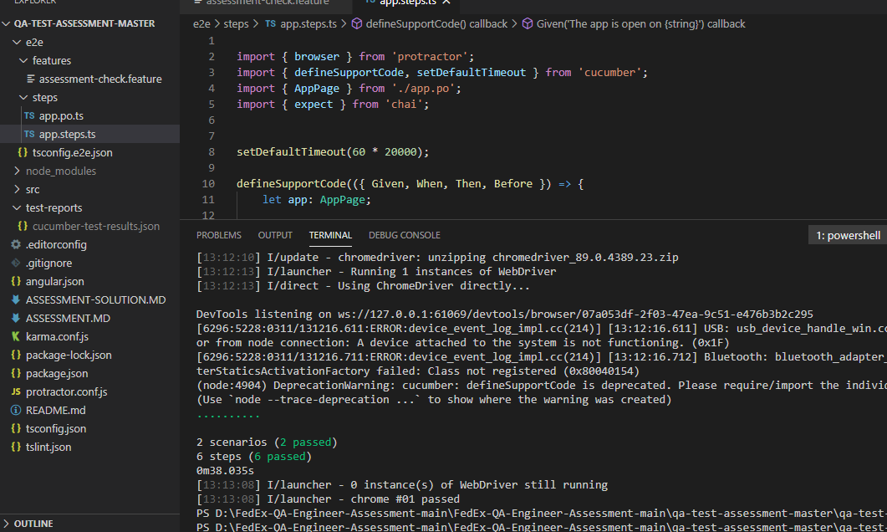

* Json reports are generated



**I would like to propose more changes would have done but due to time constraint can’t do it now :**

* Add HTML Cucumber Report configurations and install report related modules \
* Add Cucumber Hooks and capture screenshots and logs to Cucumber Reports
* Create App.config file and keep overall times, App URL etc and read form there
* Create Object Repository and keep XPATH or Element identifiers in the same file
* Also create Element Actions class and handle exceptions with waits