A project report is a formal document that provides a detailed account of the goals, progress, and outcomes of a project.

1. **Title Page:**
   * Project Title: Binary Customer Churn
   * Your Name: Saakshi(B033) and Anika(B040)
   * Date: 31 th October
   * Institution Name : Mukesh Patel School of Technology Management and Engineering
   * Contact Information (email, phone) –

7700997655 and saakshi.jain134@nmims.edu.in

1. **Table of Contents:**
2. **Executive Summary:**
   * We have tried to implement Logistic regression using pyspark and sklearn
   * We have shown visualization between the columns of
3. **Introduction:**
   * Explain the background and context of the project.
   * State the objectives and goals of the project.
   * Provide a brief overview of what the report covers.
4. **Methodology:**
   * Describe the methods and approaches used to conduct the project.
   * Explain the data collection: The dataset from 'customer_churn.csv.'
   * Explain the importance of the 'Account_Manager' field in the context of customer churn prediction.
   * Clarify the meaning of customer churn and its significance in business.
   * Tools and techniques: Use of PySpark and Sklearn for data analysis and model development.
   * To check accuracy by confusion_matrix and Area Under the ROC Curve (AUC-ROC).
   * **Data Exploration and Analysis**
   * Discuss any notable correlations between variables (e.g., "Age Type" and "Payment Delay" and

Correlation between Subscription Type and Usage Frequency).

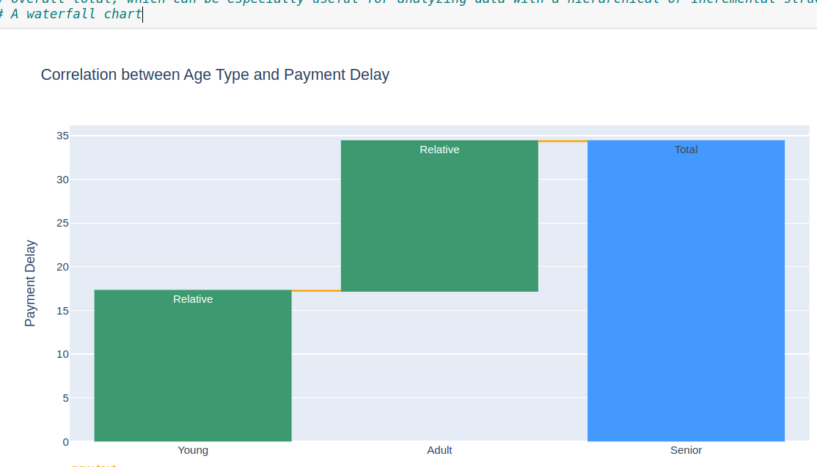

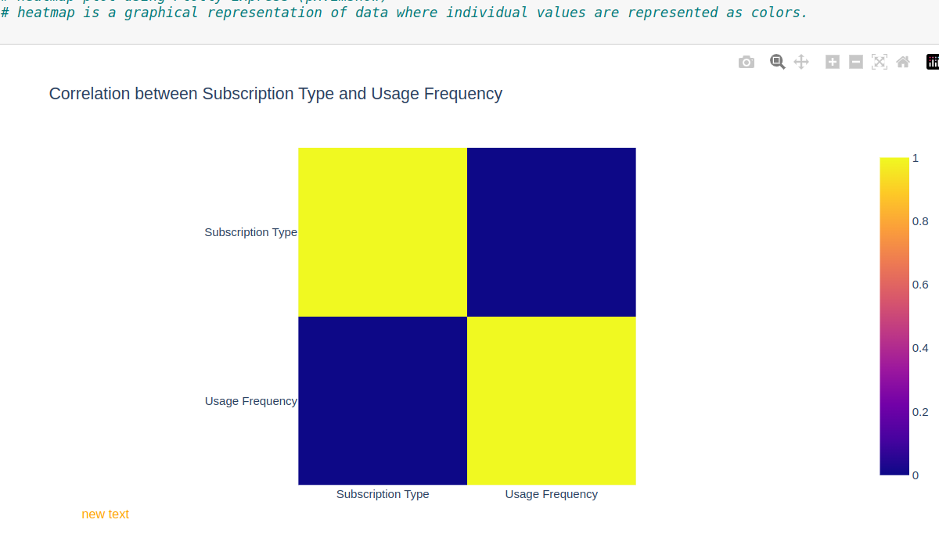

1. **Project Description:**
   * Provide detailed information about the project, including its scope, timeline, and resources.
2. **Results and Findings:**

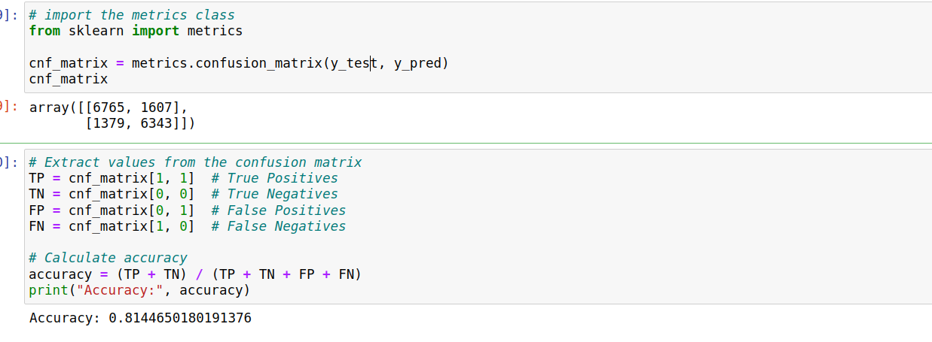

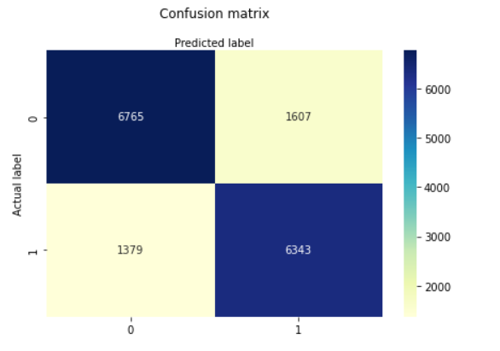

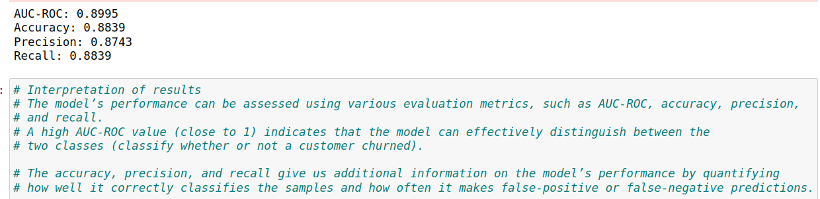

1. **Discussion:**
   * Interpret the results and their implications.
   * Discuss any challenges faced during the project and how they were addressed.
   * Compare the results to the project's objectives.
2. **Conclusion:**
   * Summarize the key findings and their importance.
   * Discuss the project's overall success and any lessons learned.
3. **Future Work:**

* Outline any future projects or research that can build on the current project.

1. **References:**

* List all the sources and references cited in the report.

1. **Appendices:**

* Include any supplementary material that is relevant to the report but not essential for the main body, such as raw data, additional charts, or detailed technical information.

1. **Acknowledgments:**

* If there are individuals or organizations you'd like to thank for their support or contributions, include acknowledgments.