2026
<student name>
<student number>
3/19/2026
CAB230 Assignment 2 Client Side

Replace image with one with some relevance to your application here
CAB230
Rentals API – Client Side Application

Contents
Introduction 2
Purpose & description 2
Completeness and Limitations 2
Use of End Points 2
/rentals/states 2
/rentals/property-types 2
/rentals/search 2
/rentals/{id} 2
/ratings 2
/ratings/rentals/{id} 2
/user/register 2
/user/login 2
Modules Used 3
React Router 3
https://reactrouter.com/ 3
Application Design 4
Navigation and Layout 4
Usability and Quality of Design 4
Accessibility 4
Technical Description 5
Architecture 5
Test plan 6
Difficulties / Exclusions / unresolved & persistent errors 6
Extensions (Optional) 6
User guide 6
References 7
Appendices as you require them 7

This template is adapted from one created for a more elaborate application. The original author spends most of his professional life talking to clients and producing architecture and services reports. You may find this a bit more elaborate than you are used to, but it is there to help you get a better mark
This report should be around 20 pages or so including screenshots – there is no formal page limit, and the length will depend a lot on the number of screen shots, but you won’t get any extra marks for a really long report.

Introduction

Purpose & description
This is written in a high-level professional tone. Tell is in about a paragraph or so what the app is supposed to do. This should be in your words, though you should feel absolutely free to steal some of it from the assignment specification.
In a second (and maybe third) paragraph, go ahead and tell us what to look for in your app: What did you do that was different? Did you do something to provide the user with functionality beyond what was expected? Is there some special set of modules that you have used that make it look great? Is there some other module that you have used that makes it more efficient? At this point, this description is at a very high level still. You will list your modules below.
At this point you can show 1-2 basic screenshots of your application to illustrate the approach, but leave the more detailed screenshotting to the use cases below.

Completeness and Limitations
Here we want you to tell us in a couple of sentences what works and what doesn’t. Make a claim against the standards we laid out in the assignment specification and briefly justify that claim. Don’t give us deep details of the bugs here. Putting a positive spin on what you have achieved is fine – by all means focus on the stuff that works. But be realistic in your claim.

Use of End Points
In this section we want you to show us the facilities that you have provided in the app. Here you should organize the discussion around the endpoints of the API, showing screenshots from your app (not screenshots of your code!) where applicable corresponding to that endpoint and providing a brief discussion of what it does. (A couple of sentences is fine here – the screen shot tells the story. Write more if there is something you want to tell us. But otherwise just keep it short.)

/rentals/states

/rentals/property-types

/rentals/search

/rentals/{id}

/ratings

/ratings/rentals/{id}

/user/register

/user/login

Modules Used
This is just a list of the external modules that you have used. You need not specify core React modules. In each case, we want the name, a brief description, and a link to the docs at npm or github or wherever. The example is react-router as most people will be using this. Just copy that style and add more as necessary.

React Router
Module used to enable Single-Page Application functionality

https://reactrouter.com/

Application Design

Navigation and Layout
Here we want you tell us – again in a paragraph or two - about the design process for the site, the choices that you have made and any alternatives considered. Tell us about the choices you have made for navigation – the menu items and the flow between the screens – and the layout. The idea here is that you will tell us in this section how the application is used and we can then use this when we are looking at the technical description describing how it is built.
Show us some of your design mock-ups – scan some of your sketches – and show us how your application flows from one screen to another.

Usability and Quality of Design
When we mark you on usability, our expectations are basic. Your application should be logically laid out and the UI widgets should be well chosen to suit the data that they control. This will not be a high bar to clear.
But in this section, we want you to be more critical and to assess – as firmly as you like – the quality of your own design work. We want you to highlight the good and the bad aspects of your design based on some of the principles you learned in the Web Design Principles Videos and Slides:
- Is your display well organized? Is the layout clean or clumsy?
- Is the navigation clear and intuitive?
- Is the application consistent with user expectations from other apps?
- Is the visual design consistent across screens? Do you use a small number of fonts and font sizes? Are there too many colours?
Comment on the usability of your design – are there compromises that make it awkward to use? How might you improve those?
Our expectation is that this section will occupy a few paragraphs or an equivalent number of bullet points. We are concerned more with the quality of the analysis than with the style.

Accessibility
In this section we expect you to analyse your site from the perspective of accessibility, including considerations for Aboriginal and Torres Strait Islander audiences, relying on our lecture slides and video, and the checklist from the W3C: https://www.w3.org/TR/WAI-WEBCONTENT/full-checklist. The documents from the W3C are dense and difficult to read, so we will work with an edited version of some of their most important, Priority 1 requirements in the list below.
It is not required that you implement accessibility or inclusion features in your site. Instead, we want you to examine your site critically. We want you to look at the checklist and, in a few paragraphs or an equivalent number of bullet points, rate your app against these guidelines – you may even be able to tick off some of them – and tell us how your design will help or hinder you in meeting the requirements.
The edited list of Priority 1 Accessibility Requirements is here:
- Provide a text equivalent for every non-text element – alternatives to images, symbols, scripts, graphical buttons, sounds, audio and video files and so on.
- Ensure that all information conveyed with color is also available without color, for example from context or markup.
- Organize documents so they may be read without style sheets. For example, when an HTML document is rendered without associated style sheets, it must still be possible to read the document.
- Ensure that text equivalents are updated when dynamic content changes.
- Avoid causing the screen to flicker.
- Use the clearest and simplest language appropriate for a site's content.
- For tables, identify row and column headers – clearly differentiated from the data.
You should feel free also to look at the lower priority guidelines available at the link above.
In addition to the above, your reflection should consider inclusive design and cultural accessibility, especially with respect to Aboriginal and Torres Strait Islander perspectives. Some examples include:
- Consider alternate device access patterns and equitable access for Aboriginal and Torres Strait Islander users.
- Consider whether, given the context of the application, it is appropriate to include an Acknowledgement of Traditional Owners on the site.
- Consider whether the language, examples, imagery, and interface choices used in the application may exclude, misrepresent, or alienate Aboriginal and Torres Strait Islander users or communities.

Technical Description

Architecture
Briefly describe the overall architecture of your application at a source code level. The description above tells us something of the application’s use. Now we want to see how that maps to the code organization. Your application source code will be organized something like this:
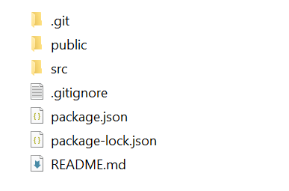
Dig into the src directory and tell us how you have split the responsibilities. Tell us in a sentence or two how the application is controlled and the services supported. In the image below we see an example organization of a React app. Include an image like this one and tell us briefly about the split across the relevant folders and why you chose it that way.
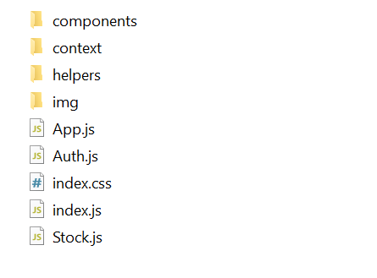
Overall, including the images, this section should still be under a page or so. We should get some sense of how the application works and how the data and control flows around. You may find it helpful to show us screen grabs of code if that makes your points clearer. Explaining quickly how the application works is the goal. Tell us anything you think we need to know about how you have structured the application and made it work, but there also a section below to describe problems.

Test plan
Manual testing is fine and our expectations are in line with the example grid below. You can show the results through a screen shot and point us to these from the table.
Your tests should include
- Positive outcome cases
- Negative outcome cases (error scenarios)
- edge cases
- non-functional cases (ideally, but not required this time).
Note that the grid below is completely unrelated to this application.
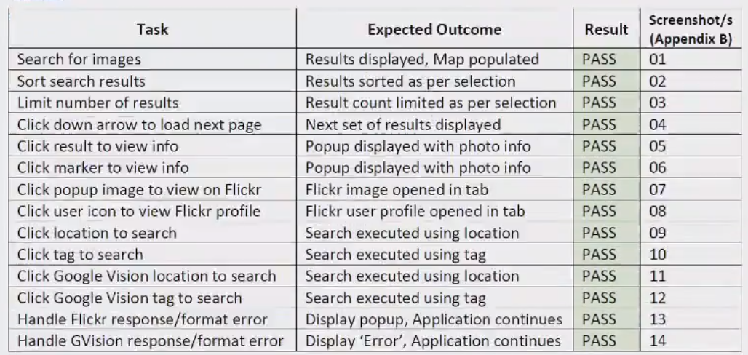

Difficulties / Exclusions / unresolved & persistent errors /
Topics to include here could be:
- What were your major roadblocks / how did you resolve them?
- Any functionality you didn’t or couldn’t finish and the technical issues encountered
- Are there any outstanding bugs?
If you are describing bugs or unresolved issues please be quite specific and feel free to show screen grabs of code which will assist us in assessing your work.

Extensions (Optional)
Where could you take this:
tell us about Potential future extensions / improvements for your app

User guide
Tell us how to use your application
Use screenshots liberally here. You may re-use screenshots from above.

References
Use a standard approach to referencing – see the guidance at https://www.citewrite.qut.edu.au/cite/.

Appendices as you require them

