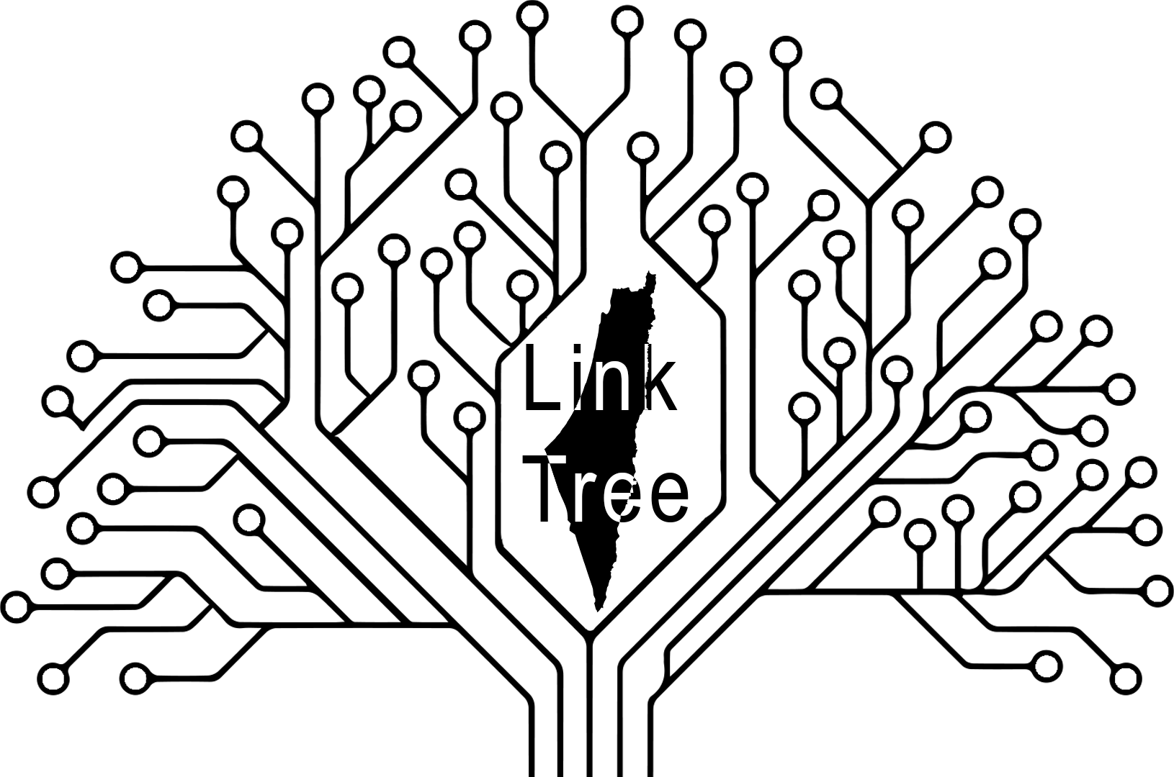
Courses
(Material for all Majors)
Tools
(check it out)
Guide & info
(Docs, links & office hours)
Socials
(Groups, Clubs, sites)
Extra
(Extra Material)

by The LinkTree Team
Fall 22 ~ Fall 25

