**Employee Database User Guide**

**By: Aamir Tahir and Varun Ramanathan**

**` ICS4U0 - Grade 12 Computer Science**

**December 12th, 2016**

**Mr. Dutton**

**Introduction:**

Welcome to the user interface guide for the Employee Database program created by Aamir Tahir and Varun Ramanathan. At this point you have the choice to continue using this guide or just using the program from scratch. The Employee Database program was designed in a very user friendly manner allowing the user to use the program without reading this guide. The buttons and commands are very descriptive and self-explanatory. A table of contents containing the steps from beginning to end of creating the employee database is given below.

**Table of Contents:**

Setup Guide

Quick Commands

Main Menu and Layout

How to add an Employee

How to edit an Employee

How to remove an Employee

Search/Find Feature

Refresh Command

ERRORS

Background Info

.DUTTON files

**Setup Guide:**

The first step to using this employee database program is to start up the program. If you have the executable jar file double click to start. If not open up netbeans and open up the employee database folder as a project. Right click the GUI panel and click run file. This should open up the program for your use.

**Quick Commands:**

**Ctrl+N**

This allows you to create a new database. Visually the display field of the program will reset. Remember to save your previous database before creating a new one.

**Ctrl+L**

If you have a .DUTTON file holding a employee database. Then using this command to find the file using the window that is shown below.

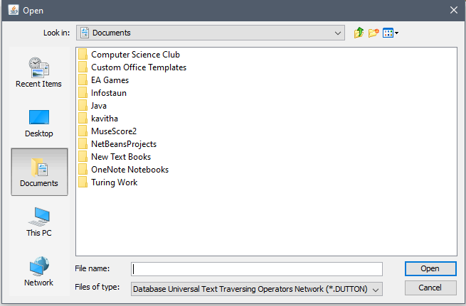

**Ctrl+S**

If you have already saved as this will save the database on your save file. If no it will prompt you to the window shown below to name your new save .DUTTON file.

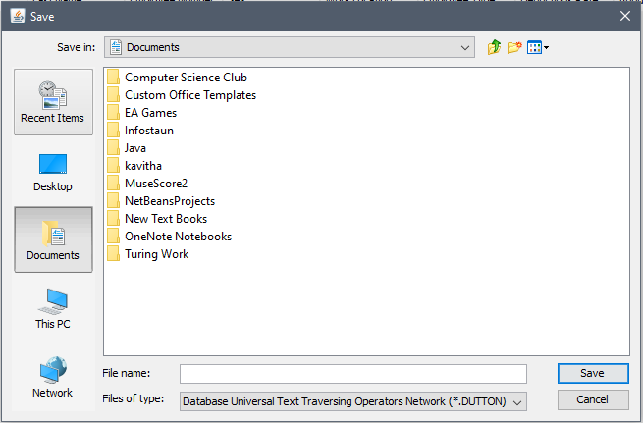

**Ctrl+Q**

This command allows you to quit the program. If you haven't recently saved it will prompt you to save first.

**Ctrl+E**

Allows you to edit an employee that is selected.

**Ctrl+A**

Selects all employees in the table.

**Ctrl+R**

Refreshes the display panel.

**Main Menu and Layout:**

When you startup the program it will take you to this screen.This will be your main menu where you can do all the tasks needed for creating the employee database.

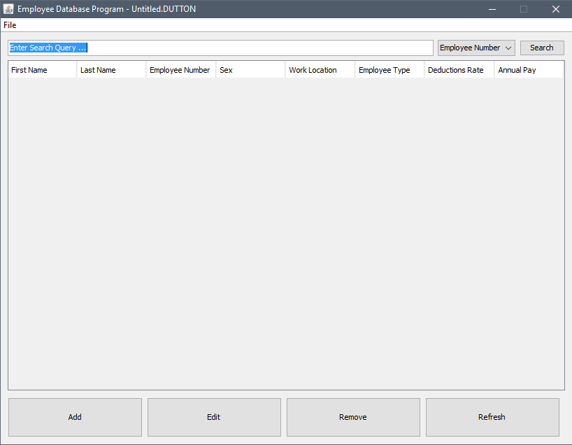

This is your display screen. When you have loaded or created an employee database, this area will display all the employees in the database. THis is where you will be able to select an employee for modifications.

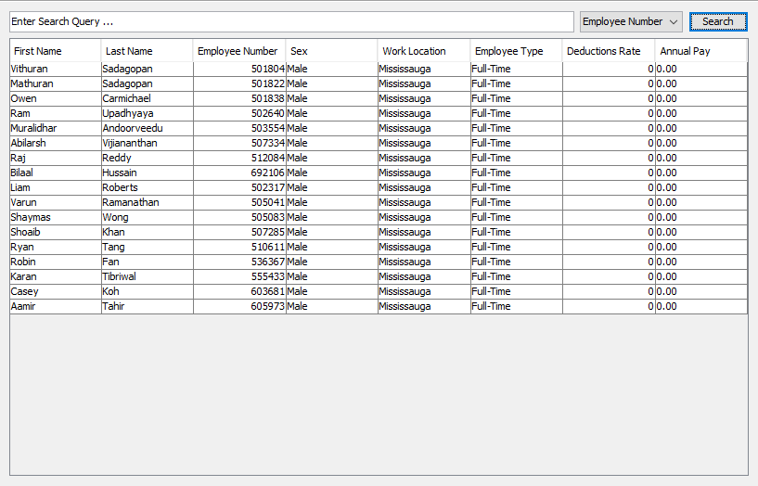

This is your pull down file menu. Here you will see quick commands such as creating a new database, loading an existing database, saving and quiting the program. Beside each button the quick command shortcuts are written for ease of access. Just always remember to save your database from time to time.

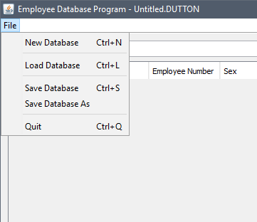

Seen below is the main command task bar. Here are listed the 4 main commands that will help you create the database. What each button does is listed below under their respective headings.

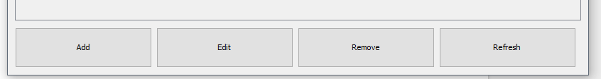

In the top right corner is the close bar. Here you can click (X) to close the program or (-) to minimize it.

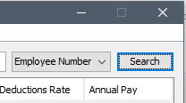

**How to add an Employee:**

If you click the ADD function it will take you to this window. Here you will be able to add all the info about the certain employee you want to add to the database.

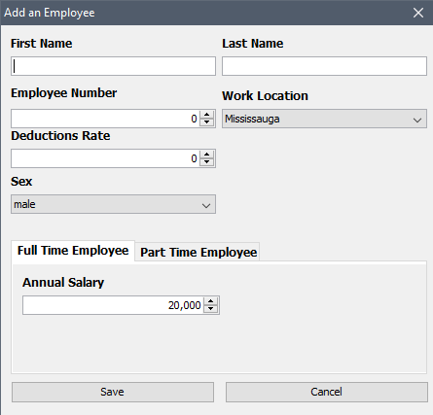

Beneath work location there will be a drop down menu to choose a location being mississauga, chicago or new york.

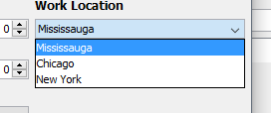

Beneath Sex there will be a drop down menu to choose a gender being male, female or other.

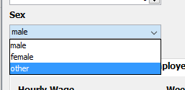

If you click the part time employee tab you will be able to edit the part time attributes of the employee such as hourly wage and number of hours.

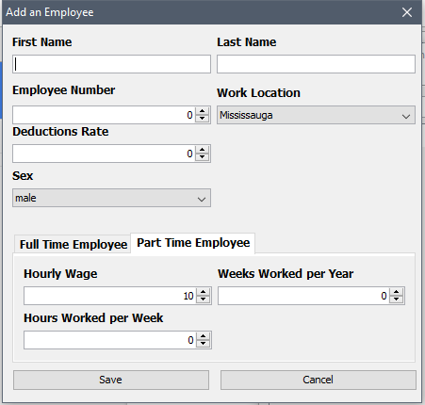

Once you have entered in all the info click save to add the employee. If you click cancel the program will discard the info you typed in and it will take you back to the main menu screen.

**How to edit an Employee:**

If you want to edit an employee first select the existing employee by clicking their row. Then click the edit button to take you to the modification window.

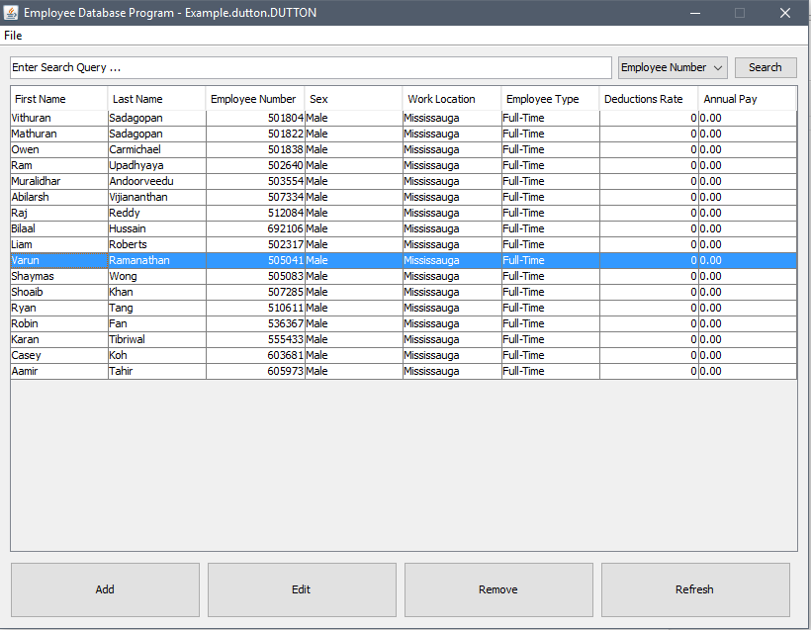

Shown below is the modification window similar to the adding employee window. Here you will be able to change existing info. When you click save it will save. If you click cancel it will take you back to the main menu.

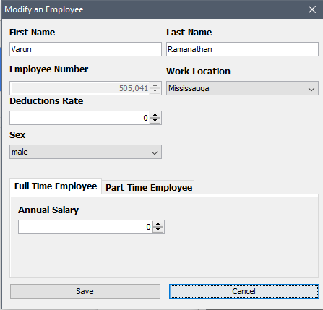

**How to remove an Employee:**

If you would like to remove an employee choose and select their row by clicking on it. Once you have click the remove button to remove them. This will be permanent so be careful about removing. You can also use shift and control commands to select more than one employee to remove.

**Search/Find Feature:**

If you would like to search and find someone in the database you can use the search bar feature. Here you can type in the Employee number to find the related employee. Type it in then press enter or click the search button. The search algorithm will search and output all results that match the attribute you typed in.

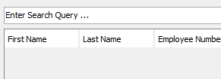

If you want to search using a different criteria use the drop down menu near the each button to select another criteria. Some of them are name, deduction rate and annual pay.

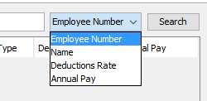

If you have a newer version of the program you will see that any term entered into the search field will automatically be searched without you having to click the search button.

**Refresh Command:**

The refresh button shown below will refresh the display screen to the most recent changes. The program will automatically refresh but some glitches may cause some recent change not to show. In this case pressing the refresh button will help with seeing the most recent data before saving or exiting.

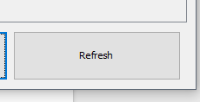

**ERRORS:**

**Search Error:**

If you leave the search field blank and click search the program will inform you that the field is blank.

If you try to search an empty database, it will give an error and say that the database is blank.

**Save Error:**

If there are unsaved edits and you try to exit the program, there will be a message that says you have unsaved changes,(Are you sure you want to exit?)

**Background Info:**

**Attributes of Employee Saves:**

For full time employees, there are 7 attributes:

* An integer for employee number
* A String for first name
* A string for last name
* An integer for sex
* A float for salary
* A float for deductions rate
* An integer for work location
* Ex. 603;Varun;Ramanathan;0;10;0;2

For part time employees, there are 9 attributes which include those of the full-time employee with the following exceptions:

* Hourly wage instead of salary
* Added integer for hours per week
* Added integer for weeks per year
* Ex. 605973;Aamir;Tahir;0.1;12.50;0;0;8;52

**.DUTTON Files:**

A .DUTTON file format is what is used to store information of type “employee” A .DUTTON file stores all the info that corresponds to different employees.

This file type stands for:

**D**atabase

**U**niversal

**T**ext

**T**raversing

**O**perators

**N**etwork

This concludes the guide. We would like to take the opportunity to thank you for choosing our employee database program.

Sincerely **Varun, Aamir**