**Lecture – 02**

**Vision Control System**

**Make a new Repository and upload any file on repository**

**Step 01:** On the top right corner you see a plus drop-down button click and select a new repository.

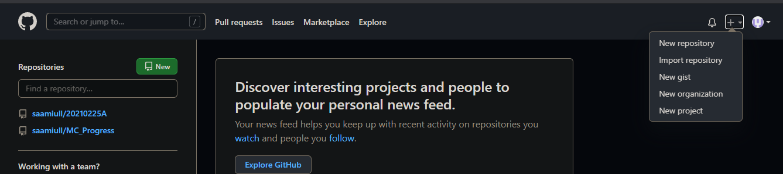

**Step 02:** Write the of your repository and go down and select Create repository.

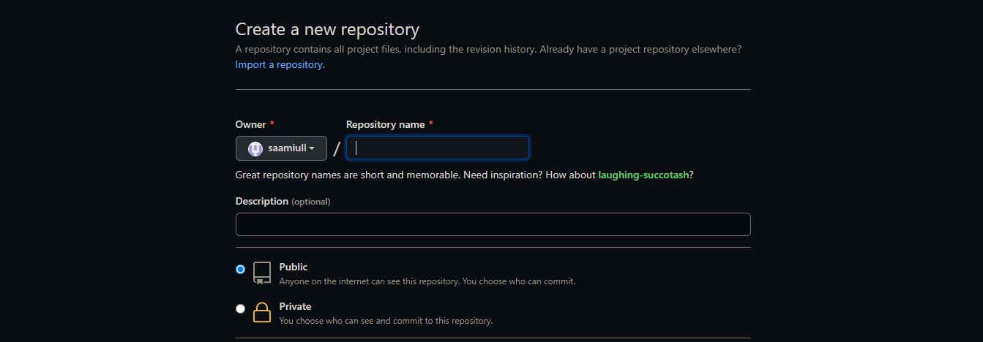

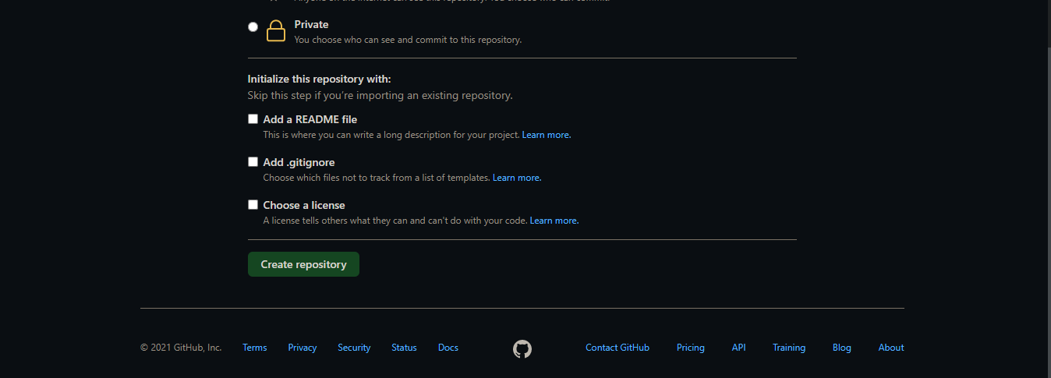

**Step 03:** New repository is created. My repository is shown below:

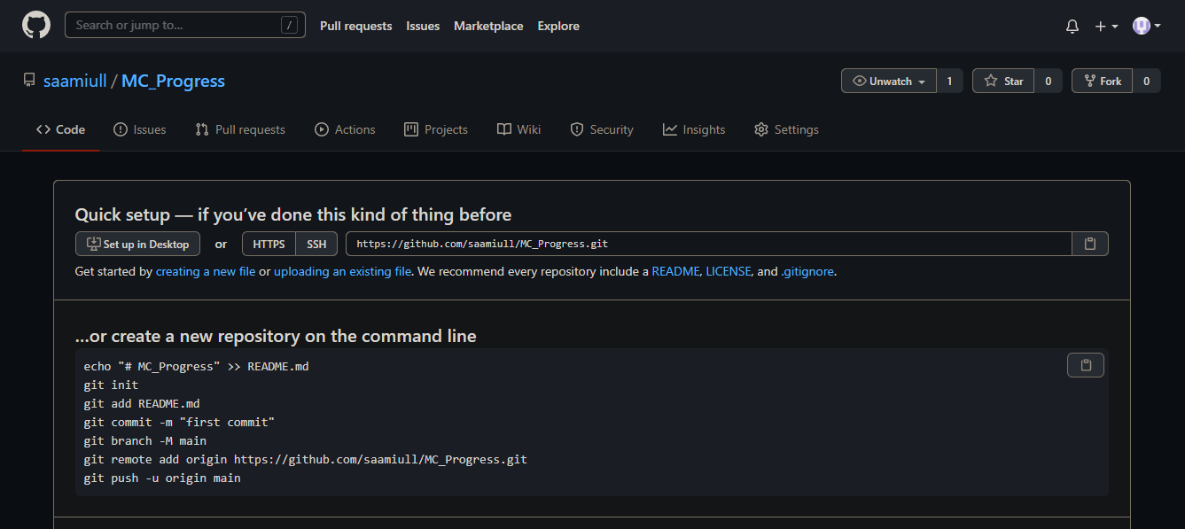

**Add any file on Git hub**

**Step 01:** Make any folder in any directory. In my case I make a folder git on Desktop.



**Step 02:** Make a clone of this repository. For this we use command prompt. Open the command prompt and run the following command.

git clone [URL]

firstly, set the path of folder which create last time. In my case I set the path of git folder.

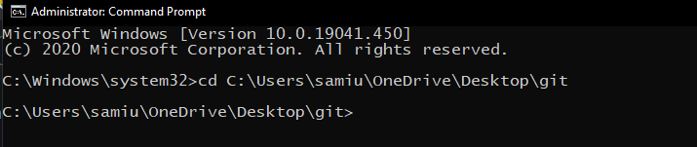

URL in this case is the URL of Repository which we can create before this.

My URL is: <https://github.com/saamiull/MC_Progress.git>

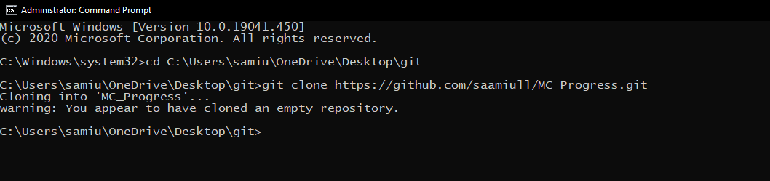

So, empty repository clone is created because repository is empty.

**Step 03:** Make any file in clone folder. In my case a make a html file which name is File 01. And write something in it.

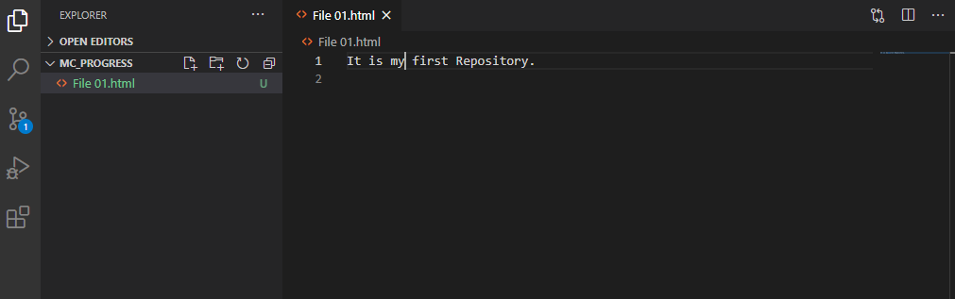

**Step 04:** Add file by use of following command.

git add filename

in my case it is git add File01.html

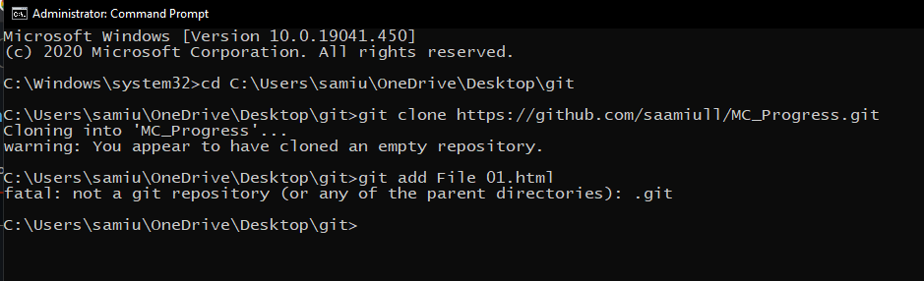

It displays an error because we are not in such directory in which file is save so first move to this directory. And again, apply this command.

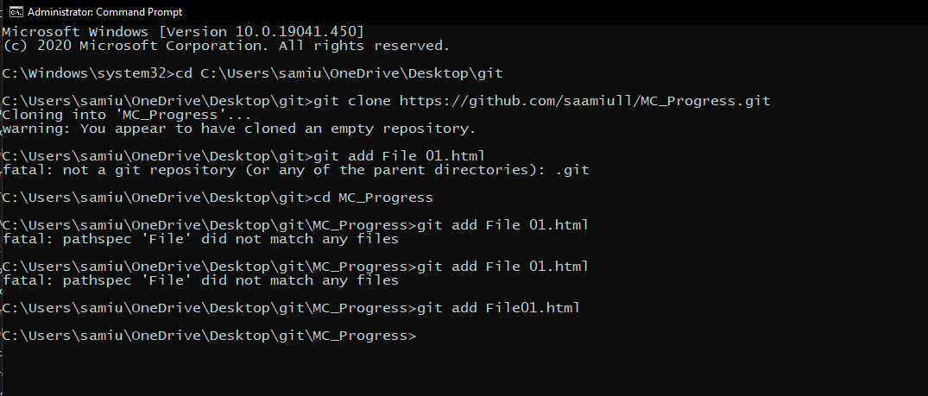

**Step 05:** Commit this file by use of following command.

git commit -m "Message"

in my case it is git commit -m "first commit".

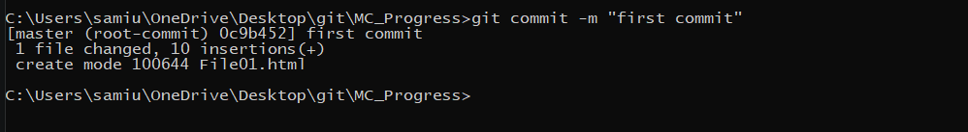

**Step 06:** Push this file by use of following command.

git push

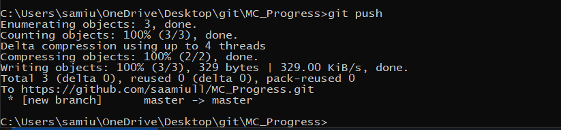

**Step 06:** Refresh the page of browser and we will see the file in our repository.

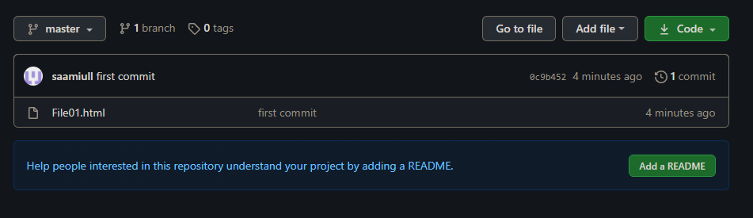

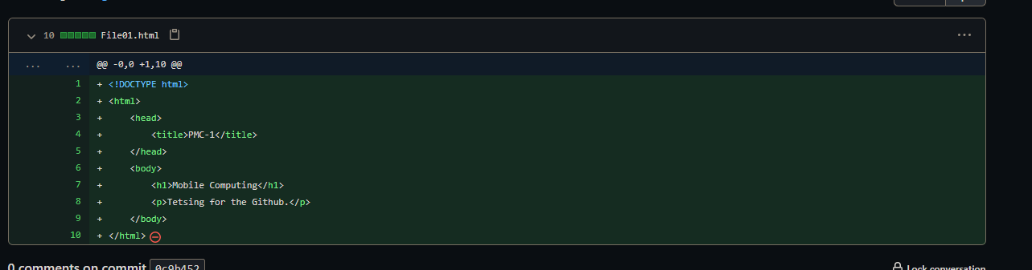

**Step 06:** Add new heading in file and see the changes.

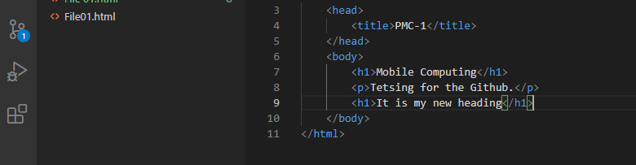

**Step 06:** Again, add this file, commit and push.

git add File01.html

git commit -m "second commit"

git push

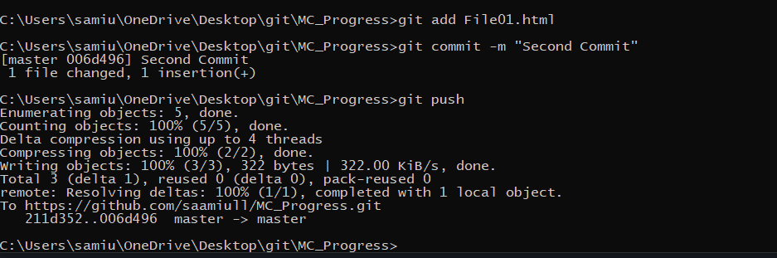

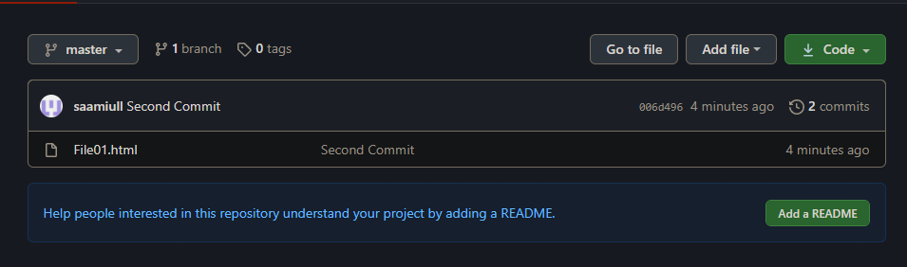

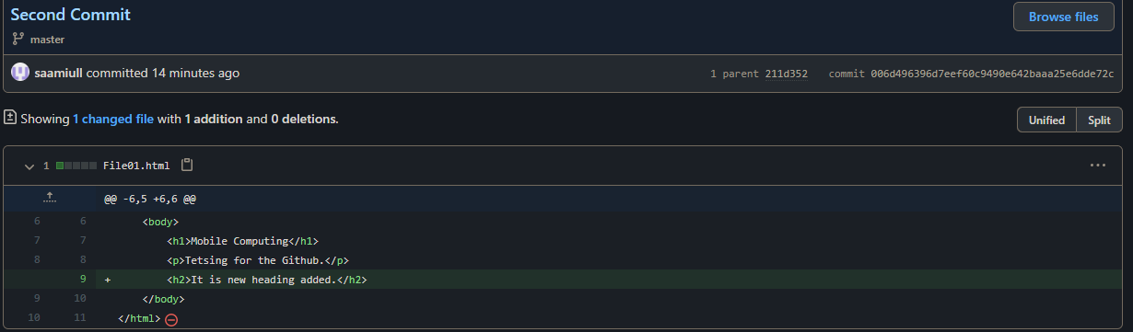

**Step 06:** By Clicking on parent, you see the previous code.

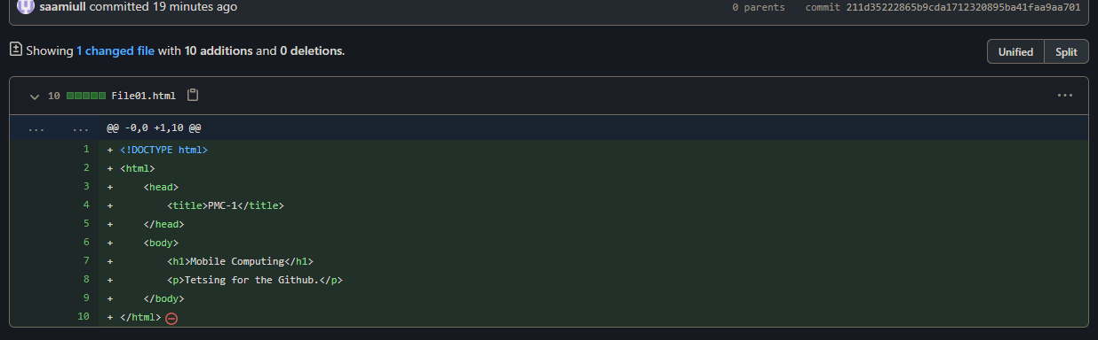

**Lecture – 03**

**Edit files at Repository**

**Step 01:** On the top right corner you see Edit button click on it.

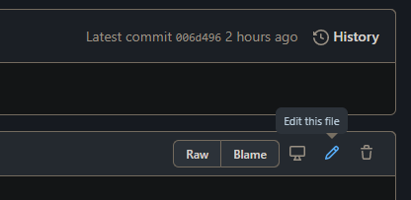

**Step 02:** Add Changes in file and Commit it. And if you want to add description then add it.

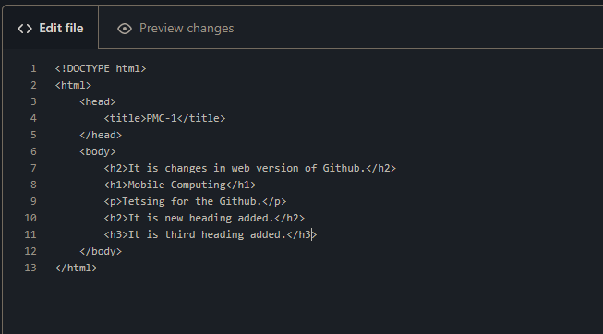

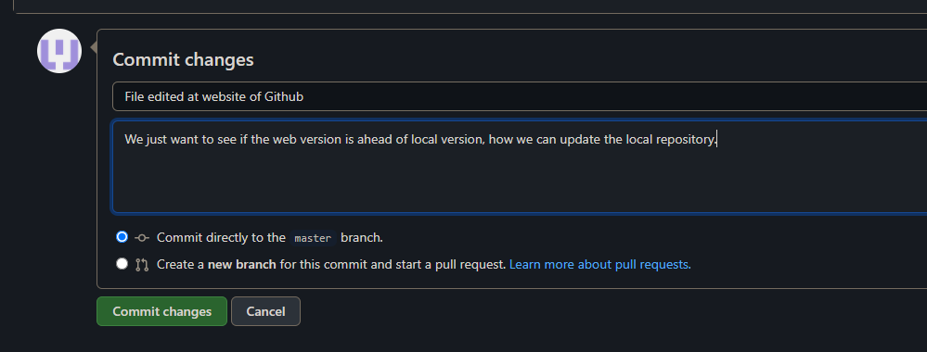

**Step 03:** Changes added in file and you see your new Commit and its description.

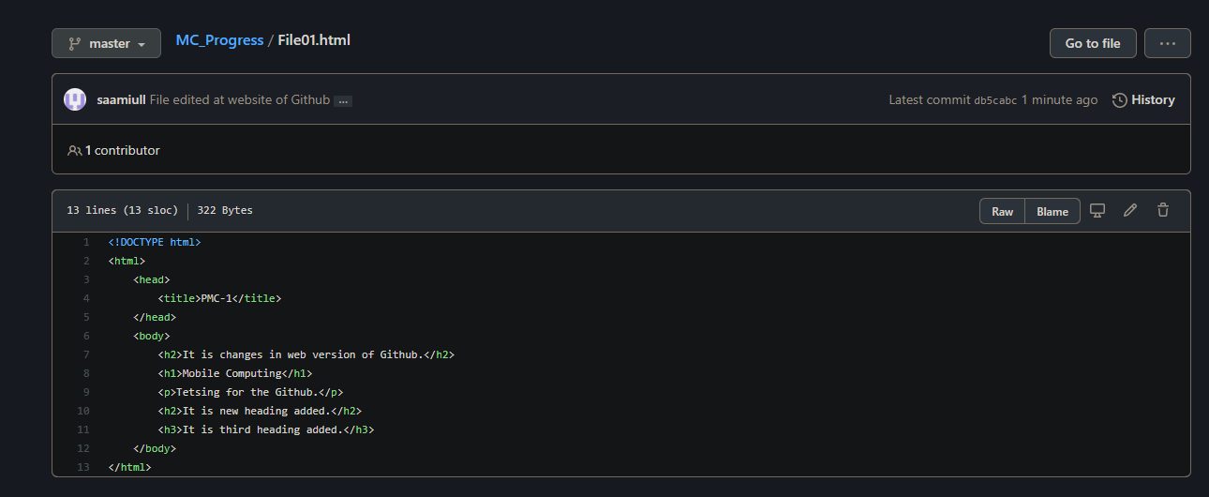

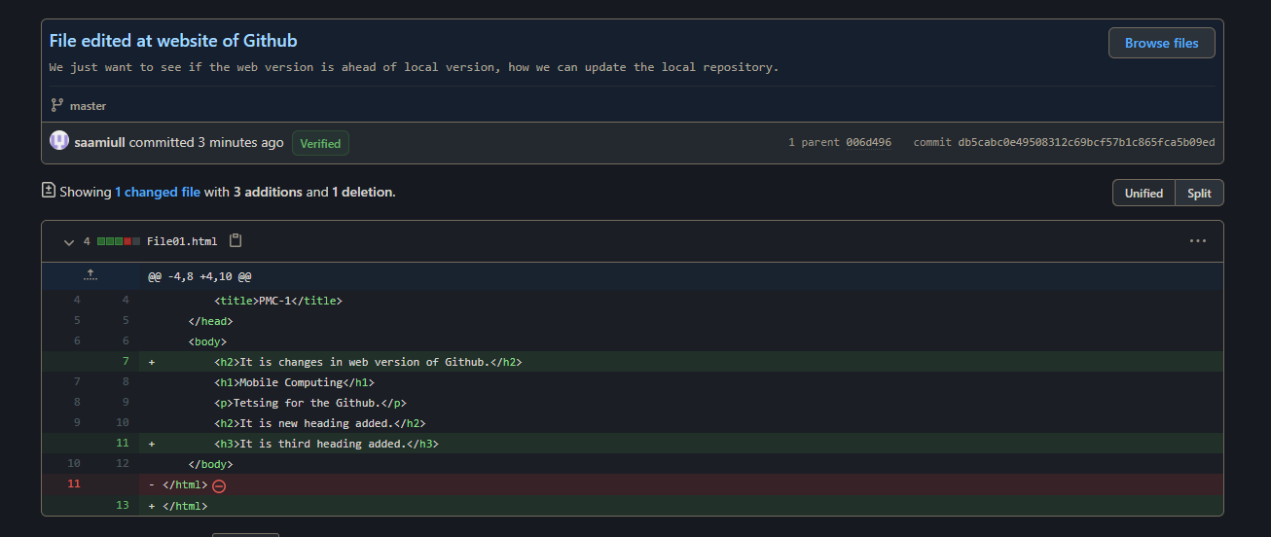

**Step 04:** To addChanges in local repository add following command on cmd.

git pull

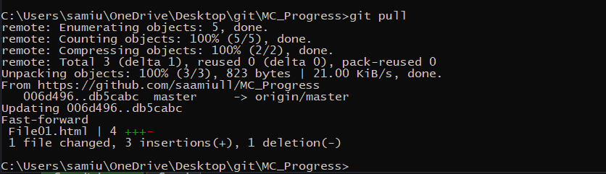

**Step 05:** Changes added in local repository.

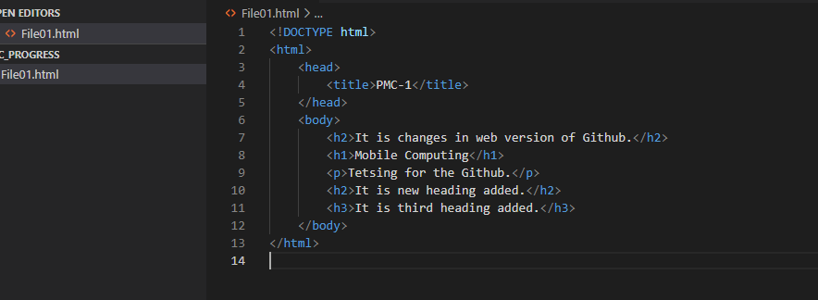

**Merge Conflicts**

**Step 01:** File changes at GitHub and add new commit.

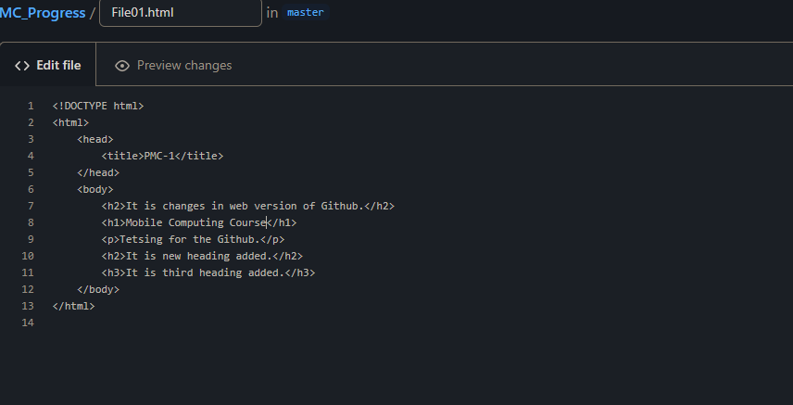

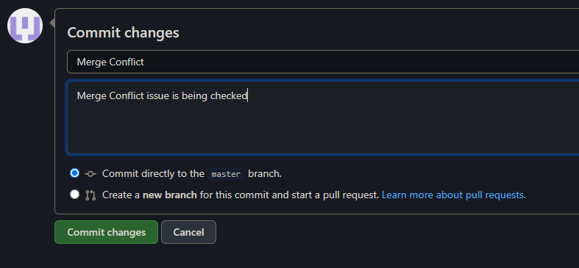

**Step 02:** Same line changed at local repository, then add, commit and push through cmd.

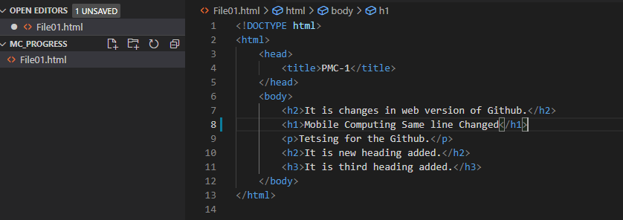

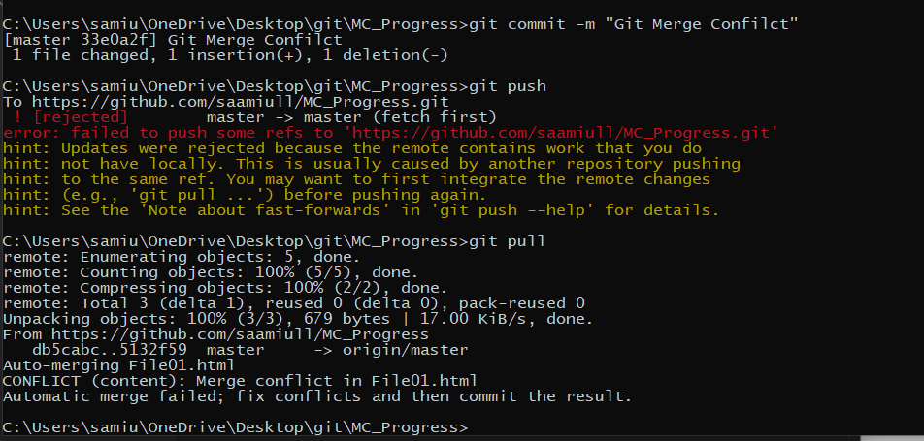

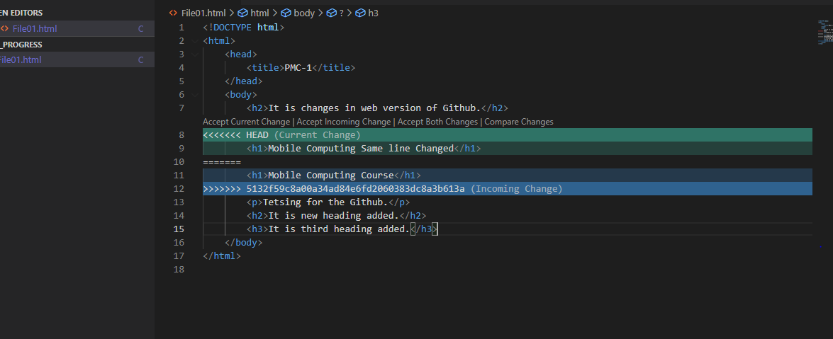

**Step 03:** Select central repository changes or local repository changes to resolve merge issue. In my case, I am adding some extra text.

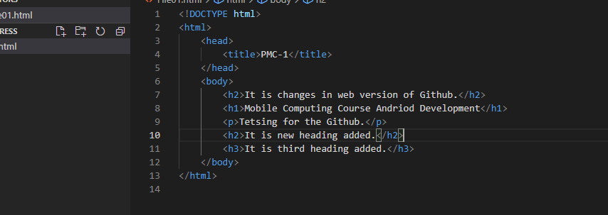

**Step 04:** now add, commit and push again.

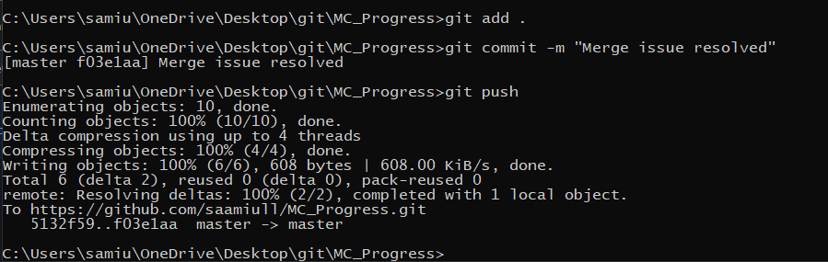

**Step 05:** Issue resolved you can see on central repository.

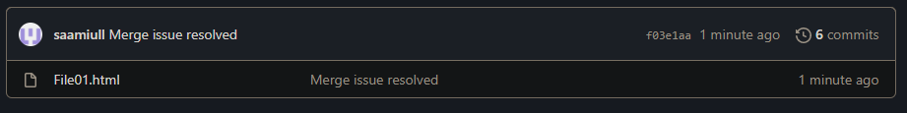

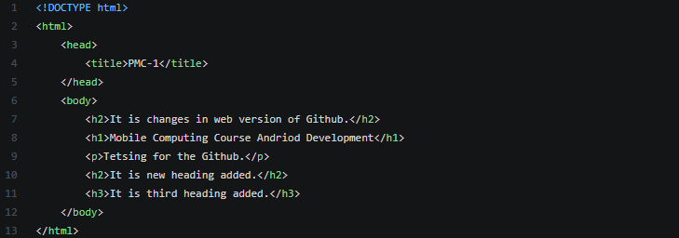

**Details of commits**

**Step 01:** Write the following command on cmd:

git log

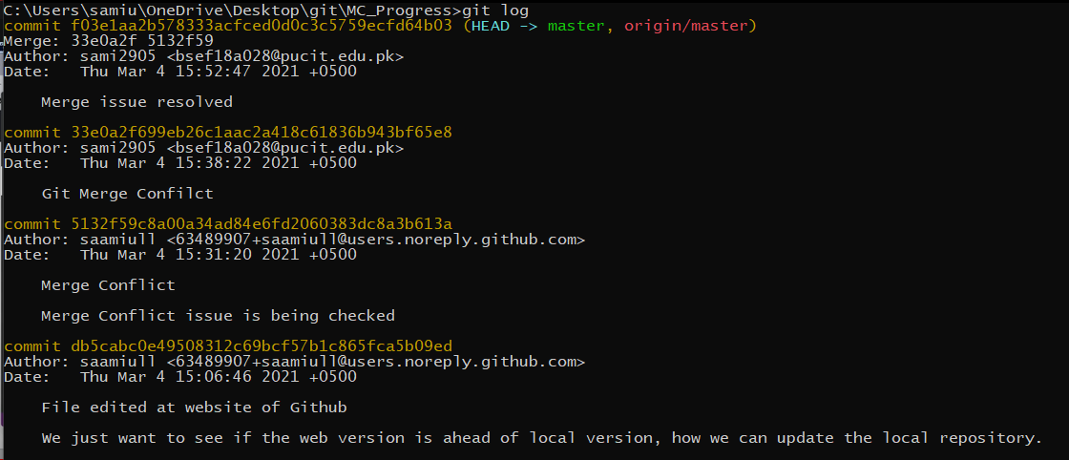

**Branching**

**Step 01:** To check your branch write the following command on cmd:

git branch

**Step 02:** To create a new branch write the following command on cmd:

git checkout -b “Branch name”

in my case it is git checkout -b “NewBranch”.

**Step 03:** We are in new branch, to check it write the git branch command.

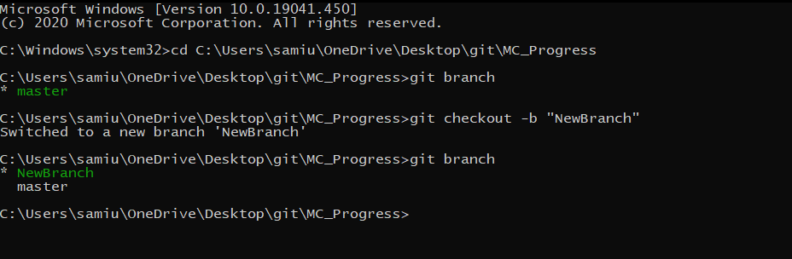

**Step 04:** Add some extra code in new branch to test it.

**Step 05:** Now add and commit the file by following command at a same time:

git commit -am “Commit Name”

in my case it is git commit -am “Styles Applied”.

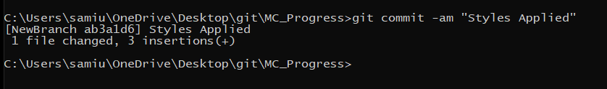

**Step 06:** Switch to Master Branch with the help of following command.

git checkout master

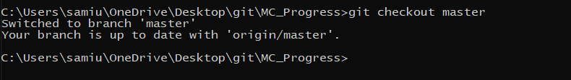

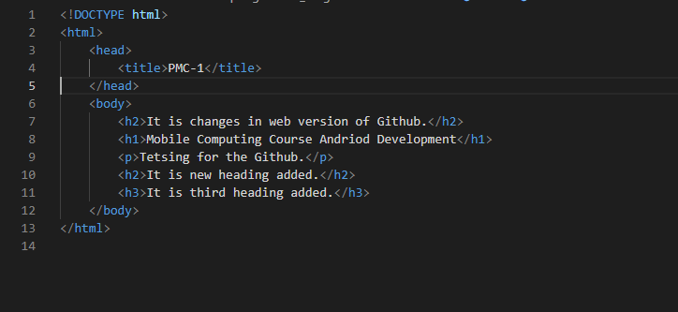

**Step 07:** Switch to NewBranch with the help of following command.

git checkout NewBranch

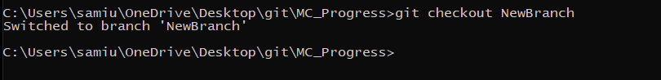

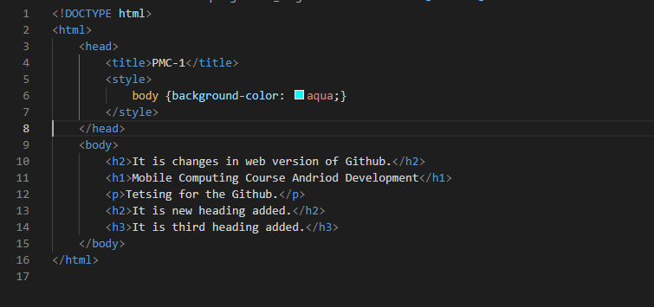

**Merge Branches**

**Step 01:** Add the new branch features or Merge the two Branches into master branch firstly switch to master branch then write the following command in cmd:

git merge NewBranch

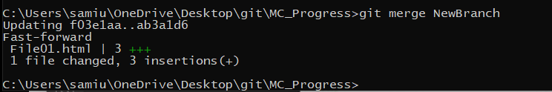

**Step 02:** See the master branch code.

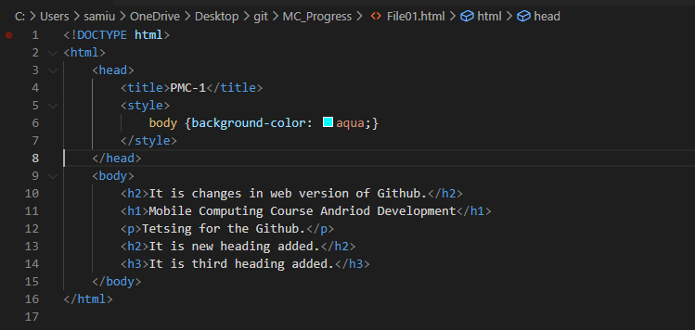

**Delete Branch**

**Step 01:** Firstly, check the all branches by following command:

git branch

**Step 02:** To delete the branch write the following command on cmd:

git branch -D Branch Name

in my case it is git branch -D NewBranch

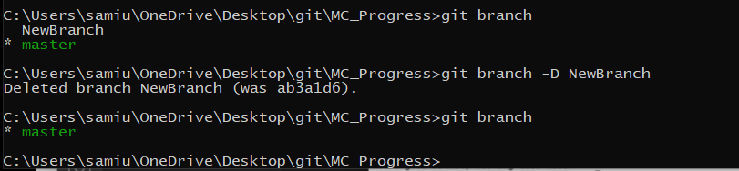

**Step 03:** Now add, commit and push this new master branch.

