**Modeling features (compared to Pancho’s model)**

This model now has the additional ability to:

1. Allow for generators to be designated as must-run.
2. Allow load uplift to accommodate must-run generators (Pumped Storage, Distributed Generation-BTM, Motorload).
3. Expand interfaces based on capacities of individual line investment decisions.
4. Run operations for any number of hours per deterministic run.
5. Generate demand profiles for buses based on population data of census tracts.
6. Generate wind and solar profiles of existing renewable units for the selected hours.
7. Generate profiles for new wind and solar units based on existing profiles.
8. Model Variable and Fixed Operations and Maintenance Costs (VOM, FOM).
9. Allow generators to have a mix of fuels.
10. Calculate marginal costs of operations based on heat rates of individual generators and monthly fuel prices based on the fuel mix.
11. Model Forced Outage Rates (FOR) and Planned Outage Rates (POR) for new generators.
12. Retire generator capacity.
13. Model a Carbon tax.
14. Model Renewable Portfolio Constraints for individual States.
15. Model requirement of mandatory in-state renewable generation.
16. Allow for cross-state trading of Renewable Energy Credits.
17. Build lines of continuous capacity connecting WREZ hubs.
18. Bound bus angles.

**Brief description of the 300 bus WECC dataset:**

***Note: This brief description is taken from [3], a report submitted to WECC. The figures and captions are all from the same report.***

The 300 bus WECC dataset is the result of a joint effort by teams at The Johns Hopkins University (JHU) and The Arizona State University (ASU). It is based on the TEPPC common case network details available at [1] and [2] that has been reduced using a MATLAB-based Ward reduction algorithm from ASU. The TEPPC original dataset had 19,780 buses, 25,188 lines, and about 5000 generators. The reduced network contains 328 buses and 526 lines. A map of this dataset is shown in Figure 1.

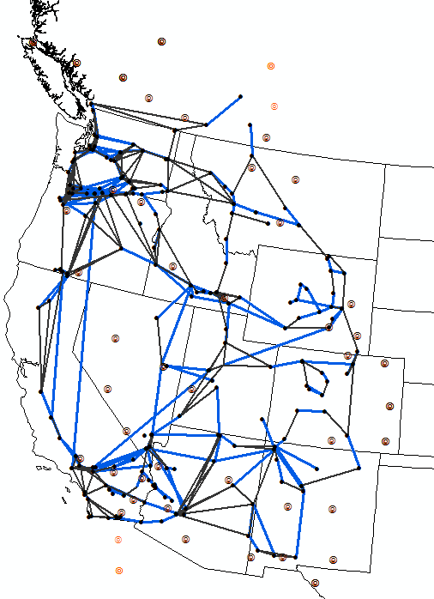

***Figure 1****: Map of the final reduced 300-bus network (dots are renewable energy zones)*

**Paths:**

Paths were defined in the TEPPC common cases and 37 paths were selected from these to divide WECC into 26 sub-regions (see Figure 2) and network constraints between these sub-regions were used to define Paths (or Interfaces) in the 300-bus dataset. Thermal limits on these interfaces are more restrictive than the collective thermal limits of transmission lines connecting the regions.

**Generators:**

Fuel prices, heat-rates, emissions data, Data sources for this are WECC Common Case Database (Common Case) [1][2], the WECC Transmission Expansion Planning Dataset (Generation Capital Cost Calculator) [6], the Database of State Incentives for Renewables and Efficiency (DSIRE) [4], and the *Western Renewable Energy Zones – Phase 1 Report* (WREZ report) [5].



Figure 2: 26 regions that were used to define Paths (Source: [3])

**Load:**

The TEPPC Common Case load data was allocated to the buses in the reduced network using a population weighting method. A Thiessen polygons analysis of the bus locations in the 300-bus network and Census tracts data, the TEPPC load data was reallocated to buses in the reduced dataset.

**Transmission lines:**

The original TEPPC dataset had a total of 25,188 lines with voltage levels spanning 11kv to 500kv (including 500 kv DC lines). Voltage ratings of all lines that are preserved in the 300-bus network are 230 kv and higher.

There are a total of existing 991 “lines” in the network comprising both actual transmission lines and lines equivalenced through the reduction algorithm.

**Transmission investments:**

There are two types of potential transmission investments. “Mirrored Backbones” are the 54 lines that are “mirrors” of the largest line (or the second largest line) in each of the paths. The interpretation is that the backbones are being reinforced. A second type of lines that can be built are the 53 lines that connect the WREZ buses to the network. These lines can be used to transport energy from new renewable energy generation at any of these buses. A map of the candidate transmission investments is shown in Figure 3.

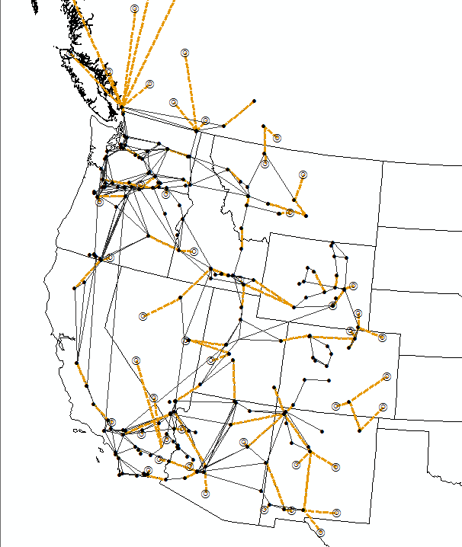

***Figure*** *3: Map of the considered line investments considered in the reduced 300-bus network*

Costs of candidate transmission lines were determined from based on the length/voltage/thermal capacities and the start/end point of the lines using the cost numbers from WECC’s Long Term Planning Tool [26]. These costs have 4 components in them: base line cost, substation cost, Right of Way (ROW) cost and a 15% Allowance for Funds Used during Construction (AFUDC). Right of way costs were calculated based on ArcGIS

**Generator investments:**

New thermal generation can be CCGTs and CTs and they are not constrained by geography or capacity limits. New renewable generation can be built at any of the 53 Western Renewable Energy Zones (WREZ). Each WREZ is represented as an individual bus in the system. Radial transmission lines connect these zones to the network and they are modeled as continuous variables.

The WREZ report [5] was used to determine the location and maximum installable capacity of these new renewable resources.

Capital costs of candidate generators, fixed O&M costs, and regional cost multipliers were obtained from the Transmission Expansion Planning Dataset

**RPSs**

Renewable Portfolio Standards (RPS) and policy information is from the Database of State Incentives for Renewables & Efficiency or DSIRE [4]. Although some states have REC multipliers (depending on location and other factors, 1 MWh generation from different units can contribute differently towards RECs), they are not implemented here. The RPS data is as follows:

|  |  |  |  |
| --- | --- | --- | --- |
| **State Name** | **RPS** | **Instate** | **RPS Fine ($/MWh)** |
| AZ | 15% | 100% | 100 |
| CA | 33% | 90% | 100 |
| CO | 30% | 0% | 100 |
| ID | 0% | - | - |
| MT | 15% | 100% | 100 |
| NM | 20% | 100% | 100 |
| NV | 25% | 100% | 100 |
| OR | 25% | 0% | 100 |
| UT | 0% | - | - |
| WA | 15% | 0% | 100 |
| WY | 0% | - | - |

The Instate column in the table indicates the percentage of RPS that must be made from generation within the state.

A detailed explanation of the dataset and sources is available in Section 4.3 of [3].

References:

1. <https://www.wecc.biz/Reliability/150409-2024CC-V1.5.zip>
2. <https://www.wecc.biz/Reliability/2026%20Common%20Case%20Version%20V1.3%20Release%20Package.zip>
3. Ho, J.L., Hobbs, B.F., Donohoo‐Vallett, P., Xu, Q., Kasina, S., Park, S.W. and Ouyang, Y., 2016. Planning Transmission for Uncertainty: Applications and Lessons for the Western Interconnection.
4. DSIRE, "Detailed Summary Maps," 2015. [Online]. Available: <http://www.dsireusa.org/resources/detailed-summary-maps/>.
5. Western Governors Association and US DOE, "Western Renewable Energy Zones Phase 1 Report," June 2009. [Online]. Available: http://www.csg.org/programs/policyprograms/ncic/documents/WREZ091.pdf. [Accessed 2014].
6. WECC, "TEPPC Generation Capital Cost Calculator," 15 May 2014. [Online]. Available: https://www.wecc.biz/Reliability/2014_TEPPC_GenCapCostCalculator.xlsm. .