Documentation
Wazuh SIEM Event Analysis
Creator: Sahana M

Project Summary
This project demonstrates the deployment and configuration of Wazuh, a SIEM tool, for security monitoring in a virtualized environment. It involves the setup of Wazuh Manager on Ubuntu, the installation of Wazuh agents on Windows and the integration of both to monitor and detect security events.

Lab Environment
Component | Details & Specifications
Virtualization | VMware Workstation Pro
Wazuh Version | 4.11.2
Server OS | Ubuntu Server 22.04 LTS
Agent OS | Windows 10 (VM)

Installation Steps
- Update and install curl on Ubuntu
sudo apt update && sudo apt upgrade -y
sudo apt install curl -y

- Install Wazuh Manager on Ubuntu
curl -sO https://packages.wazuh.com/4.11/wazuh-install.sh sudo bash ./wazuh-install.sh -a

Ubuntu Server Incorporation
Login to Wazuh on Ubuntu
- Using the IP address of your virtual machine – https://<IP Address>
- Login to Wazuh using the Username and Password as shown in Figure 1 obtained by executing Step 2
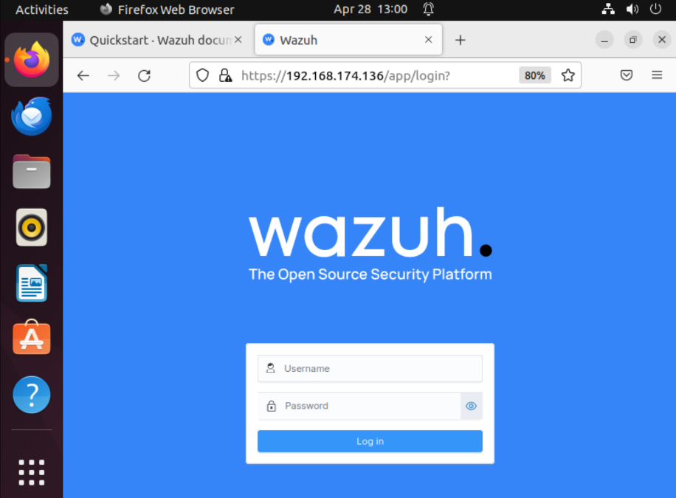
Figure 1

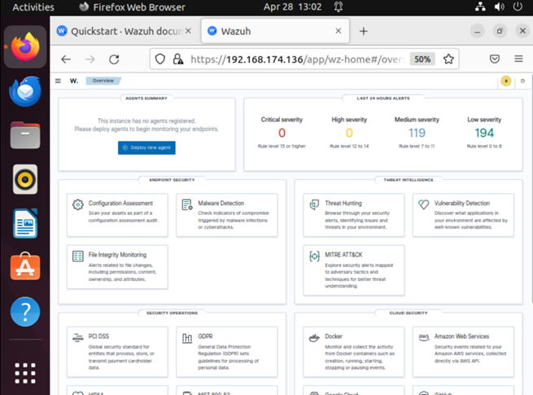
Figure 2

Windows Server Incorporation
- Login to Wazuh on Windows
- Type https://<IP Address:Port number> on Windows to login to Wazuh
- Select advanced in the browser
- Click on accept the risk and continue as shown in Figure 3 -> Wazuh opens type the username & password
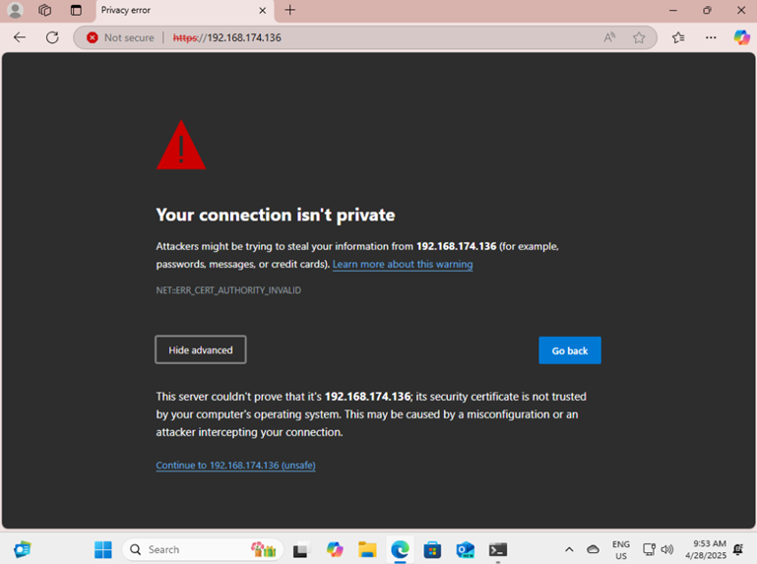
Figure 3
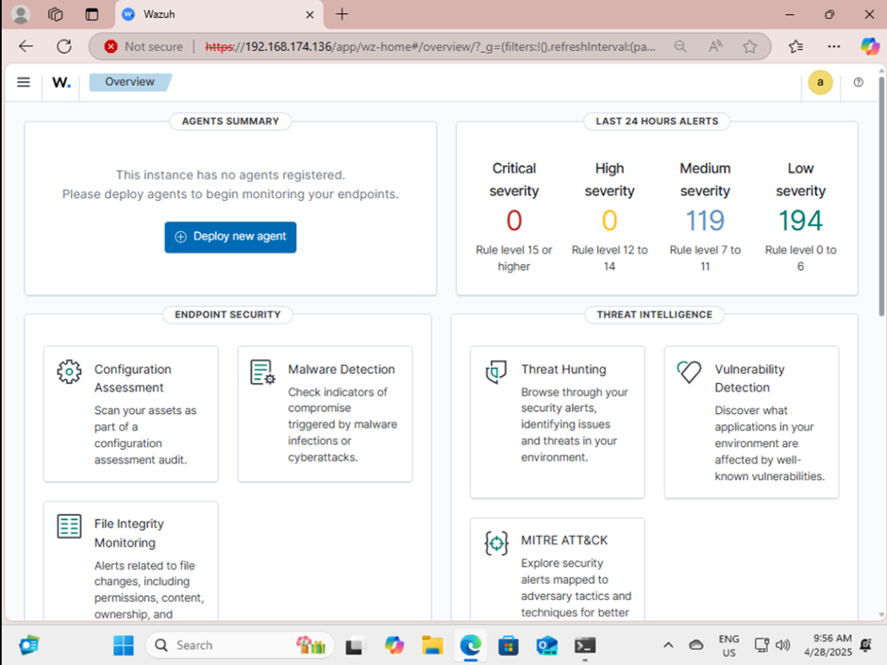
Figure 4

- Deploy new agent
- Go to Ubuntu -> Click deploy new agent -> Select Windows option
- Enter server address -> Assign agent name: Windows_VM_Wazuh
- Select one or more existing groups: Default
- Copy the command
Invoke-WebRequest -Uri https://packages.wazuh.com/4.x/windows/wazuh-agent-4.11.2-1.msi -OutFile $env:tmp\wazuh-agent; msiexec.exe /i $env:tmp\wazuh-agent /q WAZUH_MANAGER='192.168.174.136' WAZUH_AGENT_NAME='Windows_VM_Wazuh'

- Go to Windows -> Windows PowerShell -> Run as administrator
- Paste the command to deploy agent as shown in Figure 5
- Execute the command: NET START WazuhSvc to start Wazuh service
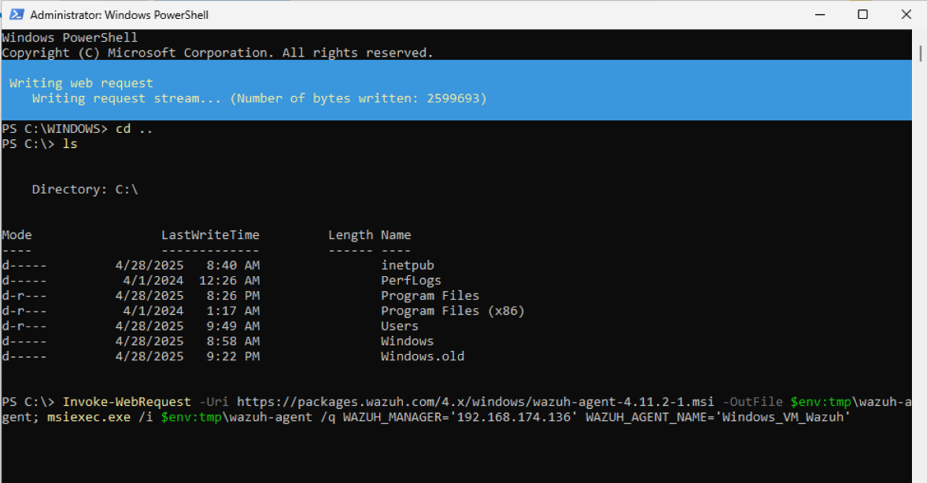
Figure 5

Windows Agent Enrollment
Set a path for communication
- Go to Ubuntu -> QuickStart -> Windows -> GUI -> Wazuh Agent Enrollment -> Enrollment methods -> Enrollment via agent configuration -> Windows
- Open notepad in Windows -> Open ossec-agent -> ossec.conf
- Copy the command
<client>
<server>
<address><WAZUH_MANAGER_IP_ADDRESS></address>
</server>
</client>

- Paste at the end of ossec.conf file
View Dashboard
- Refresh the Wazuh Server to see the overview as shown in Figure 6
- Dashboard for Configuration Assessment, Threat Hunting and more can be monitored and analysed as in Figure 7 & 8.
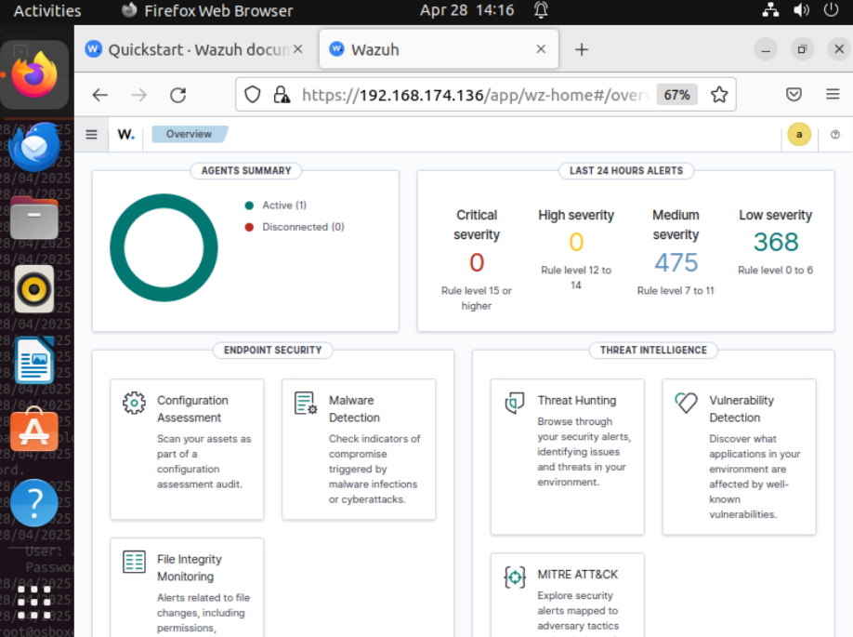
Figure 6
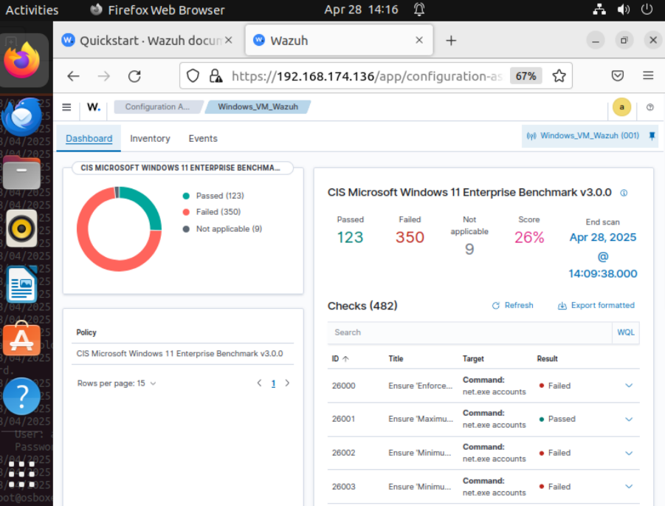
Figure 7
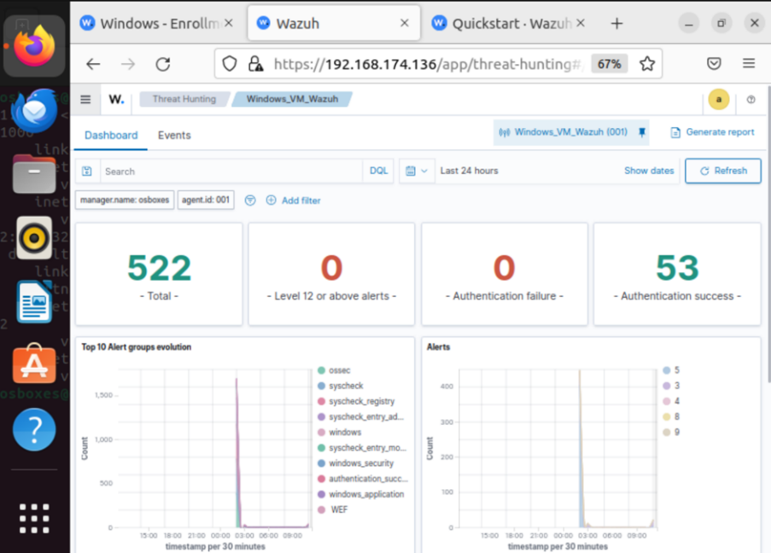
Figure 8

Conclusion
- Successfully deployed Wazuh SIEM and connected a Windows agent.
- Learned how to interpret real-time security logs.
- Understood the flow of log collection, event generation and alert visualization.

