PROJECT REPORT OF CO-OP Project at Industry (Module-2)
ON
Effect of Screen Time on Productivity and Mental Health Among University Students:
A Data-Driven and Machine Learning Approach

submitted in partial fulfilment of the requirements for the award of degree of

BACHELOR OF ENGINEERING
In
COMPUTER SCIENCE AND ENGINEERING

Submitted by: Supervised By:
Saanchi Madaan Dr. Simarjit Kaur
2210992199 Associate Professor
Department of Computer Science and Engineering
Chitkara University, Rajpura, Punjab, India


DEPARTMENT OF COMPUTER SCIENCE AND ENGINEERING

CHITKARA UNIVERSITY INSTITUTE OF ENGINEERING AND TECHNOLOGY
CHITKARA UNIVERSITY, PUNJAB, INDIA

CONTENTS

S.No. | Title | Page No.
 | Acknowledgement | 4
 | List of Figures and Tables | 5
 | Abstract | 6
1 | Introduction | 7
2 | Methodology | 7
3 | Tools and Technologies | 8
4 | Implementation | 8
5 | Major Findings/Outcomes/Output/Results | 9-12
6 | Conclusion and Future Scope | 13
 | References | 14

DECLARATION

I hereby certify that the work which is being presented in the project report entitled “Effect of Screen Time on Productivity and Mental Health Among University Students: A Data-Driven and Machine Learning Approach ” in partial fulfilment of requirement for the award of the degree of Bachelor of Engineering (Computer Science and Engineering) submitted in the department of Computer Science and Engineering at Chitkara University Institute of Engineering and Technology, Chitkara University, Punjab, India, is an authentic record of my own work carried out under the supervision of Dr. Simarjit Kaur. The matter presented in this project report has not been submitted in any other university/institute for the award of any degree.

Place: Rajpura Saanchi Madaan
Date: 28/04/2026 2210992199

This is to certify that the above statement made by the candidate is correct to the best of my knowledge and belief.

Dr. Simarjit Kaur
Associate Professor
Department of Computer Science and Engineering
Chitkara University Institute of Engineering and Technology,
Chitkara University, Punjab, India

ACKNOWLEDGEMENT

I would like to express my sincere gratitude to my mentor, Dr. Simarjit Kaur, for her constant guidance, support, and valuable suggestions throughout the completion of this research work. Her expertise and encouragement helped me understand the subject deeply and complete the project successfully.
I am also thankful to Chitkara University, Punjab, for providing the necessary resources and environment to carry out this study. I would also like to thank my friends and family for their continuous support and motivation.

List of Figures and Tables

Figures

S. No. | Figure Title | Page No.
1. | Scatter Plot: Screen Time vs Productivity | 9
2. | Bar Chart: Productivity Levels | 10
3. | Pie Chart: Screen Usage Distribution | 10
4. | Correlation Matrix | 11
5. | Linear Regression Model Graph | 12

ABSTRACT

In today’s digital era, university students spend a significant amount of time on screens for both academic and recreational purposes. This study adopts a data-driven and machine learning approach to analyze the impact of screen time on productivity and mental health. A dataset of 150 student records was used, and analysis was performed using Python-based tools. Exploratory Data Analysis (EDA), including scatter plots, bar graphs, and correlation matrices, was conducted to identify relationships between screen time, productivity, stress levels, and sleep quality. The results indicate a negative correlation between screen time and productivity, and a positive correlation between screen time and stress. Additionally, excessive screen time negatively affects sleep quality. The study highlights the importance of controlled screen usage and demonstrates the effectiveness of machine learning in behavioral analysis.

1. Introduction
With the rapid advancement of digital technology, screen-based devices such as smartphones, laptops, and tablets have become an essential part of students’ daily lives. These devices play a crucial role in education, communication, and entertainment. However, excessive screen usage has raised concerns regarding its impact on students’ productivity and mental health.
Prolonged screen exposure can lead to reduced concentration, increased stress levels, and poor sleep quality. Students often engage in multitasking, which further decreases their efficiency and focus. While previous studies have explored this issue using traditional statistical methods, there is limited application of machine learning techniques for predictive analysis.
This study aims to bridge this gap by using a data-driven approach to analyze the relationship between screen time and various factors such as productivity, stress, and sleep quality.

2. Methodology
This study follows a data-driven analytical approach to examine the impact of screen time on students’ performance and mental well-being.
A dataset consisting of 150 student records was created to represent realistic behavioral patterns. The key variables included screen time per day, productivity level, stress level, and sleep quality.
Data preprocessing and analysis were carried out using Python. Exploratory Data Analysis (EDA) techniques were applied to identify patterns and relationships among the variables.
A machine learning model, specifically linear regression, was implemented to analyze and predict the relationship between screen time and productivity. The dataset was divided into training (80%) and testing (20%) sets to evaluate the model’s performance.

3. Tools and Technologies
The following tools and technologies were used in this study:
- Python – for data analysis and model implementation
- Pandas – for data handling and preprocessing
- Matplotlib – for data visualization
- Seaborn – for advanced visualization and correlation analysis
- Scikit-learn – for implementing the linear regression model
These tools helped in efficient data processing, visualization, and predictive analysis.

4. Implementation
The implementation of the project involved multiple steps. Initially, the dataset was prepared and cleaned using Python libraries. Missing values were handled, and data was structured properly for analysis.
Exploratory Data Analysis was then performed using various visualization techniques such as scatter plots, bar charts, and pie charts to understand the relationship between variables.
A correlation matrix was generated to examine the strength and direction of relationships between screen time, productivity, stress, and sleep quality.
Finally, a linear regression model was developed using the Scikit-learn library. The model was trained on the dataset and tested to evaluate its performance using metrics such as Mean Squared Error (MSE) and R² score.

5. MAJOR FINDINGS / OUTCOMES / OUTPUT / RESULTS
The study presents the findings based on data analysis, visualization, and machine learning techniques applied to the dataset.

5.1 Relationship between Screen Time and Productivity

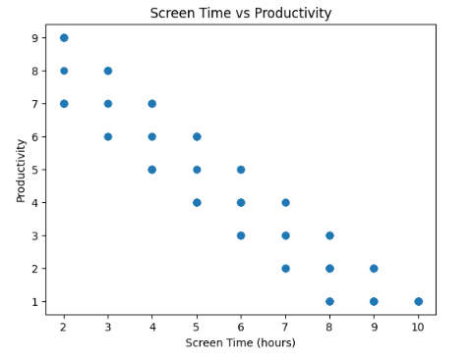
Figure 1

The scatter plot illustrates a clear negative relationship between screen time and productivity. As screen time increases, productivity levels tend to decrease, indicating reduced efficiency among students with higher screen usage.

5.2 Productivity across Screen Time Groups
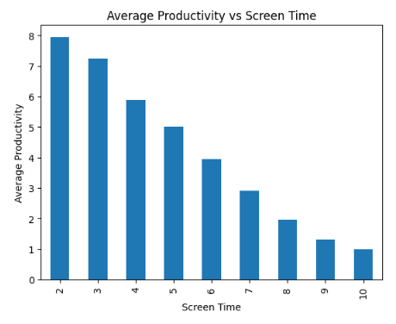
Figure 2
The bar graph shows that students with lower screen time exhibit higher productivity levels, while those with higher screen time demonstrate a gradual decline in performance.

5.3 Distribution of Screen Usage
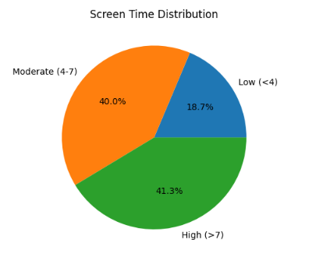
Figure 3
The pie chart represents the distribution of students based on their daily screen usage. It shows that a majority of students fall under moderate to high screen usage categories.

5.4 Correlation Analysis

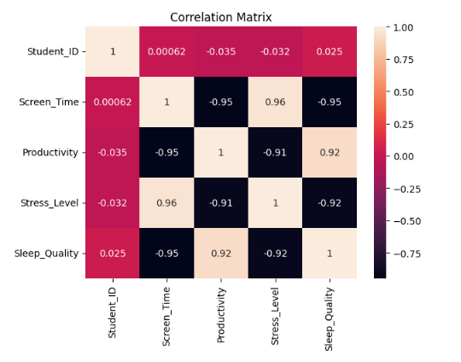
Figure 4

The correlation matrix highlights the relationships among variables:
- Negative correlation between screen time and productivity
- Positive correlation between screen time and stress levels
- Negative correlation between screen time and sleep quality
These relationships confirm that excessive screen usage adversely affects both academic performance and mental well-being.

5.5 Model Output and Prediction
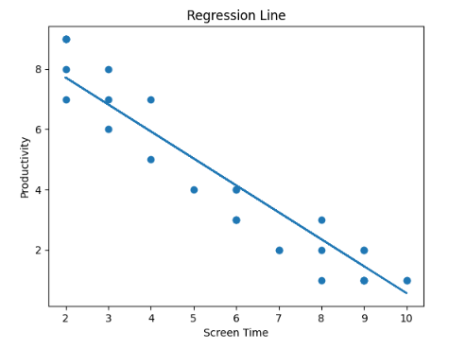
Figure 5
A linear regression model was implemented to predict productivity based on screen time. The regression line demonstrates a negative coefficient, indicating that an increase in screen time leads to a decrease in productivity.
The model was evaluated using metrics such as Mean Squared Error (MSE) and R² score, which confirm the reliability of the model in capturing the relationship between the variables.

5.6 Key Findings
- Increased screen time leads to decreased productivity
- Higher screen usage is associated with increased stress levels
- Excessive screen time negatively impacts sleep quality
- Moderate screen usage can be beneficial for academic purposes
- Machine learning model confirms the inverse relationship between screen time and productivity
6. Conclusion and Future Scope
6.1 Conclusion
The study concludes that screen time has a significant impact on students’ productivity and mental well-being. While digital devices play an essential role in enhancing learning, communication, and access to information, excessive usage can lead to negative consequences such as reduced efficiency, increased stress levels, and poor sleep quality.
The analysis shows that increased screen time is associated with lower productivity and higher mental fatigue. It also highlights that excessive screen exposure negatively affects sleep quality, which further impacts overall academic performance. However, moderate and purposeful use of digital devices can be beneficial when managed effectively.
Therefore, maintaining a balanced and controlled approach toward screen usage is essential. Adopting healthy digital habits can help students improve focus, reduce stress, and enhance their overall well-being.

6.2 Future Scope
The study can be further extended in several ways to enhance its accuracy and applicability:
- Implementation of advanced machine learning models for improved prediction
- Use of larger and real-time datasets for better reliability
- Development of applications to track and monitor screen time behavior
- Inclusion of additional factors such as physical activity, lifestyle, and social interactions
These improvements can provide deeper insights into the relationship between screen time and student performance, making the analysis more comprehensive and impactful.

7. References
- J. M. Twenge, “Have Smartphones Destroyed a Generation?”, The Atlantic, 2017.
- A. Lepp et al., “The Relationship Between Cell Phone Use and Academic Performance,” 2015.
- N. Cain and M. Gradisar, “Electronic Media Use and Sleep,” 2010.
- D. Rosen et al., “Media and Technology Use Predicts Ill-Being,” 2014.
- E. Ophir et al., “Cognitive Control in Media Multitaskers,” 2009.
- A. K. Przybylski, “Digital Screen Time and Mental Health,” 2019.

