EFFECT OF SCREEN TIME ON PRODUCTIVITY AND MENTAL HEALTH AMONG UNIVERSITY STUDENTS: A DATA-DRIVEN AND MACHINE LEARNING APPROACH

Saanchi Madaan
Student, Department of Computer Science and Engineering
Chitkara University, Rajpura, Punjab, India
saanchi2199.be22@chitkara.edu.in

Dr. Simarjit Kaur
Associate Professor, Department of Computer Science and Engineering
Chitkara University, Rajpura, Punjab, India, simarjit.4979@chitkara.edu.in

Abstract - In today’s digital era, university students spend extensive periods of time using screens for both educational and recreational activities. The current study adopts a data analytics method, which is more inclined towards machine learning techniques to examine the effects of screen time on productivity and wellbeing of individuals. Structured data consisting of records of 150 students were used in this study, and analysis was carried out via Python. Exploratory data analysis (EDA), including scatter diagrams, bar charts, and correlation matrices, was carried out to establish correlations between various factors including screen time, productivity, level of stress, and quality of sleep. The findings show a strong inverse correlation between screen time and productivity, as well as a direct correlation between screen time and stress. Furthermore, an inverse correlation exists between screen time and sleep quality. This experiment underscores the significance of using screens in moderation and illustrates the power of AI-based methods in behavioral analysis.
I. INTRODUCTION
The swift development of technological advancements has had an immense impact on educational institutions, as more and more students turn to screen-based gadgets including mobile phones, computers, and tablets for academic purposes. Technology is integral in terms of learning, communication, and availability of information. Nevertheless, extended use of screens is a matter of great concern as it has been found to affect students’ brain functions as well as overall cognitive abilities negatively. Students often multitask while using education and entertainment applications, resulting in inefficiency and higher levels of mental stress. Although previous literature mainly focuses on the use of observation and statistical methods, machine learning models have not yet been applied extensively for predictive purposes. The purpose of this study is to fill this gap by using a data-driven approach to analyze the impact of screen time on productivity, stress, and sleep quality.
II. LITERATURE REVIEW
A considerable amount of studies have been carried out on the influence of mobile device use on students' behavior and psychology. Twenge [1] found a substantial increase in anxiety and depression cases related to greater smartphone use by teenagers. In a similar way, Lepp et al. [2] established a correlation between mobile phone use and poor academic results as a result of decreased attention and more distractions. Cain and Gradisar [3] discovered that exposure to the screen, especially before bedtime, leads to disrupted sleep cycles owing to blue light emitted by electronic devices that disturb circadian rhythm regulation. Rosen et al. [4] concluded that technology use causes additional stress and emotional imbalance Ophir et al. [5] conducted an experiment regarding the impact of media multitasking, revealing that heavy multitaskers have a lower level of cognitive control and attention management. Przybylski [6] investigated the time spent by individuals using screens digitally and reached the conclusion that medium exposure may not be dangerous; however, high exposure causes considerable psychological changes. Nonetheless, most of these experiments use conventional statistics. Machine learning for behavioral prediction has rarely been implemented until now.

III. PROPOSED METHODOLOGY AND ANALYTICAL FRAMEWORK
In this paper, the data-driven and analysis-based method has been used to analyze the effects of screen time on students’ performance and psychological state.

A. Dataset Description
A dataset containing records of 150 students was developed, which would reflect realistic behavioral trends. Among the included parameters there are those of screen time per day, productivity level, degree of stress, and sleep quality.These variables were selected to represent both academic performance and mental health indicators.

B. Data Analysis Tools
Python-based software was used to analyze and visualize the data. The Pandas package was used for handling and preprocessing the data while the Matplotlib package was used for plotting graphs. For advanced visualization, especially correlation analysis, the Seaborn package was used.

C. Machine Learning Model
To perform a regression analysis to see how productive an individual is based on their screen time, a linear regression algorithm was developed using the Scikit-learn library. The data set was split into training and testing data sets with 80% of the data set used for training and 20% for testing the prediction ability of the model.
IV. EXPLORATORY DATA ANALYSIS
Data exploration was carried out for identifying relationships between various variables.
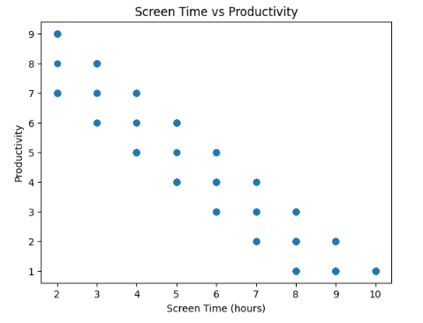
Figure 1: Scatter Plot Showing the Relationship Between Screen Time and Productivity of Students
The scatter plot presented in Figure 1 shows that there is a downward trend; this indicates that as screen time rises, productivity drops.
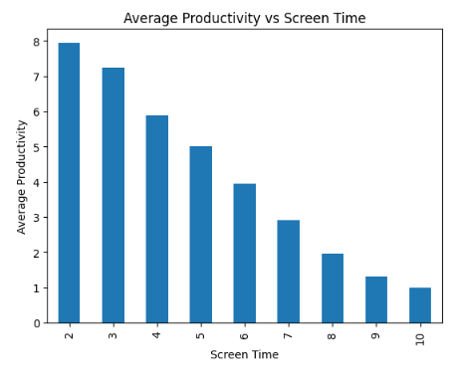
Figure 2: Bar Graph Showing Average Productivity Levels in Various Screen Time Groups
From the figure above (Figure 2), it can be observed that productivity levels are gradually declining as screen time increases.
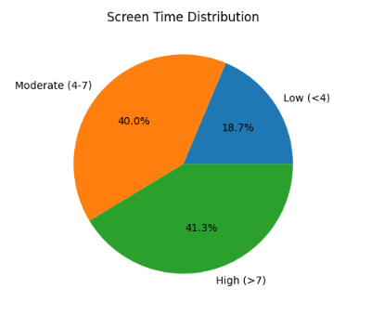
Figure 3: Pie Chart – The Proportion of Students According to Screen Usage Per Day
From Figure 3 above, the distribution clearly indicates that most students lie in the category of moderate or high use of screens.
V. CORRELATION ANALYSIS
Correlation matrix was done to analyze the connection between different variables such as screen time, productivity, stress, and quality of sleep.
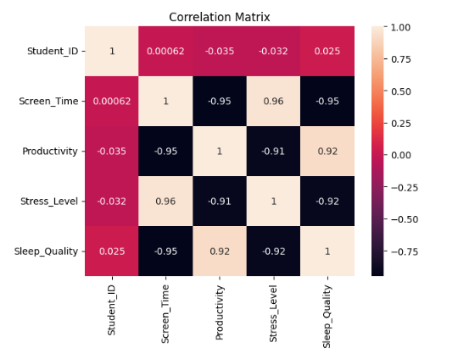
Figure 4: Correlation Matrix for Screen Time, Productivity, Stress, and Quality of Sleep
From Figure 4, the results show a negative correlation between screen time and productivity, implying that the more people spend time using screens, the less efficient they become in their tasks. On the other hand, the results show a positive correlation between screen time and stress, meaning that the higher the amount of screen time, the higher the level of stress. Moreover, there is a negative correlation between screen time and sleep quality, showing that people who use screens for a long time do not have good sleep.
VI. MACHINE LEARNING MODEL
Linear regression was used in order to determine the influence of screen time on productivity.
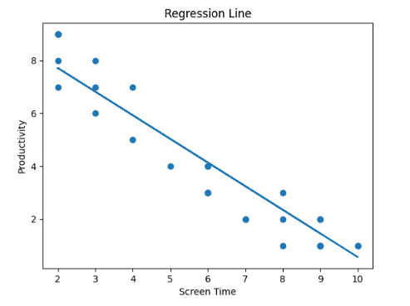
Figure 5: Linear Regression Model Demonstrating Effect of Screen Time on Productivity
As it is seen from Figure 5, there is a negative coefficient indicating that screen time causes lower productivity. Moreover, the evaluation parameters such as MSE and R² confirm reliability of the model.
VII. RESULTS AND DISCUSSION
The findings show that there is no linear association between screen time and productivity. It was found out that screen usage, especially for learning purposes, helps improve academic success and productivity. Nonetheless, when the screen usage exceeds a certain optimum level, the productivity drops significantly. These factors include distraction, cognitive fatigue, and lower concentration. From the findings, it is also clear that excessive exposure to screens results in high stress levels and poor sleep quality, leading to low academic success. Participants who spend more time on screens experience greater mental exhaustion and lack of concentration skills. The findings also show the negative association between productivity and screen time, and the positive association between stress levels and screen time. Furthermore, the regression model offers statistical proof in the sense that the higher the screen time, the lower the productivity is proportionately. The inclusion of machine learning improves the analysis of the research since it permits prediction modeling regarding students' behaviors. In contrast to the descriptive approach, the regression model facilitates a clearer comprehension of how changes in screen time affect performance.
Following these results, there are some practical guidelines that can be considered in order to increase efficiency in using screens by students. First of all, the limits must be set for any activity performed by students through the screen apart from learning. Breaks can help students stay focused and decrease fatigue during the study process. Moreover, it is crucial to avoid the use of digital screens prior to going to bed to maintain a proper sleep schedule. Finally, practicing digital detox can contribute greatly to lowering addiction levels to technology.
CONCLUSION
The conclusion drawn from the research paper is that screen time is highly influential when it comes to affecting academic productivity and mental well-being among university students. Although the technologies associated with digital devices are highly useful in terms of being tools for learning and communicating, the abuse and lack of regulation of their use leads to negative consequences such as inability to concentrate on academic tasks, increased cognitive exhaustion, high level of stress, and poor sleeping quality. Data analyses conducted as part of the research clearly demonstrate the presence of negative correlation between productivity and screen time as well as reveal significant relationships between screen time and mental well-being.
REFERENCES
[1] J. M. Twenge, “Have Smartphones Destroyed a Generation?”, The Atlantic, 2017.
[2] A. Lepp, J. E. Barkley, and A. C. Karpinski, “The Relationship Between Cell Phone Use and Academic Performance,” Computers in Human Behavior, 2015.
[3] N. Cain and M. Gradisar, “Electronic Media Use and Sleep in School-Aged Children,” Sleep Medicine, 2010.
[4] L. D. Rosen et al., “Media and Technology Use Predicts Ill-Being,” Computers in Human Behavior, 2014.
[5] E. Ophir, C. Nass, and A. D. Wagner, “Cognitive Control in Media Multitaskers,” PNAS, 2009.
[6] A. K. Przybylski, “Digital Screen Time and Mental Health,” Psychological Science, 2019.

