|  |  |
| --- | --- |
|  | TOGAF®   * which stands for Open Group Architecture Framework, came into existence in the 1990s. * It was developed by "The Open Group", a vendor and technology neutral industry consortium with over 400-member organizations. * The framework has been worked on by "The Open Group" since the early 90s, and it was derived from another enterprise architecture framework called TAFIM, which stands for Technical Architecture Framework for Information Management. |

*TOGAF® standard is defined in 6 major sections each addressing the need for a specific kind of guidance.*

1. *Architecture Content Framework*
2. *Architecture Development Method(ADM)*
3. *ADM Guidelines and Techniques*
4. *The Enterprise Continuum*
5. *The Architecture Capability Framework*
6. *TOGAF® Reference Models*

***Architecture Content Framework******#*** *is a framework within the TOGAF® framework which provides* ***guidelines*** *on creating and organizing architectural content. It primarily offers a content meta-model that is a model that describes what kinds of architectural contents and models to create.*

***Architecture Development Method******#*** *is the core of the TOGAF® framework and essentially* ***describes the sequence of interrelated steps*** *which constitute an iterative process model. This iterative process model can be adapted to the context of each organization to produce a business-aligned and organization-specific architectural process for developing its enterprise architecture.*

***ADM Guidelines and Techniques #*** *provides a large number of* ***Enterprise Architecture best practices****gleaned from across the industry, specifically focused on the practical aspects of the application of ADM methods.*

***The Enterprise Continuum #*** *offers a* ***view over the architecture repository*** *of the enterprise to facilitate discover, consistent communication, and reuse of architecture artifacts produced as the architects work through the various phases of the ADM cycles.*

***The Architecture Capability Framework*** *offers* ***guidelines around establishing an Enterprise*** *Architecture capability and establishing and running an architecture board, ensuring architectural compliance by incorporating governance into the whole process. It also defines architecture roles and the Enterprise Architecture skills framework.*

***TOGAF® reference models*** *function as an architecture* ***metaphor to base your architecture*** *on, and TOGAF® offers some generic technical reference models, which is not updated since its early releases, but is still used as a baseline reference model by some organizations.*

**TOGAF® Foundational Concepts**

TOGAF® makes it easy and defines several standard approaches to divide and conquer the enterprise's complexity.

One way of doing this is thorough what is referred to as architecture partitions. An architecture partition can be thought of as a level of abstraction of the enterprise.

TOGAF® defines three levels of abstraction.

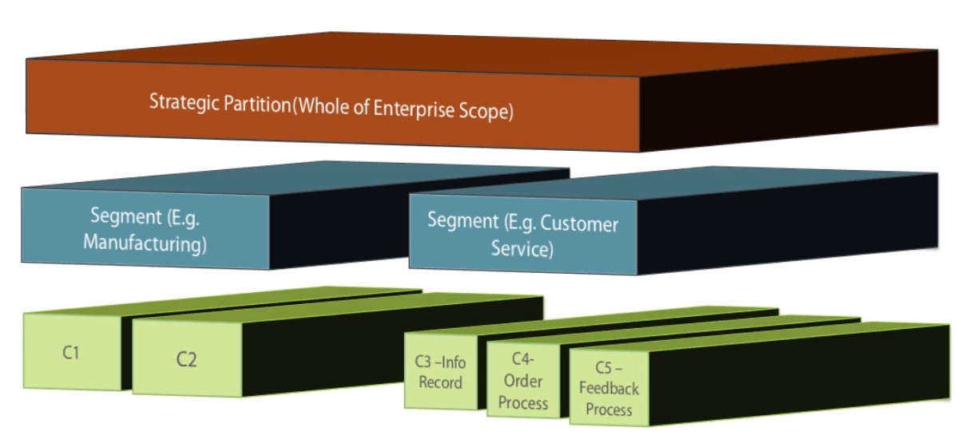

The top level represents the whole of the enterprise perspective.

The next level of abstraction represents a segment of the enterprise, and it usually corresponds to a portfolio or program-level abstraction

**ex#** Customer Service portfolio or Manufacturing portfolio

below that level of abstraction is the more granular capability level,

**ex#** within a Customer Service portfolio, may correspond to some set of capabilities such as customer information recording, customer order processing, customer feedback Processing, etc.

The operating model of an enterprise is usually a key influence on the way the partitioning is done.

Within each of these partitions, TOGAF® defines further separation of concerns through architecture domains.

Ex: if we take the Capability Partition, referring to the TOGAF® definition of Enterprise Architecture, the architecture at this level may be thought to be built out of multiple smaller components.

These components could be anything ranging from a business process, a software application, a database, a web service, or it could be an infrastructure component such as a server or a firewall, and any number of other things that need to come together to enable that capability.

TOGAF® breaks down the enterprise architecture within each partition into 4 standard architecture areas

* Business Architecture
* Data Architecture
* Applications Architecture
* Technology Architecture

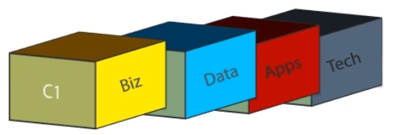

architects typically work with two primary loci of controls to guide their work,

* Architecture Vision
* Stakeholder Concerns.
* Architecture vision represents strategic view of the ideal target state of enterprise architecture enables strategic vision of the business
* Stakeholder concerns refer to the collective of tactical and operational considerations and objectives, as well as apprehensions and pain points held by the key stakeholders of the architected system and their perceptions of improvements needed to transition the system from the current state to a desired target state.
* A stakeholder could be defined as anyone who is impacted by and/or has an interest in the outcome of an enterprise initiative.
* In practice, organizations require the stakeholders to understand and endorse the architecture deliverables before they are implemented, and hence, stakeholder communication and stakeholder management is a key function of enterprise architecture.
* since stakeholder concerns form such an important influence on architecture work, it is important for architects to communicate and work effectively with various stakeholders involved.
* This involves representing architecture work products and outcomes to stakeholders that represents their perspective and addresses points of interest that the stakeholder

TOGAF® calls this the viewpoints.

* In civil engineering industry the architecture blueprint of the building may include many different viewpoints.
  + one viewpoint representing the plumbing requirements
  + one representing the electrical and data wiring or cabling plan,
  + another viewpoint which perhaps represents the general layout and facades of the building for marketing purpose.
* Similarly, in the case of enterprise architecture, different stakeholders will need to see the architecture from different vantage points that satisfy their needs and concerns.
* For example, if you want to represent the architecture of, say, a business-to-business enterprise integration gateway to a business process expert, you might want to define a viewpoint specific to those stakeholders and have models that depict the process flow, the value chains, the data exchanged, etc. While there could be some overlaps, this may be very different to what you may want to present to the network security specialist who would perhaps want to see the servers, the network segments, firewalls, cords, protocols, the nature of data being transmitted, and so forth.
* TOGAF® recommends defining and agreeing on the minimum viewpoints that are necessary to satisfy the stakeholder concerns on a given initiative.
* While the viewpoints represent an angle, or a perspective, it is expressed and articulated through views, essentially views that represent a viewpoint based on the complexity of representing the architecture, and tailors it to the perspective that is most appropriate for the target audience.
* Now views are themselves constructed using many architectural artifacts,
* where an architectural artifact generally falls within the following categories
  + catalogs,
  + mattresses or
  + diagrams.
* Usually these are further annotated with textural descriptions to aid in better understanding and to clarify or highlight certain aspects of the architecture.
* in the module through the jigsaw puzzle analogy, the enterprise architecture landscape is built out using components referred to as the Architecture Building Blocks.

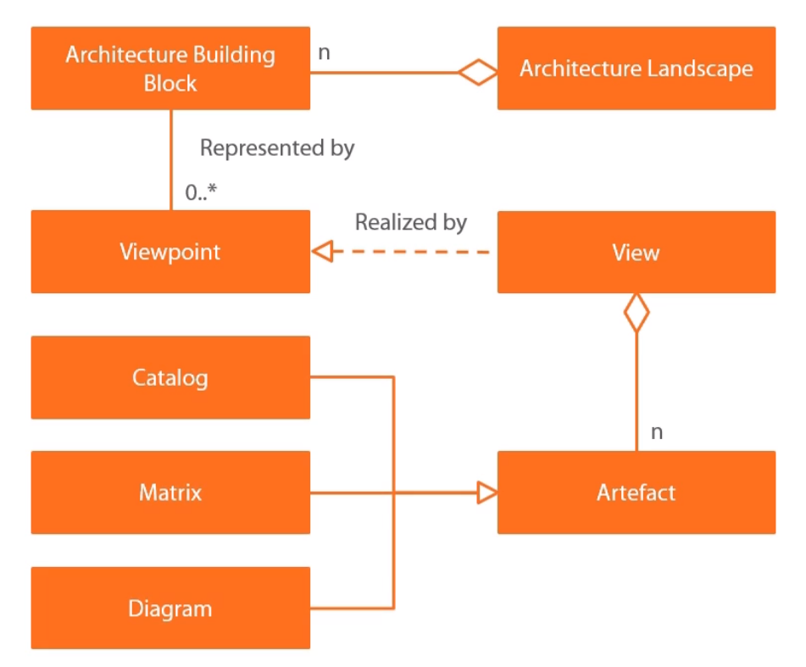

* architecture building block may be represented to different stakeholders through viewpoints that are tailored to them. Viewpoints are articulated through views, which are essentially a collection of architectural artifacts, and an artifact can be one of catalogs, mattresses or diagrams.
* TOGAF® also defines architectural deliverables, which are contractually agreed work products that may need to capture relevant architectural views of one or more architectural building blocks and their interrelationships. That brings us to the end of this very long module.

**Introducing Architecture Development Method**

* Most enterprise architects use set of well-defined process guidelines, which has an effect of making architecture development a systematic and organized activity which can then be managed, planned, executed, and directed to achieve the enterprise's strategic objectives.
* TOGAF® offers an iterative process framework in the form of Architecture Development Method.
* ADM provides guidelines to develop architecture at all levels of the enterprise by following a sequence of interrelated architecture development stages referred to as the ADM phases.
* Each phase has clearly-defined inputs, scope of activities, and outputs.
* There are 10 phases in all, as shown schematically in the image here,

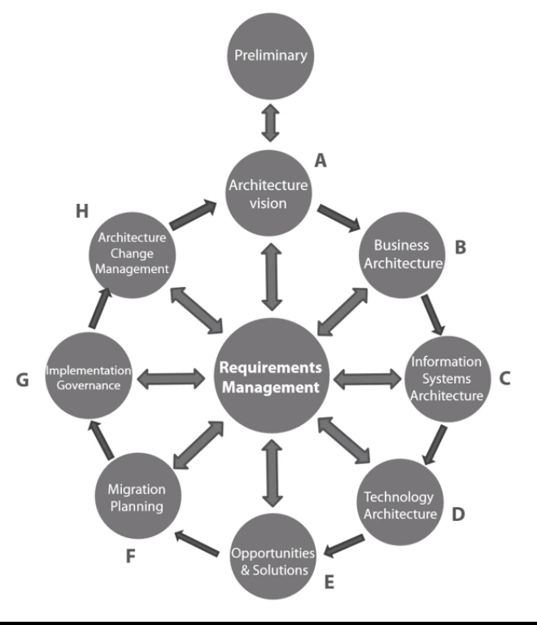

* This process model or framework is not intended to be used as a rigid model for architecture development, but is instead expected to be customized and tailored to suite the enterprise's context, and even to the context of each architecture development iteration.
* To clarify again, what this means is that although the 10 phases shown here represent the ADM in its entirety, there is no expectation that any given iteration of ADM will actually have all 10 phases. They may or they may not, which means that you may have, say, as few as just two phases in an iteration, or you may decide to execute a few iterations with 2 or 3 phases before you engage other phases of the ADM.
* You may perhaps decide to skip a certain phase in a given iteration to restrict the scope or to improve focus on certain aspects. Or, you may decide to switch the sequencing of the phases you have picked in each iteration, or to suit a certain organizational context you may decide to engage multiple phases simultaneously.
* You can also tailor the scope of each iteration to your enterprise's needs.
* There is nothing hard and fast in the guideline itself that tells you what the scope of each iteration should be.
* All this effectively means that in TOGAF® ADM you have a very flexible process framework that can be customized and tailored to the organization's context.
* ADM iterations applied in real-world enterprises typically function like a system of gears in machinery, where say a single gear represents one iteration of ADM cycle. It is acted on in certain motion, which then systematically engages other gears in turn, setting them in motion, leading to implementation of business and technology changes producing business and end customer value in the process.
* The previous module covered the concept of architecture partitions.
* For example, ADM iterations can potentially be initiated at the strategic partition through the whole of enterprise view, and then it can progressively engage architecture teams working at the Segment and Capability partitions to build out more detailed architectures targeting their specific focus areas.

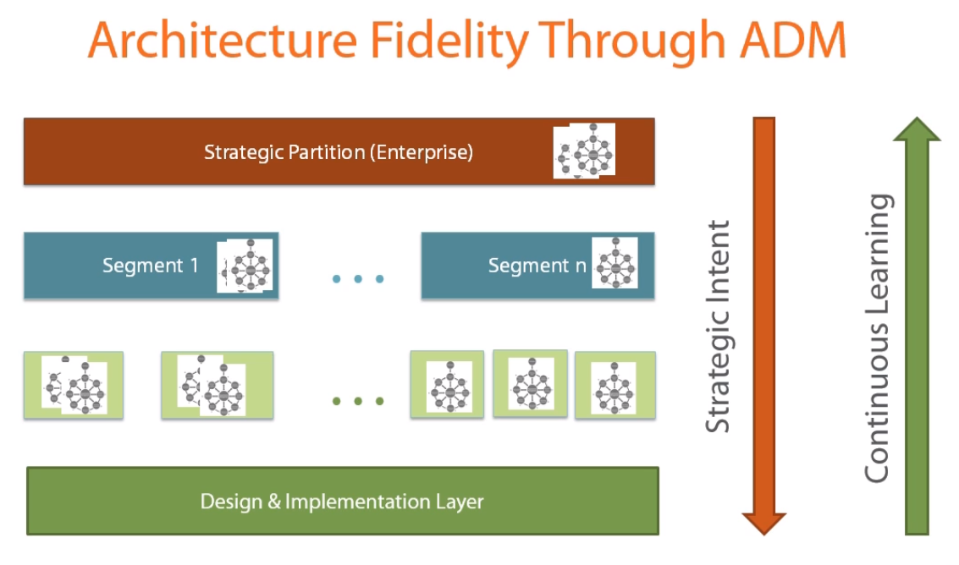

* This provides architects an affordance to percolate the strategic intent, directions, and design systematically down from vision to implementation, and do so right across the enterprise, spanning the business segments and capabilities.
* This helps maintain top-down of business vision throughout the architecture development process.
* At the same time, the governance and the implementation structures established through these iterative processes also establishes a feedback and learning loop in the direction where the architecture team learns from, and are informed and influenced by innovative design and implementation ideas, approaches, and technologies, as well as concerns, constraints, and issues faced at the design and implementation stages across the entire enterprise.
* This then informs the evolution of the strategy and the vision of the enterprise as it continually learns through these cycles. With these perspectives in mind, let us take a quick lap around the ADM phases.