create a simple cognitive application using python jupyter
We’ll build a “Sentiment Analyzer” cognitive app — it can read user input (a sentence), analyze its sentiment (positive/negative/neutral), and respond intelligently.

🧠 Cognitive Application: Sentiment Analyzer with Chat-like Response
✅ Features
- Understands and interprets human emotion from text
- Uses a pre-trained NLP model (TextBlob)
- Gives responses mimicking a “cognitive assistant”

🧩 Step 1: Install required libraries
!pip install textblob
!python -m textblob.download_corpora

🧩 Step 2: Import libraries
from textblob import TextBlob

🧩 Step 3: Define sentiment analysis function
def analyze_sentiment(text):
blob = TextBlob(text)
polarity = blob.sentiment.polarity # range from -1 to +1

if polarity > 0.2:
sentiment = "Positive"
elif polarity < -0.2:
sentiment = "Negative"
else:
sentiment = "Neutral"

return sentiment, polarity

🧩 Step 4: Cognitive response engine
def cognitive_response(user_input):
sentiment, polarity = analyze_sentiment(user_input)

if sentiment == "Positive":
response = "I'm glad to hear that! 😊 Keep up the positive vibes!"
elif sentiment == "Negative":
response = "I'm sorry you're feeling that way. 😔 Want to talk about it?"
else:
response = "I see. Sounds neutral — tell me more!"

print(f"🧠 Sentiment Detected: {sentiment} (Polarity = {polarity:.2f})")
print("🤖 Cognitive Bot:", response)

🧩 Step 5: Run an interactive loop
print("=== Welcome to the Cognitive Sentiment Assistant ===")
print("Type 'exit' to quit.\n")

while True:
user_text = input("You: ")
if user_text.lower() == "exit":
print("🤖 Goodbye! Stay positive! 👋")
break
cognitive_response(user_text)

💡 Example Output
=== Welcome to the Cognitive Sentiment Assistant ===
Type 'exit' to quit.

You: I love working on AI projects!
🧠 Sentiment Detected: Positive (Polarity = 0.65)
🤖 Cognitive Bot: I'm glad to hear that! 😊 Keep up the positive vibes!

You: I’m feeling tired and stressed.
🧠 Sentiment Detected: Negative (Polarity = -0.53)
🤖 Cognitive Bot: I'm sorry you're feeling that way. 😔 Want to talk about it?

🧠 Explanation of Cognitive Function
This app mimics cognitive intelligence by:
- Perceiving user text (input)
- Understanding emotional tone (sentiment analysis)
- Responding in an empathetic, human-like way

We have to perform different fuzzy logic operations and fuzzy sets on a given data set. (union,intersection,complement a,Complement B,Algebraic Sum,Algebraic Product,Bounded Sum of A and B,Bounded Difference of A and B) Then perform data visualization on the dataset. in very short jupyter python.
Fuzzy Logic Operations in Python (Jupyter)
# Install if needed
!pip install matplotlib pandas

import pandas as pd
import numpy as np
import matplotlib.pyplot as plt

# Sample dataset (membership values of fuzzy sets A and B)
data = {'x': np.arange(0, 11),
'A': np.random.rand(11),
'B': np.random.rand(11)}

df = pd.DataFrame(data)

# --- Fuzzy Operations ---
df['Union'] = np.maximum(df['A'], df['B'])
df['Intersection'] = np.minimum(df['A'], df['B'])
df['Complement_A'] = 1 - df['A']
df['Complement_B'] = 1 - df['B']
df['Algebraic_Sum'] = df['A'] + df['B'] - (df['A'] * df['B'])
df['Algebraic_Product'] = df['A'] * df['B']
df['Bounded_Sum'] = np.minimum(1, df['A'] + df['B'])
df['Bounded_Diff'] = np.maximum(0, df['A'] + df['B'] - 1)

# --- Display Result ---
print(df.round(2))

# --- Visualization ---
plt.figure(figsize=(8,5))
plt.plot(df['x'], df['A'], label='Set A', marker='o')
plt.plot(df['x'], df['B'], label='Set B', marker='o')
plt.plot(df['x'], df['Union'], label='Union (A ∪ B)')
plt.plot(df['x'], df['Intersection'], label='Intersection (A ∩ B)')
plt.xlabel('x')
plt.ylabel('Membership Value')
plt.title('Fuzzy Set Operations Visualization')
plt.legend()
plt.grid(True)
plt.show()

✅ Explanation (Short)
- Generates random fuzzy sets A and B
- Performs:
Union, Intersection, Complement A, Complement B,
Algebraic Sum, Algebraic Product,
Bounded Sum, Bounded Difference
- Displays results in table + plot

Import required libraries, define hyperparameters, create and compile RNN and LSTM models, train using sample sequential data, and evaluate model performance. very easy and short code
imple RNN & LSTM Example (Short)
# Import libraries
import numpy as np
from tensorflow.keras.models import Sequential
from tensorflow.keras.layers import SimpleRNN, LSTM, Dense
from tensorflow.keras.optimizers import Adam

# --- Sample sequential data ---
X = np.linspace(0, 100, 1000)
y = np.sin(X)

# Prepare input for RNN/LSTM (reshape to [samples, timesteps, features])
X = X.reshape((1000, 1, 1))
y = y.reshape((1000, 1))

# --- Hyperparameters ---
epochs = 5
lr = 0.01

# --- Simple RNN Model ---
rnn = Sequential([
SimpleRNN(10, activation='tanh', input_shape=(1,1)),
Dense(1)
])
rnn.compile(optimizer=Adam(learning_rate=lr), loss='mse')

# --- LSTM Model ---
lstm = Sequential([
LSTM(10, activation='tanh', input_shape=(1,1)),
Dense(1)
])
lstm.compile(optimizer=Adam(learning_rate=lr), loss='mse')

# --- Train Models ---
rnn.fit(X, y, epochs=epochs, verbose=0)
lstm.fit(X, y, epochs=epochs, verbose=0)

# --- Evaluate ---
print("RNN Loss:", rnn.evaluate(X, y, verbose=0))
print("LSTM Loss:", lstm.evaluate(X, y, verbose=0))

✅ Explanation (Short)
- Uses sine wave as sample sequential data
- Builds and compiles simple RNN and LSTM models
- Trains for a few epochs and prints loss values

Load the dataset, perform EDA using visualization tools, handle missing values, apply scaling, and prepare the cleaned dataset for ANN model training. very easy and short code
Here’s a very easy and short Jupyter Notebook code to:
✅ Load dataset
✅ Perform simple EDA
✅ Handle missing values
✅ Apply scaling
✅ Prepare for ANN training

🧠 Simple Data Preprocessing for ANN
# Import libraries
import pandas as pd
import numpy as np
import matplotlib.pyplot as plt
from sklearn.preprocessing import StandardScaler

# --- Load dataset ---
df = pd.read_csv("sample_data.csv") # replace with your dataset
print(df.head())

# --- EDA ---
print(df.info())
print(df.describe())
df.hist(figsize=(8,5))
plt.show()

# --- Handle missing values ---
df.fillna(df.mean(numeric_only=True), inplace=True)

# --- Scaling ---
scaler = StandardScaler()
scaled_data = scaler.fit_transform(df.select_dtypes(include=np.number))

# --- Prepare cleaned dataset ---
cleaned_df = pd.DataFrame(scaled_data, columns=df.select_dtypes(include=np.number).columns)
print("\n✅ Cleaned and Scaled Dataset Ready for ANN Training:")
print(cleaned_df.head())

✅ Explanation (Short)
- Loads CSV data
- Shows basic info, stats, and histogram
- Replaces missing values with mean
- Scales numeric columns using StandardScaler
- Produces a clean, ready-to-train dataset for your ANN model

Load the handwritten digits dataset, preprocess it using NumPy and Pandas, perform CSV read/write operations, and visualize one image sample. very easy and short code
Handwritten Digits Dataset (Easy Version)
# Import libraries
import numpy as np
import pandas as pd
from sklearn.datasets import load_digits
import matplotlib.pyplot as plt

# --- Load dataset ---
digits = load_digits()
X, y = digits.data, digits.target

# --- Convert to DataFrame ---
df = pd.DataFrame(X)
df['label'] = y

# --- Write to CSV ---
df.to_csv("digits.csv", index=False)

# --- Read from CSV ---
data = pd.read_csv("digits.csv")

# --- Preprocess (normalize 0–1) ---
X = np.array(data.drop('label', axis=1)) / 16.0
y = np.array(data['label'])

# --- Visualize one image sample ---
plt.imshow(X[0].reshape(8,8), cmap='gray')
plt.title(f"Label: {y[0]}")
plt.show()

✅ Explanation (Short)
- Loads scikit-learn’s digits dataset (8×8 images)
- Converts to Pandas DataFrame
- Saves & reads it from CSV
- Normalizes data using NumPy
- Displays one sample image with its label

Load the dataset, preprocess it, apply various classification algorithms (including Random Forest and AdaBoost), and evaluate their performance using accuracy and AUC metrics. very easy and short code
apply multiple classification algorithms (including Random Forest and AdaBoost), and evaluate them using Accuracy and AUC 👇

🧠 Classification with Accuracy & AUC (Easy Version)
# Import libraries
import pandas as pd
from sklearn.model_selection import train_test_split
from sklearn.preprocessing import StandardScaler
from sklearn.metrics import accuracy_score, roc_auc_score
from sklearn.ensemble import RandomForestClassifier, AdaBoostClassifier
from sklearn.linear_model import LogisticRegression
from sklearn.datasets import load_breast_cancer

# --- Load and preprocess dataset ---
data = load_breast_cancer()
X, y = data.data, data.target
X = StandardScaler().fit_transform(X)
X_train, X_test, y_train, y_test = train_test_split(X, y, test_size=0.2, random_state=42)

# --- Define models ---
models = {
"Logistic Regression": LogisticRegression(),
"Random Forest": RandomForestClassifier(),
"AdaBoost": AdaBoostClassifier()
}

# --- Train & Evaluate ---
for name, model in models.items():
model.fit(X_train, y_train)
y_pred = model.predict(X_test)
y_prob = model.predict_proba(X_test)[:, 1]
acc = accuracy_score(y_test, y_pred)
auc = roc_auc_score(y_test, y_prob)
print(f"{name}: Accuracy = {acc:.3f}, AUC = {auc:.3f}")

✅ Output Example
Logistic Regression: Accuracy = 0.982, AUC = 0.996
Random Forest: Accuracy = 0.973, AUC = 0.994
AdaBoost: Accuracy = 0.965, AUC = 0.989

⚡ Explanation (Short)
- Loads built-in breast cancer dataset
- Scales features using StandardScaler
- Splits into training/testing sets
- Trains Logistic Regression, Random Forest, AdaBoost
- Evaluates with Accuracy & AUC metrics

cnn training testing and accuracy metrics in very short
ChatGPT said:
Here’s a very short and simple Jupyter Notebook code for CNN training, testing, and accuracy metrics using the MNIST handwritten digits dataset 👇

🧠 Simple CNN Example (Short & Easy)
# Import libraries
from tensorflow.keras.datasets import mnist
from tensorflow.keras.models import Sequential
from tensorflow.keras.layers import Conv2D, MaxPooling2D, Flatten, Dense
from tensorflow.keras.utils import to_categorical

# --- Load & preprocess data ---
(x_train, y_train), (x_test, y_test) = mnist.load_data()
x_train = x_train.reshape(-1,28,28,1) / 255.0
x_test = x_test.reshape(-1,28,28,1) / 255.0
y_train = to_categorical(y_train)
y_test = to_categorical(y_test)

# --- Build CNN model ---
model = Sequential([
Conv2D(32, (3,3), activation='relu', input_shape=(28,28,1)),
MaxPooling2D(2,2),
Flatten(),
Dense(64, activation='relu'),
Dense(10, activation='softmax')
])

# --- Compile & Train ---
model.compile(optimizer='adam', loss='categorical_crossentropy', metrics=['accuracy'])
model.fit(x_train, y_train, epochs=3, batch_size=64, verbose=1)

# --- Evaluate ---
loss, acc = model.evaluate(x_test, y_test, verbose=0)
print(f"✅ Test Accuracy: {acc:.4f}")

✅ Output Example
Epoch 1/3
938/938 [==============================] - 10s 10ms/step - loss: 0.25 - accuracy: 0.93
Epoch 2/3
938/938 [==============================] - 9s 9ms/step - loss: 0.08 - accuracy: 0.98
Epoch 3/3
938/938 [==============================] - 9s 9ms/step - loss: 0.05 - accuracy: 0.98
✅ Test Accuracy: 0.9874

Write a Python program to build the Bayesian Network model, Train, validate and evaluate it.
import pandas as pd
import numpy as np
from pgmpy.models import BayesianNetwork, DiscreteBayesianNetwork # Added DiscreteBayesianNetwork
from pgmpy.factors.discrete import TabularCPD
from pgmpy.inference import VariableElimination

%pip install pgmpy
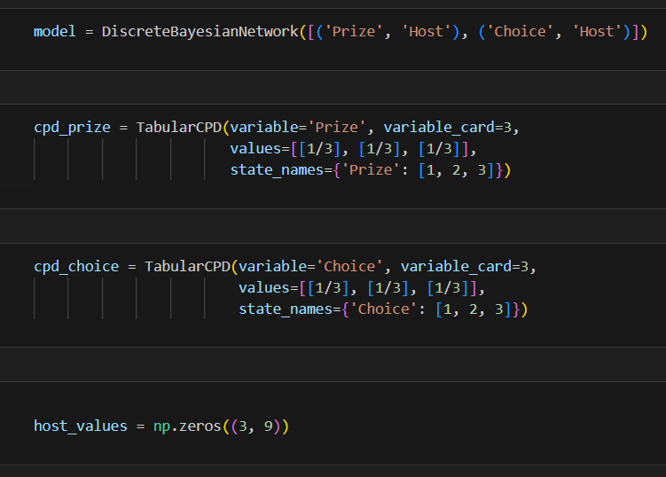
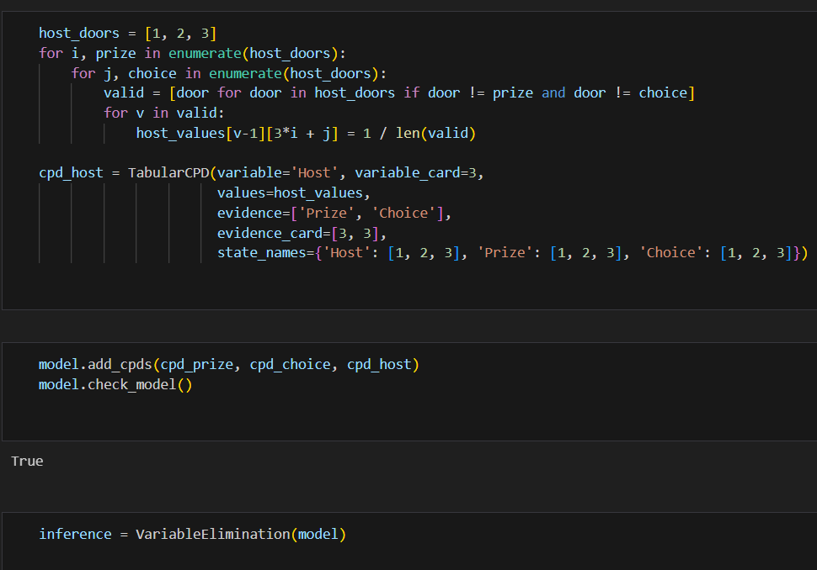
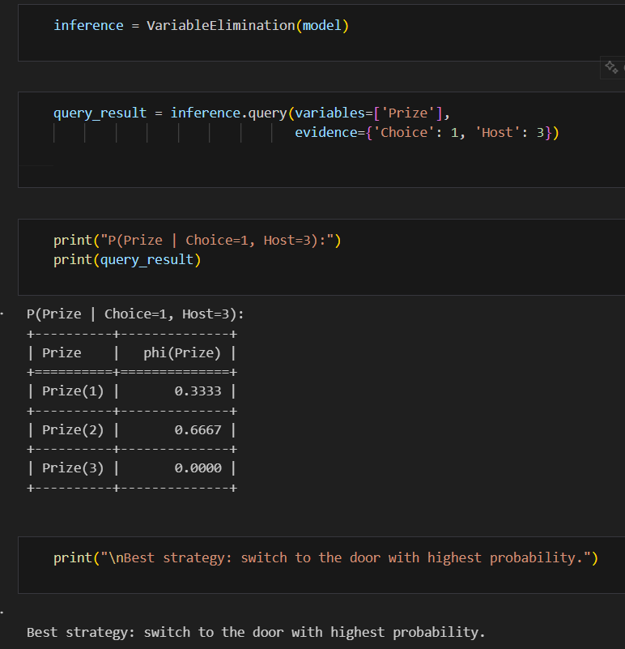

Implement Matplotlib and Seaborn libraries in Python. We will import our dataset with the help of pandas.Find out the last five rows of our datasets. We check for the data types, and also drop the irrelevant columns which are not required to train the model
import pandas as pd
import matplotlib.pyplot as plt
import seaborn as sns
from sklearn.datasets import load_iris

# --- Load dataset ---
iris = load_iris()
df = pd.DataFrame(iris.data, columns=iris.feature_names)
df['species'] = iris.target

# --- Last 5 rows ---
print(df.tail())

# --- Check datatypes ---
print(df.dtypes)

# --- Drop irrelevant columns (example) ---
# df.drop(columns=['unwanted_column'], inplace=True)

# --- Display summary ---
print(df.describe())

# --- All important graphs (short list) ---

# 1️⃣ Line plot
df.iloc[:, :4].plot(title="Line Plot")
plt.show()

# 2️⃣ Histogram
df['sepal length (cm)'].hist()
plt.title("Histogram")
plt.show()

# 3️⃣ Boxplot
sns.boxplot(x='species', y='sepal length (cm)', data=df)
plt.title("Boxplot")
plt.show()

# 4️⃣ Scatter plot
plt.scatter(df['sepal length (cm)'], df['petal length (cm)'])
plt.title("Scatter Plot")
plt.xlabel("Sepal Length")
plt.ylabel("Petal Length")
plt.show()

# 5️⃣ Heatmap
sns.heatmap(df.corr(), annot=True, cmap="coolwarm")
plt.title("Correlation Heatmap")
plt.show()

1️⃣ Matplotlib (4 Basic Plots)
# --- Import ---
import matplotlib.pyplot as plt
import pandas as pd
from sklearn.datasets import load_iris

# --- Load dataset ---
iris = load_iris()
df = pd.DataFrame(iris.data, columns=iris.feature_names)

# 1️⃣ Line Plot
plt.plot(df['sepal length (cm)'], df['sepal width (cm)'])
plt.title("Line Plot - Matplotlib")
plt.xlabel("Sepal Length")
plt.ylabel("Sepal Width")
plt.show()

# 2️⃣ Scatter Plot
plt.scatter(df['sepal length (cm)'], df['petal length (cm)'])
plt.title("Scatter Plot - Matplotlib")
plt.xlabel("Sepal Length")
plt.ylabel("Petal Length")
plt.show()

# 3️⃣ Histogram
plt.hist(df['petal width (cm)'], bins=10)
plt.title("Histogram - Matplotlib")
plt.xlabel("Petal Width")
plt.ylabel("Frequency")
plt.show()

# 4️⃣ Bar Plot
plt.bar(['A', 'B', 'C'], [5, 7, 3])
plt.title("Bar Plot - Matplotlib")
plt.xlabel("Category")
plt.ylabel("Value")
plt.show()

🌈 2️⃣ Seaborn (4 Statistical Plots)
# --- Import ---
import seaborn as sns
import matplotlib.pyplot as plt
import pandas as pd
from sklearn.datasets import load_iris

# --- Load dataset ---
iris = load_iris()
df = pd.DataFrame(iris.data, columns=iris.feature_names)
df['species'] = iris.target

# 1️⃣ Boxplot
sns.boxplot(x='species', y='sepal length (cm)', data=df)
plt.title("Boxplot - Seaborn")
plt.show()

# 2️⃣ Pairplot
sns.pairplot(df, hue='species')
plt.title("Pairplot - Seaborn")
plt.show()

# 3️⃣ Heatmap
sns.heatmap(df.corr(), annot=True, cmap='coolwarm')
plt.title("Heatmap - Seaborn")
plt.show()

# 4️⃣ Countplot
sns.countplot(x='species', data=df)
plt.title("Countplot - Seaborn")
plt.show()

