Section-Specific Structural Zoning in the Voynich Manuscript:
Global versus Section-Conditioned Models of Token Formation
Youngsan Chang
Independent Researcher
April 2026
Data source: Zandbergen-Landini EVA transcription (ZL3b)
AI Use Disclosure
AI-based tools assisted with code implementation, figure generation, manuscript editing, and synthesis drafting. Research design, analytical decisions, statistical interpretation, and final argumentation were conducted by the author.
Abstract
Previous statistical studies of the Voynich Manuscript have shown that its text is not adequately described as random character or token generation. Recent multi-level analyses have identified positional constraints, language-like predictability, prefix-core-suffix (PCS) dependency, PCS token-generation behavior, and local inter-token organization. However, global corpus-level structure does not determine whether these constraints operate uniformly across the manuscript. This paper tests whether the Voynich Manuscript is better modeled as a single homogeneous corpus or as a set of section-conditioned structural regimes. Using the Zandbergen-Landini EVA transcription (ZL3b), the study compares token distributions, PCS component dependencies, inter-token entropy, token-family clustering, global versus section-specific PCS models, cross-section transfer, inventory/order decomposition, section classification, folio-level change-point behavior, unknown-folio proximity, and robustness checks across conventional visual and codicological sections. The results indicate that several structural properties vary by section. The biological/balneological section shows the strongest section-specific PCS effect: section-specific PCS modeling improves cross-entropy over the global model, low H(suffix|core) remains robust under downsampling, and suffix selection is strongly conditioned by the operationally defined core. Classification experiments further show that structural features predict conventional section labels above permutation baseline. Inventory/order decomposition separates restricted token inventory effects from additional local ordering effects, showing that some low-entropy profiles are inventory-driven while others show stronger ordering contributions. These findings support a structural zoning interpretation: the Voynich Manuscript is not only globally structured, but contains section-conditioned regimes of token formation and local arrangement. The study does not propose decipherment, translation, source-language identification, or confirmed syntax.
Keywords: Voynich Manuscript; structural zoning; section-conditioned models; prefix-core-suffix; token generation; inter-token structure; computational text analysis; historical cryptology; undeciphered scripts

1. Introduction
The Voynich Manuscript has long resisted stable linguistic, cryptographic, or historical interpretation. Its text exhibits strong regularities in token form, repetition, line layout, and section organization, yet no proposed decipherment has achieved general acceptance. One reason the manuscript remains difficult is that it cannot be treated simply as ordinary prose, random text, or a straightforward cipher. It displays statistical order, but the nature and level of that order remain contested.
Recent component studies have approached the manuscript by separating different levels of structure. These studies examined positional constraints, comparative predictability, prefix-core-suffix dependency, PCS token generation, and inter-token sequence organization (Chang, 2026a, 2026b, 2026c, 2026d, 2026e). Taken together, those results support a conservative global conclusion: the Voynich token system is structured across multiple levels. However, a global conclusion leaves open a further question. The manuscript is visually and codicologically heterogeneous. It contains conventionally described herbal, astronomical/zodiac, biological/balneological, cosmological, pharmaceutical, and recipe-like regions, as well as folios whose assignment is uncertain. If the text is organized in relation to the manuscript's internal divisions, then global corpus statistics may conceal section-specific structural regimes.
Where Chang (2026f) treated the manuscript primarily as a global multi-level system, the present paper tests whether that system is homogeneous across the corpus or better described through section-conditioned structural regimes.
The present paper therefore moves from global multi-level structure to section-conditioned structure. Its central question is whether a single corpus-level model adequately explains token formation and local arrangement across the manuscript, or whether different manuscript sections are better described by locally varying structural profiles. This question matters because a model that reproduces the global token distribution may still fail if it cannot reproduce how structural constraints vary across visually or codicologically defined regions.
This study does not assume that conventional section labels identify semantic content. Terms such as herbal, astronomical/zodiac, biological/balneological, cosmological, pharmaceutical, and recipes/stars are used as visual and codicological labels, not as confirmed semantic descriptions. The analysis asks whether these conventional labels correlate with measurable token-structural differences. It does not claim to identify the meaning, language, or function of any section.
The paper makes four contributions. First, it summarizes section-level token, PCS, positional, inter-token, and family-clustering profiles. Second, it tests whether section-specific PCS models outperform a single global PCS model. Third, it distinguishes token inventory effects from local ordering effects. Fourth, it evaluates whether structural features predict conventional section labels above baseline, whether folio-level change points align with section boundaries, and whether the main findings are robust to sample-size and label uncertainty. The result is a section-sensitive structural baseline for future linguistic, cryptographic, codicological, or generative accounts of the manuscript.

2. Literature Review

2.1 Internal heterogeneity in Voynich studies
Internal heterogeneity has been central to Voynich research since Currier’s observation that the manuscript appears to contain distinct textual varieties. Currier’s classification, often discussed in terms of Currier A and Currier B, suggested that the manuscript is not a uniform textual object. Differences in token frequencies, preferred forms, and scribal or textual patterns have continued to motivate research on whether the manuscript contains multiple hands, languages, registers, generation rules, or section-specific conventions.
D’Imperio’s survey of earlier Voynich research emphasized that the manuscript’s visual and textual divisions cannot be ignored. The manuscript is not merely a continuous text stream: it is arranged across illustrated folios, repeated layouts, and visually distinct sections. Later statistical work has likewise shown that global regularities are insufficient on their own. A corpus-level entropy value, word-frequency profile, or Zipf-like distribution may show non-randomness, but it does not reveal whether all sections participate equally in that structure.
The present study builds on this long-standing concern with internal heterogeneity. However, it reframes the issue in terms of section-conditioned structural regimes rather than merely section-specific vocabulary. The relevant question is not only whether some sections use different tokens, but whether the rules governing token formation, component dependency, and local arrangement differ across manuscript regions.

2.2 Statistical and computational approaches to Voynich structure
Statistical approaches have played a major role in Voynich research because the text has resisted direct reading. Landini used spectral methods to argue for linguistic structure in the manuscript. Montemurro and Zanette used information-theoretic analysis to examine long-range patterns and keyword-like behavior. Reddy and Knight reviewed computational constraints on possible explanations and emphasized the difficulty of reconciling the manuscript’s surface regularities with ordinary natural-language expectations.
Other approaches have explored whether the manuscript could be produced by generative or pseudo-text mechanisms. Rugg showed that mechanical procedures can create Voynich-like forms, while Timm and Schinner proposed a self-referential generation account. These approaches are important because they show that non-randomness alone is not sufficient evidence for meaning. A successful explanation must account for several levels of organization simultaneously: token formation, position, repetition, frequency, local order, and manuscript layout.
The component studies preceding the present paper addressed this by separating structural levels. One study tested line- and paragraph-position effects (Chang, 2026a). Another compared Voynich predictability with natural-language and artificial baselines (Chang, 2026b). A third examined PCS dependency within tokens (Chang, 2026c). A fourth tested PCS token-generation performance (Chang, 2026d). A fifth examined local inter-token order (Chang, 2026e). The present paper extends that framework by asking whether these constraints remain uniform across sections or whether they vary by manuscript region.

2.3 Token morphology, slot models, and PCS terminology
Stolfi’s morphological analysis proposed that Voynich words can often be represented through slot-like patterns. Such approaches are valuable because they shift attention from whole-token frequency to internal organization. However, slot models can be interpreted too strongly if their components are treated as linguistic morphemes. The present paper avoids this assumption.
The PCS framework used here defines prefix, core, and suffix operationally. In the standard segmentation, the prefix is the first two characters, the suffix is the final character, and the core is the intervening middle component. Tokens with empty cores are excluded from conditional PCS analysis. The term core is preferred over stem because stem would imply a lexical or morphological role in a known or recoverable language. Core only means the central segment produced by the operational segmentation. Its importance is established statistically, not semantically.
This distinction is especially important in a section-level study. If a given section shows a lower H(suffix|core) or higher suffix-from-core prediction accuracy, the correct interpretation is that the operationally defined core more strongly conditions suffix selection in that section. It does not imply that the core has been translated, that the suffix is a grammatical ending, or that a semantic morphology has been identified.

2.4 Visual and codicological section labels
The Voynich Manuscript is commonly discussed in terms of visual or codicological sections: herbal, astronomical or zodiac, biological or balneological, cosmological, pharmaceutical, and recipes or stars. These labels are useful because they refer to visible manuscript organization, but they must be handled cautiously. A label such as herbal does not prove that the text encodes plant names or herbal recipes. A label such as biological or balneological does not prove that the accompanying text discusses anatomy, bathing, or medicine. In this paper, section labels are treated as conventional visual categories used for grouping folios.
This distinction allows the analysis to ask a limited and testable question: do conventional visual and codicological regions correlate with token-structural profiles? If they do, this would not identify meaning, but it would show that visible manuscript organization is not independent of textual organization. Conversely, if no structural differences were found, that would suggest that global text statistics may be largely independent of section layout.

2.5 Medieval structured record systems as comparative context
A section-sensitive approach is historically plausible because many medieval manuscripts organize knowledge through visual and textual zones rather than continuous prose alone. Herbals, medical recipe collections, lunar calendars, bloodletting lunaria, Zodiac Man diagrams, and health-regimen manuscripts such as the Tacuinum Sanitatis provide comparative examples of visual-textual organization.
This comparison is structural rather than identificatory: the analysis does not argue that the Voynich Manuscript is an herbal, medical calendar, recipe book, or zodiac manual. It only motivates testing whether conventional visual and codicological regions correspond to measurable token-structural profiles.

3. Research Questions
The study is organized around seven research questions.
RQ1. Do conventional visual and codicological sections differ in token inventory and PCS structure?
RQ2. Do section-specific PCS models outperform a single global PCS model in explaining held-out section tokens?
RQ3. Do PCS models transfer asymmetrically across sections, indicating structural similarity or divergence among manuscript regions?
RQ4. Are section-level entropy differences driven primarily by token inventory, local ordering, or both?
RQ5. Can structural features predict conventional section labels above baseline?
RQ6. Do folio-level structural change points align with conventional section boundaries?
RQ7. How robust are section-specific findings to unknown folios, sample-size imbalance, label uncertainty, and baseline choice?

4. Data and Section Metadata

4.1 Corpus
The study uses the Zandbergen-Landini EVA transcription (ZL3b). The pipeline parsed 5,303 text lines and 37,600 tokens. The transcription was processed with line boundaries preserved so that line-position and inter-token analyses could distinguish within-line and cross-line behavior. Tokens were mapped to folio and section metadata when such metadata were available.

4.2 Section labels
The analysis used conventional visual and codicological labels: herbal, astronomical/zodiac, biological/balneological, cosmological, pharmaceutical, recipes/stars, and unknown. Unknown or unassigned folios were retained for completeness but were not interpreted as a coherent semantic or codicological section. The unknown category is a residual category and must be treated cautiously in all interpretation.

4.3 PCS segmentation
PCS segmentation followed the operational rule used in the earlier component framework: prefix = first two characters, suffix = final character, and core = middle component. Tokens with empty cores were excluded from PCS conditional analyses. The analysis computed H(suffix|core), H(core|prefix), mutual information, suffix-from-core prediction accuracy, core-from-prefix prediction accuracy, and section-specific PCS token counts.

4.4 Baselines and reproducibility
All stochastic experiments used seed = 42. Permutation, bootstrap, and shuffle procedures used N = 1,000. No fallback to a smaller N was required. When section counts were too small for a given test, results were marked as low-confidence, not applicable, or excluded from that test rather than estimated.

5. Methods

5.1 Descriptive section-level metrics
The first stage computed section-level corpus summaries: total lines, total tokens, alphabetic tokens, token types, type-token ratio, hapax count, mean and median token length, token entropy, normalized token entropy, Zipf slope, top tokens, and section share of the total corpus. These metrics establish whether sections differ in basic token inventory and distribution.

5.2 Section-level token distribution distance
The second stage compared token-frequency profiles across sections. Jensen-Shannon divergence, cosine distance, frequency rank correlation, and distinctive-token scores were computed where applicable. These measures determine whether section differences are visible at the level of token inventory alone.

5.3 PCS dependency by section
The third stage computed PCS component distributions and conditional dependencies by section. The key metrics were H(suffix|core), H(core|prefix), suffix-from-core top-1 and top-3 accuracy, core-from-prefix accuracy, mutual information, and valid PCS token count. These metrics test whether token-internal structure is section-dependent.

5.4 Global versus section-specific PCS models
The central model-comparison experiment compared a global PCS model with section-specific PCS models. The global model was trained on the corpus-level PCS distribution. Each section-specific model was trained on its section PCS distribution. Models were evaluated on held-out section tokens using cross-entropy, approximate perplexity, negative log-likelihood, token matching rate, token mass coverage, suffix-from-core accuracy, and conditional entropy.
The main comparison is delta = global cross-entropy - section-specific cross-entropy. A positive delta indicates that the section-specific model provides a better fit than the global model for that section.

5.5 Cross-section transfer
Cross-section transfer tested whether a PCS model trained on one section predicts another section. Rows represent source sections and columns represent target sections. Good transfer indicates structural similarity; poor transfer indicates divergence. Transfer is interpreted structurally, not semantically.

5.6 Inventory versus ordering decomposition
Section-level entropy differences may arise because a section uses a restricted token inventory, because it imposes additional local order, or both. To separate these effects, each section was compared under real sequences, section-internal shuffled sequences, global shuffled sequences, inventory-matched shuffled baselines, and line-internal shuffled baselines.
The key derived quantities were inventory contribution = global shuffled entropy - section-internal shuffled entropy; ordering contribution = section-internal shuffled entropy - real bigram entropy; and line-ordering contribution = line-internal shuffled entropy - real bigram entropy.

5.7 Section classification from structural features
The classification experiment tested whether structural features predict conventional visual/codicological section labels above baseline. Unknown or unassigned folios were excluded from the primary classification analysis and retained for separate structural-proximity analysis. The feature set was evaluated using nearest-centroid and k-nearest-neighbor classifiers, logistic regression, random forest, and linear SVM models. These models were compared against majority-class, stratified-random, token-count-only, and label-permutation baselines. Because section classes are imbalanced, macro-F1 and balanced accuracy were emphasized alongside raw accuracy.

5.8 Folio-order change-point analysis
Folio-level feature vectors were used to compute adjacent and sliding-window structural distances. Peaks in structural change-point scores were compared with conventional section boundaries. Change points are treated as structural discontinuity candidates, not as confirmed semantic boundaries.

5.9 Unknown-folio proximity
Unknown folios were compared with labeled section centroids using structural feature distance. This analysis estimates structural proximity only. It does not reclassify unknown folios as semantically belonging to any section.

5.10 Robustness checks
Robustness checks included unknown-section exclusion, token-count matched downsampling, label permutation, folio-level bootstrap, line-block bootstrap, and low-count warnings. The strongest results were classified as robust, moderate, descriptive, fragile, or low-confidence.

6. Results

6.1 Section corpus profiles
The parsed corpus contained 5,303 text lines and 37,600 tokens. The largest parsed section was herbal, with 11,034 tokens. Because herbal contributes the largest section share, global corpus-level statistics may partly reflect the structural profile of this large region. This motivates section-level analysis: a global result may be real while still being unevenly distributed across the manuscript.
The unknown category comprised 831 lines and 4,855 tokens in Table 1; the metadata report identified 22 unassigned folio records contributing to this residual group. These records were retained for completeness, but the unknown category was not treated as a coherent section.
Table 1. Section Corpus Summary. Corpus-level descriptive statistics by conventional visual/codicological section label. Section labels are treated as manuscript-description labels, not semantic categories.
Section | Lines | Tokens | Types | TTR | Token H | Norm. H | Share
herbal | 1614 | 11034 | 3173 | 0.2876 | 9.8237 | 0.8446 | 0.2935
recipes/stars | 1117 | 10744 | 3048 | 0.2837 | 9.8056 | 0.8472 | 0.2857
biological | 854 | 6240 | 1425 | 0.2284 | 8.5099 | 0.8123 | 0.166
unknown | 831 | 4855 | 1992 | 0.4103 | 9.8034 | 0.8945 | 0.1291
pharm. | 414 | 2338 | 1039 | 0.4444 | 8.9781 | 0.8959 | 0.0622
cosmo. | 234 | 1543 | 824 | 0.534 | 8.9718 | 0.9262 | 0.041
zodiac | 239 | 846 | 603 | 0.7128 | 8.9099 | 0.9647 | 0.0225

6.2 Descriptive PCS variation by section
PCS metrics varied by section. The strongest descriptive contrast appeared in the biological/balneological section, which showed the lowest H(suffix|core), reported as 0.3823 in the descriptive pipeline, and the highest suffix-from-core top-1 accuracy, reported as 0.9028. These values indicate a strong local relationship between the operationally defined core and suffix selection.
This result does not mean that the biological/balneological section has been semantically identified. It means that this conventional visual/codicological region displays a stronger token-internal constraint regime than other sections under the PCS segmentation.
Table 2. PCS Metrics by Section. Prefix-core-suffix metrics by section. These values summarize token-internal structural variation across conventional manuscript regions.
Section | PCS n | H(s|c) | H(c|p) | MI(c;s) | MI(p;c) | Suf. top-1 | Suf. top-3
recipes/stars | 9258 | 0.7498 | 4.8237 | 1.5859 | 2.263 | 0.8084 | 0.975
herbal | 8781 | 0.9074 | 4.6287 | 1.6584 | 2.3847 | 0.7615 | 0.9617
biological | 5051 | 0.3823 | 4.0858 | 1.3919 | 2.2808 | 0.9028 | 0.9925
unknown | 3960 | 0.7674 | 4.8509 | 1.7017 | 2.4768 | 0.7846 | 0.9763
pharm. | 1937 | 0.8195 | 3.9365 | 1.7629 | 2.6222 | 0.7697 | 0.9742
cosmo. | 1188 | 0.7498 | 4.1809 | 1.8333 | 2.691 | 0.7879 | 0.9739
zodiac | 698 | 0.6926 | 3.9109 | 1.824 | 3.2628 | 0.7966 | 0.9742

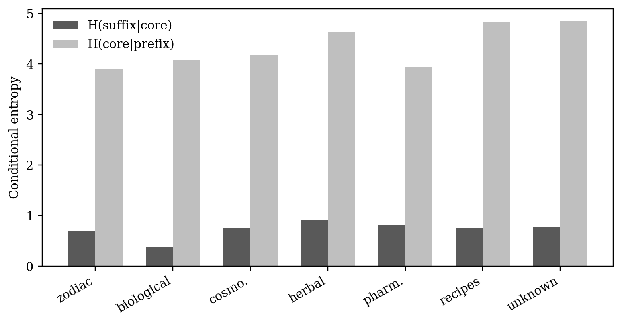
Figure 1. PCS Conditional Entropy by Section. Section-level comparison of H(suffix|core) and H(core|prefix). Lower H(suffix|core) indicates stronger suffix constraint given the core within a conventional visual/codicological section.

6.3 Global versus section-specific PCS modeling
The model-comparison experiment strengthened the descriptive PCS result. Under the 80/20 split, the largest improvement of section-specific PCS modeling over the global PCS model occurred in the biological/balneological section, with delta cross-entropy = 0.6098. Across all tested splits, the maximum global-versus-section delta was also observed in the biological/balneological section, reaching 0.6386.
These results support the interpretation that at least some manuscript regions are better described by section-conditioned PCS models than by a single global PCS model. The finding is especially important because it is not merely a frequency comparison. It directly evaluates model fit on held-out data.
Table 3. Global versus Section-Specific PCS Model Comparison. Positive delta cross-entropy values indicate cases where the section-specific model fits held-out tokens better than the global model.
Section | 80/20 Global CE | 80/20 Section CE | 80/20 Delta | Max Delta | Max Split | Note
herbal | 12.3824 | 12.1991 | 0.1833 | 0.2007 | 70/30 | standard
recipes/stars | 11.8651 | 11.7967 | 0.0684 | 0.1228 | 70/30 | standard
biological | 10.6971 | 10.0873 | 0.6098 | 0.6386 | 50/50 | standard
unknown | 13.0453 | 13.2136 | -0.1682 | -0.0832 | 50/50 | standard
pharm. | 12.3047 | 11.9898 | 0.3149 | 0.3149 | 80/20 | standard
cosmo. | 13.2961 | 13.3895 | -0.0934 | -0.0049 | 50/50 | standard
zodiac | 14.3397 | 14.3079 | 0.0318 | 0.6359 | 70/30 | low-count

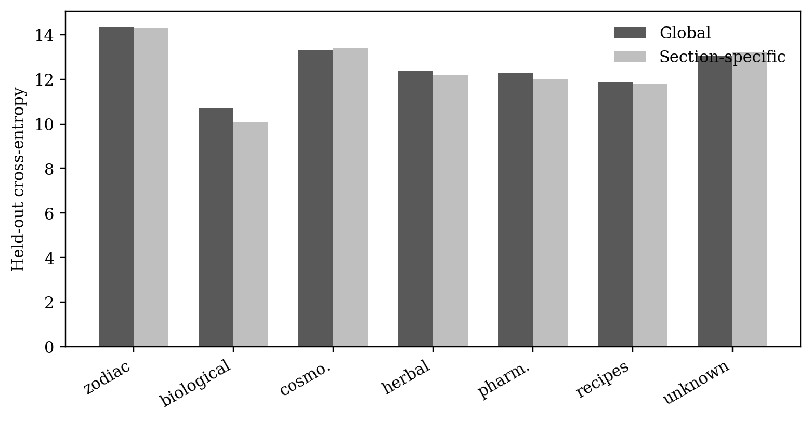
Figure 2. Global versus Section-Specific PCS Model Performance. Held-out cross-entropy for global and section-specific PCS models. Lower section-specific cross-entropy supports section-conditioned token-formation regimes where improvements are stable.

6.4 Cross-section transfer
Cross-section PCS transfer tested whether models trained on one section predict another section. Transfer results are interpreted as structural similarity or divergence among sections. Asymmetric transfer is possible: one section may generalize to another better than the reverse if one has broader or more restricted PCS distributions.
The transfer matrix should be read as a map of structural compatibility, not semantic similarity. Strong transfer suggests that two sections share PCS structural properties; weak transfer suggests that their token-formation regimes differ.
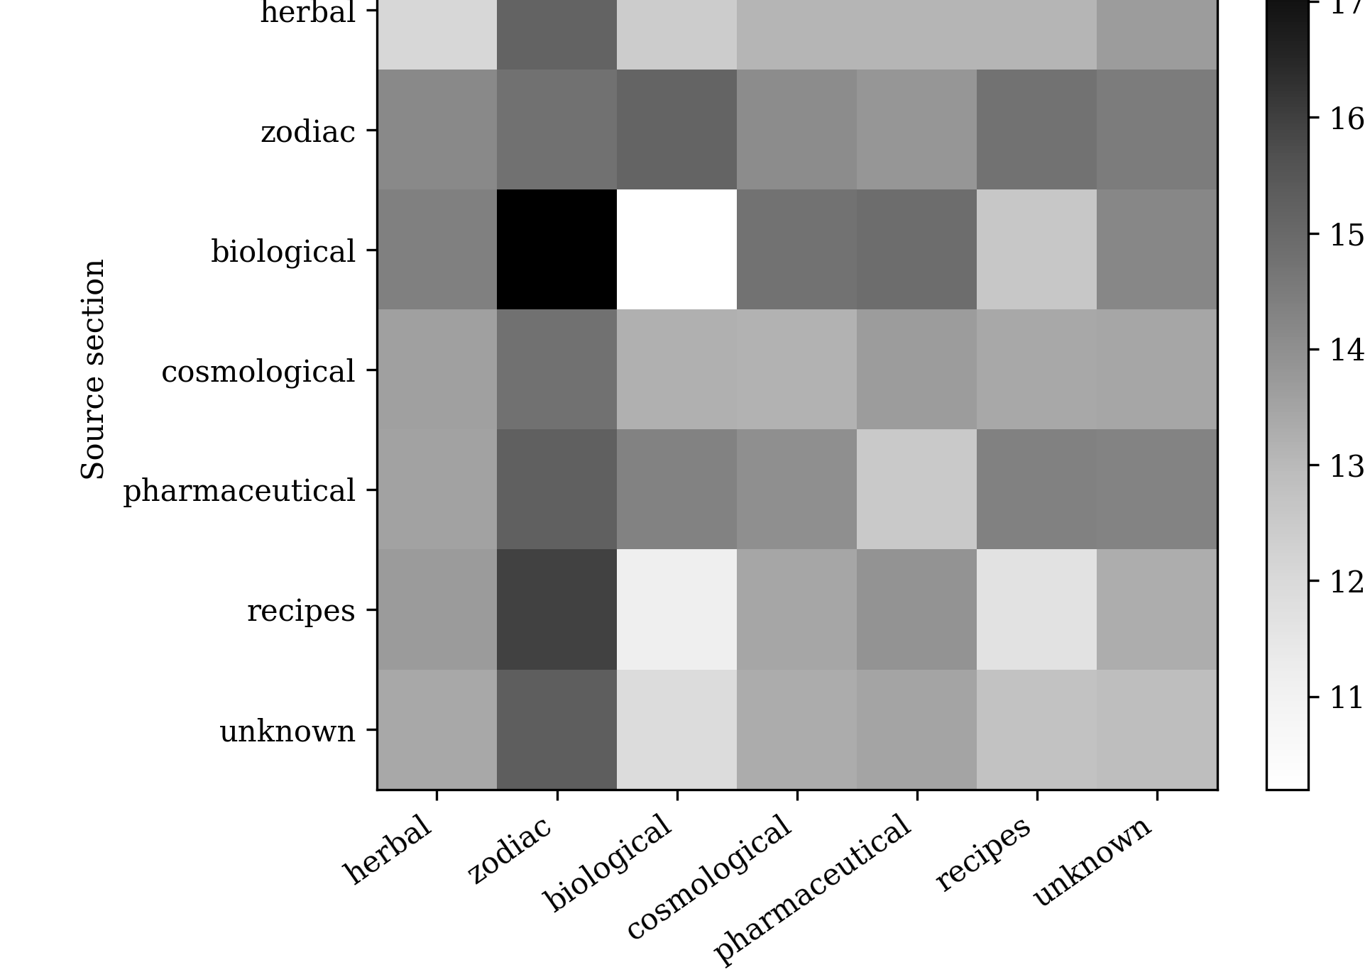
Figure 3. Cross-Section Transfer Heatmap. PCS transfer performance when models trained on one section are tested on another. Transfer is interpreted as structural similarity or divergence, not semantic similarity.

6.5 Inventory versus ordering effects
Inventory/order decomposition clarified the interpretation of section-level entropy. The biological/balneological section showed the largest ordering contribution, reported as 0.2052. This indicates that its local sequence structure is not explained only by restricted token inventory; actual ordering contributes additional constraint.
By contrast, the astronomical/zodiac section had low real bigram entropy, but its ordering contribution was small, reported as 0.0045. This suggests that its low entropy may be driven primarily by restricted token inventory rather than strong additional ordering. This distinction prevents overinterpretation of low entropy as evidence of syntax or sequence grammar.
Table 4. Inventory versus Ordering Decomposition. Decomposition of section-level entropy differences into inventory contribution and ordering contribution.
Section | Real bigram H | Inventory contrib. | Ordering contrib. | Line-order contrib. | Order/Inv.
herbal | 12.9716 | 0.046 | 0.099 | 0.0619 | 2.1526
zodiac | 9.239 | -0.0042 | 0.0045 | 0.0022 | -1.0621
biological | 11.9254 | 0.2127 | 0.2052 | 0.1622 | 0.9647
cosmo. | 10.3091 | 0.0026 | 0.0292 | 0.0221 | 11.3301
pharm. | 10.8202 | 0.0211 | 0.0488 | 0.0212 | 2.309
recipes/stars | 13.0103 | 0.0186 | 0.1175 | 0.0946 | 6.3311
unknown | 11.8709 | -0.0066 | 0.0707 | 0.0508 | -10.7256

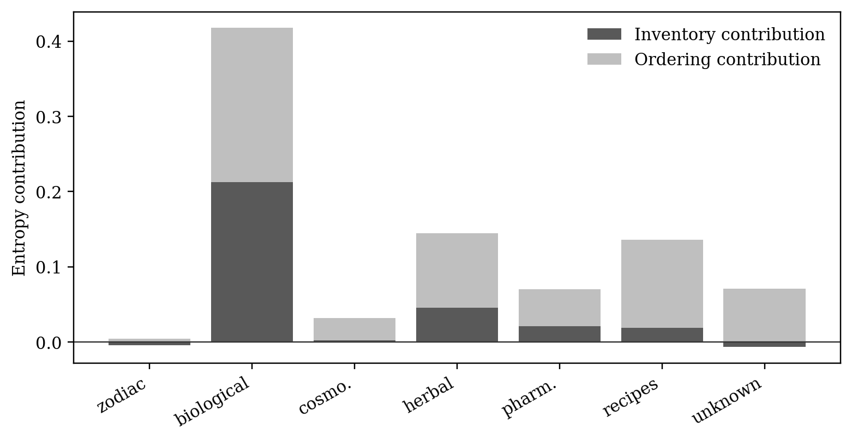
Figure 4. Inventory versus Ordering Contribution by Section. Entropy decomposition separating token-inventory effects from local ordering effects. This distinction prevents low section entropy from being overread as sequence organization alone.

6.6 Section classification from structural features
Structural features predicted conventional section labels above baseline. Among the tested standard and interpretable classifiers, linear SVM achieved the highest macro-F1 score (0.7418), while logistic regression achieved the highest balanced accuracy (0.7917). The label-permutation test yielded p = 0.000999, conventionally reported as p < .001. These results indicate that conventional visual/codicological section labels are not arbitrary with respect to the measured token-structural features.
The classification result should be interpreted carefully. It does not show that semantic categories were recovered. It shows that conventional visual and codicological section labels correlate with measurable structural profiles. Unknown or unassigned folios were excluded from this primary classification test and treated separately through structural-proximity analysis.
Table 5. Section Classification Results. Selected classification results for conventional visual/codicological section labels from structural features and baseline models. Unknown or unassigned folios were excluded from the primary classification and analyzed separately. Predictive performance is interpreted as structural correlation with labels, not semantic category identification; full classifier outputs are provided in the reproduction package.
Model | Macro-F1 | Balanced acc. | Role / note
Majority class | 0.1287 | 0.1667 | Baseline
Stratified random | 0.1513 | 0.1481 | Baseline
Token-count only | 0.5565 | 0.5748 | Control
Nearest centroid | 0.6403 | 0.7166 | Interpretable structural model
kNN-3 | 0.6190 | 0.5966 | Interpretable structural model
Logistic regression | 0.7405 | 0.7917 | Best balanced accuracy
Linear SVM | 0.7418 | 0.7632 | Best macro-F1

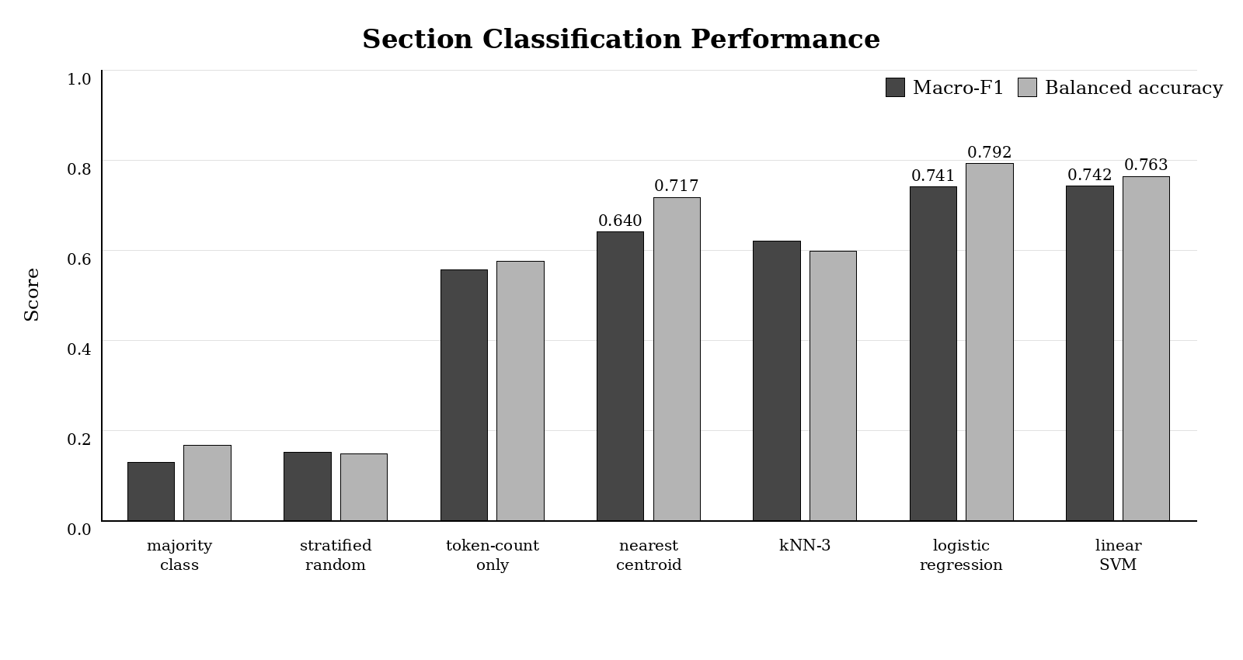
Figure 5. Section Classification Performance. Macro-F1 and balanced accuracy for baseline, interpretable, and standard supervised classifiers. The figure evaluates structural separability among conventional visual/codicological labels, not semantic category identification.

6.7 Folio-order change points
The strongest folio-level change-point candidate occurred at f116r -> f116v, and this transition aligned with a conventional boundary. This result suggests that at least some visual or codicological boundaries correspond to measurable structural discontinuities.
However, a change point is not a confirmed section boundary in a semantic sense. It is a structural discontinuity candidate. The result should be used as supporting evidence for structural zoning, not as evidence of section meaning.

6.8 Unknown folio proximity
The unknown-folio proximity analysis produced 22 rows, corresponding to unassigned or residual folios. These folios were compared with labeled section centroids by structural distance. The resulting proximity scores may be useful for identifying which structural profiles unknown folios resemble, but they must not be used as semantic reclassification.
The unknown category is therefore best treated as a residual and diagnostic group. Its results may inform future metadata refinement, but they do not establish a new section.

6.9 Robustness checks
The main biological/balneological PCS finding remained robust. Its low H(suffix|core) persisted after excluding the unknown category and after excluding low-count sections, and token-count matched downsampling produced an average H(suffix|core) of 0.2835. This reduces the likelihood that the biological/balneological result is merely an artifact of section size.
Additional checks addressed baseline choice and label uncertainty. Classification remained above baseline under majority-class, stratified-random, token-count-only, and label-permutation comparisons, with the updated linear SVM macro-F1 result remaining significant under label permutation (p < .001). The label-certainty restriction did not leave enough usable sections for a separate positive test, so it is reported as low-confidence/not applicable rather than as supporting evidence.
Table 6. Robustness Checks. Robustness checks for key section-specific findings under unknown-section exclusion, low-count exclusion, token-count matched downsampling, label-certainty restriction, and label permutation baselines.
Condition | Target | Metric | Value | Status
all sections | lowest H(suffix|core) | biological | 0.3823 | robust/descriptive
all sections | highest suffix top-1 | biological | 0.9028 | robust/descriptive
unknown excluded | lowest H(suffix|core) | biological | 0.3823 | robust/descriptive
unknown excluded | highest suffix top-1 | biological | 0.9028 | robust/descriptive
low-count excluded | lowest H(suffix|core) | biological | 0.3823 | robust/descriptive
low-count excluded | highest suffix top-1 | biological | 0.9028 | robust/descriptive
downsampling | mean H(suffix|core) | biological | 0.2835 | robust
label permutation | classification macro-F1 | linear SVM | 0.7418 | robust (p < .001)
label-certainty restriction | section variation | not applicable | insufficient sections | low-confidence
baseline choice | classification macro-F1 | linear SVM | 0.7418 | robust (p < .001)

6.10 Integrated structural zoning summary
Figure 6 and Table 7 synthesize the advanced evidence across model comparison, transfer, inventory/order decomposition, classification, and robustness checks. They are presented here as an integrated results summary rather than as a semantic interpretation of the manuscript sections.
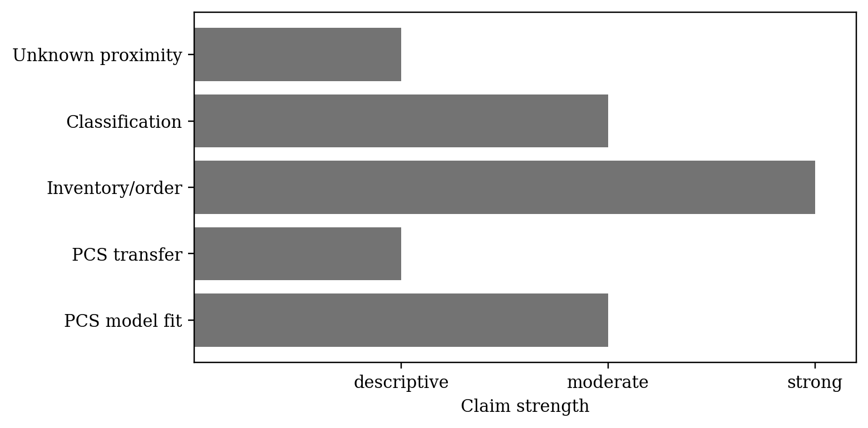
Figure 6. Advanced Structural Zoning Model Summary. Compact summary of advanced evidence for section-conditioned structural regimes, including model comparison, transfer, inventory/order decomposition, classification, and robustness.
Table 7. Final Key Findings. Summary of the principal findings, supporting evidence, interpretation, limitations, and recommended manuscript claim strength. Claim strength is limited to structural zoning and section-conditioned regimes.
Finding | Evidence/contrast | Interpretation | Limitation | Strength
Section-specific PCS models improve fit in some regions. | biological delta=0.6386 | Evidence for section-conditioned token-formation regimes. | Depends on smoothing, split, and token count. | moderate
PCS transfer varies across sections. | cross-section heatmap | Sections differ in structural transferability. | Transfer is structural, not semantic. | descriptive
Entropy separates into inventory and ordering effects. | Table 4 | Some low-entropy profiles are inventory-driven; others include ordering effects. | Baseline assumptions affect decomposition. | strong
Structural features predict conventional labels above baseline. | linear SVM macro-F1=0.7418; logistic regression balanced accuracy=0.7917 | Labels correlate with structural profiles. | Small class counts and imbalance remain. | moderate
Unknown folios can be profiled by structural proximity. | unknown proximity analysis | Supports structural proximity mapping. | Not section identification. | descriptive

7. Discussion

7.1 From section differences to section-conditioned models
The main contribution of this paper is the shift from descriptive section comparison to section-conditioned modeling. Many studies can show that different sections use different tokens. The present analysis asks a stronger question: whether section-specific structural models explain the manuscript better than a single global model.
The answer is not uniformly yes for every metric and every section, but several results support section-conditioned structure. The biological/balneological section is the clearest case. It shows strong PCS dependency, section-specific improvement over the global PCS model, robust low H(suffix|core), and the largest ordering contribution in entropy decomposition. This combination suggests a local regime of token formation and arrangement.

7.2 The biological/balneological section as a strong PCS-constraint zone
The biological/balneological section is the strongest structural zoning signal in the current analysis. It has the lowest H(suffix|core), high suffix-from-core prediction accuracy, the largest section-specific PCS improvement over the global model, and robust results under downsampling. The safest interpretation is that this section has a stronger core-conditioned suffix system than other sections.
This does not identify the section's meaning. It does not show that the section is biological, medical, balneological, or linguistic in content. The label is conventional and visual. The result concerns token structure only: in this region, the operationally defined core is a stronger predictor of suffix selection.

7.3 Token inventory effects versus ordering effects
One of the most important methodological results is the separation of inventory and ordering effects. Low entropy can arise because a section has a restricted token inventory. It can also arise because tokens are arranged in a locally constrained order. Without decomposition, these effects can be conflated.
The astronomical/zodiac section illustrates the problem. It shows low real bigram entropy, but its ordering contribution is small. This suggests that its low entropy may reflect restricted token inventory more than additional local sequencing. By contrast, the biological/balneological section shows a larger ordering contribution, indicating stronger local arrangement beyond inventory restriction.
This distinction should guide future Voynich modeling. A model that matches section-level token frequencies may still fail if it does not reproduce ordering contributions, and a model that produces low entropy may do so for the wrong reason.

7.4 Structural features and visual/codicological labels
The section classification experiment provides independent evidence that structural features correspond to conventional visual and codicological labels. Linear SVM achieved macro-F1 = 0.7418, while logistic regression achieved balanced accuracy = 0.7917; the label-permutation test yielded p < .001. This means that measured token-structural features predict section labels above baseline under both interpretable and standard supervised classifiers.
The result should not be read as semantic classification. It does not mean that the model has identified herbal, zodiac, or biological content. It means that the manuscript's visible or codicological divisions correlate with differences in token structure.

7.5 Structural boundaries and manuscript organization
The folio-level change-point result suggests that structural discontinuities may align with some conventional section boundaries. The strongest detected change point, f116r -> f116v, matched a conventional boundary. This supports the broader structural zoning interpretation, but it should remain a moderate claim. A single or limited set of change-point alignments does not prove that all section boundaries are structurally encoded.
Future work should test folio-order boundaries with richer visual metadata, higher-resolution layout features, and independent metadata for scribal or Currier-style text types.

7.6 Relation to Currier-style heterogeneity
The results are consistent with the broader view that the Voynich Manuscript is internally heterogeneous. However, the present study frames heterogeneity in terms of measurable token, PCS, inter-token, and model-transfer profiles. This differs from simply assigning a folio to a Currier language or hand. Section-conditioned structural regimes may overlap with Currier-style distinctions, but they are not identical to them unless directly tested.
Where Currier metadata are unavailable, the study does not infer them. Where available, they should be used as potential confounds or covariates. The present analysis therefore treats section structure as one axis of heterogeneity rather than the only possible axis.

7.7 Implications for future models
The results place new constraints on future explanations of the Voynich Manuscript. A successful linguistic, cryptographic, mnemonic, classificatory, or generative model should not only reproduce global token statistics. It should also explain why PCS dependency, token inventory, ordering contribution, and classification profiles vary by section.
In particular, future models should be tested against at least five section-sensitive requirements: reproduce section-level token inventory differences; reproduce section-specific PCS conditional dependencies; explain why section-specific models outperform global models in some regions; distinguish inventory-driven low entropy from ordering-driven low entropy; and account for structural-feature classification above baseline.
A model that matches the manuscript globally but fails section-level tests should be considered incomplete.

8. Limitations
First, section labels are conventional visual and codicological labels, not confirmed semantic categories. The analysis depends on the quality and certainty of section metadata.
Second, unknown folios remain a residual category. They were retained for completeness but were not interpreted as a coherent manuscript section.
Third, PCS segmentation is operational. Prefix, core, and suffix do not imply linguistic morphemes. The core is a statistically defined middle component, not a deciphered stem.
Fourth, the classification experiment should be interpreted cautiously because section labels are imbalanced and some sections contain relatively few folios. For this reason, macro-F1, balanced accuracy, and label-permutation baselines were emphasized alongside raw accuracy. Unknown or unassigned folios were excluded from the primary classification analysis and treated separately through structural-proximity analysis.
Fifth, cross-section transfer indicates structural similarity, not semantic similarity. A high-transfer pair should not be read as two sections sharing meaning.
Sixth, change-point alignment identifies structural discontinuity candidates, not confirmed section boundaries.
Seventh, all analyses depend on the ZL3b transcription and the chosen tokenization procedures. Alternative transcriptions may shift some values.

9. Conclusion
This paper extends global multi-level Voynich analysis to section-conditioned structural modeling. The results indicate that the manuscript is not adequately described only as a homogeneous corpus. Several structural properties vary across conventional visual and codicological sections, and some sections are better explained by local PCS models than by a single global PCS model.
The strongest evidence comes from the biological/balneological section, which shows strong core-conditioned suffix structure, robust low H(suffix|core), section-specific improvement over the global PCS model, and the largest ordering contribution in entropy decomposition. Classification results further show that structural features predict conventional section labels above baseline, with standard supervised classifiers improving over the earlier nearest-centroid result. Inventory/order decomposition clarifies that low entropy can arise from restricted token inventory, local ordering, or both.
Together, the findings support a structural zoning interpretation. The Voynich Manuscript appears to contain section-conditioned regimes of token formation and local arrangement. This conclusion remains independent of decipherment, translation, source-language identification, or confirmed syntax. It establishes a section-sensitive structural baseline that future linguistic, cryptographic, algorithmic, or generative explanations must address.

Data and Code Availability
The analysis uses the Zandbergen-Landini EVA transcription (ZL3b). The reproduction package for this article is archived on Zenodo at [INSERT PAPER 6 REPRODUCTION PACKAGE DOI BEFORE SUBMISSION]. The package contains the section metadata, parsed token and line files, scripts, output tables, figures, QC reports, and manuscript assets generated by the section-zoning and advanced model-comparison pipelines. The DOI placeholder must be replaced before journal submission.

Funding
This research received no external funding.

Competing Interests
The author declares no competing interests.

Ethics Statement
This study uses publicly available manuscript transcription data and does not involve human participants, animals, or personally identifiable information.

Acknowledgements
AI-based tools assisted with code implementation, figure generation, manuscript editing, and synthesis drafting. Research design, analytical decisions, statistical interpretation, and final argumentation were conducted by the author.

References
Chang, Y. (2026a). Robust positional constraints in the Voynich Manuscript: Toward a structured token architecture. Zenodo. https://doi.org/10.5281/zenodo.19687875
Chang, Y. (2026b). Language-like predictability and structural divergence in Voynich tokens: A comparative statistical study. Zenodo. https://doi.org/10.5281/zenodo.19737888
Chang, Y. (2026c). Conditional structure and generative dependencies in Voynich tokens: A prefix-core-suffix analysis. Zenodo. https://doi.org/10.5281/zenodo.19765707
Chang, Y. (2026d). Evidence for a structured token-generation system in the Voynich Manuscript. Zenodo. https://doi.org/10.5281/zenodo.19858094
Chang, Y. (2026e). Beyond token generation: Inter-token structure in the Voynich Manuscript. Zenodo. https://doi.org/10.5281/zenodo.19869629
Chang, Y. (2026f). From Token Structure to Sequential Organization: A Multi-Level Statistical Analysis of the Voynich Manuscript. Zenodo. https://doi.org/10.5281/zenodo.19877135
Currier, P. H. (1976). Some important new statistical findings. In M. D’Imperio (Ed.), New Research on the Voynich Manuscript: Proceedings of a Seminar (pp. 1-10). National Security Agency.
D’Imperio, M. E. (1978). The Voynich Manuscript: An Elegant Enigma. National Security Agency.
Landini, G. (2001). Evidence of linguistic structure in the Voynich Manuscript using spectral analysis. Cryptologia, 25(4), 275-295.
Montemurro, M. A., & Zanette, D. H. (2013). Keywords and co-occurrence patterns in the Voynich Manuscript: An information-theoretic analysis. PLOS ONE, 8(6), e66344.
Reddy, S., & Knight, K. (2011). What we know about the Voynich Manuscript. Proceedings of the 5th ACL-HLT Workshop on Language Technology for Cultural Heritage, Social Sciences, and Humanities, 78-85.
Rugg, G. (2004). An elegant hoax? A possible solution to the Voynich Manuscript. Cryptologia, 28(1), 31-46.
Stolfi, J. (1997). A morphological analysis of Voynich text. Unpublished manuscript. https://www.ic.unicamp.br/~stolfi/voynich/
Timm, T., & Schinner, A. (2020). A possible generating algorithm of the Voynich manuscript. Cryptologia, 44(1), 1-19.
Zandbergen, R. (2025). ZL3b EVA transcription files. Voynich.nu. https://www.voynich.nu

