The Effect of Local Road Maintenance Tax Cuts on House Values Ñ
Saannidhya Rawat ^{ț} David Brasington ^{ț}
May 5, 2026

Abstract
Most studies focus on the impact of new public infrastructure on local housing mar-kets. In this paper, we avoid endogeneity issues coming from the placement of new infrastructure by studying the maintenance of existing infrastructure and design a quasi-experiment to study local referendums conducted to renew property taxes levied for road maintenance. We compare housing sale prices between similar areas that narrowly pass or fail renewal road tax levies and use aerial imagery to fine-tune an Artificial Intelligence (AI) vision model for classifying road quality. Our results show that local jurisdictions with close elections that decide to cut road taxes face an average loss of 11% in road maintenance funds, experience up to about a 16% decline in road quality in delayed post-election windows, and suffer a 9% drop in house prices over the course of 10 years relative to areas that renew funding. Rolling 3-year post-election windows show little immediate effect in the 1 to 3 year window after the vote, followed by sta-tistically significant in years 2 through 4 and continued strong negative effects in years 3 through 5. Heterogeneity analysis reveals a stronger percentage decline in urban areas and for expensive houses relative to rural areas and cheaper houses, along with evidence for dosage-response for larger tax cuts. We rationalize these findings using a Dynamic General Equilibrium (DGE) framework and show that short-run gains from tax cuts are outweighed by the long-run capitalization of infrastructure decay, revealing how public disinvestment negatively affects property values.

^{s} Acknowledgements: We are grateful for comments from CK Tang, Guoyang Yang, Dan Boles, Eunjee Kwon, Gary Painter, Olivier Parent, Jeffrey Mills, Nayoung Lee, Matias Cattaneo, and Chris Bollinger, to CoreLogicQe for leasing us the housing dataset, to Albert Saiz, Lu Han, Siqi Zheng, David Albouy, Chao Liu, Tony Yezer and other attendees at the AREUEA-ASSA Conference, AREUEA National Conference and UEA North American Meeting for their insightful comments. We thank John Schroeder, Public Service Director of Beavercreek township, Ohio, for his insights on funding and maintenance of local roads in Ohio. No external funding was received for this project.
^{ț}PhD Student, University of Cincinnati. Corresponding author: rawatsa@mail.uc.edu
^{ț}Professor, University of Cincinnati

JEL Codes: R42, H71, R10

Introduction
Roads are an important form of infrastructure investment that affect households’ amenity values, firms’ production functions, and people’s commuting costs. A great deal of existing research has focused on the effects of new roads¹, especially in developing nations, providing valuable policy insights and spurring development initiatives like China’s Belt and Road Ini-tiative (Huang, 2016) and India’s Pradhan Mantri Gram Sadak Yojana (Asher and Novosad, 2020). However, the literature is constrained by two fundamental challenges. The first is endogenous selection as infrastructure investments are not exogenous events but are delib-erate policy choices. New road placement is selected by policymakers and is endogenous to anticipated economic growth, while repavement schedules and decisions are systematically correlated with confounding local factors such as political cycles or unobserved community characteristics that independently drive economic outcomes (Duranton and Turner, 2011; Gonzalez-Navarro et al., 2023). This identification problem is exacerbated by the second challenge: measurement. Most studies rely on road quality metrics that are inherently sub-jective, labor-intensive, and generated at low frequency (Attoh-Okine and Adarkwa, 2013). Such data are not only prone to measurement error that produces biased estimates, but their lack of scalability limits the geographic and temporal scope of empirical analysis (List, 2022).
In this paper, we avoid endogeneity issues by studying property taxes that fund the maintenance of existing roads and by utilizing a quasi-experimental setting that arises from analyzing close elections. We establish a novel dataset that allows us to study how changes in local taxes affect local infrastructure maintenance and neighborhood house prices. We match voting data on local road maintenance taxes from the Ohio Secretary of State with financial records of cities from Ohio Auditor of State and property sale prices from CoreLogic.
¹See Ghani, Goswami and Kerr (2016), Beenstock, Feldman and Felsenstein (2016), Levkovich, Rouwen-dal and Van Marwijk (2016), Hoogendoorn et al. (2019), Theisen and Emblem (2021), Gibbons et al. (2019), Fretz, Parchet and Robert-Nicoud (2022). Some papers have also observed adverse effects of new roads such as state-led repression (Gonz´alez et al., 2025) and environmental degradation (Asher, Garg and Novosad, 2020).

Our data also includes aerial imagery of local roads in Ohio from the National Agriculture Imagery Program (NAIP) and the Ohio Statewide Imagery Program (OSIP3). Using these rich data, we first estimate the expected loss in the road maintenance budget for a local government after a tax cut from a failed renewal of road maintenance levy. We fine-tune an Artificial Intelligence (AI) vision model using more than 53,000 satellite images from Brewer et al. (2021) to predict changes in road quality after a road maintenance tax cut. Finally, we use the Regression Discontinuity (RD) estimator to estimate the effect of cutting local road maintenance taxes on housing prices.
Our empirical findings reveal that when a city cuts its renewal road maintenance taxes, it faces an 11% loss in maintenance funds, its road quality declines by up to about 16% in delayed post-election windows, and its house prices decrease by around $15,350 (9%). In rolling 3-year post-election windows, we find little immediate road-quality response in years 1 to 3 after the vote, followed by statistically significant deterioration in years 2 to 4 and continued strong negative effects in years 3 to 5. After establishing the main results, we explore heterogeneity in the effects. We find that the effects on house prices are driven by urban areas rather than rural areas, with urban areas experiencing a 7.6% decline in house prices while rural areas experience inconsistent changes in house prices. Moreover, we find an effect on the intensive margin with evidence for dosage-response based on the size of the levy. We also observe that higher-priced homes experience larger percentage reductions in value relative to lower-priced homes. This suggests that wealthier households are more sensitive to road quality, as a poor road in front of a high-priced home is more likely to be noticed than a poor road in front of a low-priced home. We rationalize our main findings using a Dynamic General Equilibrium (DGE) framework and show how public disinvestment negatively affects property values, highlighting the trade-off between short-term tax savings and long-term private capital losses. Following Hendren and Sprung-Keyser (2020), we compute a conservative estimate of the Marginal Value of Public Funds (MVPF) using our empirical estimates and find a 1.4 net welfare loss to households for every dollar of revenue

loss to the government. Our focus on road maintenance instead of new development, our approach of leveraging close elections as a quasi-experiment to study the effects of local road maintenance tax cuts, and our use of an AI vision model to measure changes in road quality distinguish our study from the existing literature.
These results are consistent with other work on the impact of roads on house prices. For instance, Gonzalez-Navarro and Quintana-Domeque (2016) finds that paving roads in Acayucan, Mexico, increases property values by 28%, while Theisen and Emblem (2021) finds 13% higher housing prices in towns nearest to a new highway in Norway. Unlike Beenstock, Feldman and Felsenstein (2016) and Diao, Leonard and Sing (2017), we do not find any anticipation effects but we do find statistically significant effects starting in the fourth year after the vote and continuing at least through the ninth year. This delayed effect highlights how the consequences of road tax cuts are not immediate but gradually accumulate as it takes time for roads to deteriorate and for the decline in road quality to be capitalized into house prices.
Roadmap. The rest of the paper is organized as follows. Section 2 reviews the related literature and positions our contribution. Section 3 provides background information, es-tablishes the road quality metrics and presents the variables used in the study. Section 4 outlines the empirical strategy. Section 5 presents the results of the study and shares the relevant robustness checks. Section 6 examines the mechanisms underlying our findings². Section 7 implements our MVPF calculation to assess the impact of this tax cut policy. Section 8 concludes.

Literature Review
Roads and House Prices. Gonzalez-Navarro and Quintana-Domeque (2016) studies the effects of paving roads in Acayucan, Mexico. The government identified 56 neighborhoods
²In this section, we highlight the main findings from the DGE framework and relegate the model details to Appendix D.

that needed paved roads. Of these, 28 were randomly selected for paving. About 1,000 people were surveyed in these neighborhoods before paving (2006) and after (2009), although 11 of the 28 treatment groups were still in the process of being paved at the time of the post-treatment survey. It finds a 17% increase in property values as measured by professional appraisals, a 28% increase in homeowner-estimated property values, a 36% increase in rents, and a 72% increase in vacant land values, along with effects on a few non-housing outcomes. Our study evaluates cuts in road maintenance rather than a switch from unpaved to paved roads, and our Ohio geography contrasts with that of a developing nation. Our housing values are not based on professional appraisals or homeowner valuation but on actual sales transactions; and the fact that we observe sales transactions every year lets us analyze pre-and post-treatment trends in house prices over a long timeframe rather than a one-time change in house values.
We find almost no research on road maintenance. The exceptions include theoretical work by Rioja (2003), which develops a dynamic general equilibrium model to study the optimal amount of road maintenance, which is found to depend on the size of new infrastructure in-vestments and the productivity of infrastructure. Rioja (2003) solves and parameterizes the model, finding that increasing funding away from new infrastructure and toward the main-tenance of existing infrastructure decreases the depreciation rate of existing infrastructure, increases the stock of existing infrastructure, and increases economic output and consump-tion levels.
Another study, Chaurey and Le (2022), assesses the impact of infrastructure maintenance in India. As their research notes, the Indian national government identified 17 major states as the poorest and made an index of “backwardness” for districts in these states. The 115 most backward districts were awarded 450 million rupees and were given discretion on how to spend these funds to “improve and maintain” or “make complementary investments” to existing infrastructure. Money could be used to widen roads, add lanes, add electricity transmission and distribution infrastructure, build new road links to markets, and build

bridges, for example. The treatment is therefore a mixture of road and non-road spending and of maintenance and new construction, especially, presumably, in districts that did not already have paved roads and electricity, where Chaurey and Le (2022) finds the largest effects. Unlike Chaurey and Le (2022), we focus on the effects of infrastructure spending on real estate values rather than employment outcomes.
The only other study we find on maintenance and house prices is the classic capitaliza-tion study by Edel and Sclar (1974). It studies the effect of local public spending on median house values in the Boston area using decennial Census years from 1930 to 1970. Control-ling for latitude and longitude, the tax rate, population density, tenure status, and school expenditures, its ordinary least squares regressions do not find a statistically significant link between road maintenance spending and house prices.
Identification. Asher and Novosad (2020) studies the impact of new roads on villages in India. Like our study, its identification strategy is regression discontinuity, although ours is sharp rather than the fuzzy form. It argues the main obstacle to identification in prior studies is that the placement of new roads is usually correlated with economic (or political) characteristics rather than exogenous. Its findings suggest this is a serious problem with the literature because, unlike prior studies, it finds no strong link between economic growth and new road placement, suggesting that the estimates of previous studies that find a link are driven by road placement in villages that are already growing. Asher and Novosad (2020) touts its use of village-level rather than regional-level data. We, too, look at economic outcomes at the level of village, city, and township, the most local levels of government. A surprising finding of Asher and Novosad (2020) is that investment in transportation infrastructure does not affect village incomes, assets, or agricultural output. Its measure of assets is a village-level average of a series of binary indicators of ownership of a variety of assets, along with separate regressions for the presence of a ‘solid house’, refrigerator, and phone; whereas we study the effect of local road tax cuts on housing sale prices. Of course, our use of a developed geography contrasts with rural villages in India.

Our efforts to achieve identification focus on the maintenance of existing roads, which avoids the endogeneity of the placement of new roads. We also find similarities with Boudot-Reddy and Butler (2024), which employs a similar identification strategy but studies new roads instead of the maintenance of existing roads and finds that villagers reward the political party responsible for spearheading the road expansion.
Another study with an identification strategy similar to ours is Cellini, Ferreira and Roth-stein (2010), which studies the effect of new capital projects for schools, funded via new local bond issues and raised by referendums. Both our study and Cellini, Ferreira and Rothstein (2010) employ a dynamic regression discontinuity design and analyze changes in regional property values. Moreover, both papers rely on broadly similar identification strategies and assignment mechanisms: in each case, votes in favor of or against a local referendum serves as the source of exogenous variation. Despite these similarities, a few key distinctions stand out. First, Cellini, Ferreira and Rothstein (2010) looks at the impact of bond elections for addi-tional funding on new capital infrastructure projects, while we focus on the impact of cutting renewal referendums for existing road maintenance. Second, Cellini, Ferreira and Rothstein (2010) implements a fuzzy regression discontinuity approach, whereas ours is sharp. Lastly, we focus on the Intent-to-Treat (ITT) estimator, which analyzes the effect of an election on outcomes without controlling for the results of subsequent elections³ (more details in Section 4). As Cellini, Ferreira and Rothstein (2010) shows, when elections are independent, the ITT estimator is equal to the Treatment on the Treated (TOT) estimator.
Road Quality. Measuring road quality remains empirically challenging. Currier, Glaeser and Kreindler (2023) exploits vertical-acceleration signals from millions of Uber trips to con-struct a Road Roughness Index (RRI) and shows that it moves predictably with resurfacing events. Although RRI is highly correlated with engineering benchmarks such as the Inter-
³Recent papers such as Hsu and Shen (2024) and Biasi, Lafortune and Sch¨onholzer (2025) have focused on improving upon methods from Cellini, Ferreira and Rothstein (2010). However, these papers focus on the effects of new capital projects rather than maintaining existing capital infrastructure. Given the exogeneity of the timing of renewal elections and our focus on existing maintenance, the ITT estimator is more appropriate for our setting.

national Roughness Index (IRI) and the Pavement Condition Index (PCI), each of these legacy measures has drawbacks that limit their use for large-scale economic analysis: IRI data are collected only where a costly profilometer van has recently driven, and PCI ratings depend on labour-intensive, inspector-specific visual surveys that are updated irregularly. Moreover, the Uber-based approach cannot cover streets outside the platform’s service foot-print—precisely where many suburban and rural housing markets are located. In contrast, high-resolution satellite imagery is available nationwide and available at low marginal cost. By fine-tuning a vision model on a labelled road-surface dataset, we generate a consistent, wall-to-wall measure of road quality that spans urban, suburban and rural networks alike, and captures the visual cues that prospective home-buyers directly observe.
We find another study, Wong et al. (2017), which examines the effect of local political reform in rural Chinese villages on local infrastructure projects and finds that these reforms result in younger village leaders and higher quality roads. It measures road quality by cre-ating a village-level road quality rating, which is based on the observations of field surveyors that use their “road quality evaluation scheme”. They emphasize minimization of subjec-tivity in the evaluation process, as the surveyors are trained to use a standardized set of criteria to assess road quality, such as number of bends per 100 meters and road width. Unlike Wong et al. (2017), which relies on surveyor-based evaluations, our road quality mea-sure is derived from high-resolution satellite imagery processed through our fine-tuned vision model, ensuring consistency and scalability across diverse geographic regions.
Transportation and House Prices. We highlight a substantial literature studying the effect of transportation infrastructure on house prices. Hoogendoorn et al. (2019) studies the effect of the opening of a tunnel on house prices in the Netherlands, noting that prior research on transportation infrastructure in developed regions often suffers from reverse causality. It argues that the opening of the Westerscheldtunnel is a fairly exogenous event, with natural borders that prevent contamination of results by the surrounding environment. Hoogendoorn et al. (2019) finds that half the capitalized value of the tunnel occurs more

than a year before the tunnel opens and argues that the exogeneity of the tunnel’s opening, along with hedonic controls, time trends, and postcode fixed effects, identifies its estimates. Our data also pertains to a developed nation. One novelty of our study is how ordinary the events are that we study. While the opening of a new tunnel is significant, it is rare. Votes to renew infrastructure spending are common events in many local governments in the United States, and the amount of road maintenance spending is regularly determined by governments worldwide, either through voting or directly by bureaucrats. It is therefore important to study the effects of road maintenance spending on house prices.
Li et al. (2016) studies the overall effect on apartment prices of new subway lines in Beijing, but the estimates may represent the net effect of competing factors. Gibbons and Machin (2005), studying the construction of new rail stations for the London underground and light rail services, notes that the effect on house prices captures the net effect of better access, increased crime, and increased noise pollution. Levkovich, Rouwendal and Van Mar-wijk (2016) looks at the effect of highway development on house prices in the Netherlands. It separates out accessibility effects from noise pollution and increased traffic effects by look-ing at different neighborhoods near the highway development. Its repeat sales difference in differences model finds increased house prices from anticipation effects (Kohlhase, 1991). Beenstock, Feldman and Felsenstein (2016) also finds anticipation effects for house prices for the development of a highway across Israel.
Contribution. Our paper contributes to the literature on three main fronts. First, we contribute to the literature on the effects of public infrastructure on house prices. Our quasi-experimental design complements recent evidence from developing nations, such as Mexico (Gonzalez-Navarro and Quintana-Domeque, 2016) and Indonesia (Gertler et al., 2024). By exploiting close elections for renewal referendums earmarked to fund road maintenance, we mitigate the endogeneity concerns common in the literature and estimate the capitalization of road maintenance into property values. Second, we compute a novel measure of road quality using a fine-tuned vision model trained on satellite images. Current literature has

relied on measures based on Pavement Condition Index (PCI) or International Roughness Index (IRI) to measure road quality, but these are not available for many localities. Similarly, Currier, Glaeser and Kreindler (2023) measures road roughness using vertical acceleration data from a smartphone app, but this also requires large-scale data available mainly for large metropolitan areas and is not available for smaller towns. Our approach allows us to measure road quality at the local level, bypassing the limitations of existing measures. Third, by assessing the long-term capitalization of road maintenance, we uncover a dynamic trade-off between immediate tax savings and deferred infrastructure quality, highlighting the role of local government investment in public goods for sustaining property values (Oates, 1972; Rioja, 2003). While immediate tax cuts may initially increase house prices by lowering ownership costs and making properties more attractive to buyers, our results suggest that these savings are eventually eclipsed by the future decline in local public amenities.

Background & Data

How are roads funded in Ohio?
Roads in Ohio are funded through a combination of federal, state, and local sources. A significant portion of road funding provided by federal and state governments comes from gas taxes, which are currently set at $0.18 per gallon for federal tax and $0.38 per gallon for Ohio state tax. Additional sources for these two levels of government include vehicle registration fees, license plate fees, tolls, and driver’s license fees. Funding for local governments largely comes from property taxes. Below, we provide an overview of road funding in Ohio from national, state, and local sources.
Federal Funding. U.S. Department of Transportation is responsible for federal road infrastructure funding and allocates funds through the Federal Highway Administration (FHWA). The FHWA provides funding for the construction, maintenance, and operation of highways, bridges, and tunnels through the Highway Trust Fund (HTF), which is funded

by the federal gas tax. The HTF is divided into two accounts: the Highway Account and the Mass Transit Account. The Highway Account is used to fund highway construction and maintenance, while the Mass Transit Account is used to fund public transportation projects. Under the Bipartisan Infrastructure Law (BIL) (U.S. Department of Transportation, 2022), the HTF funds key programs like the National Highway Performance Program (NHPP), which targets the National Highway System (NHS), and the Surface Transportation Block do something about the justification Grant (STBG) program, which provides flexibility for a broader range of federal-aid roads. However, federal funding for local road infrastructure is largely restricted to major roads, leaving most neighborhood streets dependent on local revenue. As of 2022, about 4/5th of all road funding came from state and local governments (Peter G. Peterson Foundation, 2024). State Funding. The Ohio Department of Transportation (ODOT) is responsible for maintaining the Interstate system, the U.S. and State Routes. In Ohio, gas taxes, licensing fees and user fees account for 69% of the state’s road funding (Boesen, 2021), which can be used for both maintenance and new construction. However, about 70% of funds goes to highway construction⁴, 2% is given to local governments as grants and only 4% of state funds are directed towards roadway maintenance (Ohio Department of Transportation, 2023). The remaining funds are part of payroll and operating expenses and other miscellaneous expenses.
Hence, most of the road maintenance funding for local, neighborhood-specific roads in Ohio comes from local governments.
Local Funding. Local governments in Ohio fund roads mainly through property taxes, although the extent of this funding varies across different localities. These municipalities have the authority to levy property taxes specifically for road maintenance, providing a crucial source of funding for the upkeep of local infrastructure. For instance, as per our correspondence with Beavercreek Township, 61% of its road funds come from property taxes, and only 8% from gas taxes. Moreover, 77% of funding for roads in Beavercreek Township is provided by the local government and 11% of the overall local government budget is
⁴According to (Ohio Department of Transportation, 2023), most of this category is used for presevering existing infrastructure rather than new capacity.

allocated to roadway maintenance (Public Service Department of Beavercreek Township, 2025). We can see that local roads are primarily funded by local governments in Ohio and road maintenance funding is a significant part of the local government’s budget.

Local Taxation in Ohio
Background. Ohio consists of 88 counties, each covering about 464 miles² (1,200 kilometers²). Each county was historically divided into about 15 equally-sized townships, which do not cross county lines. Citizens can petition to incorporate as a village, which has a different type of government structure than a township and the ability to levy both income and prop-erty taxes, whereas townships may only levy property taxes. When a village exceeds 5,000 population in Ohio, it is reclassified as a city. Villages and cities may cross township and county lines, dissolve, or annex parts of contiguous townships. Villages, cities and townships, which we call “cities” for brevity, are the most local governmental unit in Ohio. Each local government covers about 18.2 miles² (47.1 km²) on average. The Ohio Revised Code lets local governments collect a small amount of tax without a vote. Beyond this limited amount local governments put tax levies on the ballot to ask for additional money from voters. Our data on renewal road tax levies include 3,184 referendums and cover 617 local governments in Ohio.
The type of tax levy we study is for the renewal of road tax levies. Most of the renewal taxes we consider have stated purposes of “road and bridges repair”, “road repair”, “street fund”, and “street improvements”, although there are less common stated purposes like “repair and maintenance of streets and sewers system” and “resurfacing and rehabilitation of city streets.” The construction of new roads and bridges, in contrast, would be funded with a tax levy for additional money, not a renewal tax; and it would likely be funded by a bond levy lasting 20 or 30 years. We eliminate from our dataset stated purposes that might suggest new road construction like a 30-year 1.9-mill new tax in Moscow Village for “permanent improvements” and 0.5-mill new tax for 20 years in Shawnee Hills Village for

“general construction and road and bridges repair.” Our dataset includes tax levies such as a 2-mill, 5-year renewal in Adams Township (Champaign County) in 1995; a 3-mill, 5-year renewal in Lore City Village in 2016; and a 2.5-mill, 5-year renewal in Pataskala City in 2007.
Levies that had originally passed typically expire, and the most common duration to collect a levy is five years, representing about 90% of the road tax levies in our sample. If a tax levy is renewed, taxes and funding continue. If 50% or fewer votes approve the levy, it fails. When a tax levy for additional funding fails, there is no increase in funding, but existing funding from other tax levies continues as normal. When a renewal tax levy fails, funding from that tax levy stops. 99% of the road tax levies in our sample are property taxes and 1% are income taxes.
Renewal levies. Most RD studies that use voting data to look at the impact of funding changes examine new tax levies for additional funding. Cellini, Ferreira and Rothstein (2010) observes that votes for additional tax money may not be statistically independent; a vote may be proposed until it passes. We minimize this source of endogeneity of new votes by only considering renewal votes (Brasington, 2017). While a government may choose when to put a vote for additional funding on the ballot and keep proposing the new tax until it is passed, when a vote passes, it has an expiration date. So if a road tax levy for additional funding passes in 2007 to last five years, in 2012 voters will have the chance to renew or reject the tax. The timing of the vote in 2012 is not endogenous, having been set in 2007. If voters renew it in 2012, it will be up for renewal again in 2017. The exogeneity of the timing of a renewal tax levy contrasts with the timing of new taxes for additional money as explained by Cellini, Ferreira and Rothstein (2010) because local governments can endogenously choose the timing of a new tax levy to coincide with positive economic conditions or positive sentiment toward government action, making an election more likely to pass.
Spending impact of failing to renew a levy. When a renewal tax levy fails, the local government loses the funding from that tax levy. The local government may still have

tax levies for other purposes in effect, but the road tax levy that failed to renew is no longer collected. We determine the dollar amount in consideration when a household is making a decision on whether to vote for or against a renewal road tax levy, and we call it Average Road Tax per household, which is the tax amount that a household will pay if the levy is successfully renewed. Average Road Tax per household is computed following Equation 1:

Average Road Tax per householdit = millage rateit × Average Assessed valueit (1)

where i is the city, t is the year, and millage-rate ⁵ is the predetermined millage amount set for the road tax levy. The Average Assessed value is 35% of the average appraisal value⁶, which for our study equals the average sale price of houses in the city for that year. From this, we can also compute the average road tax per city by multiplying the average road tax per household with the number of households in the city.
Although we acknowledge a large variation in the appraisal value across cities and in millage rates across referendums, we find that the average road tax per household is $76, and the average road tax per city is $167,011 as shown in Table 1. We do not observe any significant difference in the average road tax per household between cities that renew and cut road tax levies, which suggests the levies up for renewal are not systematically different between areas that renew and areas that fail to renew them. Whenever a renewal tax levy fails, the local government loses the funding from that tax levy, which is the average road tax per city. This loss in funding directly impacts local government’s spending budget needed to maintain local roads in Ohio and accounts for 11% of a local government’s budget for road maintenance ⁷.
⁵Millage-rate is property tax rate expressed in mills (tax per $1,000 of assessed value).
⁶Assessment ratio of 35%, as set by Ohio Department of Taxation (2020).
⁷For townships within our effective bandwidth, we use the average expenditure by the public works department as our base, which is $1,528,404 as per their audited financial reports. All local roads in such municipalities are funded via this department. Average loss in maintenance spending for areas that cut their renewal levy is $163,547, thus giving us 11% = ^{163,547} × 100
1,528,404

Table 1: Spending impact of failing to renew a Road Tax Levy

Aggregate Renewed Cut

Panel A: road tax per household
Mean 76 75 79
(55) (53) (62)

Panel B: road tax per city
Mean 167,011 167,648 163,547
(340,268) (340,628) (338,671)

Notes: This table presents descriptive statistics for two measures of the money collected via road tax levies. Panel A reports the mean and standard deviation (SD) of the road tax per household per year. Panel B reports the mean and SD of the total road tax collected per city. “Aggregate” denotes the full sample, while “Renewed” and “Cut” refer to levies that were renewed and failed to renew respectively. All monetary values are in constant 2010 U.S. dollars and rounded to the nearest integer.

Running Variable
The running variable plays a critical role in RD, which in this study represents the proportion of votes against the renewal of a road tax levy. A vote share of 50% or more against the renewal road tax levy means the levy fails and the tax will no longer be collected, resulting in a stoppage of road funding via that particular tax levy. There are 3,184 referendum results in our sample, 83% of which renew the tax, and 17% of which cut taxes and road maintenance. The Great Financial Crisis falls in the middle of our dataset, so readers might wonder if voting behavior was affected, but we find vote share the same to two decimal points during and outside the years 2008-2009. Our key identification assumption is that

the election results are not predetermined and vote share is not precisely manipulated to fall just above or below the cutoff. This assumption allows us to exploit the randomization around the cutoff and provides the variation needed to identify the causal effect of cutting road tax. We test this assumption using a density test detailed below and covariate balance tests (see Appendix C).
Density test. A classic RD assumption states that agents cannot precisely manipulate the running variable to fall just above or below the cutoff. In our context, it means that the election results are not determined prior to when the ballot takes place. In other words, no individuals, organizations, higher levels of government, foreign governments, or the firm that programs the voting machines are dictating the precise vote share for the renewal road tax levy referendums raised by a city. The standard way to test this assumption is to perform a density test like that of Cattaneo, Jansson and Ma (2020), which is based on the idea that manipulation of elections might cause a clustering of votes just to one side of the cutoff, with a pronounced drop-off on the other side of the cutoff. The p-value of this density test is 0.98. A histogram of vote share is shown in Figure 1 that graphically illustrates the lack of abrupt change in density.
Although Table 3 shows covariate balance between sets of cities that pass and fail to renew road tax levies, covariate values could still jump from one side of the cutoff to another. A drop in education levels, for example, could cause a drop in house prices that might coincide with a change in treatment, so that what might look like a treatment effect from cutting taxes and spending might in fact be caused by lower education levels. Graphs that suggest covariate smoothness around the cutoff are found in Appendix C. A formal way to assess covariate smoothness is to use each covariate as an outcome variable in a regression of the running variable and the treatment effect dummy. When we do so, the p-value of the treatment effect dummy varies from 0.234 to 0.981, as shown in Table 13, indicating no statistically significant jump in covariate values.

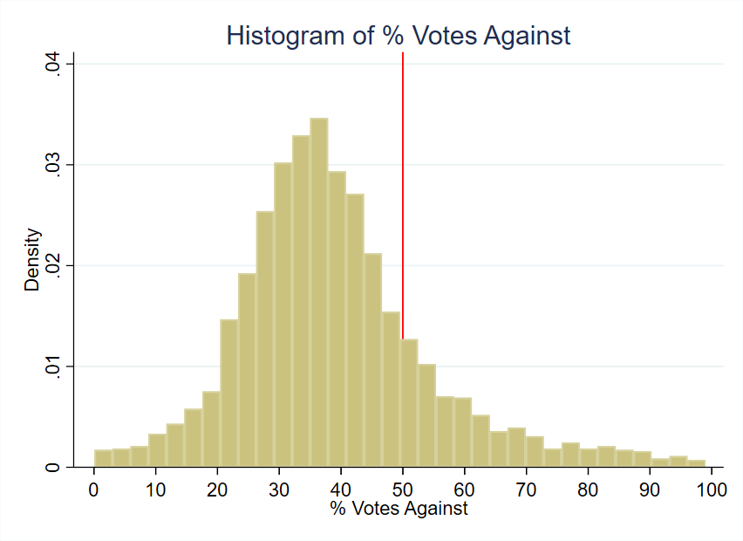
Figure 1: Histogram of Running Variable

Tax Cuts & Evidence of Road Quality
Roads in Ohio last 15-20 years and deteriorate faster with poor drainage, utility cuts to the road, and snowplow damage (City of Hudson, 2020). To understand the effect of cutting local road taxes on road quality, we fine-tune an AI vision model on satellite imagery data from Brewer et al. (2021). Following the seminal work on text-based Transformers in Natural Language Processing (NLP) by Vaswani (2017), vision transformers (ViTs) were introduced by Google Brain’s team and are part of a recent class of deep learning models that have shown to outperform classic Convolutional Neural Networks (CNNs) on image classification tasks (Dosovitskiy, 2020). Nevertheless, a more recent class of vision models learns from ViTs and uses CNNs to achieve high accuracy on image classification tasks (Woo et al.,

2023). We use one such model to classify road quality from satellite images⁸. Below, we outline the steps we take to assess road quality.
Satellite Images for fine-tuning. Fine-tuning a vision model involves taking a pre-trained model and adapting it for a specific image-classification task. In order to ensure appropriate fine-tuning and enable our vision model to accurately predict road quality, we need large-scale road-image data. We use the road-image dataset of Brewer et al. (2021) which consists of 53,677 labeled satellite images of roads in different conditions, and a clas-sification representing quality of each road: 0 (poor), 1 (decent) and 2 (high). We divide the data into training, validation and test datasets, and use 70% of the data for training, 15% for validation and 15% for testing. For a detailed analysis of the road-image dataset, see the Appendix, Section E. In section 5.1, we present the results from our fine-tuned model, when applied to roads in areas with close elections within the effective bandwidth.
Ohio Satellite Images. While the fine-tuning of our vision image-classification model uses images from Brewer et al. (2021), our Ohio application uses aerial imagery from the Na-tional Agriculture Imagery Program (NAIP) and Ohio Statewide Imagery Program (OSIP3). These sources provide substantially broader coverage than the earlier hand-collected sample, but image resolution and timing still vary across products and years. For that reason, our empirical analysis does not rely on a single before-and-after image pair. Instead, Section
5.1 aggregates predicted road quality within pre-election and post-election windows around each renewal election, excludes election-year imagery, and censors each window at adjacent renewal elections so the same subdivision-year is not reused across levy cycles. For inter-pretability, the main Table 4 reports NAIP-based Road Quality Rating and Road Quality Score outcomes, while pooled NAIP-OSIP3 standardized estimates are used only in sup-porting diagnostics. Figure 2 presents two illustrative NAIP road images from Ohio, one classified as poor quality and one classified as high quality.
Road Quality Rating. Our fine-tuned vision model classifies each satellite image into one

⁸see the Appendix, Section E for details.

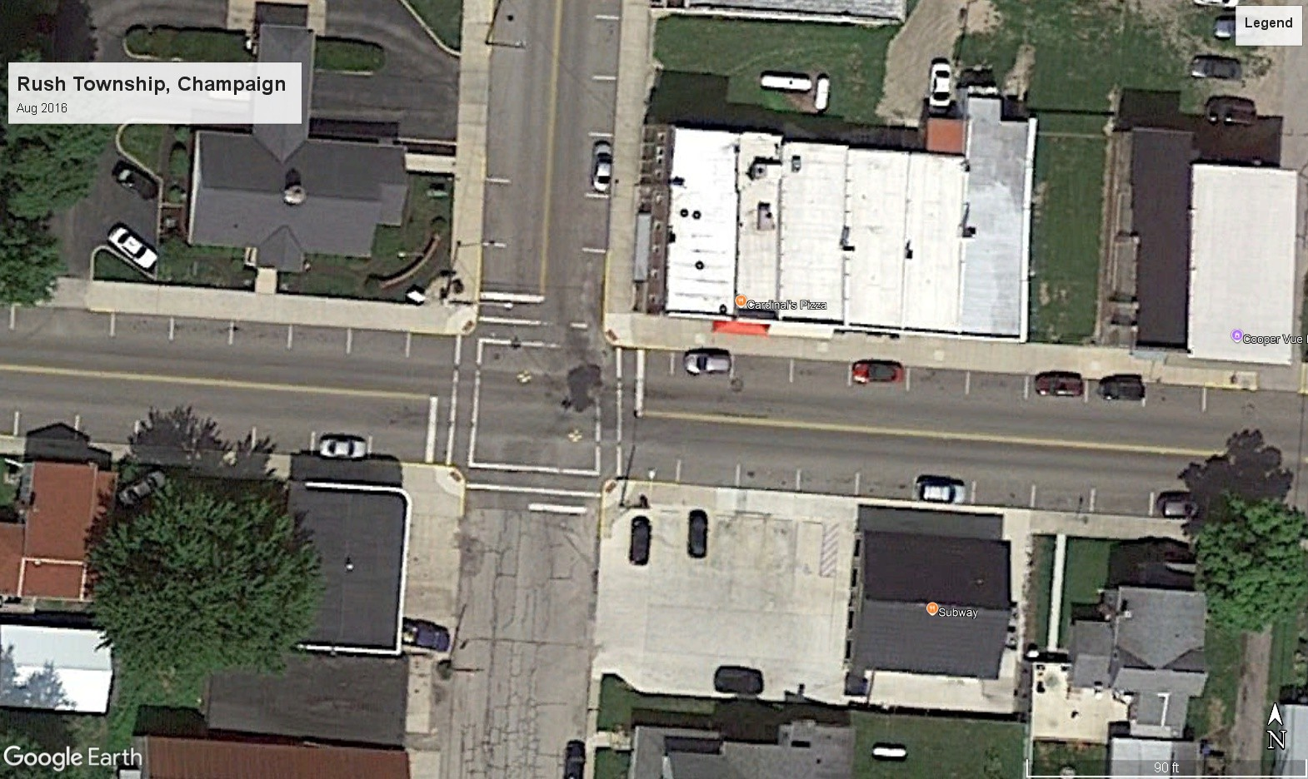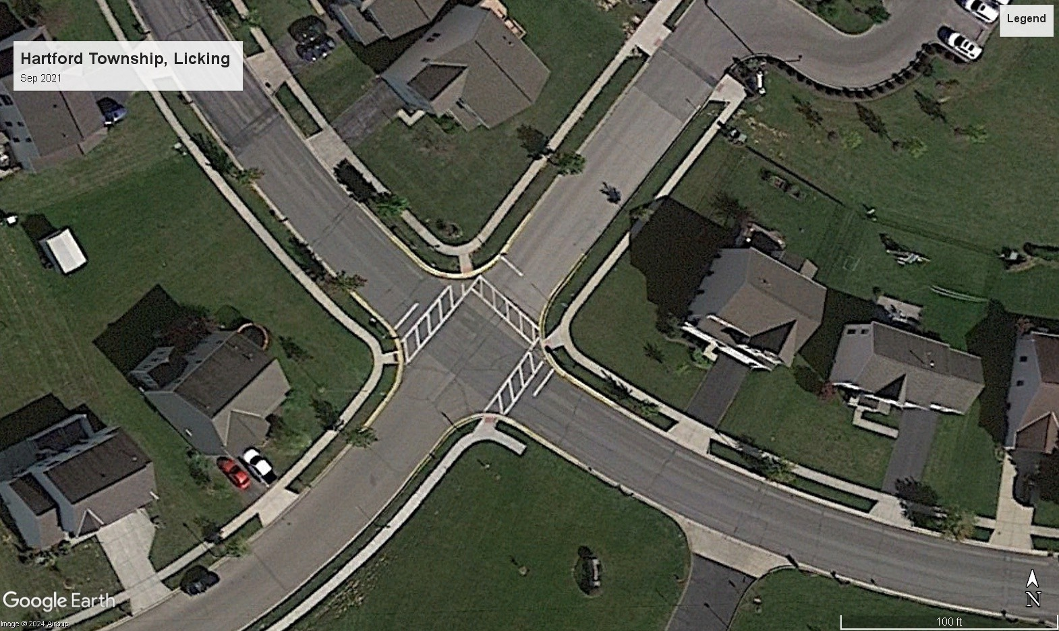
(A) A Poor Quality Road (B) A High Quality Road Figure 2: Road Quality Satellite Images for Ohio
of three categories: 0 (poor), 1 (average), or 2 (high). This rating is based on visual cues such as pavement quality, visible cracks, patchwork, and overall surface condition, as learned by the vision model from the labeled training data. For each image, the model outputs both the predicted class and a confidence score, which reflects the model’s certainty in its prediction. These ratings provide a standardized, objective measure of road quality across locations and time periods, enabling us to compare changes in road conditions before and after tax levy referendums for both treated and control groups.
Road Quality Score. Even though our original model output is a road quality rating⁹, we also convert the discrete model output to a continuous measure of road quality between 1 and
100. This Road Quality Score (RQS) combines the predicted road quality rating with the model’s confidence so that higher values correspond to better predicted pavement condition. We use RQS as a companion outcome to RQR because it preserves the ordinal classification while allowing finer comparisons across images and election windows.
Next, we share a summary of means and standard deviations of the predicted road quality rating and road quality score for the treatment and control groups, before and after the referendum.
⁹This is a direct result of our training data from Brewer et al. (2021) which uses the discrete 0 (low), 1
(medium), 2 (high) road-quality metric.

Table 2: Predicted Road Quality by Treatment Status and Period

Treated (Failed Levy) Control (Renewed Levy)

Panel A: Road Quality Rating (0, 1, 2)

Pre-Election | 1.62 | 1.56
 | (0.490) | (0.499)
Post-Election | 1.47 | 1.56
 | (0.505) | (0.499)
Panel B: Road Quality Score (1–100)
Pre-Election | 74 | 71
 | (17.3) | (17.9)
Post-Election | 68 | 70
 | (18.0) | (17.2)

Notes: The control group comprises townships within the effective RD bandwidth that successfully renewed their road tax levies; the treated group comprises those that failed to renew. Ratings are derived from our fine-tuned vision model. Scores combine the predicted class and model confidence into a 1–100 measure. Standard deviations are in parentheses.

Panel A of Table 2 summarizes the Road Quality Rating (RQR) in a simple descriptive comparison. Treated areas, i.e. jurisdictions that cut their renewal road tax levies, started with a slightly higher average RQR (1.62) than control areas (1.56) before the referendum, but experienced a decline from 1.62 to 1.47 after the referendum, while control areas remained at 1.56.
Panel B of Table 2 presents the continuous Road Quality Score (RQS), where treated areas also began with a higher average RQS (74) compared to control areas (71) before the referendum. After the referendum, RQS fell from 74 to 68 in treated cities, but only slightly from 71 to 70 in control cities. These descriptive differences are suggestive, but the formal

evidence in Section 5.1 comes from the stacked-event regression discontinuity design.
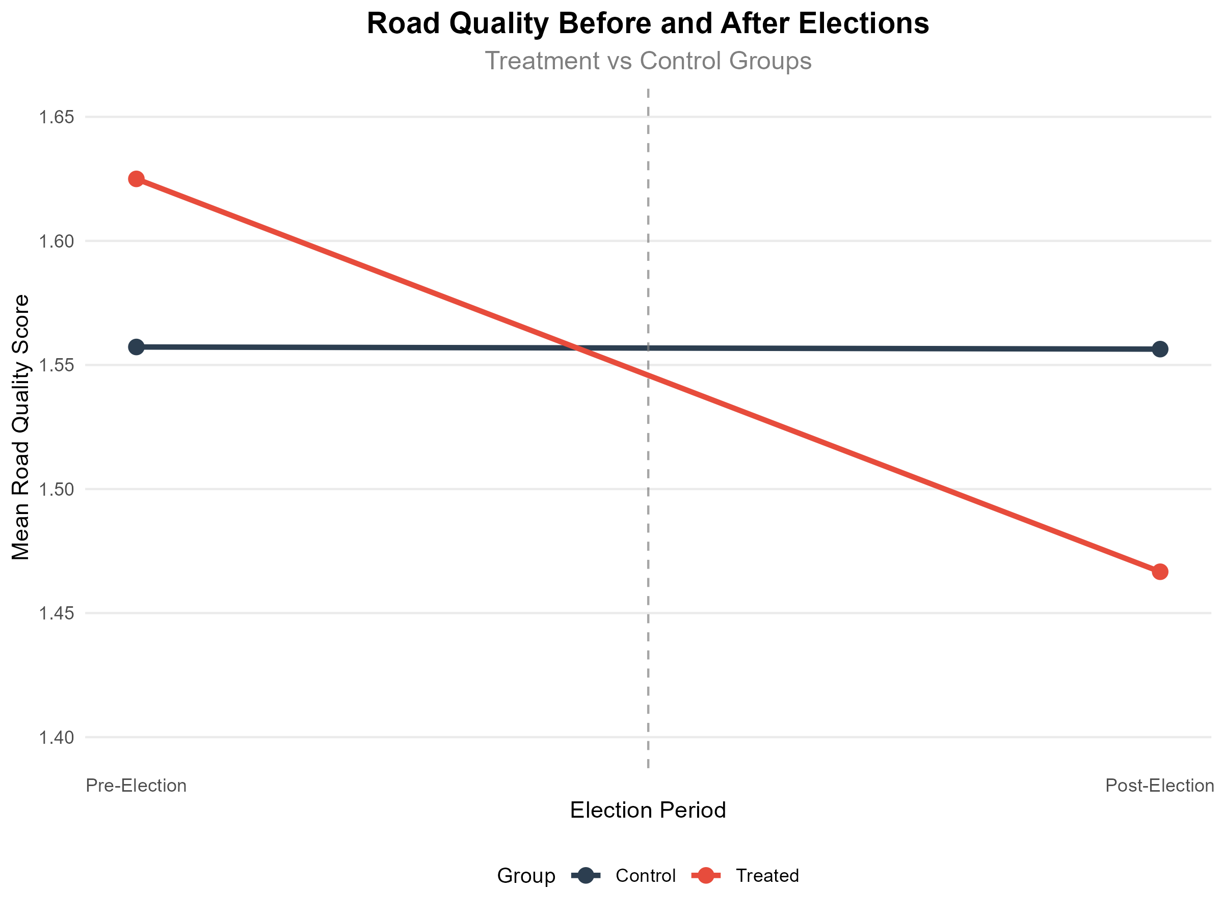
- Before and after referendum
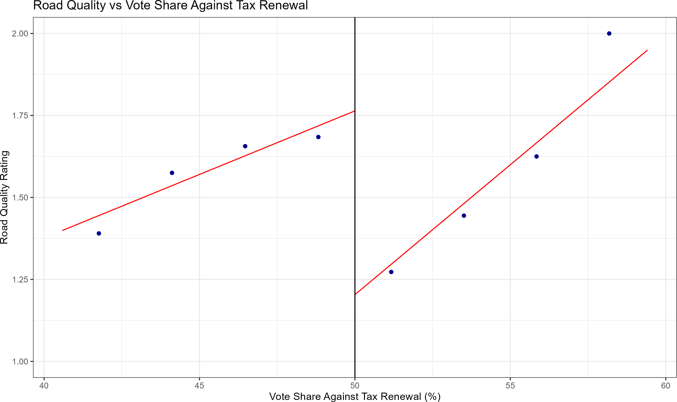
- Road Quality vs Vote Share Against Renewal (%)
Figure 3: Difference in Road Quality Rating by Treatment Status and Vote Share

Figure 3 provides descriptive evidence on road quality around the referendum. Panel A illustrates the before-and-after difference in road quality rating for treated and control groups, while Panel B plots post-election road quality against vote share against renewal. Both panels are consistent with lower road quality on the fail-levy side of the cutoff, but Section 5.1 provides the formal stacked-event RD estimates.

Outcome Variable: Median House Price
Our house price data comes from a CoreLogic) does this look better in .pdf? dataset of actual sales transaction prices in Ohio from 1995 through 2021 containing over 7 million observations. The dependent variable, Median House Price, reflects the median sale price of houses within a specific city and year. For example, for the houses sold in Delaware Township during the year 2002, the median sale price was $205,041. We take precaution to only include arm’s-length transactions, and we restrict our attention to single-family residential structures for comparability. The overall sample mean for the 10-year period from the time of votes considered in this study is $166,082 in constant 2010 dollars with a standard deviation of $372,135 which suggests the presence of outliers. Although our use of median sale price addresses outliers, one of our robustness checks drops 1% tails and re-estimates the treatment effects (Figure 9).
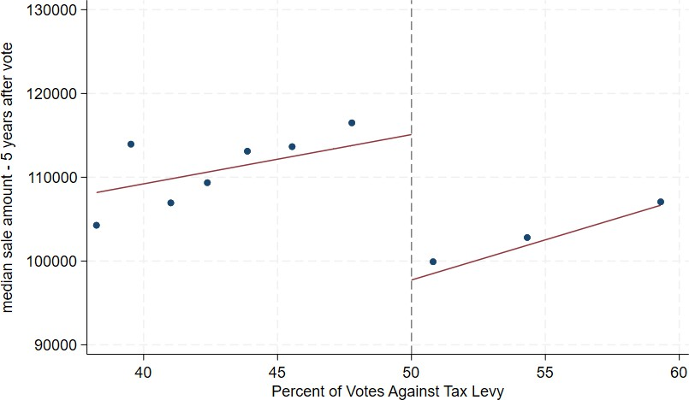

Figure 4: Median Sale Price of Houses: 5 years after vote

Figure 4 shows house prices from five years after the vote graphed alongside the percent of votes against the tax levy¹⁰. The points represent the mean house price for the 10 repre-sentative bins of vote shares for the average effective bandwidth around the cutoff of 50%. The graph suggests a discontinuity in house prices at the cutoff, which is the basis of our
¹⁰after deflating to 2010 U.S. dollars

identification strategy, suggesting that the failure to renew a road tax levy has a negative impact on house prices.

Covariates
Table 3 shows covariate means for both the global sample of all votes in the data set as well as the local sample within a representative effective bandwidth of the decision cutoff. The effective bandwidth displayed in Table 3 is the mean bandwidth for all the housing outcome regressions. The first columns for the global sample show similar values of characteristics between cities that renew and cut road taxes and spending. The second set of columns for the effective bandwidth show even closer similarity between cities that renew and cut road taxes and spending.
The data, captured at the time of the vote and as observed in Table 3, shows minimal differences within the effective bandwidth: mean population differs by only 301, and median family income varies by $436, measured in 2010 U.S. dollars. Other variables, including poverty rates, married household percentages, educational attainment, age distribution, and racial composition, show differences of two percentage points or less, bolstering the com-parability of the treatment and control groups. This similarity suggests that any observed differences in outcomes can more confidently be attributed to the treatment effect rather than to pre-existing differences¹¹.

Empirical Strategy
In this section, we describe our empirical strategy to estimate the causal effect of cutting road maintenance spending on house prices. One key feature of our quasi-experimental design is the exogeneity of the timing of the election. The timing is determined by the natural expiration of a road maintenance tax levy, which is typically 5 years, and is not
¹¹We also find similar covariate means for cities that have no road tax levies, which we explain in Section 5.4

Table 3: Variable Means by Road Tax Levy Renewal Status

Variable |  | Global |  |  | Effective
 | Full | Renewed | Cut |  | Renewed | Cut
Sample |  | (Control) (Treat-
 |  |  |  |  |  | ment)
Population | 5,072 | 4,733 | 5,139 |  | 4,885 | 5,186
(7,936) |  | (7,291) | (8,058) |  | (7,036) (8,229)
Poverty Rate | 0.11 | 0.11 | 0.11 |  | 0.10 | 0.11
 | (0.08) | (0.07) | (0.08) |  | (0.07) | (0.08)
% with Kids | 0.39 | 0.40 | 0.39 |  | 0.39 | 0.39
 | (0.08) | (0.08) | (0.08) |  | (0.07) | (0.08)
% Households with Children under 18 | 0.09 | 0.09 | 0.09 |  | 0.09 | 0.08
 | (0.06) | (0.05) | (0.06) |  | (0.06) | (0.05)
% Less than High School Education | 0.16 | 0.18 | 0.15 |  | 0.18 | 0.16
 | (0.11) | (0.12) | (0.11) |  | (0.12) | (0.10)
% Some College Education | 0.25 | 0.24 | 0.25 |  | 0.24 | 0.25
 | (0.06) | (0.06) | (0.06) |  | (0.07) | (0.06)
% Renters | 0.20 | 0.20 | 0.20 |  | 0.19 | 0.20
 | (0.11) | (0.10) | (0.11) |  | (0.09) | (0.11)
Unemployment Rate | 0.05 | 0.05 | 0.05 |  | 0.05 | 0.06
 | (0.04) | (0.03) | (0.04) |  | (0.03) | (0.04)
% White | 0.96 | 0.97 | 0.96 |  | 0.97 | 0.97
 | (0.07) | (0.07) | (0.07) |  | (0.07) | (0.08)

Table 3: Variable Means by Road Tax Levy Renewal Status (continued)

Variable Global Effective

 | Full Sample | Renewed | Cut | Renewed (Control) | Cut (Treat-ment)
% Black | 0.02 | 0.02 | 0.02 | 0.02 | 0.02
 | (0.07) | (0.06) | (0.07) | (0.07) | (0.07)
% Married | 0.59 | 0.60 | 0.59 | 0.61 | 0.60
 | (0.09) | (0.08) | (0.09) | (0.08) | (0.09)
% Separated | 0.01 | 0.01 | 0.01 | 0.01 | 0.01
 | (0.01) | (0.01) | (0.01) | (0.01) | (0.01)
Income Heterogeneity Index | 0.10 | 0.09 | 0.10 | 0.09 | 0.09
 | (0.08) | (0.07) | (0.08) | (0.07) | (0.06)
Median Family Income | 61,018 | 58,761 | 61,467 | 59,934 | 60,370
 | (17,649) | (13,915) | (18,270) | (13,655) | (15,713)
% Under 5 Years Old | 0.06 | 0.06 | 0.06 | 0.06 | 0.06
 | (0.02) | (0.02) | (0.02) | (0.02) | (0.02)
% Aged 5 to 17 | 0.20 | 0.21 | 0.20 | 0.20 | 0.20
 | (0.05) | (0.04) | (0.05) | (0.04) | (0.05)
% Aged 18 to 64 | 0.60 | 0.60 | 0.60 | 0.60 | 0.60
 | (0.05) | (0.05) | (0.05) | (0.04) | (0.05)
% Racial Minority | 0.04 | 0.03 | 0.04 | 0.03 | 0.03
 | (0.07) | (0.07) | (0.07) | (0.08) | (0.07)
Number of Observations | 3,184 | 2,656 | 528 | 653 | 269

impacted by factors such as the prevailing economic conditions or whether a road tax levy was passed or failed in earlier years.

Regression Discontinuity in Panel Data Setting
Suppose that local government in area i and year t conducts a referendum to renew an existing road tax levy. Let v_{it} be the vote share against the renewal tax levy and v∗ be the threshold determining the result of the referendum (levy fails to renew if v_{it} > v∗). Let F_{it} = 1(v_{it} > v∗) be an indicator to represent if the renewal road tax levy fails, and y_{it} be the outcome variable median housing sale price. We can write Equation 2 as follows:

y_{it} = α + θF_{it} + ϵ_{it} (2)

where α is the intercept, θ is the parameter of interest representing the causal effect of cutting a renewal road tax levy and ϵ_{it} is the error term representing all other determinants of the outcome. Around a narrow enough window around the threshold v∗, we can estimate the causal effect of cutting a renewal road tax levy on the outcome variable y_{it} by comparing the outcome variable for cities that narrowly pass the referendum to those that narrowly fail it.

Intent-to-Treat (ITT) Estimator
We follow a model of RD design similar to Cellini, Ferreira and Rothstein (2010) and estimate the Intent-to-Treat or ITT estimator. We prefer using the ITT estimator instead of the alternative Treatment on the Treated (TOT) estimator because the ITT estimator is more suited to our setting given the independence of the renewal elections. As described in Cellini, Ferreira and Rothstein (2010), when the elections are independent, the ITT estimator equals the TOT estimator.
We operationalize our ITT estimator using Equation 3:

Yi,t+τ = ατ + κt + FitθITT + Pg (vit, γτ ) + Zitβτ + ϵi,t+τ (3)
τ

Equation 3 shows a city i that holds an election in year t and we study this city’s outcome τ years later. Y_{i,t+τ} represents the outcome variable for city i at year t + τ . We define treatment as failure of a city, village or township to renew its road maintenance tax levy,

which is represented by the indicator F_{it}. θ^{ITT}
τ
is the causal effect of failing to renew road

tax on the outcome. P_{g}(v_{it}, γ_{τ} ) is a polynomial function of the running variable v_{it}, which is the percent of votes against the renewal tax levy. α_{τ} and κ_{t} represent timing and year-specific fixed effects. Z_{it} is a vector of control variables that include city-level demographics, economic conditions, and other relevant covariates. ϵ_{i,t+τ} is the error term.
We use the bandwidth selection method of Calonico et al. (2019) to find the mean opti-mal bandwidth h and then conduct a local polynomial regression after choosing a weighting scheme k. The bandwidth h determines the size of the neighborhood around the cutoff v∗, defined as (v∗ − h, v∗ + h). Only observations within this neighborhood are used to compute
the bias-corrected treatment effect estimate τˆ. For a sufficiently small neighborhood, the
continuity assumption central to the RD estimator is considered valid. We also cluster the standard errors by city to account for any serial correlation between years within each city. The weighting scheme k determines the weights of the observations within the neighborhood (v∗ − h, v∗ + h) and is crucial in estimating θ_{τ} . Common weighting schemes include uniform, triangular, and Epanechnikov. We use the default Mean Squared Error Regression Discon-tinuity (MSERD) method to compute the effective bandwidth (h) and bias bandwidth (b) for the outcome variable. This method identifies the bandwidth that minimizes the trade-off between bias and variance of the treatment effect estimate. All observations are used to estimate h and b, but only those within the effective bandwidth h are used to identify our treatment effect estimates θ_{τ} for different τ years.
For road-quality outcomes, we apply the same close-election RD logic in a stacked-event setting. Each renewal election defines an event, and predicted road quality is aggregated over

pre-election and post-election windows around that vote. We omit election-year imagery (t + 0) and censor each event window at the adjacent renewal elections so that the same subdivision-year is not assigned to multiple levy cycles. The main road-quality table fixes the pre-election window at t − 3 to t − 1 and reports rolling 3-year post-election windows,
controlling for the corresponding pre-election level. Table 4 reports NAIP-based raw Road
Quality Rating and Road Quality Score outcomes so the units remain directly interpretable across columns. Supporting outputs report pooled standardized NAIP-OSIP3 outcomes, placebo tests, and alternative event-window specifications.

Results

Road Quality Decline
First, we present the results of our analysis on the impact of cutting road maintenance taxes on road quality. As discussed in Section 3.4, we use a fine-tuned AI vision model to assess road quality based on satellite imagery data. The model gives us a road quality rating of 0 (poor), 1 (medium), or 2 (high), which we also convert to a continuous variable called Road Quality Score (RQS) ranging from 1 to 100. The main estimates in Table 4 use NAIP-based raw outcomes so the reported units are directly interpretable, while pooled NAIP-OSIP3 standardized specifications are used only in supporting diagnostics.
Table 4 fixes the pre-election window at t − 3 to t − 1 and begins with a placebo RD
in Column (1) using average pre-election road quality over those same years. Columns (2) through (6) then report RD estimates for rolling 3-year post-election windows using the Road Quality Rating (RQR, 0–2) and Road Quality Score (RQS, 1–100). The placebo estimate is small in both outcomes, and the post-election columns exclude t + 0 and control for the corresponding pre-election level.
The rolling-window pattern suggests that road deterioration emerges with a lag. In Column (2), which uses the post-election window t + 1 to t + 3, the estimated effects are

Table 4: Road Quality Decline after a Failed Renewal Election

t−3 to t−1 |  | t+1 to t+3 | t+2 to t+4 | t+3 to t+5 | t+4 to t+6 | t+5 to t+7
Panel A: Road Quality Rating
Change in Road Quality | 0.042 | 0.017 | -0.188∗ | -0.238∗∗∗ | -0.250 | -0.075
 | (0.089) | (0.080) | (0.099) | (0.070) | (0.163) | (0.232)
Eff. bandwidth (h) | 7.47 | 10.85 | 4.53 | 4.43 | 5.11 | 7.06
Bias bandwidth (b) | 13.21 | 18.55 | 8.73 | 8.34 | 7.11 | 8.96
Eff. observations | 170 | 209 | 53 | 46 | 34 | 23
Total observations | 515 | 378 | 279 | 221 | 132 | 46
Panel B: Road Quality Score
Change in Road Quality | 1.144 | 0.648 | -6.914∗∗ | -8.362∗∗∗ | -9.626 | -5.038
 | (3.035) | (3.088) | (3.445) | (2.621) | (6.401) | (9.094)
Eff. bandwidth (h) | 7.38 | 8.84 | 4.66 | 4.68 | 5.15 | 7.09
Bias bandwidth (b) | 13.01 | 15.31 | 8.83 | 8.73 | 7.11 | 8.99
Eff. observations | 167 | 160 | 55 | 51 | 34 | 24
Total observations | 515 | 378 | 279 | 221 | 132 | 46
Notes: Entries are bias-corrected sharp RD estimates at the 50% vote-share cutoff. Column (1) is a placebo RD using average pre-election road quality over t−3 to t−1. Columns (2)–(6) use rolling 3-year post-election windows, exclude t + 0, and control for population and the corresponding pre-election outcome. Standard errors clustered by ten-digit FIPS code are in parentheses.

close to zero and statistically insignificant. By Column (3), which uses t + 2 to t + 4, the estimates become negative and statistically significant: RQR falls by about 0.19 points and RQS by about 6.9 points. Relative to the pass-side local counterfactual, these estimates imply declines of about 16% for RQR and about 14% for RQS. Column (4), which uses t + 3 to t + 5, remains strongly negative, with RQR lower by about 0.24 points and RQS lower by about 8.4 points. In Column (5), which uses t + 4 to t + 6, the estimates remain negative but are less precise. By Column (6), which uses t + 5 to t + 7, the estimates are no longer informative because the available sample becomes thin. Taken together, the rolling 3-year windows are consistent with gradual infrastructure deterioration rather than an immediate visible break right after the vote.
Supporting diagnostics from the stacked-event analysis include pooled standardized spec-ifications, a pre-election placebo RD, the full pre-specified window grid, bandwidth sensi-tivity, sample flow, and continuity checks for image availability and source composition. In

those supporting results, the pooled standardized estimates are generally negative and the pre-election placebo is small, which is consistent with deterioration after the tax cut rather than a discontinuity in baseline road quality.
The next section presents our main results on the impact of cutting road maintenance taxes on house prices.

House Prices Decline
Table 5 below shows the ITT estimates of failing a road tax levy on housing sale prices. Each treatment effect estimate represents the discount in median sale price for cities that cut road taxes relative to otherwise similar cities that renew the taxes. We show dynamic effects starting three years before the vote and extending to ten years after the vote. Treatment effect estimates for years 4 through 9 after the vote are statistically significant in Table 5. The estimate for year t + 10 has a smaller estimate and is only significant at the 10% level, suggesting that the effect of tax and service cuts on house prices may peter out ten years after the vote. Overall, we find an average reduction of $15,349 in median house price over the 10-year period for houses in cities that vote to cut road tax levies, representing 9% of overall house value¹². The 9% reduction we estimate may be compared to Gonzalez-Navarro and Quintana-Domeque (2016) which observes a change in property values of 17-28% after paving previously unpaved roads and the 13% increase in house prices Theisen and Emblem (2021) finds in towns nearest to a newly-constructed highway¹³.
¹²The average treatment effect estimate of $15,349 was divided by the mean house sale price in the dataset of $166,000 to get 9%.
¹³Note that these studies focus on the effect of developing paved roads whereas we focus on deterioration of existing paved roads.

Table 5: Effect on median house prices of failing to renew a road tax levy

Panel A: Years t − 3 through t + 3

Year | t−3 | t−2 | t−1 | t | t+1 | t+2 | t+3
Treatment effect | 5,307 | 166 | –273 | –4,261 | –3,908 | –11,001 | –14,733∗
Standard error | (7,341) | (6,943) | (7,391) | (7,955) | (8,719) | (9,405) | (7,989)
Effective band- | 10.30 | 10.06 | 8.76 | 7.97 | 9.78 | 9.63 | 11.93
width (h)  Bias bandwidth (b) | 20.22 | 17.48 | 14.39 | 13.03 | 17.50 | 18.22 | 22.69
Effective observa- | 724 | 725 | 650 | 587 | 774 | 778 | 1,003
tions  Total observations | 2,552 | 2,631 | 2,696 | 2,784 | 2,764 | 2,699 | 2,640
Panel B: Years t + 4 through t + 10
Year | t+4 | t+5 | t+6 | t+7 | t+8 | t+9 | t+10
Treatment effect | –21,701∗∗∗ | –21,706∗∗ | –17,365∗∗ | –15,975∗∗ | –21,984∗∗ | –19,857∗∗ | –16,090∗
Standard error | (7,747) | (8,751) | (8,355) | (7,248) | (9,074) | (7,751) | (9,027)
Effective band- | 8.52 | 11.20 | 9.79 | 13.16 | 8.25 | 7.28 | 6.24
width (h)  Bias bandwidth (b) | 16.25 | 20.16 | 17.32 | 23.42 | 15.28 | 14.09 | 16.27
Effective observa- | 688 | 922 | 764 | 1,061 | 591 | 505 | 402
tions  Total observations | 2,614 | 2,531 | 2,438 | 2,324 | 2,199 | 2,115 | 2,017
Notes: Outcome is median house price in constant 2010 U.S. dollars. Unit of observation is the city–year, so a treatment effect of –$21,701 in year t + 4 means that four years after the vote, cities that fail to renew road taxes have median sale prices $21,701 lower than similar cities that renew. Covariates include the demographic and socioeconomic controls listed in Table 3.

Figure 5 provides an event-study plot that summarizes the treatment effects for each

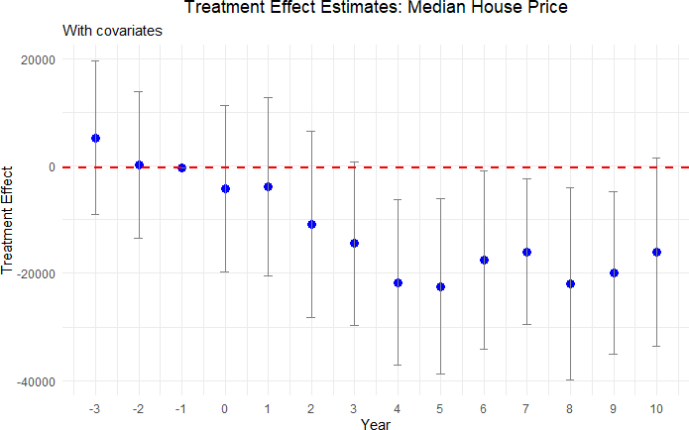
Figure 5: Effect plot for Median Housing Price

time period. In the graph, we include placebo years up to 3 years before the treatment to show that the median housing prices are statistically identical for cities above and below the threshold prior to the treatment. Each dot represents the treatment effect point estimate for that year and the bar around it represents the 95% confidence interval for that estimate. For year 0, which is the year of the vote, we see a slight decrease in the estimate. However, this effect is not statistically significant, as evidenced by the confidence interval containing the null effect. Up to year 3, we observe that the treatment effect estimates are fairly close to zero, and the confidence interval overlaps with zero. As stated previously and shown in Table 5, we start to see a sizable increase in treatment effect from year 4 onwards and continue to observe it through year 9 after the vote.

Heterogeneity Analysis
We show the results of our heterogeneity analysis, where we explore the differential impact of cutting road maintenance spending on house prices in urban and rural neighborhoods, for tax levies of different sizes, and for different housing price quantiles.
Urban vs Rural neighborhoods: Analyzing regional heterogeneity is important be-cause the impact of public goods like road maintenance on house prices can differ substan-tially between areas due to factors such as differences in elasticity of housing supply. In this section, we check how treatment effects differ between urban and rural areas¹⁴.
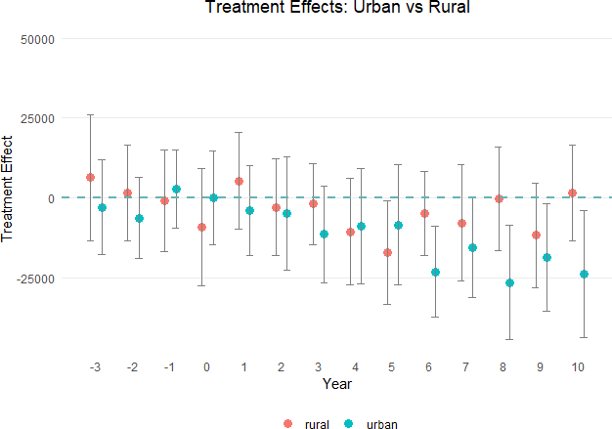

Figure 6: Median Housing Price in Urban and Rural Areas

¹⁴Urban areas are identified using data from U.S Census Bureau. We strictly consider urban areas with atleast 0.3 allocation factor in 2010 and do not consider urbanized clusters, making our classification of urban areas more restrictive.

As shown by Figure 6, we do not find any significant differences in housing prices in rural areas after a renewal tax levy fails to pass. On the other hand, we do find a statistically significant decline in housing prices in urban areas starting six years after voting. The standard errors are somewhat smaller for the rural estimates due to a larger number of observations. The stronger effects in urban than rural areas may stem from a more inelastic housing supply (Brasington, 2002). Overall, we find that housing prices decrease by $13,302 on average over the decade¹⁵ after cutting road maintenance tax levies in urban areas.

Tax magnitude: We check for dose-response by splitting the sample by the size of the tax levy. First, we consider splitting the sample based on the median size of the tax levies. The median size of the tax levies in our sample is 1.9 mills, however we find that the tax levies above and below the median size do not show any significant differences in treatment effects. Next, we focus on the top quartile of the tax levies, which in our sample is the set of tax levies ranging from 2.1 to 8 mills. Figure 7 below presents the results for this subsample. The treatment effect estimates for these larger tax cuts are both statistically significant and of greater magnitude, indicating a more pronounced decline in house prices when the reduction in road tax levies is more substantial.
Despite the reduction in sample size leading to wider standard errors in Figure 7, the overall pattern in decline of house price remains, with mean treatment effect for this sub-sample being approximately $30,000 which is about double the effect observed in the full sample. This finding supports the presence of an intensive margin effect: the larger the tax cut, the greater the negative impact on housing prices. Such a pattern is consistent with a dose-response relationship, where the magnitude of the fiscal shock translates directly into the size of the decline in property values.
15This is equal to 7.6% = ^{13,302} × 100, where the denominator is average sale price of houses in urban
175,217
areas in our dataset.

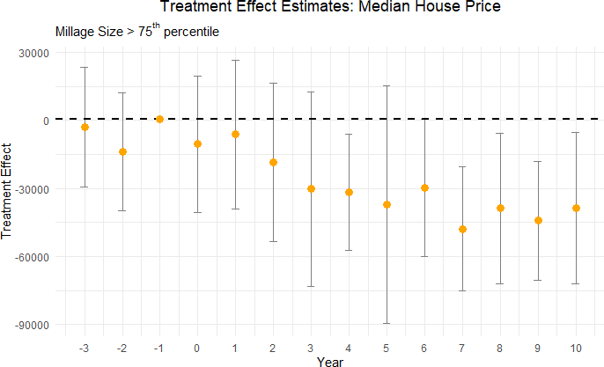

Figure 7: Effect of Large Road Maintenance Tax Cuts (>2 mills) on Median House Price

RD Quantile Estimation: We analyze our results by estimating quantile-level treat-ment effects, as suggested by Frandsen, Fro¨lich and Melly (2012), to study how the treat-ment’s impact varies at different quantiles of the outcome variable.
Table 6 shows the treatment effect heterogeneity of cutting road spending on high and low quantiles of median house prices. The top percentiles consistently exhibit a statistically significant decline in house sale prices, beginning in year 6 after the reduction in road spend-ing. In contrast, the lower percentiles do not demonstrate a consistent treatment effect. This suggests a differential impact, where higher-valued properties are more sensitive to road dis-repair than lower-valued houses. Figure 8 contrasts the treatment effects of the 20th and 80th percentiles of house sale prices in an effect plot to highlight this differential impact of reduction in road maintenance spending.

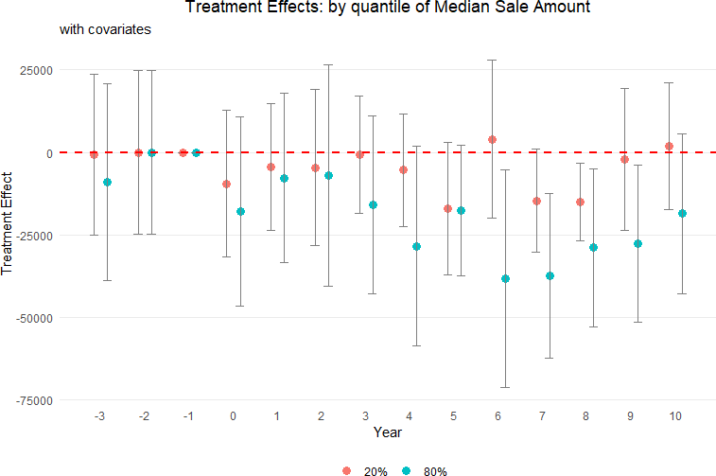

Figure 8: Treatment Effect of Cutting Road Maintenance Taxes for 20th and 80th Percentiles of Median House Price

Table 6: Quantile-level Treatment Effects of Cutting Road Spending on Median House Prices

Percentile | t + 4 | t + 5 | t + 6 | t + 7 | t + 8 | t + 9 | t + 10
10% | -6,433 | -22,570∗∗ | -9,602 | -12,984 | -11,217 | -6,569 | -1,326
 | (9,364) | (9,065) | (9,205) | (8,420) | (9,136) | (10,809) | (8,793)
20% | -5,400 | -15,070 | 4,014 | -14,682∗ | -15,040∗ | -3,228 | 624
 | (9,983) | (9,886) | (7,443) | (8,502) | (8,160) | (10,435) | (8,509)
70% | -21,760∗ | -11,171 | -38,082∗∗∗ | -36,685∗∗∗ | -21,356∗ | -25,605∗ | -18,600∗
 | (12,333) | (11,806) | (12,835) | (12,163) | (12,218) | (13,984) | (9,872)
80% | -28,478∗∗ | -16,379 | -38,460∗∗ | -37,470∗∗∗ | -28,950∗∗ | -27,800∗∗ | -18,658
 | (13,343) | (11,404) | (18,623) | (12,169) | (12,507) | (12,421) | (11,808)
90% | -51,470∗∗∗ | -34,604∗∗ | -38,510∗ | -27,039∗ | -29,010∗ | -49,093∗∗∗ | -36,662∗
 | (18,409) | (15,837) | (22,194) | (16,308) | (16,640) | (14,498) | (19,110)
Notes: The outcome is median house price in constant 2010 U.S. dollars. The unit of observation is the city-year, so a treatment effect of −$28,478 means that at the 80th percentile of house prices four years after the vote, cities that fail to renew road taxes and the associated spending have houses that sell for $28,478 less than cities that vote to renew them. Covariates include demographic and socioeconomic characteristics as described in Table 3.

Robustness Tests
We conduct several robustness tests to ensure the validity of our results. We test the sensitiv-ity of our treatment effect estimates by removing contaminated observations and winsorizing the outcome variable to reduce the influence of outliers. Lastly, we consider other tax levies to alleviate endogeneity concerns.
Removing contaminated observations: In this test, we focus on independence and exogeneity. Estimates may be biased if tax levies for additional money pass after renewal tax levy decisions. To address this concern, we exclude observations from our analysis if a tax levy for additional funding is introduced and passed within a ten-year period following a renewal tax levy vote, as these votes may contaminate the treatment effect of the renewal tax levy vote. For example, consider a scenario where a city votes to fail its renewal tax levy in the year 2000 i.e. funding for road maintenance is cut. If that city subsequently introduces and passes a tax levy for additional road spending in 2004, we exclude all votes for that city from 2005 through 2010. This exclusion ensures that the effect on house prices from the 2000 vote are captured for uncontaminated years but not for years after 2004 when

the effect of additional road taxes may counteract the drop in tax money from the elections in the year 2000.
Table 7: Effect on median house prices of failing to renew a road tax levy – uncontaminated observations only

Panel A: Years t − 3 through t + 3

Year relative to vote | t−3 | t−2 | t−1 | t | t+1 | t+2 | t+3
Treatment effect | 5,295 | –369 | 1,207 | –2,482 | –3,107 | –12,236 | –15,026∗
Standard error | (7,255) | (7,359) | (7,776) | (8,482) | (9,270) | (10,123) | (8,746)
Effective bandwidth (h) | 10.25 | 9.70 | 8.84 | 7.48 | 9.19 | 8.20 | 10.09
Bias bandwidth (b) | 20.08 | 16.41 | 14.45 | 12.03 | 16.04 | 16.33 | 20.21
Effective observations | 719 | 682 | 630 | 510 | 680 | 604 | 763
Total observations | 2,552 | 2,574 | 2,593 | 2,640 | 2,627 | 2,536 | 2,449
Panel B: Years t + 4 through t + 10
Year relative to vote | t+4 | t+5 | t+6 | t+7 | t+8 | t+9 | t+10
Treatment effect | –21,082∗∗ | –16,827 | –17,565∗ | –18,179∗∗ | –20,427∗∗ | –29,970∗∗∗ | –23,593∗
Standard error | (9,145) | (11,228) | (10,128) | (9,202) | (9,829) | (9,059) | (10,838)
Effective bandwidth (h) | 6.85 | 5.64 | 8.48 | 9.34 | 7.41 | 5.51 | 6.20
Bias bandwidth (b) | 13.19 | 14.82 | 14.53 | 18.06 | 14.23 | 11.74 | 16.54
Effective observations | 473 | 367 | 573 | 609 | 442 | 303 | 322
Total observations | 2,389 | 2,274 | 2,145 | 2,016 | 1,890 | 1,787 | 1,666
Notes: Sample excludes any potentially contaminated city–year observations. Outcome is median house price
constant 2010 U.S. dollars. Each coefficient is the difference between treated and control cities in the indicat
year; standard errors are heteroskedasticity-robust. All regressions control for the demographic and socioeconom
covariates listed in Table 3.

Upon implementing this data filtration, we observe that the treatment effect of the re-

newal levies on housing prices, measured from t + 1 to t + 10, remains consistent with our initial findings. This consistency in treatment effect, despite the exclusion of potentially confounding data, lends credence to our results. The standard errors increase slightly due to the reduction in sample size caused by the aforementioned data filtration process.
Placebo cutoffs: In our primary analysis, the pivotal threshold for the vote share running variable is 50%, indicating whether a renewal levy passes or fails. Although we find significant treatment effects using this 50% threshold, it could be random jumps in the data rather than cutting road taxes and funding that are responsible for the significant estimates. To this end we conduct a series of placebo tests using alternative cutoffs: 30%, 40%, 60%, and 70%. Table 8 below summarizes the results from the placebo cutoffs analysis.
Table 8: Robust Treatment Effect Estimate for Placebo Cutoffs

Years after vote | 30% | 40% | 60% | 70%
t + 4 | 2,578 | 9,149 | 9,419 | -12,987
 | (8,209) | (7,284) | (11,462) | (14,365)
t + 5 | -6,381 | -29,077 | 6,383 | 41,683∗∗
 | (9,086) | (20,680) | (10,786) | (17,836)
t + 6 | 7,681 | 5,573 | -1,095 | -14,226
 | (9,616) | (8,120) | (8,612) | (15,733)
t + 7 | 1,162 | 3,982 | -12,050 | 22,261
 | (10,468) | (8,191) | (9,396) | (19,765)
t + 8 | 4,334 | 12,881 | 3,593 | 31,696∗∗∗
 | (9,670) | (8,625) | (10,061) | (6,902)
t + 9 | 851 | 7,381 | -6,935 | 42,790∗∗∗
 | (5,921) | (6,333) | (7,114) | (15,663)
t + 10 | 10,032 | -35,038 | 324 | -8,566
 | (10,599) | (35,569) | (8,220) | (17,281)
Notes: Robust treatment effect estimates at placebo cutoffs using the estimator from Calonico et al. (2017). The unit of observation is the city-year. Standard errors are reported in parentheses below each estimate.

Table 8 does not show consistently significant treatment effects for any of the placebo cutoffs for our parameter of interest. This absence of significance at thresholds other than the true 50% reinforces the idea that the effects we observe at the 50% mark are not a mere coincidence or a result of random variation in the data, but are indeed attributable to the

dynamics surrounding the passing or failing of renewal tax levies.
Winsorization: The debate over whether to include or exclude outliers continues, with some research suggesting that trimming outliers does not improve mean squared er-ror (Bollinger and Chandra, 2005). We now drop the 1% tails to help curtail the influence of outliers. The overall sample mean after dropping 1% tails is $150,505 in constant 2010 dollars with a standard deviation of $115,646. After performing this winsorization step, we re-estimate the treatment effect of failing to renew a road tax levy on housing outcome variables. The results from this estimation process are summarized in Figure 9 below:
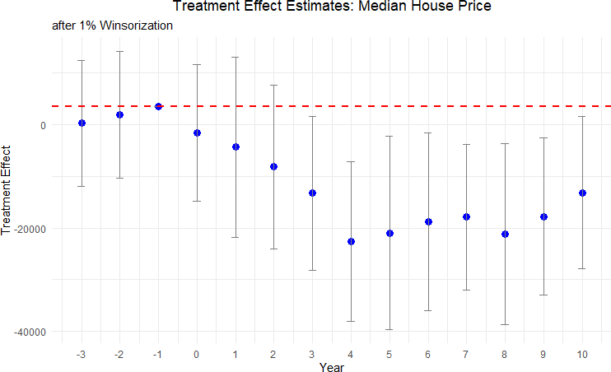

Figure 9: Effect of Cutting Road Maintenance Taxes on Median Housing Price after 1% Winsorization

The treatment effect estimates with winsorization mimic those from our baseline regres-sion results qualitatively and quantitatively.
Other Tax Levies: A potential threat to identification is that a cut in road tax levy might be correlated with cuts in other local tax levies, or may simply reveal an underlying,

time-varying taste for lower taxes or smaller government. If the same electorate simulta-neously rejects (or approves) levies for police, fire, recreation, or schools, our estimated road-maintenance effect could in fact be picking up broader changes in local public-service bundles that are themselves capitalised into housing prices. To address this concern, we examine whether the election results of a renewal road levy is systematically correlated with the results of other levy referenda held on the same ballot or within the same fiscal year i.e. whenever a road tax levy is cut, are there elections and subsequent tax cuts for other tax levies as well?
Table 9: Association of Road Tax Levy Referenda Results with Other Types of Levies

 | Police | Fire | Recreational | School
Estimate | 0.248 | 0.053 | 0.015 | -0.024
 | (0.153) | (0.043) | (0.317) | (0.092)
Notes: This table presents coefficients from regressions associating road tax levy referendum outcomes with outcomes for other types of levies (police, fire, recreational, school). Standard errors are reported in parentheses. All regression control for year and neighborhood fixed effects, as well as neighborhood characteristics. The school levy analysis is conducted at the county level, while all other analyses are at the county subdivisions level. Statistical significance levels are indicated as follows: *** p < 0.01, ** p < 0.05,
* p < 0.1.

Table 9 reports coefficients from separate regressions in which each column regresses the pass/fail outcome of another levy type on the pass/fail outcome of road tax levy¹⁶, controlling for year fixed effects, jurisdiction fixed effects, and demographic covariates. For school levies we cluster to the county level as an approximation, while all other specifications are at the township/city (“county subdivision”) level. The point estimates are small and statistically indistinguishable from zero: a failed road-maintenance renewal is neither more nor less likely to coincide with the failure of levies earmarked for police, fire, recreation, or schools. For example, the largest coefficient, 0.248 for police levies, has a standard error of 0.153 and is not significant even at the 10 percent level. These results suggest that voters treat the road-maintenance question separately from other local tax questions, and that decisions to cut or renew road funding are not simply proxies for a general anti-tax or austerity sentiment.
¹⁶This is represented by a dummy variable indicating a cut in road tax levies, with 1 as denoted as a cut
and 0 denoted as a renewal.

Consequently, our main RD estimates are unlikely to be confounded by contemporaneous changes in other public services.
A more comprehensive approach to address this concern is to check for balance in other tax levies around the cutoff. As the theory of regression discontinuity suggests, cities close to the 50% vote cutoff are as good as randomized along the cutoff. If true, there should be no difference in funding changes between the pass-levy and fail-levy groups. To confirm this, we collect all 50,000 local tax levies for all municipal purposes from 1991 to 2021, including current expense tax levies, parks and recreation, and police funding, for example. We identify the tax levies for the cities within the effective bandwidth and compare the proportion of cities that renew and fail to renew road tax levies that have other tax levies on the ballot for different purposes at the same time as the road tax levy. The pass-levy group has a non-road tax levy on the ballot 48.1% of the time, and similarly the fail-levy group has a non-road tax levy on the ballot 47.96% of the time. The two groups are balanced, as suggested by RD theory. We next focus on the set of cities within our effective bandwidth with non-road tax levies on the ballot. The cities that barely vote to renew road taxes experience a change in other taxes, either an increase in new spending or a cut in existing spending, 12% of the time. The corresponding number for the set of cities that barely votes to cut road taxes is 15%. Again, randomization near the cutoff suggests that both observable and unobservable characteristics are balanced between pass and fail road tax levy groups. Thus, the difference in house prices can be attributed to tax cuts in road maintenance funding and decreases in road quality.

Mechanisms
A key question surrounding our findings is why cutting road taxes would lead to a sustained decline in local house prices. In this section, we argue that these results are consistent with classical insights from the literature on local public finance, especially the work of Oates

(1972) and Edel and Sclar (1974). We develop a theoretical framework using Dynamic Gen-eral Equilibrium (DGE) model to explain the mechanisms behind our empirical findings. The model captures the dynamic interplay between local government budget constraints, road quality, and housing prices. Specifically, cutting road-maintenance tax levies reduces local government funds for maintaining infrastructure, which in turn constrains the government’s ability to provide road-upkeep services. These lower levels of maintenance funding result in a deterioration of road quality, which then directly and indirectly lowers housing values. For brevity, we summarize the key insights here and relegate the full model description to Appendix D. Below, we outline the three-step channel through which road tax cuts lead to lower house prices.
- Road Tax Cuts and Reduced Road Maintenance Funds. Local governments in Ohio, like those in many other U.S. states, rely on property taxes and dedicated road levies to fund local public goods. The Oates (1972) decentralization theorem highlights that local authorities can generally provide public services in a manner better aligned with resident preferences than would a higher-level government, provided they have adequate revenue sources. When a renewal levy fails at the ballot box, one of these critical revenue sources vanishes. Consistent with the premise that local road quality is a local public good, losing a dedicated revenue stream substantially weakens a city’s ability to maintain or upgrade roads. Empirically, we infer the size of the drop in maintenance funds when a maintenance levy fails to renew in Table 1.
- Decline in Road Quality. Once the road tax levy is not renewed and the budget is cut, the local government has fewer resources to maintain roads, but does it reflect in the quality of roads? We study this question and explain our method to measure road quality in Section 3.4. Results from our AI model-based road-quality measures in Section 5.1 show a marked decrease in road quality following the cut of renewal road tax levies. The resulting deterioration in road quality is primarily seen through remote sensing data, but may be experienced via ride discomfort, declining aesthetics, and reduced usability of neighborhood

roads. This is precisely what a local public goods framework would predict: fewer financial resources for upkeep reduces the quality of a local public good. In the delayed post-election windows reported in Table 4, the implied decline reaches about 16% in the first statistically significant window, with continued negative effects over the following years.
- Capitalization into House Prices. Falling road quality imposes a disamenity on local residents via reduced local infrastructure that is capitalized into house values (Oates, 1969). A couple of mechanisms help explain the ultimate discount in property values:
  - Appearance and Neighborhood Appeal. Rough roads, potholes, and poorly patched surfaces reduce aesthetic appeal of the houses in a neighborhood. Poten-tial buyers, seeing visible signs of neglect, bid less, thereby reducing the sale price of houses.
  - Travel Costs. Lower quality roads and chronic maintenance issues translate into slower commute times for residents, particularly in urban areas. This is a direct disu-tility for homeowners, as time lost in traffic takes time away from leisure or work.
Short-Run versus Long-Run Trade-Off. Importantly, a trade-off emerges over time. In the short run, residents in cities that voted against a road tax levy experience immediate relief in terms of lower property tax bills¹⁷. Their out-of-pocket expenses decline, which can be a tangible financial benefit, particularly in communities where property tax burdens were already viewed as high. However, as road quality begins to deteriorate in the delayed post-election windows reported in Table 4, the same residents eventually find themselves negatively affected by a decline in house prices. By about the fourth year after the vote, the housing market responds as shown in Table 5. This lag reflects the time it takes for infrastructure disrepair to become apparent, be it through more frequent potholes or visibly eroding surfaces. By the time these problems are evident, the city’s real-estate market has had sufficient time to register the disamenity, capitalizing it as a discount in property values. ¹⁷Table 1 reflects the relief in property tax payments for households when a road tax levy is not renewed.

This dynamic captures a fundamental insight of local public finance: the preferences of current taxpayers can diverge from the longer-term public interest (Buchanan and Tullock, 1962; Alesina and Tabellini, 1990).

Welfare Analysis
Following Hendren and Sprung-Keyser (2020) and Finkelstein and Hendren (2020), we con-duct welfare analysis to evaluate the overall impact of the road maintenance tax cuts and compute a conservative estimate of the Marginal Value of Public Funds (MVPF). We de-fine MVPF as the ratio of household’s willingness to pay (WTP) for the tax cut to the government’s net cost of providing the tax cut. Specifically, we compute MVPF as follows:

MVPF =
WTP
=
Net Cost to Government
Tax Savings - House Value Decline Direct Long Run Cost + Fiscal Externality
(4)

Where,

- Direct Long Run Cost is the tax revenue loss per household to the government due to the road maintenance tax cut over the life of the tax cut.
- Fiscal Externality is the additional loss in property tax revenue to the government due to the decline in tax base following the decline in house prices.
- Tax Savings is the overall value of tax savings from the road maintenance tax cut.

- House Value Decline is the average of the yearly capitalized loss in house values over the period of analysis.
Using this framework, we compute an MVPF of -$1.4, indicating that for every dollar of revenue loss the government, the households incur a net loss of $1.4, after accounting for both direct costs and fiscal externalities. This negative MVPF suggests that the road

maintenance tax cut leads to a net welfare loss for society, making it a welfare destroying policy. To put this in perspective, although Hendren and Sprung-Keyser (2020) do not report a sub-category for public infrastructure and focus on government spending programs instead of tax cuts, their MVPF estimates for policies targeting adults range from 0.5 to 2.

Conclusion
Most studies examine the impact of new infrastructure on housing values, particularly in developing nations (Asher and Novosad, 2020; Huang, 2016; Li et al., 2016). Recent work emphasizes the challenge of endogenous placement where new projects are correlated with unobserved growth potential (Biasi, Lafortune and Scho¨nholzer, 2025; Donaldson and Horn-beck, 2016). We circumvent this identification problem by studying the maintenance of existing infrastructure in a developed economy. This focus is particularly salient for policy-makers in the U.S. and other advanced economies, where the primary infrastructure challenge is not new construction but the preservation of a massive stock of existing assets.
By constructing a novel panel of over 3,000 renewal referendums and matching election results to local financial records and property sales, we design a quasi-experiment to estimate the causal effect of road maintenance tax cuts. We also introduce a scalable method for measuring infrastructure condition by fine-tuning an AI vision model on satellite imagery. Our results reveal that local governments failing to renew road levies face an 11% loss in maintenance funds. This fiscal shock is followed by up to about 16% lower road quality in delayed 3-year post-election windows beginning about two years after the vote and by a 9% decrease in median house prices, with housing effects emerging four years after the tax cut. Our heterogeneity analysis indicates that these effects are driven by urban areas, which see a 7.6% decline in house prices, while rural areas show inconsistent effects. We also find that higher-priced homes are more sensitive to road quality shocks, and that larger tax cuts lead to larger price declines consistent with a dose-response relationship. Using a Dynamic

General Equilibrium (DGE) framework, we rationalize these findings as a trade-off where the immediate benefit of lower taxes is eventually outweighed by the capitalization of public capital depreciation. Finally, our welfare analysis yields an MVPF of -1.4, implying a net welfare loss to the households due to the road maintenance tax cuts.
From a policy perspective, our findings underscore the hidden costs of deferred mainte-nance. While tax cuts offer short-term relief, they can trigger a vicious cycle of infrastructure decay and asset devaluation that leaves homeowners worse off. Future research could ex-tend our RD framework to other public goods funded by local levies, or other geographies. Advances in AI vision architectures open new avenues for researchers that could potentially allow real-time evaluation of road quality, and enable timely assessments of infrastructure policies and their welfare consequences.

References
Alesina, Alberto, and Guido Tabellini. 1990. “A Positive Theory of Fiscal Deficits and Government Debt.” Review of Economic Studies, 57(3): 403–414.
Asher, Sam, and Paul Novosad. 2020. “Rural roads and local economic development.” American Economic Review, 110(3): 797–823.
Asher, Sam, Teevrat Garg, and Paul Novosad. 2020. “The ecological impact of trans-portation infrastructure.” The Economic Journal, 130(629): 1173–1199.
Attoh-Okine, Nii, and Offei Adarkwa. 2013. “Pavement condition surveys–overview of current practices.” Delaware Center for Transportation, University of Delaware: Newark, DE, USA.
Beenstock, Michael, Daniel Feldman, and Daniel Felsenstein. 2016. “Hedonic pricing when housing is endogenous: The value of access to the trans-Israel highway.” Journal of Regional Science, 56(1): 134–155.
Biasi, Barbara, Julien Lafortune, and David Sch¨onholzer. 2025. “What Works and for Whom? Effectiveness and Efficiency of School Capital Investments Across the U.S.” The Quarterly Journal of Economics, qjaf013.
Boesen, Ulrik. 2021. “How Are Your State’s Roads Funded?” Accessed: 2025-01-23.
Bollinger, Christopher R, and Amitabh Chandra. 2005. “Iatrogenic specification er-ror: A cautionary tale of cleaning data.” Journal of Labor Economics, 23(2): 235–257.

Boudot-Reddy, Camille, and Andr´e Butler. 2024. “Paving the road to re-election.” Journal of Public Economics, 239: 105228.
Brasington, David M. 2002. “Edge versus center: Finding common ground in the capi-talization debate.” Journal of Urban Economics, 52(3): 524–541.
Brasington, David M. 2017. “School spending and new construction.” Regional Science and Urban Economics, 63: 76–84.
Brewer, Ethan, Jason Lin, Peter Kemper, John Hennin, and Dan Runfola. 2021. “Predicting road quality using high resolution satellite imagery: A transfer learning ap-proach.” Plos one, 16(7): e0253370.
Buchanan, James M., and Gordon Tullock. 1962. The Calculus of Consent: Logical Foundations of Constitutional Democracy. Ann Arbor:University of Michigan Press.
Calonico, Sebastian, Matias D Cattaneo, Max H Farrell, and Roc´ıo Titiunik. 2017. “rdrobust: Software for regression-discontinuity designs.” The Stata Journal, 17(2): 372–404.
Calonico, Sebastian, Matias D Cattaneo, Max H Farrell, and Roc´ıo Titiunik. 2019. “Regression discontinuity designs using covariates.” Review of Economics and Statistics, 101(3): 442–451.
Cattaneo, Matias D, Michael Jansson, and Xinwei Ma. 2020. “Simple local polyno-mial density estimators.” Journal of the American Statistical Association, 115(531): 1449–1455.
Cellini, Stephanie R, Fernando Ferreira, and Jesse Rothstein. 2010. “The value of school facility investments: Evidence from a dynamic regression discontinuity design.” The Quarterly Journal of Economics, 125(1): 215–261.
Chatterjee, Santanu, John Gibson, and Felix Rioja. 2017. “Optimal Public Debt Redux.” Journal of Economic Dynamics and Control, 83: 162–174. Originally circulated as ICePP Working Paper No. 16-13 at Georgia State University.
Chaurey, Ritam, and Duong Trung Le. 2022. “Infrastructure maintenance and rural economic activity: Evidence from India.” Journal of Public Economics, 214: 104725.
Chetty, Raj, Adam Guren, Day Manoli, and Andrea Weber. 2011. “Are Micro and Macro Labor Supply Elasticities Consistent? A Review of Evidence on the Intensive and Extensive Margins.” American Economic Review, 101(3): 471–475.
City of Hudson. 2020. “Asphalt Road Resurfacing Frequently Asked Questions (FAQ’s).” Accessed: 2025-05-19.
Cooley, Thomas F. 1995. Frontiers of business cycle research. Princeton University Press.

Currier, Lauren, Edward L Glaeser, and Gabriel E Kreindler. 2023. “Infrastructure Inequality: Who Pays the Cost of Road Roughness?” National Bureau of Economic Research Working Paper w31981.
Diao, Mi, Devon Leonard, and Tien Foo Sing. 2017. “Spatial-difference-in-differences models for impact of new mass rapid transit line on private housing values.” Regional Science and Urban Economics, 67: 64–77.
Donaldson, Dave, and Richard Hornbeck. 2016. “Railroads and American economic growth: A “market access” approach.” The Quarterly Journal of Economics, 131(2): 799–858.
Dosovitskiy, Alexey. 2020. “An image is worth 16x16 words: Transformers for image recognition at scale.” arXiv preprint arXiv:2010.11929.
Duranton, Gilles, and Matthew A Turner. 2011. “The fundamental law of road con-gestion: Evidence from US cities.” American Economic Review, 101(6): 2616–2652.
Edel, Matthew, and Elliott Sclar. 1974. “Taxes, spending, and property values: Supply adjustment in a Tiebout-Oates model.” Journal of Political Economy, 82(5): 941–954.
Finkelstein, Amy, and Nathaniel Hendren. 2020. “Welfare analysis meets causal infer-ence.” Journal of Economic Perspectives, 34(4): 146–167.
Frandsen, Brigham R., Markus Fr¨olich, and Blaise Melly. 2012. “Quantile treatment effects in the regression discontinuity design.” Journal of Econometrics, 168(2): 382–395.
Fretz, Stephan, Rapha¨el Parchet, and Fr´ed´eric Robert-Nicoud. 2022. “Highways, market access and spatial sorting.” The Economic Journal, 132(643): 1011–1036.
Gertler, Paul J, Marco Gonzalez-Navarro, Tadeja Graˇcner, and Alexander D Rothenberg. 2024. “Road maintenance and local economic development: Evidence from Indonesia’s highways.” Journal of Urban Economics, 143: 103687.
Ghani, Ejaz, Arti Grover Goswami, and William R Kerr. 2016. “Highway to success: The impact of the Golden Quadrilateral project for the location and performance of Indian manufacturing.” The Economic Journal, 126(591): 317–357.
Gibbons, Stephen, and Stephen Machin. 2005. “Valuing rail access using transport innovations.” Journal of Urban Economics, 57(1): 148–169.
Gibbons, Stephen, Teemu Lyytik¨ainen, Henry G Overman, and Rosa Sanchis-Guarner. 2019. “New road infrastructure: The effects on firms.” Journal of Urban Eco-nomics, 110: 35–50.
Gonz´alez, Felipe, Josepa Miquel-Florensa, Mounu Prem, and St´ephane Straub.
2025. “The dark side of infrastructure: Roads, repression and land in authoritarian

Paraguay.” The Economic Journal, 135(666): 653–669.
Gonzalez-Navarro, Marco, and Climent Quintana-Domeque. 2016. “Paving streets for the poor: Experimental analysis of infrastructure effects.” Review of Economics and Statistics, 98(2): 254–267.

Gonzalez-Navarro, Marcos, R David Zarate, Remi Jedwab, and Nick Tsivanidis.
2023. “Land transport infrastructure.” VoxDevLit, 9(1): 3.
Hendren, Nathaniel, and Ben Sprung-Keyser. 2020. “A unified welfare analysis of government policies.” The Quarterly Journal of Economics wasn't capitalized, 135(3): 1209–1318.
Hilber, Christian AL. 2011. “The economic implications of house price capitalization: A survey of an emerging literature.” Spatial Economics Research Centre Discussion Paper,
, (91) why is there an extra comma?.
Hoogendoorn, Sander, Jochem van Gemeren, Paul Verstraten, and Kees Folmer. 2019. “House prices and accessibility: Evidence from a quasi-experiment in transport infrastructure.” Journal of Economic Geography, 19(1): 57–87.
Hsu, Yu-Chin, and Shu Shen. 2024. “Dynamic regression discontinuity under treatment effect heterogeneity.” Quantitative Economics, 15(4): 1035–1064.
Huang, Yiping. 2016. “Understanding China’s Belt & Road initiative: motivation, frame-work and assessment.” China Economic Review, 40: 314–321.
King, Robert G, Charles I Plosser, and Sergio T Rebelo. 1988. “Production, growth and business cycles: I. The basic neoclassical model.” Journal of monetary Economics, not capitalized 21(2-3): 195–232.
Kohlhase, Janet E. 1991. “The impact of toxic waste sites on housing values.” Journal of Urban Economics, 30(1): 1–26.
Levkovich, Oleg, Jan Rouwendal, and Rolf Van Marwijk. 2016. “The effects of highway development on housing prices.” Transportation, 43(2): 379–405.
Li, Shanjun, Jun Yang, Ping Qin, and Shouyang Chonabayashi. 2016. “Wheels of fortune: Subway expansion and property values in Beijing.” Journal of Regional Science, 56(5): 792–813.
List, John A. 2022. The voltage effect: How to make good ideas great and great ideas scale.
Crown Currency.
Oates, Wallace E. 1969. “The Effects of Property Taxes and Local Public Spending on Property Values: An Empirical Study of Tax Capitalization and the Tiebout Hypothesis.” Journal of Political Economy, 77(6): 957–971.

Oates, Wallace E. 1972. Fiscal Federalism. New York:Harcourt Brace Jovanovich.
Ohio Department of Taxation. 2020. “Real Property Tax – General.” Accessed: 2025-01-30.
Ohio Department of Transportation. 2023. “2023 Annual Report.” Accessed: 2024-01-23.
Peter G. Peterson Foundation. 2024. “The Highway Trust Fund Explained.” Accessed: 2025-01-23.
Public Service Department of Beavercreek Township. 2025. “Road funding & main-tenance in Beavercreek Township, Ohio.” Personal communication, Email to Saani Rawat, January 21, 2025.
Rioja, Felix K. 2003. “Filling potholes: Macroeconomic effects of Maintenance versus New Investments in public infrastructure.” Journal of Public Economics, 87(9-10): 2281–2304.
Theisen, Theis, and Anne Wenche Emblem. 2021. “The road to higher prices: Will improved road standards lead to higher housing prices?” The Journal of Real Estate Finance and Economics, 62: 258–282.
U.S. Bureau of Labor Statistics. 2024. “Consumer Expenditures in 2023.” U.S. Bureau of Labor Statistics BLS Report. Published on BLS website.
U.S. Department of Transportation. 2022. “The Bipartisan Infrastructure Law Will Deliver for Ohio.” Accessed: 2025-01-23.
Vaswani, A. 2017. “Attention is all you need.” Advances in Neural Information Processing Systems.
Wong, Ho Lun, Yu Wang, Renfu Luo, Linxiu Zhang, and Scott Rozelle. 2017. “Local governance and the quality of local infrastructure: Evidence from village road projects in rural China.” Journal of Public Economics, 152: 119–132.
Woo, Sanghyun, Shoubhik Debnath, Ronghang Hu, Xinlei Chen, Zhuang Liu, In So Kweon, and Saining Xie. 2023. “Convnext v2: Co-designing and scaling convnets with masked autoencoders.” 16133–16142.

Appendix
- Road Tax Renewal Elections in Ohio
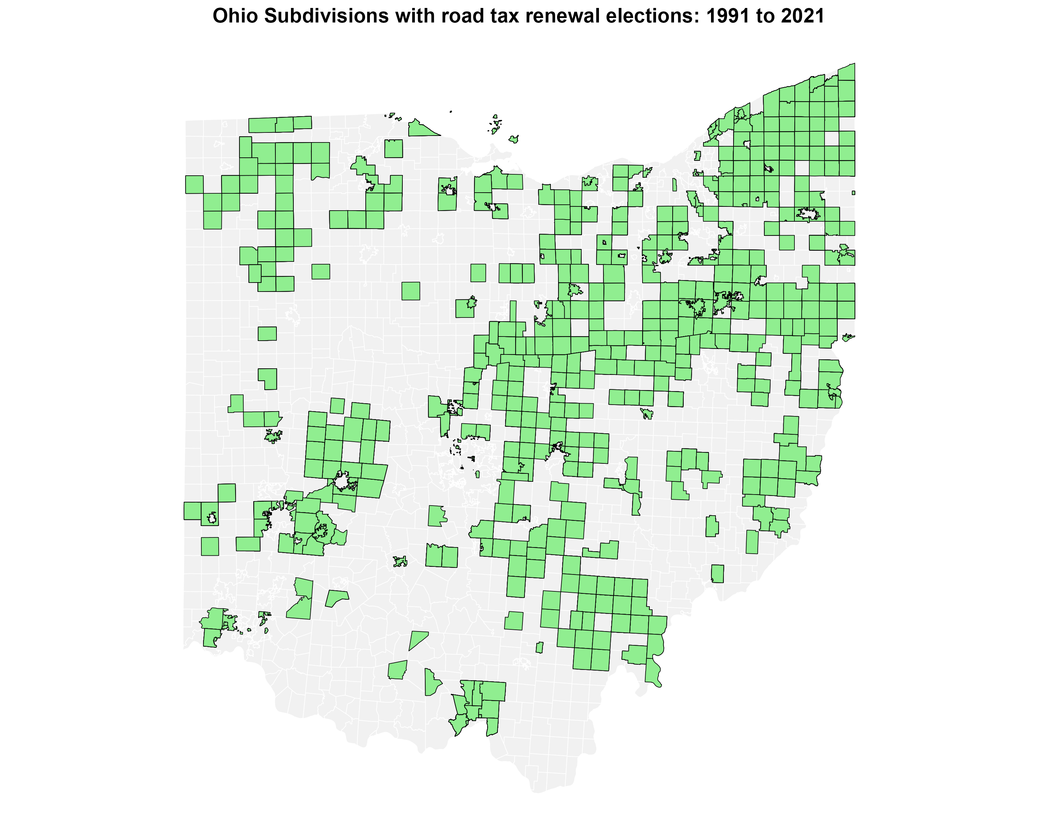
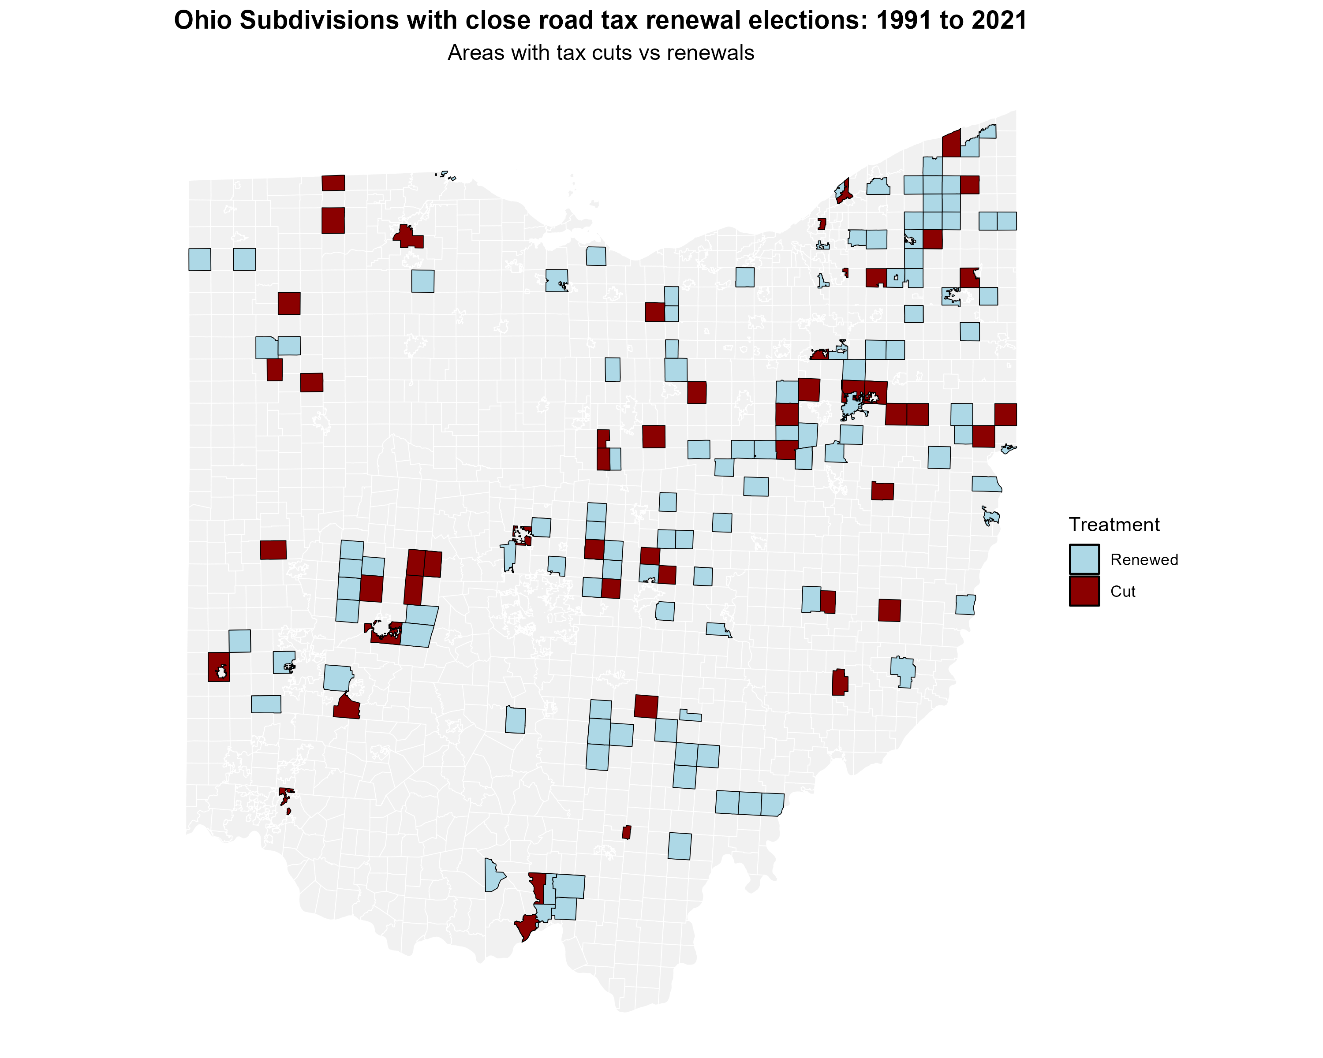

Figure 10: All Road Tax Renewal Elections in Ohio (1991-2021)
Figure 11: Close Road Tax Renewal Elec-tions in Ohio (1991-2021)

Figure 10 displays the distribution of county subdivisions in Ohio that held at least one road tax renewal election between 1991 and 2021. The map reveals that although elections are relatively dispersed, they are more common in metropolitan areas such as Cleveland, Columbus, Cincinnati, Toledo etc. For jurisdictions that held multiple elections during this period, Figure 11 focuses on the subset of elections that were decided by narrow margins, specifically those closest to the 50% approval threshold that forms the basis of our regression discontinuity analysis. These close elections provide the quasi-experimental variation we exploit to identify the causal effects of road tax levy decisions on housing prices, and we do not observe any spatial clustering of the appearance of these close elections on the ballot, as well as the results of these close elections. The geographic distribution of close elections largely mirrors that of all elections, suggesting that narrow electoral outcomes are not systematically concentrated in particular types of communities, which supports the validity of our identification strategy.

Additional Tables

Full set of Treatment Effects
Tables below present the full set of treatment effects for the results presented in our hetero-geneity analysis and robustness checks. Table 10 presents the treatment effects after applying 1% Winsorization to the data, ensuring robustness against outliers. Table 11 breaks down the treatment effects by urban and rural categories, highlighting the differential impacts on housing prices based on the urbanization level.

Table 10: Full set of estimates – Median Housing Price (after 1% Winsorization)

Year  to vote | relative | Estimate | Std. error | p-value | Confidence interval
t − 3 |  | 258 | 6,217 | 0.967 | [−11,927, 12,443]
t − 2 |  | 1,870 | 6,257 | 0.765 | [−10,393, 14,134]
t − 1 |  | 3,489 | 7,202 | 0.628 | [−10,627, 17,605]
t |  | −1,626 | 6,730 | 0.809 | [−14,818, 11,566]
t + 1 |  | −4,312 | 8,906 | 0.628 | [−21,767, 13,143]
t + 2 |  | −8,190 | 8,099 | 0.312 | [−24,063, 7,683]
t + 3 |  | −13,275∗ | 7,588 | 0.080 | [−28,146, 1,597]
t + 4 |  | −22,582∗∗∗ | 7,904 | 0.004 | [−38,074, −7,090]
t + 5 |  | −20,952∗∗ | 9,554 | 0.028 | [−39,678, −2,225]
t + 6 |  | −18,793∗∗ | 8,789 | 0.033 | [−36,020, −1,566]
t + 7 |  | −17,918∗∗ | 7,180 | 0.013 | [−31,990, −3,845]
t + 8 |  | −21,146∗∗ | 8,921 | 0.018 | [−38,631, −3,660]
t + 9 |  | −17,789∗∗ | 7,770 | 0.022 | [−33,018, −2,561]
t + 10 |  | −13,147∗ | 7,526 | 0.081 | [−27,898, 1,604]
Notes: Supplements Figure 9 in main text. This table reports the treatment-effect estimates of cutting road tax levies (relative to renewing them) from three years before to ten years after the vote. Data are winsorized at the 1% level. All regressions include the covariates listed in Table 3. The outcome is the median house price in constant 2010 U.S. dollars (city-year observations). A coefficient of −22,582 at t + 4 means that, four years after the vote, cities that cut their levies had median house prices $22,582 lower than those that renewed. Standard errors are in parentheses.

Table 11: Treatment Effects on Housing Prices by Urban vs. Rural Categories
Panel A: Urban
Year | Estimate | Std. Error | p-value | Conf. Interval
t − 3 | -2,636 | 8,066 | 0.744 | [-18,446, 13,173]
t − 2 | -9,607 | 7,310 | 0.189 | [-23,935, 4,722]
t − 1 | 1,045 | 6,496 | 0.872 | [1,045, 1,045]
t | 458 | 7,873 | 0.954 | [-14,973, 15,889]
t + 1 | -5,087 | 7,617 | 0.504 | [-20,016, 9,843]
t + 2 | -3,675 | 9,077 | 0.686 | [-21,465, 14,115]
t + 3 | -11,657 | 7,667 | 0.128 | [-26,684, 3,370]
t + 4 | -8,846 | 9,162 | 0.334 | [-26,804, 9,112]
t + 5 | -8,967 | 9,311 | 0.336 | [-27,217, 9,284]
t + 6 | -24,476∗∗∗ | 7,127 | 0.001 | [-38,446, -10,507]
t + 7 | -14,457∗ | 7,869 | 0.066 | [-29,880, 966]
t + 8 | -26,174∗∗∗ | 8,921 | 0.003 | [-43,659, -8,688]
t + 9 | -19,469∗∗ | 8,221 | 0.018 | [-35,582, -3,357]
t + 10 | -23,969∗∗ | 10,364 | 0.021 | [-44,284, -3,655]
Panel B: Rural
Year | Estimate | Std. Error | p-value | Conf. Interval
t − 3 | 6,384 | 9,962 | 0.522 | [-13,142, 25,910]
t − 2 | 1,609 | 7,758 | 0.836 | [-13,597, 16,814]
t − 1 | -835 | 8,354 | 0.920 | [-835, -835]
t | -8,727 | 9,351 | 0.351 | [-27,056, 9,601]
t + 1 | 5,731 | 7,458 | 0.442 | [-8,886, 20,349]
t + 2 | -2,970 | 7,107 | 0.676 | [-16,899, 10,960]
t + 3 | -1,866 | 6,538 | 0.775 | [-14,681, 10,949]
t + 4 | -10,505 | 8,641 | 0.224 | [-27,441, 6,431]
t + 5 | -16,897∗∗ | 7,564 | 0.026 | [-31,722, -2,072]
t + 6 | -4,561 | 6,551 | 0.486 | [-17,402, 8,280]
t + 7 | -7,632 | 8,936 | 0.393 | [-25,146, 9,882]
t + 8 | -469 | 8,063 | 0.954 | [-16,273, 15,335]
t + 9 | -11,492 | 8,383 | 0.170 | [-27,923, 4,940]
t + 10 | 1,851 | 7,790 | 0.812 | [-13,417, 17,119]
Notes: Supplements Figure 6 in text. Each panel reports separate regressions of median house price on a referendum “cut vs. maintain” indicator, broken down by Urban and Rural classifications. Columns show the year relative to the referendum vote, estimated treatment effect, standard error, p-value, and 95% confidence interval. Standard errors are robust. A negative estimate indicates lower house prices in areas that cut their road taxes relative to areas that maintain them.

Table 12: Treatment Effect on Housing Prices for Top-Quartile Tax Cuts

Year relative to vote | Estimate | Std. error | p-value | Confidence interval
t − 3 | -2,850 | 13,435 | 0.832 | [−29,183, 23,482]
t − 2 | -13,984 | 13,290 | 0.293 | [−40,032, 12,064]
t − 1 | 447 | 12,148 | 0.971 | [−23,363, 24,257]
t | -10,456 | 15,381 | 0.497 | [−40,603, 19,692]
t + 1 | -6,199 | 16,738 | 0.711 | [−39,006, 26,608]
t + 2 | -18,657 | 17,844 | 0.296 | [−53,631, 16,317]
t + 3 | -30,307 | 21,968 | 0.168 | [−73,365, 12,751]
t + 4 | -31,679∗∗ | 13,072 | 0.015 | [−57,300, −6,058]
t + 5 | -37,063 | 26,790 | 0.167 | [−89,571, 15,446]
t + 6 | -29,830∗ | 15,478 | 0.054 | [−60,167, 508]
t + 7 | -47,933∗∗∗ | 13,968 | 0.001 | [−75,310, −20,557]
t + 8 | -38,800∗∗ | 16,894 | 0.022 | [−71,913, −5,687]
t + 9 | -44,279∗∗∗ | 13,410 | 0.001 | [−70,563, −17,995]
t + 10 | -38,659∗∗ | 17,087 | 0.024 | [−72,150, −5,168]
Notes: Supplements Figure 7 in the text. Estimates compare cities that failed to renew a large (top-quartile) road maintenance tax levy with similar cities that renewed. The outcome is median house price in constant 2010 U.S. dollars; the unit of observation is the city–year. Covariates from Table 3 are included in every regression. A treatment effect of −$31,679 in year t + 4 means that four years after the vote, treated cities’ median sale prices are $31,679 lower than those of renewing cities.

Additional Robustness Tests
A key RD assumption is that observations just above and below the threshold are comparable in all aspects except for treatment status. Table 13 presents balance tests across community characteristics at the voting threshold. As shown, demographic and socioeconomic vari-ables—including population size, poverty rates, educational attainment, employment status, and racial composition—exhibit no statistically significant discontinuities at the cutoff. The absence of any discontinuity suggests that our estimated effects on housing prices represent the impact of failing to renew road tax levies rather than pre-existing community differ-ences. This balance verification via a formal RD test, using covariates as the outcome vari-able, strengthens our conclusion that the observed housing price effects stem from decisions regarding road tax levies, not from underlying differences in community characteristics.

Covariate Discontinuity Table
Table 13: Covariate Discontinuity Test Results

Variable | Estimate | Std. error | p-value | Confidence interval
Population | −388 | 1,094 | 0.722 | [−2,532, 1,755]
Poverty Rate | 0.017 | 0.014 | 0.234 | [−0.011, 0.045]
% with Kids | −0.007 | 0.012 | 0.539 | [−0.030, 0.015]
% Households with Chil- | 0.0001 | 0.007 | 0.981 | [−0.014, 0.014]
dren < 18
% Less than High School | −0.004 | 0.020 | 0.834 | [−0.043, 0.035]
Education
% Some College Education | −0.012 | 0.011 | 0.274 | [−0.034, 0.009]
% Renters | −0.005 | 0.015 | 0.754 | [−0.035, 0.025]
Unemployment Rate | −0.002 | 0.006 | 0.733 | [−0.013, 0.009]
% White | −0.007 | 0.011 | 0.499 | [−0.028, 0.014]
% Black | −0.004 | 0.009 | 0.685 | [−0.021, 0.014]
% Married | −0.013 | 0.015 | 0.374 | [−0.042, 0.016]
% Separated | 0.001 | 0.002 | 0.485 | [−0.002, 0.004]
Income Heterogeneity Index | 0.007 | 0.013 | 0.566 | [−0.018, 0.033]
Median Family Income ($) | −3,147 | 2,963 | 0.288 | [−8,953, 2,660]
% Under 5 Years Old | −0.006 | 0.004 | 0.126 | [−0.013, 0.002]
% Aged 5 to 17 | −0.007 | 0.007 | 0.284 | [−0.021, 0.006]
% Aged 18 to 64 | 0.004 | 0.008 | 0.611 | [−0.012, 0.021]
% Racial Minority | 0.007 | 0.011 | 0.499 | [−0.014, 0.028]
Notes: Each row reports the estimated discontinuity at the levy-approval cutoff for the specified covariate, using robust local-linear RD with the mean effective bandwidth. Confidence intervals are 95%.

Covariate Discontinuity Plots

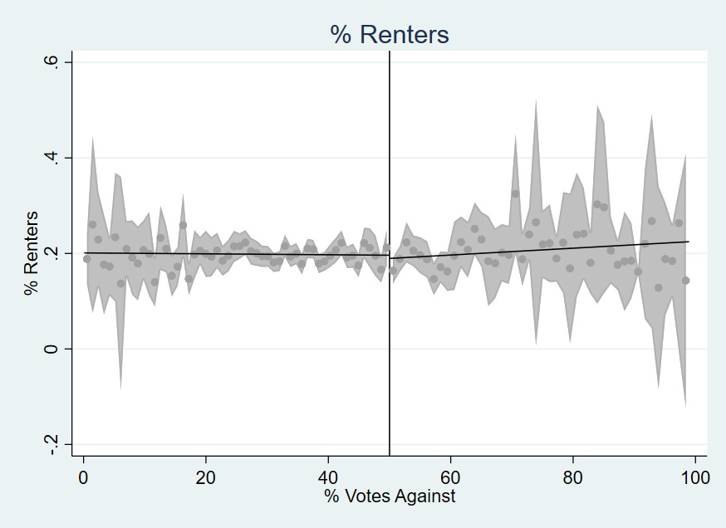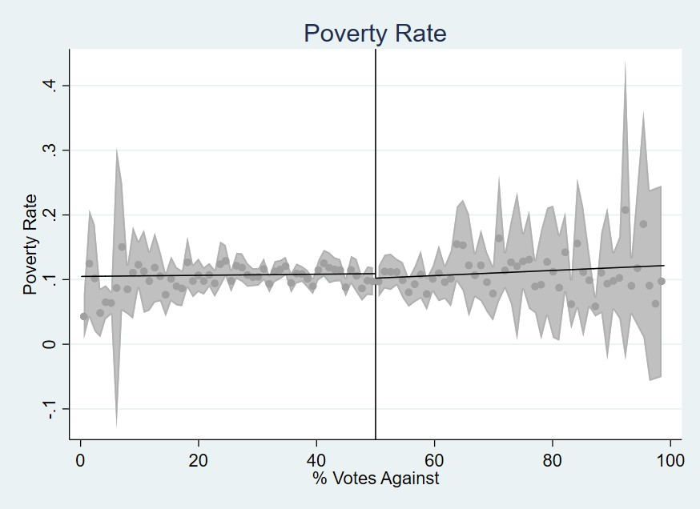
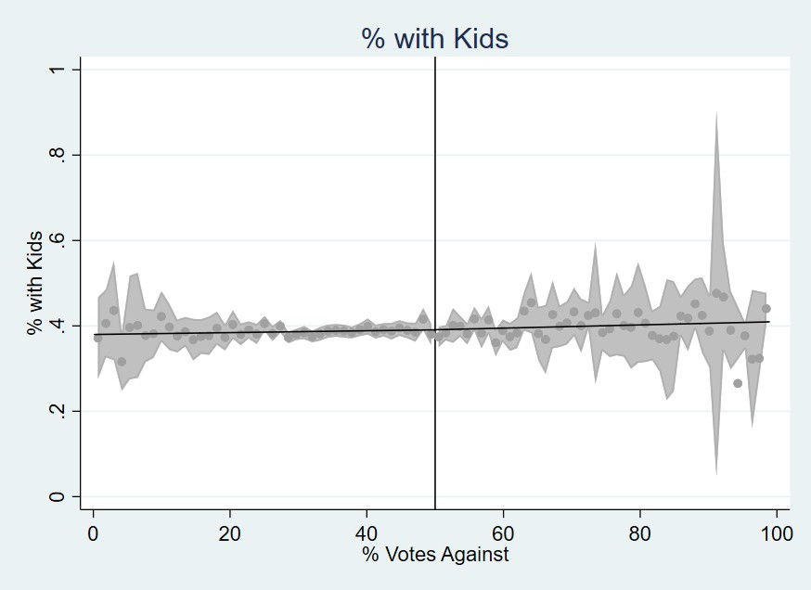
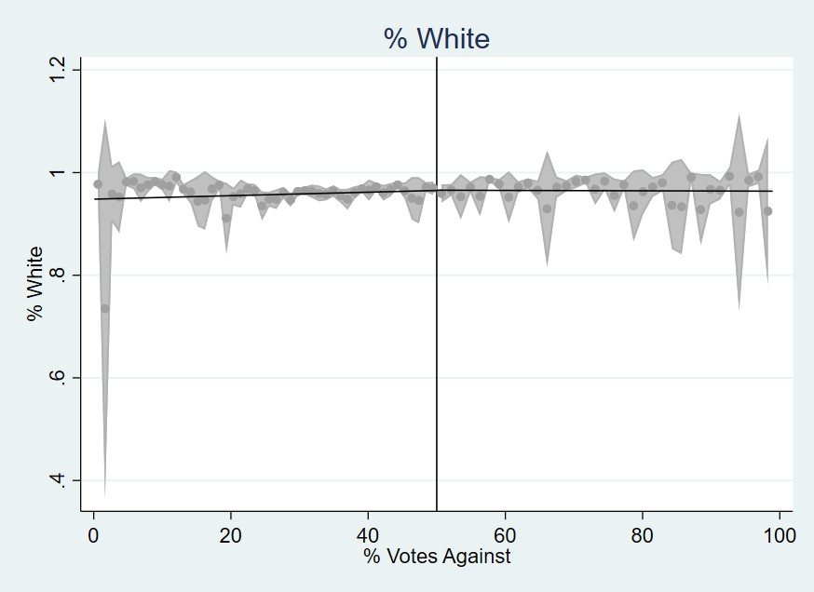
% Renters Poverty Rate
% With Kids % White
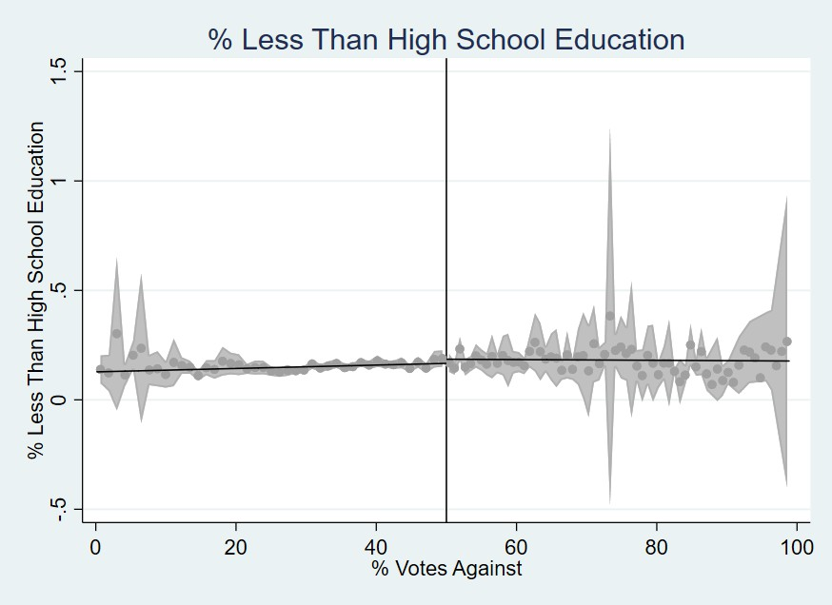
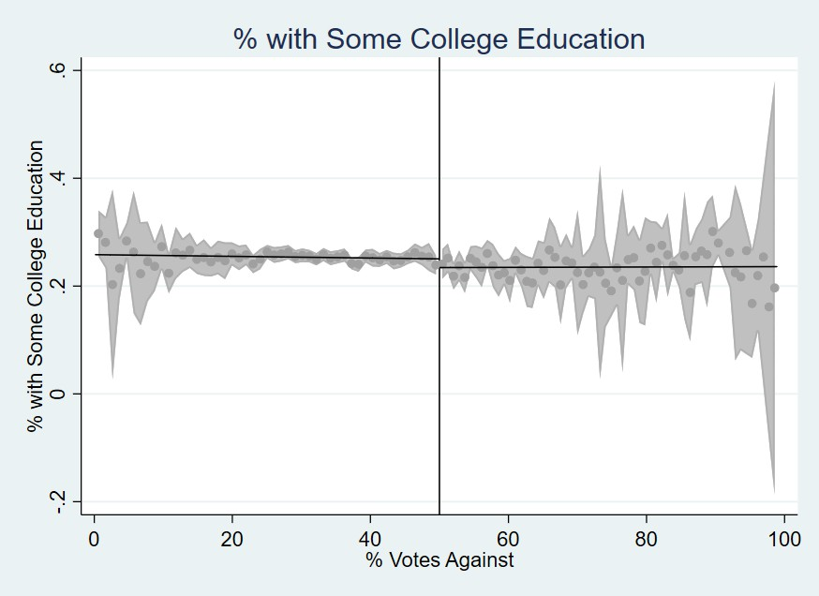
% with Less than High School edu-
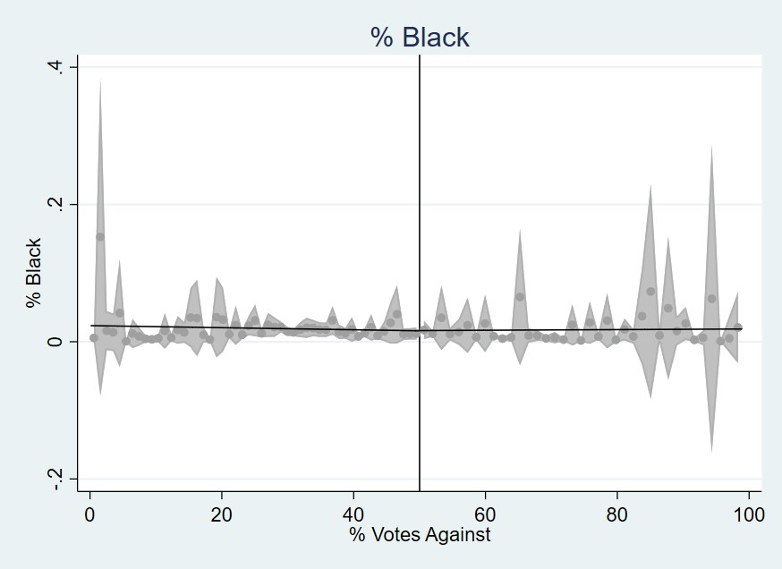
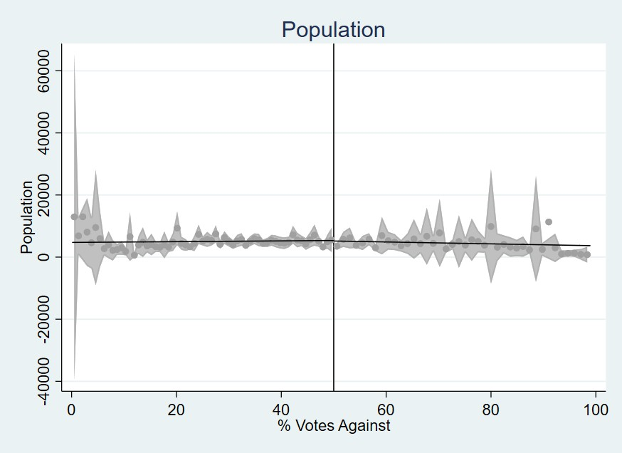
cation % Attended Some College
% Black Population
Figure 12: Covariate Di5s6continuity Plots - Part 1

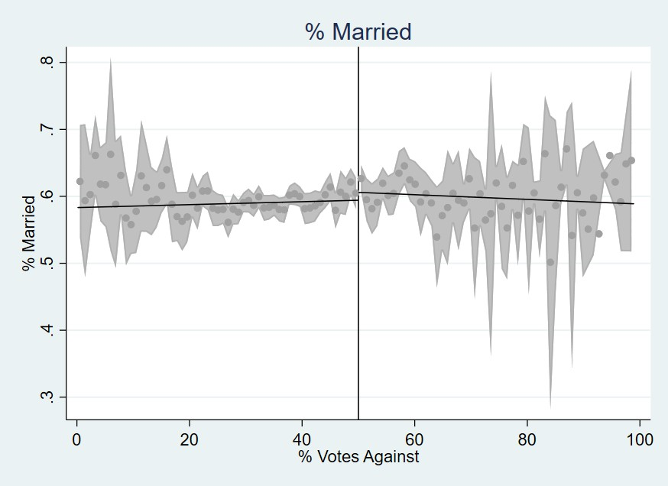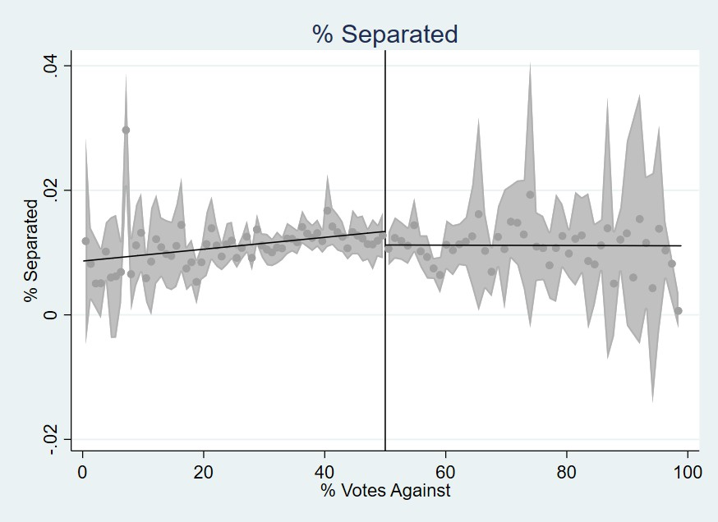
% Married % Separated
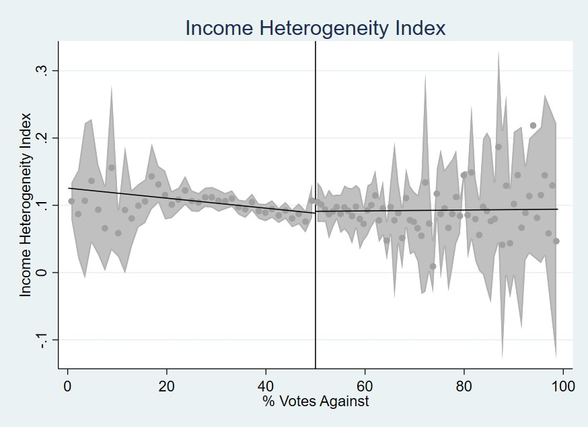
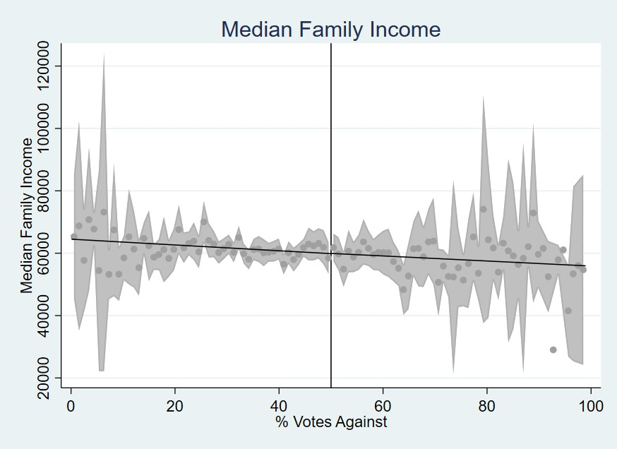
Income Heterogeneity Index Median Family Income
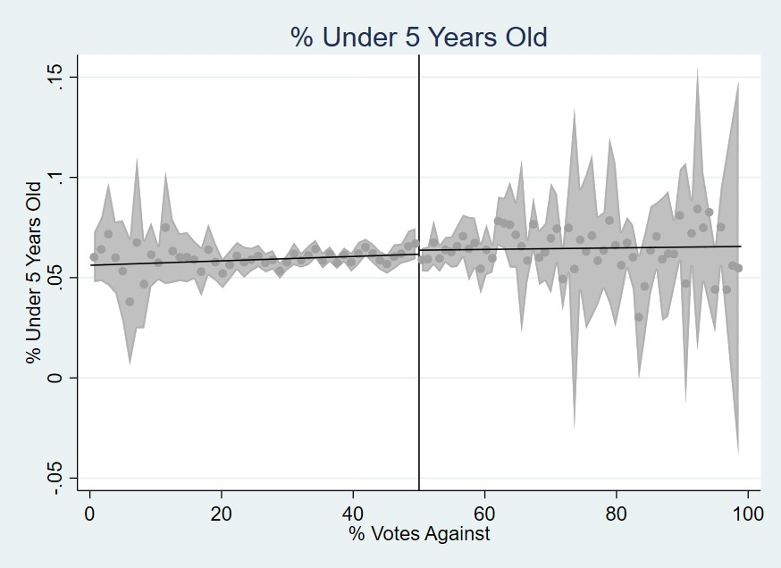
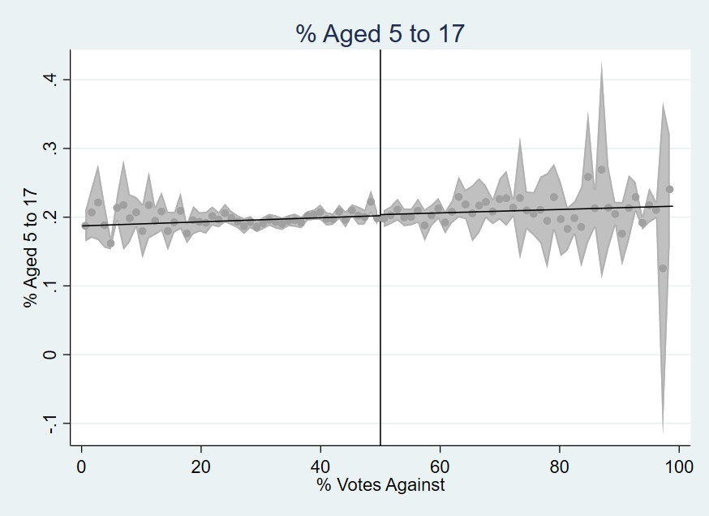
% Less than 5 years old % between 5 to 17 years
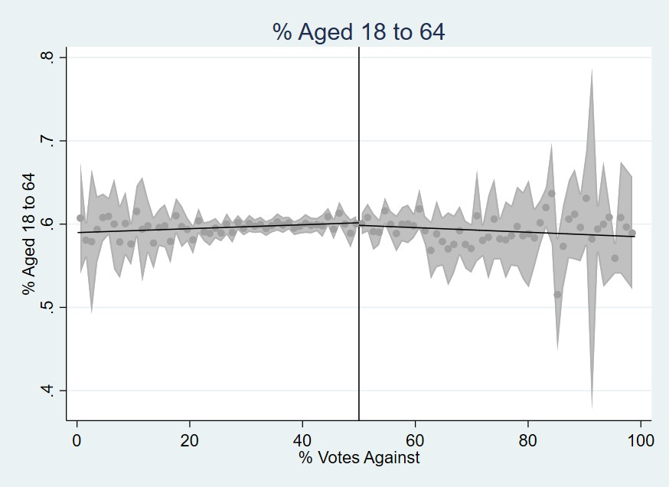
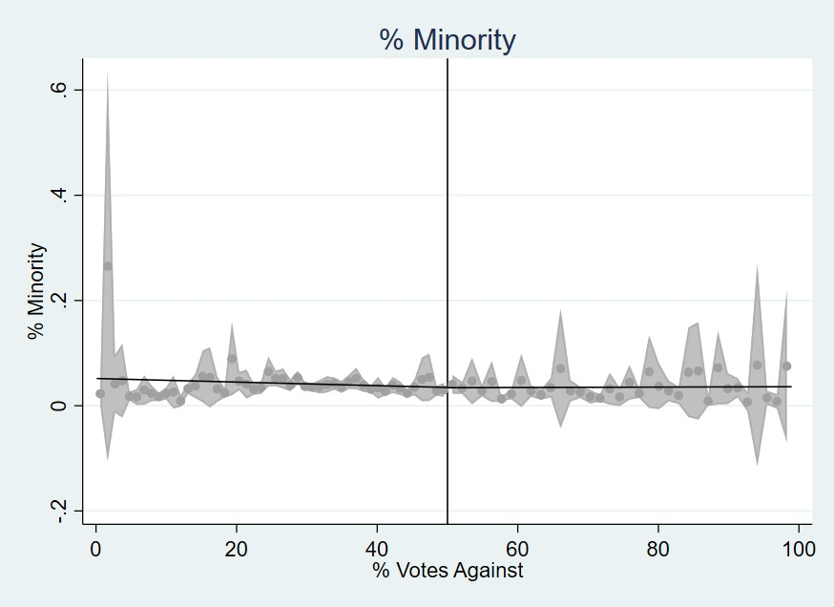

% between 18 to 64 years
57 % Minority

Figure 13: Covariate Discontinuity Plots - Part 2

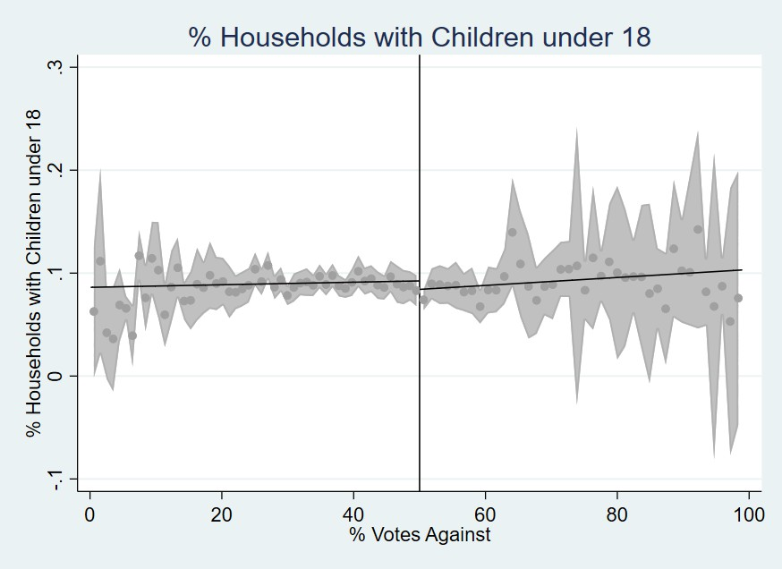

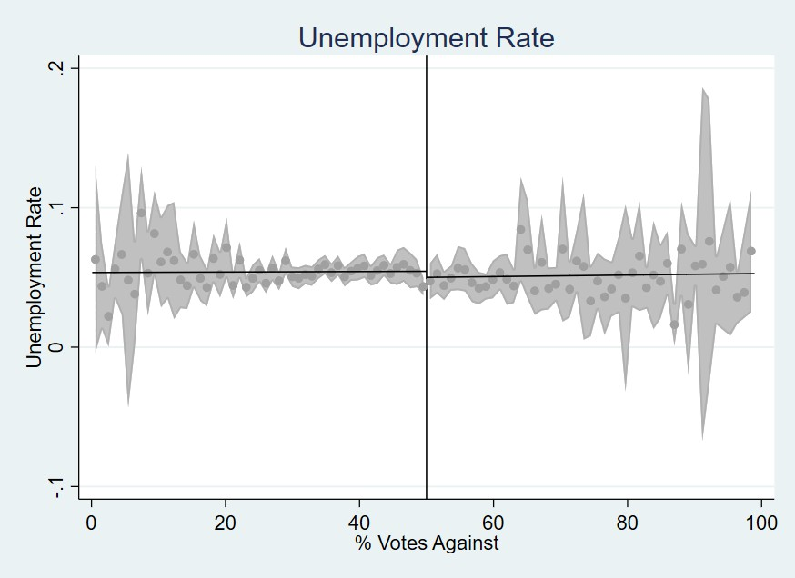
Unemployment Rate
% Households with Children 18 years old or less

Figure 14: Covariate Discontinuity Plots - Part 3

Hedonic Balance Check

Table 14: Hedonic Balance: Full Sample vs. Close to Cutoff

Full Sample Close to Cutoff

 | Treated | Control |  | Treated | Control
Universal building square feet | 1800 | 1940 |  | 1762 | 1907
 | (794) | (874) |  | (740) | (878)
Acres | 1.5 | 1.6 |  | 1.6 | 1.6
 | (5.5) | (5.8) |  | (6.2) | (5.0)
Total rooms | 6.4 | 6.6 |  | 6.4 | 6.5
 | (2.5) | (1.7) |  | (3.3) | (1.7)
Total baths | 2.1 | 2.3 |  | 2.1 | 2.2
 | (1.0) | (1.0) |  | (1.1) | (1.0)
Age of house | 39 | 38 |  | 40 | 37
 | (33) | (32) |  | (33) | (32)
Air Conditioning | 0.91 | 0.92 |  | 0.90 | 0.91
 | (0.28) | (0.27) |  | (0.30) | (0.28)
Condition: Excellent | 0.02 | 0.02 |  | 0.03 | 0.02
 | (0.15) | (0.13) |  | (0.16) | (0.13)
Condition: Good | 0.37 | 0.34 |  | 0.37 | 0.31
 | (0.48) | (0.47) |  | (0.48) | (0.46)
Condition: Fair | 0.06 | 0.06 |  | 0.05 | 0.06
 | (0.23) | (0.24) |  | (0.22) | (0.24)
Condition: Poor | 0.01 | 0.01 |  | 0.01 | 0.01
 | (0.11) | (0.10) |  | (0.10) | (0.11)
One-story | 0.56 | 0.52 |  | 0.52 | 0.53
 | (0.50) | (0.50) |  | (0.50) | (0.50)
Notes: This table compares hedonic characteristics of houses in treated and control areas for the full sample and for the subsample close to the cutoff (within 40-60% votes against). Standard deviations are in parentheses. Hedonic characteristics include house size (in square feet), lot size (in acres), number of rooms, number of bathrooms, age of house (in years), presence of air conditioning, condition of house (excellent, very good, good, fair, poor), and an indicator variable for whether the house is one-story.

We examine whether housing characteristics are balanced across the treatment threshold. Table 14 compares hedonic features—building square footage, lot size, rooms, bathrooms, age, air conditioning, condition ratings, and architectural style—between treated (failed renewals) and control (successful renewals) jurisdictions. The results demonstrate balance both in the full sample and the subsample of close elections. The similarity in characteristics near the threshold supports the continuity assumption underlying our identification and validates using narrow election outcomes as quasi-random treatment assignment.

Bandwidth Sensitivity Analysis
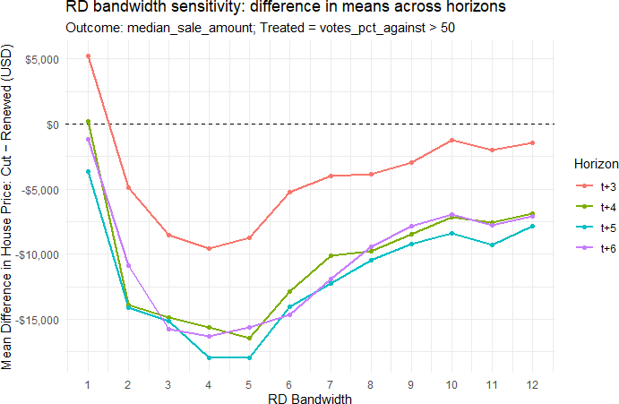
Figure 15: Bandwidth Sensitivity Analysis

Figure 15 plots the differences in mean estimate of the outcome variable, median house prices, between treated and control groups across a grid of bandwidth choices to observe how sensitive the estimates are to the choice of bandwidth. Estimates are consistently negative starting year t+4 and of comparable magnitude over a broad interval around the MSERD optimal bandwidth used in the main analysis. The relative flatness of the curve near the optimal bandwidth indicates that our main result is not driven by a finely tuned bandwidth choice.

Road Quality RD Bandwidth Sensitivity

Table 15: Bandwidth Sensitivity for the Main Stacked-Event Change RD

Multiplier | Bandwidth (h) | RD estimate | Robust SE | p-value | Eff. Obs (L/R)
0.5h | 3.81 | -0.002 | (0.293) | 0.180 | 37 / 18
0.75h | 5.72 | -0.129 | (0.238) | 0.627 | 64 / 26
1h | 7.63 | -0.137 | (0.204) | 0.638 | 100 / 36
1.25h | 9.54 | -0.111 | (0.188) | 0.421 | 140 / 40
1.5h | 11.44 | -0.106 | (0.179) | 0.449 | 172 / 45
Notes: The outcome is the main pooled standardized change in predicted road quality. All specifications use the main stacked-event sample and fixed bandwidths equal to the reported multiple of the MSE-optimal bandwidth.
Should h be capitalized in the "multiplier" column?
Table 15 reports bandwidth sensitivity for the main pooled standardized stacked-event change RD. The point estimates remain negative across the reported bandwidth grid, but the estimates are imprecise and the confidence intervals include zero at each bandwidth. This pattern suggests directional stability in the pooled change specification, while the delayed NAIP-based results reported in Table 4 provide the clearest evidence on post-election road quality declines.
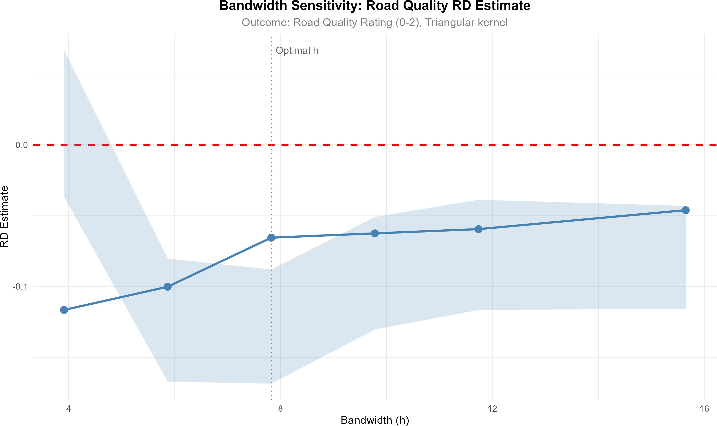
Figure 16: Bandwidth Sensitivity: Road Quality RD Estimate

Figure 16 visualizes the bandwidth sensitivity analysis for the main pooled road-quality RD. The point estimate (solid line) and 95% robust confidence interval (shaded region) are shown for each bandwidth. The dashed red line marks zero, and the dotted vertical line indicates the MSE-optimal bandwidth. The figure shows that the point estimates remain negative, although the confidence intervals overlap zero throughout the reported bandwidth range.

A Dynamic General Equilibrium Model of Roads

Representative Household
The economy is populated by a representative, infinitely–lived household that maximizes utility over consumption¹⁸, housing services, and local amenities while disliking labor (in-cluding commuting time). In its most general form, the household’s problem is to choose
sequences of consumption {c_{t}}∞ , housing stock {h_{t+1}}∞ , private capital {K_{t+1}}∞ , and
t=0
t=0
t=0
labor supply {n_{t}}∞ to maximize lifetime utility:
t=0

max
{c_{t},h_{t},n_{t},K_{t+1},h_{t+1}}∞
Σ β^{t} u˜ c_{t}, h_{t}, n_{t}, G_{t} , 0 < β < 1, (5)

t=0 t=0
∞
We consider the following utility function,
u˜ c , h , n , G = c h^{α}hA(Gt) exph− κ n [1 + ϕ(G )] 1+θ i (6)
t
t
t
t
t
t
1 + θ
t
t
where c_{t} denotes non–housing consumption, h_{t} the flow of housing services, and A(G_{t}) the amenity derived from the public capital stock G_{t}, which represents the quality of local public goods.
After taking logs, we can write the utility function as a convenient separable specification
u c , h , n , G = ln c + α A(G ) ln h − κ hn 1 + ϕ(G ) i1+θ, (7)
t
t
t
t
t
h
t
t
1 + θ
t
t
with n_{t} hours of work¹⁹, ϕ(G_{t}) ≥ 0 a commuting factor that rises as road quality falls, κ > 0, and θ > 0 is the inverse Frisch elasticity of labor supply i.e. ¹ is the Frisch elasticity of labor supply with respect to real wages. The parameter α_{h} captures the household’s preference for housing services, and A(G_{t}) is a function that captures how public infrastructure quality (e.g., roads) affects the utility derived from housing. The term ϕ(G_{t}) captures the disutility
θ
of commuting, which increases as road quality deteriorates.

Budget Constraint and Capital/Housing Accumulation:
Let w_{t} be the real wage, r_{t} the rental rate on private capital K_{t}, p_{h,t} the pre–tax purchase price of one unit of housing stock, τ_{L} the labor–income tax rate, and τ_{h} the property-tax rate levied on the value of the housing stock. The household’s per-period budget can be written in the following way:

c_{t} + i_{t} + p_{h,t} x_{t} = (1 − τ_{L})w_{t}n_{t} + r_{t}K_{t} − τ_{h} p_{h,t} h_{t}
propert`y ta˛x¸on hxoldings

(8)

¹⁸Since we don’t have any random variables or distributions, we are not dealing with any expectations or expected utility.
¹⁹We model labor disutility using standard isoelastic form, as used in King, Plosser and Rebelo (1988) and Chetty et al. (2011).

where x_{t} is net housing investment and i_{t} is private–capital investment. The capital and housing asset laws of motion are

K_{t+1} = (1 − δ_{K})K_{t} + i_{t}, | δ_{K} ∈ (0, 1), | (9)
h_{t+1} = (1 − δ_{h})h_{t} + x_{t}, | δ_{h} ∈ (0, 1). | (10)
Equivalently, we can substitute out i_{t} and x_{t} to rewrite the budget constraint as,

c_{t} + K_{t+1} − (1 − δ_{K})K_{t} + p_{h,t}[h_{t+1} − (1 − δ_{h})h_{t}] = (1 − τ_{L})w_{t}n_{t} + r_{t}K_{t} − τ_{h}p_{h,t}h_{t} (11)

Optimality Conditions:
Maximization of (7) subject to (8)–(11) yields:
- Consumption–Saving Euler Equation: The household equalizes the marginal util-ity of consuming an additional unit today to the discounted utility of saving it until tomorrow. This yields:

U (c , h , A(G )) = βU (c
c
t
t
t
c
t+1
, h , A(G
)) (1 − τ )w
∂nt+1 + r
t+1
+ 1 − δ
. (12)

which simplifies (under certainty and taking labor choices as separate) to

t+1
t+1
L
t+1 ∂K
t+1
K
U_{c}(c_{t}, ·) = βU_{c}(c_{t+1}, ·) 1 + r_{t+1} − δ_{K} (13)
In other words, the marginal rate of intertemporal substitution equals the (1+net discounted return o factor. This is the standard Euler equation ensuring optimal capital accumulation.

Moreover, given that U_{c} = ¹
ct
from our utility specification, we have

1 1
c
= β 1 + r ct t+1

t+1
— δ_{K}
; (14)

- Labor–leisure trade–off: The household chooses labor n_{t} such that the marginal disutility of working (including commuting) equals the after-tax marginal benefit of earning wages. Formally,

−U_{n}(c_{t}, h_{t}, A(G_{t})) = (1 − τ_{L})w_{t}U_{c}(c_{t}, h_{t}, A(G_{t})) (15)
where U_{n} is the partial derivative of utility with respect to labor (negative due to disutility) and U_{c} is the partial derivative with respect to consumption. Using our utility form, we get

U = −κ n (1 + ϕ(G θ
n
t
_{t}))

ϕ(G )), U
(1 +
t
1
= . (16)
c
c
t

Thus, the labor optimality condition 15 becomes:
κ n (1 + ϕ(G θ ϕ(G )) = (1 − τL)wt . (17)
t
t
_{t}))
(1 +
t
c

κ 1 + ϕ(G ) 1+θn^{θ} = (1 − τL)wt ; (18)
t
t
t
c
" (1 − τ ) w #1/θ
t 1+θ
n
=
L
t
(19)
κc_{t} 1 + ϕ(G )
t
Intuitively, the marginal rate of substitution between leisure (or time) and consumption equals the real after-tax wage. An increase in commuting factor ϕ(G_{t}) (worse roads) raises the left-hand side (effective disutility of labor), leading the household to supply less labor for a given wage. This aligns with the idea that poor road quality reduces effective labor supply as households require higher compensation to work the same hours because commuting erodes their usable time.
- Euler equation for Housing: From our utility function, we have u_{c,t} = 1/c_{t} and u_{h,t} = α_{h}A(G_{t})/H_{t}. The FOC with respect to H_{t+1} gives
ph,t uc,t = βhuh,t+1 + uc,t+1 (1 − δh − τh) ph,t+1i, (20) or, in consumption units,
h
i

ph,t
= β ct (1 − δ
ct+1
h
— τ_{h}
) ph,t+1
+ α_{h}
A(G

t+1
) ct+1 (21)
Ht+1

ph,t
= βh(1 − δ_{h}
— τ_{h}
c_{t}
) p
ct+1

h,t+1

+ α_{h}

A(G

t+1

(τ_{h}
)) ct . (22)
Ht+1
i

The equation 22 encapsulates how the current price of housing p_{h,t} reflects the dis-counted value of future benefits from owning housing and the benefits associated with holding it. The bracketed terms are, respectively, the after–tax, after–depreciation resale value next period and the service dividend (marginal value of one more unit of housing services) next period. The first term inside the brackets represents the discounted future resale value of the housing asset after accounting for depreciation and property taxes. The second term captures the flow of housing services (ameni-ties) derived from owning the house, adjusted for the quality of public infrastructure A(G_{t+1}(τ_{h})) and scaled by consumption per unit of housing stock. Notice that the amenity value A(G_{t+1}(τ_{h})) depends on the future road quality, which in turn is influ-enced by the current property tax τ_{h} through its effect on maintenance spending, as explained in subsequent subsections. A cut in τ_{h} today leads to lower maintenance M_{t}, causing G_{t+1} to decline over time, which reduces A(G_{t+1}(τ_{h})) and thus lowers the

service dividend from housing. This mechanism captures how changes in public infras-tructure quality, driven by tax policy, affect housing prices through their impact on the flow of housing services.

Representative Firm
A competitive firm produces output Y_{t} with Cobb–Douglas technology
Y_{t} = K^{α}k (A_{t}L_{t})^{1−α}k , 0 < α_{k} < 1, (23) enforcing factor–price equalization
t

w_{t} = (1 − α_{k}
) Yt , r = α L_{t}
Yt . (24)
t
K
k

Profit Maximization. The firm operates in a competitive market for inputs and output, so it hires labor and rents capital until factor prices equal their marginal products. In each period, the firm solves
}
t
max F (K_{t}, L_{t}) − w_{t}L_{t} − r_{t}K_{t} , (25)
Kt,Lt
taking wage w_{t} and capital rental r_{t} as given. The first-order conditions are:

Labor demand:
w = (1 − α )K^{α}k (A L )^{−α}k = (1 − α ) Yt . (26)
k
t k t t t
L
t
This is the usual result that the real wage equals the marginal product of labor (MP_{L}).

Capital demand:
r = α K^{α}k −1(A L )^{1−α}k = α Yt . (27)
k
t k t t t
K
t
Thus, the rental rate on capital equals the marginal product of capital (MP_{K}).
Under constant returns and competitive markets, the firm earns zero economic profit in equilibrium (all output is paid out to factors). This means
Y_{t} = w_{t}L_{t} + r_{t}K_{t} (28)
in equilibrium. Because poor local roads can indirectly reduce effective labor supplied (house-holds may choose smaller L_{t}) or even the productivity of labor (if A_{t} were to depend on G_{t}), the equilibrium wage and output will adjust accordingly. In our model, we focus on the household-side mechanism; we do not explicitly insert G_{t} into F (·) so A_{t} is treated as exoge-nous, but one could imagine an extension where A_{t} = A(G_{t}) similar to household amenities function, making public infrastructure a productive externality that boosts TFP. That would
reinforce the mechanism: a decline in G_{t} would lower productivity and thus lower wages from the firm side as well. For now, wages change endogenously mainly due to labor supply shifts in the simple model.

Government and Public Infrastructure
Taxation and Spending. The government collects taxes and uses the revenue to finance road maintenance. Taxes have two components: an exogenous property tax τ_{h} (subject to voter approval) and an endogenous tax (such as τ_{L} on labor income, or potentially a lump-sum tax) that provides additional revenue. Denote by T ^{exo} the exogenous tax revenue from
t
the voted levy, and T ^{endo} the endogenous tax revenue from other sources. For example,
t
if τ_{L} is a labor tax, then T ^{endo} = τ_{L}w_{t}n_{t}, which varies with the economy and is therefore
t
“endogenous”. The property tax revenue is T ^{exo} = τ_{h}p_{h,t}h_{t} each period, directly tied to the
t
housing market outcome.
The government budget constraint is:
T ^{endo} + T ^{exo} = M_{t}, (29)
t t
assuming all tax revenue is spent on road maintenance M_{t}. We abstract from any other government consumption or transfers.
In a scenario where the road tax is cut (e.g., τ_{h} drops to zero after a failed levy vote), T ^{exo} falls exogenously. For a balanced budget, maintenance spending M_{t} must be reduced by an equal amount. This captures the immediate fiscal impact of the tax cut, such as an observed 11% loss in road maintenance funding empirically.
t
Public Capital (Roads) Accumulation. The stock of public road infrastructure G_{t} evolves over time depending on maintenance. We adopt a law of motion in line with Rioja (2003) to formalize how insufficient maintenance leads to infrastructure depreciation, whereas sufficient maintenance can maintain road quality²⁰. Let δ_{G} be the “normal” depreciation rate of roads (wear-and-tear if adequately maintained). Actual effective depreciation δ_{G,t} can exceed δ_{G} if maintenance is below the requirement. A convenient formulation is:

where
G_{t+1} = G_{t}(1 − δ_{G,t}), (30)
δ = φ · maxn0, 1 − Mt ,. (31)
G
G,t
δ
ψ
t
G

In words, if maintenance spending M_{t} falls short of the amount needed to cover normal depreciation (δ_{G}G_{t}), the depreciation rate increases proportionally to the shortfall. The parameter φ ≥ 0 governs how sensitive the infrastructure is to under-maintenance. For ex-

ample, if M_{t} is only half of δ_{G}G_{t}, then 1 − ^{M}t
δ Gt
G
= 0.5, and δ_{G,t} = 0.5φ; this means roads

wear out. If M_{t} is zero (no upkeep), depreciation could jump substantially (if φ is large, G_{t}
may deteriorate very quickly). On the other hand, if M_{t} is at least δ_{G}G_{t} (maintenance fully covers yearly wear), then δ_{G,t} = 0 (no deterioration). We also assume δ_{G,t} cannot go be-low 0 even if M_{t} exceeds δ_{G}G_{t} (any extra maintenance beyond replacing depreciation might marginally improve roads but with diminishing returns). This Riojas-style law of motion captures the intuition that lack of maintenance shortens the life of existing public capi-

²⁰In this setup, roads can only be maintained, not improved.

tal. Maintenance spending effectively slows down depreciation, preserving the infrastructure stock; cutting maintenance causes G_{t} to decline faster over time. Importantly, a reduction in the road tax τ_{h} translates to lower M_{t} and thus a gradual decline in G_{t} over several peri-ods. The deterioration in road quality will typically become noticeable after a few periods of under-maintenance, consistent with evidence that the negative effects on road conditions (and subsequently house prices) emerge with a lag. In our model, that lag is endogenously determined by the above law of motion – if M_{t} drops at t = 0, G_{t} will depreciate a bit faster each period, compounding into a significant drop in infrastructure quality after some years.

Housing Market
Housing is a tradable asset in fixed aggregate supply h¯21. With a representative household, market clearing is
h_{t} = H¯ for all t. (32)
Given (32), the price p_{h,t} is determined by the housing Euler (21) and the paths of {c_{t}, G_{t}}.
In steady state, substituting c_{t+1} = c_{t} = c, h_{t+1} = h_{t} = h = H¯ , G_{t+1} = G_{t} = G, p_{h,t+1} = p_{h,t} = p_{h} into (21) yields the user–cost formula:

p_{h} =
β
1 − β(1 − δ_{h}

— τ_{h}
c
)α_{h} A(G) h. (33)

Better roads i.e. higher A(G) higher raise p_{h}. Larger h reduces marginal service value (log utility), lowering p_{h} ceteris paribus.
The steady-state housing price formula in equation (33) reveals how the discount factor β interacts with depreciation δ_{h} and property taxes τ_{h} to determine asset valuation. The

β
term
1−β(1−δ_{h}−τ_{h})
represents the present value multiplier that converts the flow of housing

services into an asset price.
To understand this multiplier, consider that 1−δ_{h} −τ_{h} represents the net retention rate of housing value after accounting for physical depreciation and tax obligations. The household effectively loses fraction δ_{h} + τ_{h} of the housing asset’s value each period through wear and tax payments. The remaining fraction 1 − δ_{h} − τ_{h} carries forward to the next period, where it generates both service flows and continuation value.
The economic intuition is clear: higher property taxes τ_{h} reduce the net retention rate, making housing a less attractive store of value and lowering equilibrium prices. A patient household (high β) values future service flows more highly, increasing the multiplier and thus housing prices. Conversely, rapid depreciation δ_{h} erodes the asset’s continuation value, reducing prices through the same channel.
This formulation also shows why property tax cuts can have ambiguous effects on housing prices in our model. While lower τ_{h} directly increases the multiplier and boosts prices, it also reduces maintenance funding, leading to infrastructure decay that lowers the service flow α_{h}A(G). The net effect depends on the relative magnitudes of these opposing forces and their timing.

²¹This means that the total quantity of housing is constant over time, and any changes in demand will only affect prices. We can also allow extensions to the model that incorporate changes in housing supply.

Competitive Equilibrium
We now define a recursive competitive equilibrium for this economy. Given an initial private capital stock K₀ and initial public capital (road quality) G₀, and a sequence of exogenous tax policy {τ_{h,t}} (with a drop in τ_{h} at the time of the tax cut shock), a competitive equilibrium is
a sequence of allocations {c_{t}, h_{t+1}, n_{t}, K_{t+1}, M_{t}, G_{t}}_{t≥0} and prices {w_{t}, r_{t}, p_{h,t}}_{t≥0} such that:
- Household Optimization: Given prices and taxes, the representative household chooses {c_{t}, h_{t+1}, n_{t}, K_{t+1}} to maximize its utility subject to its budget and accumula-tion constraints. The household’s choice satisfies the first-order optimality conditions described above (Consumption and housing Euler equations, labor supply condition, and housing demand condition, etc.), and the transversality condition on capital hold-ing.
- Firm Optimization: The representative firm chooses inputs {K_{t}, L_{t}} each period to maximize profit. In equilibrium, L_{t} = n_{t} (labor market clears) and K_{t} = K_{t} held by the household (capital market clears), and the wage and rental rates satisfy w_{t} = F_{L}(K_{t}, L_{t}) and r_{t} = F_{K}(K_{t}, L_{t}) as given by the Cobb-Douglas marginal products. This ensures the firm’s first-order conditions are met and profit is zero.
- Government Budget and Public Capital: The government budget constraint holds each period: T ^{endo} + T ^{exo} = M_{t}, with T ^{exo} = τ_{h,t}p_{h,t}h_{t} and T ^{endo} = τ_{L}w_{t}n_{t}. The
t t t t
road maintenance M_{t} feeds into the law of motion for G_{t}: given G_{t} at the start of period t, the next period’s public capital G_{t+1} is determined by G_{t+1} = G_{t}(1 − δ_{G,t}) with δ_{G,t} increasing if M_{t} is insufficient (as specified above). The government sets M_{t}
according to the available tax revenue each period.
- Market Clearing: All markets clear in equilibrium:
  - Goods market: Output is used for private consumption, private investment, and public maintenance. The resource constraint each period is:
Y_{t} = c_{t} + i_{t} + M_{t}. (34)
Total output Y_{t} produced by the firm equals the sum of household consumption c_{t}, private investment i_{t}, and government demand for road maintenance M_{t}.
  - Labor market: L_{t} = n_{t}. The labor supplied by the household equals labor demanded by the firm. The real wage adjusts such that this holds.
  - Capital market: The firm’s capital input equals the household’s capital stock: K_{t} (used in production) = K_{t} (owned by household). The rental rate r_{t} adjusts to clear this market.

  - Housing market: h_{t} =
H¯ . The total housing demanded by the household

equals the fixed housing stock. The house price p_{h,t} adjusts each period to clear the housing market.
- Consistency: The expectations of the household are consistent with realized out-comes. In a deterministic steady-state scenario, this means the household correctly

anticipates the path of prices and G_{t}. In a perfect-foresight or rational expectations equilibrium, the household foresees that a cut in τ_{h} implies lower future M_{t} and thus a gradually declining G_{t}, factoring this into its decisions. The sequence {p_{h,t}} reflects the present value of housing services given the expected decline in amenities.

Solving the model
The steady-state equilibrium can be characterized as a system of 9 equations in 9 unknowns. We solve for the following endogenous variables: (c, n, K, Y, w, r, q, M, G), where q ≡ (1 + τ_{h})p_{h} is the effective housing price and housing quantity is fixed at h = H¯ .

System of Equilibrium Equations
The steady-state equilibrium is determined by the following 9 independent equations:
      - Euler equation (steady-state): From the intertemporal optimality condition:
1 = β(1 + r − δ_{K}) ⇒ r = δ_{K} + β⁻¹ − 1 (35)
This pins down the rental rate r directly from parameters.
      - Firm capital pricing: From profit maximization:
Y
r = α_{k} K (36)
This relates the output-capital ratio to the rental rate.
      - Firm wage pricing: With labor market clearing L = n:
Y
w = (1 − α_{k}) n (37)
This relates the wage to output and labor supply.
      - Production technology: The Cobb-Douglas production function:
Y = K^{α}k (A · n)^{1−α}k (38)
This ties together output, capital, and labor.

      - Labor-leisure trade-off: From household optimization:
κ[1 + ϕ(G)]^{1+θ}n^{θ} = (1 − τL)w
c

(39)

This links labor supply to wages, consumption, and road quality through commuting costs.

      - Housing price determination: From the housing Euler equation in steady state:

β
q =
1 − β(1 − δ_{h}

— τ_{h}
c
) · α_{h}A(G)H¯
(40)

This determines the housing price from the present value of housing services, incorpo-rating the discount factor and net retention rate.

      - Government budget constraint: Balanced budget condition:
M = τ_{L}wn + τ_{h}p_{h}H¯

(41)

This defines maintenance spending from tax revenues.
      - Road quality steady-state: From the law of motion G_{t+1} = G_{t}(1 − δ_{G,t}):

G = G(1 − δ_{G}

) where δ_{G}
= φ · max 0, 1 − M (42)
δnormGψ
G

In the minimal-upkeep steady state, this simplifies to M = δ^{norm}G^{ψ}.
G
      - Resource constraint: Goods market clearing with capital accumulation:
c = Y − δ_{K}K − M (43)
Note that i = K − (1 − δ_{K})K = δ_{K}K in steady state. This accounts for the allocation of output between consumption, investment, and maintenance.

Transitional Dynamics and Welfare Analysis
To analyze the transitional dynamics following a tax cut, we solve the model numerically two different ways: under perfect foresight²² and partial adjustment²³. The key steps are:
- Calibration: Assign parameter values based on empirical estimates or literature benchmarks. For example, β, α_{h}, η, κ, θ, δ_{K}, δ_{G}, and φ are calibrated to match observed household behavior, infrastructure depreciation rates, and labor supply elas-ticities.
- Initial Steady State: Compute the pre-tax-cut steady state by solving the equilib-rium conditions under the initial τ_{h}. This provides baseline values for {M_{t}, G_{t}, p_{h,t}, c_{t}, n_{t}, Y_{t}}.
- Shock Implementation: Introduce the tax cut by reducing τ_{h} at t = 0. Solve the model forward to trace the path of endogenous variables {M_{t}, G_{t}, p_{h,t}, c_{t}, n_{t}, Y_{t}} as the economy transitions to the new steady state.

²²Households are forward-looking and adjust their behavior immediately to changes in policy and economic conditions.
²³Households adjust their behavior gradually in response to changes in policy and economic conditions.

- Dynamic Path: Use one of the methods stated above to compute the full transition path of {M_{t}, G_{t}, p_{h,t}, c_{t}, n_{t}, Y_{t}}. Households anticipate the future decline in G_{t} due to lower maintenance and adjust their consumption, labor supply, and housing demand accordingly. The path of G_{t} is updated each period using the law of motion in equation 30.
- Welfare Analysis: Compute the household’s lifetime utility before and after the tax cut. Decompose the welfare change into short-run gains (higher disposable income) and long-run losses (lower amenities and higher commuting costs).
- Sensitivity Analysis: Vary key parameters (e.g., φ, α_{h}, θ) to test the robustness of the results. Examine how the magnitude of the tax cut or alternative government policies affect outcomes.
The numerical solution involves iterating on the household’s Euler equations, firm con-ditions, and government budget constraint while updating G_{t} using its law of motion. This allows us to simulate the gradual decline in road quality and its impact on housing prices, labor supply, and overall welfare.

Discussion of Policy Shock
A permanent cut in the voted levy lowers τ_{h} exogenously. In the short run, disposable income rises as tax burden decreases, but G_{t} is initially unchanged. This leads to a sharp increase in consumption but also a sharp decrease in maintenance budget. Over time, reduced maintenance spending accelerates depreciation in equation 30, lowering A(G_{t}) and raising ϕ(G_{t}); this depresses labor supply, housing demand, and therefore equilibrium house prices, as demonstrated in Section D.10.

Model Calibration
The model parameters are calibrated based on empirical evidence and standard values from the literature. Table 16 summarizes the calibrated values used in the analysis. These values are chosen to reflect realistic economic conditions. For example, β = 0.96 corresponds to a 4% annual discount rate, while δ_{K} = 0.05 reflects typical depreciation rates for private capital. Other parameters such as labor disutility parameters κ and θ are calibrated to match observed labor supply elasticities, and φ captures the empirical sensitivity of road quality to maintenance shortfalls.

Model Results
The model is solved numerically using both a perfect foresight and a partial adjustment algorithm to simulate the economy’s response to a permanent cut in the road maintenance tax τ_{h}. Below, we present the key results from partial adjustment simulations²⁴.

²⁴We focus on partial adjustment results here as they are better equipped for illiquid housing markets and gradual behavioral responses. Perfect foresight results are qualitatively similar but exhibit sharper short-run dynamics.

Table 16: Baseline calibration and sensitivity ranges

Parameter | Model block | Baseline | Sensitivity range | Key empirical source
β | Household | 0.96 | 0.94–0.99 | Cooley (1995)
 | intertemporal
 | utility
α_{h} | utility weight on  housing services | 0.35 | 0.25–0.40 | (U.S. Bureau of  Labor Statistics,
 |  |  |  | 2024)
η | Amenity elasticity | 0.88 |  | †
θ | Inverse Frisch | 2 | 1.5–4.0 | Chetty et al. (2011)
 | elasticity labor
 | supply
κ | Labor-disutility | 2.9 | 2.9 | Chatterjee, Gibson
 | scale |  |  | and Rioja (2017)
α_{k} | Private-capital  share | 0.30 | 0.25–0.40 | Chatterjee, Gibson  and Rioja (2017)
δ_{K} | Private Capital  depreciation | 0.06 | 0.04–0.08 | Cooley (1995)
 | (annual)
δ_{h} | Housing  depreciation | 0.05 | 0.04–0.08
 | (annual)

norm G
δ
Road stock
0.25 †

 | depreciation
φ | Under- | 0.64 | 0.25–0.75 | Rioja (2003)
 | maintenance
 | sensitivity
γ | commuting | 0.47 |  | †
 | disutility
 | sensitivity
ψ | maintenance | 0.47 |  | †
 | requirement
 | elasticity
τ_{L} | Labor income tax  share for roads | 0.35 |  | †
Note: † Calibrated to match empirical moments

- A reduction in τ_{h} from 1% to 0% leads to an decrease in maintenance budget M_{t} and road quality G_{t}, which declines gradually over time due to the law of motion for public capital.
- The house price p_{h,t} first increases and then falls significantly as the amenity value A(G_{t}) declines, reflecting the reduced desirability of housing in areas with deteriorating roads
The figures 17 illustrates the dynamics of key variables over time following the tax cut. The model’s transitional dynamics following a permanent reduction in the property tax from 1 mills to 0 mills.
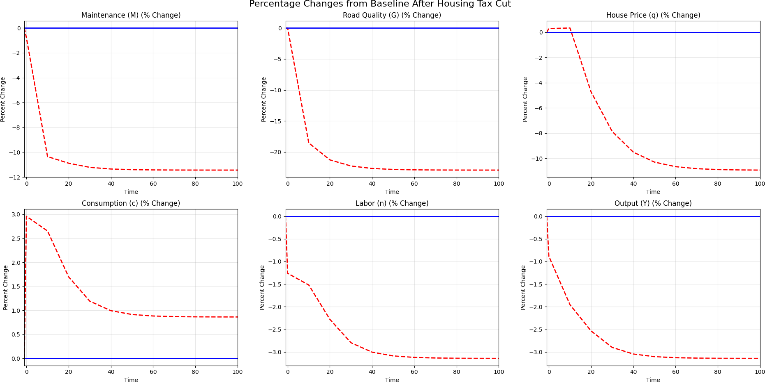
Figure 17: Dynamics of variables following the tax cut.

Figure 17 plots the full transition paths (percentage deviations from baseline). Most of the adjustment in M_{t} and q_{t} occurs early, while G_{t} converges more gradually as under-maintenance compounds over time.Findings from Figure 17 are summarized below:
- Roads and maintenance. Following the road tax cut, the road maintenance budget drops by about 10% and then drifts to roughly −11% (top-left panel of Figure 17). Given the law of motion for roads, G_{t} declines gradually and monotonically, approach-ing a long-run decline to 21% by the end of the simulated horizon.
- House prices. The housing price q_{t} initially shows a small blip (about +0.3%) and then declines smoothly toward a long-run drop of an average of 9% over the simulated horizon as the amenity value A(G_{t}) deteriorates.
- Aggregates. The macro aggregates move modestly: labor n_{t} falls by about −3.0%, output also Y_{t} by about −3%, and consumption c_{t} increases by about 3% in the long run. Consumption exhibits a slight short-run overshoot (of +3%) as households ini-
tially respond to higher disposable income from the tax cut, before settling slightly

above baseline (bottom row). This reflects the household’s initial response to higher disposable income from the tax cut, followed by adjustments and substitution effect as road quality declines.

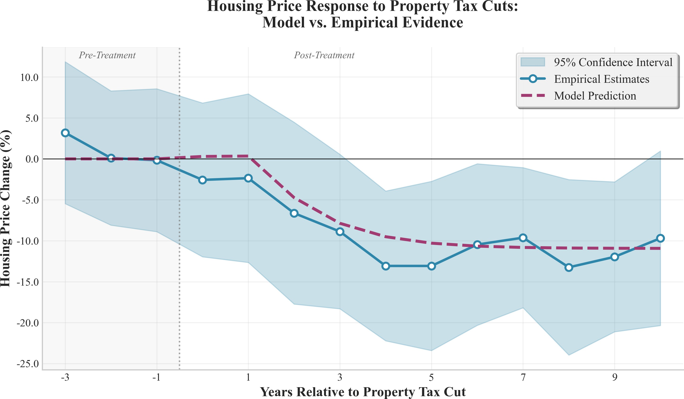
Figure 18: Model vs Empirical Estimates of House Prices Following the Tax Cut.

Model vs. empirical house-price path. Figure 18 compares the model-implied house-price response to the event-study estimates in Figure 5. After aligning the time units, the model tracks the medium- and long-run decline well, squarely within the empirical confidence band. The model is slightly conservative initially as the drop in housing prices occurs more gradually than the empirical estimates. Nevertheless, the overall magnitude and timing of the decline remain consistent with the data as the model starts to deviate from the baseline around year 2 and approaches a long-run average drop of about 9% by year 10. This pattern is consistent with the mechanism presented in the paper: eliminating the tax reduces maintenance revenues, which gradually lowers road quality, depresses amenity A(G_{t}), and in turn pulls down housing valuations.
Overall, the calibrated model reproduces the targeted steady-state effects (about −21% in roads, −9% in house prices, and −11% in maintenance) and generates transitional dynamics for house prices that closely follow the empirical path while remaining slightly less sharp at
the short-run trough.

Model Limitations
- Representative agent assumption. Heterogeneity in income or commuting pref-erences could attenuate price effects. Sensitivity analyses with quasi-linear preferences or idiosyncratic ϕ(G_{t}) show qualitative robustness.

- No spatial heterogeneity. We currently ignore spatial heterogeneity. The model intentionally abstracts from space for tractability. Future work can embed G_{t} in a Rosen–Roback framework to capture cross-location sorting.
- Fixed housing stock. Allowing new construction would introduce a supply elasticity that dampens price responses. Empirical evidence suggests housing supply in many
U.S. jurisdictions is quite inelastic.
- No direct productivity role for roads. Incorporating G_{t} into firm TFP A_{t} would further enrich the model. However, this would require additional assumptions about how road quality affects firm location and productivity, which is beyond our current scope.
The DGE framework formalizes the intuition that road–maintenance tax cuts provide immediate relief but, by undermining infrastructure quality, erode local amenities and raise commuting costs, culminating in lower house values and welfare.

Derivations of Key Equations

Derivation of the Euler Equation for consumption 14
Below U_{c} ≡ ∂u/∂c and λ_{t} is the Lagrange multiplier on the period-t budget constraint.
Set up the Lagrangian:

∞
L =
Σ
t=0
βth

u(c_{t}, h_{t}, A(G_{t}))+λ_{t}
(1−τ_{L})w_{t}n_{t}+r_{t}K_{t}−τ_{h}p_{h,t}h_{t}−c_{t}−p_{h,t}h_{t}−K_{t+1}+(1−δ_{K})K_{t}
i.

FOC w.r.t. consumption c_{t}:

∂L = 0 =⇒ β^{t}U (c , h , A(G )) − λ = 0 =⇒ λ = β^{t}U (c , h , A(G )). (A1)

∂c_{t}
c t t t t
t c t t t

FOC w.r.t. next-period capital K_{t+1}:
+ r

∂L
= 0 =⇒ −λ_{t}
∂Kt+1
Combine (A1) and (A2):

+ λt+1
h(1 − τ_{L}
∂nt+1
)wt+1
∂K
t+1

t+1
+ 1 − δ_{K}
i = 0. (A2)

Insert λ_{t} and λ_{t+1} from (A1) into (A2):

β^{t}U (c , h , A(G )) = β^{t+1}U (c , h , A(G ))h(1 − τ )w ∂nt+1 + r + 1 − δ i.
c
t
t
t
c
t+1
t+1
t+1
L
t+1 ∂K
t+1
t+1
K

Divide both sides by β^{t} to obtain:

U (c , h , A(G )) = βU (c , h , A(G ))h(1 − τ )w ∂nt+1 + r + 1 − δ i.
c
t
t
t
c
t+1
t+1
t+1
L
t+1 ∂K
t+1
t+1
K

Why the derivative ^{∂n}t+1 ? Capital chosen today affects tomorrow’s labor choice only
∂K
t+1
through the household’s optimal plan. If, as we assume, labor in each period is chosen
independently of the inherited capital stock, this derivative is zero and the term drops out, giving the familiar
U_{c}(c_{t}, ·) = βU_{c}(c_{t+1}, ·) 1 + r_{t+1} − δ_{K} ,

which is the standard Euler equation for intertemporal consumption smoothing. Equation 10 still contains the marginal utility of consumption U_{c}(·). Because the one-
period utility function chosen is:
u(c , h , A(G )) = ln c + α ln h + η ln A(G ) − n (1 + ϕ(G )) 1+θ, (6)
κ
t
t
t
t
h
t
t
1 + θ
t
t
its partial derivative with respect to consumption is:

∂u U_{c}(c_{t}, h_{t}, A(G_{t})) = ∂c
t
1
= . (log utility)
c_{t}

Substituting U_{c} into the Euler Equation:
Start from Eq. 10:

U_{c}(c_{t}, ·) = β U_{c}(c_{t+1}, ·) 1 + r_{t+1} − δ_{K} . (10)
Replace U_{c} with ¹ (log utility):
c

This is exactly Eq. 11:
1 1
= β 1 + r ct t+1
c

t+1
— δ_{K}
.

. (11)
t+1
c
1
= β 1 + r_{t+1} − δ_{K} c
1
t

Labor–leisure trade–off
To derive the labor-leisure trade-off condition, we start by computing the partial derivatives of the utility function with respect to consumption and labor:
For consumption:

For labor, we have:
1
u_{c}(c_{t}, h_{t}, n_{t}, G_{t}) =
c
t
(B1)

u (c , h , n , G ) = − κ n 1 + ϕ(G ) θ 1 + ϕ(G ) . (B2)
n
t
t
t
t
t
t
t
Optimal labour supply equates the marginal disutility of work to the after-tax marginal

benefit of wages
— u_{n}(c_{t}, h_{t}, n_{t}, G_{t}) = (1 − τ_{L}) w_{t} u_{c}(c_{t}, h_{t}, n_{t}, G_{t}) Using B1 and B2, we can rewrite this as:
κ n 1 + ϕ(G ) θ 1 + ϕ(G ) = (1 − τL) wt
t
t
t
t
c
This is exactly the condition we wanted to derive:

κ 1 + ϕ(G ) 1+θ n^{θ}
t
t
= (1 − τ_{L}) w_{t}
t

" (1 − τ ) w #1/θ
c
n
=
L
t
t 1+θ
κc_{t} 1 + ϕ(G )
t

Euler equation for Housing
We derive the housing Euler starting from the household’s problem.

- Primitives. Per–period utility:
κ

u(c , h , n , G ) = ln c + α A(G ) ln h
t
t
t
t
t
h
t
t
— n (1 + ϕ(G )) 1+θ.

Marginal utilities (holding G_{t} fixed):
1 + θ
t
t

uc,t
1
= , u c_{t}

h,t
∂u
=
∂h_{t}
= α_{h}
A(G_{t}).
h_{t}

- Budget constraint in stock form. Using H_{t+1} = (1 − δ_{h})H_{t} + x_{t} and substituting x_{t} = H_{t+1} − (1 − δ_{h})H_{t}, the period-t budget is

c_{t} + i_{t} + p_{h,t} H_{t+1} − (1 − δ_{h})H_{t} = (1 − τ_{L})w_{t}n_{t} + r_{t}K_{t} − τ_{h}p_{h,t}H_{t}.
Rearrange the housing terms:
−p_{h,t}H_{t+1} + p_{h,t}(1 − δ_{h})H_{t} − τ_{h}p_{h,t}H_{t} = −p_{h,t}H_{t+1} + p_{h,t}(1 − δ_{h} − τ_{h})H_{t}.
- Lagrangian. Let λ_{t} be the multiplier on the budget constraint:

∞
L =
Σ
t=0
βtn

u(c_{t}, h_{t}, n_{t}, G_{t})
+ λ_{t} (1 − τ_{L})w_{t}n_{t} + r_{t}K_{t} − c_{t} − i_{t} − p_{h,t}(H_{t+1} − (1 − δ_{h})H_{t})

— τ_{h}p_{h,t}H_{t} − (K_{t+1} − (1 − δ_{K})K_{t}) , (44)

- FOCs for c_{t} and H_{t+1}. Consumption:
∂L

∂c_{t}
= 0 ⇒ λ_{t} = u_{c,t}.

For H_{t+1} (differentiating with respect to the housing stock chosen for next period):

∂L

∂Ht+1
= 0 : β^{t+1}u

h,t+1
+ βt+1λ

t+1

ph,t+1
(1 − δ_{h}
— τ_{h}
) − β^{t}λ_{t}p

h,t
= 0.

Divide by β^{t} and rearrange:
ph,tλt = β uh,t+1 + λt+1ph,t+1(1 − δh − τh) .

- Replace multipliers with marginal utility of consumption. Since λ_{t} = u_{c,t}: ph,tuc,t = βhuh,t+1 + uc,t+1(1 − δh − τh)ph,t+1i,
which is equation (20).

- Convert to consumption units. Divide both sides by u_{c,t+1}:

p uc,t = β (1 − δ
h,t u
h
h
c,t+1
— τ_{h}

)ph,t+1
+ uh,t+1
uc,t+1
i

With u
= 1/c
uc,t ct+1
we have = , so

c,t t
h
i
uc,t+1 ct

ph,t
= β ct (1 − δ ct+1
— τ_{h}

)ph,t+1
+ uh,t+1 . uc,t+1

Substitute u_{h,t+1}/u_{c,t+1} = α_{h}A(G_{t+1})/H_{t+1} · c_{t+1}:
h
i
h

ph,t
= β ct (1 − δ ct+1
— τ_{h}

)ph,t+1
+ α_{h}
A(G

t+1
h
) ct+1
Ht+1

which is equation (21).

Road-Quality Vision Model: Fine-Tuning and Eval-uation
In this section, we document our pipeline to classify road-surface quality from satellite im-agery into three classes: poor (0), medium (1), and high (2). We begin from an ImageNet-pretrained vision model called ConvNeXt V2, available on Hugging Face and supported by Meta AI (Woo et al., 2023). We use the ConvNeXt V2 backbone and fine-tune the base version of the model on labeled road imagery from Brewer et al. (2021). The resulting model produces categorical ratings which can be converted into a continuous Road Quality Score (RQS), used in Section 5.1.

Fine-tuning Workflow. Figure 19 summarizes the end-to-end workflow. We begin with a corpus of 53,677 satellite tiles (224x224 pixels) labeled for road quality from Brewer et al. (2021). We feed these images into a ConvNeXt V2 model, replacing the original classification head with a 3-way softmax layer. We then fine-tune the entire model end-to-end using cross-entropy loss and the AdamW optimizer. The training process is monitored via a validation set, and we select the best-performing checkpoint based on minimum validation loss. Finally, we evaluate the fine-tuned model on a held-out test set to report accuracy, F1, and class-wise precision and recall.
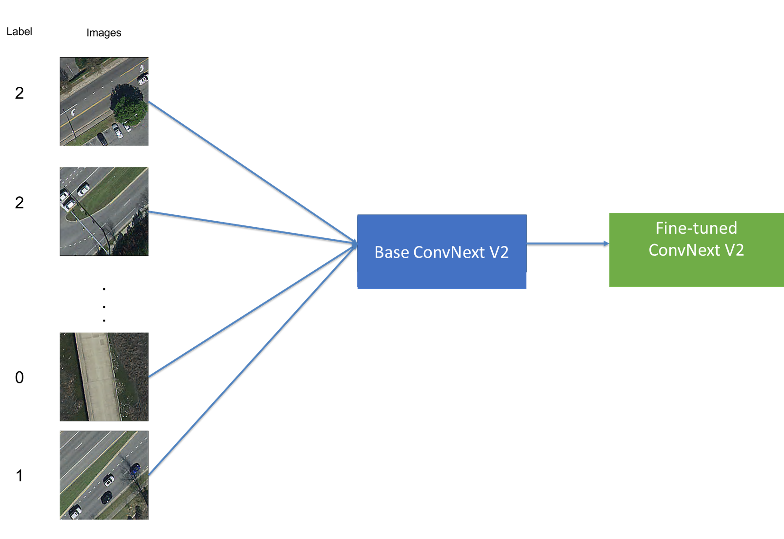
Figure 19: Fine-tuning workflow for road-quality classification

Data and Training. We fine-tune ConvNeXt V2 trained on ImageNet-1k dataset. The classification head is replaced by a 3-way softmax. We fine-tune the model for 3 epochs and use cross-entropy loss, AdamW optimizer with learning rate of 5 × 10⁻⁵ and weight decay of 0.01, and a batch size of 16 for training and 32 for evaluation. Inputs use the model’s ImageNet normalization; no explicit augmentation. We use a weighted, stratified 70/15/15 split and select the checkpoint with the lowest validation loss.

Split | Share | Stratified | Weights | Rationale
Train | 70% | By label | 3/2/1 | Mitigates class imbalance by allocating
 |  |  |  | more minority-class samples to training,
 |  |  |  | improving gradient signal and stability.
Validation | 15% | By label | 3/2/1 | Class-aware monitoring consistent with
 |  |  |  | train; used for model selection (min. val.
 |  |  |  | loss).
Test | 15% | By label | 3/2/1 | Hold-out evaluation with comparable
 |  |  |  | class mix for fair assessment across splits.
Table 17: Split design and class-aware allocation. Weights are used only to allocate per-class counts into splits, not as loss weights.

Model Evaluation Metrics. We report accuracy, macro F1, and class-wise precision/recall to account for any residual imbalance. We also provide a confusion matrix to diagnose sys-tematic confusions between adjacent quality classes.
Table 18: Overall accuracy by split (fine-tuned ConvNeXt V2).

Split | Overall Accuracy
Train | 0.9115
Validation | 0.8525
Test | 0.8337

Table 19: Confusion matrix on the held-out Test set (N=1,539). Low/Medium/High corre-spond to classes 0/1/2.

Predicted

Low Medium High

Low | 33 | 11 | 9
Actual Medium | 12 | 78 | 181
High | 2 | 41 | 1172

Table 18 presents model accuracy results on training, validation and test datasets. Ac-curacy is 0.9115 on train, 0.8525 on validation, and 0.8337 on test, indicating a good fit without overfitting on training data. As expected, accuracy declines slightly from train to

Table 20: Classification metrics on the Test set derived from Table 19.

Class | Precision | Recall | F1 | Support
0 | 0.702 | 0.623 | 0.660 | 53
1 | 0.600 | 0.288 | 0.389 | 271
2 | 0.861 | 0.965 | 0.910 | 1,215
Macro avg | 0.721 | 0.625 | 0.653 | 1,539
Weighted avg | 0.810 | 0.834 | 0.810 | 1,539
Accuracy |  | 0.8337 |  | 1,539

validation to test. However, the gap between validation and test is less than 10 percentage points, suggesting good generalization across unseen data.
Table 19 shows the confusion matrix on the held-out test set and is useful to understand the types of errors the model makes when classifying road quality. As presented in the table, most errors are between adjacent classes: medium (1) is often predicted as high (2), and poor (0) occasionally as medium (1). Confusions between poor (0) and high (2) are rare, while high (2) is predominantly classified correctly.
Table 20 presents per-class metrics. Class 2 attains high precision and recall, driving weighted averages near overall accuracy, which suggests the model is very reliable at identi-fying high-quality roads. Class 1 shows low recall, lowering macro F1 and reflecting difficulty on borderline surfaces. This means the model often misses medium-quality roads, misclas-sifying them as high quality. Class 0 performs moderately, with balanced precision/recall relative to its smaller support, indicating reasonable reliability on poor-quality roads despite fewer examples. Overall, the model excels at identifying high-quality roads but nevertheless struggles more with medium and poor classes, especially in recall for medium quality.

Base vs. Fine-Tuned ConvNeXt V2. Table 21 summarizes the main gains from end-to-end adaptation. We compare our fine-tuned ConvNeXt V2 against a baseline where the pretrained backbone is frozen and only the classification head is trained. This linear-probe baseline on frozen ImageNet features approach is common in transfer learning.
Table 21: Fine-tuned vs. baseline ConvNeXt V2.

Model Overall Accuracy
Fine-tuned ConvNeXt V2 0.8337 Baseline ConvNeXt V2 0.2586
Fine-tuning improves test accuracy by 57.51 (from 0.2586 to 0.8337) percentage points, a more than 220% relative gain. This indicates that adapting the pretrained backbone to road imagery is crucial for learning task-specific features and achieving reliable generalization, justifying end-to-end fine-tuning over a frozen baseline.

F MVPF Calculation
As stated in Section 7, we use the following formula to calculate the Marginal Value of Public Funds (MVPF):

MVPF =

WTP
=
Net Cost to Government

Tax Savings - House Value Decline Direct Long Run Cost + Fiscal Externality

(45)

We combine our estimated treatment effects on house prices with expected loss in tax revenue to calculate the MVPF of road maintenance tax levies. The expected loss in tax revenue, as calculated in Table 1, is $76 per household per year. Using a capitalization rate of 5% (Hilber, 2011; Cellini, Ferreira and Rothstein, 2010), the lifetime present value of this annual tax saving is $1,520 per household, which can also be interpreted as the tax savings from cutting the renewal road tax levy. Using the standard property tax rate of 1.5% in Ohio, and the estimated decline in house prices from the tax cut in Table 5, we compute the 10-year tax base decline of $1,911, which represents the fiscal externality from cutting the road tax levy. The net cost to the government is then calculated as the direct long-run cost of $1,520 plus the fiscal externality of $1,911, totaling $3,431. The willingness to pay (WTP) is calculated as the tax savings of $1,520 minus the yearly capitalization of house price estimates over 10 years, which amounts to $6,370 per household²⁵, giving a WTP of
−$4, 850. Finally, we compute the MVPF as −$4, 850/$3, 431 = −$1.41.

²⁵This calculation is based on the idea that the house price estimate in year t reflects future disutility from decline in public amenity.

