The Effect of Road Taxes on Local Wages and Employment

Abstract:

Introduction

Literature Review
Roads and labor outcomes (wages and employment). The importance of the topic has created an abundant literature on the effect of infrastructure investment on wages and employment. Although much of the literature is macro-oriented in nature, like Suarez-Cuesta and Latorre (2023), which models the impact on GDP and labor demand of the U.S. Infrastructure Investment and Jobs Act, our review focuses on studies on a more local geography.
Chaurey and Le (2022) examines the effects of infrastructure maintenance in India. The national government identified 17 of the poorest states and developed a “backwardness” index to rank districts within them. Based on this index, 115 of the most disadvantaged districts received 450 million rupees each, with flexibility in how the funds could be used—either to maintain and improve existing infrastructure or to make complementary investments. Eligible projects included road widening, lane additions, electricity transmission and distribution upgrades, new road links to markets, and bridge construction. As a result, the intervention combined both road and non-road investments, as well as maintenance and new construction. The most significant impacts were observed in districts lacking basic infrastructure like paved roads and electricity.
Although two other village-level infrastructure programs were active during the same period, Chaurey and Le argue that their estimates remain unaffected. This is because those programs allocated funds based on population rather than backwardness, and population was included as a covariate in their analysis. However, there is concern that some districts may have qualified under both criteria. Moreover, as noted by Lee and Lemieux (2010), including covariates in a regression discontinuity design does not eliminate bias but rather improves the precision of the estimated treatment effects.
Our study differs in many ways, the most apparent of which is that we study Ohio, a developed economy. Chaurey and Le (2022) are not given the "backwardness" ranking by the Indian government but do a careful job inferring it, achieving an 80.2% accuracy in predicting treatment status. In contrast, the data to construct our running variable, Vote Share, is obtained from the Ohio Secretary of State's office, ensuring a high degree of accuracy. Next, while the treatment studied in Chaury and Le (2022) is additional funding, the districts are given discretion in how to use the funds to "improve and maintain" and to "make complementary investments" in existing infrastructure, so that the treatment is a mixture of maintenance spending and new investments. While the use of regression discontinuity gives unconfounded treatment effects for district-level spending, districts are still free to invest the funds in faster-growing areas within the district, which may re-introduce the endogeneity of the effect of new infrastructure on outcomes. In contrast, our treatments are cleanly divided into 1) the renewal of maintenance funds for existing infrastructure, and 2) new funds for additional infrastructure, and for the latter treatment we account for the endogeneity of the vote with the fancy RDD technique of BLS (2025) [even though it doesn't get around the endogeneity of how the city might spend the money]. Chaurey and Le (2022) studies more outcome variables than we do. Both studies look at the effect on wages and employment, but Chaurey and Le (2022) also studies effects on the number of formal firms, informal microenterprises, and number of days worked by individuals.
Gibbons et al. (2019) analyzes how new road infrastructure in Britain affects employment and labor productivity. It finds that while new roads increase area-level employment and the number of firms, they may lead to job reductions in existing firms, coupled with increased wages and output per worker. Our results are consistent with Gibbons et al. (2019) in that changes in road investment do not seem to be related to employment at the establishment level. Neither Dalenberg and Partridge (1995) nor Gibbons et al. (2019) look at the effect of transportation infrastructure in high-poverty areas specifically. While we find no link between transportation infrastructure investment and wages or employment in our overall sample, we do find a link in high-poverty cities. While our identification strategy is regression discontinuity with its treatment and control groups, Gibbons, et al. (2019) identifies its estimates by looking at effects within buffer zones of 10 to 30 km from project sites, relying on different treatment intensity between wards within these buffer zones.
Asher and Novosad (2020) has many similarities with our study. Both use regression discontinuity to compare otherwise-similar local governments, some of which receive treatment, others of which act as controls. The running variable in our study is vote share to renew existing road funding or enact higher taxes for additional road funding, while the Indian government relied on a population cutoff to assign new road funding. Asher and Novosad 2020) studies the effect of new road funding on a variety of outcomes. It finds a 9% increase in wages and a small effect on village employment, while we find essentially the opposite: no change in wages but large changes in employment in various subgroups of cities, like those with especially high poverty rates. Like Asher and Novosad (2020), we generally find a lag of a few years until a significant treatment effect is found.
While Chaurey and Le (2022) contains a component of infrastructure maintenance spending, few other studies do. We regard the maintenance of road spending to have a special place in the identification of economic effects because the many studies on the placement of new infrastructure are always affected by, but rarely address, the reverse causation that new roads might be placed in the highest-growth areas, upwardly biasing the estimated impact of infrastructure spending on wages and employment. In fact, the recent 300+ study survey of the effect of infrastructure on economic outcomes (Foster, et al. 2023) mentions "maintenance" only once, and that in the context of construction maintenance jobs; and "identification" once, and not in a statistical context. We find only two other studies on transportation infrastructure maintenance. The landmark capitalization study of Edel and Sclar (1974) finds no effect on house prices of road maintenance spending in the Boston area, and Rioja (2003) develops a dynamic general equilibrium model that shows the output-enhancing effect of diverting funds away from new infrastructure and toward maintaining existing infrastructure. We therefore consider the part of our study that examines renewal tax levies to be among the least biased of the studies on the effect of infrastructure spending on wages and outcomes in the literature.
Roads and firms.
Road quality.
Tax cuts and local spending.

Road Quality
The taxes we study are to renew and to increase road maintenance funding. If cities vote to cut road taxes, we expect the drop in maintenance to be reflected in reduced road quality. If cities pass tax levies for additional road maintenance, we expect visible improvement in road quality. A novel feature of this study is the use of artificial intelligence to quantify the change in road quality following changes in road taxes.
Brewer, et al. (2021) contains 54,000 images of roads classified into three quality levels--0 for poor, 1 for decent, and 2 for high. We collect satellite images of local Ohio roads before and after tax changes from Google Earth Pro. There are limitations to this process. The images are not always of high resolution. There is not a yearly panel of images available for the same road so, for example, we might have before and after images from 2017 and 2023 for a tax change in 2020, while for another city we might have before and after images from 2014 and 2021 for a 2018 tax change, and some areas do not have both before and after images, especially for tax levies toward the end of our dataset.
We use the pre-trained data from Brewer, et al. (2021) and have Chat GPT-4O apply the same 0, 1, 2 rating system to our Ohio roads. For each image, Chat GPT-4O produces a predicted classification and confidence score based on visible cracks, surface condition, pavement quality, and patchwork learned from the training data. A working paper on house prices by the same authors of this study also predicts road quality for renewal tax levies, but this is the first study to use artificial intelligence to score road quality for cases where additional money for road maintenance is passed. Talk more about the results of the road scoring for the renewal and new taxes here, including possibly our conversion to a 0 to 100 scale like for the roads hp paper.

Methodology

Event Study Style Regression Discontinuity
Our study uses two different styles of regression discontinuity: one for votes to renew existing taxes and another for votes to increase road taxes and spending. The event study style is appropriate for studying renewal levy votes.
Regression discontinuity exploits institutional rules to compare units close to a cutoff value. In our setting, votes by citizens of Ohio villages, cities, and townships must exceed a cutoff of 50% to pass. The theory of regression discontinuity states that cities that vote close to 50% are similar to each other, so that the only difference between cities that barely pass and fail a tax levy is the change in taxes one set of cities experiences, perfectly identifying the effect of a change in taxes on an outcome variable.
The event study style of regression discontinuity is appropriate for renewal tax levies because there is no strategic behavior to model with renewal taxes (Brasington, 2017). When a new tax is passed, it is typically passed to collect taxes for five years, a duration representative of 84% of our sample. When collection is about to expire, a city will propose to citizens that they renew the tax. The decision of when to put the tax levy on the ballot is not determined by economic conditions or other tax levies on the ballot; it is set by the duration of the original tax levy and therefore exogenous to the city. The event study style of regression discontinuity is therefore more internally valid than more general types of estimators like Cellini, Ferreira and Rothstein (2010) because there is less room to misspecify strategic behavior in the model.
I stole this section from my pctblack paper with Mike so I'll need to change it, and it might change anyway if the BLS description comes first Let $Y_{i}$ denote the outcome of interest for a city i, and let $T_{i}$ $∈ \left\{0,1\right\}$ be an indicator for whether the police levy is renewed. The running variable $R_{i}$ is the proportion of votes in favor of renewal. Treatment is assigned as in Equation (1):
$T_{i}=1(R_{i} ≥c)$ (1)
where c = 0.5 is the cutoff. The observed outcome follows Equation (2):
$Y_{i}= Y_{i}\left(0\right)\left(1-T_{i}\right)+ Y_{i}(1)T_{i}$. (2)
The parameter of interest is the average treatment effect at the cutoff, as in Equation (3):
$τ= \lim_{r↓c}{E\left[Y_{i}|R_{i}=r\right]- \lim_{r↑c}{E\left[Y_{i}|R_{i}=r\right]}}.$ (3)
We estimate τ in Equation (3) using local polynomial regression with a triangular kernel and bias-corrected inference as proposed by Calonico, et al. (2019). The estimator is
${\hat{τ}}_{BC}= {\hat{u}}_{+}\left(c\right)- {\hat{u}}_{-}\left(c\right)-\hat{β}$ (4)
where ${\hat{u}}_{+}\left(c\right)$ and ${\hat{u}}_{-}\left(c\right)$ are local polynomial estimates from the right and left of the cutoff, and $\hat{β}$ is the bias correction term. The literature favors the use of the local linear or quadratic polynomial (Gelman and Imbens, 2019), and testing shows the local linear has a lower asymptotic mean squared error in our sample (Pei, et al. 2022).
The triangular kernel is defined as
$K\left(u\right)=\left(1-\left|u\right|\right)1\left(\left|u\right|≤1\right).$ (5)
This kernel if favored in the literature (Cattaneo, Idrobo, and Titiunik, 2020) because it minimizes the asymptotic mean squared error in local polynomial estimation by placing more weight on observations close to the cutoff.
Let $X_{i}$ be a vector of covariates. Following Calonico, et al. (2019) we incorporate covariates to improve precision without introducing bias. The covariate-adjusted estimator is
${\hat{τ}}_{BC}^{adj}={\hat{μ}}_{-}^{adj}\left(c\right)- {\hat{β}}^{adj}.$ (6)
The bandwidth h is selected to minimize the mean squared error of the bias corrected estimator. The optimal bandwidth is given by Equation (7):
$h_{MSE}= {\left(\frac{R(K)σ^{2}}{μ_{2}^{2}\left(K\right)f{(c)}^{2}τ^{''2}}\right)}^{1/5}$ (7)
where $R\left(K\right)= \int{K{(μ)}^{2}dμ}$, $μ_{2}\left(K\right)= \int{μ^{2}K\left(μ\right)dμ}$, $f(c)$ is the density of $R_{i}$ at the cutoff, and $τ^{''}$ is the second derivative of the conditional expectation function. Covariates are included via residualization, ensuring that the treatment effect is still identified from the discontinuity in $R_{i}$.

Regression Discontinuity Design with Strategic Behavior
This section should probably go first since renewal taxes are just new taxes that are up for renewal, but going second makes sense because results are less interesting and method is more complex

Data

4.1. Voting Data
The crux of our study is a set of votes by Ohio cities on road tax levies from the Ohio Secretary of State's office. There are 5,154 such votes from 1991 to 2021, of which 1,606 are votes for additional funding and 3,548 are votes to renew existing funding.
The running variable is Vote Share, the mean of which is 0.49 for new levies and 0.62 for renewal levies, each with a standard deviation of 0.16. An important assumption of regression discontinuity studies is that no agent be able to precisely manipulate the vote share. We test this assumption with the density test of Cattaneo, Jansson, and Ma (2020). The test fails to reject the null of equal density on either side of the cutoff, with a p-value of 0.51. A graph of the results is available upon request.

Outcome Data
We study the effect of road tax changes on two labor market outcomes: employment and wages. We obtain special permission from the Ohio Department of Jobs and Family Services (ODJFS) to access establishment-level data on wages and employment. It shows total wages and the average number of employees for each quarter. We aggregate up from quarterly to yearly values. Each establishment has an address, which we geocode to the proper local government jurisdiction (city, village or township), and we aggregate total wages and average employment up to the local government level to match the unit of geography of the voting data. The outcome variables considered are employment and wages, where employment is the average number of employees on the payroll in a particular city during a specific year, and wages per capita is aggregate total wages paid to the employees on the payroll in particular city during a year divided by average employment. While our voting data covers the years 1991 to 2021, the ODJFS data starts in 2006.
Within the typical effective bandwidth of 14 percentage points, mean city-level employment is 1,575 for the fail levy group with a standard deviation of 3,319; and it is 1,342 with a standard deviation of 3,514 for the pass levy group the year before the vote. The average wage outcome we study also has similar means within the effective bandwidth the year before the vote. For the high-poverty sample, the sample with the only significant treatment effects, mean wages in 2010 dollars are $29,153 for the fail-levy sample with a standard deviation of 8,515; and they are $29,968 for the pass-levy sample with a standard deviation of 7,524. While we find a better fit using the linear form of employment, the natural log fits the data better for the wage outcome. This is true for renewal, may need to revise for new
A graph of Vote Share as a function of Employment six years after the vote for our high-poverty sample, the sample for which we find a significant treatment effect, is shown in Figure ???:
Figure ???
Employment as a Function of Vote Share
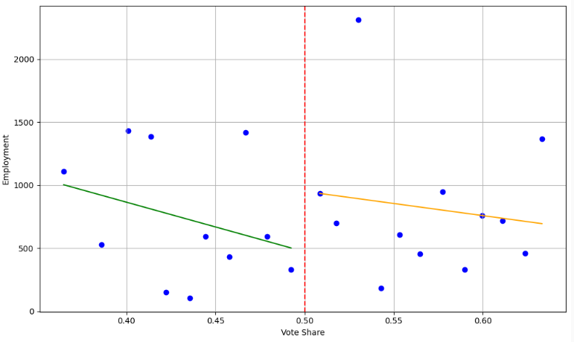
Figure ??? shows binned data, not actual data points, and unlike regression analysis the bins are unadjusted for controls, but Figure ??? may show higher employment for cities that renew rather than cut road tax levies, a possibility explored by formal analysis in Section ???. Similarly, we graph Wages against Vote Share, also six years after the vote, in Figure ???
Figure ???
Wages as a Function of Vote Share
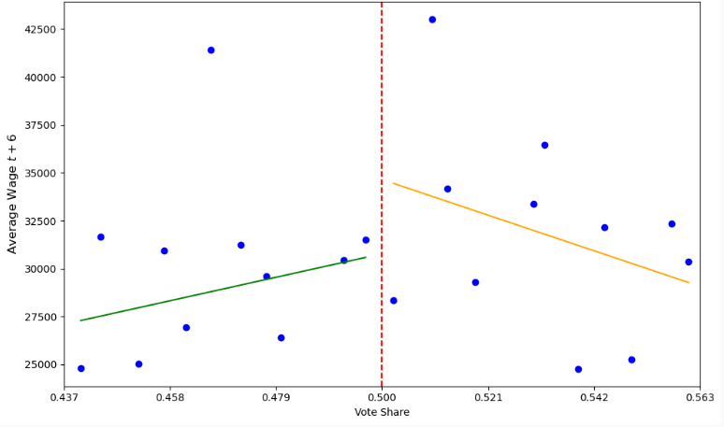
Figure ??? also may suggest higher outcome values for cities that renew rather than cut road taxes, a possibility formally explored in Section ???

Covariates
Covariates in ordinary least squares regression help control for omitted variable bias, letting researchers isolate the independent relationship between the outcome variable and the key explanatory variable. Regression discontinuity already identifies treatment effect estimates with only the treatment dummy and the running variable, so covariates are not necessary, but they are useful for increasing the precision of treatment effect estimates. They are also essential to test key assumptions of the regression discontinuity model. de la Cuesta and Imai (2016) shows that covariate balance is not necessary for identification, but traditionally this is a key assumption, and intuitively it makes sense that a researcher would want a treatment group to look like the control group in every measurable aspect other than the treatment itself. We do not show means for the full sample because we find no significant treatment effects for this sample. We assure readers that the full-sample regressions show great similarity and offer to share the means upon request. We do, however, show a table of covariate means within the effective bandwidth for the different subsamples we will use:
Table ???
Covariate Means for Renewal Tax Levy Regressions
 | Sample
 | > 50th Percentile Labor Force Participation Rate |  | > 75th Percentile Poverty Rate |  | > 50th Percentile % Aged 0 to 5
Covariate | Fail | Pass | Fail | Pass | Fail | Pass
% Aged 0 To 4 | 0.06  (0.02) | 0.06  (0.03) | 0.07  (0.03) | 0.07  (0.03) | 0.08  (0.02) | 0.08  (0.02)
% Aged 5 To 17 | 0.19  (0.05) | 0.20  (0.06) | 0.21  (0.06) | 0.22  (0.07) | 0.21  (0.05) | 0.22  (0.06)
% Aged 18 To 64 | 0.59  (0.06) | 0.58  (0.05) | 0.58  (0.08) | 0.58  (0.06) | 0.58  (0.04) | 0.58  (0.05)
% Aged 65+ | 0.17  (0.05) | 0.16  (0.06) | 0.13  (0.06) | 0.14  (0.05) | 0.13  (0.04) | 0.12  (0.04)
Income Herfindahl | 0.06  (0.07) | 0.06  (0.08) | 0.06  (0.08) | 0.04  (0.06) | 0.06  (0.07) | 0.05  (0.06)
Race Herfindahl | 0.93  (0.08) | 0.93  (0.10) | 0.90  (0.11) | 0.91  (0.12) | 0.92  (0.07) | 0.95  (0.09)
Median Income ($1,000s 2010) | 56.2  (11.8) | 53.6  (12.3) | 48.1  (9.6) | 46.6  (8.5) | 59.6  (16.1) | 59.0  (17.1)
% No HS Diploma | 0.15  (0.11) | 0.17  (0.12) | 0.21  (0.16) | 0.21  (0.15) | 0.15  (0.15) | 0.20  (0.16)
Hs Diploma Only | 0.44  (0.09) | 0.43  (0.09) | 0.40  (0.07) | 0.42  (0.10) | 0.40  (0.10) | 0.41  (0.10)
Some College | 0.26  (0.06) | 0.26  (0.07) | 0.26  (0.08) | 0.25  (0.08) | 0.27  (0.07) | 0.24  (0.07)
Bachelors Degree | 0.10  (0.05) | 0.09  (0.05) | 0.08  (0.04) | 0.08  (0.04) | 0.11  (0.07) | 0.10  (0.08)
% Black Pop | 0.03  (0.13) | 0.03  (0.11) | 0.08  (0.21) | 0.05  (0.16) | 0.05  (0.18) | 0.01  (0.05)
% Hispanic Pop | 0.02  (0.02) | 0.01  (0.02) | 0.01  (0.02) | 0.01  (0.01) | 0.02  (0.03) | 0.01  (0.02)
% Minority Pop | 0.06  (0.13) | 0.05  (0.12) | 0.10  (0.21) | 0.08  (0.17) | 0.08  (0.18) | 0.03  (0.06)
% Married | 0.58  (0.09) | 0.56  (0.09) | 0.55  (0.13) | 0.52  (0.11) | 0.60  (0.09) | 0.60  (0.09)
% Never Married | 0.23  (0.07) | 0.25  (0.08) | 0.27  (0.09) | 0.28  (0.09) | 0.24  (0.07) | 0.23  (0.06)
% Divorced | 0.10  (0.04) | 0.11  (0.04) | 0.10  (0.05) | 0.12  (0.04) | 0.09  (0.04) | 0.09  (0.04)
% Separated | 0.01  (0.01) | 0.01  (0.01) | 0.02  (0.01) | 0.02  (0.01) | 0.01  (0.01) | 0.01  (0.01)
% Renters | 0.17  (0.10) | 0.20  (0.11) | 0.20  (0.14) | 0.25  (0.12) | 0.17  (0.10) | 0.18  (0.10)
% Single Parent Hhld | 0.10  (0.06) | 0.11  (0.07) | 0.11  (0.08) | 0.14  (0.08) | 0.11  (0.07) | 0.10  (0.07)
% With Children | 0.38  (0.08) | 0.40  (0.10) | 0.43  (0.07) | 0.42  (0.10) | 0.43  (0.08) | 0.46  (0.09)
Population (1,000s) | 6.1  (10.2) | 5.4  (8.4) | 4.7  (4.3) | 5.9  (9.7) | 4.6  (4.6) | 4.7  (8.2)
% Poverty | 0.12  (0.07) | 0.14  (0.08) | 0.22  (0.06) | 0.22  (0.07) | 0.12  (0.08) | 0.12  (0.09)
Unemployment Rate | 0.07  (0.03) | 0.08  (0.04) | 0.09  (0.05) | 0.09  (0.05) | 0.07  (0.04) | 0.06  (0.04)
Notes: Covariate means shown with standard deviation in parentheses below for the set of cities within the effective bandwidth that barely fail and barely pass their road tax renewal levies. Means shown for three subsamples: the set of cities with lower than median labor force participation rates, the set of cities with above the 75th percentile of poverty rates, and the set of cities with higher than median proportion of residents aged less than five years. Sample means shown at time of vote for the optimal estimated effective bandwidth from Calonico, et al. (2019). Full number of votes for each subsample and (number of votes within effective bandwidth) are as follows: labor force participation 820 (215), poverty 345 (96), under age 5 539 (124).

We find considerable similarity in covariate means between the sets of cities that barely pass and barely fail their road tax renewal levies. There are a few causes for concern. The first we identify are Population and Median Income for the high poverty subsample. While the differences in means could be considered large, the medians are more similar: 3.3 vs. 3.1 for population and 49.4 vs. 46.9 for median income. The difference in % Renters remains large regardless of whether we consider the means or the medians, however. While this difference could invalidate any findings for this subsample in readers' eyes, three arguments may help: 1) the other 22 covariates show similarity, 2) de la Cuesta and Imai (2016) argues that covariate balance is not necessary for identification, and 3) there is a larger proportion of renters in the pass-levy group, not the fail-levy group. The final set of covariate differences are from the subsample with a high share of the youngest children. The 0.15 vs. 0.20 difference in % No HS Diploma shrinks to a 0.12 vs. 0.14 difference in medians; and the difference in % Black Population and % Minority Population are driven by outliers. The largest value in the pass sample is 0.42 but 0.93 in the fail sample, leading to a kurtosis of 21.5 vs. 46.4.
It is important for regression discontinuity not to use endogenous covariates. A traditional way to test for endogeneity is to use each covariate as an outcome variable, where a significant treatment effect would indicate that levy passage or failure might cause a change in the covariate, and any significant treatment effect on the outcome variables wages and employment might actually be attributed to the change in covariate. We perform this test, finding two instances of statistical significance. Two false positives might be expected in 24 regressions at the 5% level of significance, but for further verification we remove these covariates from the regressions that show statistical significance and find statistical significance remains. The graphs in Figure ??? also show significant smoothness across the cutoff.
Figure ???
Covariate Smoothness at the Cutoff

We will need a separate table for covariate means for new tax sample because it has a different number of obs and uses different covariates

Institutional Background
Ohio has 253 cities, 673 villages, and 1,308 townships. The township is the default form of local government. Citizens can petition the Board of County Commissioners to form a village, and when a village exceeds 5,000 residents it is reclassified as a city. Cincinnati is the largest urban area in Ohio, but unlike many states Ohio is not dominated by a single large city but has six urban areas that range in population between 600,000 and 2.2 million. The fact that incorporated cities and villages can cross county lines complicates data collection, but cities, villages, and townships offer similar public services, including road construction and maintenance.
The local government may pass a resolution for new road funding or to renew an existing, expiring tax levy. The resolution specifies the purpose of the levy, the size of the tax (in mills for a property tax, where one mill is one tenth of one percent of taxable value), and the duration of the levy. When a resolution is passed, the local government submits the resolution to the county board of elections, and citizens vote on the bill. Most votes occur in November, although about one-third occur in May, and occasionally there are off-cycle referenda in February or August. There is some variation in the gap between when a tax levy is passed and when collections start, but a levy voted upon in 2022 will generally start collecting tax revenue in 2023. Registered voters aged 18 and above who have been residents of the local government for 30 days may vote on the referendum.
While money from the national government through the Highway Trust Fund helps fund interstate highways, U.S. highways, and some state highways, local roads are almost entirely excluded from national funding. The State of Ohio provides little funding for local roads, too, as only 2% of the Ohio Department of Transportation's budget goes to local governments as grants to help fund local road maintenance and construction. Much of the funding for local roads comes from local tax effort, then. We reached out to John Schroeder, the Public Service Director of the Beavercreek Township suburb of Dayton (population 56,000), who said 77% of funding for roads comes from Beavercreek Township itself, primarily through property taxes, but also 8% from gas taxes. Overall, 11% of the budget of Beavercreek Township is dedicated to road maintenance. Local funding for roads can come from current operating expense tax levies or from the dedicated special purpose road tax levies that are the focus of our study.
The Ohio Auditor of State provides financial data for cities, village, and townships. The data for townships is sufficiently uniform in layout to ask ChatGPT to extract public works expenditure data from the thousands of .pdf files. We perform a regression discontinuity analysis of public works expenditures as a function of failure to renew a road tax levy for townships in the overall sample, finding a $130,000 drop in public works funding the year after the vote, relative to otherwise similar townships that successfully renewed the tax levy. The drop persists the second year after the vote with a similar $120,000 treatment effect, indicating an approximately 9% drop in road maintenance funding. (insert footnote thanking high school sophomore Sricharan Bala for doing this exercise). Add corresponding information about increases in funding from new tax levies

Results

5.1. Renewal Tax Levies
Our first set of results uses the set of tax levies to renew existing road maintenance funding. Section ??? will examine the effects of passing new road tax levies for additional funding.

Renewal Tax Levies and Wages
The first outcome we consider is wages. Our results are summarized by the event-study figure below:
Figure ???
Effect of Renewing Road Maintenance Taxes on Average Wages

We find no statistically significant effects of cutting local road tax levies on average wages. We find no effect for various subsamples, either. In contrast, Chaurey and Le (2022) finds increased road funding causes wage gains between 11 and 16%; Gibbons, et al. (2019) finds a 10% increase in accessibility leads to 2.5% wage gains in one specification. Our null findings are useful when interpreting the effect of road levy renewal on employment in the next section.

Renewal Tax Levies and Employment
We now turn our attention to the effect of renewing road maintenance taxes on employment. The results are summarized in Table ??? below.
Table ???
Effect of Renewing Road Maintenance Taxes on Employment
Year | Full Sample | < Median Labor Force Participation  with Outliers | < Median Labor Force Participation  without Outliers
t+1 | 400  (0.25) | 288  (0.79) | 231  (0.51)
t+2 | 173  (0.56) | 298  (0.74) | 389  (0.18)
t+3 | 68  (0.83) | 794  (0.04) | 416  (0.04)
t+4 | -24  (0.94) | 904  (0.02) | 519  (0.02)
t+5 | -100  (0.78) | 837  (0.04) | 464  (0.04)
t+6 | -357  (0.28) | 729  (0.04) | 601  (0.01)
t+7 | -384  (0.21) | 665  (0.03) | 530  (0.01)
t+8 | -281  (0.37) | 578  (0.05) | 390  (0.05)
t+9 | -237  (0.50) | 613  (0.04) | 331  (0.15)
t+10 | -406  (0.28) | 675  (0.04) | 357  (0.17)
t-1 | 429  (0.25) | 51  (0.97) | 80  (0.86)
t-2 | 449  (0.26) | 144  (0.80) | 125  (0.74)
t-3 | 489  (0.27) | 672  (0.29) | 449  (0.31)
Notes: Treatment effect estimates shown with p-values in parentheses below. As an example of interpretation, the treatment effect of 400 for the full sample would mean that, the year after the vote, cities that renew road tax levies experience 400 extra workers than cities that vote to cut road taxes, if it were significant. Number of observations ranges from 1,305 to 1,376 for the full sample; from 630 to 834 for the sample with labor force participation rates below the median of 0.66 with outliers; and from 568 to 756 for the below-median labor force participation rate sample with 5% outliers in employment removed. Covariates drawn from those in Table ???.

Consistent with the wage finding, there is no statistically significant treatment effect of renewing road maintenance taxes on employment for the full sample of cities. When we split the sample, we do see an effect.
Our first experiment is to split the sample by median labor force participation rate, a measure of a city's economic health. While we find no significance in healthy cities by this measure, Table ??? shows an effect for cities with a below-median labor force participation rate. The effect becomes statistically evident three years after the vote. In this case, starting three years after the vote, we find cities with low labor force participation that renew road maintenance spending increase employment relative to cities with low labor force participation that cut road maintenance spending. The treatment effect of 794 in year t+3 indicates a whopping 47% higher growth in employment. The higher growth rate persists through all ten post-vote years that we test. Even in year t+10 the 675 treatment effect means that renewing road taxes causes a four percentage point higher employment growth than tax cutting cities annualized over the 10 year period.
The large treatment effect makes us suspect the presence of outliers. Trimming the top and bottom 5% (but not 1%) of employment reduces the magnitude of the treatment effect estimates, as shown in the last column of Table ???. Now the t+3 estimate of 416 suggests a 24% higher employment three years after the tax renewal, relative to the set of cities that votes to cut road funding. [insert studies that show large treatment effect but note that probably no one has looked at this subsample].
Our next experiment that bears fruit comes from splitting the sample by age. Specifically, we split the sample by the median proportion of youngest residents: those less than five years of age. Age 5 is when almost all U.S. states offer kindergarten, so those aged 0 to 4 will attend preschool or stay at home with a caregiver.
Table ???
Effect of Renewing Road Maintenance Taxes on Employment
Year | > Median % Aged 0 to 5 with Outliers | > Median % Aged 0 to 5 without Outliers | > 75th Percentile Poverty with Outliers | > 75th Percentile Poverty without Outliers
t+1 | 355  (0.40) | 444  (0.29) | 276  (0.78) | 681  (0.07)
t+2 | 331  (0.25) | 370  (0.15) | 955  (0.30) | 863  (0.02)
t+3 | 594  (0.03) | 519  (0.04) | 1,546  (0.11) | 987  (0.01)
t+4 | 680  (0.02) | 549  (0.03) | 2,224  (0.03) | 1,380  (0.01)
t+5 | 1,002  (0.01) | 799  (0.02) | 2,426  (0.04) | 1,208  (0.01)
t+6 | 996  (0.02) | 997  (0.01) | 2,271  (0.03) | 1,227  (0.01)
t+7 | 787  (0.04) | 835  (0.01) | 1,763  (0.06) | 1,214  (0.01)
t+8 | 854  (0.02) | 922  (0.01) | 1,074  (0.24) | 1,105  (0.01)
t+9 | 700  (0.04) | 831  (0.01) | 1,227  (0.21) | 783  (0.01)
t+10 | 922  (0.01) | 938  (0.01) | 1,676  (0.10) | 1,165  (0.01)
t-1 | 45  (0.93) | 348  (0.38) | 260  (0.79) | 379  (0.32)
t-2 | -203  (0.67) | 122  (0.76) | 100  (0.90) | -199  (0.55)
t-3 | -35  (0.94) | -130  (0.79) | -204  (0.83) | -101  (0.78)
Notes: Treatment effect estimates shown with p-values in parentheses below. As an example of interpretation, the treatment effect of 355 for the > Median % Aged 0 to 5 with Outliers column would mean that, the year after the vote, cities that renew road tax levies experience 355 extra workers than cities that vote to cut road taxes, if it were significant. Number of observations ranges from 462 to 698 for > Median % Aged 0 to 5 with Outliers sample; from 412 to 612 for the > Median % Aged 0 to 5 without Outliers sample; from 248 to 349 for > 75th Percentile Poverty with Outliers sample; and from 225 to 315 for the > 75th Percentile Poverty without Outliers sample. Covariates drawn from those in Table ???.

We find significant treatment effects in cities with an above-median proportion of children aged 0 to 4. The effects are first evident in the third year after the vote, and they extend through all periods we test, through ten years after the vote. In this case trimming outliers in employment does not markedly affect the treatment effect estimates. The 922 estimate for period t+10 suggests a 5.4 yearly percentage point difference in employment growth between cities that renew and cut road taxes.
Our last experiment for the renewal tax sample that bears fruit is to examine high-poverty cities. The literature often finds improved labor market outcomes in developing nations as a result of infrastructure investment, so it makes sense that disinvestment in road infrastructure in a developed economy might hurt employment in high-poverty cities. Splitting the sample by the median poverty rate bears no fruit, but focusing on the cities with a poverty rate above the 75th percentile--a 14% poverty rate--does. For these high-poverty cities, cutting road maintenance funding hurts employment. We again find lower treatment effects after removing 5% outliers in employment, but even for this sample, after ten years we still find a persistent decrease in employment growth for high-poverty cities that cut road maintenance, at the rate of 6.8 percentage points per year.

5.2. New Tax Levies for Additional Road Funding
Our next set of results uses the set of tax levies for new taxes to increase road maintenance funding. While the renewal tax levies used event-style RDD, the results from the current section come from RDD models that account for vote history (cite BLS or whoever).

Effect of New Road Tax Levies on Government Revenue and Spending

In the first stage, we analyze whether passing a road tax levy affects the property tax revenue and government spending on local roads. Using yearly financial reports of local governments in Ohio via Auditor of State’s website, we collect data on property tax revenue reported by the local governments in their financial reports and assess the changes in the reported tax revenue before and after a township passes a road tax levy. For spending numbers, we use the annual expenditure of public works department, which is the primary department responsible for maintenance and development of local roads in Ohio. Due to data sparseness, we create a time window, averaging the data before and after a tax levy is passed or failed, and compare the changes in the treatment and the control groups.

The equation below summarizes our method –

Yiτ = αi+λτ+βpassiτ×Postiτ+μiτ

i indexes townships, with elections occurring in years ti and τ is a two-period indicator (pre vs post), with pre=ti -3, ti-2, ti-1, post={ti+1, ti+2, ti+3}
Postiτ=1{τ=post} and passiτ= 1 if election was passed, 0 otherwise.
β is the first-stage effect for our collapsed DiD-style specification, with standard errors clustered at the township level. Yiτ is the 3-year mean or median of the outcome variable.

Panel A. Property Tax Revenue
 | Mean | Median, τ=0.5 (95% CI)
Pass | 0.0922**  (0.0345) | 0.1270***  [0.0719, 0.1704]
N | 266 | 266
Panel B. Public Works Spending
 | Median | Median, τ=0.5 (95% CI)
Pass | 0.0852*  (0.0444) | 0.0859***  [0.0196, 0.1444]
N | 266 | 266

Table above shows a clear relationship between passing a road tax levy and our outcomes: townships that pass an additional road‐funding levy experience statistically significant budget increases between the pre- and post-election periods than townships that fail their road tax levy. For property tax revenue, the DiD estimate indicates that passing raises the log change by 0.092, which corresponds to a 9.6% larger increase in revenue over the post window relative to failed elections. The median (τ=0.5) estimate is even larger at 0.127 with a 95% cluster-bootstrap interval [0.072, 0.170], implying about a 13.6% typical gain.

For public works spending, the DiD coefficient is 0.085, meaning about an 8.9% larger post-election increase for passes than fails. This estimate is marginally significant but is corroborated by the median regression, 0.086 with a 95% interval (around 9.0%). Taken together, the estimates demonstrate a strong and economically meaningful first stage: when voters approve new road money, township revenues and road-related expenditures subsequently rise, with effects on the order of 9–14% for revenues and ~9% for public works in the first few years after the election.

New Tax Levies and Wages

New Tax Levies and Employment
Mechanism
Add in the fact that for renewals there's no change in price of labor, just Q, suggesting a pattern of simultaneous S&D curve shifting
Falsification Testing
One falsification test is to use the wrong value of c in regressions, called placebo cutoffs. We perform this test for the trimmed version of the low labor force participation sample, for periods t+3 through t+8, to see if these statistically significant estimates might not in fact represent the effect of cutting road maintenance taxes on employment but might stem from random discontinuities in the data. We generally use false cutoffs of 0.35, 0.65, 0.70, and 0.75, chosen because they are outside the estimated optimal effective bandwidth. We have to exclude 0.65 for t+6 because 0.65 is very close to the actual 0.64 upper bandwidth; and the optimal bandwidth is small enough to allow testing for false cutoffs of 0.60 and 0.40 for two periods. In all, we find one statistically significant treatment effect out of 27 regressions with false cutoffs, which is about what random chance at the 5% cutoff would predict. This test argues that the renewal regression treatment effects are more likely the result of changes in taxes and spending on roads than random discrete jumps in the data at the true 0.50 cutoff. Should say something about the new tax levies placebo cutoffs here

Conclusion

References
Asher, Sam, and Paul Novosad. 2020. “Rural roads and local economic development.”
American Economic Review, 110(3): 797–823.
Biasi, B., LaFortune, J., & Schönholzer, D. 2025. What works and for whom? Effectiveness and efficiency of school capital investments across the U.S. Quarterly Journal of Economics (forthcoming).
Brasington, David M. 2017. “School spending and new construction.” Regional Science and Urban Economics, 63: 76–84.
Brewer, Ethan, Jason Lin, Peter Kemper, John Hennin, and Dan Runfola. 2021. “Predicting road quality using high resolution satellite imagery: A transfer learning ap- proach.” Plos one, 16(7): e0253370.
Calonico, Sebastian, Matias D Cattaneo, Max H Farrell, and Roc´ıo Titiunik. 2019. “Regression discontinuity designs using covariates.” Review of Economics and Statistics, 101(3): 442–451.
Cattaneo, M. D., N. Idrobo, and R. Titiunik (2020): A Practical Introduction to Regression Discontinuity Designs: Foundations. Cambridge Elements: Quantitative and Computational Methods for Social Science, Cambridge University Press.
Cattaneo, Matias D, Michael Jansson, and Xinwei Ma. 2020. “Simple local polynomial density estimators.” Journal of the American Statistical Association, 115(531): 1449–1455.
Cellini, Stephanie R, Fernando Ferreira, and Jesse Rothstein. 2010. “The value of school facility investments: Evidence from a dynamic regression discontinuity design.” The Quarterly Journal of Economics, 125(1): 215–261.
Chaurey, Ritam, and Duong Trung Le. 2022. “Infrastructure maintenance and rural
economic activity: Evidence from India.” Journal of Public Economics, 214: 104725.
Dalenberg, D. R., & Partridge, M. D. (1995). The effects of taxes, expenditures, and public infrastructure on metropolitan area employment. Journal of Regional Science, 35(4), 617-640.
de la Cuesta, B., & Imai, K. (2016). Misunderstandings about the regression discontinuity design in the study of close elections. Annual Review of Political Science, 19(1), 375-396.
Edel, Matthew, and Elliott Sclar. 1974. “Taxes, spending, and property values: Supply adjustment in a Tiebout-Oates model.” Journal of Political Economy, 82(5): 941–954.
Foster, V., Gorgulu, N., Straub, S., & Vagliasindi, M. (2023). The impact of infrastructure on development outcomes. Washington, DC: World Bank.
Gelman, A., & Imbens, G. (2019). Why high-order polynomials should not be used in regression discontinuity designs. Journal of Business & Economic Statistics, 37(3), 447-456.
Gibbons, Stephen, and Stephen Machin. 2005. “Valuing rail access using transport innovations.” Journal of Urban Economics, 57(1): 148–169.
Pei, Z., Lee, D. S., Card, D., & Weber, A. (2022). Local polynomial order in regression discontinuity designs. Journal of Business & Economic Statistics, 40(3), 1259-1267.
Rioja, Felix K. 2003. “Filling potholes: Macroeconomic effects of Maintenance versus New Investments in public infrastructure.” Journal of Public Economics, 87(9-10): 2281–2304. Suárez-Cuesta, D., & Latorre, M. C. (2023). Modeling the Impact of Public Infrastructure investments in the US: A CGE Analysis. International Advances in Economic Research, 29(3), 165-176.

Appendix

Data Benchmarking

QCEW Wages and Employment Data
Benchmarking source: https://ohiolmi.com/Home/QCEW/QCEWpubs
Our data from ODJFS:
Aggregate comparison Results:
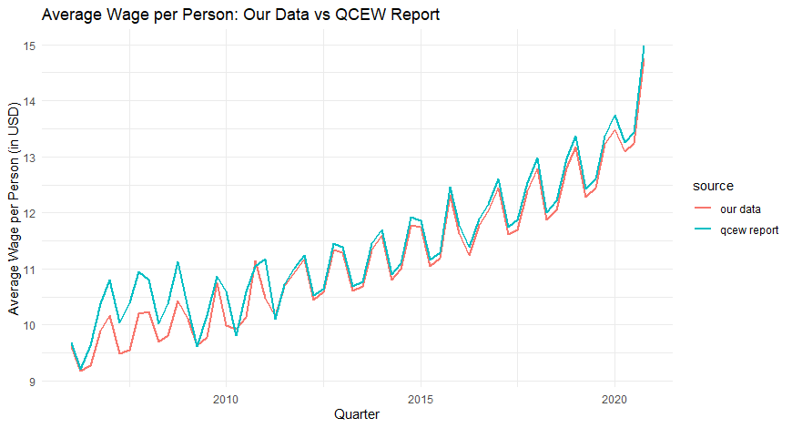
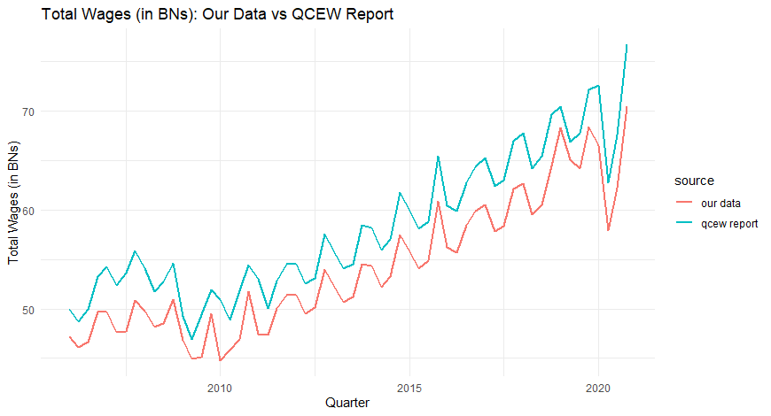

New Road Tax Levies and Government Revenue/Spending
We find 10-12% difference in revenue/spending between townships that passed their elections and townships that failed them.

“Additional” road taxes and Labor Outcomes

These reports are available for years in which Ohio Auditor of State performed a financial audit. Hence, data is not available uniformly for all years for a local government.
We restrict our analysis to townships due to consistency in reporting and data availability.
We right-truncate the post-window if another election was passed immediately afterwards to avoid any contamination.
We consider property tax revenue and public works expenditures as our outcome variables.

