The Effect of Local Road Tax Cuts on House Values *

David Brasington Saani Rawat

February 28, 2025

### [Please click here for the latest draft.](https://drive.google.com/file/d/18fS35u8sh9TMduSvmkO6O6uvLmoLFGa5/view?usp=sharing)

**Abstract**

Using data from Ohio Secretary of State Office, we design a quasi-experiment to study county subdivision-level referendums introduced to renew local road maintenance taxes, which are typically levied via property taxes. We compare housing sale prices between similar areas that narrowly pass or fail road tax levies and use satellite images to fine-tune an Artificial Intelligence (AI) model for classifying road quality. Our results show that local jurisdictions with close elections that decide to cut road taxes face an average loss of $163,547 (what percent is that?)in road maintenance funds, experience a 15% decline in road quality, and suffer a $15,350 (9%) drop in housing prices over the course of 10 years relative to similar areas that renewed funding. Heterogeneity analysis reveals differential decline in urban and rural areas and for expensive homes relative to their cheaper counterparts.

**Keywords:** Road Maintenance, Local Taxation, Housing values, Artificial Intelligence

**JEL Codes:** R42, H71, R10, C21

*Acknowledgements: We are grateful for comments from CK Tang, Guoyang Yang, Dan Boles, Eunjee Kwon, Gary Painter, Olivier Parent, Jeffrey Mills, Nayoung Lee, Matias Cattaneo, and Chris Bollinger, to CoreLogic for leasing us the housing dataset, to Albert Saiz, Lu Han, Siqi Zheng, David Albouy and other attendees at AREUEA National Conference for their insightful comments.

Professor, University of Cincinnati

PhD Student, University of Cincinnati

# Introduction

Roads are an important form of infrastructure investment that affect firms’ production func- tions and people’s commuting costs. Many studies examine the importance of roads and how they affect residents’ daily lives (Currier, Glaeser and Kreindler 2023; Adukia, Asher and Novosad 2020; Asher and Novosad 2020). Some papers emphasize that building new roads increases employment and entry of new firms (Gibbons et al., 2019), thereby increasing economic activity. Other papers point out the potential for worse outcomes in the form of increased inequality between the rich and the poor (Hettige, 2006) and an exodus of workers seeking access to larger labor markets (Asher and Novosad, 2020).

In this paper, we highlight the importance of road maintenance spending for townships, cities and villages ("cities") in Ohio. We collect data on more than 3,000 elections to renew road-tax levies in Ohio from 1991 to 2021. Using dynamic regression discontinuity design, we examine how these exogeneous cuts in maintenance spending influence housing prices, focusing on cities where voting results were narrowly decided. Our results reveal that when a city cuts its renewal road taxes, it experiences a loss in maintenance funds, its road quality declines by 15% and house prices decrease by around $15,350, with the effect starting four years after the vote and persisting through many years after the vote. This discount in house prices represents about 9 percent of house value over the decade. The delayed effect is consistent with the time it takes for roads to deteriorate noticeably. We find that these price effects are driven by urban areas rather than rural areas. We also observe that higher-priced houses experience larger percentage reductions in value than lower-priced houses, indicating a heterogeneous impact across different quantiles. This suggests that higher-income households are more sensitive to road quality than lower-income households.

**Related Literature.** Perhaps the study most related to ours is Asher and Novosad (2020), which studies the impact of new roads on villages in India. Like our study, its identification strategy is regression discontinuity, although ours is sharp rather than the fuzzy

form. It argues the main obstacle to identification in prior studies is that the placement of new roads is usually correlated with economic (or political) characteristics rather than exogenous. Its findings suggest this is a serious problem with the literature because, unlike prior studies, it finds no strong link between economic growth and new road placement, suggesting that the estimates of previous studies that find a link are driven by road placement in villages that are already growing. Asher and Novosad (2020) touts its use of village-level rather than regional-level data. We, too, look at economic outcomes at the level of village, city, and township, the most local levels of government. A surprising finding of Asher and Novosad (2020) is that investment in transportation infrastructure does not affect village incomes, assets, or agricultural output. Its measure of assets is a village-level average of a series of binary indicators of ownership of a variety of assets, along with separate regressions for the presence of a ‘solid house’, refrigerator, and phone; whereas we study the effect of local road tax cuts on housing sale prices. Of course, our use of a developed geography contrasts with rural villages in India. Our efforts to achieve identification focus on the maintenance of existing roads, which avoids the endogeneity of the placement of new roads.

Another study that is related to ours is Cellini, Ferreira and Rothstein (2010), which studies the effect of new capital projects for schools, funded via new local bond issues and raised by referendums, on house prices to deduce the value of school facility investments. Both our study and Cellini, Ferreira and Rothstein (2010) employ a dynamic regression discontinuity design and analyze changes in regional property values. Moreover, both papers rely on broadly similar identification strategies and assignment mechanisms: in each case, votes in favor of or against a local referendum serve as the source of exogenous variation. Despite these similarities, a few key distinctions stand out. First, Cellini, Ferreira and Rothstein (2010) draws on all observations in their sample, while we limit our analysis to the optimal bandwidth around the 50% vote-share cutoff, even after using flexible controls. Second, Cellini, Ferreira and Rothstein (2010) implements a fuzzy regression discontinuity approach, whereas ours is sharp. Lastly, we focus on the Intent-to-Treat (ITT) estimator, which analyzes the effect of an election on outcomes without controlling for the results of subsequent elections. The ITT estimator suits our setting given the independence of renewal referendums coming from exogeneous timing of such elections (more details in Section 3). As Cellini, Ferreira and Rothstein (2010) show, when elections are indeed independent, the ITT estimator is equal to the Treatment on the Treated (TOT) estimator.

We highlight a substantial literature studying the effect of transportation infrastructure on house prices. Hoogendoorn et al. (2019) studies the effect of opening of a tunnel on house prices in the Netherlands, noting that prior research studying transportation infrastructure in developed geographies suffers from reverse causality. It argues that the opening of the Westerscheldtunnel is a fairly exogenous event, with natural borders that prevent contami- nation of results by the surrounding environment. It finds half the capitalized value of the tunnel occurs more than a year before the tunnel opens. Our data, too, is for a developed nation. Hoogendoorn et al. (2019) argues that the exogeneity of the opening of the tunnel, along with hedonic controls, time trends and postcode fixed effects, identifies its estimates. One novelty of our study is how ordinary the events are that we study. While the opening of a new tunnel is important, it is rare. Votes to renew infrastructure spending are common events in many local governments in the United States, and the quantity of road mainte- nance spending is regularly chosen by governments around the world, if not by voting then directly by bureaucrats. It is therefore also important to study the effects of road main- tenance spending on house prices.

Li et al. (2016) studies the overall effect on apartment prices of new subway lines in Beijing, but the estimates may be a net effect of competing factors. Gibbons and Machin (2005), studying the construction of new rail stations for the London underground and light rail services, notes that the effect on house prices captures the net effect of better access, increased crime, and increased noise pollution. Levkovich, Rouwendal and Van Marwijk (2016) looks at the effect of highway development on house prices in the Netherlands. It separates out accessibility effects from noise pollution and in-

creased traffic effects by looking at different neighborhoods near the highway development. Its repeat sales difference in differences model finds increased house prices from anticipation effects (Kohlhase, 1991). Beenstock, Feldman and Felsenstein (2016) also finds anticipation effects for house prices (but not new construction) for the development of a highway across Israel.

**Contribution.** Our paper contributes to the literature on three main fronts. First, we establish a new dataset that allows us to study how changes in local taxes affect local infrastructure maintenance and neighborhood home prices. The votes on road maintenance taxes are matched with auditor data on road maintenance spending by Ohio cities, and property sale prices from CoreLogic. Our data also includes images of roads from Google Street Views API before and after cities vote to cut road maintenance. We train an artificial intelligence model to measure road attractiveness to see if cutting road taxes causes a decline in the physical appearance of roads.

Second, we focus on long-term effects of reduced road taxes funded mainly via property taxes, and observe statistically significant decline in house prices occurring after four years and persisting in later years. This delayed effect highlights how the consequences of road tax cuts are not immediate but gradually accumulate as funding is reduced and roads deteriorate. Our research also identifies heterogeneous impacts, showing that urban areas and higher- priced homes suffer more pronounced price declines. By focusing on distributional effects, the study adds nuance to the understanding of how infrastructure maintenance affects local housing markets.

Third, while much of the literature focuses on new infrastructure development and ex- pansion in developing nations, we study infrastructure maintenance in a developed economy. Focusing on existing roads mitigates an important source of identification problems. Our approach provides insights that are more relevant for policymakers in advanced economies, where road infrastructure is well established but requires continuous upkeep.

**Roadmap.** The rest of the paper is organized as follows. Section 2 provides background

information on the data and provides information about the variables used in the study. Section 3 outlines the empirical strategy. Section 4 presents the results of the study and shares the relevant robustness checks. Section 5 suggests some mechanisms and Section 6 concludes.

# Background & Data

## How are roads funded in Ohio?

Roads in Ohio are funded through a combination of federal, state, and local sources. A significant portion of road funding provided by federal and state governments comes from gas taxes, which are currently set at $0*.*18 per gallon for federal tax and $0*.*38 per gallon for Ohio state tax. Additional sources for these two levels of government include vehicle registration fees, license plate fees, tolls, and driver’s license fees. Funding for local governments largely comes from property taxes. Below, we provide an overview of road funding in Ohio from national, state, and local sources.

**Federal Funding.** U.S Department of Transportation provides funding for road infrastructure through the Federal Highway Administration (FHWA). The FHWA pro- vides funding for the construction, maintenance, and operation of highways, bridges, and tunnels. The federal government provides funding for road infrastructure through the High- way Trust Fund (HTF), which is funded by the federal gas tax. The HTF is divided into two accounts: the Highway Account and the Mass Transit Account. The Highway Account is used to fund highway construction and maintenance, while the Mass Transit Account is used to fund public transportation projects. The federal government also provides funding for road infrastructure through the Surface Transportation Block Grant Program or Bipartisan Infrastructure Law (U.S. Department of Transportation, 2022), which provides funding for road projects that are not eligible for funding through the HTF. Nevertheless, federal government funding for road infrastructure is generally limited, as in 2022, about

4/5th of the funding came from state and local governments (Peter G. Peterson Foundation, 2024).

**State Funding.** In Ohio, gas taxes, licensing fees and user fees account for 69% of the state’s road funding (Boesen, 2021). The Ohio Department of Transportation is responsible for the allocation of state funds, which are used for both maintenance and new construction. However, about 70% of funds go to new highway construction, 2% is given to local governments as grants and only 4% of state funds is directed towards road maintenance (Ohio Department of Transportation, 2023). The remaining funds are part of payroll & operating expenses, and other miscellaneous expenses. Hence, most of the road maintenance funding for local, neighborhood-specific roads in Ohio comes from local governments.

**Local Funding.** Local governments in Ohio fund roads mainly through property taxes, although the extent of this funding varies across different localities. These municipalities have the authority to levy property taxes specifically for road maintenance, providing a crucial source of funding for the upkeep of local infrastructure. For instance, as per our correspondence with Beavercreek Township, 61% of its road funds come from property taxes, and only 8% from gas taxes. Moreover, 77% of funding for roads in Beavercreek Township is provided by the local government and 11% of overall local government budget is allocated to roadway maintenance (Public Service Department of Beavercreek Township, 2025). We can see that these local roads are primarily funded by local governments in Ohio and road maintenance funding is a significant part of the local government’s budget.

## Local Taxation in Ohio

**Background.** Ohio consists of 88 counties, each covering about 464 miles2 (1,200 kilometers2). Each county was historically divided into about 15 equally-sized townships, which do not cross county lines. Citizens can petition to incorporate as a village, which has a different type of government structure than a township and the ability to levy both income and prop-

erty taxes, whereas townships may only levy property taxes. When a village exceeds 5,000 population in Ohio, it is reclassified as a city. Villages and cities may cross township and county lines, dissolve, or annex parts of contiguous townships. Villages, cities and townships, which we call “cities” for brevity, are the most local governmental unit in Ohio. Each local government covers about 18.2 miles2 (47.1 km2) on average. The Ohio Revised Code lets local governments collect a small amount of tax without a vote. Beyond this limited amount local governments put tax levies on the ballot to ask for additional money from voters. Ohio has 3,939 local governments in total as of 2022 (Federal Reserve Bank of St. Louis, 2024).

The type of tax levy we study is for the renewal of road taxes, which covers a broad range of activities. Most of the renewal taxes we consider have stated purposes of “road and bridges repair”, “road repair”, “street fund”, and “street improvements”, although there are less common stated purposes like “repair and maintenance of streets and sewers system” and “resurfacing and rehabilitation of city streets.” The construction of new roads and bridges, in contrast, would be funded with a tax levy for additional money, not a renewal tax; and it would likely be funded by a bond levy lasting 20 or 30 years. We eliminate from our dataset stated purposes that might suggest new road construction like a 30-year 1.9-mill new tax in Moscow Village for “permanent improvements” and 0.5-mill new tax for 20 years in Shawnee Hills Village for “general construction and road and bridges repair.” Our dataset includes tax levies such as a 2-mill, 5-year renewal in Adams Township (Champaign County) in 1995; a 3-mill, 5-year renewal in Lore City Village in 2016; and a 2.5-mill, 5-year renewal in Pataskala City in 2007.

(insert paragraph indentation here)Levies that had originally passed typically expire, and the most common duration to collect a levy is five years, representing about 90% of the road tax levies in our sample. If a tax levy is renewed, taxes and funding continue. If 50% or fewer votes approve the levy, it fails. When a tax levy for additional funding fails, there is no increase in funding, but existing funding from other tax levies continues as normal. When a renewal tax levy fails, funding from that tax levy stops. 99% of the road tax levies in our sample are property taxes and

1% are income taxes.

**Renewal levies.** Most regression discontinuity studies that use voting data to look at the impact of funding changes examine new tax levies for additional funding. Cellini, Ferreira and Rothstein (2010) observes that votes for additional tax money may not be statistically independent; a vote may be proposed until it passes. We minimize this source of endogeneity of new votes by only considering renewal votes (Brasington, 2017). While a government may choose when to put a vote for additional funding on the ballot and keep proposing the new tax until it is passed, when a vote passes it has an expiration date. So if a road tax levy for additional funding passes in 2007 to last five years, in 2012 voters will have the chance to renew or reject the tax. The timing of the vote in 2012 is not endogenous, having been set in 2007. If voters renew it in 2012, it will be up for renewal again in 2017.

**Spending impact of failing to renew a levy.** When a renewal tax levy fails, the local government loses the funding from that tax levy. The local government may still have tax levies for other purposes in effect, but the road tax levy that failed to renew is no longer collected. To investigate the amount of loss in road maintenance funds after a failure to renew road tax levy, we use information from the levy database, along with home prices and demographics information. We use these data to determine the dollar amount in consideration when a household is making a decision on whether to vote for or against a renewal road tax levy, and we call it Average Road Tax per household, which is the tax amount that a household will be paying if the levy is successfully renewed. Average Road Tax per household is computed using the following formula:

Average Road Tax per household*it* = millage rate*it ×* Average Assessed value*it* (1) where *i* is the city, *t* is the year, and millage rate 1 is the predetermined millage amount

1Millage is property tax rate expressed in mills (tax per $1,000 of assessed value).

set for the road tax levy. The average assessed value is 35% of the average appraisal value2, which for our study equals the average sale price of homes in the city for that year. From this, we can also compute the average road tax per city by multiplying the average road tax per household with the number of households in the city.

Although we acknowledge large variation in the appraisal value across neighborhoods and in millage rates across referendums, we find that the average road tax per household is $76, and the average road tax per city is $167,011 as shown in Table 1. We do not observe any significant difference in the average road tax per household between cities that renew and cut road tax levies, which suggests the levies up for renewal are not systematically different between areas that renewed and areas that failed to renew them. Whenever a renewal tax levy fails, the local government loses the funding from that tax levy, which is the average road tax per city. This loss in funding directly impacts local government’s spending budget needed to maintain local roads in Ohio.

Table 1: Spending impact of failing to renew a Road Tax Levy

### Aggregate Renewed Cut

**Panel A: road tax per household and city**

Mean 76 75 79

(55) (53) (62)

### Panel B: road tax per city

Mean 167,011 167,648 163,547

(340,268) (340,628) (338,671)

*Notes:* This table presents descriptive statistics for two measures of the money collected via road tax levies. **Panel A** reports the mean and standard deviation (SD) of the road tax per household per year. **Panel B** reports the mean and SD of the total road tax collected per city. “Aggregate” denotes the full sample, while “Renewed” and “Cut” refer to levies that were renewed and failed to renew respectively. All monetary values are in constant 2010 U.S. dollars and rounded to the nearest integer.

2Assessment ratio of 35%, as set by Ohio Department of Taxation (2020).

## Tax Cuts & Evidence of Road Quality

To understand the effect of cutting local road taxes on road quality, we fine-tune a Vision Transformer (ViT) model, gpt-4o by OpenAI, on satellite imagery data from Brewer et al. (2021). Following the seminal work on text-based Transformers in Natural Language Pro- cessing (NLP) by Vaswani (2017), ViTs were introduced by Google Brain’s team and are part of a recent class of deep learning models that have shown to outperform Convolutional Neural Networks (CNNs) on image classification tasks (Dosovitskiy, 2020). Below, we outline the steps we take to assess road quality using the ViT model.

**Satellite Images for fine-tuning.** In order to enable ViTs to accurately predict road quality, we needed large-scale road-image data to fine-tune OpenAI’s gpt-4o, a Large Lan- guage Model (LLM) with multi-modal ability that has shown to outperform various other models and benchmarks (Achiam et al., 2023). We use the road-image dataset by Brewer et al. (2021) which consists of 53,677 labeled images of road infrastructure across the United States. The dataset includes images of roads in different conditions, and a classification representing quality of the road: 0 (poor), 1 (decent) and 2 (high).

**Ohio Satellite Images.** We use satellite images from Google Earth Pro for roads in different neighborhoods in Ohio. We collect road images for areas within the average effective RD bandwidth provided in Table 4 and ensure that we have pre- and post-referendum images for both the treatment and control groups. This allows us to construct a novel database of road images, which we use to classify road quality for areas that are part of our quasi-experiment. Figure 1 presents two examples of road images from Ohio, one from a road classified as high and the other as poor quality.

**Fine-tuning process.** Fine-tuning a ViT involves taking a pretrained model and adapt- ing it for specific image-classification task. We fine-tune gpt-4o, a pretrained model with over 200 billion parameters, on the road-image dataset by Brewer et al. (2021) to classify road images into three categories: 0, 1 and 2. Next, we divide the data into training and validation datasets. Using OpenAI’s API, we set up a training seed, convert the images into

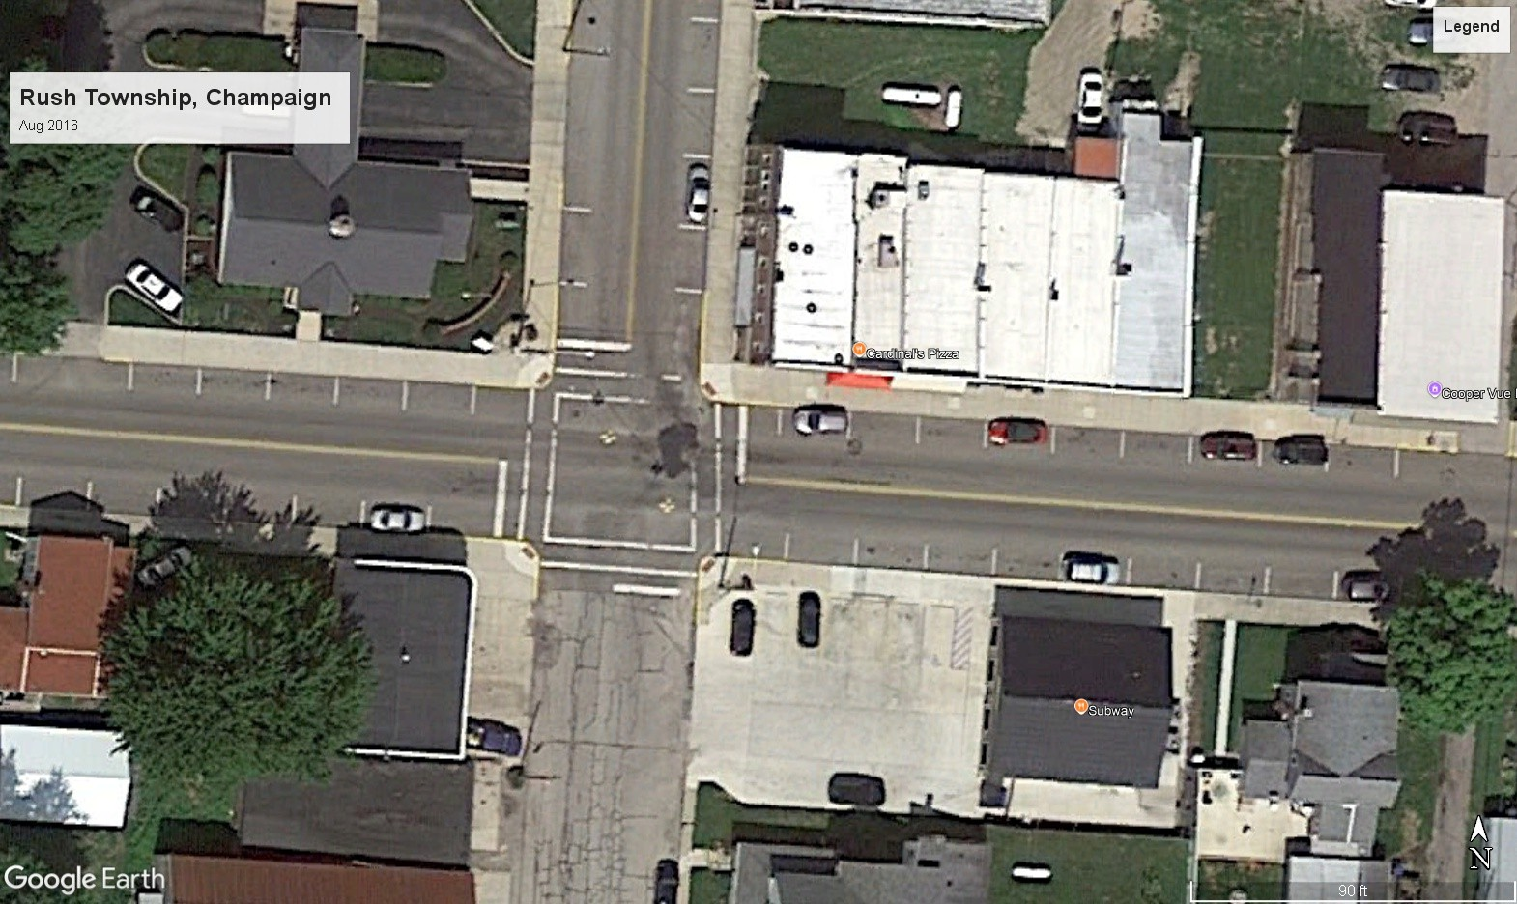

* + 1. 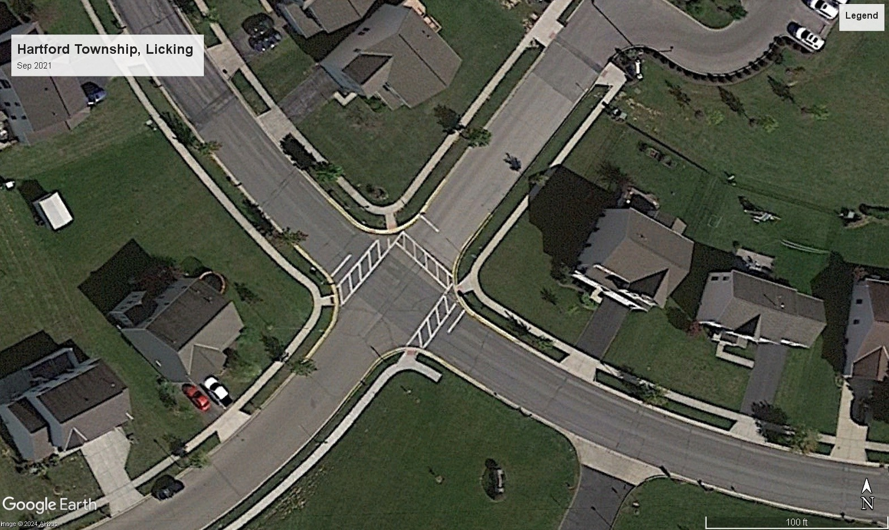A **Poor** Quality Road
    2. A **High** Quality Road

Figure 1: Road Quality Satellite images for Ohio

their corresponding base64 encoding and fine-tune the model on the road-image dataset for 10 epochs with a batch size of 9 and a learning rate multiplier of 2. In section 4.1, we present the results from our fine-tuned model, when applied on roads in areas with close elections within our effective bandwidth. For full details on the modeling methodology, fine-tuning results and robustness tests, see Suresh and Rawat (2025).

## Running Variable

The running variable plays a critical role in regression discontinuity, which in this study represents the proportion of votes against the renewal of a road tax levy.

A vote share of more than 50 means the renewal road tax levy fails and tax will no longer be collected, resulting in a stoppage of road funding via that particular tax levy. However, other road tax levies may continue to be in effect, and funds from current expense tax levies may still be used for road maintenance. There are 3,184 referendum results in our sample, 83% of which renew the tax, and 17% of which cut taxes and road maintenance. We quantify the size of the cut in road spending a city faces in two ways. The Great Financial Crisis falls in the middle of our dataset, so readers might wonder if voting behavior was affected, but we find vote share the same to two decimal points during and outside the years 2008-2009. Our key identification assumption is that the election results are not predetermined and vote share is not precisely manipulated to fall just above or below the cutoff. This assumption allows us to exploit the randomization around the cutoff and provides the variation needed to identify the causal effect of cutting road tax. We test this assumption using a density test

detailed below and covariate balance tests (see Appendix B).

**Density test.** Classic regression discontinuity design (RDD)sometimes you say RDD other times you say RD so be consistent assumption states that agents cannot precisely manipulate the running variable to fall just above or below the cutoff. In our context, it means that the election results are not determined prior to when the ballot takes place. In other words, no individuals, organizations, higher levels of government, foreign governments, or the firm that programs the voting machines are dictating the precise vote share for the renewal road tax levy referendums raised by a city. The standard way to test this assumption is to perform a density test like that of Cattaneo, Jansson and Ma (2020), which is based on the idea that manipulation of elections might cause a clustering of votes just to one side of the cutoff, with a pronounced drop-off on the other side of the cutoff. The *p*-value of this density test is 0.98. A histogram of vote share is shown in Figure 2 that graphically illustrates the lack of abrupt change in density.

Although Table 2 shows covariate balance between sets of cities that pass and fail to renew road tax levies, covariate values could still jump from one side of the cutoff to another. A drop in education levels, for example, could cause a drop in house prices that might coincide

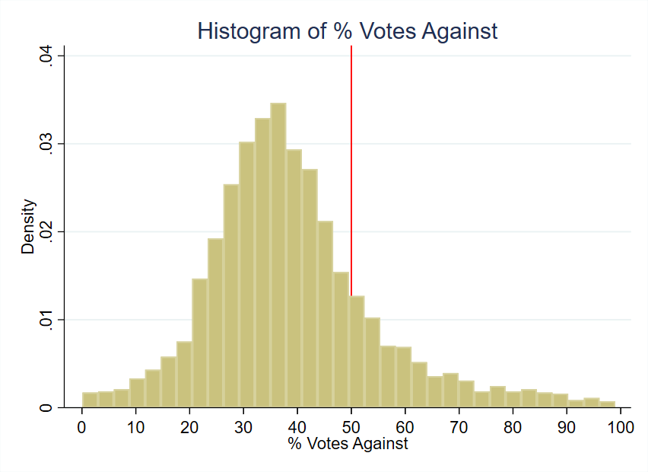

Figure 2: Histogram of Running Variable

with a change in treatment, so that what might look like a treatment effect from cutting taxes and spending might in fact be caused by lower education levels. Graphs of covariate smoothness around the cutoff are found in the Appendix B. A formal way to assess covariate smoothness is to use each covariate as an outcome variable in a regression of the running variable and a treatment effect dummy. When we do so, the *p*-value of the treatment effect dummy varies from 0.13 to 0.98, indicating no statistically significant jump in covariate values.

## Outcome Variables

**Median Housing Prices.** Our house price data comes from a CoreLogic dataset of actual sales transaction prices in Ohio from 1995 through 2021 containing over 7 million

observations. The dependent variable, *Median House Price*, reflects the median sale price of houses within a specific city and year. For example, for the houses sold in Delaware Township during the year 2002, the median sale price was $205,041. We take precaution to only include arm’s-length transactions, and we restrict our attention to single-family residential structures for comparability. The overall sample mean for the 10-year period from the time of vote considered in this study is $166,082 in constant 2010 dollars with a standard deviation of $372,135 which suggests the presence of some outliers. Although our use of median sale price addresses outliers, one of our robustness checks drops 1% tails and re- estimates the treatment effects. The mean for this winsorized sample is $150,375 in constant 2010 dollars with a standard deviation of $116,020.

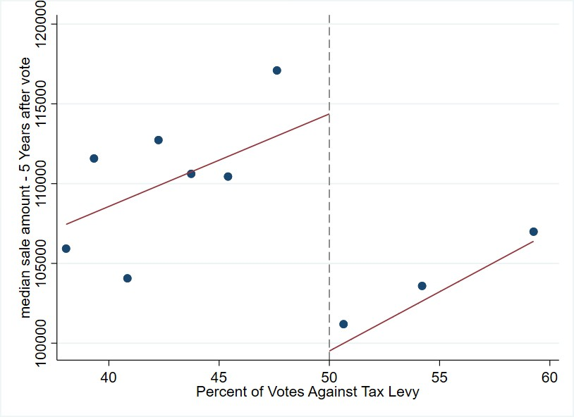

Figure 3: Median Sale Price of Homes: 5 years after vote

Figure 3 shows house prices from 5 years after the vote graphed against the percent of votes for the tax levy. The points represent the mean house price for the 10 representative bins of vote shares for the average effective bandwidth around the cutoff of 50%. The graph shows a clear discontinuity in house prices at the cutoff, which is the basis of our

identification strategy. We observe a sharp decline after the cutoff in house prices, indicating that the failure to renew a road tax levy has a negative impact on house prices.

## Covariates

Covariates can be useful in regression discontinuity studies, although they are not necessary for the identification of treatment effects. One use of covariates is to increase the precision of treatment effect estimates. The other is to see if cities that barely pass and fail tax levies are similar to each other like the theory of regression discontinuity says they should be. Table 2 shows covariate means for both the global sample of all votes in the data set as well as the local sample within a representative effective bandwidth of the 0.50 cutoff. The effective bandwidth displayed in Table 2 is the mean bandwidth for all the housing outcome regressions. The first columns for the global sample show similar values of characteristics between cities that renew and cut road taxes and spending, but it is the two rightmost columns that are critical for the credibility of the regression discontinuity design.

Table 2 demonstrates the covariate balance between cities that renew their tax levies and those that do not, indicating similar demographic and economic profiles across both groups. The data, captured at the time of the vote, shows minimal differences within the effective bandwidth: the mean population differs by only 301, and median family income varies by $436, measured in 2010 U.S. dollars. Other variables, including poverty rates, married household percentages, educational attainment, age distribution, and racial composition, show differences of two percentage point or less, bolstering the comparability of the two groups.

Table 2: Variable Means & Standard Deviation by Tax Levy Renewal Status

Variable Global Effective

|  |  |  |  |  |  |
| --- | --- | --- | --- | --- | --- |
|  | Full Sample | Renewed | Cut | Renewed (Control) | Cut (Treatment) |
| Population | 5,072 | 4,733 | 5,139 | 4,885 | 5,186 |
|  | (7,936) | (7,291) | (8,058) | (7,036) | (8,229) |
| Poverty Rate | 0.11 | 0.11 | 0.11 | 0.10 | 0.11 |
|  | (0.08) | (0.07) | (0.08) | (0.07) | (0.08) |
| % with Kids | 0.39 | 0.40 | 0.39 | 0.39 | 0.39 |
|  | (0.08) | (0.08) | (0.08) | (0.07) | (0.08) |
| % Households with | 0.09 | 0.09 | 0.09 | 0.09 | 0.08 |
| Children under 18  % Less than High | (0.06)  0.16 | (0.05)  0.18 | (0.06)  0.15 | (0.06)  0.18 | (0.05)  0.16 |
| School Education  % Some College Edu- | (0.11)  0.25 | (0.12)  0.24 | (0.11)  0.25 | (0.12)  0.24 | (0.10)  0.25 |
| cation  % Renters | (0.06)  0.20 | (0.06)  0.20 | (0.06)  0.20 | (0.07)  0.19 | (0.06)  0.20 |
|  | (0.11) | (0.10) | (0.11) | (0.09) | (0.11) |
| Unemployment Rate | 0.05 | 0.05 | 0.05 | 0.05 | 0.06 |
|  | (0.04) | (0.03) | (0.04) | (0.03) | (0.04) |
| % White | 0.96 | 0.97 | 0.96 | 0.97 | 0.97 |
|  | (0.07) | (0.07) | (0.07) | (0.07) | (0.08) |
| % Black | 0.02 | 0.02 | 0.02 | 0.02 | 0.02 |
|  | (0.07) | (0.06) | (0.07) | (0.07) | (0.07) |
| % Married | 0.59 | 0.60 | 0.59 | 0.61 | 0.60 |
|  | (0.09) | (0.08) | (0.09) | (0.08) | (0.09) |
| % Separated | 0.01 | 0.01 | 0.01 | 0.01 | 0.01 |

Continued on next page

### Table 2 – continued from previous page

Variable Global Effective

|  |  |  |  |  |
| --- | --- | --- | --- | --- |
| Full Sample | Renewed | Cut | Renewed (Control) | Cut (Treatment) |
| (0.01) | (0.01) | (0.01) | (0.01) | (0.01) |
| Income Heterogeneity 0.10 | 0.09 | 0.10 | 0.09 | 0.09 |
| Index (0.08) | (0.07) | (0.08) | (0.07) | (0.06) |
| Median Family In- 61,018 | 58,761 | 61,467 | 59,934 | 60,370 |
| come (17,649) | (13,915) | (18,270) | (13,655) | (15,713) |
| % Under 5 Years Old 0.06 | 0.06 | 0.06 | 0.06 | 0.06 |
| (0.02) | (0.02) | (0.02) | (0.02) | (0.02) |
| % Aged 5 to 17 0.20 | 0.21 | 0.20 | 0.20 | 0.20 |
| (0.05) | (0.04) | (0.05) | (0.04) | (0.05) |
| % Aged 18 to 64 0.60 | 0.60 | 0.60 | 0.60 | 0.60 |
| (0.05) | (0.05) | (0.05) | (0.04) | (0.05) |
| % Racial Minority 0.04 | 0.03 | 0.04 | 0.03 | 0.03 |
| (0.07) | (0.07) | (0.07) | (0.08) | (0.07) |
| Number of Observa- 3,184 | 2,656 | 528 | 653 | 269 |

tions

Table 2 shows that the treatment and control groups are well-balanced with respect to the covariates considered, suggesting that the groups are comparable and any observed differences in outcomes can more confidently be attributed to the treatment effect rather than to pre-existing differences.

# Empirical Strategy

In this section, we describe our empirical strategy to estimate the causal effect of cutting road maintenance spending on different outcome variables. One key feature of our quasi-

experiment design is the exogeneity of the timing of the election. The timing is determined by the natural expiration of a road maintenance tax levy, which is typically 5 years, and is not impacted by factors such as the prevailing economic conditions or whether a road tax levy was passed or failed in earlier years.

## Regression Discontinuity in Panel Data setting

Suppose that local government in area *i* and year *t* has to conduct a referendum to renew its road tax levy. The referendum is conducted to determine whether the road maintenance tax levy should be renewed or not. Let *vit* be the vote share against the renewal tax levy and *v*∗ be the threshold determining the result of the referendum (levy fails to renew if *vit > v*∗). Let *Fit* = 1(*vit > v*∗) be an indicator to represent if the renewal road tax levy fails, and *yit* be some outcome variable of interest. We can write,

*yit* = *α* + *θFit* + *ϵit*

get rid of paragraph indentationwhere *α* is the intercept, *θ* is the parameter of interest representing the causal effect of renewing a road tax levy and *ϵit* is the error term representing all other determinants of the outcome. Then, around a narrow enough window around the threshold *v*∗, we can estimate the causal effect of renewing a road tax levy on the outcome variable *yit* by comparing the outcome variable for cities that narrowly passed the referendum to those that narrowly failed the referendum

## Intent-to-Treat (ITT) Estimator

We follow a model of Regression Discontinuity Design (RDD) similar to Cellini, Ferreira and Rothstein (2010) and estimate the **Intent-to-Treat** or ITT estimator. We prefer using ITT estimator instead of the alternative **Treatment on the Treated** (TOT) estimator because the ITT estimator is more suited to our setting given the independence of the

renewal elections. As described in Cellini, Ferreira and Rothstein (2010), when the elections are independent, the ITT estimator equals the TOT estimator.

We operationalize our ITT estimator using the following regression equation:

*Yi,t*+*τ* = *ατ* + *κt* + *FitθIT T* + *Pg* (*vit, γτ* ) + *Zitβτ* + *ϵi,t*+*τ*

*τ*

No paragraph indentataion Above, we have a city *i* that holds an election in year *t* and we study this city's outcome *τ* years later. *Yi,t*+*τ* represent the outcome variable for city *i* at year *t* + *τ* . The outcome variables we study is median house prices at city-year level. We define treatment as failure of a city, village or township to renew its

road maintenance tax levy, which is represented by the indicator *Fit* and *θIT T*

*τ*

is the causal

effect of failing to renew road tax on the outcome. *Pg*(*vit, γτ* ) is a polynomial function of the running variable *vit*, which is the percent of votes against the renewal tax levy. *ατ* and *κt* represent timing and year-specific fixed effects. we already said thisWe use the bandwidth selection method described in Calonico et al. (2019) to find the mean optimal bandwidth *h* and then conduct a local polynomial regression after choosing a weighting scheme *k*. The bandwidth *h* determines the size of the neighborhood around the cutoff *v*∗, defined as (*v*∗ *−h, v*∗ + *h*). Only observations within this neighborhood are used to compute the bias-corrected treatment effect estimate *τ*ˆ (as per Calonico et al. (2019)). For a sufficiently small neighborhood, the continuity assumption central to the RDD estimator is considered valid. We also cluster the standard errors by municipality to account for any serial correlation between years within each municipality. The weighting scheme *k* determines the weights of the observations within the neighborhood (*v*∗ *− h, v*∗ + *h*) and is crucial in estimating *θτ* . Common weighting schemes include uniform, triangular, and Epanechnikov. We use the default Mean Squared Error Regression Discontinuity (MSERD) method to compute the effective bandwidth (*h*) and bias bandwidth (*b*) for each outcome

*τ*

Variable there is only one outcome variable now. This method identifies the bandwidth that minimizes the trade-off between bias and variance of the treatment effect estimate. All observations are used to estimate *h* and *b*, but only those within the effective bandwidth *h* are used to identify our treatment effect estimates *θτ* for different *τ* years.

# Results

## Road Quality Decline

To assess the impact of cutting local road taxes on road quality, we utilized a fine-tuned Vision Transformer (ViT) model, leveraging labeled satellite imagery data for U.S. roads. The ViT model, fine-tuned using a large dataset of road images, assigns quality ratings on a scale of 0 (poor) to 2 (high) to our collected satellite imagery for Ohio neighborhoods, as explained in Section 2.3. We compare road quality ratings from the fine-tuned ViT model before and after the referendum in areas that fail to renew their road tax levy versus those that successfully pass the levy. The results are summarized in Table 3.

Table 3: Effect of Referendum Outcome on Road Quality

### Cut Levies Maintained Levies

Change in Road Quality after a Referendum -0.444** 0.067

(0.210) (0.340)

*Notes:* Each column represents a separate regression of the predicted road-quality classi- fication variable on an indicator for the post-election period for areas with close elections, as determined by the effective bandwidth around the RD cutoff. “Cut Levies” refers to jurisdictions that failed to renew their road tax levies, while “Maintained Levies” refers to jurisdictions that renewed. Standard errors are shown in parentheses.

Significance levels: *p *<* 0.10, **p *<* 0.05, ***p *<* 0.01.

Areas that cut their renewal road tax levies experienced an average decline in road qual- ity ratings of -0.444 points, equivalent to a 15% deterioration in road quality relative to the

three-point scale.3 In contrast, areas that maintained their tax levies experience did not experience a statistically significant change, suggesting effectively no deterioration in road quality. In neighborhoods where renewal taxes were cut, the decline in road quality high- lights the potential long-term implications of fiscal policy decisions on public infrastructure maintenance.

## House Prices Decline

Table 4 below shows the ITT estimates of failing a road tax levy on housing sale prices starting four years after the vote.

Table 4: Effect on median house prices of failing to renew a road tax levy

|  |  |  |  |  |  |  |  |
| --- | --- | --- | --- | --- | --- | --- | --- |
| Year rela-  tive to vote | *t* + 4 | *t* + 5 | *t* + 6 | *t* + 7 | *t* + 8 | *t* + 9 | *t* + 10 |
| Treatment | -21,638 | -22,271 | -17,336 | -15,975 | -21,993 | -19,857 | -16,090 |
| effect |  |  |  |  |  |  |  |
| Standard | (7,731) | (8,864) | (8,331) | (7,248) | (9,079) | (7,751) | (9,027) |
| error |  |  |  |  |  |  |  |
| Effective | 8.540 | 10.796 | 9.840 | 13.158 | 8.246 | 7.285 | 6.241 |
| bandwidth |  |  |  |  |  |  |  |
| (*h*) |  |  |  |  |  |  |  |
| Bias band- | 16.379 | 19.879 | 17.397 | 23.413 | 15.255 | 14.091 | 16.266 |
| width (*b*) |  |  |  |  |  |  |  |
| Effective | 688 | 883 | 769 | 1,061 | 591 | 505 | 402 |
| Observa- |  |  |  |  |  |  |  |
| tions |  |  |  |  |  |  |  |
| Total Ob- | 2,614 | 2,531 | 2,438 | 2,324 | 2,199 | 2,115 | 2,017 |
| servations |  |  |  |  |  |  |  |

Outcome is median house price in constant 2010 U.S. dollars. Unit of observation is the city-year, so a treatment effect of -$21,638 means that four years after the vote, cities that failed to renew road taxes and its associated spending have houses that sell for $21,638 less than cities that vote to renew road taxes and spending. Treatment effects for years prior to *t* + 4 are statistically insignificant at the 5% level; full results shown in Table

9. The regressions include covariates related to the demographics and socioeconomic factors of the cities, drawn from Table 2.

Each treatment effect estimate represents the discount in median sale price for cities that

3Calculated as -0.444/3 = 15%.

cut road taxes in the years after voting on a road tax levy relative to otherwise similar cities that renew the taxes. Treatment effect estimates for years 4 through 9 after the vote are statistically significant in Table 4 as the *p*-values are below the canonical 0.05 threshold. The estimate for year *t* + 10 has a smaller estimate and is only significant at the 10% level, suggesting that the effect of tax and service cuts on house prices may peter out ten years after the vote. Overall, we find an average reduction of $15,349 in median house price over the 10 year period for houses in cities that vote to cut road tax levies representing 9% of overall house value.4

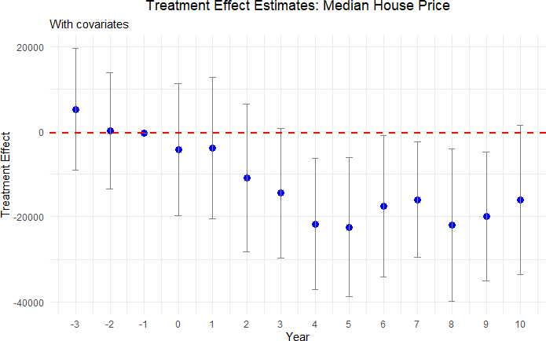

Figure 4: Effect plot for Median Housing Price

Figure 4 provides an event-study plot that summarizes the treatment effects for each time period. In the graph, we include placebo years up to 3 years before the treatment to show that the median housing prices are statistically identical for cities above and below the

4The average treatment effect estimate of $15,349 was divided by the mean home sale price in the dataset of $166,000 to get 9%.

threshold prior to the treatment. Each blue dot represents the treatment effect estimate for that year and the bar around it represents the 95% confidence interval for that estimate. For year 0, which is the year of the vote, we see a slight decrease in the estimate. However, this effect is not statistically significant, as evidenced by the confidence interval containing the null effect. Up to year 3, we observe that the treatment effect estimates are fairly close to zero, and the confidence interval overlaps with zero. As stated previously and shown in Table 4, we start to see a sizable increase in treatment effect from year 4 onwards and continue to observe it through year 9 after the vote.

## Heterogeneity Analysis

We show the results of our heterogeneity analysis, where we explore the differential impact of cutting road maintenance spending on house prices in urban and rural neighborhoods, the size of the tax levy and housing price quantiles.

**Urban vs Rural neighborhoods**: We first compare treatment effects in urban and rural areas. We consider two different ways to define a city as urban: one including only urbanized areas and another one including both urban areas and urbanized clusters. The event study plot in Figure 6 shows this result.

As shown by Figure 5, we do not find any significant differences in housing prices after a renewal tax levy fails to pass for rural areas. On the other hand, we do find a statistically significant decline in housing prices in urban areas starting six years after voting. The standard errors are somewhat smaller for the rural estimates due to a larger number of observations. The difference in point estimates between urban and rural areas may stem from differences in housing supply elasticity (Brasington 2002). Overall, we find that housing

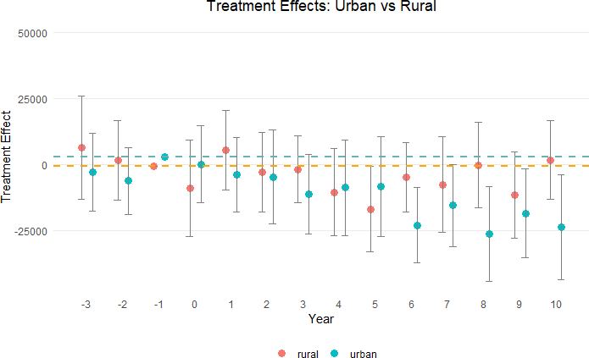

Figure 5: Median Housing Price in Urban and Rural Areas

prices decrease by $13,302 on average over the decade5 after cutting road maintenance tax levies in urban areas.

**Tax magnitude**: We check for dose-response by seeing whether the treatment effect is greater for bigger tax levies than smaller tax levies. For this analysis, we split the tax levies into two parts: small tax levies *≤* 1.9 mills and large tax levies *>* 1.9 mills. Figure 6 illustrates the results.

All the years before the reduction in road spending have treatment effect estimates with

175*,*217

5This is equal to 7*.*6% =  13*,*302 *×* 100, where the denominator is average sale price of homes in urban

areas in our dataset.

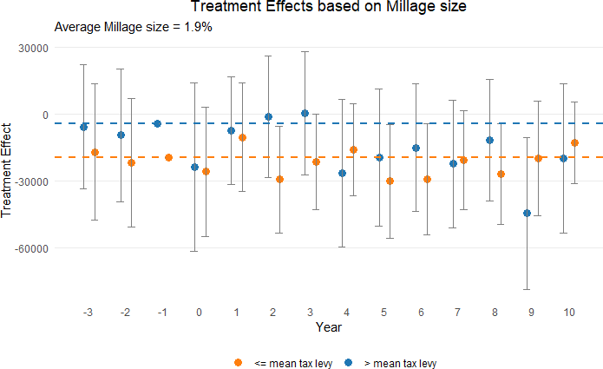

Figure 6: Median Housing Price based on Millage size

confidence intervals containing zero. Starting in year *t*+2, we observe statistically significant treatment effects in some years after the vote such as years 5, 6 and 8 that show a for tax levies with millage size equal to or below the mean. However, we do not see a consistent decrease in housing prices. Hence, we conclude that the decrease in housing prices of cities that fail to maintain their roads does not vary significantly based on the size of the tax levy.

**RDD Quantile Estimation**: We further analyze our results by estimating quantile- level treatment effects, as suggested by Frandsen et al. (2012), to study how the treatment’s impact varies at different quantiles of the outcome variable.

Table 5 shows the treatment effect heterogeneity of cutting road spending on high and low quantiles of median house prices. The top percentiles consistently exhibit a statistically significant decline in house sale prices, beginning in year 6 after the reduction in road spend- ing. In contrast, the lower percentiles do not demonstrate a consistent treatment effect. This

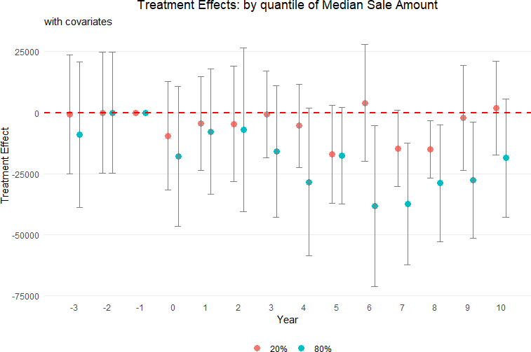

Figure 7: Median Housing Price based on Quantiles: 20% and 80%

Table 5: Quantile-level Treatment Effects of Cutting Road Spending on Median House Prices

|  |  |  |  |  |  |  |  |
| --- | --- | --- | --- | --- | --- | --- | --- |
| Percentile | *t* + 4 | *t* + 5 | *t* + 6 | *t* + 7 | *t* + 8 | *t* + 9 | *t* + 10 |
| 10% | -6,433 | -22,570 | -9,602 | -12,984 | -11,217 | -6,569 | -1,326 |
|  | (9,364) | (9,065) | (9,205) | (8,420) | (9,136) | (10,809) | (8,793) |
| 20% | -5,400 | -15,070 | 4,014 | -14,682 | -15,040 | -3,228 | 624 |
|  | (9,983) | (9,886) | (7,443) | (8,502) | (8,160) | (10,435) | (8,509) |
| 70% | -21,760 | -11,171 | -38,082 | -36,685 | -21,356 | -25,605 | -18,600 |
|  | (12,333) | (11,806) | (12,835) | (12,163) | (12,218) | (13,984) | (9,872) |
| 80% | -28,478 | -16,379 | -38,460 | -37,470 | -28,950 | -27,800 | -18,658 |
|  | (13,343) | (11,404) | (18,623) | (12,169) | (12,507) | (12,421) | (11,808) |
| 90% | -51,470 | -34,604 | -38,510 | -27,039 | -29,010 | -49,093 | -36,662 |
|  | (18,409) | (15,837) | (22,194) | (16,308) | (16,640) | (14,498) | (19,110) |

The outcome is median house price in constant 2010 U.S. dollars. The unit of observation is the city-year, so a treatment effect of -$28,478 means that at the 80th percentile of house prices four years after the vote, cities that fail to renew road taxes and the associated spending have houses that sell for $28,478 less than cities that vote to renew road taxes and spending. The regressions include covariates related to the demographics and socioeconomic factors of the cities, drawn from Table 2.

suggests a differential impact, where higher-valued properties are more sensitive to road dis- repair than lower-valued houses. Figure 7 contrasts the treatment effects of the 20th and 80th percentiles of home sale prices in an effect plot to highlight this differential impact of reduction in road maintenance spending.

## Robustness Tests

We conduct several robustness tests to ensure the validity of our results. We test the sensi- tivity of our results to different bandwidths, covariates, and functional forms. We also check for the presence of pre-trends and perform a placebo test to confirm the validity of our RDD.

**Removing contradictory observations**: In this test, we focus on ensuring the inde- pendence and exogeneity of our dataset. Estimates may be biased if tax levies for additional money pass after renewal tax levy decisions. To address this concern, we exclude observations from our analysis if a tax levy for additional funding

is introduced and passed within a ten-year period following a renewal tax levy vote. For example, consider a scenario where a city votes on a renewal tax levy in the year 2000. If that city subsequently introduces and passes a tax levy for additional road spending in 2004, we ex- clude all votes for that city from 2005 through 2010. This exclusion ensures that the effect on house prices from the 2000 vote are captured for uncontaminated years but not for years after 2004 when the effect of additional road taxes may counteract the drop in tax money from the year 2000 vote. It allows us to isolate and examine the pure impact of the drop in funding from failing renewal levies on housing prices.

Table 6: Effect on Median Sale Amount of Failing to Renew a Road Tax Levy

|  |  |  |  |  |  |  |  |
| --- | --- | --- | --- | --- | --- | --- | --- |
| year relative to  vote | *t* + 4 | *t* + 5 | *t* + 6 | *t* + 7 | *t* + 8 | *t* + 9 | *t* + 10 |
| Treatment | -19,015 | -15,609 | -18,403 | -20,842 | -18,950 | -28,634 | -23,823 |
| effect |  |  |  |  |  |  |  |
| standard error | (9,563) | (10,283) | (10,246) | (9,629) | (9,179) | (7,770) | (10,594) |
| Effective band- | 6.88 | 5.92 | 8.36 | 9.42 | 7.91 | 5.43 | 7.05 |
| width (h) |  |  |  |  |  |  |  |
| Bias bandwidth | 12.14 | 15.94 | 14.53 | 17.87 | 15.24 | 11.90 | 17.33 |
| (b) |  |  |  |  |  |  |  |
| Effective Ob- | 475 | 389 | 561 | 611 | 475 | 300 | 374 |
| servations |  |  |  |  |  |  |  |
| Total Observa- | 2,389 | 2,274 | 2,145 | 2,016 | 1,890 | 1,787 | 1,666 |
| tions |  |  |  |  |  |  |  |

The outcome is median house price in constant 2010 U.S. dollars. The unit of observation is the city-year, so a treatment effect of -$19,015 means that four years after the vote, cities that fail to renew road taxes and its associated spending have houses that sell for

$19,015 less than cities that vote to renew road taxes and spending. The regressions include covariates related to the demographics and socioeconomic factors of the cities, drawn from Table 2.

Upon implementing this data filtration, we observe that the treatment effect of the re- newal levies on housing prices, measured from *t* + 1 to *t* + 10, remains largely consistent with our initial findings. This consistency in treatment effect, despite the exclusion of potentially confounding data, lends further credence to our results. The standard errors increase slightly

due to reduction in sample size caused by the aforementioned data filtration process.

**Placebo cutoffs**: In our primary analysis, the pivotal threshold for the vote share running variable is 50%, indicating whether a renewal levy passes or fails. Although we find significant treatment effects using this 50% threshold, it could be random jumps in the data rather than cutting road taxes and funding that are responsible for the significant estimates. To this end we conduct a series of placebo tests using alternative cutoffs: 30%, 40%, 60%, and 70%. Table 7 below summarizes the results from the placebo cutoffs analysis.

Table 7: Robust Treatment Effect Estimate for Placebo Cutoffs

|  |  |  |  |  |
| --- | --- | --- | --- | --- |
| Years after | 30% | 40% | 60% | 70% |
| vote |  |  |  |  |
| *t* + 4 | 2,578 | 9,149 | 9,419 | -12,987 |
|  | (8,209) | (7,284) | (11,462) | (14,365) |
| *t* + 5 | -6,381 | -29,077 | 6,383 | 41,683 |
|  | (9,086) | (20,680) | (10,786) | (17,836) |
| *t* + 6 | 7,681 | 5,573 | -1,095 | -14,226 |
|  | (9,616) | (8,120) | (8,612) | (15,733) |
| *t* + 7 | 1,162 | 3,982 | -12,050 | 22,261 |
|  | (10,468) | (8,191) | (9,396) | (19,765) |
| *t* + 8 | 4,334 | 12,881 | 3,593 | 31,696 |
|  | (9,670) | (8,625) | (10,061) | (6,902) |
| *t* + 9 | 851 | 7,381 | -6,935 | 42,790 |
|  | (5,921) | (6,333) | (7,114) | (15,663) |
| *t* + 10 | 10,032 | -35,038 | 324 | -8,566 |
|  | (10,599) | (35,569) | (8,220) | (17,281) |

*Notes:* Robust treatment effect estimate for placebo cutoffs as per the estimator from Calonico et al. (2017). The unit of observation is city-year level. Standard errors are shown in parentheses below each estimate.

Table 7 does not show consistently significant treatment effects for any of the placebo cutoffs for our parameter of interest. This absence of significance at thresholds other than the true 50% reinforces the idea that the effects we observe at the 50% mark are not a mere coincidence or a result of random variation in the data, but are indeed attributable to the dynamics surrounding the passing or failing of renewal tax levies.

**Winsorization**: The debate over whether to include or exclude outliers continues, with some research suggesting that trimming outliers does not improve mean squared error (e.g.,

Bollinger and Chandra, 2005). We now drop the 1% tails to help curtail the influence of outliers. The overall sample mean after dropping 1% tails is $144,268 in constant 2010 dollars with a standard deviation of $109,624 these are different than the figures given for the winsorized sample on p. 16. After performing this winsorization step, we re-estimate the treatment effect of failing to renew a road tax levy on housing outcome variables. The results from this estimation process are summarized in Figure 8 below:

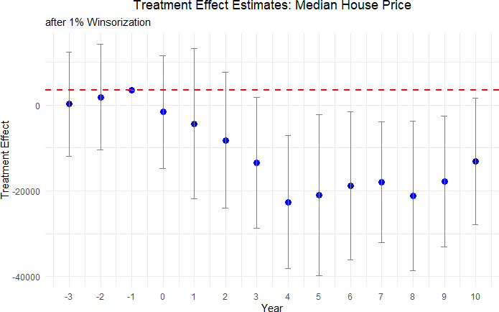

Figure 8: Median Housing Price after 1% Winsorization

The treatment effect estimates with winsorization mimic those from our baseline regres- sion results qualitatively and quantitatively.

**Covariate Discontinuity**: A fundamental RDD assumption is that observations just above and below the threshold are comparable in all aspects except for treatment status. Ta- ble 12 presents balance tests across key community characteristics at the voting threshold. As shown, demographic and socioeconomic variables—including population size, poverty rates, educational attainment, employment status, and racial composition—exhibit no statistically significant discontinuities at the cutoff. The absence of any discontinuity suggests that our

estimated effects on housing prices represent the impact of failing to renew road tax levies rather than pre-existing community differences. This balance verification via a formal RD test, using covariates as the outcome variable, further strengthens our conclusion that the observed housing price effects stem directly from decisions regarding road tax levies, not from underlying differences in community characteristics.

Table 8: Covariate Discontinuity Test Results

|  |  |  |  |  |
| --- | --- | --- | --- | --- |
| Variable | Estimate | Standard  error | p-value | Confidence  interval |
| Population | -388 | 1,094 | 0.722 | [-2,532, |
|  |  |  |  | 1,755] |
| Poverty Rate | 0.017 | 0.014 | 0.234 | [-0.011, |
|  |  |  |  | 0.045] |
| % with Kids | -0.007 | 0.012 | 0.539 | [-0.030, |
|  |  |  |  | 0.015] |
| % Households with Children under 18 | 0.0001 | 0.007 | 0.981 | [-0.014, |
|  |  |  |  | 0.014] |
| % Less than High School Education | -0.004 | 0.020 | 0.834 | [-0.043, |
|  |  |  |  | 0.035] |
| % Some College Education | -0.012 | 0.011 | 0.274 | [-0.034, |
|  |  |  |  | 0.009] |
| % Unemployment Rate | -0.002 | 0.006 | 0.733 | [-0.013, |
|  |  |  |  | 0.009] |
| % Renters | -0.005 | 0.015 | 0.754 | [-0.035, |
|  |  |  |  | 0.025] |
| % White | -0.007 | 0.011 | 0.499 | [-0.028, |
|  |  |  |  | 0.014] |
| % Black | -0.004 | 0.009 | 0.685 | [-0.021, |
|  |  |  |  | 0.014] |
| % Married | -0.013 | 0.015 | 0.374 | [-0.042, |
|  |  |  |  | 0.016] |
| % Separated | 0.001 | 0.002 | 0.485 | [-0.002, |
|  |  |  |  | 0.004] |

*Notes:* Estimates indicate the treatment effect of failing to renew a road maintenance tax levy on each covariate considered during our study. Confidence intervals are presented in square brackets.

# Mechanisms

A key question surrounding our findings is *why* cutting road taxes would lead to a sustained decline in local house prices. In this section, we argue that these results are consistent with classical insights from the literature on local public finance, especially the work of Tiebout (1956) and Oates (1972). Specifically, cutting road-maintenance tax levies reduces local government funds, which in turn constrains the government’s ability to provide road-upkeep services. This deterioration in road quality then directly and indirectly lowers housing values. Three interconnected channels explain this relationship.

**Road Tax Cuts and Reduced Road Maintenance Funds.** Local governments in Ohio, like those in many other U.S. states, rely on property taxes and dedicated road levies to fund local public goods. The Oates (1972) decentralization theorem highlights that local authorities can generally provide public services in a manner better aligned with resident preferences than would a higher-level government, provided they have adequate revenue sources. When a renewal levy fails at the ballot box, one of these critical revenue sources vanishes. Consistent with the premise that local road quality is a “local public good,” losing a dedicated revenue stream substantially weakens a city’s ability to maintain or upgrade roads. Empirically, we surmise the size of the drop in maintenance funds available to local governments (see Section 1 do we? I don't see where it is).

**Declining Road Quality.** Results from our AI model-based road-quality measure in Section 4.1 show a marked decrease in road quality following the cessation of renewal levies. The resulting deterioration in road quality may be accompanied by ride discomfort, declining aesthetics, and reduced usability of neighborhood roads. This is precisely what a local public goods framework would predict: fewer financial resources for upkeep immediately impact the

daily “consumption” of roads. Residents observe these changes slowly over time, often after four to five years, before road conditions become visibly poor.

**Capitalization into house Prices.** Falling road quality imposes a disamenity on local residents. As recognized by Oates (1969), property values in a community incorporate expectations of both the level of taxation and the quality of local services. While homebuyers benefit from understanding they might pay lower property taxes in a municipality with a failing levy, they also factor in the anticipated (and eventually realized) deterioration of roads. Several mechanisms help explain the ultimate discount in property values:

1. **Appearance and Neighborhood Appeal.** Rough roads, potholes, and poorly patched surfaces reduce aesthetic appeal. Potential buyers, seeing visible signs of neglect, bid less.
2. **Vehicle Damage and Travel Costs.** Chronic maintenance problems translate into higher expenditures on tires, suspensions, and alignments, as well as more time lost to slower commutes.
3. **Expectation of Reduced Public Services.** A failed renewal levy may signal broader fiscal stringency, causing residents to expect other future service cutbacks. Uncertainty about service levels weighs negatively on property values.

**Short-Run versus Long-Run Trade-Off.** Importantly, a trade-off emerges over time. In the short run, residents who voted down the road tax levy experience immediate relief in terms of lower property tax bills. Their out-of-pocket expenses decline, which can be a tangible financial benefit—particularly in communities where property tax burdens were

already viewed as high. However, as road quality starts to visibly deteriorate from around the fourth year onward (see 4), the same residents find themselves negatively affected by a decline in house prices. This lag reflects the time it takes for infrastructure disrepair to become apparent, be it through more frequent potholes or visibly eroding surfaces. By the time these problems are evident, the neighborhood’s real-estate market has had sufficient time to register the disamenity, capitalizing it as a discount in property values. This dynamic captures a fundamental insight of local public finance: the preferences of current taxpayers can diverge from the longer-term public interest (Buchanan and Tullock, 1962; Alesina and Tabellini, 1990).

# Conclusion

A great deal of existing research has focused on the effect of new roads on house prices, es- pecially in developing nations, providing valuable policy insights and spurring development

initiatives like China’s Belt (Huang, 2016) and Road Initiative and India’s Pradhan Mantri Gram Sadak Yojana (Asher and Novosad, 2020). However, the endogeneity of road place- ment makes it difficult to identify causal effects. In this paper, we study taxes that fund maintenance of existing roads and avoid endogeneity issues by utilizing a quasi-experiment setting that naturally arises from the voted levies enacted by local governments in Ohio. We study more than 3,000 referendums raised by cities, villages, and townships to renew local road taxes funding existing roads and use ITT RD estimator inspired by Cellini, Ferreira and Rothstein (2010) to estimate the effect of failure to renew a levy on housing prices.

We also compute the loss in funding experienced by local governments when they face a tax cut due to failure of a renewal tax levy and fine-tune a Vision Transformer model to predict and identify the changes in road quality in these areas. We find an average decline of 15% in road quality in areas that cut their renewal taxes and a decline in home sale price of 9% over the 10-year period. We find no anticipation effects, unlike Beenstock, Feldman and Felsenstein (2016) and Diao, Leonard and Sing (2017), but we find statistically significant effects starting in the fourth year after the vote and continuing at least through the ninth year. We find these effects to be more consistent for urban rather than rural areas. We find a lack of dose-response based on the size of the levy, but we find larger house price reductions for more expensive houses than for cheaper houses.

Future research could extend the regression discontinuity identification strategy we employ to other geographies, using vote share as a running variable for places that vote on road spending, or using time as a running variable for cities that directly change road spending without a referendum. Moreover, it could also shift away from studying votes to maintain spending toward studying votes to increase road spending, although the endogeneity of choosing when to propose such a referendum makes identification for such settings more challenging.

# References

**Achiam, Josh, Steven Adler, Sandhini Agarwal, Lama Ahmad, Ilge Akkaya, Flo- rencia Leoni Aleman, Diogo Almeida, Janko Altenschmidt, Sam Altman, Shya-** **mal Anadkat, et al.** 2023. “Gpt-4 technical report.” *arXiv preprint arXiv:2303.08774*.

**Adukia, Anjali, Sam Asher, and Paul Novosad.** 2020. “Educational investment re- sponses to economic opportunity: Evidence from Indian road construction.” *American* *Economic Journal: Applied Economics*, 12(1): 348–376.

**Alesina, Alberto, and Guido Tabellini.** 1990. “A Positive Theory of Fiscal Deficits and Government Debt.” *Review of Economic Studies*, 57(3): 403–414.

**Asher, Sam, and Paul Novosad.** 2020. “Rural roads and local economic development.”

*American Economic Review*, 110(3): 797–823.

**Beenstock, Michael, Daniel Feldman, and Daniel Felsenstein.** 2016. “Hedonic pricing when housing is endogenous: The value of access to the trans-Israel highway.” *Journal of* *Regional Science*, 56(1): 134–155.

**Boesen, Ulrik.** 2021. “How Are Your State’s Roads Funded?” Accessed: 2025-01-23.

**Brasington, David M.** 2002. "Edge versus center: Finding common ground in the capitalization debate." *Journal of Urban Economics*, 52(3): 524-541.

**Brasington, David M.** 2017. “School spending and new construction.” *Regional Science* *and Urban Economics*, 63: 76–84.

**Brewer, Ethan, Jason Lin, Peter Kemper, John Hennin, and Dan Runfola.** 2021. “Predicting road quality using high resolution satellite imagery: A transfer learning ap- proach.” *Plos one*, 16(7): e0253370.

**Buchanan, James M., and Gordon Tullock.** 1962. *The Calculus of Consent: Logical* *Foundations of Constitutional Democracy.* Ann Arbor: University of Michigan Press.

**Calonico, Sebastian, Matias D Cattaneo, Max H Farrell, and Roc´ıo Titiunik.** 2017. “rdrobust: Software for regression-discontinuity designs.” *The Stata Journal*, 17(2): 372– 404.

**Calonico, Sebastian, Matias D Cattaneo, Max H Farrell, and Roc´ıo Titiunik.** 2019. “Regression discontinuity designs using covariates.” *Review of Economics and Statistics*, 101(3): 442–451.

**Cattaneo, Matias D, Michael Jansson, and Xinwei Ma.** 2020. “Simple local polyno- mial density estimators.” *Journal of the American Statistical Association*, 115(531): 1449– 1455.

**Cellini, Stephanie R, Fernando Ferreira, and Jesse Rothstein.** 2010. “The value of school facility investments: Evidence from a dynamic regression discontinuity design.” *The Quarterly Journal of Economics*, 125(1): 215–261.

**Currier, Lauren, Edward L Glaeser, and Gabriel E Kreindler.** 2023. “Infrastructure Inequality: Who Pays the Cost of Road Roughness?” National Bureau of Economic Research Working Paper w31981.

**Diao, Mi, Devon Leonard, and Tien Foo Sing.** 2017. “Spatial-difference-in-differences models for impact of new mass rapid transit line on private housing values.” *Regional* *Science and Urban Economics*, 67: 64–77.

**Dosovitskiy, Alexey.** 2020. “An image is worth 16x16 words: Transformers for image recognition at scale.” *arXiv preprint arXiv:2010.11929*.

**Federal Reserve Bank of St. Louis.** 2024. “Local Governments in the U.S.: A Breakdown by Number and Type.” *Regional Economist*.

**Gibbons, Stephen, and Stephen Machin.** 2005. “Valuing rail access using transport innovations.” *Journal of Urban Economics*, 57(1): 148–169.

**Gibbons, Stephen, Teemu Lyytik¨ainen, Henry G Overman, and Rosa Sanchis- Guarner.** 2019. “New road infrastructure: The effects on firms.” *Journal of Urban Eco-* *nomics*, 110: 35–50.

**Hettige, Hemamala.** 2006. *When do rural roads benefit the poor and how? An in-depth* *analysis based on case studies.* Asian Development Bank.

**Hoogendoorn, Sander, Jochem van Gemeren, Paul Verstraten, and Kees Folmer.** 2019. “House prices and accessibility: Evidence from a quasi-experiment in transport infrastructure.” *Journal of Economic Geography*, 19(1): 57–87.

**Huang, Yiping.** 2016. “Understanding China’s Belt & Road initiative: motivation, frame- work and assessment.” *China Economic Review*, 40: 314–321.

**Kohlhase, Janet E.** 1991. “The impact of toxic waste sites on housing values.” *Journal of* *Urban Economics*, 30(1): 1–26.

**Lee, David S, and Thomas Lemieux.** 2010. “Regression discontinuity designs in eco- nomics.” *Journal of Economic Literature*, 48(2): 281–355.

**Levkovich, Oleg, Jan Rouwendal, and Rolf Van Marwijk.** 2016. “The effects of highway development on housing prices.” *Transportation*, 43(2): 379–405.

**Li, Shanjun, Jun Yang, Ping Qin, and Shouyang Chonabayashi.** 2016. “Wheels of fortune: Subway expansion and property values in Beijing.” *Journal of Regional Science*, 56(5): 792–813.

**Oates, Wallace E.** 1969. “The Effects of Property Taxes and Local Public Spending on Property Values: An Empirical Study of Tax Capitalization and the Tiebout Hypothesis.” *Journal of Political Economy*, 77(6): 957–971.

**Oates, Wallace E.** 1972. *Fiscal Federalism.* New York: Harcourt Brace Jovanovich.

**Ohio Department of Taxation.** 2020. “Real Property Tax – General.” Accessed: 2025- 01-30.

**Ohio Department of Transportation.** 2023. “2023 Annual Report.” Accessed: 2024-01- 23.

**Peter G. Peterson Foundation.** 2024. “The Highway Trust Fund Explained.” Accessed: 2025-01-23.

**Public Service Department of Beavercreek Township.** 2025. “Road funding & mainte- nance in Beavercreek Township, Ohio.” *Personal communication*, Email to Saani Rawat, January 21, 2025.

**Suresh, Vikram, and Saani Rawat.** 2025. “Predicting road quality in Ohio using satellite images and Vision Transformers.” Working paper.

**Tiebout, Charles M.** 1956. “A pure theory of local expenditures.” *Journal of Political* *Economy*, 64(5): 416–424.

**U.S. Department of Transportation.** 2022. “The Bipartisan Infrastructure Law Will Deliver for Ohio.” Accessed: 2025-01-23.

**Vaswani, A.** 2017. “Attention is all you need.” *Advances in Neural Information Processing Systems*.

# Appendix

1. **Additional Tables**

## Full set of Treatment Effects for Median Housing Price

The full set of treatment effects in Table 9 supports Table 4, which provides treatment effects for the housing price outcome variable in the main body of the paper. These treatment effects are estimated using a regression discontinuity model explained in Section 3. Additionally, Table 10 presents the treatment effects after applying 1% Winsorization to the data, ensuring robustness against outliers. Furthermore, Table 11 breaks down the treatment effects by urban and rural categories, highlighting the differential impacts on housing prices based on the urbanization level.

Table 9: Full set of estimates - Median Housing Price

|  |  |  |  |  |  |
| --- | --- | --- | --- | --- | --- |
| **Year**  **to vote** | **relative** | **Estimate** | **Standard error** | ***p*-value** | **Confidence interval** |
| *t −* 3 |  | 5,295 | 7,255 | 0.466 | [-8,926, 19,515] |
| *t −* 2 |  | 247 | 6,969 | 0.972 | [-13,412, 13,907] |
| *t −* 1 |  | -258 | 7,594 | 0.973 | [-15,141, 14,626] |
| *t* + 1 |  | -3,815 | 8,502 | 0.654 | [-20,480, 12,849] |
| *t* + 2 |  | -10,829 | 8,840 | 0.221 | [-28,156, 6,497] |
| *t* + 3 |  | -14,437 | 7,782 | 0.064 | [-29,691, 817] |
| *t* + 4 |  | -21,684 | 7,838 | 0.006 | [-37,047, -6,321] |
| *t* + 5 |  | -22,415 | 8,348 | 0.007 | [-38,777, -6,052] |
| *t* + 6 |  | -17,539 | 8,465 | 0.038 | [-34,130, -947] |
| *t* + 7 |  | -16,001 | 6,918 | 0.021 | [-29,560, -2,442] |
| *t* + 8 |  | -21,973 | 9,111 | 0.016 | [-39,830, -4,116] |
| *t* + 9 |  | -19,890 | 7,756 | 0.010 | [-35,092, -4,687] |
| *t* + 10 |  | -16,042 | 8,915 | 0.072 | [-33,515, 1,432] |

Supplements Table 4 in text. Full set of treatment effect estimates of renewing road tax levies relative to cutting road tax levies from 3 years before the vote to 10 years after the vote. Covariates from Table 2 used in all regressions. Outcome is median house price in constant 2010 U.S. dollars. Unit of observation is the city-year. A treatment effect of

-$21,684 means that four years after the vote, cities that vote to cut road taxes and its associated spending have houses that sell for $21,684 less than cities that vote to renew road taxes and spending.

Table 10: Full set of estimates - Median Housing Price (after 1% Winsorization)

|  |  |  |  |  |  |
| --- | --- | --- | --- | --- | --- |
| **Year**  **to vote** | **relative** | **Estimate** | **Standard error** | **p-value** | **Confidence interval** |
| *t −* 3 |  | 286 | 6,334 | 0.964 | [-12,128, 12,701] |
| *t −* 2 |  | 1,878 | 6,320 | 0.766 | [-10,509, 14,266] |
| *t −* 1 |  | 3,493 | 7,383 | 0.636 | [-10,979, 17,964] |
| *t* + 1 |  | -4,173 | 8,657 | 0.630 | [-21,142, 12,795] |
| *t* + 2 |  | -8,160 | 7,544 | 0.279 | [-22,945, 6,626] |
| *t* + 3 |  | -13,364 | 7,497 | 0.075 | [-28,058, 1,330] |
| *t* + 4 |  | -22,583 | 8,020 | 0.005 | [-38,303, -6,864] |
| *t* + 5 |  | -21,063 | 8,996 | 0.019 | [-38,696, -3,430] |
| *t* + 6 |  | -18,767 | 8,872 | 0.034 | [-36,156, -1,379] |
| *t* + 7 |  | -17,930 | 6,879 | 0.009 | [-31,414, -4,447] |
| *t* + 8 |  | -21,092 | 8,947 | 0.018 | [-38,629, -3,556] |
| *t* + 9 |  | -17,801 | 7,802 | 0.023 | [-33,092, -2,510] |
| *t* + 10 |  | -13,108 | 7,555 | 0.083 | [-27,916, 1,700] |

Supplements Figure 8 in text. Full set of treatment effect estimates of renewing road tax levies relative to cutting road tax levies from 3 years before the vote to 10 years after the vote, with 1% winsorization applied to the data. Covariates from Table 2 used in all regressions. Outcome is median house price in constant 2010 U.S. dollars. Unit of observation is the city-year. A treatment effect of -$22,583 means that four years after the vote, cities that vote to cut road taxes and its associated spending have houses that sell for $22,583 less than cities that vote to renew road taxes and spending.

All tables should italicize the "p" in *p*-value

Table 11: Treatment Effects on Housing Prices by Urban vs. Rural Categories

**Panel A: Urban**

|  |  |  |  |  |
| --- | --- | --- | --- | --- |
| **Year** | **Estimate** | **Std. Error** | **p-value** | **Conf. Interval** |
| *t −* 3 | -2,636 | 8,066 | 0.744 | [-18,446, 13,173] |
| *t −* 2 | -9,607 | 7,310 | 0.189 | [-23,935, 4,722] |
| *t −* 1 | 1,045 | 6,496 | 0.872 | [1,045, 1,045] |
| *t* + 0 | 458 | 7,873 | 0.954 | [-14,973, 15,889] |
| *t* + 1 | -5,087 | 7,617 | 0.504 | [-20,016, 9,843] |
| *t* + 2 | -3,675 | 9,077 | 0.686 | [-21,465, 14,115] |
| *t* + 3 | -11,657 | 7,667 | 0.128 | [-26,684, 3,370] |
| *t* + 4 | -8,846 | 9,162 | 0.334 | [-26,804, 9,112] |
| *t* + 5 | -8,967 | 9,311 | 0.336 | [-27,217, 9,284] |
| *t* + 6 | -24,476 | 7,127 | 0.001 | [-38,446, -10,507] |
| *t* + 7 | -14,457 | 7,869 | 0.066 | [-29,880, 966] |
| *t* + 8 | -26,174 | 8,921 | 0.003 | [-43,659, -8,688] |
| *t* + 9 | -19,469 | 8,221 | 0.018 | [-35,582, -3,357] |
| *t* + 10 | -23,969 | 10,364 | 0.021 | [-44,284, -3,655] |
| **Panel B: Rural** | | | | |
| **Year** | **Estimate** | **Std. Error** | **p-value** | **Conf. Interval** |
| *t −* 3 | 6,384 | 9,962 | 0.522 | [-13,142, 25,910] |
| *t −* 2 | 1,609 | 7,758 | 0.836 | [-13,597, 16,814] |
| *t −* 1 | -835 | 8,354 | 0.920 | [-835, -835] |
| *t* + 0 | -8,727 | 9,351 | 0.351 | [-27,056, 9,601] |
| *t* + 1 | 5,731 | 7,458 | 0.442 | [-8,886, 20,349] |
| *t* + 2 | -2,970 | 7,107 | 0.676 | [-16,899, 10,960] |
| *t* + 3 | -1,866 | 6,538 | 0.775 | [-14,681, 10,949] |
| *t* + 4 | -10,505 | 8,641 | 0.224 | [-27,441, 6,431] |
| *t* + 5 | -16,897 | 7,564 | 0.026 | [-31,722, -2,072] |
| *t* + 6 | -4,561 | 6,551 | 0.486 | [-17,402, 8,280] |
| *t* + 7 | -7,632 | 8,936 | 0.393 | [-25,146, 9,882] |
| *t* + 8 | -469 | 8,063 | 0.954 | [-16,273, 15,335] |
| *t* + 9 | -11,492 | 8,383 | 0.170 | [-27,923, 4,940] |
| *t* + 10 | 1,851 | 7,790 | 0.812 | [-13,417, 17,119] |

*Notes:* Each panel reports separate regressions of median house price on a referendum “cut vs. maintain” indicator, broken down by Urban and Rural classifications. Columns show the year relative to the referendum vote, estimated treatment effect, standard error, *p*-value, and 95% confidence interval. Standard errors are robust. A negative estimate indicates lower house prices in areas that cut their road taxes relative to areas that maintained them.

# Additional Robustness Tests

## Covariate Discontinuity Tables

Table 12: Covariate Discontinuity Test Results

|  |  |  |  |  |
| --- | --- | --- | --- | --- |
| Variable | Estimate | Standard  error | p-value | Confidence  interval |
| Population | -388 | 1,094 | 0.722 | [-2,532, |
|  |  |  |  | 1,755] |
| Poverty Rate | 0.017 | 0.014 | 0.234 | [-0.011, |
|  |  |  |  | 0.045] |
| % with Kids | -0.007 | 0.012 | 0.539 | [-0.030, |
|  |  |  |  | 0.015] |
| % Households with Children under 18 | 0.0001 | 0.007 | 0.981 | [-0.014, |
|  |  |  |  | 0.014] |
| % Less than High School Education | -0.004 | 0.020 | 0.834 | [-0.043, |
|  |  |  |  | 0.035] |
| % Some College Education | -0.012 | 0.011 | 0.274 | [-0.034, |
|  |  |  |  | 0.009] |
| % Unemployment Rate | -0.002 | 0.006 | 0.733 | [-0.013, |
|  |  |  |  | 0.009] |
| % Renters | -0.005 | 0.015 | 0.754 | [-0.035, |
|  |  |  |  | 0.025] |
| % White | -0.007 | 0.011 | 0.499 | [-0.028, |
|  |  |  |  | 0.014] |
| % Black | -0.004 | 0.009 | 0.685 | [-0.021, |
|  |  |  |  | 0.014] |
| % Married | -0.013 | 0.015 | 0.374 | [-0.042, |
|  |  |  |  | 0.016] |
| % Separated | 0.001 | 0.002 | 0.485 | [-0.002, |
|  |  |  |  | 0.004] |

*Notes:* Estimates indicate the treatment effect of failing to renew a road maintenance tax levy on each covariate considered during our study. Confidence intervals are presented in square brackets.

## Covariate Discontinuity Plots

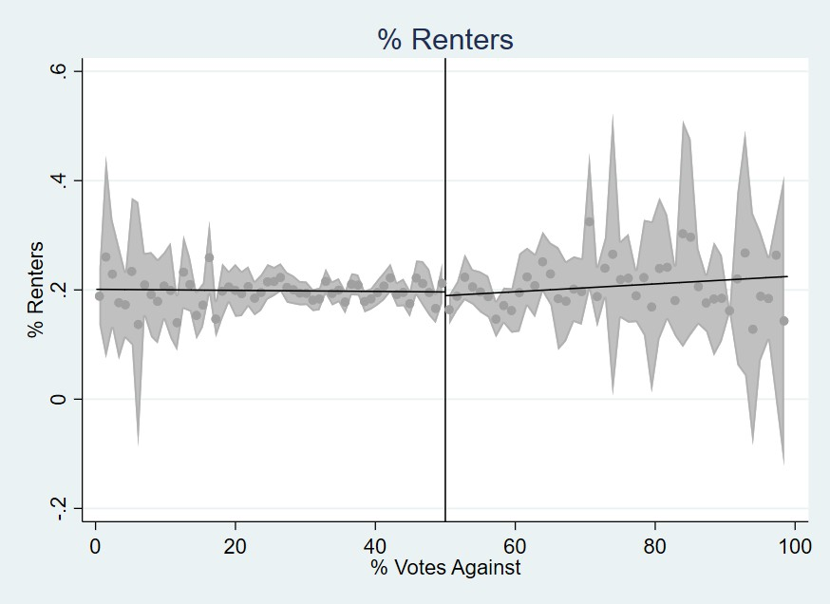 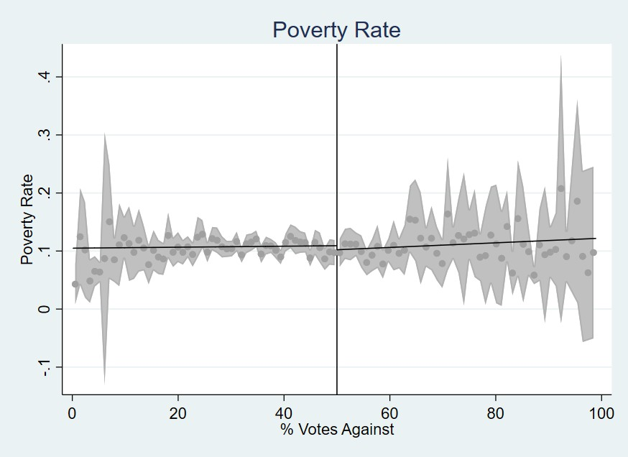

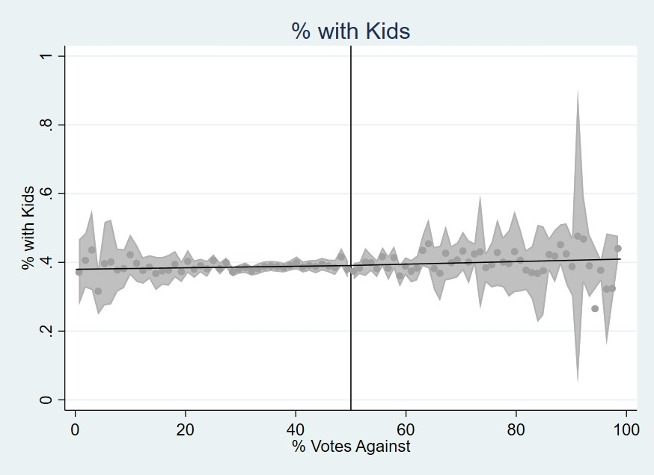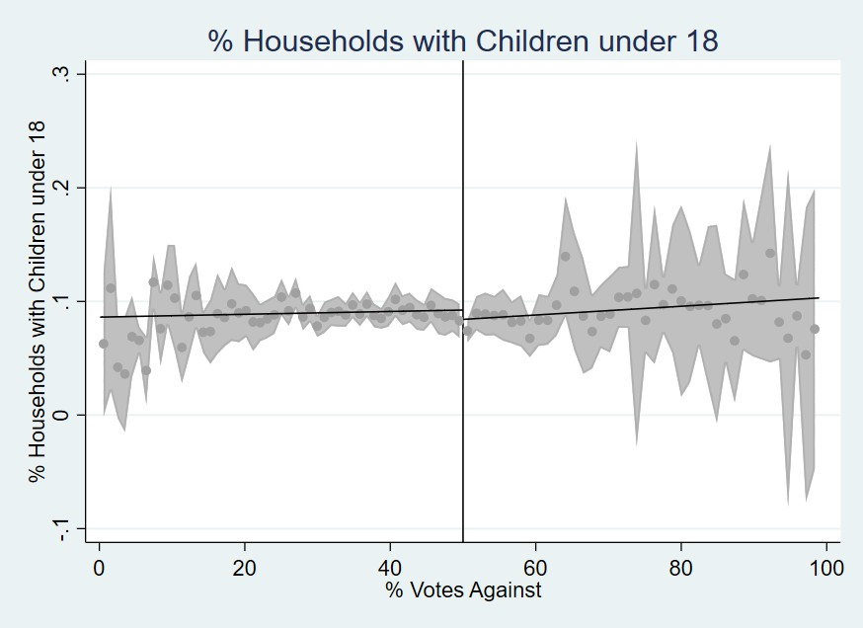Pct Rent Poverty Rate

Pct With Kids Pct Single Parent Hhld

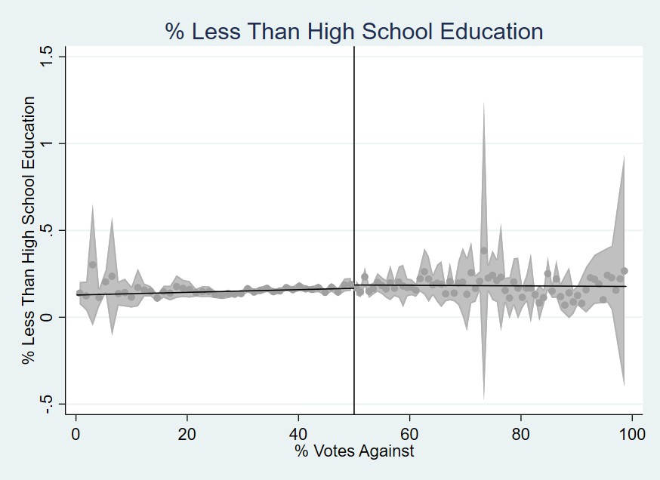 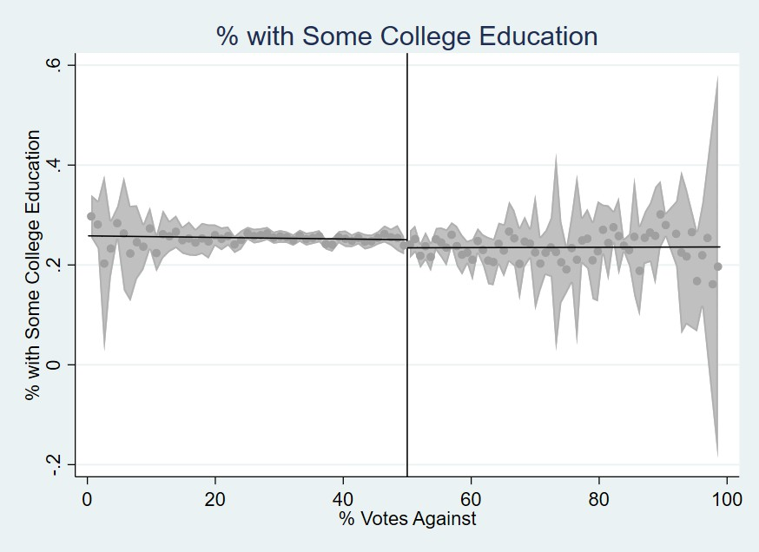

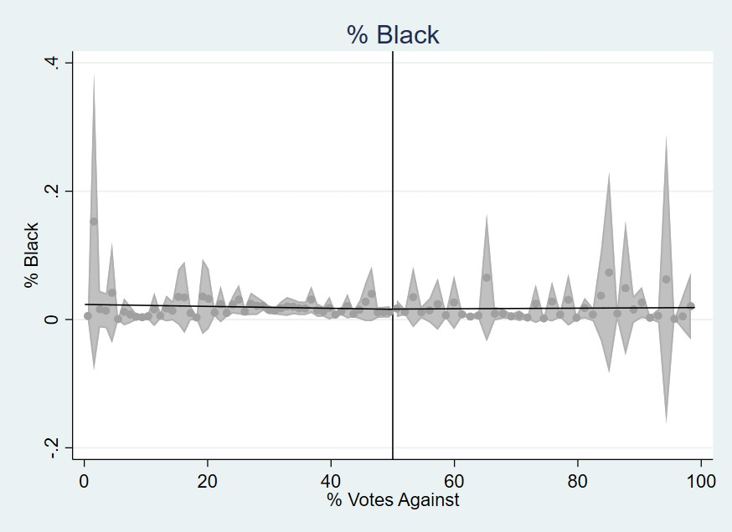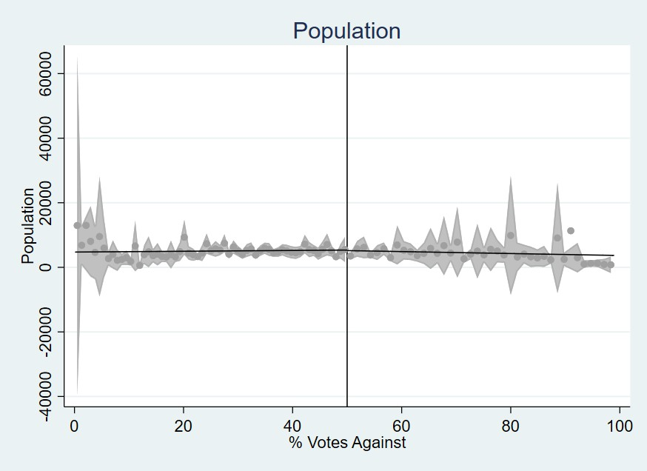Pct Less than HS Pct Some College

Pct Black Population

Figure 9: Covariate Discontinuity Plots - Part 1

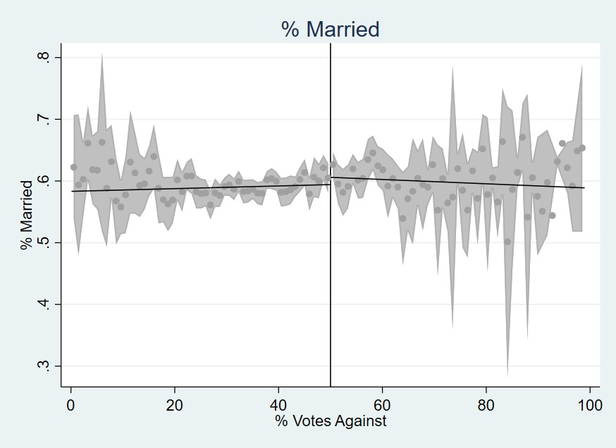 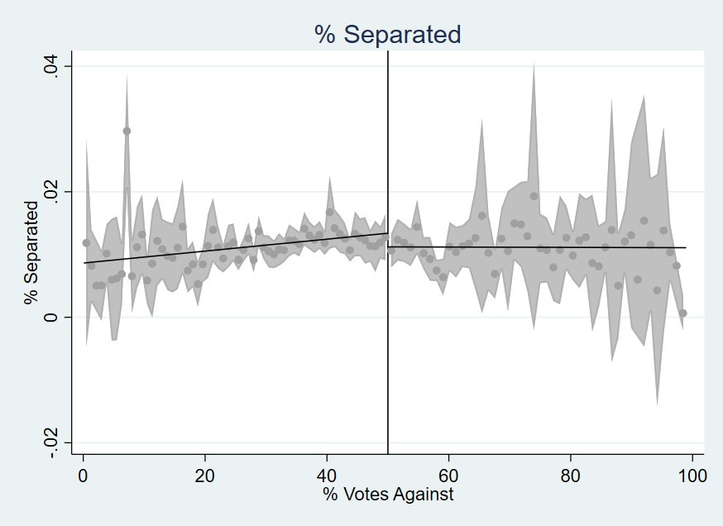

Pct Married Pct Separated

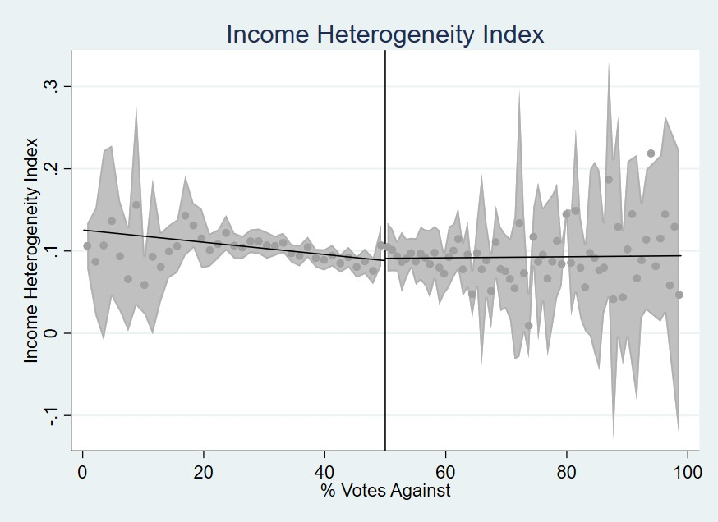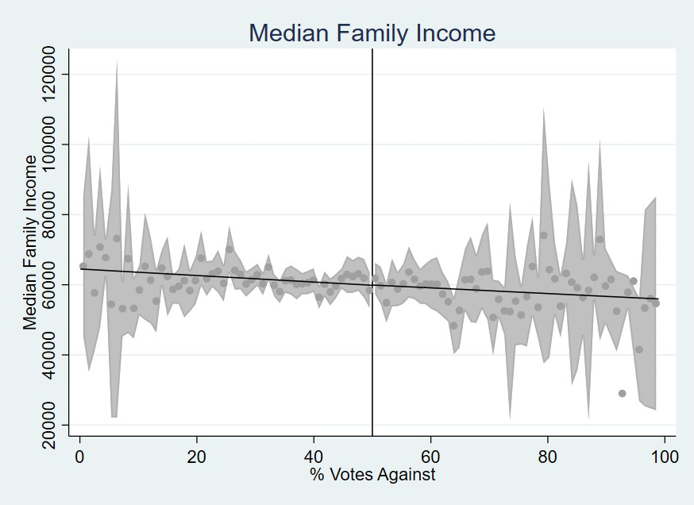

Income Herfindahl Index Median Family Income

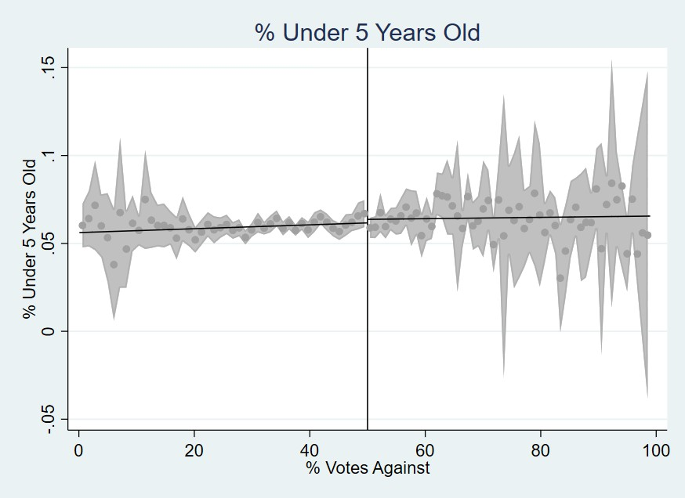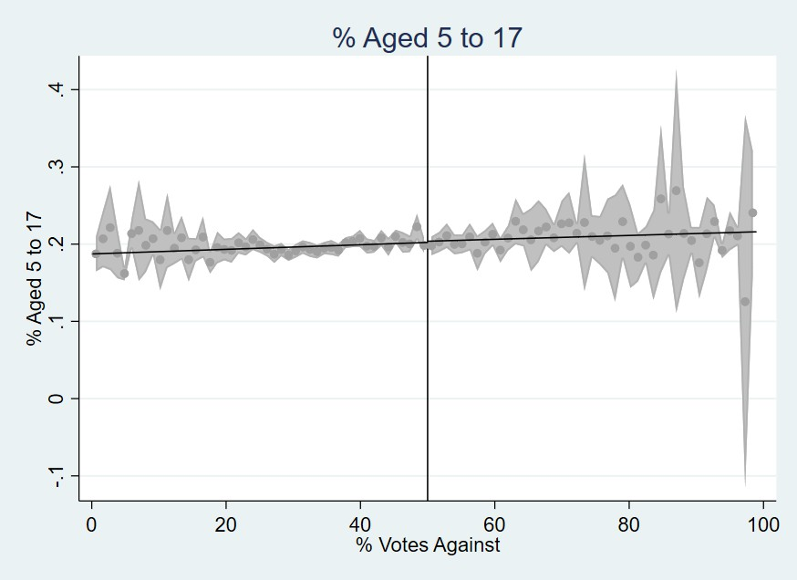

Pct Less than 5 Pct 5 to 17

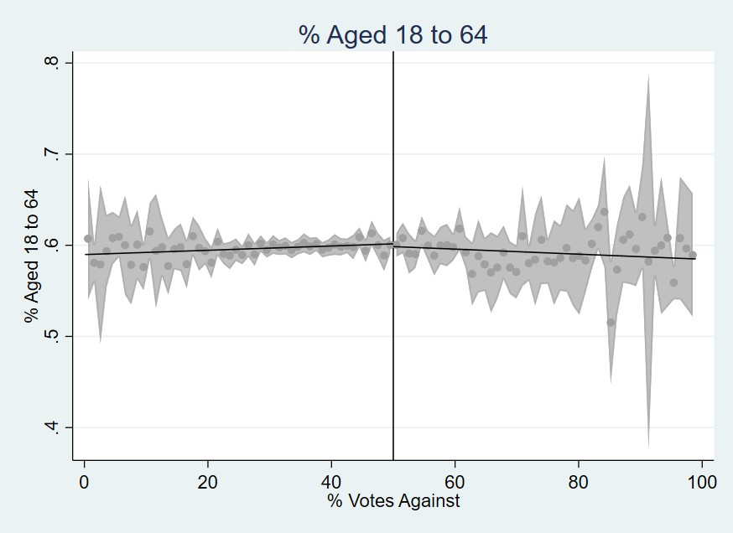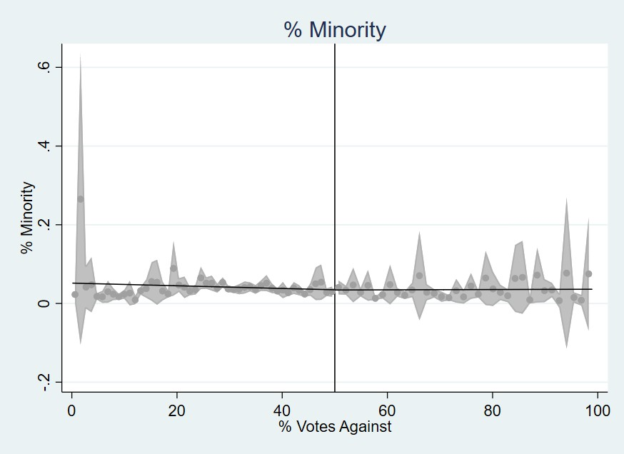

Pct 18 to 64

43 Pct Minority

Figure 10: Covariate Discontinuity Plots - Part 2

# Additional Information

## Road tax levies vs. Other types of levies

Table 13: Correlation of Road Tax Levy Referenda Results with Other Types of Levies

|  |  |  |  |  |
| --- | --- | --- | --- | --- |
| Police | Fire | Current Expenses | Recreational | School |
| Estimate 0.248 | 0.053 | 0.388*** | 0.015 | -0.024 |
| (0.153) | (0.043) | (0.099) | (0.317) | (0.092) |

*Notes:* This table presents coefficients from regressions correlating road tax levy referendum outcomes with outcomes for other types of levies (police, fire, current expenses, recreational, school). Standard errors are reported in parentheses. The coefficient for ”Current Expenses” is statistically significant at the 1% level (***). All regression control for year and neighborhood fixed effects, as well as neighborhood characteristics. The school levy analysis is conducted at the county level, while all other analyses are at the county subdi- visions level. Statistical significance levels are indicated as follows: *** *p <* 0*.*01, ** *p <* 0*.*05, * *p <* 0*.*1.

44