COVID-19 Impact on jobs in Ohio’s Public Health Sector

**Abstract**

Background: This study seeks to measure the impact of COVID-19 on public healthcare jobs in Ohio. We ask whether public health sector workers were similarly affected compared to workers in other industries in Ohio and if there were any significant differences within the public healthcare sectors.

Methods: Using each firm’s detailed unit-level data from Ohio Jobs and Family Services (OJFS) department, we study the employment levels for different public health care sectors in Ohio by calculating job creation, destruction and reallocation rates and analyze the disruption in labor markets caused by COVID-19.

Results: Certain sectors such as Ambulatory Health Care Services and Hospitals recovered to previous employment levels almost immediately after lockdown. Social Assistance also recovered but never reached previous employment levels whereas Nursing sector experienced permanent decline. Although both job creation and destruction rates reached their relative peaks, the gap between pre and post COVID levels was higher for job destruction rate.

Conclusion: Ohio’s public healthcare sector has not yet fully recovered from COVID-19 lockdown imposed in 2020.

Keywords: COVID-19, Public Health, Labor Economics

Introduction

**General Covid Impact**

Centers for Disease Control and Prevention (hereby CDC) confirmed the first case of coronavirus disease 2019 (hereby COVID-19) on January 28th, 2020 (source 1). Since then, there have been more than 82,000,000 cases and 995,000 deaths in U.S due to COVID-19 as of May 2022 (source 2). To contain the deadly virus in the U.S, states implemented various safety measures such as stay-at-home orders and mask mandates. Federal government also announced CARES ACT to provide economic support to U.S citizens. These events have led to a nationwide shock as people start to accept this new reality.  
  
**Why study Health care Impact: Importance of healthcare sector in Ohio**

Along with being a global health crisis, COVID-19 has also been an economic crisis (source 3).  
U.S Gross Domestic Product (GDP) declined by record 32.9 percent in the second quarter of 2020 (source 4) and unemployment rate reached 15% (source 5).   
  
**What all closed in Ohio**

On March 22nd 2020, Governor DeWine issued a stay at home order for all Ohioans. This required closure of all non-essential businesses and ensured a state-wide lockdown to curb the spread of the virus, as defined by Ohio Department of Health (ODH) (source 7).

**Impact on Ohio**

**Healthcare impact on Ohio**

Healthcare workers were uniquely affected by COVID-19 lockdown as it comprised of subsectors that provided essential-care services that were not under complete lockdown. Because the healthcare workers are 14% of the total workforce in Ohio, which is one of the highest in the nation, it is important to identify the effect of COVID-19 lockdown on people employed by this sector[1]. Furthermore, even within the healthcare sector, the impact may be quite different for different groups. For instance, clinics providing outpatient services such as general practitioners, optometrists and dentists may experience a more sudden decrease in in-person interaction due to COVID-19 as compared to hospitals, which contrastingly may experience a surge in patients admitted due to coronavirus. In this paper, we study the detailed data provided by OJFS to study the dynamics of such labor markets. We observe each unique location identifier or “unit”, which is defined as a particular location or address in Ohio that provides healthcare services, and our data covers a wide spectrum of healthcare providers ranging from residential healthcare facilities to major hospitals. For a complete definition of locations covered and the associated healthcare sector and its subsectors, see the methodology section.

OHPHS vs Non-OHPHS

There were significant differences between the healthcare sectors and the rest of the Ohio (referred as non-healthcare) during the great recession.

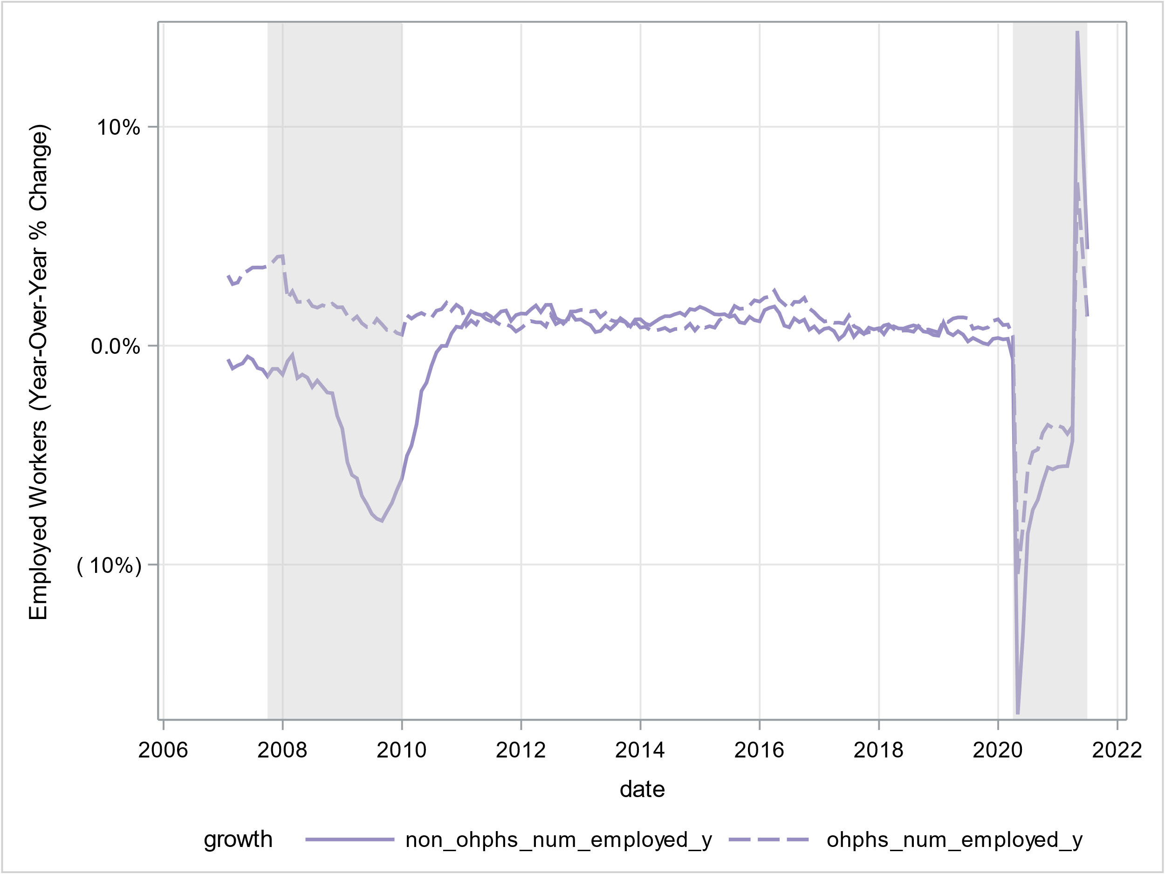

The above figure shows year-over-year percentage change in number of employed workers in healthcare and non-healthcare sectors in Ohio. As seen above, the public health sector employment levels were not impacted by The Great Recession, even though other sectors saw a significant reduction in job levels. Contrastingly, COVID-19 recession led to a sharp reduction in public healthcare workforce and this decline mimicked the reduction in non-healthcare sectors, although the decline in public health was not as steep.

**Why look at jobs created and destroyed**

This unit-level data allows us to dive deeper than just observing aggregate employment patterns and observe how people may be affected by the changing state of economy. Whenever a representative unit hires a new person and adds them to their payroll, a new job is created and whenever a person is removed from payroll, a job is destroyed. Even within Ohio, thousands of jobs are added and destroyed every day. These new jobs can either be created by existing firms which are expanding their workforce or by new firms entering the market. Analyzing the number of jobs created by new and existing firms in Ohio can tell us how likely is a person to get a job. Similarly, when firms downsize their workforce or exit the market, they destroy jobs. Analyzing the number of jobs destroyed by surviving and exiting firms in Ohio can tell us how likely a person is to lose a job. Together, these variables can tell us about the ongoing shifts in the labor markets.

**Areas explored by this paper**

1. Employment level (net increase or decrease in number of healthcare workers)
   1. Comparing Ohio Public Health Sector with non-public health sector
   2. Drop in OHPHS explored
   3. Breakdown of OHPHS by subcategory
   4. Recovery by OHPHS
   5. Reasons behind differences
      1. Jobs created, destroyed and Job reallocation rate
      2. Movement between sectors
      3. Movement within sectors

What is the breakdown?

1. Ambulatory Health Care Services
2. Hospitals
3. Nursing and Residential Care Facilities
4. Social Assistance

**Summary of findings/Results**

Methodology

**Data**

The data for this study comes from Ohio Department of Job and Family Services (OJFS). Ohio Revised Code (ORC) Section 4141.13 (G) requires the OJFS to collect information from all Ohio employers to determine if they are subject to the state’s unemployment insurance laws. According to OJFS website (source 6), unemployment benefits are financed by taxes paid by employers to the federal and state governments. The federal taxes cover most of the program’s administrative costs and the state taxes fund the actual benefits. Unemployment benefits provide short-term income to workers who lose their jobs through no fault of their own and who are actively seeking work. OJFS collects this data via their State of Ohio Unemployment Resource for Claimants and Employers (SOURCE) application. The employers report to JFS with the number of employees on their payroll every month and the wages paid to the employees. Each employer has a unique Employer Identification Number (EIN) and is classified as per North American Industry Classification system. Data used by this study ranges from January 2006 to June 2021.

**Variables**

1. Number of employed persons is the variable of interest and is defined as the number of workers that were reported to OJFS by a unit and were part of their payroll
2. NAICS code variable identifies the specific industrial category of a unit, as per North American Industry Classification System
3. Sub-categories variable uses NAICS code and separates sectors into healthcare and non-healthcare
4. Unique location identifier, known as “unit” throughout this paper, was used to identify a particular location related to public healthcare sector

**Measures**

In order to truly understand the jobs related to Ohio’s public health sector, we need to study the dynamics of the Ohio’s public health labor market. In this paper, we do this by analyzing job flows, that is, the creation and destruction of jobs within the healthcare sector, and its subsectors.

Job creation rate represents the sum of job gains measured at a unit over one month due to either opening of new units or expansion of jobs within an existing unit.

Job destruction rate represents the sum of job losses resulting from either closing of a production unit or contraction in the number of jobs by an existing unit.

Job reallocation rate is equal to the sum of job creation rate and job destruction rate.

Net employment rate is equal to the difference between job creation rate and job destruction rate.

Excess job reallocation rate corresponds to the difference between job reallocation rate and absolute value of net employment growth.

All the rates were calculated on an annual or year-over-year basis.

Below, we will mathematically define each of these measures.

Let $E_{t}$ be the sum of job gains (or losses) reported by an ith existing unit at time period t

Let $S_{t}$ be the sum of jobs created by new unit entering the market at time period t

Let there be a total of N firms

1. Job creation rate represents the sum of
2. Job destruction rate:
3. Job Reallocation rate:
4. Net Employment rate:
5. Excess Job Reallocation rate:

These variables can give us great insights into the prevailing conditions of the labor markets. High job creation rate is associated with expansionary motives, with market conditions making it favorable for the existing or new units to expand their workforce. A temporary spike in job creation rate may also be a sign of an exogenous demand shock, as new workers enter the labor force.

Conversely, job destruction rate is associated with contractionary motives, as units aim to leave the market or reduce their operations.

Elevated levels of job creation and destruction rates can be captured by job reallocation rate. This measure tends to be high for newer markets that experience a lot of within or between sector movement of labor.

Net employment rate summarizes the overall change in workforce from one time period to another.

Results

**Health care jobs breakout**

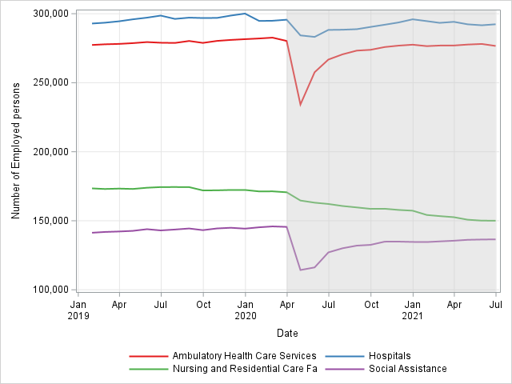

This figure shows monthly number of employed persons by each major NAICS subsector within Ohio. All the sectors experienced a decline due to COVID-19, but the sharpest decline was experienced by Ambulatory Health Care services and social assistance sectors. Both these sectors recovered bounced back after the shock, but have so far failed to reach the pre-COVID levels. Hospitals experienced a temporary decline but also recovered promptly. Nursing sector has experienced a constant decline since the advent of COVID crisis.

**Job creation and destruction rate**



The above table shows average pre and post COVID lockdown levels for job creation, destruction, reallocation, net employment and excess job reallocation rates for public healthcare and its subsectors.

Each sector had a positive net employment rate before COVID but has a negative net employment rate post COVID.

All sectors had a higher job destruction rate post COVID than pre COVID.

All sectors also had a higher job reallocation rate post COVID than pre COVID.

Job destruction rates were higher than pre COVID levels, but the gap between pre and post COVID levels was smaller for each sector when compared to the gaps for job destruction rate.

Hospitals were the most stable and were least impacted by COVID-19 lockdown among the sectors. Social Assistance and Ambulatory Health services experienced the most volatility.

Discussion

COVID recession was different from The Great Recession in terms of its impact on the healthcare sector. While other (aggregated) sectors in Ohio experienced a decrease in workforce during The Great Recession, healthcare and social assistance sector experienced no such decline. However, COVID had a very similar on both these broad sectors as all employers were forced to take safety measures.

COVID-19 also had a dissimilar impact on different healthcare sub-sectors.

Ambulatory healthcare sector experienced the sharpest decline due to lockdown imposed by COVID-19. This seems reasonable given that all outpatient services were temporarily halted by the stay-at-home order imposed by Ohio’s department of health. Soon after the stay-at-home order was lifted, the sector recovered from the temporary shock as units in this sector were allowed to reopen, albeit with COVID restrictions and policies in place.

Hospitals were the most stable out of all public health subcategories as they were allowed to operate during the lockdown. The relatively small decline in this sector can possibly be attributed to closure of certain non-essential services or increased COVID-19 spread forcing the workers stay at home and as a result, out of the payroll system. On the other hand, one would imagine that hospitals should have experienced a surge in new workforce as there was cases of extreme labor market tightening during the pandemic. However, even when they were the most important institutions during the pandemic, hospitals experienced a moderate decline in net employment rate.

Social Assistance sector had an average post COVID job reallocation rate of 9% and was the highest among the public health subsectors. This suggests a lot of movement of workforce, as a number of people in this sector were laid off during lockdown and had to find other jobs.

Nursing sector never recovered from COVID and is experiencing a continuous decline in workforce. This suggests a deeper problem than a one-time shock. Because elderly were disproportionately affected by COVID-19 (as shown by higher death rate), this possibly resulted in a lower demand for nursing and residential care facilities.

Public Health Implications

Acknowledgements:

This project was supported by Wolfgang Mayer Fellowship provided by University of Cincinnati. I acknowledge and thank Dr. Michael Jones, Professor at University of Cincinnati, for his help with procurement of data. The data was provided via quarterly csv files uploaded by Office of Workforce Development at Ohio JFS on Axway Server maintained by the department. The opinions, findings, and conclusions expressed in this publication are those of the author and do not necessarily reflect the official views of any other parties involved.

References:

1. <https://www.cdc.gov/media/releases/2020/p0121-novel-coronavirus-travel-case.html>

2. <https://covid.cdc.gov/covid-data-tracker/#datatracker-home>

3. <https://www.ncbi.nlm.nih.gov/pmc/articles/PMC7753392/>

4. <https://www.bea.gov/news/2020/gross-domestic-product-2nd-quarter-2020-advance-estimate-and-annual-update#:~:text=Real%20gross%20domestic%20product%20(GDP,the%20Bureau%20of%20Economic%20Analysis>.

5. <https://www.bls.gov/opub/ted/2020/unemployment-rate-rises-to-record-high-14-point-7-percent-in-april-2020.htm>

6. <https://jfs.ohio.gov/ouio/uctax/UITaxForNewEmployers.stm>

7. <https://coronavirus.ohio.gov/static/publicorders/Directors-Stay-Safe-Ohio-Order.pdf>

1. <https://www.kff.org/other/state-indicator/health-care-employment-as-total/?currentTimeframe=0&sortModel=%7B%22colId%22:%22Location%22,%22sort%22:%22asc%22%7D>