Game Design Document

Fill up the following document

1. Write the title of your project.

The Snake Game

1. What is the goal of the game?

The goal of the game is that the snake should eat the fruits and leaves without touching the insect.

1. Write a brief story of your game.

In this game a snake has to eat the leaves and fruits falling from above to score a point. If the snake touches the insect then the game would be over.

1. Which are the playing characters of this game?

* Playing characters are the ones who respond to the user based on the input from the user.
* Cars, monkeys, dinos, wizards, etc., are the playing characters in the game.

|  |  |  |
| --- | --- | --- |
| Number | Character Name | What can this character do? |
| 1 | snake | It can move with the help of the arrow keys to eat the fruits and leaves. |
| 2 |  |  |
| 3 |  |  |
| 4 |  |  |
| 5 |  |  |
| 6 |  |  |
| 7 |  |  |
| 8 |  |  |

1. Which are the Non-Playing Characters of this game?

* Non-Playing characters are the ones that don't have an action or behavior when the user interacts with the game.
* Hurdles, stones, bananas, coins, etc., are non-playing characters in the game.

|  |  |  |
| --- | --- | --- |
| Number | Character Name | What can this character do? |
| 1 | fruits | They can move randomly |
| 2 | leaves | They can move randomly |
| 3 | insect | It can move to touch the snake for the game to end. |
| 4 |  |  |
| 5 |  |  |
| 6 |  |  |
| 7 |  |  |
| 8 |  |  |

Draw your imagination of this game. What does this game look like?

* Draw the game either on your computer or on paper.
* Add images of the game scenes to show each of the playing and non-playing characters at least once.

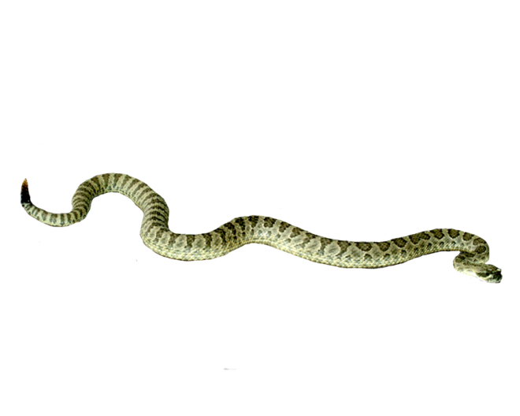

How do you plan to make your game engaging?

I plan to make it engaging by adding sound and visual effects.