- MAXIMUM PAYLOAD WHILE MAINTAINING STABLE FLIGHT.
For the given purpose the candidate aerofoils are:

1) CAMBERED AIRFOIL:
A fixed curved profile that produces lift efficiently over its intended operating range. It is comparatively simple and is a useful baseline for a payload-carrying aircraft.

2) HIGH-LIFT AIRFOIL:
A wing with flaps and possibly leading-edge slats that increase lift when needed, particularly during take-off and landing. The increased lift generally comes with extra drag and mechanical complexity.

3) EFFICIENT CAMBERED AIRFOIL- VARIABLE/MORPHING CAMBERED AIRFOIL:
The wing changes its curvature to suit different flight conditions. It can use a more efficient shape in cruise and a higher-lift shape at low speeds, if properly designed and tested.

## COMPARING THE CANDIDATE AIRFOILS ON XFLR5 AND XFOIL WITH RELEVANT REYNOLD NUMBER:
**WE KEEP THE REYNOLD NUMBER AND ALL OTHER PARAMETERS SAME FOR ALL THREE CANDIDATES TO MAKE COMPARISON MORE FAIR.**
The candidate air foils in the XFLR5:

1] **For Conventional Cambered Airfoil we use NACA2412**:
Conventional cambered baseline. The four-digit designation indicates 2% maximum camber, located at 40% chord, and 12% maximum thickness.

2] **For High-lift Airfoil we use NACA4415**:
A more highly cambered baseline for examining lift and pitching-moment trade-offs. This is not a complete multi-element high-lift system; it is a single aerofoil with greater camber and thickness.

3] **For Efficient Cambered Airfoil with laminar flow candidate we use NACA64-415**:
A representative six-series laminar-flow candidate. Its performance depends on the actual Reynolds number, surface condition and operating lift coefficient.

## REYNOLDS NUMBER:

This is essential because an aerofoil can behave differently at different speeds and sizes.

$$Re=\frac{ρVc}{μ}$$
Where ,

$ρ$ = air density in kg/m³

$V$ = airspeed in m/s

$c$ = chord length in metres

$μ$ = dynamic viscosity in Pa*s

By keeping in mind the above mentioned condition I have taken these as some suitable values of the parameters to calculate Reynolds number:

Flight Speed = 11.68 m/s

Chord = the distance of the leading edge from the trailing edge = 0.25 m

here are some values which actually depend on the air conditions,

Air Density = 1.225 kg/m³

Dynamic Viscosity = 1.789 * 10^(-5) Pa * s

**CALCULATION**

$$Re=\frac{1.225×11.68×0.25}{1.789×{10}^{-5}}$$

# FOR RUNNING 2D STIMULATION OF AIRFOIL THE VALUES TAKEN IN ANALYSIS SETTINGS ARE:

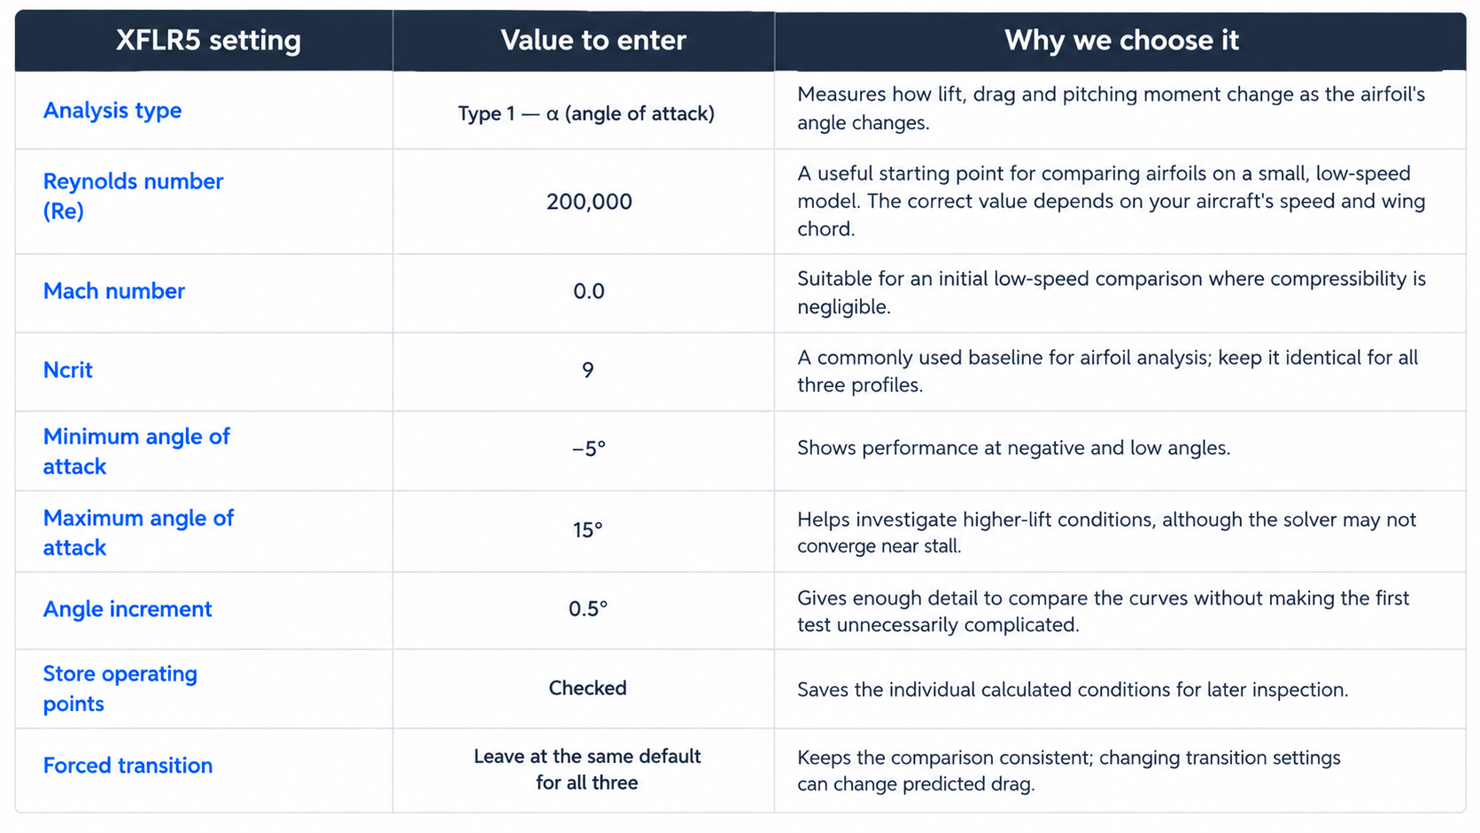

We have compared the following ratios for the three candidate airfoils through the graphs formed with the help of XFLR5 and XFOIL:
- C_{L} vs. angle of attack: how lift changes as the airfoil tilts into the airflow.
- C_{D} vs. angle of attack: how much drag is predicted.
- C_{L} / C_{D} vs. angle of attack: aerodynamic efficiency.
- C_{M} vs. angle of attack: how pitching moment changes, which is relevant to the aircraft's trim and stability.
I have also included the trailing-edge flap withs values for moderate flap and the reasoning behind these values:
- Hinge at 70% chord
This leaves the front 70% of the airfoil unchanged and makes the rear 30% the flap. It is a reasonable baseline for testing how additional camber changes lift and drag. The best hinge position still depends on the actual airfoil and flap geometry.

- Deflection of 7° downward
A downward flap increases effective camber, which generally increases lift at a given angle of attack. A moderate initial deflection lets you measure that benefit while avoiding the larger drag increases that can occur at higher deflections.

- Why not use a larger angle immediately?
More flap deflection does not automatically mean a better aircraft. It can increase drag, change pitching moment, and reduce the angle-of-attack margin before stall. Stable flight must be checked for the complete aircraft, not inferred from lift alone
THE FINAL COMPARISON: Let us first see the models of the three candidate airfoils given by XFLR5 given is the link of those models in XFLR5 in its default form .xfl:
- Let us first see the models of the three candidate airfoils with flap: 

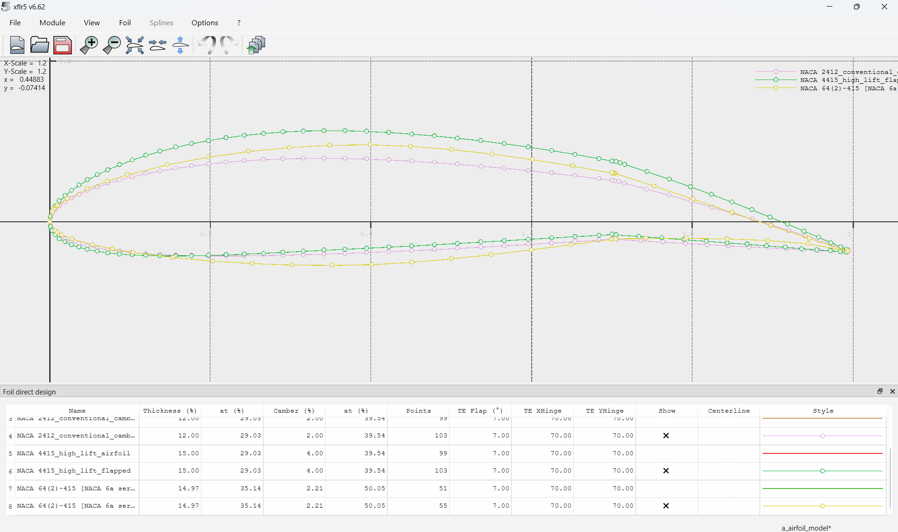

- Also look towards there the 4 important graphs related to them:
THE LINK OF THE 4 GRAPHS (.CSV FLIES) WITH FLAPPED AS WELL AS WITHOUT FLAPPED AIROFOIL

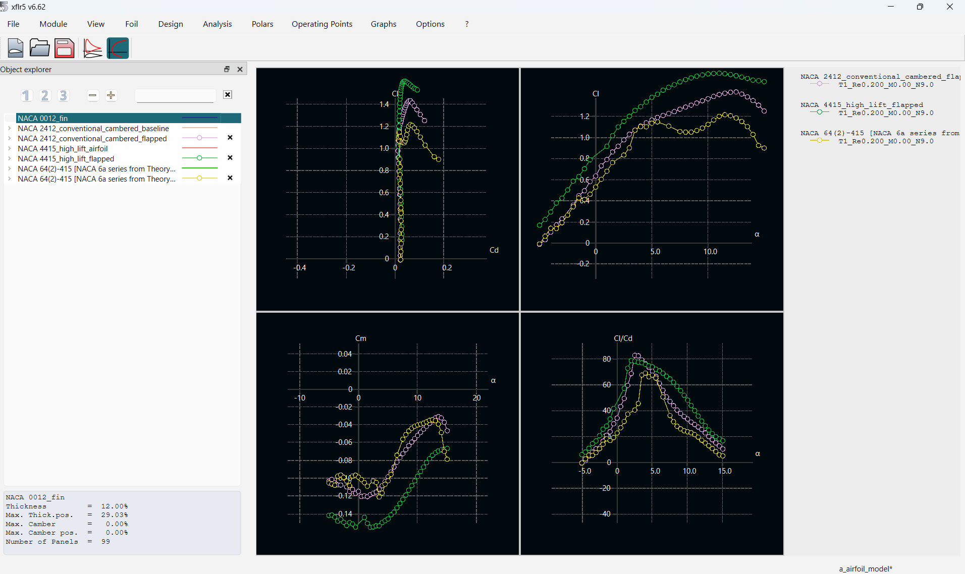

The final result of the compared values: 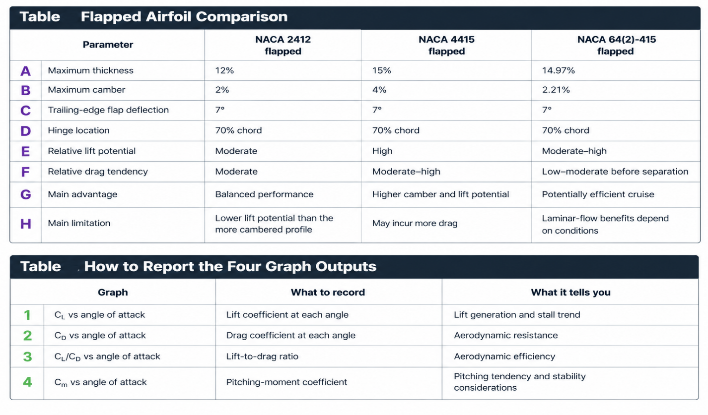

THE FINAL CONCLUSION FROM THE ABOVE COMPARISON IS:
My final preliminary choice is HIGH-LIFT CAMBERED AIRFOIL – NACA4415. The main reasons are:
- Greater lift potential
NACA 4415 has 4% maximum camber, compared with 2% for NACA 2412. Its greater camber can help generate more lift at a given angle of attack under suitable conditions. This can be useful when carrying additional payload.
- More thickness for structural design
Its 15% thickness gives the wing designer more internal space for spars and structure than a 12%-thick profile, all else being equal. Actual strength depends on the spar design, materials, and wing construction.
- Potentially useful at low flight speeds
Higher lift at a given speed can help a model support its weight at a lower speed or reduce the angle of attack required. The actual stall speed must be determined from the maximum lift coefficient and the aircraft's total weight and wing area.

NOTE: THERE EXIST ALSO MANY MORE FACTORS WHICH CAN AFFECT THE CAPACITY OF PAYLOAD AND STABILITY LIKE THE AIRCRAFTS WEIGHT, LONGITUDINAL STABILITY, CENTER OF GRAVITY, WING-TAIL ARRANGMENT AND THE ACTUAL FLIGHT CONDITIONS.
- OPTIMIZED FOR MANEUVERABILITY (TURNS, ROLLS, LOOPS).
Maneuverability is an aircraft’s ability to change its direction and orientation quickly, accurately, and controllably while remaining stable.

- Turns: Change the aircraft’s flight direction.
- Rolls: Rotate the aircraft around its longitudinal axis.
- Loops: Perform a vertical circular flight path by changing pitch and managing lift and speed.

For this purpose the candidate airfoils are:
- NACA 2412 — balanced baseline
- Recommended baseline
- Moderate camber and 12% thickness.
- A useful starting point for predictable handling and general-purpose flying.
- Compare its lift curve, drag, and stall behaviour before choosing it.

- NACA 23012 — alternative for balanced lift
- 12% thickness, with a different camber distribution from NACA 2412.
- Worth testing for lift and pitching-moment characteristics.
- Its actual handling advantages depend on Reynolds number and the complete aircraft design.

- NACA 0012 — symmetrical aerobatic candidate
- Zero camber and 12% thickness.
- Similar basic geometry when the aircraft flies upright or inverted, at equal-magnitude positive and negative angles of attack in ideal conditions.
- A useful candidate for evaluating loops and inverted flight.
NOTE: HERE IT IS NOT THAT SIGNIFICANT TO ADD FLAP IN THE AIRFOIL AS OUR AIM IS TO OPTIMIZE MANEUVERABILITY WHICH IS NOT HEAVILY DEPENDED ON THE FACTOR OF HIGH LIFT COEFFICIENT.

For the Reynolds number the value remains same here also that is Re= 200000 in XFLR5.
The reasons are:
- Suitable for a small RC aircraft
- Fair comparison of your airfoils
- Useful for evaluating maneuverability
The suitable values for the 2d stimulation by XFLR5 and XFOIL:
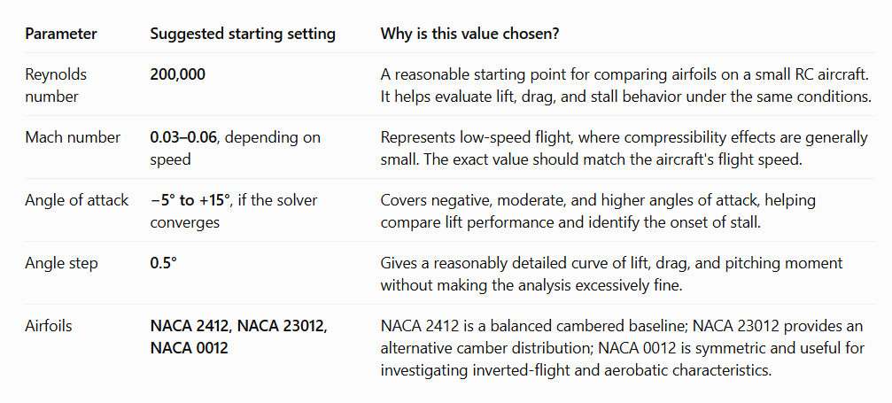
THE FINAL COMPARISON
Let us see the final comparison between the three candidate airfoils:
- Comparison between the models of the candidate airfoils: 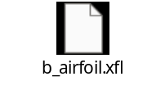
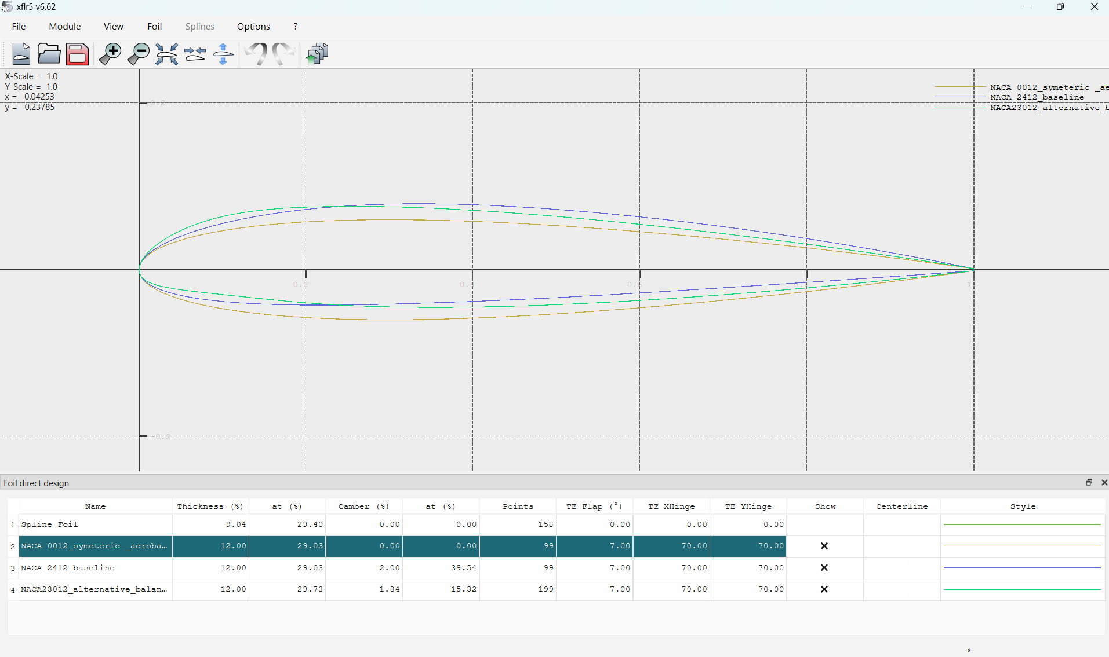
- Also look towards there the 4 important graphs related to them:
THE LINK OF THE 4 GRAPHS (.CSV FLIES) WITHOUT FLAP AIRFOILS ARE GIVEN BELOW:   
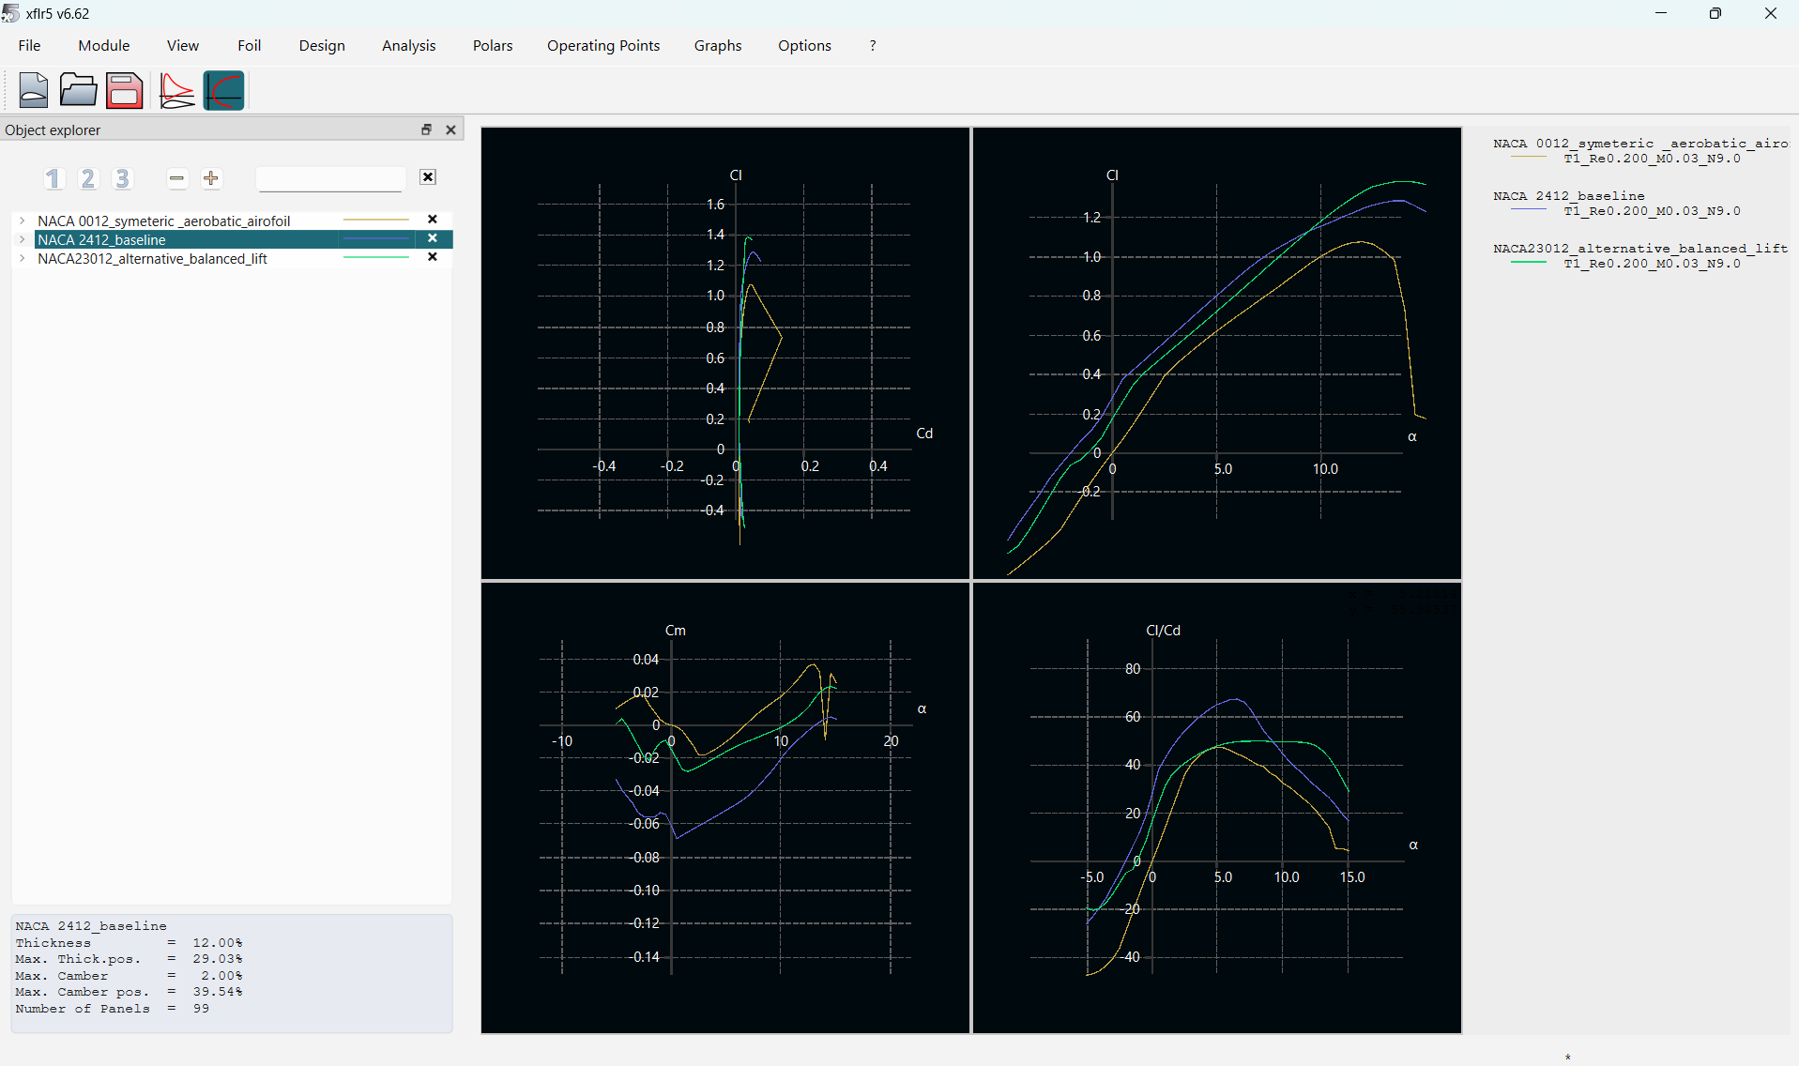

The final result of the compared values:
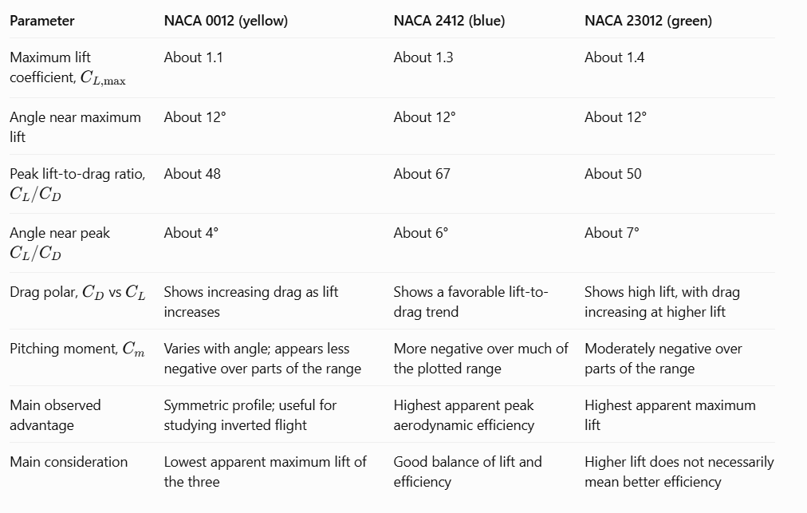

THE FINAL CONCLUSION:
My final preliminary choice is NACA 2412. The main reasons are:
- It offers a useful balance of lift and aerodynamic efficiency, and your XFLR5 graphs show the highest apparent peak C_{L} / C_{D} among the three candidates.

- The high C_{L} / C_{D} implies that how efficiently an airfoil produces lift relative to drag.

NOTE: THE PROPERTY OF MANEUVERABILITY ALSO DEPENDS ON FACTORS LIKE AILERONS, ELEVATOR AUTHORITY, WING LOADING AND COMPLETE AIRCRAFT DESIGN.

HOW AIRFOIL GEOMETRY AFFECTS THE AIRCRAFTS PERFORMANCE:

An airfoil is the cross-sectional shape of a wing. Its geometry determines how air flows around the wing and strongly influences the lift, drag, stall behavior, and pitching moment produced by the wing.

For an RC plane, airfoil geometry affects how much payload the aircraft can carry, how slowly it can fly, how efficiently it uses battery power, and how effectively it performs maneuvers such as turns, rolls, and loops.

The main geometric features are:

- Camber
Camber is the curvature of the airfoil's mean line.

- More positive camber generally produces more lift at a given angle of attack.
- It can help an RC plane generate lift at lower speeds.
- Excessive camber can increase drag and pitching moment.

Effect: Useful for payload carrying and low-speed flight, but the optimum depends on the operating conditions.

- Thickness

Thickness is the maximum distance between the upper and lower surfaces, expressed as a percentage of chord.

- A thicker airfoil can provide more room for structural strength and internal components.
- It can help accommodate a strong wing structure.
- Thickness also affects drag, flow separation, and pitching characteristics.

Effect: Useful when balancing structural strength and aerodynamic performance.
- Symmetric versus cambered shape

- A cambered airfoil, such as NACA 2412, typically produces positive lift at zero angle of attack.
- A symmetric airfoil, such as NACA 0012, produces approximately zero lift at zero angle of attack in ideal conditions.

Effect: Cambered airfoils are often useful for efficient normal flight, while symmetric airfoils are useful when similar aerodynamic behavior at positive and negative angles of attack is desirable, such as during inverted flight.

- Leading-edge and trailing-edge shape

The leading edge affects how smoothly the airflow accelerates around the front of the airfoil. The trailing edge influences how the flow leaves the airfoil.
Effect: These shapes influence drag, stall behavior, and the response to angle of attack.
Physics Behind The Airfoil Performance:
As an RC plane moves forward, air flows around its wings. The wing changes the airflow and creates a pressure distribution; the resulting aerodynamic forces include lift and drag.
LIFT IS EXPRESSED AS:
$$LIFT=L=\frac{1}{2}ρV^{2}SC_{L}$$
DRAG IS EXPRESSED AS:
$$DRAG=D=\frac{1}{2}ρV^{2}SC_{D}$$
Where:
- L = lift force
- D = drag force
- $ρ$ = air density
- V= aircraft speed
- S= wing reference area
- C_{L} = lift coefficient
- C_{D} = drag coefficient

- A higher lift coefficient can help an RC plane support more weight at a given speed and wing area. However, if the airfoil generates too much drag, the motor must provide more power. If the angle of attack becomes too large, airflow separation can cause a stall and a loss of lift.
- In terms of stability; Airfoil geometry contributes to pitching moment, but overall aircraft stability also depends on the center of gravity, horizontal tail, tail volume, and wing configuration.
AIRFOILS GEOMETRY EFFECT ON THE CASE (A) AIRCRAFT:
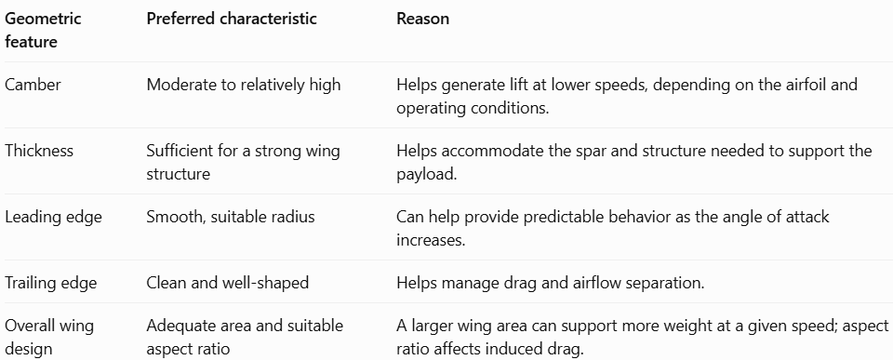

AIRFOILS GEOMETRY EFFECT ON THE CASE (B) AIRCRAFT:
• Turns: Depend on lift capability, wing loading, bank angle, and available control.
• Rolls: Depend strongly on aileron size, placement, and control authority, along with wing inertia.
• Loops: Depend on pitch control, speed, lift, available thrust, and structural strength.
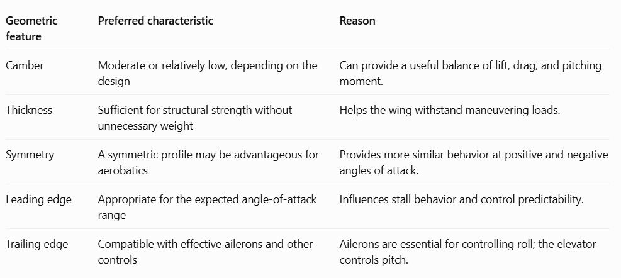

Discuss whether one airfoil can satisfy both missions, including the trade-offs.
Yes, one airfoil can serve both missions to a reasonable extent, but it will involve trade-offs. Let us see how different parameters act in both the cases and what are its trade-offs:
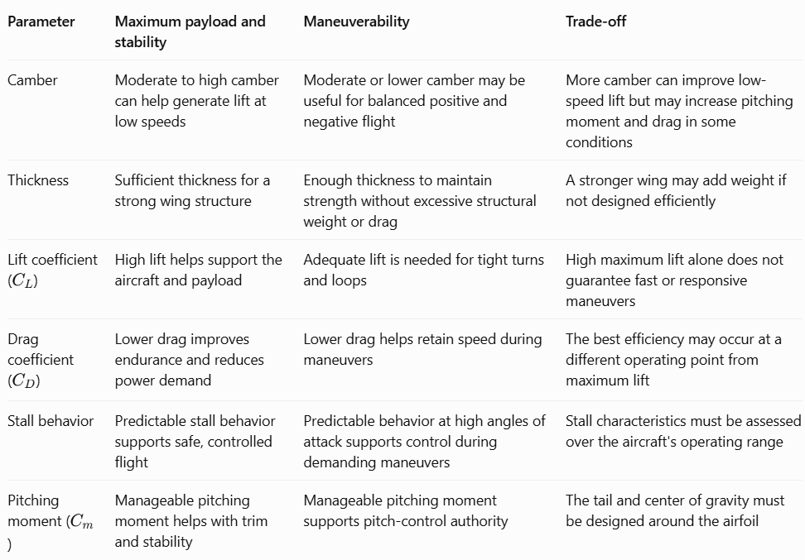
I would use NACA 2412 as the best compromise candidate amongst the total of six candidates.
- Moderate camber can provide useful lift during normal flight.
- Its 12% thickness provides a practical starting point for wing structural design.
- Your XFLR5 plots suggest favorable peak lift-to-drag efficiency among the three candidates.
- It is worth testing for both payload-carrying flight and general maneuverability.
We can reduce the trade-offs by keeping the basic airfoil the same but changing some other features like:
• Wing area: Choose enough area to support the intended payload at the target flight speed.
• Aspect ratio: Balance induced drag against the roll response and structural requirements.
• Control surfaces: Use appropriately designed ailerons for rolls and an elevator for pitch control.
• Center of gravity and tail: Design these for suitable stability and control authority.
- Structural design: Make the wing strong enough for the intended maneuvering loads without adding unnecessary mass.

Distinguishing Airfoil Characteristics from Whole-Aircraft Factors
Comparison between Airfoil and Aircraft Characteristics and table containing some important factors affecting the performance of the aircraft:
A. Airfoil characteristic: These describe the cross-sectional shape of the wing and its aerodynamic behavior.

- Camber: Influences lift and pitching moment.
- Thickness: Influences aerodynamic behavior and provides space for wing structure.
- Lift coefficient: Indicates how effectively the airfoil generates lift under specified conditions.
- Drag coefficient: Indicates its aerodynamic resistance.
- Stall behavior: Describes how lift changes when the angle of attack becomes too high.
- Pitching moment: Describes the airfoil's tendency to rotate nose-up or nose-down.
B. Whole-aircraft factors: These describe the design and behavior of the entire RC plane.
- Wing loading: Aircraft weight divided by wing area.
- Wing geometry: Wingspan, aspect ratio, taper, and twist.
- Control surfaces: Ailerons, elevator, and rudder.
- Structure: Wing strength, stiffness, and total mass.
- Thrust and power: Motor, propeller, battery, and available thrust.
- Stability and balance: Center of gravity, tail size, and tail arrangement.
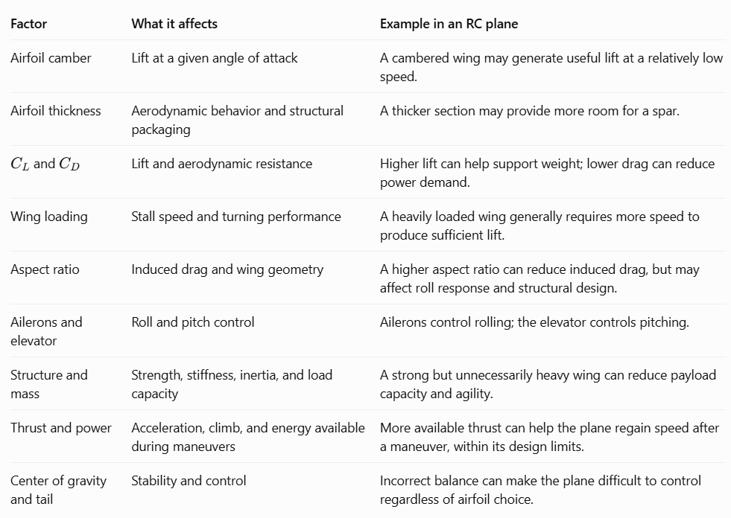
NOTE: AIRFOILS ARE AN IMPORTANT DETERMINANT OF THE PERFORMANCE OF AIRCRAFT BUT THEY ARE NOT THE SOLE DETERMINANTS THERE EXIST VARIOUS OTHER FACTORS THAT ARE ALSO A SIGNIFICANT FACTORS IN CONTRIBUTING TOWARDS THE PERFORMANCE OF AN AIRCRAFT.

