BEST TWO PAPER AIRPLANE DESIGNS FOR THE LONGEST FLIGHT DURATION The key is to minimize the airplane's downward speed while maintaining enough forward speed to generate lift.

- Design 1: Wide-wing glider Main objective: Slow, gentle descent.
- Broad wings and a relatively short, lightweight body.
- Large wing area for the airplane's weight.
- Simple folds that are easy to reproduce accurately.
- Good candidate for a low launch speed and long flight time.
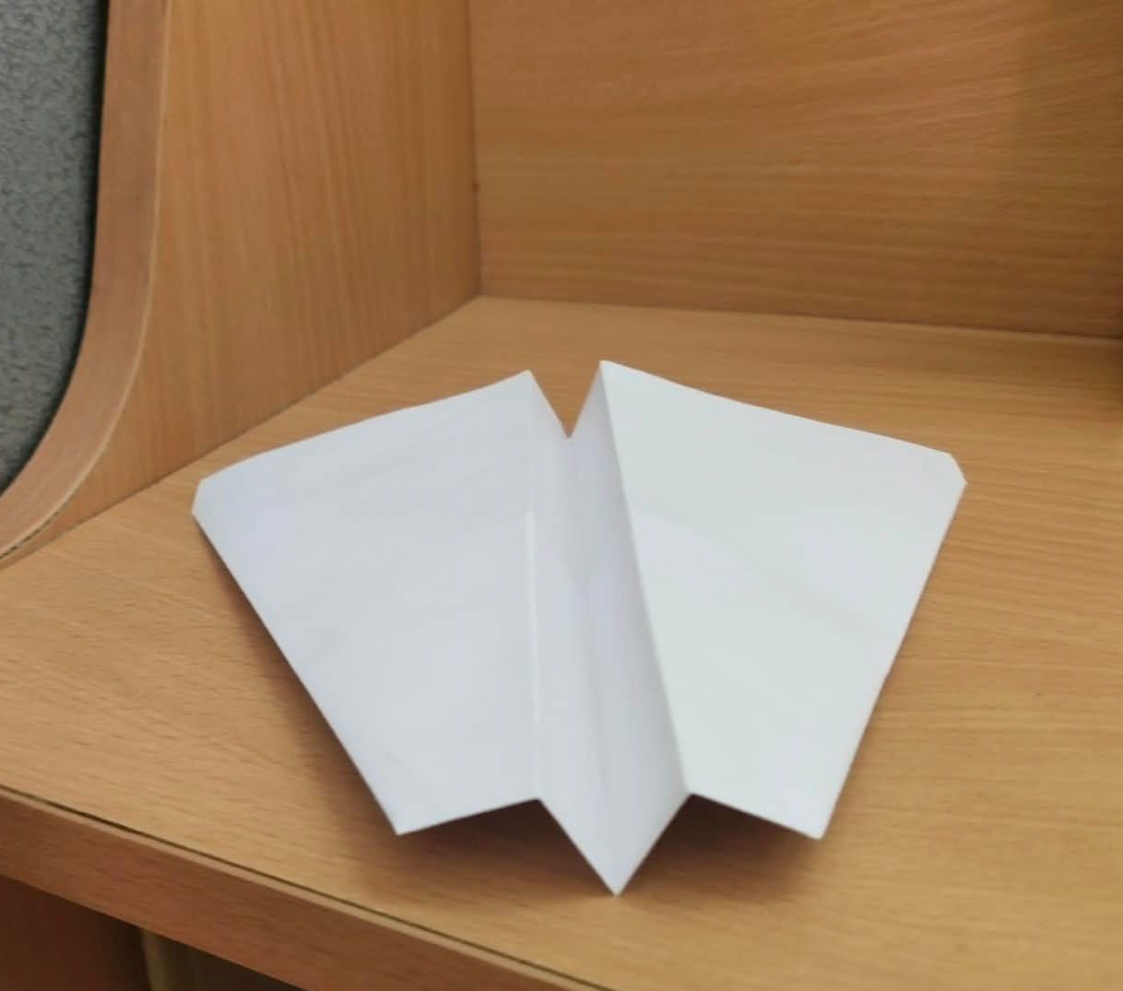

- Design 2: Long, slender-wing glider Main objective: Reduce drag while maintaining a slow descent.
- Long wings relative to their chord (front-to-back width).
- Higher aspect ratio than Design 1.
- Potentially better aerodynamic efficiency.
- Requires careful folding and a well-balanced centre of gravity.
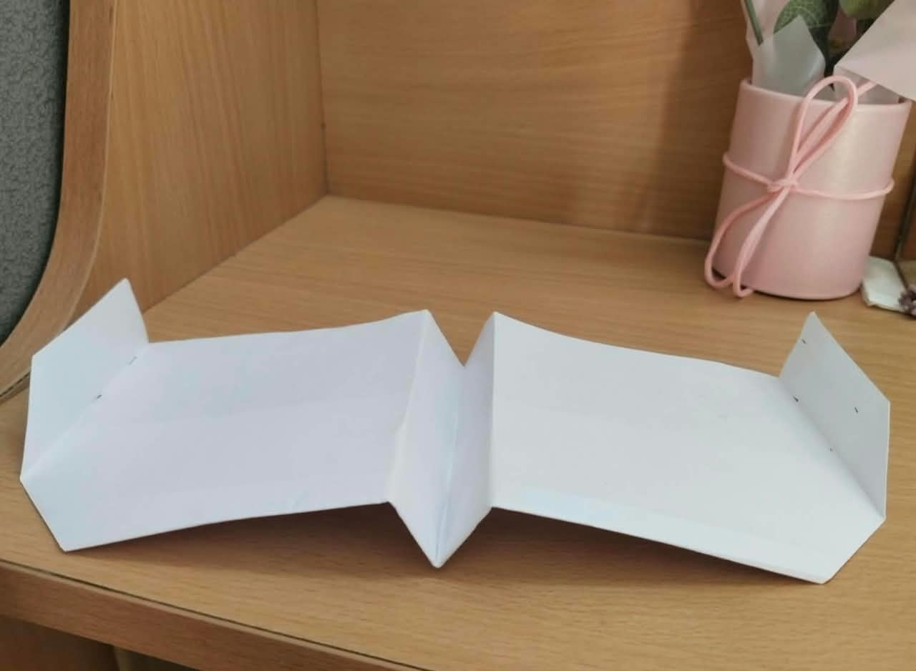

STEPS OF CONSTRUCTION:
- DESIGN 1:
STEP 1: cut the A4 sheet in the dimension of 210 × 235 mm
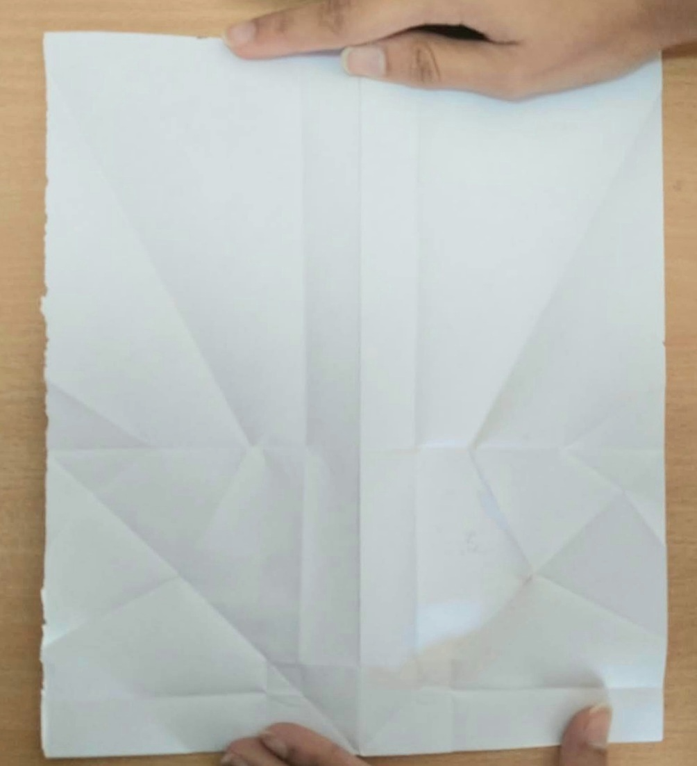
STEP 2: folding along the longer side of rectangle to form a central line and then again reopen it.
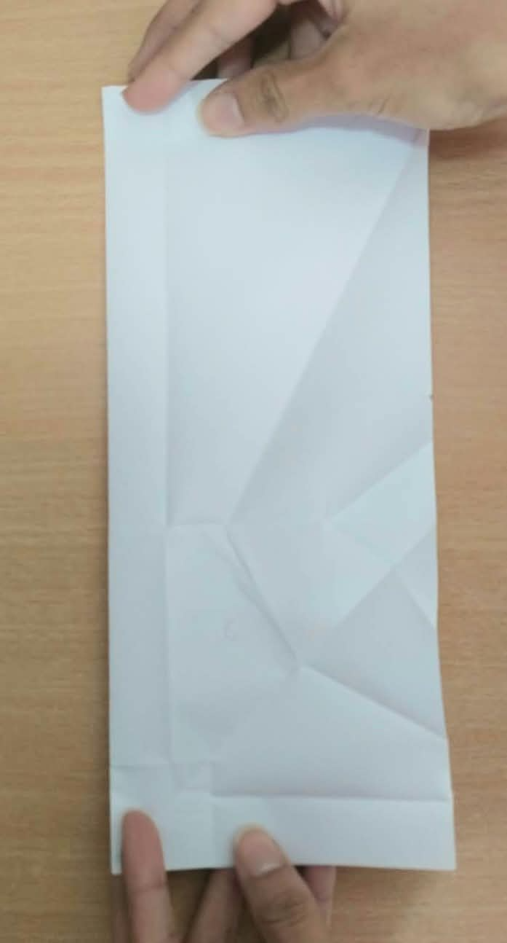
STEP 3: Bringing two adjacent corners to meet the central line and each other.
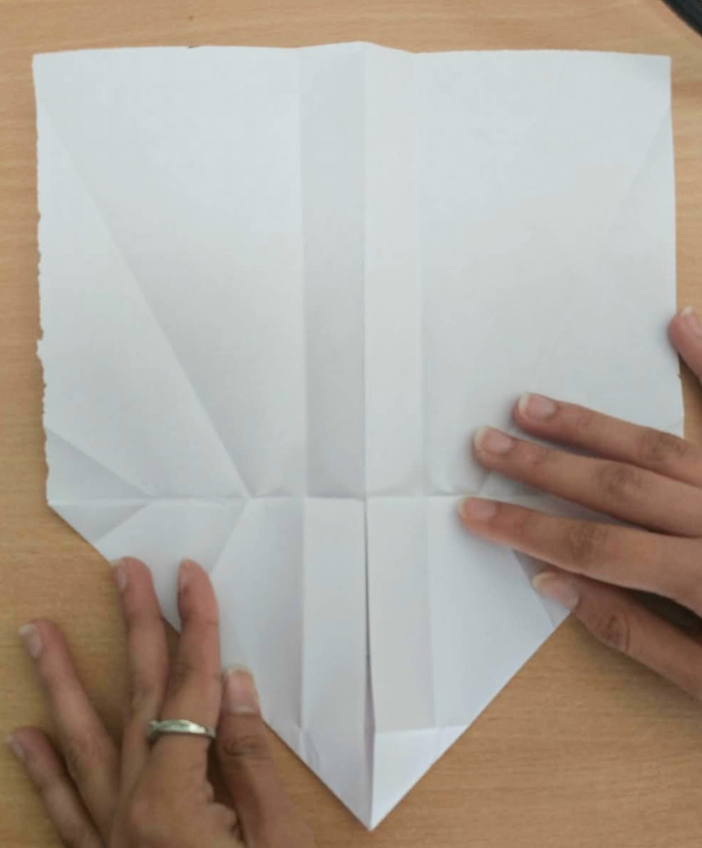
STEP 4: fold the triangle (formed by folding the corners above) downwards.
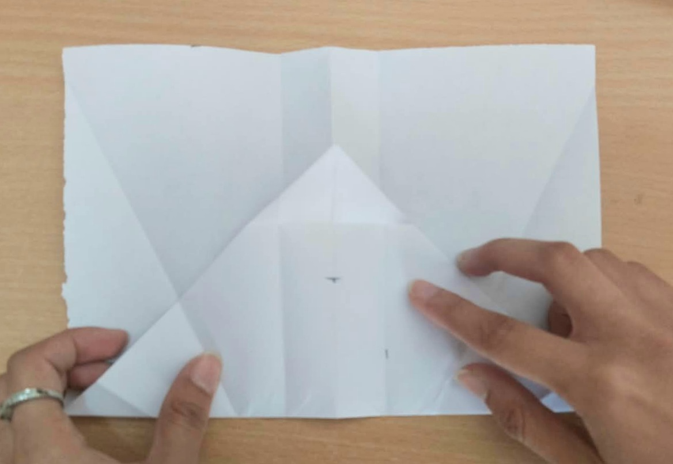
STEP 5: fold the corners of the triangle such that they touch the central line and creates a longer slant edge.
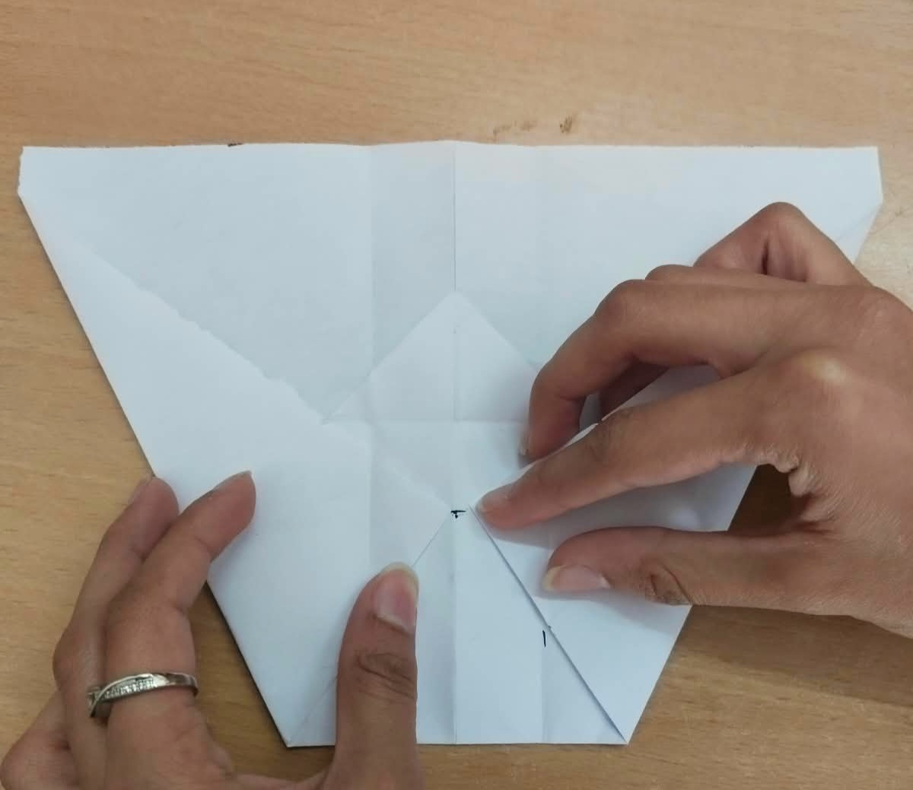

STEP 6: fold the tip of the triangle formed in step 4 upwards.
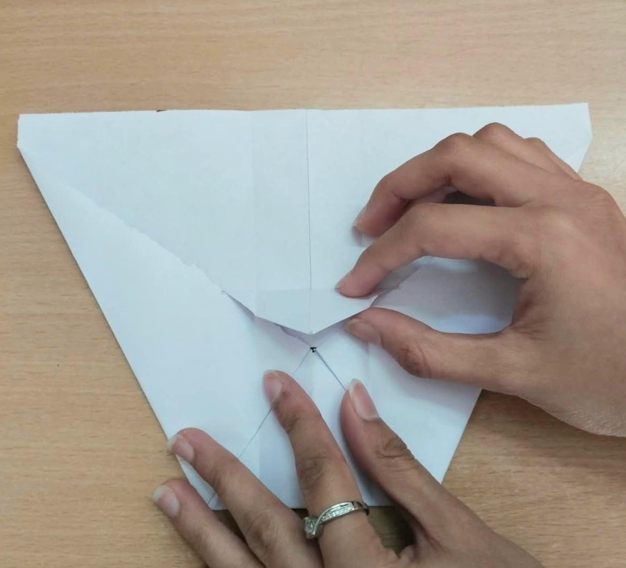
STEP 7: fold from the central line backwards.
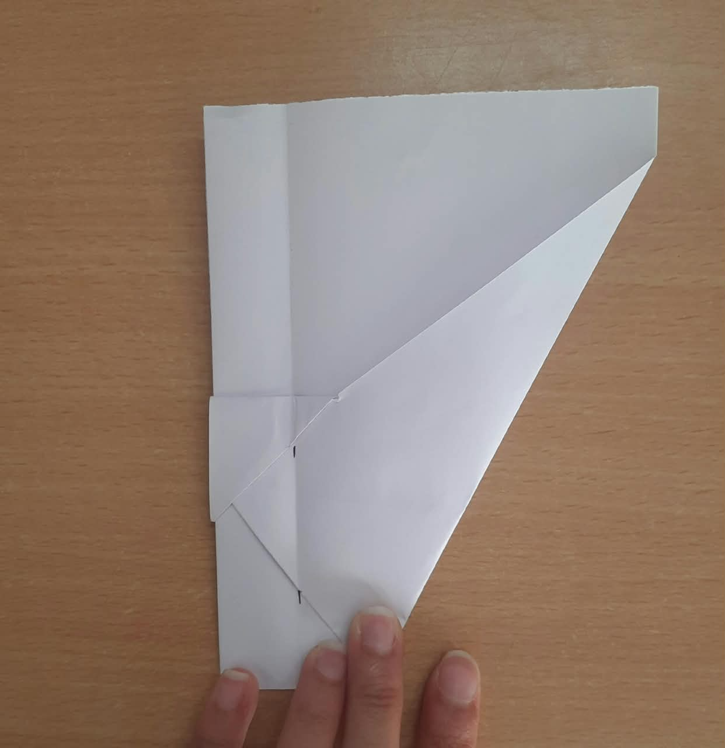
STEP 8: by keeping the central body of width 2cm fold the wing along a straight line.
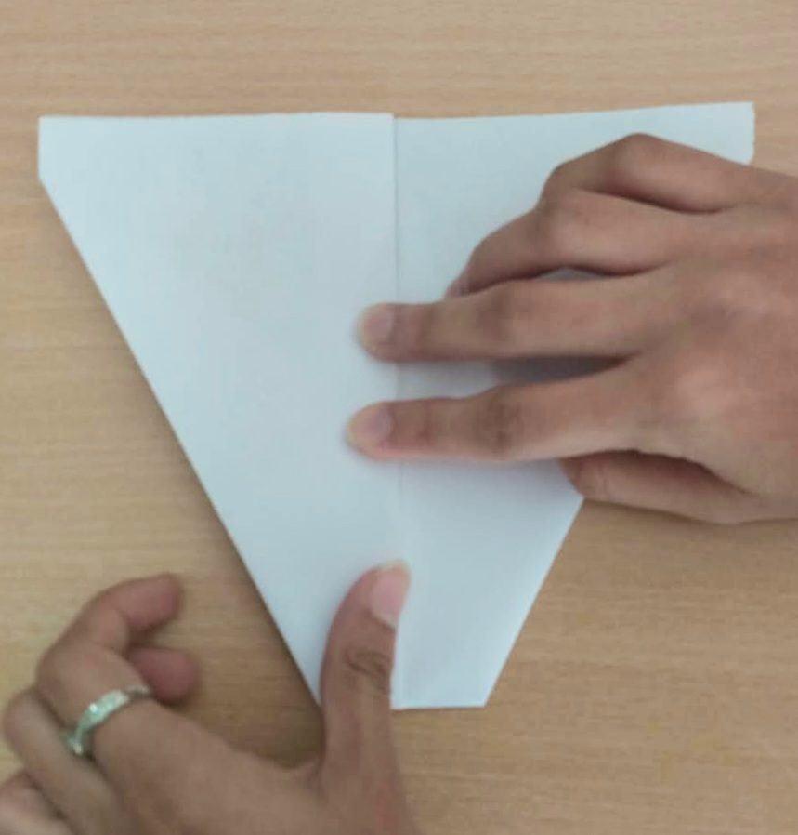

FINAL STEP: open the wings such that they are parallel to the horizontal.
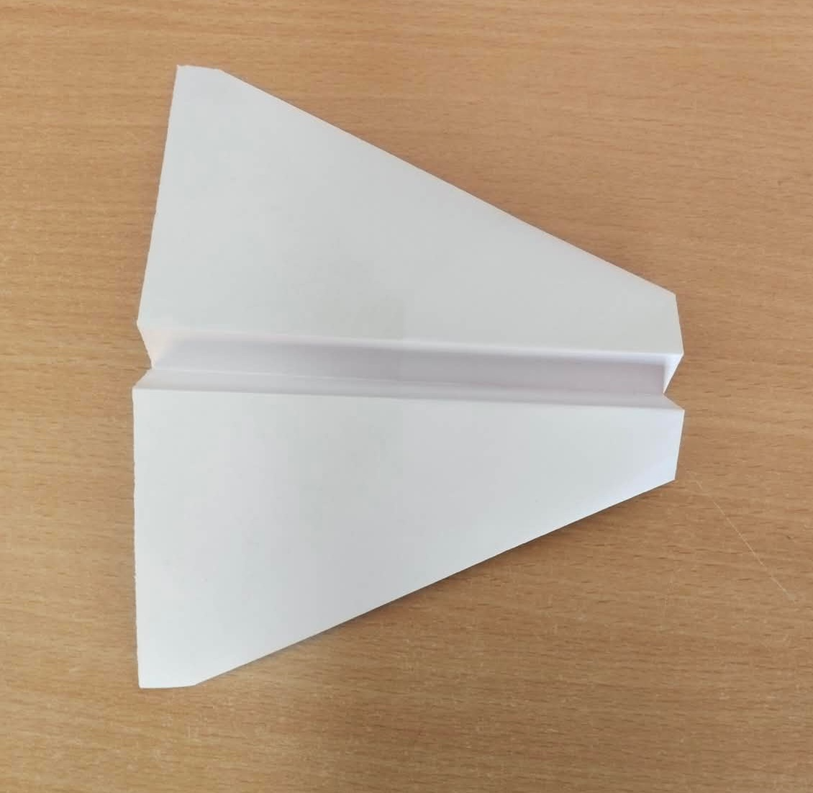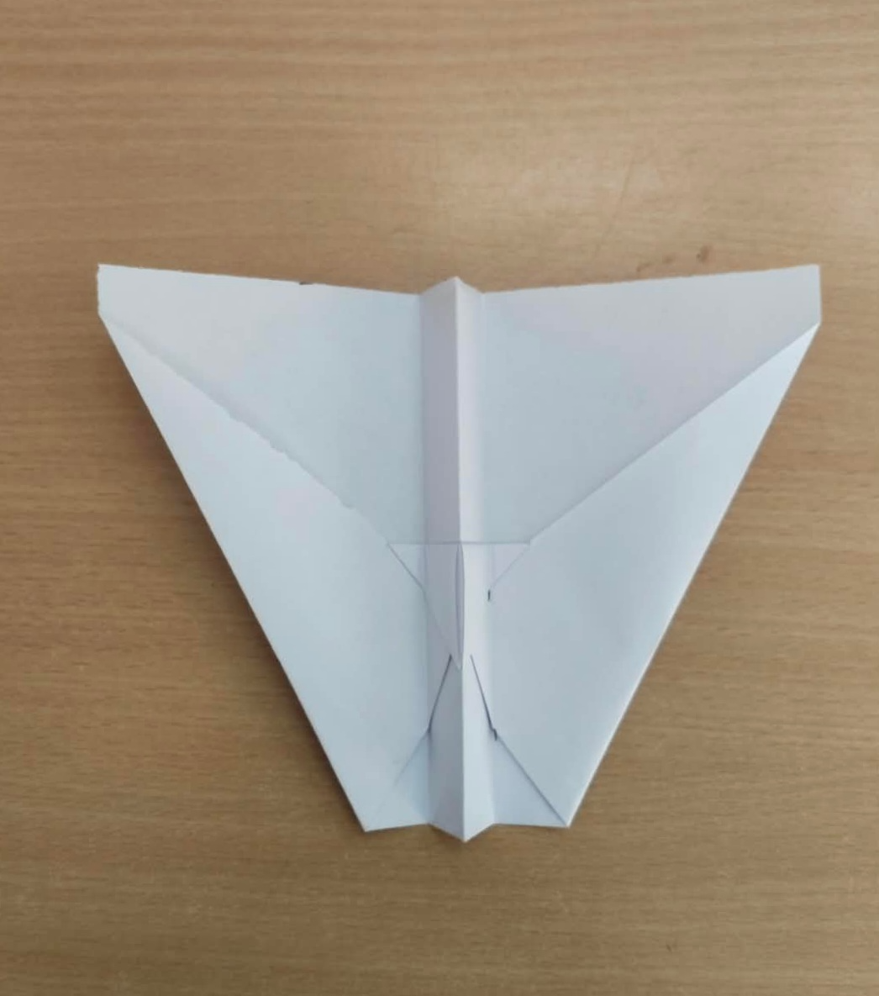
TOP VEIW BOTTOM VEIW
- DESIGN 2:
STEP 1: take a A4 paper and keep it horizontal.
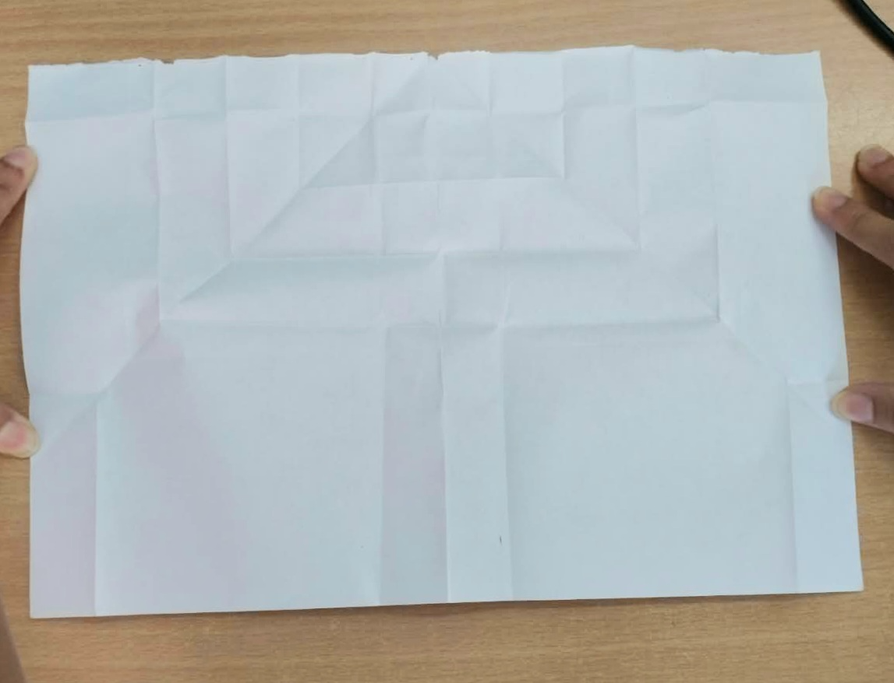
STEP 2: fold the paper along the shorter side and obtain a central line and reopen it. Then fold the corners of the paper such that they touch the central line and each other.
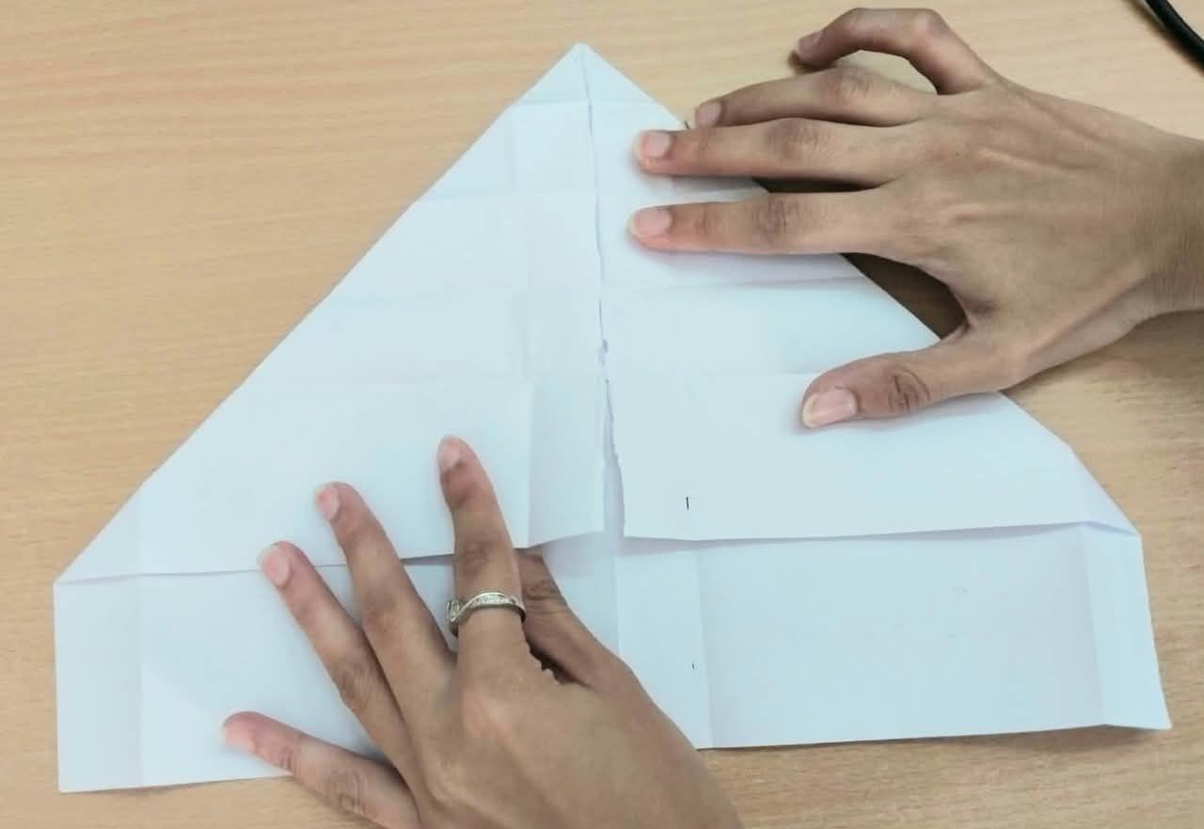
STEP 3: fold the tip of the triangle to touch the base of the formed triangle
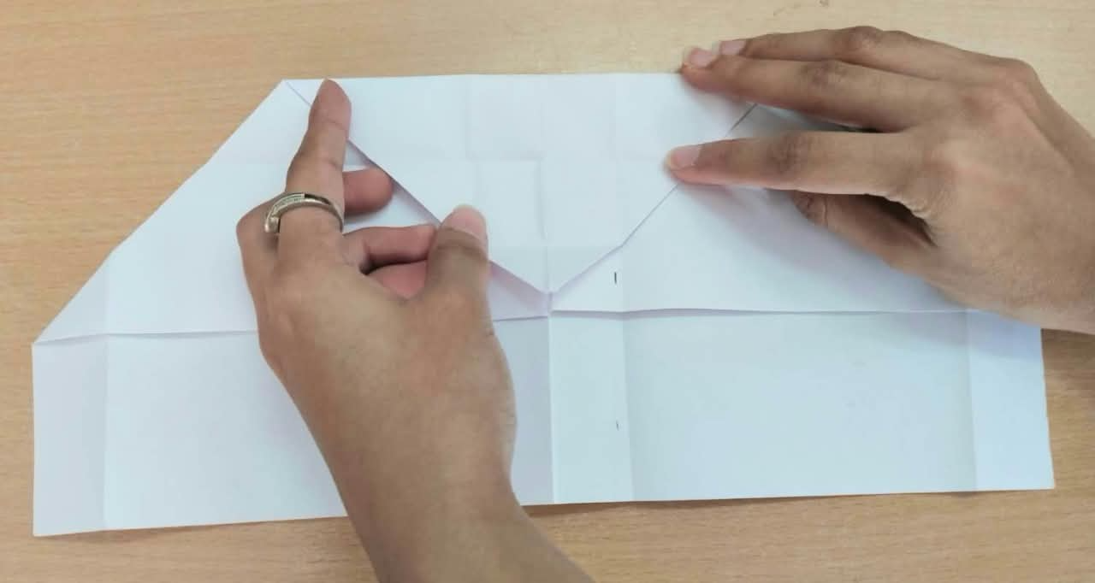
STEP 4: fold a strip from the base of the triangle formed.
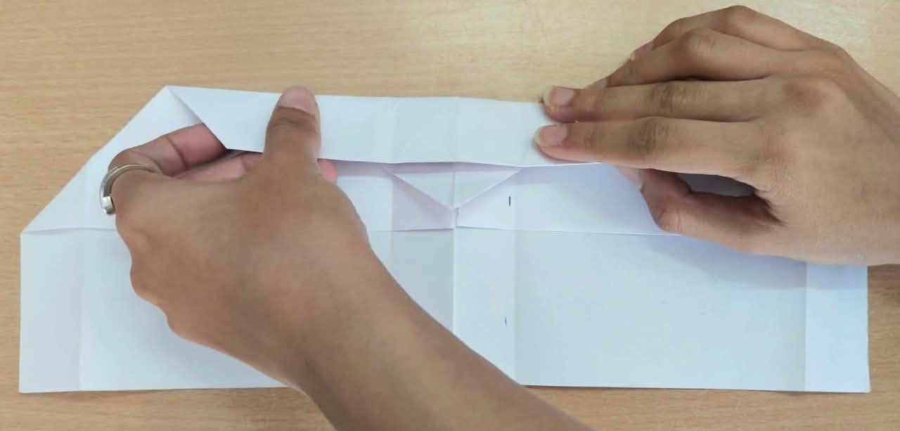
STEP 5: fold the tip of the triangle upwards
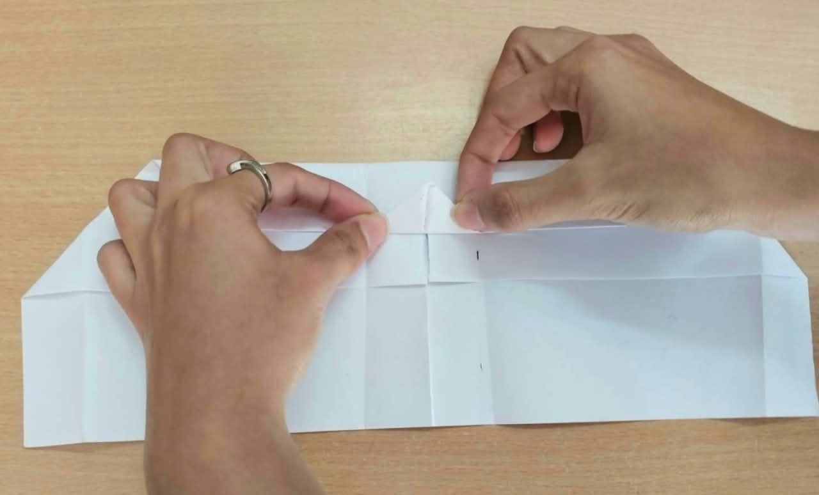
STEP 6: fold from the central line backwards
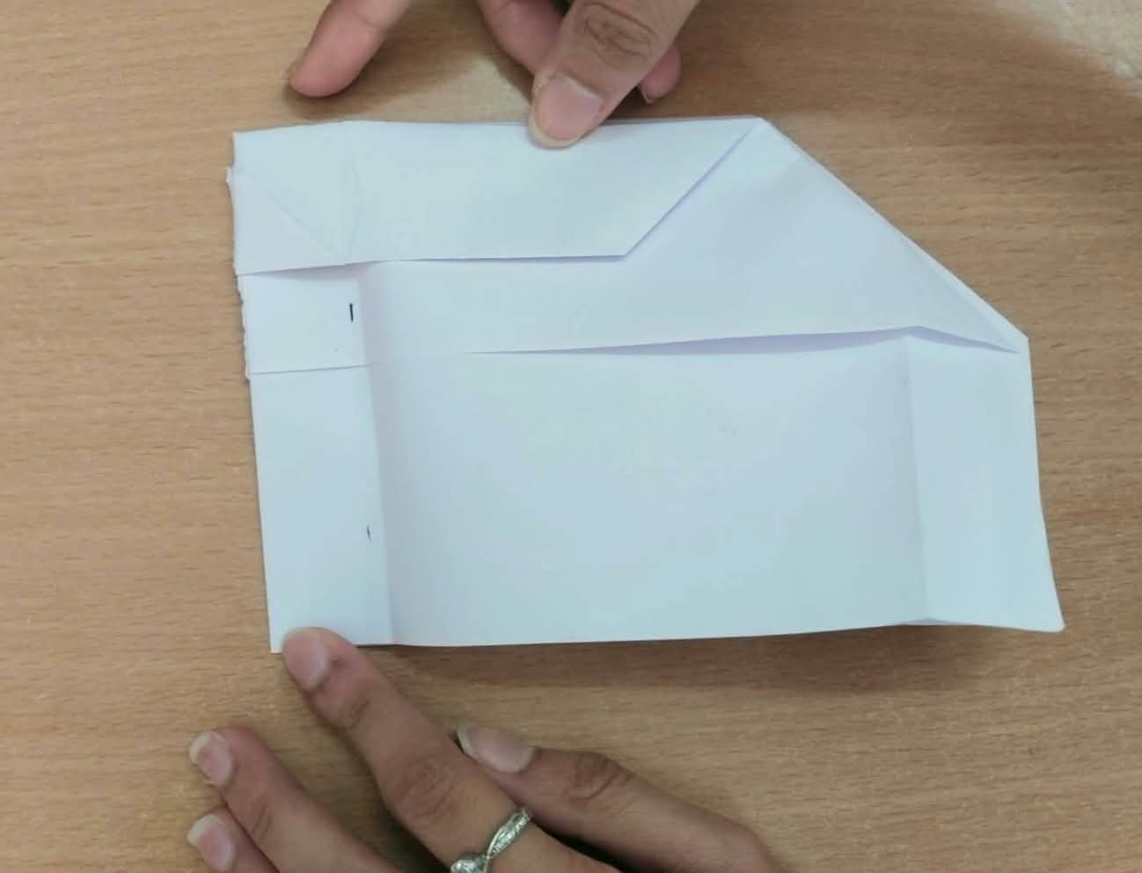
STEP 7: by keeping the central body of width 2cm fold the wing along a straight line.
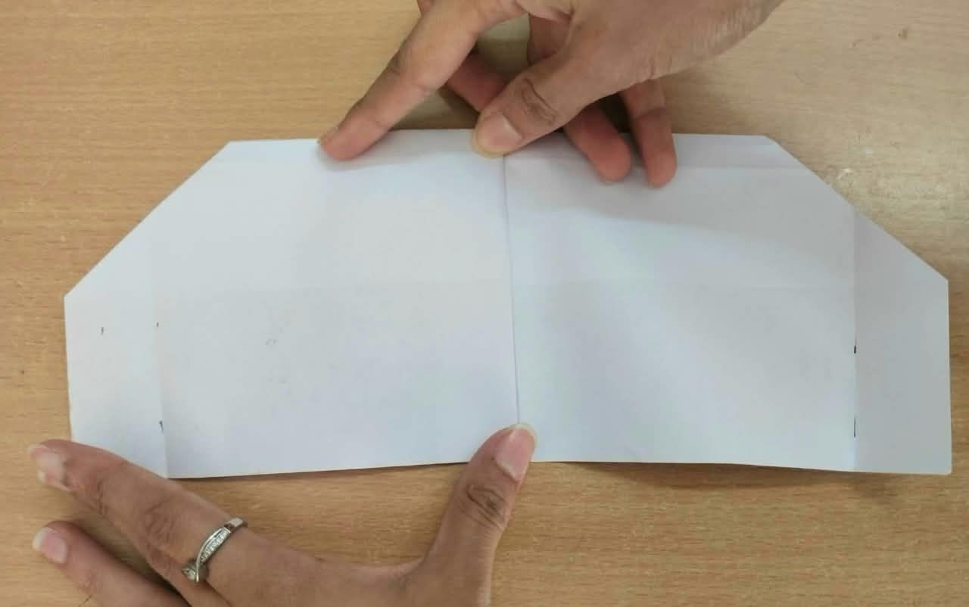
FINAL STEP: open the wings such that they are parallel to the horizontal.

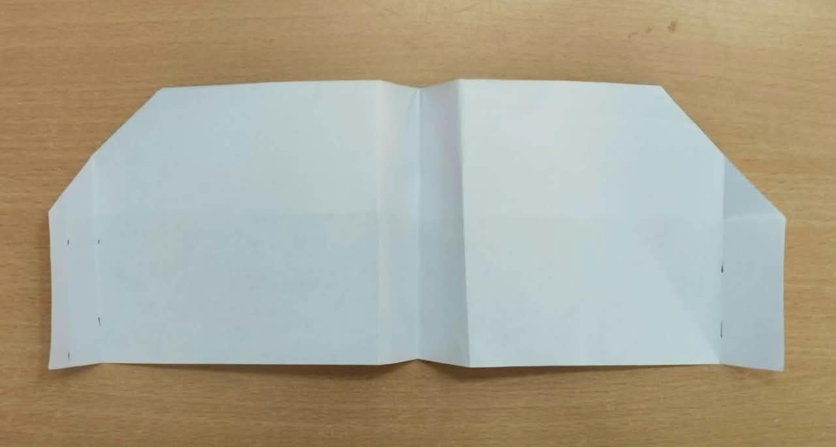
TOP VEIW

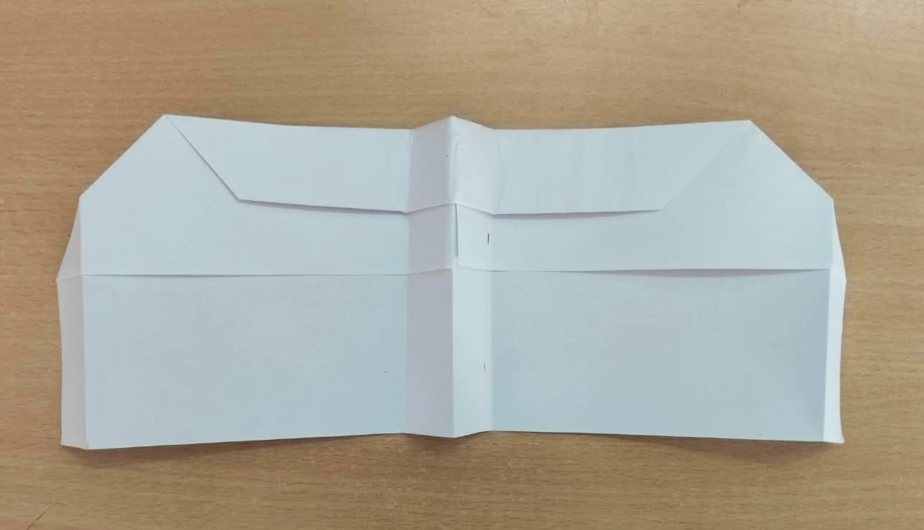
BOTTOM VEIW

DIMENSIONS AND CONFIGURATION – One standard A4 sheet (210 × 297 mm) for each airplane is taken. We can fold and cut the paper to make airplanes but we cannot use tape, glue, paper clips, or external propulsion.
Design 1 — Wide-wing glider: I have cut the A4 sheet in the dimension of 210 × 235 mm so as to maintain the center of gravity nearest to the center of lift.
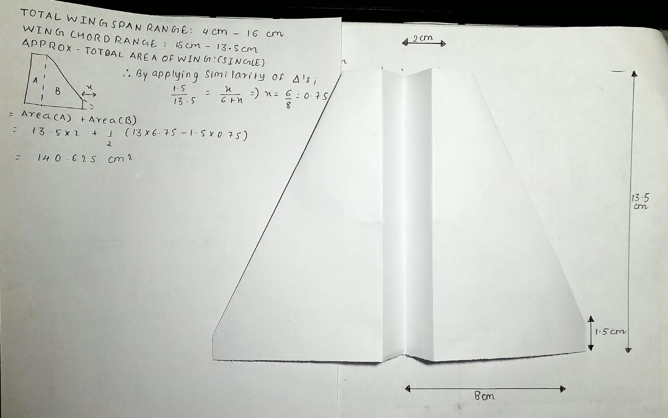

Design 2 --- High aspect ratio – long, slender wing glider
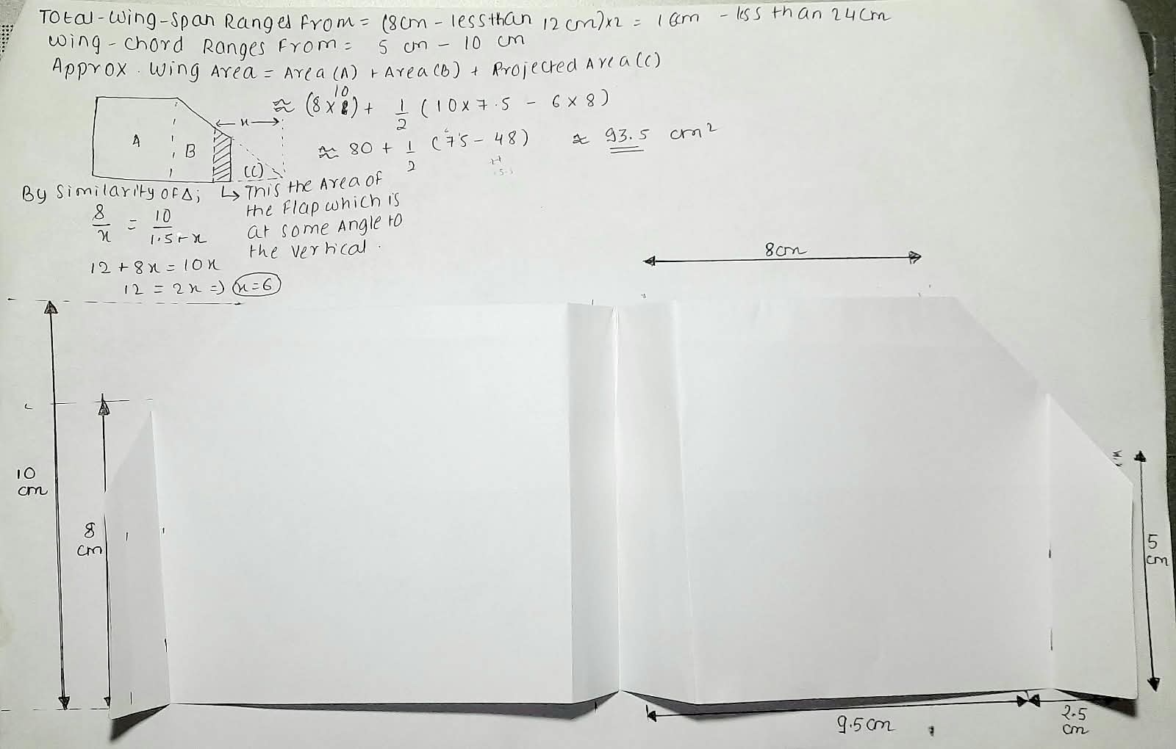
HOW DOES EACH AIRPLANE GENERATE LIFT?
When the airplane moves forward relative to the surrounding air, air flows around its wings. The wing's shape and angle of attack cause the airflow and pressure distribution to change. The wing also deflects air downward, and the corresponding aerodynamic reaction produces an upward force on the airplane. This is also contributed by Bernolli’s principle, Newtons third law, angle of attack and airfoil shape.
$$L=\frac{12}{ρ}V^{2}SC_{L}$$
$L$ = lift force
$ρ$ = air density
$V$ = airplane speed relative to the air
$S$ = wing area
$C_{L}$= lift coefficient, determined by the wing shape and angle of attack, among other factors

# How the lift force acts in the case of both the planes?
Design 1: Its broad wing area helps it generate the required lift at a lower speed for the same weight, provided its lift coefficient is sufficient.
Design 2: Its longer, slender wings can reduce induced drag at a given lift and wing area. However, its narrower chord may make it more sensitive to low-speed airflow separation and poor trimming.

LIFT, WEIGHT, DRAG AND THRUST DURING LAUNCH AND GLIDE

- During Launch:

• Thrust: Your hand supplies the initial force that accelerates the airplane.
• Lift: As airspeed develops, the wings begin producing aerodynamic lift.
• Weight: Gravity acts downward throughout the flight.
• Drag: Air resistance opposes the airplane's motion.

#NOTE: A GENTLE, CONTROLLED LAUNCH IS PREFERABLE TO A HARD THROW, WHICH CAN MAKE THE AIRPLANE CLIMB SHARPLY, STALL AND FALL.

- During Glide:

- Thrust: There is no sustained engine thrust.
- Lift: The wings continue generating lift as the airplane moves through the air.
- Weight: Gravity supplies the energy that is gradually lost during descent.
- Drag: Air resistance dissipates mechanical energy and reduces the airplane's speed.
The airplane converts some gravitational potential energy into forward motion while descending. It cannot maintain level flight indefinitely in still air without an external energy source.

SOME IMPORTANT DISTINCTIONS BETWEEN THE TWO AIRCRAFTS:
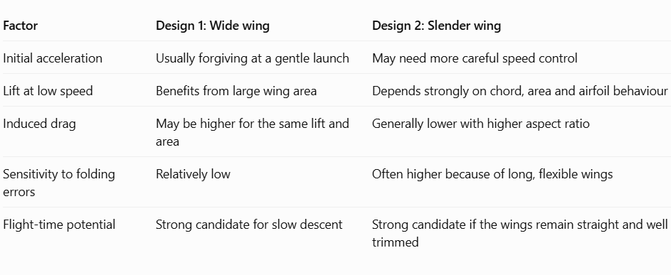
WING AREA, WING LOADING, CENTRE OF GRAVITY AND STABILITY
These four factors are crucial when the objective is maximum flight duration.
- Wing area:
Wing area is the total planform area of both wings, viewed from above.
Design 1 uses broad wings to provide a relatively large area.
Design 2 uses long, narrow wings to achieve a higher aspect ratio, even if its total area is smaller.
A larger wing area can reduce the speed needed to support the same weight, assuming comparable lift coefficients.
- Wing loading:
Wing loading is the airplane's weight divided by its wing area:
$$\text{Wing loading}=\frac{W}{S}$$
Here, $W$ is weight as a force, not mass. For the same weight, increasing wing area lowers wing loading. Lower wing loading usually allows slower flight, which is valuable for a paper airplane intended to descend gently.
Best approach: Keep both designs light, avoid unnecessary folded layers, and make the wings large enough to support the airplane at a stable low speed.
- Centre of gravity (CG)
The centre of gravity is the point at which the airplane's mass can be considered to act.
- If the CG is too far forward, the airplane may dive.
- If the CG is too far backward, the airplane may pitch up, stall or become unstable.
For initial testing, aim for the CG to be approximately 25–35% of the wing's mean chord behind its leading edge, as a rough starting point. This is not a universal optimum; the suitable location depends on the entire folding pattern and tail configuration.
# For a folded paper airplane, balance it gently on two fingertips under corresponding points on the body. Adjust the folds if the nose consistently drops or the airplane pitches upward excessively.
- Stability
Stability means the airplane tends to return toward its normal flight attitude after a small disturbance.
- Pitch stability: Helps prevent repeated climbing and diving.
- Roll stability: Helps prevent one wing from dropping.
- Yaw stability: Helps the nose remain aligned with the direction of travel.
For both designs, keep the left and right wings symmetrical, the body straight and any wing-tip fins equal. Make only small adjustments to the trailing edges during testing.
WHY MIGHT THESE DESIGNS STAY AIRBORNE LONGER THAN A CONVENTIONAL DART? A conventional paper dart generally has a narrow wing area, relatively high wing loading and a shape that often favours faster forward flight. It can travel a long distance, but it may descend relatively quickly.
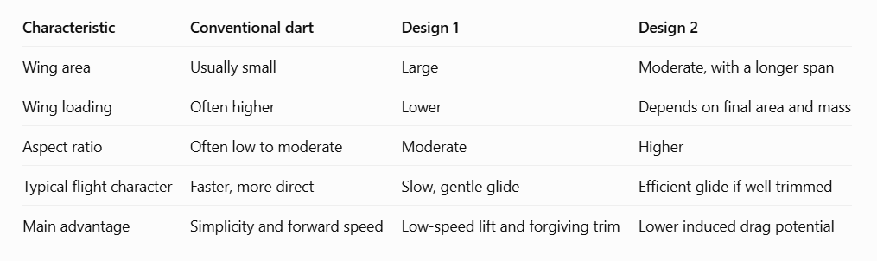
Minimum sink rate versus maximum glide distance:
Minimum sink rate means the lowest possible rate of downward motion. A design with a low sink rate can remain in the air longer for a given starting height.
Maximum glide distance means travelling the greatest horizontal distance before landing. It is closely associated with a high lift-to-drag ratio, or L/D, at the relevant flight condition.
# NOTE: A DESIGN OPTIMIZED FOR MAXIMUM DISTANCE DOES NOT NECESSARILY STAY AIRBORNE THE LONGEST. THE ACTUAL DURATION DEPENDS ON HOW THE AIRPLANE'S SPEED, LIFT, DRAG AND SINK RATE CHANGE THROUGHOUT ITS GLIDE.
TRIALS AND THE AVERAGE OF RECORDED TIME
- DESIGN 1:

VIDEO OF THE LONGEST FLIGHT IN THE TRIALS:
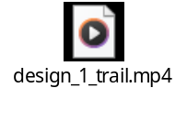
OBSERVATIONS – the recorded time of flight of 5 trials:

NO. OF TRAIL | TIME PERIOD OF FLIGHT (sec)
1 | 2.5
2 | 2.3
3 | 2.6
4 | 2.5
5 | 2.2

CALCULATION – average time of flight:
Average Time Period of Flight= $\frac{SUM OF ALL RECORDED TIME OF FLIGHT }{NO . OF TRAILS}$
AVERAGE TIME OF FLIGHT = 2.5 + 2.3 +2.6 + 2.5 + 2.2 / (5) = 2.42 seconds

- DESIGN 2:

VIDEO OF THE LONGEST FLIGHT IN THE TRIALS:
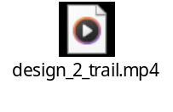
OBSERVATIONS – the recorded time of flight of 5 trials:

NO. OF TRAIL | TIME PERIOD OF FLIGHT (sec)
1 | 4.4
2 | 4.8
3 | 3.9
4 | 4
5 | 3.8

CALCULATION – average time of flight:
Average Time Period of Flight= $\frac{SUM OF ALL RECORDED TIME OF FLIGHT }{NO . OF TRAILS}$

AVERAGE TIME OF FLIGHT = 4.4 + 4.8 +3.9 + 4 + 3.8 / (5) = 4.18 seconds

MODIFICATIONS AND TESTING FOR BOTH THE PLANES
Your objective is to maximize flight duration in still air, so every modification should aim to reduce the rate of descent while maintaining stable flight.
Aircraft 1 — Wide-wing glider
Modification 1: Increase wing area
- Change: Make the wings slightly broader while keeping the body and paper type unchanged.
- Expected effect: Lower wing loading may allow the glider to fly more slowly while generating enough lift.
- Possible drawback: Excessively broad wings can increase drag or make the airplane harder to trim.
Modification 2: Add a small amount of wing dihedral
- Change: Bend both wings slightly upward so they form a shallow V when viewed from the front.
- Expected effect: Improve roll stability and reduce unwanted banking.
- Possible drawback: Too much upward bend can reduce effective horizontal span and increase drag.

Aircraft 2 — High-aspect-ratio glider
Modification 1: Increase wingspan
- Change: Extend both wings equally, keeping the wing chord and paper type as close to the original as practical.
- Expected effect: A higher aspect ratio can reduce induced drag for a given lift.
- Possible drawback: Longer paper wings may bend or twist, increasing drag and reducing stability.
Modification 2: Adjust wing-tip shape and alignment
- Change: Make the wing tips symmetrical and remove unwanted twists. Test small upturned tips as a separate change.
- Expected effect: Better symmetry may reduce unwanted rolling and turning.
- Possible drawback: Large wing-tip fins can add drag, so they are not automatically beneficial.

How to test the modifications fairly?

STEP 1: Establish a baseline
Fly the original aircraft five times. Record each flight duration and calculate the average.

STEP 2: Change one variable
Make only the selected modification. For example, widen Aircraft 1's wings without changing its nose or wing-tip angles.

STEP 3: Keep other variables constant
Use the same paper weight, launch height, launch direction, release technique, indoor location and timing method. Check that the centre of gravity has not shifted significantly.

STEP 4: Repeat five trials
Record the flight time for every trial. Use the same gentle launch technique and avoid fans or drafts.

STEP 5: Compare averages
Calculate the modified aircraft's average flight time and compare it with its own original baseline, not just with the other design.

