STIMULATIONS VS. PRACTICAL

PROS AND CONS - STIMULATION LED AND PROTOTYPE LED:

- STIMULATION LED:
Simulation-led design uses computer software and mathematical models to predict aircraft behavior before manufacturing the physical aircraft.
HOW IT WORKS: The designer enters parameters such as airfoil shape, wing dimensions, mass estimates, speed, and operating conditions. Software estimates aerodynamic forces, stability, structural behavior, or other performance characteristics.

Advantages
- Reduces material waste: Several designs can be compared before building them.
- Allows early optimization: Wing area, aspect ratio, airfoil, and tail dimensions can be adjusted digitally.
- Provides useful predictions: Lift, drag, pressure distribution, and stability trends can be studied.
- Improves design understanding: Engineers can investigate why a design may perform poorly.
- Makes comparisons easier: Multiple design options can be evaluated using consistent assumptions.

Limitations
- Results depend on the accuracy of the input data and mathematical models.
- Simplified models may not capture complex airflow, turbulence, or separation accurately.
- Actual construction may introduce misalignment, surface roughness, excess mass, and structural flexibility.
- Some advanced software requires powerful computers, expertise, or expensive licences.
- A simulation cannot fully reproduce real-world take-off, control response, radio problems, or manufacturing defects.

- PROTOTYPE LED:
Prototype-led design involves manufacturing an actual aircraft or test component early, testing it, and improving it based on observed performance.
HOW IT WORKS: The team builds a prototype using materials such as foam board, balsa wood, plywood, or composite materials. It then measures mass, checks geometry, tests the propulsion system, and performs controlled flight tests.

Advantages
- Reveals real construction and assembly problems.
- Measures actual aircraft mass, motor thrust, and control-system response.
- Detects issues that simplified simulations may miss.
- Provides direct evidence of take-off, handling, and flight performance.
- Helps the team develop practical manufacturing and troubleshooting skills.

Limitations
- Materials and components may be wasted when a design fails.
- Manufacturing and testing take physical effort and workshop time.
- Poorly controlled tests may produce misleading results.
- Rebuilding an entire aircraft for each change can be slow.
- Flight tests require suitable weather, space, supervision, and safety precautions.

CONCLUSION: Neither approach is sufficient alone. Simulation is most useful for comparing alternatives and reducing avoidable mistakes; practical prototyping is essential for verifying the actual aircraft.

Comparison Between Stimulations vs. Practical Led:

The table given below compares some important features of aircraft building and constraints in its building:

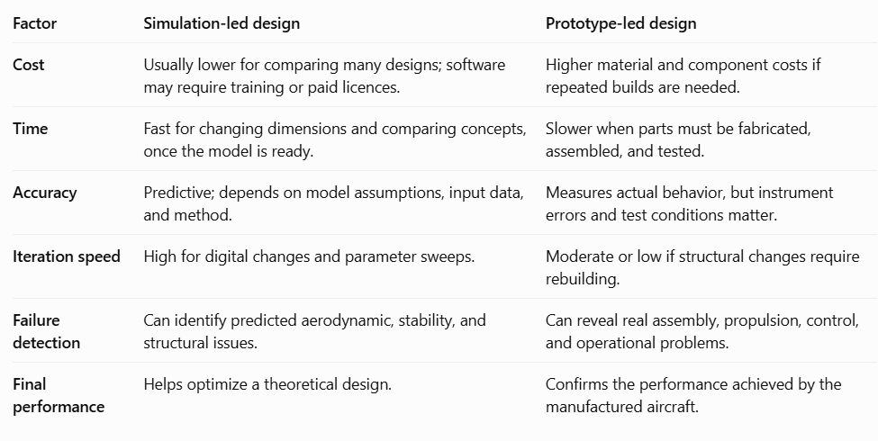

NOTE: A SIMPLE PHYSICAL TEST CAN BE QUICKER THAN A COMPLICATED SIMULATION, AND A CAREFULLY VALIDATED SIMULATION CAN BE MORE USEFUL THAN AN UNCONTROLLED PHYSICAL TEST.

I recommend a simulation-first, prototype-verified hybrid approach.
- Use simulations to eliminate poor design options before spending money.
- Build an early prototype as soon as the basic design meets the requirements.
- Test the prototype and compare measured results with predictions.
- Correct the most important discrepancies before producing the competition-ready aircraft.
This approach balances cost, speed, accuracy, and practical reliability.

THE WORKFLOW OF THE PROJECT OF RC PLANE AND HOW IS PERFORMED:
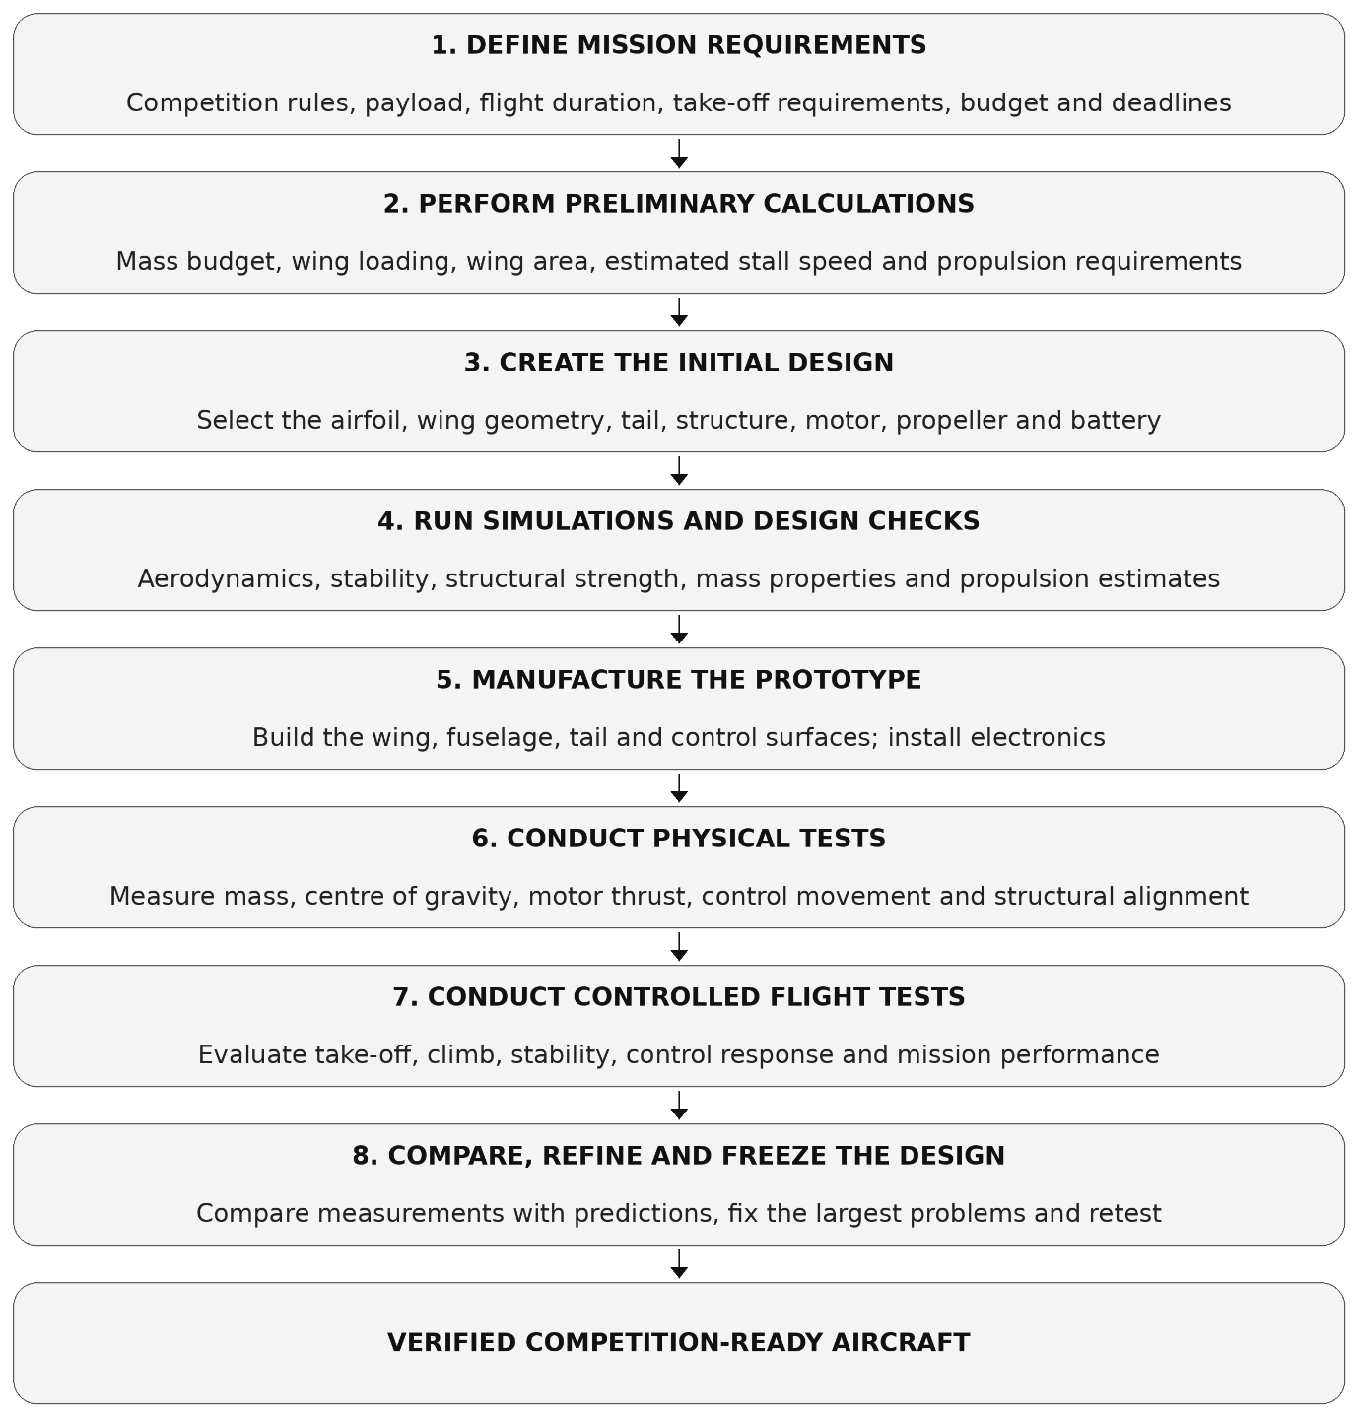
NOTE: THE REFINING AND DESIGNING STEP CAN BE REPEATEDLY PERFORMED IF REQUIRED.
# Let us discuss the preliminary calculations that are to be performed:
- Estimate the total mass, wing area, wing loading, stall speed, and required thrust. These calculations help reject unsuitable concepts before detailed design.
- For example; WING LOADING is,
$$\text{Wing loading}=\frac{W}{S}$$

$W=$aircraft weight ( newtons ) $S=$wing surface area
- The stall speed in steady level flight is calculated as;

$$V_{s}=\sqrt{\frac{2W}{ρSC_{L_{max}}}}$$

$W=$aircraft weight(newtons) $S=$wing surface area
$ρ=$density of air $C_{L_{max}}=$maximum lift coefficient
- The aspect ratio it affects the induced drag and wing geometry:

Aspect ratio= (span of wing)²/ (area of the wing)

- These are some of the important values to be calculated. Other than this also there are various values which are important like lift force, drag force, coefficient of lift, coefficient of drag, lift to drag ratio and many more important parameters exist.

# For designing we can use softwares like Autocad, Solidworks.

# For Running Stimulations one can use XFOIL, Ansys, Matlab & Simulink, FlexSim.

# Building the actual Prototype includes countering towards measurement of actual component masses and inspection of warping, asymmetry, loose connections, and dimensional errors.

# Conduct physical tests: Verify the centre of gravity against the approved design range, control- surface direction and travel, structural integrity, radio operation, and propulsion performance.

# Conduct controlled flight tests. Only proceed after the aircraft passes its ground checks. Begin with a suitable low-risk test plan and an experienced, authorized operator. Record take-off behavior, climb, control response, and stability.

# Refine the design. Identify the largest difference between prediction and measurement. To resolve the issues start by changing one suspected variable at one time and while implementing a new one also first check its stimulation and then fix it.

PARAMETERS CHOOSEN FOR STIMULATION CHECK AND ITS VERIFICATION THROUGH PHYSICAL PROTOTYPE:
The team should choose parameters that directly influence the competition mission rather than spending time analysing every possible variable.
- Parameters to study through simulation
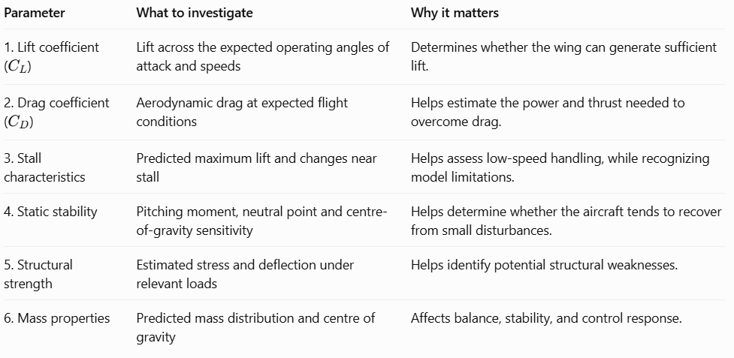
- Parameters to verify physically
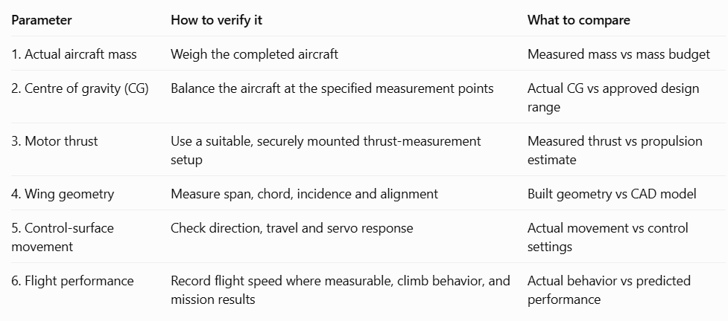

Explain how simulations should be validated
Simulation validation means checking whether a model's predictions agree sufficiently with measurements from the real world. The process should be systematic:
Step 1 — Establish a reference design.
Create the exact aircraft geometry, airfoil, estimated mass, CG, control settings, motor and propeller configuration used in the simulation.
Step 2 — Record predicted values.
Save the simulation outputs before physical testing. These might include estimated stall speed, lift coefficient, drag coefficient, pitching moment, and required thrust.
Step 3 — Measure the prototype.
Use calibrated instruments where possible. Measure mass using a scale, CG using a balancing method, and static thrust using a suitable thrust stand. Record the conditions under which each measurement was made.
Step 4 — Match the conditions.
Compare like with like. Aerodynamic results depend on factors such as airspeed, air density, angle of attack, Reynolds number, and configuration. Differences in test conditions can explain apparent disagreement.
Step 5 — Calculate the discrepancy.
For a predicted value P and measured value M, calculate the percentage difference as:
$$\text{Difference (\%)}=\frac{\left|M-P\right|}{\left|P\right|}×100$$
NOTE: THIS FORMULA IS APPROPRIATE WHEN THE PREDICTED VALUE IS NONZERO AND IS A MEANINGFUL REFERENCE. FOR QUANTITIES NEAR ZERO, USE AN ABSOLUTE DIFFERENCE OR A SUITABLE UNCERTAINTY-BASED COMPARISON INSTEAD.
Step 6 — Investigate discrepancies.
Possible explanations include inaccurate input data, simplified models, measurement uncertainty, manufacturing differences, and environmental conditions.
The team should investigate the installed propeller, battery voltage under load, motor performance, and test setup rather than assuming the simulation is correct.
Step 7 — Update and retest.
Correct the inputs or model assumptions when evidence supports doing so. Repeat measurements if needed, and rerun the simulation using the revised information.
NOTE: THE MEASURED VALUES CAN ALSO CONTAIN SOME ERROR DUE THE INSTRUMENTS LEAST COUNT AND OTHER LIMITATIONS.
CASE STUDY: The Stimulated Plane Performs Well But The Prototype Cannot Take-Off --- Plausible Causes And A Systematic Diagnostic Plan.
A. Plausible causes:
1.Incorrect mass or centre of gravity
The completed aircraft may be heavier than the model, or its CG may lie outside the approved design range. This changes the lift required and can make control difficult.
2. Insufficient installed thrust
The real propulsion system may produce less thrust than expected because of battery voltage drop, an unsuitable propeller, motor problems, or excessive installation losses.
3. Incorrect wing geometry
Wing incidence, airfoil orientation, surface shape, or alignment may differ from the simulated model. Warped wings or rough construction may also affect performance.
4. Control-system problems
An incorrectly configured elevator, a reversed control direction, inadequate servo movement, or a loose linkage may prevent the aircraft from rotating or responding properly.
5. Structural or aerodynamic mismatch
Flexible surfaces, weak attachment points, excessive gaps, or a damaged propeller can cause the real aircraft to behave differently from the model.

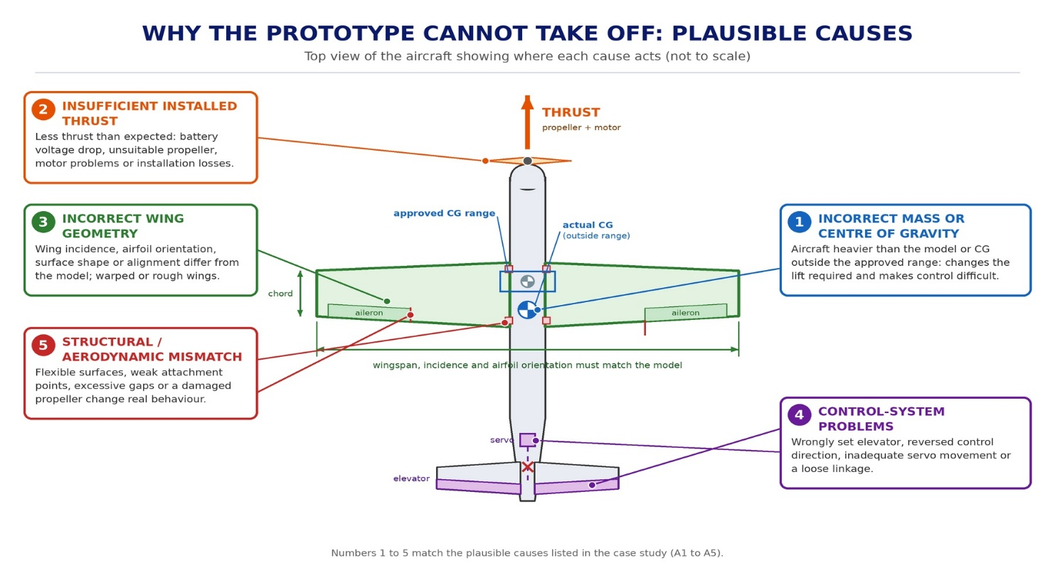

B. Systematic diagnostic plan

Check 1: Confirm the aircraft's actual condition
Weigh the aircraft, measure the CG, inspect the wing and tail alignment, and compare the finished aircraft with the design drawings.
Check 2: Verify propulsion
Inspect the motor, propeller, battery, wiring, and speed controller. Measure static thrust with a suitable test fixture and compare it with the estimate. Keep clear of the propeller and follow appropriate supervision and safety procedures.
Check 3: Verify controls
With propulsion made safe, check transmitter response, servo direction, control-surface travel, linkage security, and radio reliability.
Check 4: Recalculate take-off requirements
Use the measured aircraft mass and realistic estimates of lift and installed thrust. Check whether the predicted take-off speed and available ground distance are consistent with the actual setup and conditions.
Check 5: Compare the simulation with reality
Verify that the simulation uses the actual wing dimensions, mass, CG, airfoil, control configuration, and propulsion assumptions. Correct any inaccurate inputs.
Check 6: Retest before returning to flight
Correct the identified fault, repeat the relevant ground checks, and obtain approval from the responsible experienced operator before conducting another controlled flight test.

C. Decision logic: The approach towards solving the issue.

- If the aircraft is too heavy, investigate mass reduction without compromising structural integrity.
- If measured thrust is too low, identify the propulsion-system cause before redesigning the wing.
- If CG or wing alignment is incorrect, correct the construction or mass distribution and recheck stability.
- If controls are faulty, fix the control system before any flight test.
- If all physical checks pass but performance remains poor, revisit the aerodynamic model and test assumptions.

SOFTWARES FOR DESIGN AND STIMULATIONS
There exists various softwares that help designing of model and running stimulations at various conditions and parameters Some of them are described below with there main purpose of use and how they contribute to a project of building an RC Plane.
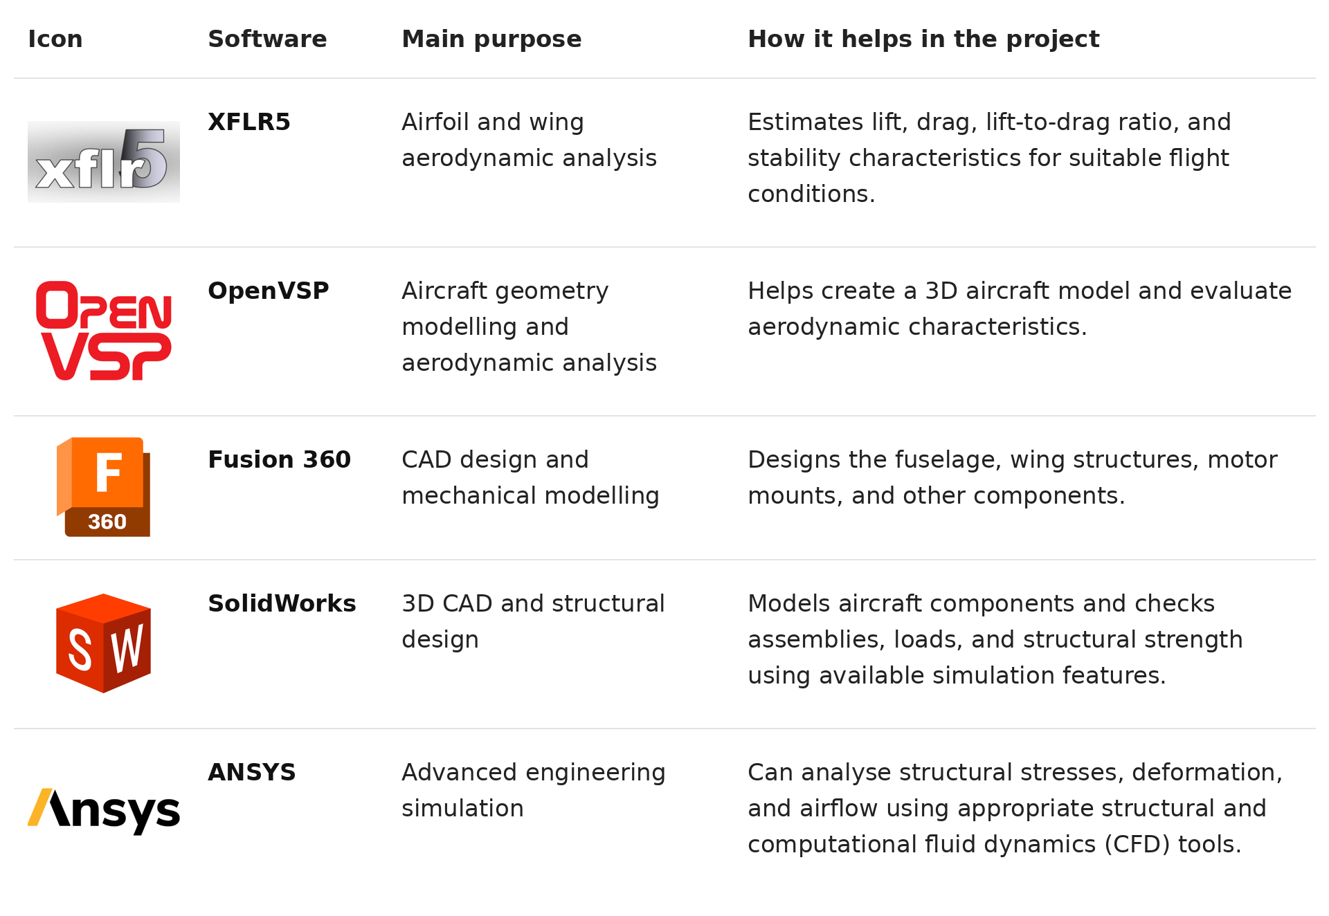
Realistic Four Week Development Schedule:
We can divide above mentioned work flow in a 4 week schedule.

WEEK 1: Understanding the mission definition, performing all preliminary calculations and preparing a design of aircraft using various softwares.
- Study competition rules and set measurable requirements.
- Estimate mass, wing loading, wing area, stall speed, and propulsion needs; that is all the required calculated values.
- Choose candidate airfoils and basic wing configurations whose features suits our mission the best.
- Prepare CAD geometry and an initial mass budget.
Milestone: Preliminary designs approved.

WEEK 2: Running of stimulations and preparing a prototype of the aircraft.
- Run aerodynamic and preliminary stability analyses.
- Finalize the wing, tail, and structural layout.
- Procure and check the required components.
- Manufacture the wing, fuselage, and tail; begin assembly.
Milestone: Initial prototype assembled

WEEK 3: Ground testing and initial flight testing
- Complete assembly and measure mass and CG.
- Verify propulsion, control surfaces, radio operation, and structure.
- Conduct approved controlled flight tests if the aircraft passes all checks and conditions permit.
- Compare measured results with simulation predictions.
Milestone: First test results recorded

WEEK 4: Refinement, contingency, and final checks
- Reserve the first part of the week for repairs and unresolved issues.
- Correct significant differences between measured and predicted performance.
- Repeat relevant ground and flight tests.
- Freeze the final configuration, document the results, and prepare for the competition.
Milestone: Verified competition-ready aircraft
- A REALISTIC SCHEDULE MUST ALLOW FOR SETBACKS RATHER THAN ASSUMING EVERY TASK SUCCEEDS ON THE FIRST ATTEMPT.
