COMPLETE BILL OF MATERIALS (BOM) FOR AN ELECTRIC FIXED-WING RC AIRCRAFT:

Identify all aircraft components

The aircraft needs both mechanical parts (to form the airplane) and electronic parts (to power and control it).

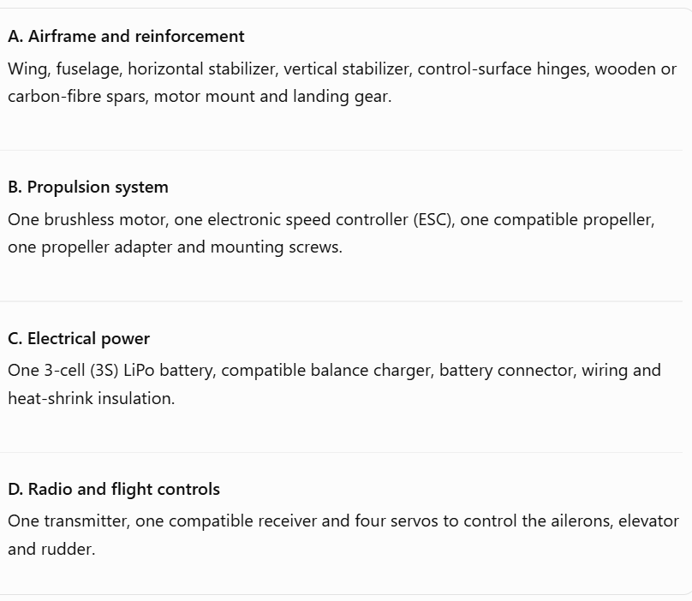

Complete BOM with two alternatives
# NOTE: PRICES ARE APPROXIMATE PLANNING ESTIMATES IN INDIAN RUPEES (INR). THE FINAL PRICE DEPENDS ON THE SELLER, SPECIFICATIONS, SHIPPING AND STOCK.
A. Propulsion and power components
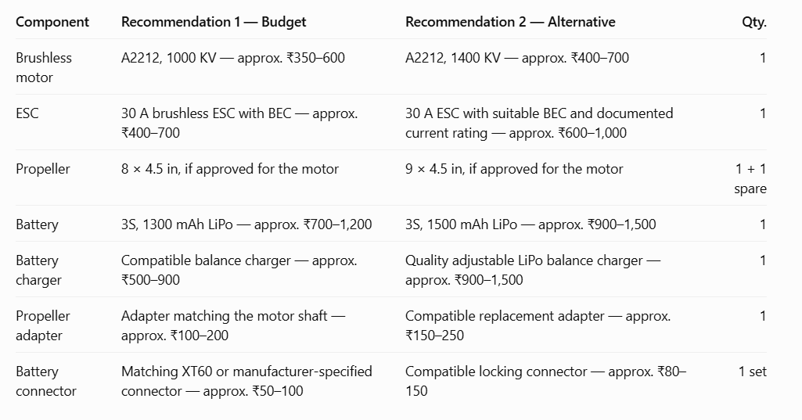
# NOTE: FOR YOUR AIRCRAFT, DO NOT CHOOSE THE PROPELLER BASED ONLY ON ITS DIAMETER. CHECK THE EXACT MOTOR'S PERMITTED PROPELLER, MAXIMUM CURRENT AND POWER AT THE SELECTED BATTERY VOLTAGE.
B. Radio control and electronics
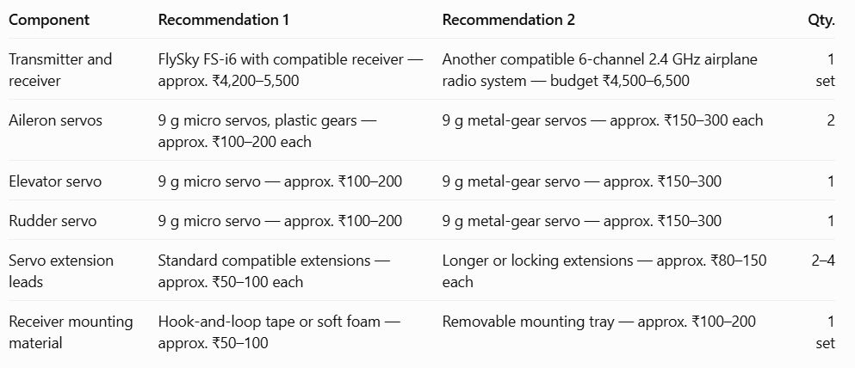
# Servo count: four. Two servos operate the ailerons, one operates the elevator, and one operates the rudder. A design using one servo to operate both ailerons through a mechanical linkage could reduce the count, but four independent servos are the straightforward choice for this BOM.
# A six-channel radio system provides enough channels for throttle, ailerons, elevator and rudder, with spare channels available. The FlySky FS-i6 and its compatible receiver are one example; check the exact receiver model, supported protocol and voltage requirements before selecting the set.
C. Airframe, structure and assembly

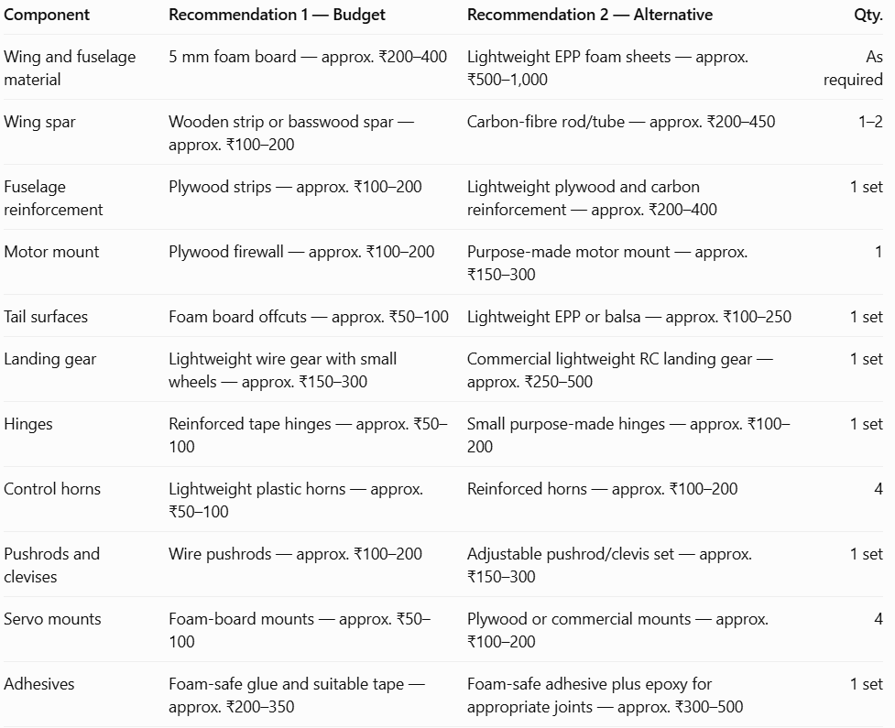
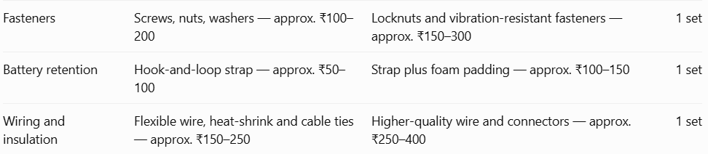

# NOTE: THE PROJECT OF RC PLANE ALSO REQUIRES VARIOUS SMALL THINGS LIKE GLUE, FOMS, SPARECOLOURS AND MANY MORE THINGS.
Justify the component selections
Motor–propeller matching and available thrust
A brushless motor converts electrical energy from the battery into rotational motion. The propeller converts that rotation into thrust, which pushes the aircraft forward.
For the proposed 1.2 m high-wing aircraft, the A2212 1000 KV motor is a candidate for a lightweight trainer, provided the completed aircraft's mass and measured thrust are suitable.
To evaluate the motor–propeller match:
- Check the motor's permitted voltage, current and propeller sizes.
- Check the ESC's continuous current rating against the motor's measured maximum current.
- Verify that the battery can supply the required current.
- Use reliable manufacturer data or a properly conducted static thrust test to estimate thrust.
- Confirm the final aircraft's mass, wing loading and centre of gravity before flight.
A rough preliminary goal is a static thrust-to-weight ratio around 0.7–1.0 for a basic trainer, depending on the design and launch method. This is a design target, not a guarantee of takeoff or climb performance.
ESC rating and electrical margin
An ESC (Electronic Speed Controller) Rating specifies the electrical boundaries—specifically current (amperage) and voltage—that an ESC can safely handle while regulating power from a battery to a brushless or brushed electric motor.
CURRENT MARGIN = CURRENT OF ESC – CURRENT DRAWN
For a motor expected to draw up to approximately 12 A, a 30 A ESC is a reasonable candidate, assuming the selected motor and propeller combination is actually limited to that current.For example, if the measured maximum current is 12 A:
$$\text{Current margin}=30-12=18\text{ A}$$
$$\text{ESC sizing ratio}=\frac{30}{12}=2.5$$
This indicates substantial nominal current headroom, but it does not replace checking cooling, wiring, connector ratings, battery voltage and the ESC's continuous-current specification. The ESC's BEC must also supply the receiver and servos adequately.
Battery selection and trade-offs
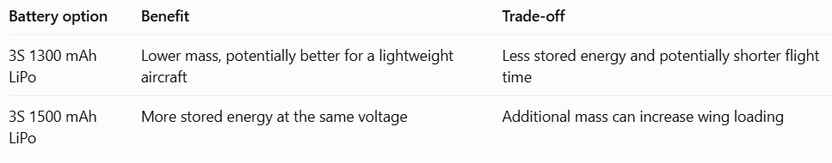
A 3S LiPo has a nominal voltage of 11.1 V and a fully charged voltage of 12.6 V. Both the motor and ESC must support this voltage.
Battery energy can be estimated as:
$$E=V×Ah$$
For a 3S 1300 m Ah battery:
$$E=11.1×1.3=14.43\text{ Wh}$$
# NOTE: THE ACTUAL FLIGHT TIME DEPENDS ON AVERAGE ELECTRICAL POWER, BATTERY CONDITION, THROTTLE USE, AIRCRAFT DRAG AND RESERVE CAPACITY. A LARGER BATTERY DOES NOT AUTOMATICALLY MEAN BETTER FLIGHT PERFORMANCE.
Servo count and control surfaces
- 2 aileron servos: control roll by moving the ailerons.
- 1 elevator servo: controls pitch by moving the elevator.
- 1 rudder servo: controls yaw by moving the rudder.
Four 9 g micro servos are a suitable starting point for this size of foam aircraft, provided their torque, travel and mounting dimensions are adequate.
Structural material selection
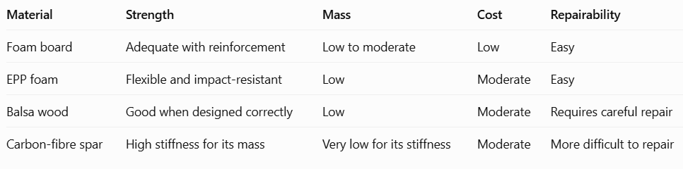
Recommended combination: foam-board or EPP airframe with a properly sized wooden or carbon-fibre wing spar and plywood motor-mount reinforcement.
This balances low mass, affordability, stiffness and repairability. The spar must be designed for the wing loads; adding reinforcement everywhere can make the aircraft unnecessarily heavy.
Electrical and mechanical compatibility checks
Before assembly, verify the following:
- Motor and ESC: compatible brushless motor type, voltage and current ratings.
- ESC and battery: compatible 3S voltage, connector polarity and current capacity.
- Battery and charger: charger supports LiPo chemistry, 3S balance charging and the battery's specified charge rate.
- Receiver and transmitter: matching radio protocol, frequency system and binding procedure.
- Receiver and servos: compatible operating voltage and signal connections.
- BEC and servos: adequate regulated voltage and total current capacity for all four servos.
- Motor mount and propeller: shaft adapter fits correctly, mount is rigid and propeller is suitable for the motor.
- Airframe: wing is securely attached, control surfaces move freely, and the centre of gravity falls within the design's specified range.
# NOTE: FOR SAFETY, DISCONNECT THE PROPULSION BATTERY AND REMOVE THE PROPELLER WHILE CONFIGURING THE RECEIVER, ESC AND CONTROL SURFACES. LIPO BATTERIES SHOULD BE CHARGED USING A COMPATIBLE BALANCE CHARGER, UNDER ADULT SUPERVISION, AWAY FROM FLAMMABLE MATERIALS.

Budget and cost-saving options
Estimated build budget
The following estimate combines the BOM allowances above. It assumes that the builder already has basic hand tools and that the aircraft is built from raw materials rather than purchased as a complete kit.
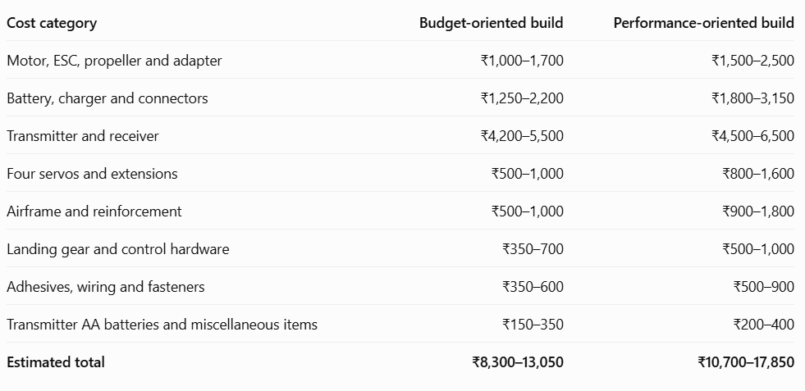
# NOTE: THESE ARE PLANNING RANGES, NOT SUPPLIER QUOTATIONS
Safe cost-saving opportunities
- Use foam board for the main airframe. Reuse offcuts for the tail and internal supports, but retain adequate wing reinforcement.
- Buy a matched motor-and-ESC combination only after confirming the specifications and whether a propeller is included. A listed A2212 1000 KV and 30 A ESC combination is approximately ₹899 before any options or shipping.

- Choose a 3S 1300 m Ah battery if its current rating and capacity meet the design requirements. Do not choose a battery based on price alone.
- Use one compatible radio system for the project. Borrowing an existing system can save money if it is compatible and in good condition.
- Reuse suitable tools and test equipment instead of purchasing duplicate items.
- Avoid unnecessary decoration and oversized components. Extra paint, heavy glue and excessive reinforcement can increase aircraft mass.
Budget versus performance configuration

Option A — Budget-oriented
₹8,300–13,050
- Foam-board airframe
- A compatible A2212 motor and 30 A ESC
- 3S 1300 mAh battery
- Four basic 9 g servos
- Reusable tools and simple landing gear
Best when minimizing build cost is the main priority.

Option B — Performance-oriented
₹10,700–17,850
- Reinforced foam or EPP construction
- Carefully matched propulsion components
- Better-quality servos and linkages
- Reliable battery, charger and connectors
- Improved structural reinforcement
Best when repairability, component quality and reliability matter more than the lowest initial cost.
RESULT: Choose Option A, with a properly reinforced wing and a verified motor–propeller–battery combination. For a 1.2 m trainer, good weight management, stable geometry and reliable control surfaces are more important than simply installing a more powerful motor.

Sources and purchase-reference links
These links are included only as references for your assignment. Do not purchase any parts for this task. Prices and availability may change.

ITEMS | REFERANCE LINKS
Motor and ESC | https://fioparts.com/products/a2212-1000kv-brushless-motor-30a-esc-combo?utm_source=chatgpt.com
Motor specifications | https://www.mathaelectronics.com/product/a2212-brushless-dc-motor-1000kv/?utm_source=chatgpt.com
Transmitter and receiver | https://www.sunrobotics.in/products/flysky-fsi6-rc-transmitter-receiver?utm_source=chatgpt.com
Servos and accessories | https://rotoryard.in/parts/c/servo?utm_source=chatgpt.com
Airframe materials | https://flyingmachines.in/product-category/rc-plane-building-material/?utm_source=chatgpt.com
Battery and charger references | https://flyingmachines.in/product-category/rc-accessories/lipo-battery-chargers/?utm_source=chatgpt.com

