Title: Session Hijacking and Cookie Analysis using Wireshark and DVWA
• A session is a unique code (session ID) generated when a user logs into a website or a local network site.
• The session remains active until the user logs out. Once logged out, the session is destroyed. This session ID helps maintain the user’s authenticated state during browsing without requiring repeated logins.
• Session hijacking is an attack where an attacker steals or uses a session ID to impersonate a victim. The attacker copies their own session ID and aims to inject this ID into the victim’s machine. By doing this, the attacker can monitor or control the victim’s browsing session remotely.
Demonstration of session hijacking:
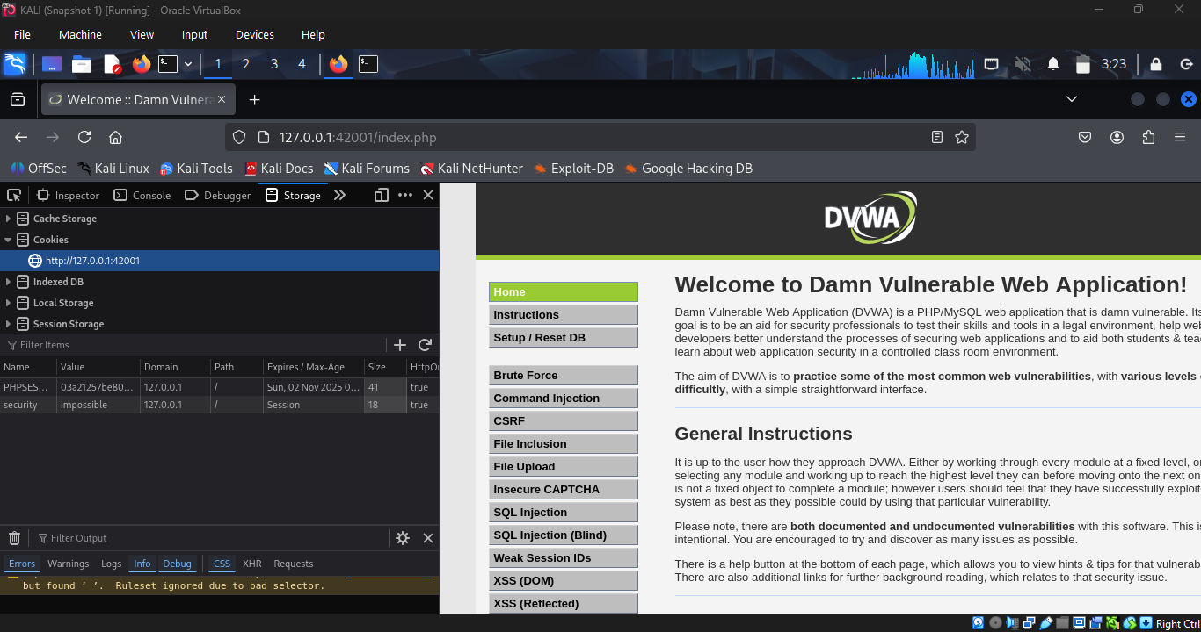
In kali linux, here firefox browser is considered as the attacker. In firefox, I have opened DVWA and logged in. To get the session ID I have gone to storage -> cookies. Thus copied the session ID for further use.
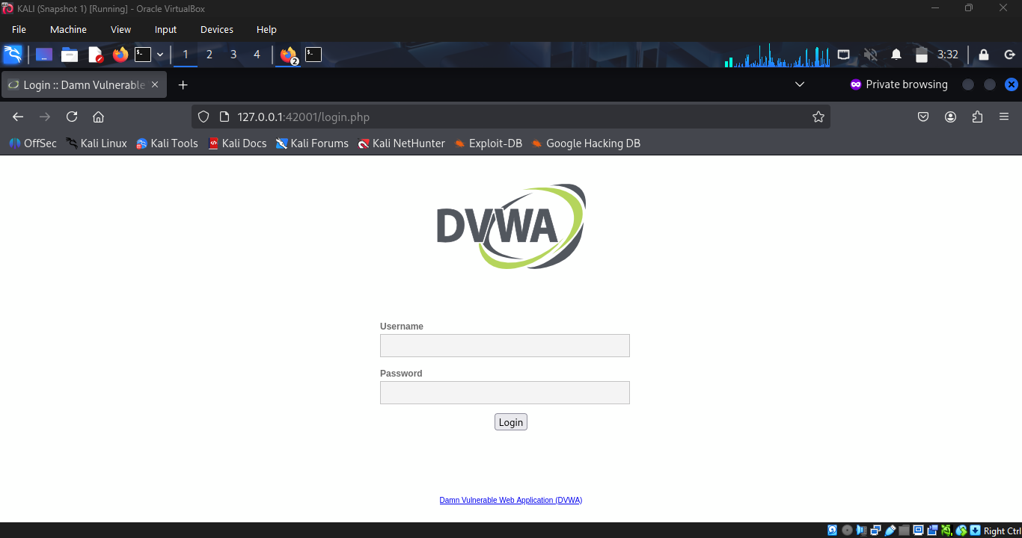
In the next step, I have opned firefox private browsing (incognito) which is considered to be the victim.

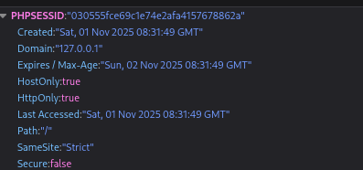
This is the session ID of the incognito. The attacker uses an incognito browser window to simulate the victim's environment, ensuring the victim has no suspicion while the session ID injection occurs silently.
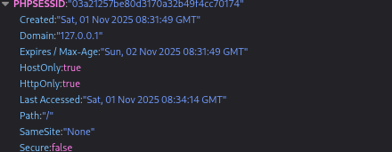
Thus I have replaced the session ID of incognito with the session ID of attacker browser.
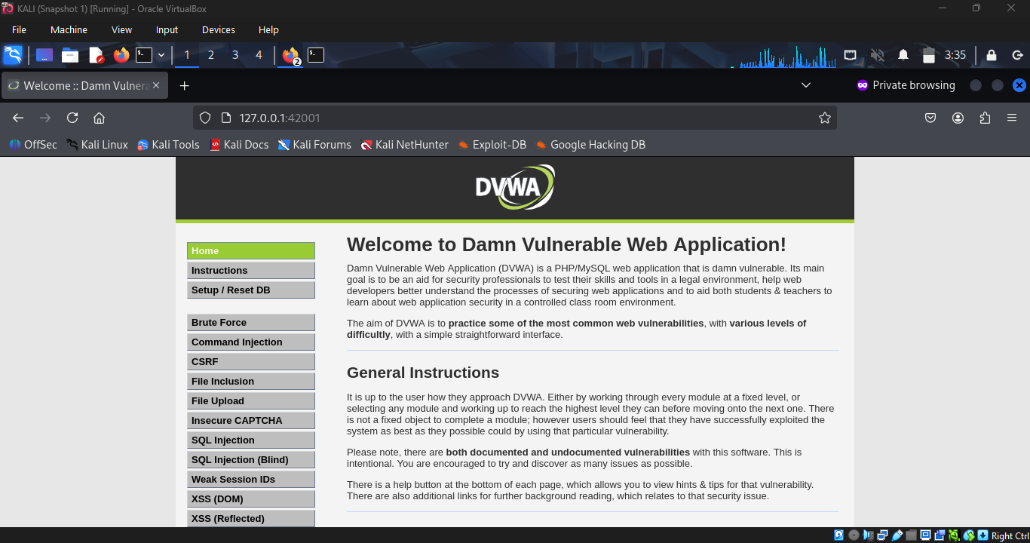
Even without providing the victim’s credentials I was able to login.

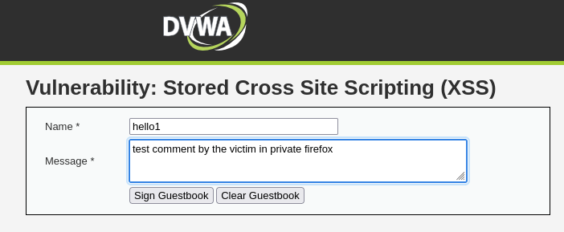
The victim continues to operate normally, performing tasks such as reflected XSS (cross-site scripting) test.

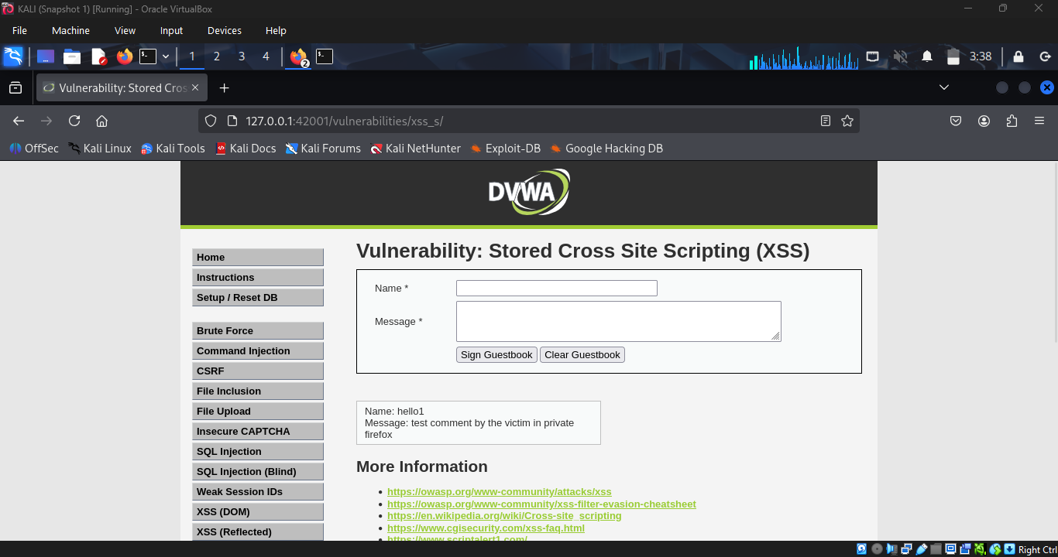
Thus the attacker observes all activity remotely. The attacker can see exact inputs typed by the victim, like "hello 1”, showcasing the depth of surveillance possible with hijacked sessions.
Cookie Analysis:

Cookie Security Checklist
- Always use Secure, HttpOnly, and SameSite=Strict attributes for session cookies.
- Regenerate session IDs on login and after privilege changes to prevent fixation.
- Avoid storing session IDs in localStorage; use short-lived cookies and enforce HTTPS-only transmission.

