Git Hands-On Lab — Solution
This document walks through both hands-on labs (Git setup & first commit, and .gitignore) with the commands run and the resulting terminal output.

Lab 1: Git Setup, Notepad++ Integration & First Commit
Step 1: Check Git is installed
Open Git Bash and run:
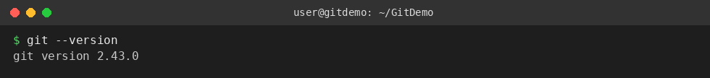
The version output confirms Git is installed correctly.
Step 2: Configure username and email
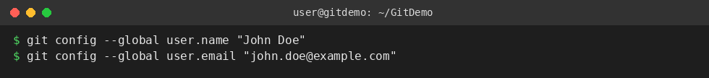
Step 3: Verify the configuration
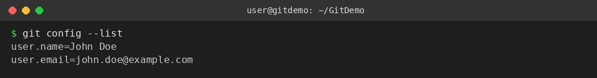
Step 4: Integrate Notepad++ as the default editor
First check if notepad++ runs from Git Bash:
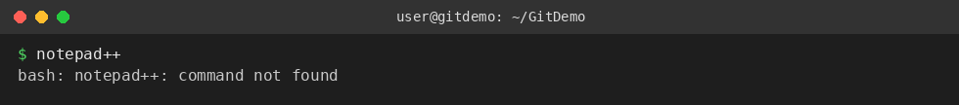
If it isn't recognized, add Notepad++'s install folder to the Windows PATH environment variable (Control Panel → System → Advanced System Settings → Environment Variables):
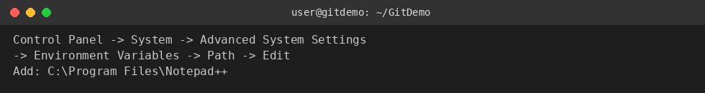
Close and reopen Git Bash, then try again:
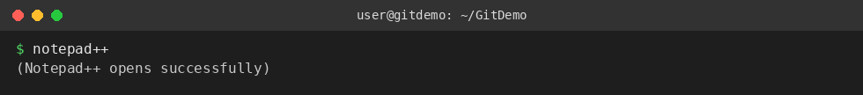
Create a convenient alias:
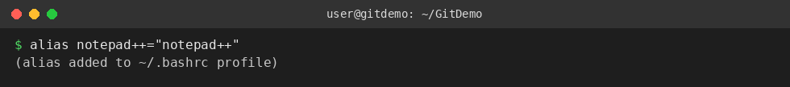
Set Notepad++ as Git's default editor:
Verify it by opening the global config with the editor:
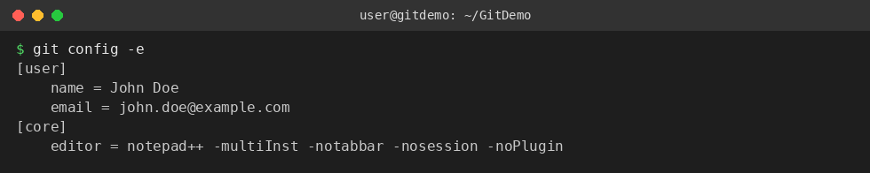
Step 5: Create the GitDemo repository
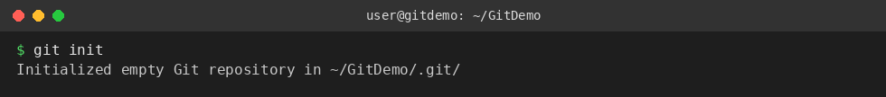
Confirm the hidden .git folder was created:
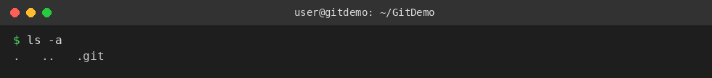
Step 6: Create welcome.txt with content
Verify the file exists:
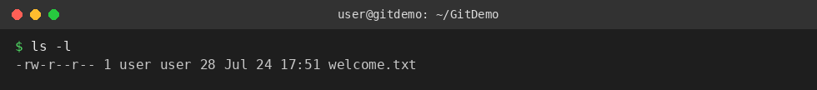
Verify its content:
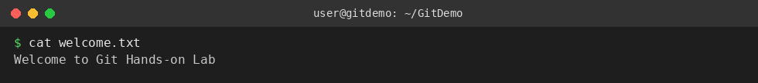
Step 7: Check status (file is untracked)
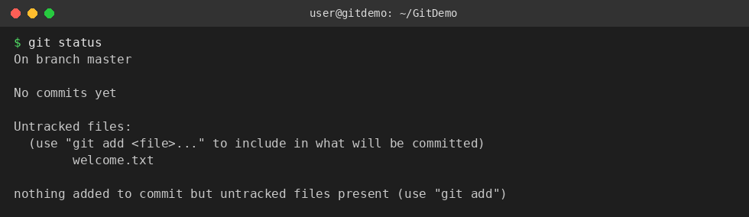
Step 8: Stage the file
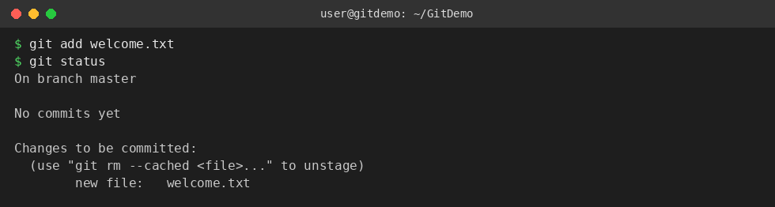
Step 9: Commit the file
A commit message can be typed inline, or Notepad++ will open for a multi-line message if -m is omitted.
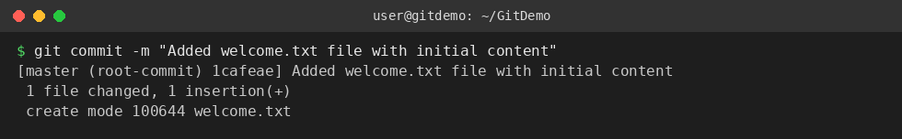
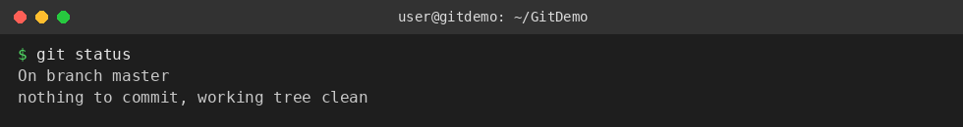
welcome.txt is now committed to the local repository.
Step 10: Sync with the remote (GitLab) repository
After creating a remote 'GitDemo' project on GitLab and linking it as origin:
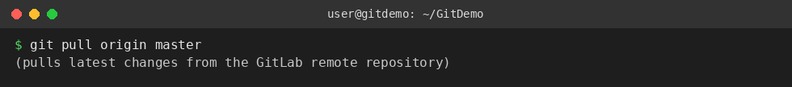
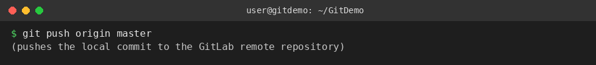

Lab 2: Ignoring Files with .gitignore
Goal: create a .log file and a log folder, then update .gitignore so both are ignored by Git.
Step 1: Create a .log file and a log folder
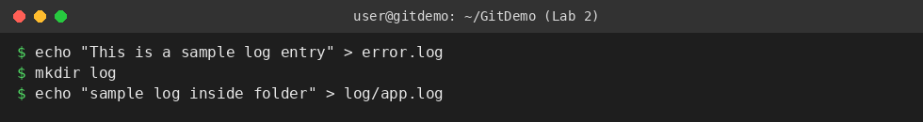
Step 2: Check status before adding .gitignore
Both error.log and the log/ folder show up as untracked:
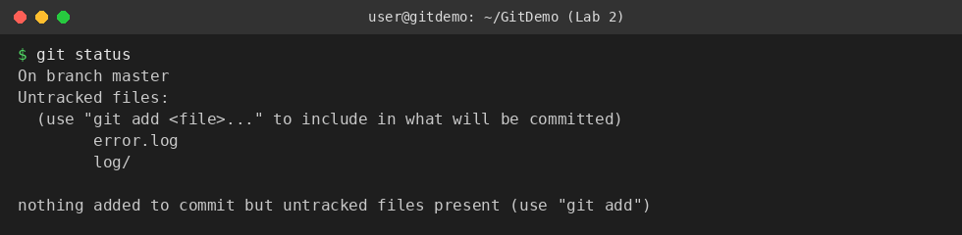
Step 3: Create/update .gitignore
Add patterns to ignore all .log files and the log folder:
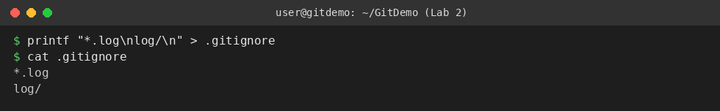
Step 4: Check status after adding .gitignore
error.log and log/ no longer appear — only .gitignore itself shows as untracked:
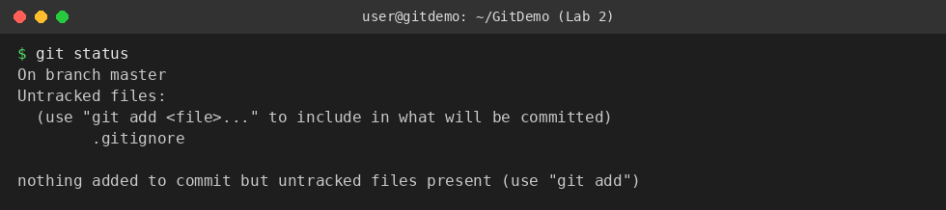
Step 5: Commit the .gitignore file
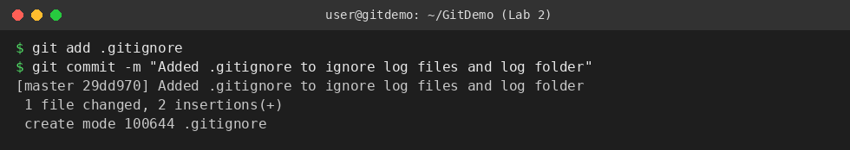
Step 6: Final status check
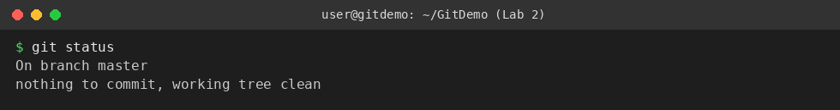
The working directory, local repository, and .gitignore are all in sync — the log file and log folder are correctly excluded.

