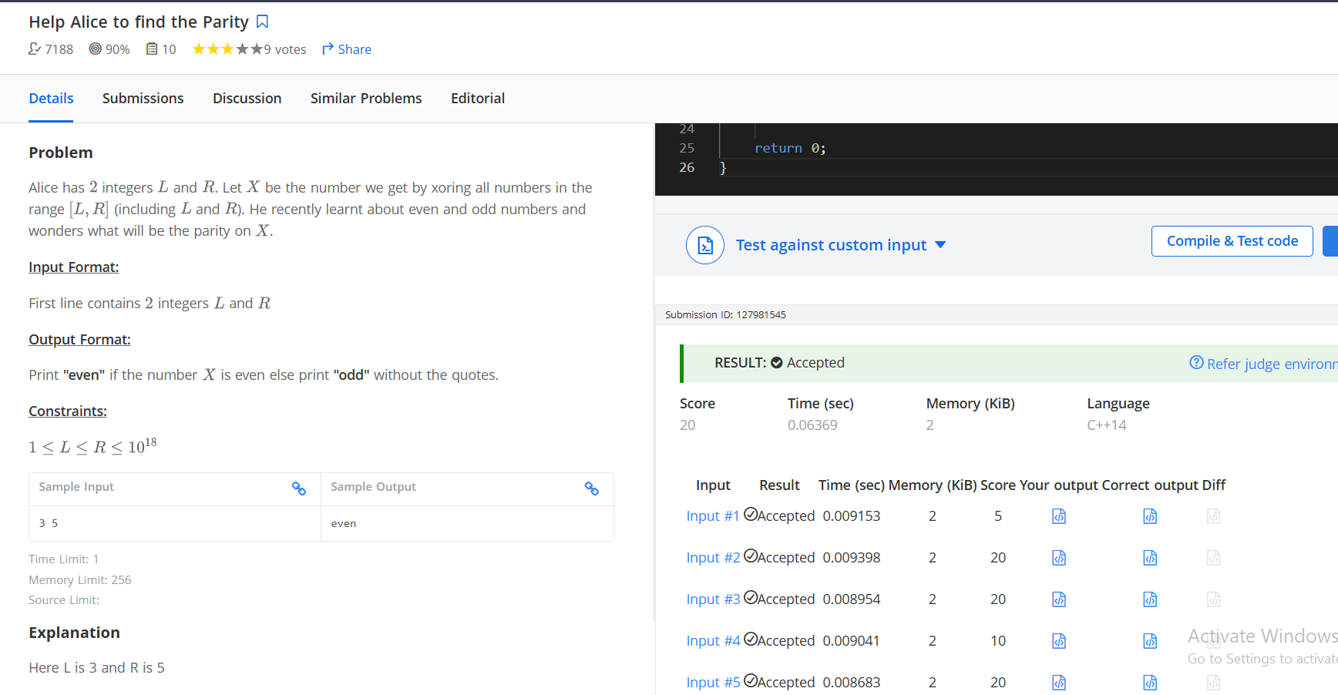
#include <iostream>
using namespace std;

long long xorTillN(long long n) {
if (n % 4 == 0) return n;
if (n % 4 == 1) return 1;
if (n % 4 == 2) return n + 1;
return 0;
}

int main() {
ios::sync_with_stdio(false);
cin.tie(nullptr);

long long L, R;
cin >> L >> R;

long long X = xorTillN(R) ^ xorTillN(L - 1);

if (X % 2 == 0)
cout << "even";
else
cout << "odd";

return 0;
}
Q4)
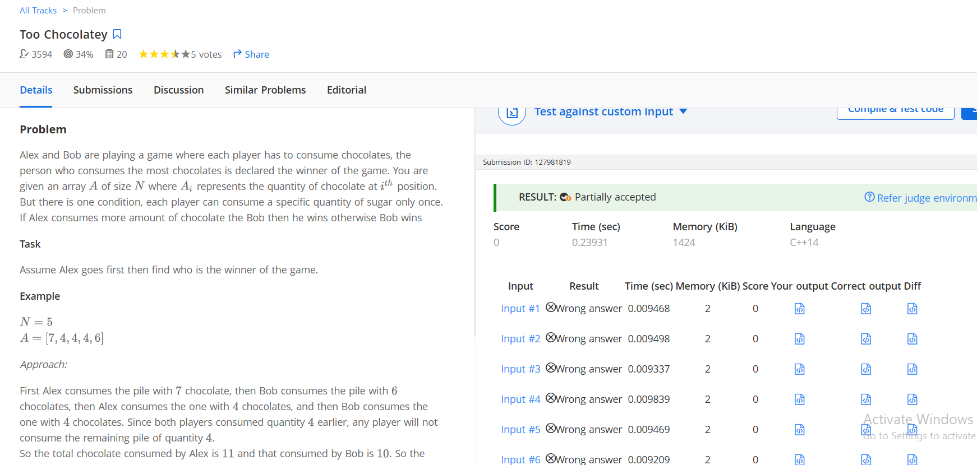
#include <iostream>
#include <vector>
#include <algorithm>
#include <set>

using namespace std;

string solve(int n, vector<int>& a) {

sort(a.begin(), a.end(), greater<int>());

long long alex = 0, bob = 0;

set<int> sa, sb;

for (int i = 0; i < n; i++) {

// Alex's turn
if (i % 2 == 0) {
if (sa.find(a[i]) == sa.end()) {
alex += a[i];
sa.insert(a[i]);
}
}

// Bob's turn
else {
if (sb.find(a[i]) == sb.end()) {
bob += a[i];
sb.insert(a[i]);
}
}
}

if (alex > bob)
return "Alex";
else
return "Bob";
}

int main() {

ios::sync_with_stdio(false);
cin.tie(nullptr);

int T;
cin >> T;

while (T--) {

int n;
cin >> n;

vector<int> a(n);

for (int i = 0; i < n; i++) {
cin >> a[i];
}

cout << solve(n, a) << '\n';
}

return 0;
}

